Model Comparison Study
Dataset: camels; ID: 01013500; Year: 1980; Variable: Q_cfs
This document presents pairwise comparisons of synthetic model predictions. For each comparison, choose which time series better matches the ground truth.

Comparison 1: TS 17 vs TS 18
Which time series better matches the ground truth?
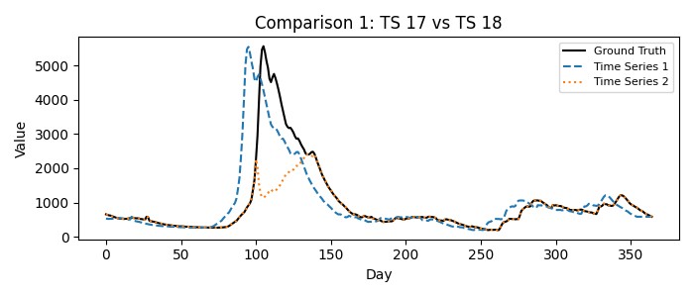
1 = Time Series 17, 2 = Time Series 18
Please fill in your choice (enter 1 or 2): 1__

Comparison 2: TS 0 vs TS 4
Which time series better matches the ground truth?
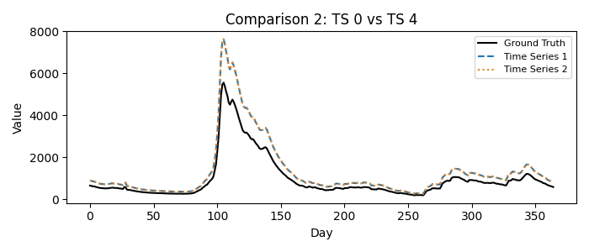
1 = Time Series 0, 2 = Time Series 4
Please fill in your choice (enter 1 or 2): _1_

Comparison 3: TS 1 vs TS 2
Which time series better matches the ground truth?
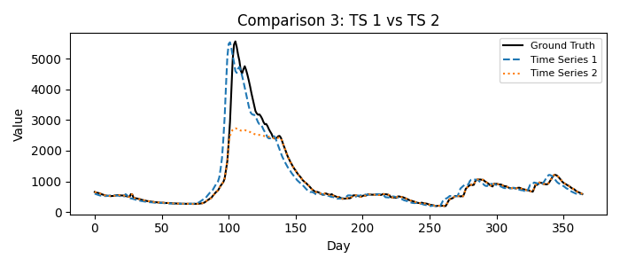
1 = Time Series 1, 2 = Time Series 2
Please fill in your choice (enter 1 or 2): 1__

Comparison 4: TS 12 vs TS 19
Which time series better matches the ground truth?
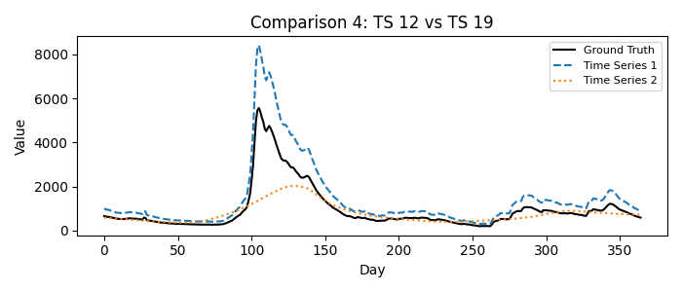
1 = Time Series 12, 2 = Time Series 19
Please fill in your choice (enter 1 or 2): __1

Comparison 5: TS 9 vs TS 11
Which time series better matches the ground truth?
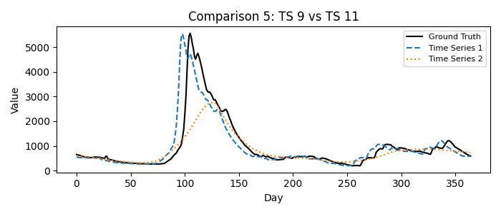
1 = Time Series 9, 2 = Time Series 11
Please fill in your choice (enter 1 or 2): __1

Comparison 6: TS 0 vs TS 6
Which time series better matches the ground truth?
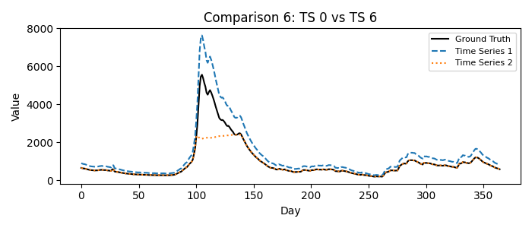
1 = Time Series 0, 2 = Time Series 6
Please fill in your choice (enter 1 or 2): __1

Comparison 7: TS 14 vs TS 16
Which time series better matches the ground truth?
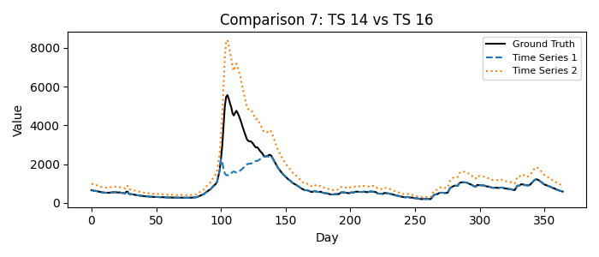
1 = Time Series 14, 2 = Time Series 16
Please fill in your choice (enter 1 or 2): 2__

Comparison 8: TS 7 vs TS 8
Which time series better matches the ground truth?
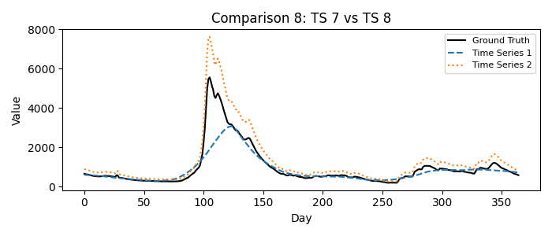
1 = Time Series 7, 2 = Time Series 8
Please fill in your choice (enter 1 or 2): _2_

Comparison 9: TS 5 vs TS 8
Which time series better matches the ground truth?
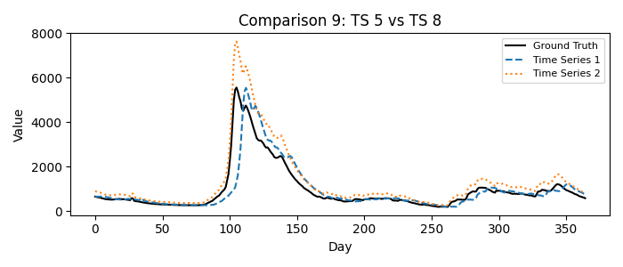
1 = Time Series 5, 2 = Time Series 8
Please fill in your choice (enter 1 or 2): 1_

Comparison 10: TS 9 vs TS 10
Which time series better matches the ground truth?
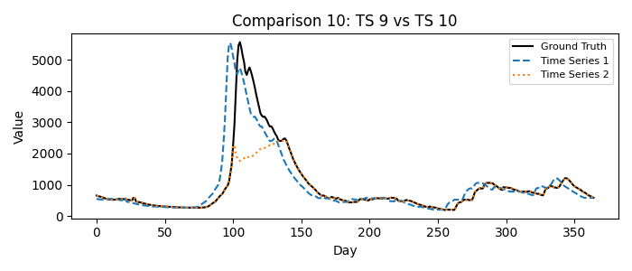
1 = Time Series 9, 2 = Time Series 10
Please fill in your choice (enter 1 or 2): _1_

Comparison 11: TS 9 vs TS 15
Which time series better matches the ground truth?
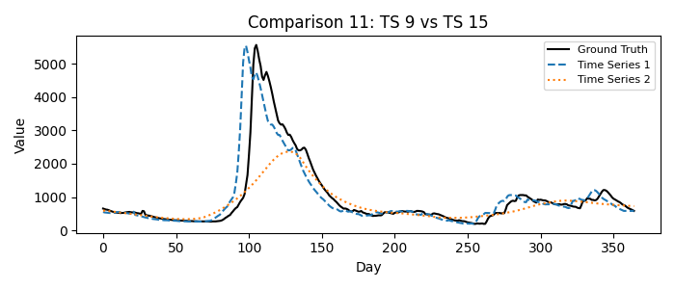
1 = Time Series 9, 2 = Time Series 15
Please fill in your choice (enter 1 or 2): _1_

Comparison 12: TS 3 vs TS 4
Which time series better matches the ground truth?
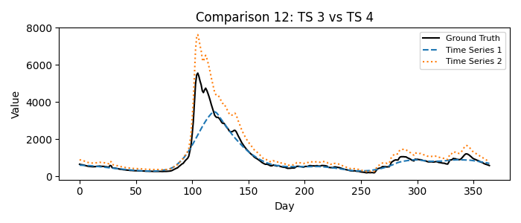
1 = Time Series 3, 2 = Time Series 4
Please fill in your choice (enter 1 or 2): __2

Comparison 13: TS 12 vs TS 13
Which time series better matches the ground truth?
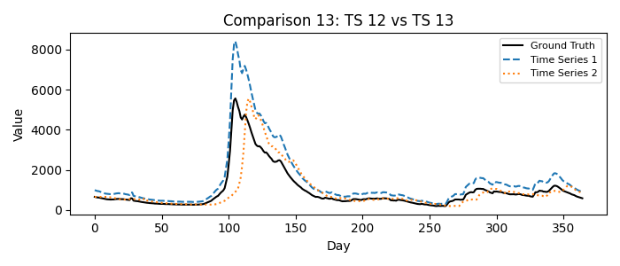
1 = Time Series 12, 2 = Time Series 13
Please fill in your choice (enter 1 or 2): _2_

Comparison 14: TS 6 vs TS 8
Which time series better matches the ground truth?
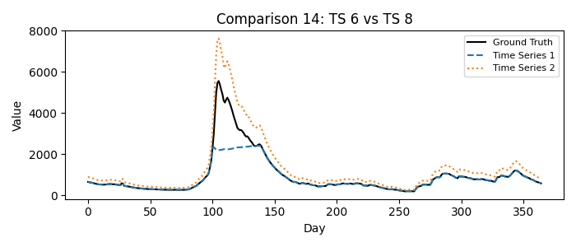
1 = Time Series 6, 2 = Time Series 8
Please fill in your choice (enter 1 or 2): _2_

Comparison 15: TS 11 vs TS 14
Which time series better matches the ground truth?
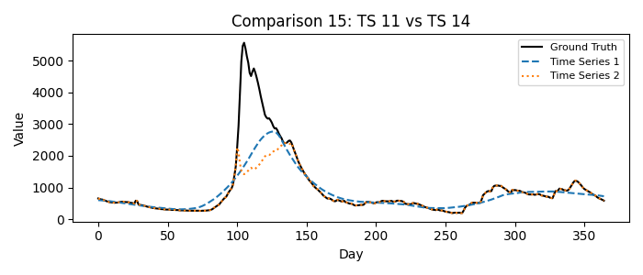
1 = Time Series 11, 2 = Time Series 14
Please fill in your choice (enter 1 or 2): __1

Comparison 16: TS 10 vs TS 12
Which time series better matches the ground truth?
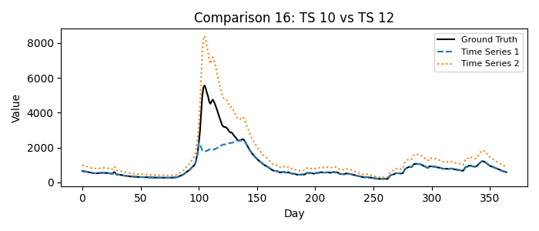
1 = Time Series 10, 2 = Time Series 12
Please fill in your choice (enter 1 or 2): _2_

Comparison 17: TS 0 vs TS 1
Which time series better matches the ground truth?
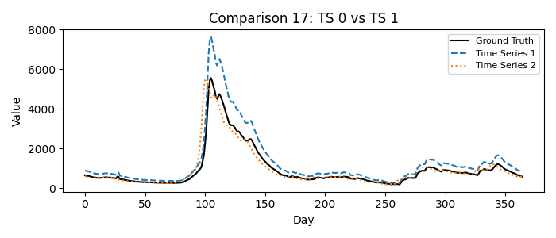
1 = Time Series 0, 2 = Time Series 1
Please fill in your choice (enter 1 or 2): 2__

Comparison 18: TS 18 vs TS 19
Which time series better matches the ground truth?
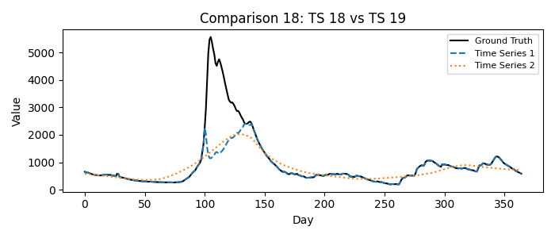
1 = Time Series 18, 2 = Time Series 19
Please fill in your choice (enter 1 or 2): _1_

Comparison 19: TS 13 vs TS 18
Which time series better matches the ground truth?
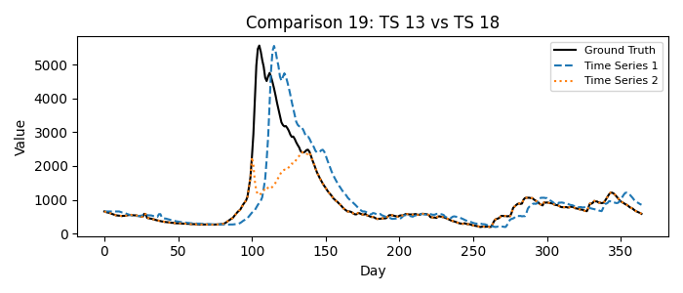
1 = Time Series 13, 2 = Time Series 18
Please fill in your choice (enter 1 or 2): 1__

Comparison 20: TS 5 vs TS 15
Which time series better matches the ground truth?
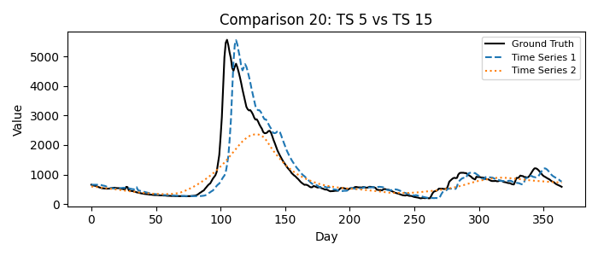
1 = Time Series 5, 2 = Time Series 15
Please fill in your choice (enter 1 or 2): __1

Comparison 21: TS 3 vs TS 8
Which time series better matches the ground truth?
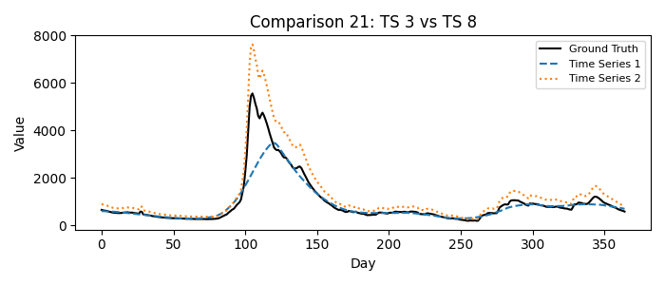
1 = Time Series 3, 2 = Time Series 8
Please fill in your choice (enter 1 or 2): __2

Comparison 22: TS 16 vs TS 17
Which time series better matches the ground truth?
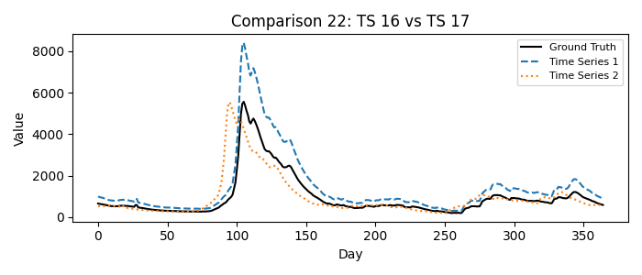
1 = Time Series 16, 2 = Time Series 17
Please fill in your choice (enter 1 or 2): _2_

Comparison 23: TS 2 vs TS 4
Which time series better matches the ground truth?
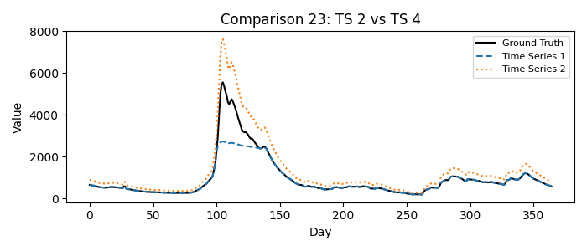
1 = Time Series 2, 2 = Time Series 4
Please fill in your choice (enter 1 or 2): __2

Comparison 24: TS 7 vs TS 9
Which time series better matches the ground truth?
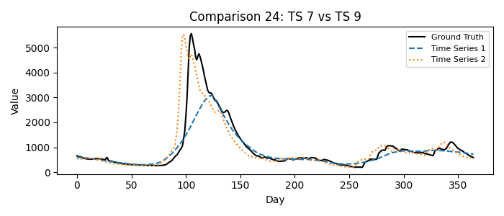
1 = Time Series 7, 2 = Time Series 9
Please fill in your choice (enter 1 or 2): _2_

Comparison 25: TS 13 vs TS 14
Which time series better matches the ground truth?
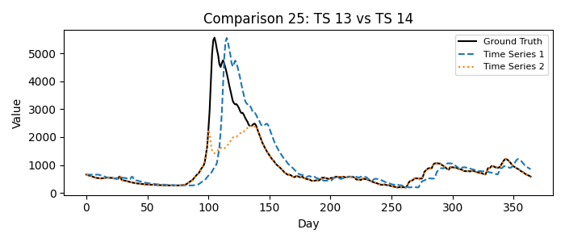
1 = Time Series 13, 2 = Time Series 14
Please fill in your choice (enter 1 or 2): _1_

Comparison 26: TS 5 vs TS 14
Which time series better matches the ground truth?
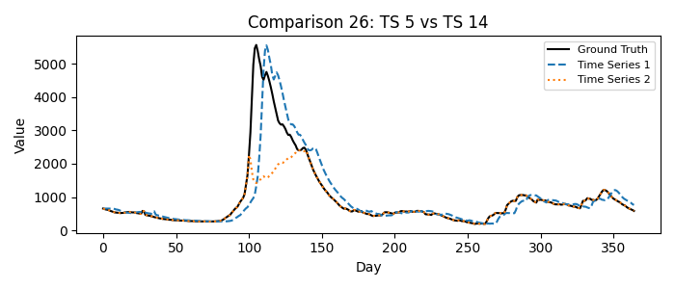
1 = Time Series 5, 2 = Time Series 14
Please fill in your choice (enter 1 or 2): __1

Comparison 27: TS 11 vs TS 15
Which time series better matches the ground truth?
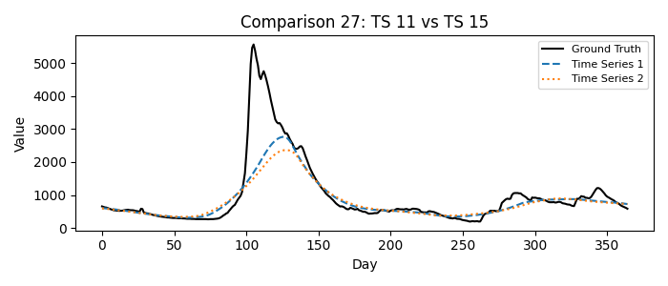
1 = Time Series 11, 2 = Time Series 15
Please fill in your choice (enter 1 or 2): __1
Comparison 28: TS 16 vs TS 19
Which time series better matches the ground truth?
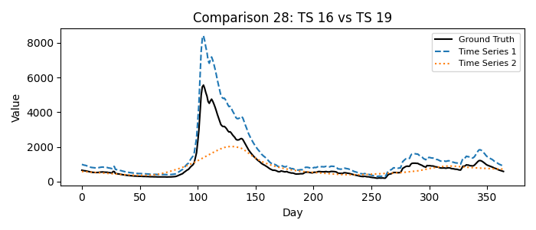
1 = Time Series 16, 2 = Time Series 19
Please fill in your choice (enter 1 or 2): _1_

Comparison 29: TS 2 vs TS 8
Which time series better matches the ground truth?
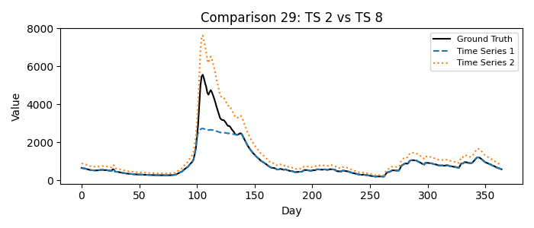
1 = Time Series 2, 2 = Time Series 8
Please fill in your choice (enter 1 or 2): _2_

Comparison 30: TS 6 vs TS 9
Which time series better matches the ground truth?
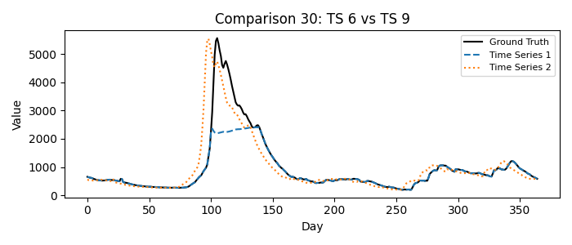
1 = Time Series 6, 2 = Time Series 9
Please fill in your choice (enter 1 or 2): _2_

Comparison 31: TS 17 vs TS 19
Which time series better matches the ground truth?
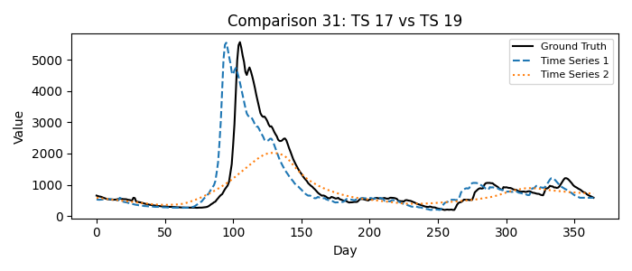
1 = Time Series 17, 2 = Time Series 19
Please fill in your choice (enter 1 or 2): __1

Comparison 32: TS 10 vs TS 11
Which time series better matches the ground truth?
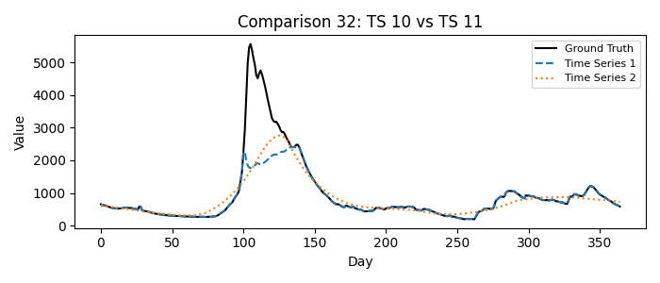
1 = Time Series 10, 2 = Time Series 11
Please fill in your choice (enter 1 or 2): _1_

Comparison 33: TS 7 vs TS 10
Which time series better matches the ground truth?
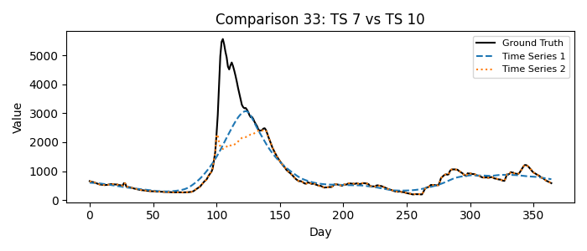
1 = Time Series 7, 2 = Time Series 10
Please fill in your choice (enter 1 or 2): __1

Comparison 34: TS 1 vs TS 3
Which time series better matches the ground truth?
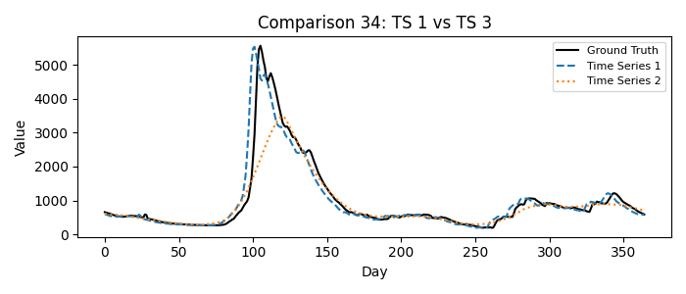
1 = Time Series 1, 2 = Time Series 3
Please fill in your choice (enter 1 or 2): __1

Comparison 35: TS 5 vs TS 6
Which time series better matches the ground truth?
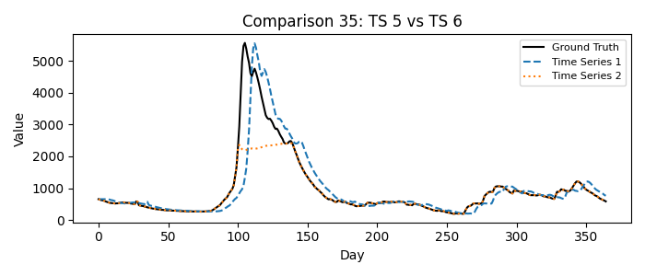
1 = Time Series 5, 2 = Time Series 6
Please fill in your choice (enter 1 or 2): _1_

Comparison 36: TS 12 vs TS 15
Which time series better matches the ground truth?
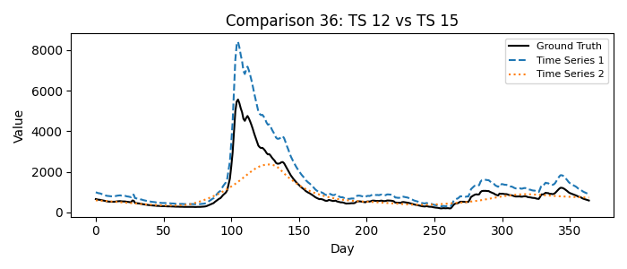
1 = Time Series 12, 2 = Time Series 15
Please fill in your choice (enter 1 or 2): __1

Comparison 37: TS 0 vs TS 8
Which time series better matches the ground truth?
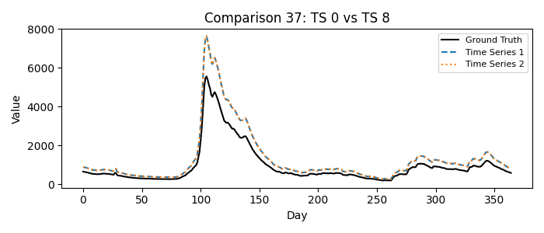
1 = Time Series 0, 2 = Time Series 8
Please fill in your choice (enter 1 or 2): _1_

Comparison 38: TS 16 vs TS 18
Which time series better matches the ground truth?
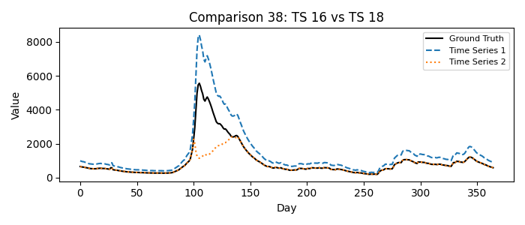
1 = Time Series 16, 2 = Time Series 18
Please fill in your choice (enter 1 or 2): _1_

Comparison 39: TS 13 vs TS 16
Which time series better matches the ground truth?
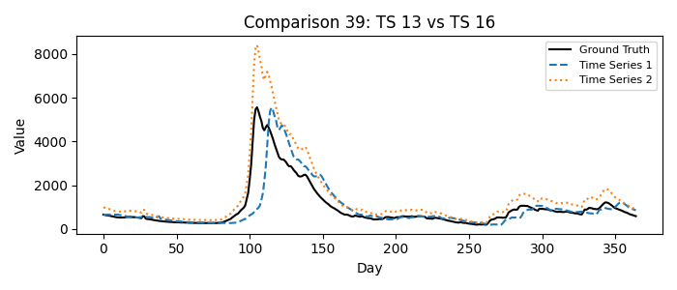
1 = Time Series 13, 2 = Time Series 16
Please fill in your choice (enter 1 or 2): __1

Comparison 40: TS 3 vs TS 6
Which time series better matches the ground truth?
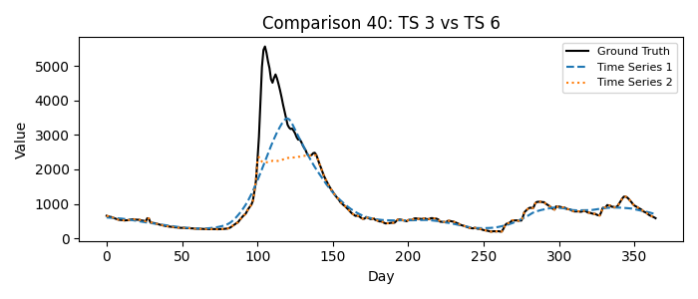
1 = Time Series 3, 2 = Time Series 6
Please fill in your choice (enter 1 or 2): _2_

Comparison 41: TS 7 vs TS 11
Which time series better matches the ground truth?
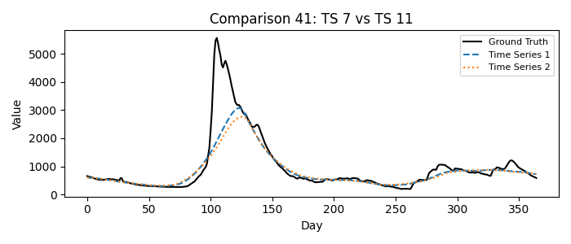
1 = Time Series 7, 2 = Time Series 11
Please fill in your choice (enter 1 or 2): _1_

Comparison 42: TS 4 vs TS 8
Which time series better matches the ground truth?
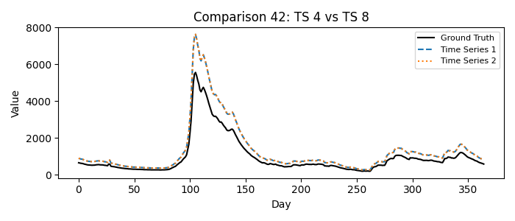
1 = Time Series 4, 2 = Time Series 8
Please fill in your choice (enter 1 or 2): __1

Comparison 43: TS 15 vs TS 17
Which time series better matches the ground truth?
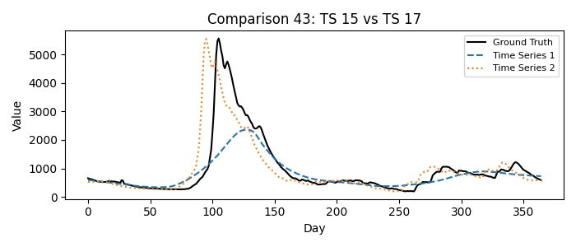
1 = Time Series 15, 2 = Time Series 17
Please fill in your choice (enter 1 or 2): _2_

Comparison 44: TS 2 vs TS 3
Which time series better matches the ground truth?
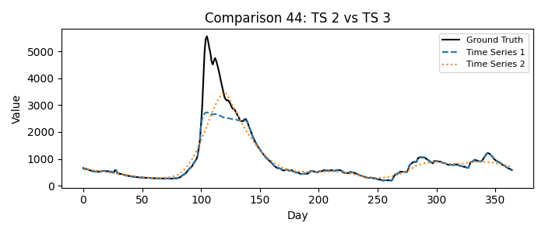
1 = Time Series 2, 2 = Time Series 3
Please fill in your choice (enter 1 or 2): __2

Comparison 45: TS 1 vs TS 4
Which time series better matches the ground truth?
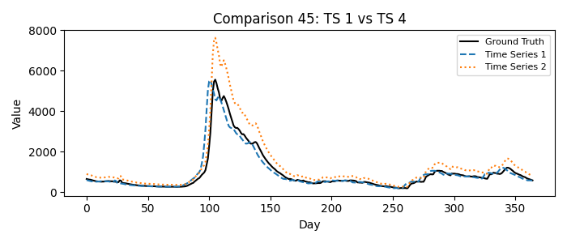
1 = Time Series 1, 2 = Time Series 4
Please fill in your choice (enter 1 or 2): 1__

Comparison 46: TS 1 vs TS 5
Which time series better matches the ground truth?
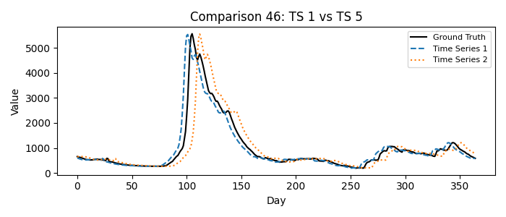
1 = Time Series 1, 2 = Time Series 5
Please fill in your choice (enter 1 or 2): _1_

Comparison 47: TS 14 vs TS 15
Which time series better matches the ground truth?
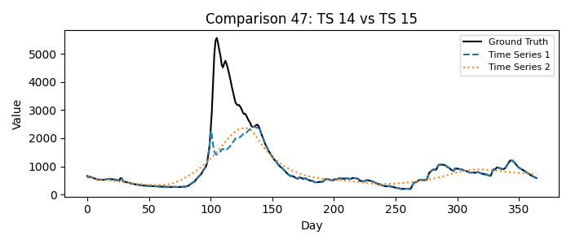
1 = Time Series 14, 2 = Time Series 15
Please fill in your choice (enter 1 or 2): __1

Comparison 48: TS 0 vs TS 7
Which time series better matches the ground truth?
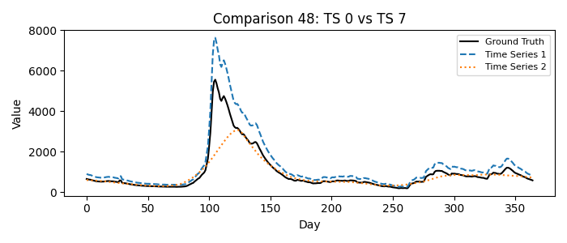
1 = Time Series 0, 2 = Time Series 7
Please fill in your choice (enter 1 or 2): _1_

Comparison 49: TS 14 vs TS 17
Which time series better matches the ground truth?
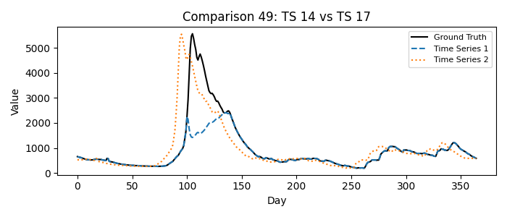
1 = Time Series 14, 2 = Time Series 17
Please fill in your choice (enter 1 or 2): 2__

Comparison 50: TS 5 vs TS 10
Which time series better matches the ground truth?
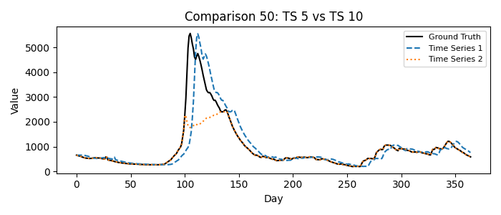
1 = Time Series 5, 2 = Time Series 10
Please fill in your choice (enter 1 or 2): _1_

Comparison 51: TS 0 vs TS 18
Which time series better matches the ground truth?
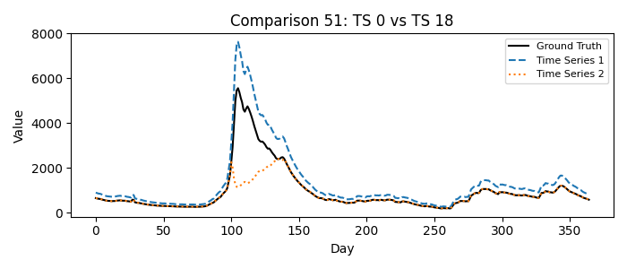
1 = Time Series 0, 2 = Time Series 18
Please fill in your choice (enter 1 or 2): 1__

Comparison 52: TS 0 vs TS 2
Which time series better matches the ground truth?
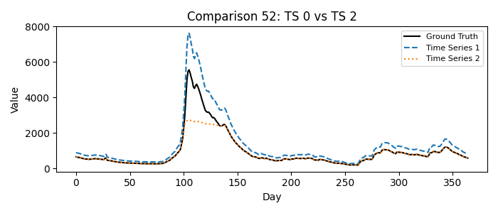
1 = Time Series 0, 2 = Time Series 2
Please fill in your choice (enter 1 or 2): _1_

Comparison 53: TS 13 vs TS 19
Which time series better matches the ground truth?
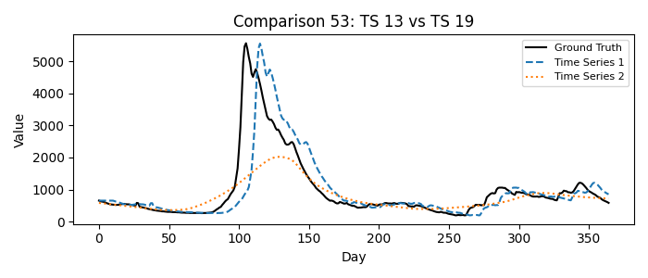
1 = Time Series 13, 2 = Time Series 19
Please fill in your choice (enter 1 or 2): _1_

Comparison 54: TS 12 vs TS 14
Which time series better matches the ground truth?
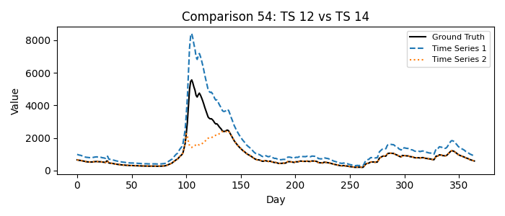
1 = Time Series 12, 2 = Time Series 14
Please fill in your choice (enter 1 or 2): __1

Comparison 55: TS 4 vs TS 7
Which time series better matches the ground truth?
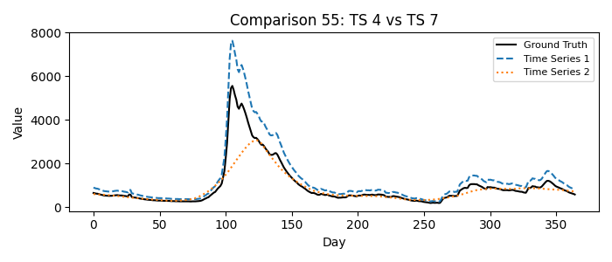
1 = Time Series 4, 2 = Time Series 7
Please fill in your choice (enter 1 or 2): __1

Comparison 56: TS 11 vs TS 12
Which time series better matches the ground truth?
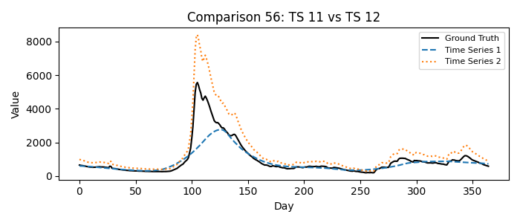
1 = Time Series 11, 2 = Time Series 12
Please fill in your choice (enter 1 or 2): _2_

Comparison 57: TS 10 vs TS 16
Which time series better matches the ground truth?
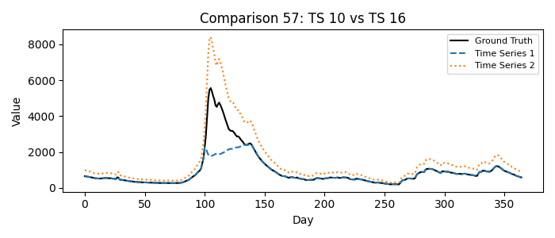
1 = Time Series 10, 2 = Time Series 16
Please fill in your choice (enter 1 or 2): _2_

Comparison 58: TS 0 vs TS 3
Which time series better matches the ground truth?
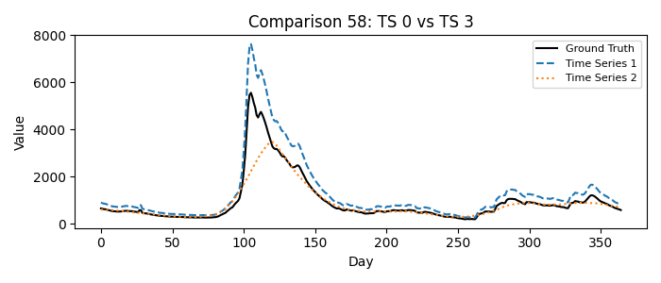
1 = Time Series 0, 2 = Time Series 3
Please fill in your choice (enter 1 or 2): _1_

Comparison 59: TS 2 vs TS 5
Which time series better matches the ground truth?
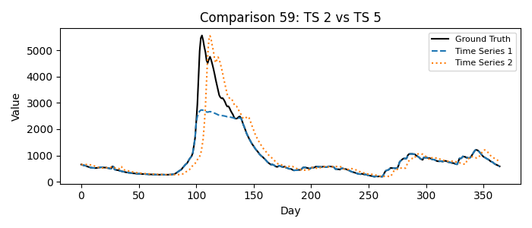
1 = Time Series 2, 2 = Time Series 5
Please fill in your choice (enter 1 or 2): _2_

Comparison 60: TS 1 vs TS 6
Which time series better matches the ground truth?
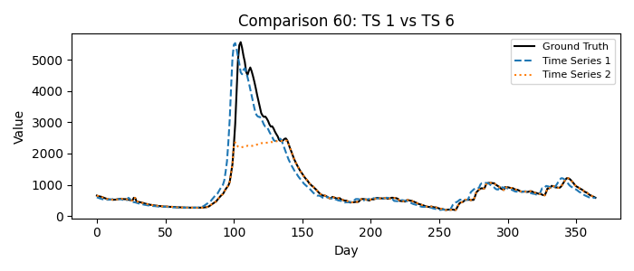
1 = Time Series 1, 2 = Time Series 6
Please fill in your choice (enter 1 or 2): _1_

Comparison 61: TS 13 vs TS 17
Which time series better matches the ground truth?
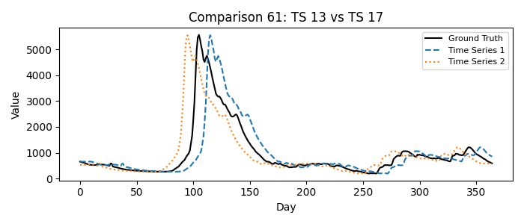
1 = Time Series 13, 2 = Time Series 17
Please fill in your choice (enter 1 or 2): 2__

Comparison 62: TS 1 vs TS 18
Which time series better matches the ground truth?
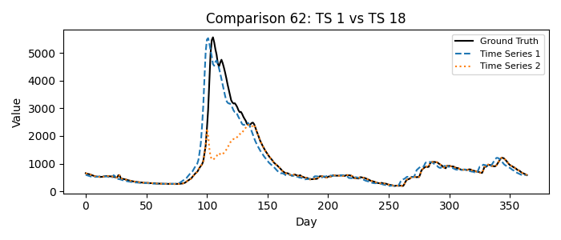
1 = Time Series 1, 2 = Time Series 18
Please fill in your choice (enter 1 or 2): 1__

Comparison 63: TS 0 vs TS 19
Which time series better matches the ground truth?
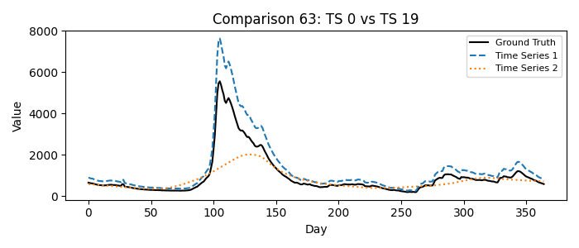
1 = Time Series 0, 2 = Time Series 19
Please fill in your choice (enter 1 or 2): _1_

Comparison 64: TS 5 vs TS 9
Which time series better matches the ground truth?
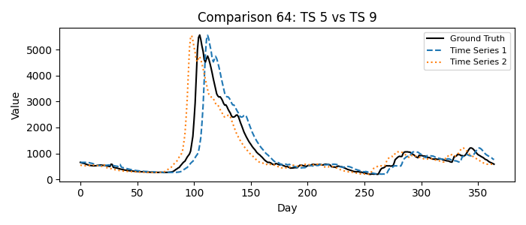
1 = Time Series 5, 2 = Time Series 9
Please fill in your choice (enter 1 or 2): _1_

Comparison 65: TS 2 vs TS 18
Which time series better matches the ground truth?
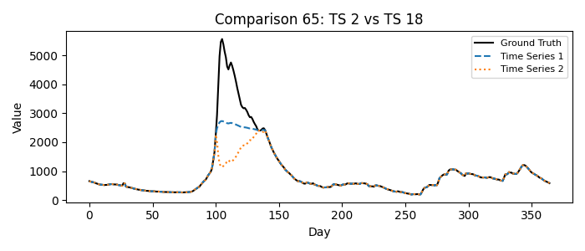
1 = Time Series 2, 2 = Time Series 18
Please fill in your choice (enter 1 or 2): __1

Comparison 66: TS 10 vs TS 14
Which time series better matches the ground truth?
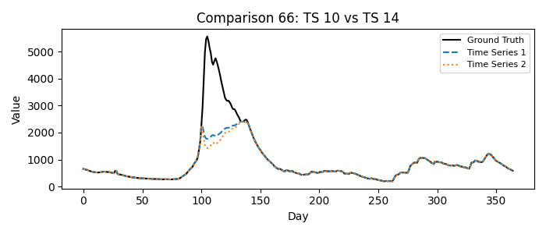
1 = Time Series 10, 2 = Time Series 14
Please fill in your choice (enter 1 or 2): _1_

Comparison 67: TS 15 vs TS 16
Which time series better matches the ground truth?
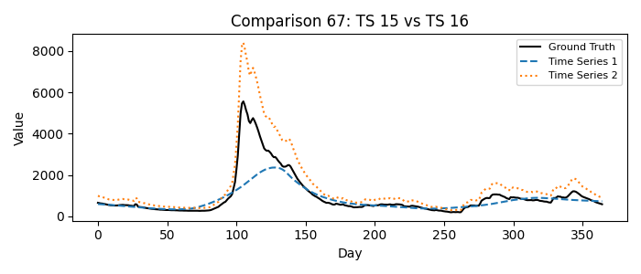
1 = Time Series 15, 2 = Time Series 16
Please fill in your choice (enter 1 or 2): _2_

Comparison 68: TS 8 vs TS 9
Which time series better matches the ground truth?
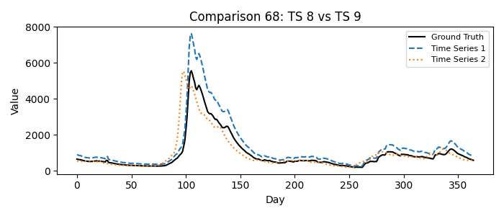
1 = Time Series 8, 2 = Time Series 9
Please fill in your choice (enter 1 or 2): __2

Comparison 69: TS 4 vs TS 6
Which time series better matches the ground truth?
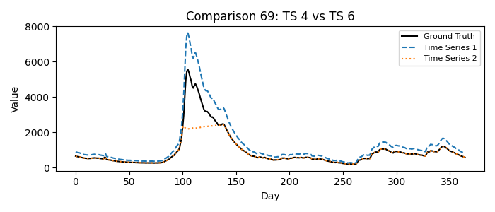
1 = Time Series 4, 2 = Time Series 6
Please fill in your choice (enter 1 or 2): _1_

Comparison 70: TS 12 vs TS 17
Which time series better matches the ground truth?
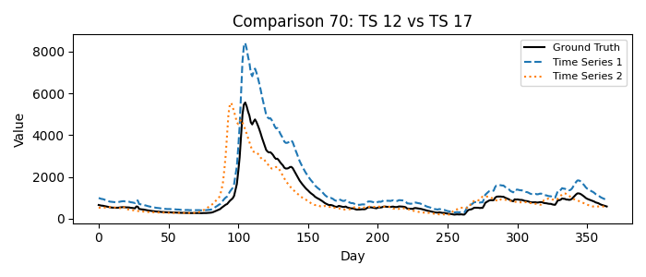
1 = Time Series 12, 2 = Time Series 17
Please fill in your choice (enter 1 or 2): _2

Comparison 71: TS 3 vs TS 5
Which time series better matches the ground truth?
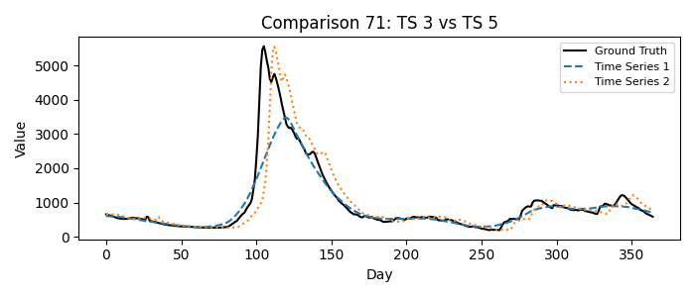
1 = Time Series 3, 2 = Time Series 5
Please fill in your choice (enter 1 or 2): _2_

Comparison 72: TS 6 vs TS 11
Which time series better matches the ground truth?
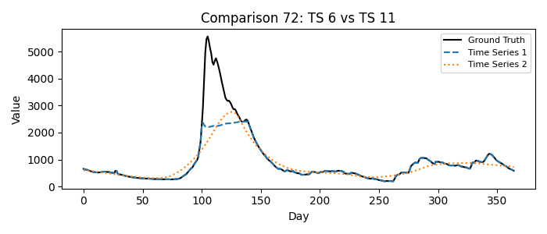
1 = Time Series 6, 2 = Time Series 11
Please fill in your choice (enter 1 or 2): __1

Comparison 73: TS 0 vs TS 13
Which time series better matches the ground truth?
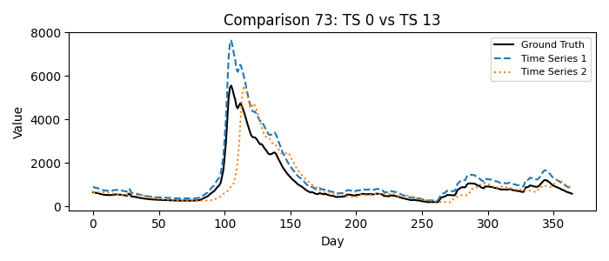
1 = Time Series 0, 2 = Time Series 13
Please fill in your choice (enter 1 or 2): __1

Comparison 74: TS 1 vs TS 19
Which time series better matches the ground truth?
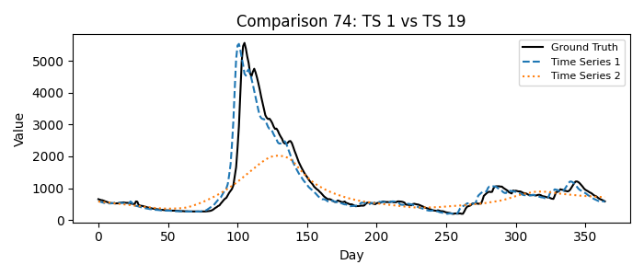
1 = Time Series 1, 2 = Time Series 19
Please fill in your choice (enter 1 or 2): _1_

Comparison 75: TS 6 vs TS 7
Which time series better matches the ground truth?
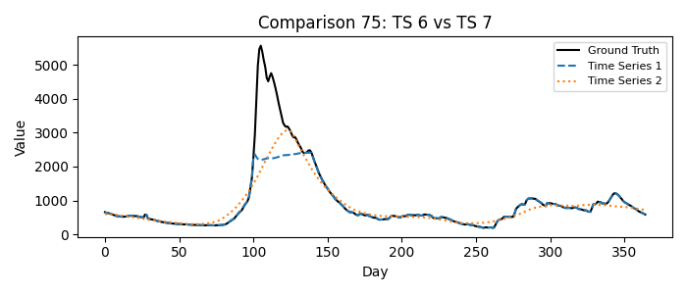
1 = Time Series 6, 2 = Time Series 7
Please fill in your choice (enter 1 or 2): __1

Comparison 76: TS 12 vs TS 16
Which time series better matches the ground truth?
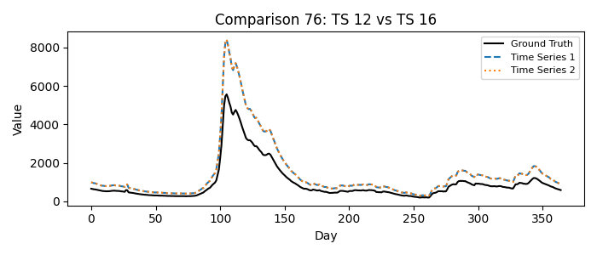
1 = Time Series 12, 2 = Time Series 16
Please fill in your choice (enter 1 or 2): _1_

Comparison 77: TS 0 vs TS 17
Which time series better matches the ground truth?
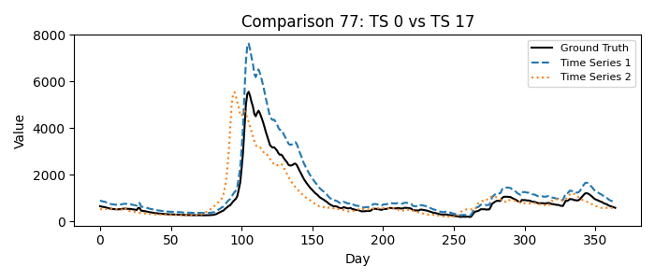
1 = Time Series 0, 2 = Time Series 17
Please fill in your choice (enter 1 or 2): 2_

Comparison 78: TS 4 vs TS 9
Which time series better matches the ground truth?
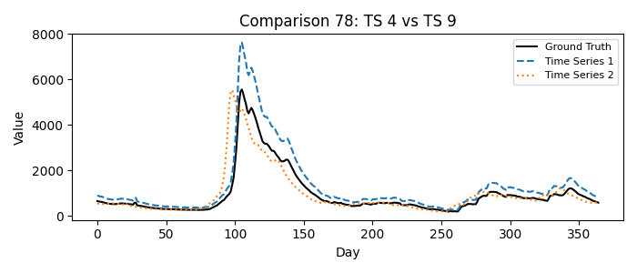
1 = Time Series 4, 2 = Time Series 9
Please fill in your choice (enter 1 or 2): _2_

Comparison 79: TS 10 vs TS 15
Which time series better matches the ground truth?
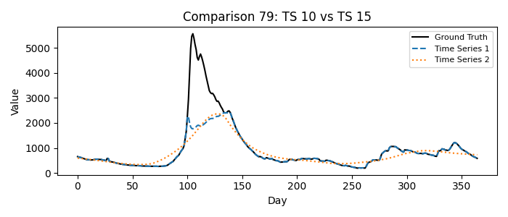
1 = Time Series 10, 2 = Time Series 15
Please fill in your choice (enter 1 or 2): _1_

Comparison 80: TS 2 vs TS 6
Which time series better matches the ground truth?
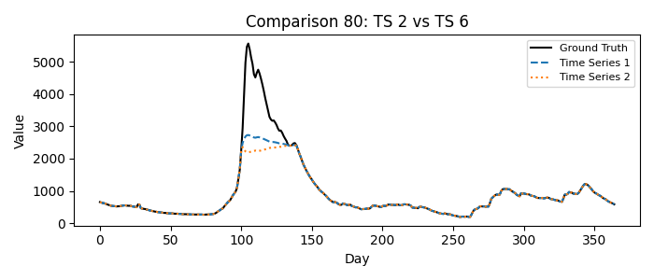
1 = Time Series 2, 2 = Time Series 6
Please fill in your choice (enter 1 or 2): __1

Comparison 81: TS 3 vs TS 18
Which time series better matches the ground truth?
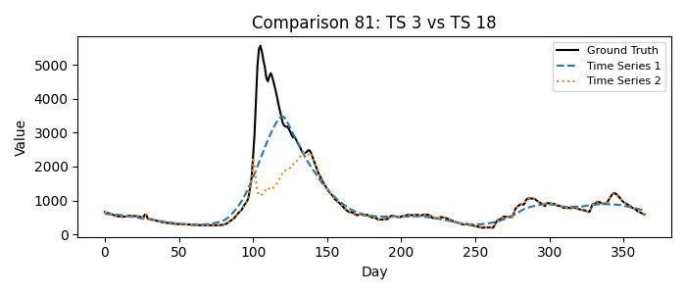
1 = Time Series 3, 2 = Time Series 18
Please fill in your choice (enter 1 or 2): __2

Comparison 82: TS 5 vs TS 11
Which time series better matches the ground truth?
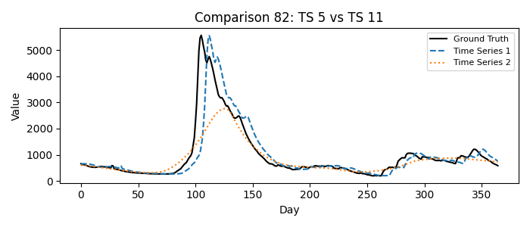
1 = Time Series 5, 2 = Time Series 11
Please fill in your choice (enter 1 or 2): _1_

Comparison 83: TS 5 vs TS 7
Which time series better matches the ground truth?
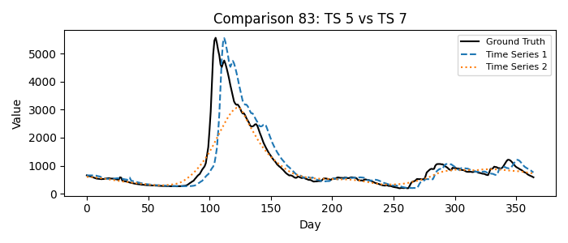
1 = Time Series 5, 2 = Time Series 7
Please fill in your choice (enter 1 or 2): 1__

Comparison 84: TS 2 vs TS 19
Which time series better matches the ground truth?
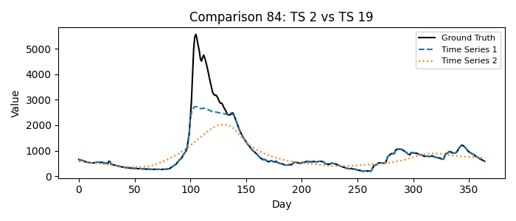
1 = Time Series 2, 2 = Time Series 19
Please fill in your choice (enter 1 or 2): _1_

Comparison 85: TS 1 vs TS 13
Which time series better matches the ground truth?
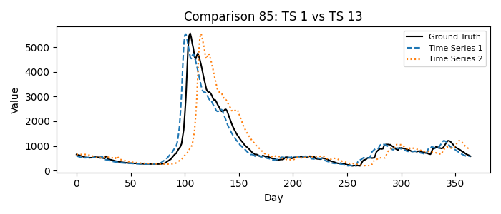
1 = Time Series 1, 2 = Time Series 13
Please fill in your choice (enter 1 or 2): _1_

Comparison 86: TS 0 vs TS 14
Which time series better matches the ground truth?
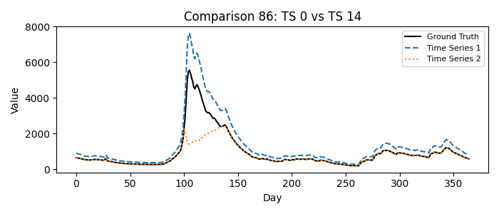
1 = Time Series 0, 2 = Time Series 14
Please fill in your choice (enter 1 or 2): 1__

Comparison 87: TS 3 vs TS 19
Which time series better matches the ground truth?
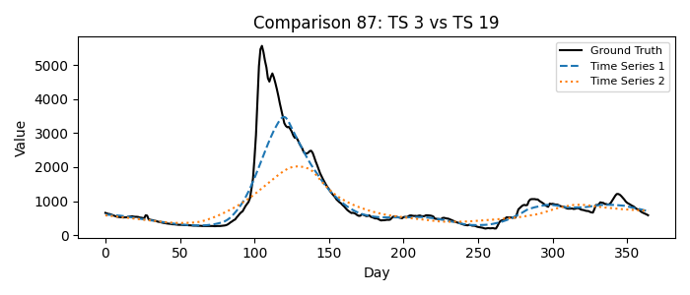
1 = Time Series 3, 2 = Time Series 19
Please fill in your choice (enter 1 or 2): __1

Comparison 88: TS 4 vs TS 18
Which time series better matches the ground truth?
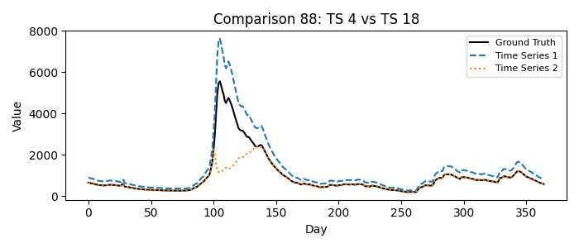
1 = Time Series 4, 2 = Time Series 18
Please fill in your choice (enter 1 or 2): __1

Comparison 89: TS 1 vs TS 8
Which time series better matches the ground truth?
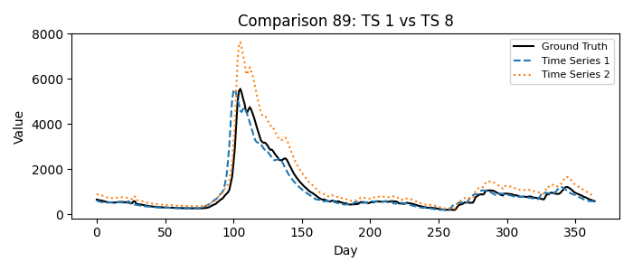
1 = Time Series 1, 2 = Time Series 8
Please fill in your choice (enter 1 or 2): __1

Comparison 90: TS 2 vs TS 13
Which time series better matches the ground truth?
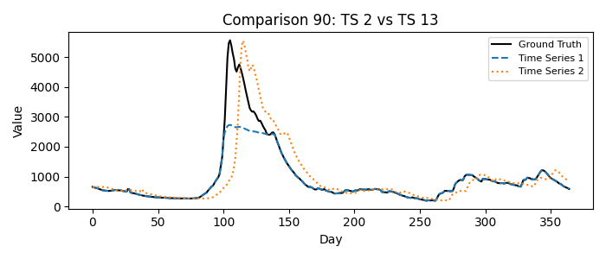
1 = Time Series 2, 2 = Time Series 13
Please fill in your choice (enter 1 or 2): 2__

Comparison 91: TS 0 vs TS 10
Which time series better matches the ground truth?
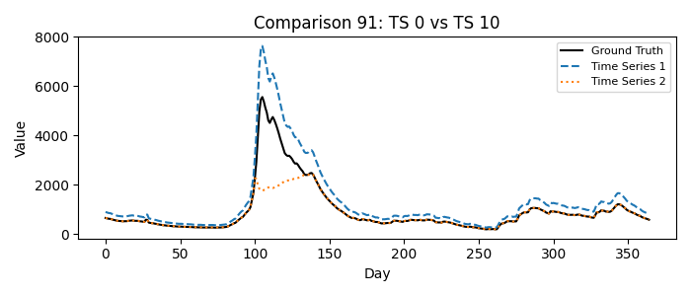
1 = Time Series 0, 2 = Time Series 10
Please fill in your choice (enter 1 or 2): _1_

Comparison 92: TS 0 vs TS 9
Which time series better matches the ground truth?
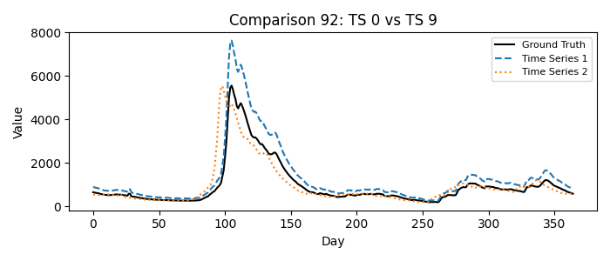
1 = Time Series 0, 2 = Time Series 9
Please fill in your choice (enter 1 or 2): 2__

Comparison 93: TS 0 vs TS 16
Which time series better matches the ground truth?
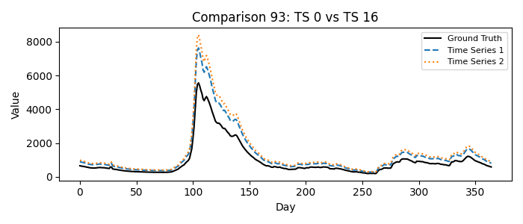
1 = Time Series 0, 2 = Time Series 16
Please fill in your choice (enter 1 or 2): _1_

Comparison 94: TS 0 vs TS 15
Which time series better matches the ground truth?
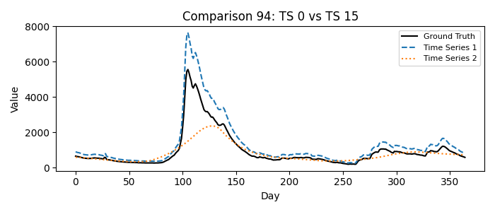
1 = Time Series 0, 2 = Time Series 15
Please fill in your choice (enter 1 or 2): _1_

Comparison 95: TS 0 vs TS 12
Which time series better matches the ground truth?
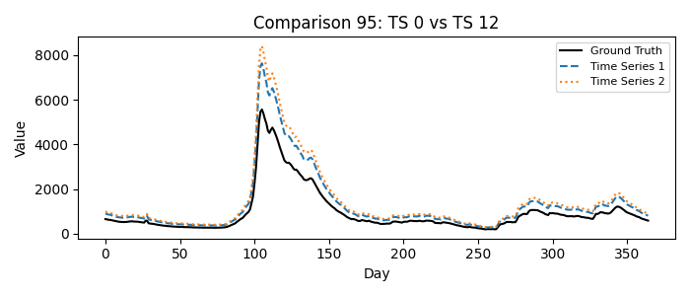
1 = Time Series 0, 2 = Time Series 12
Please fill in your choice (enter 1 or 2): _1_

Comparison 96: TS 1 vs TS 17
Which time series better matches the ground truth?
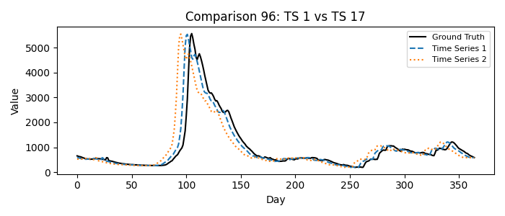
1 = Time Series 1, 2 = Time Series 17
Please fill in your choice (enter 1 or 2): _1_

Comparison 97: TS 1 vs TS 7
Which time series better matches the ground truth?
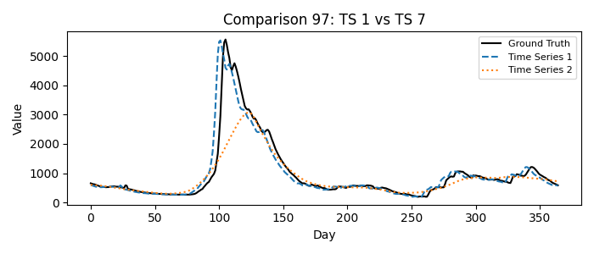
1 = Time Series 1, 2 = Time Series 7
Please fill in your choice (enter 1 or 2): __1

Comparison 98: TS 0 vs TS 11
Which time series better matches the ground truth?
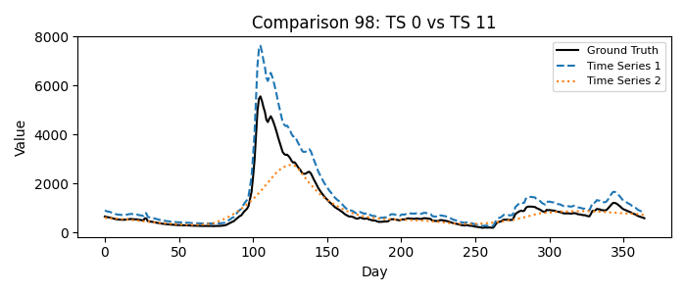
1 = Time Series 0, 2 = Time Series 11
Please fill in your choice (enter 1 or 2): _1_

Comparison 99: TS 1 vs TS 10
Which time series better matches the ground truth?
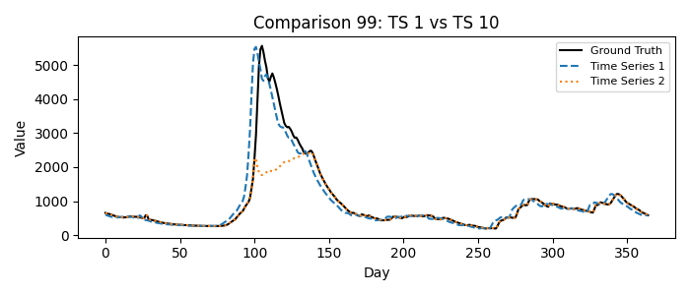
1 = Time Series 1, 2 = Time Series 10
Please fill in your choice (enter 1 or 2): __1

Comparison 100: TS 1 vs TS 12
Which time series better matches the ground truth?
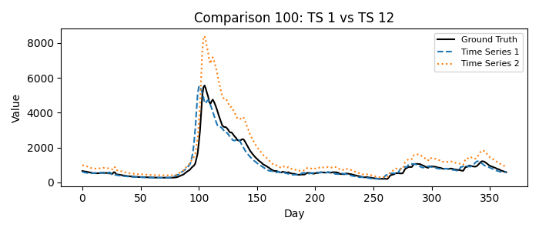
1 = Time Series 1, 2 = Time Series 12
Please fill in your choice (enter 1 or 2): __1

