**About us**

Traditional ambience, quiet, relaxing, delicate taste, are these what you are looking for in a Japanese dining experience? Then come to our restaurant! Our restaurant features truly traditional Japanese ambience with Tatami room for dining with privacy, a village like setting inside the dining hall and a friendly, experienced staff waiting to give you that unique experience.

Here is a full service restaurant with take out available, is open for lunch and dinner from Monday to Saturday, and features variety of fresh sushi, ramen, Japanese dessert and traditional Japanese cuisine from the kitchen made only with the freshest ingredients.

**Contact**

Contact us today at (678)699-2345. We’ll be happy to help you!

Address: 107 E Broadway New York, NY 10038

Chinatown, Lower West Side

**Mon 10:AM -8:00 PM**

**Tue 10:AM -8:00 PM**

**Wed 10:AM -8:00 PM**

**Thu 10:AM -8:00 PM**

**Fri 10:AM -8:00 PM**

**Sat 9:AM -7:00 PM**

**Sun CLOSED**

Chef1:

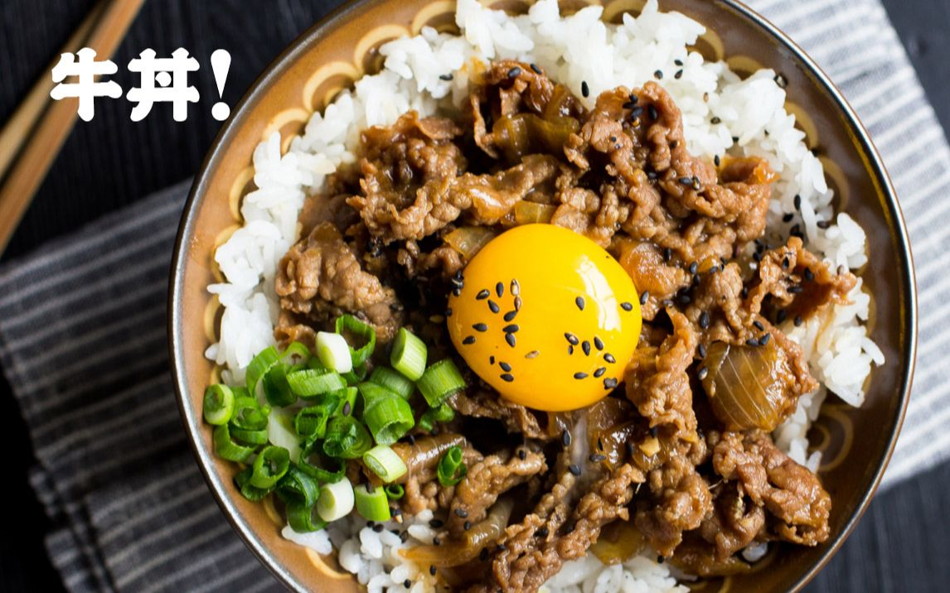

**Yoshinoya Beef Bowl**

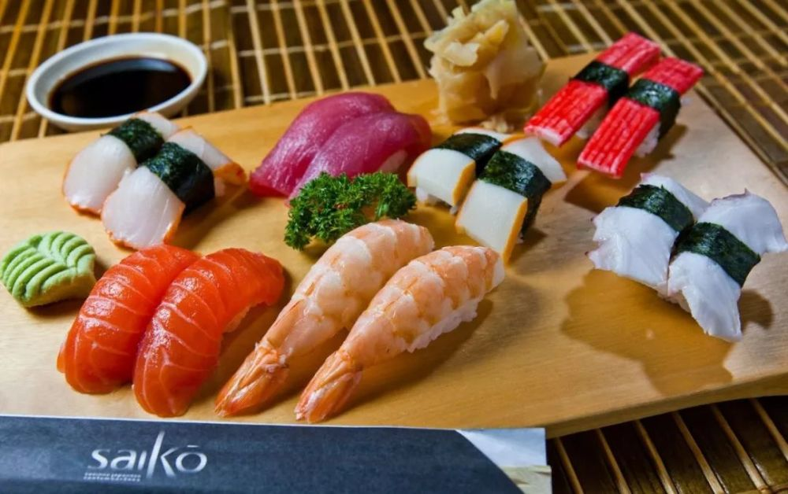

**Nigirizushi**

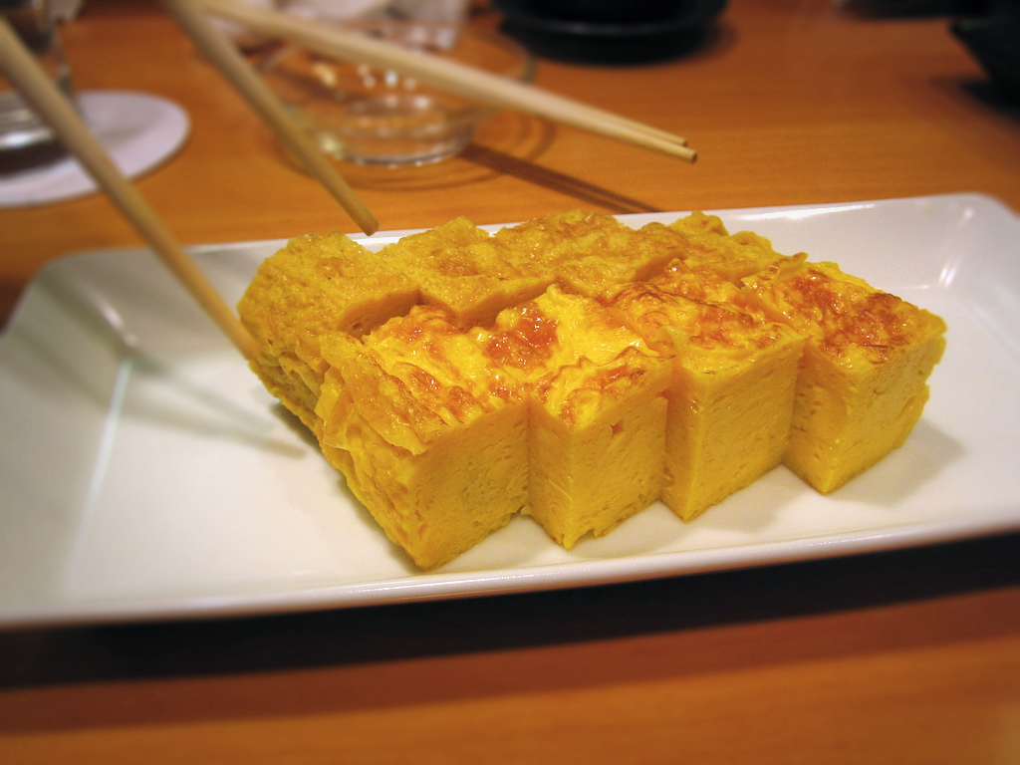

**Tamagoyaki**

Chef2:

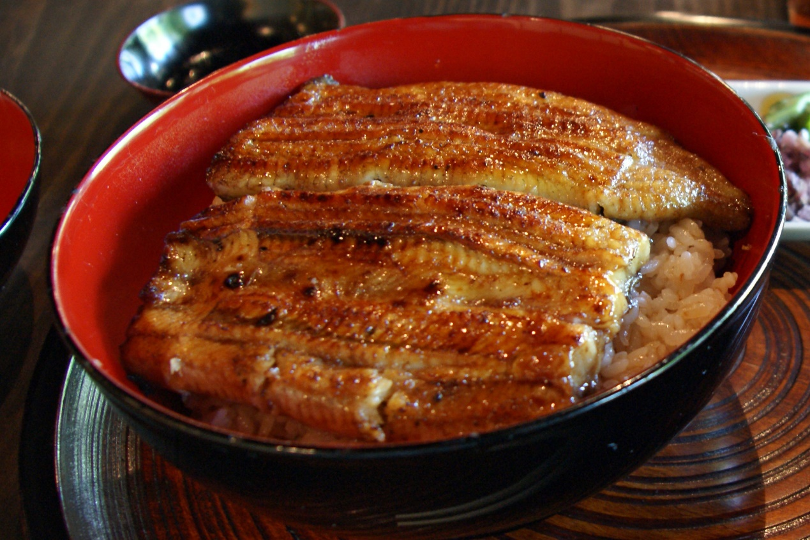

**Unadon**

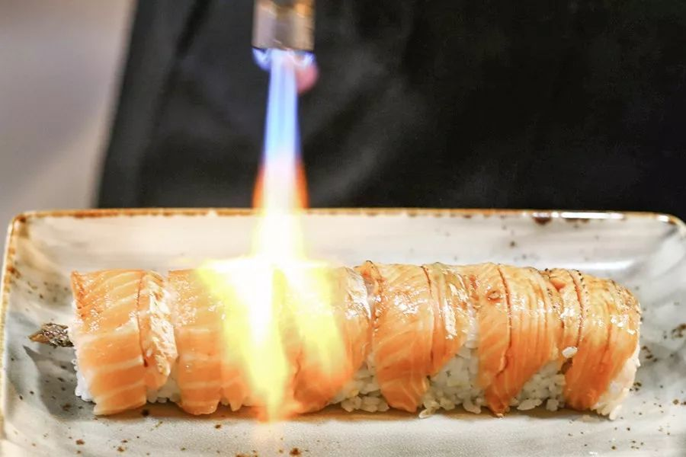

**Aburi zushi**

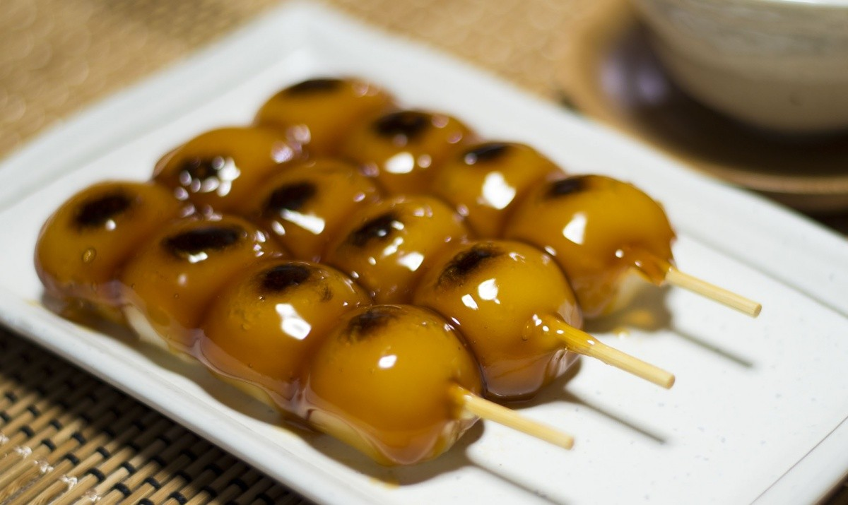

**Japanese Dumpling**