Question 1:
I achieved the standard version of the assignment including the following features:
1) three-way handshake
2) the four-segment connection termination
3) single-timer mainted by sender.py
4) selective repeat in section 3.5.4 of the text including simplified TCP sender and fast retransmit
5) receiver.py containing the features mentioned in Section 3.5.4 of the text
6) sequence and acknowledgement number in header
7) Maximum segment size
8) Maximum Window size
9) usage of only UDP socket
10) PLD module
11) constant timeout in sender.py

sender.py:
My first step is a funtion called SYN_state() controling the sending and receiving in three-way handshake process.
The second step is two thread runing simultaneously. One is receive_thread() in which there is a loop whenever receiving an in-order ack, add 1 to the sendbase of the window. Another is send_thread() in which there is a loop cheking rules of Selective Repeat and fast retransmition and also a single simer to decide whether to send a corespongding segment or not.
The last step is a funtion FIN_state() controling the four-segment connection termination. It starts when receiving the last ACK from the second step.

receiver.py:
My first step is a funtion called SYN_state() controling the sending and receiving in three-way handshake process.
The second is a funtion called TRANS_FIN_state() in which there is a loop to reply the ACK directly after the last in-order segment and a buffer to contain not-in-order segments. And when it receives a FIN segment, the funtion goes to the FIN state to deal with the four-segment cnnection termination.

Question 2:
My segement format is showed below. The header is a dict concluding four kinds of flags and sequence and acknowledgement number. Payload part is a string containing the data. And segment to be transmit is a list with the first element being header and second element being payload. Additionally, I use pickle module to encode and decode.
Source Port |  | Destination Port
SYN_FLAG | ACK_FLAG | FIN_FLAG | DATA_FLAG
Sequence number
Acknowledgement number
data
STP segment

Question 3:
(a)
Experiments are showed below.
Timeout = 5 ms
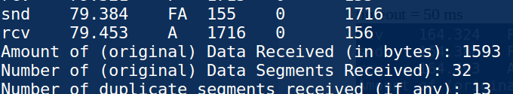

timeout = 10 ms
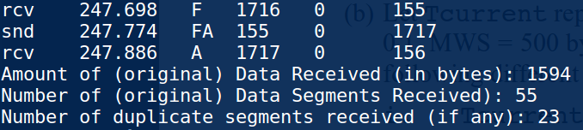

timeout = 20ms
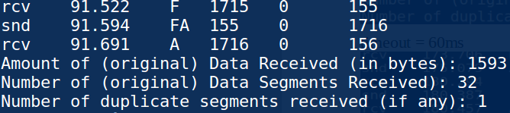

timeout = 40ms
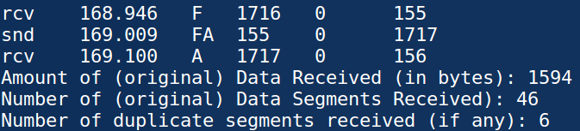

timeout = 50 ms
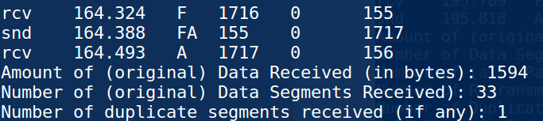

timeout = 60ms
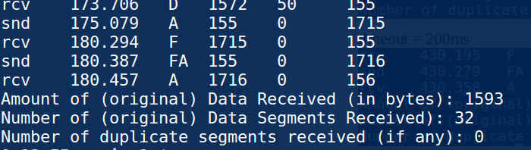

timeout = 70ms
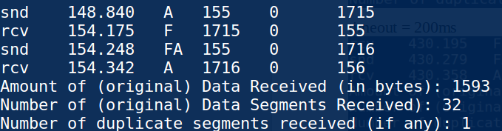

timeout = 80ms
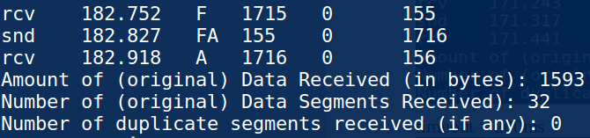

timeout = 100ms
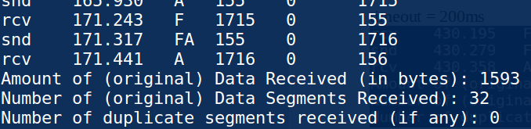

timeout = 200ms
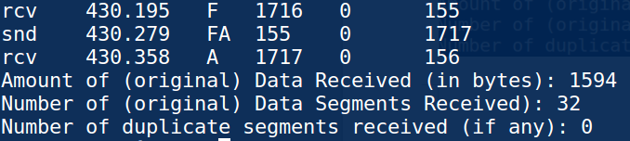

From experiments, it took one of the least times to transfer the same data when timeout = 20ms. And number of duplicate segments is acceptble Thus, 20ms is a suitable timeout value.

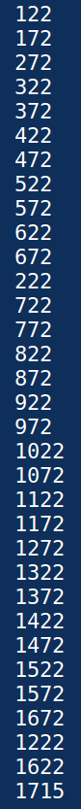
Dprob = 0.1: Dprob = 0.3:

In dprop of 0.1, drop occourred in 172-272, 1172-1272, 1572-1672.
In dprop of 0.3, drop occourred in 172-272, 422-522, 872-972, 1022-1172, 1372-1472.

(b)
 | 20ms | 80ms | 5ms
Number of transmitted packets | 41 | 40 | 48
Time overall tranfer takes(in ms) | 80.832 | 142.596 | 49.239

Number of transmitted packets increases only when there are both a time-out packet and a fast retransmit packet occuring simultaneously, the same as dupilicate segments in receiver end. When the timeout is short enough, it is easy to trigger the timer resulting much more duplicate segments which will take more capicity in the link and vice versa. But when timeout is too long, it takes more time to trigger the timer as fast retransmition is not satisfied, which results more total transfer time.

