|  |  |  |
| --- | --- | --- |
| **Problem Chosen** C | **2022 MCM/ICM Summary Sheet** | **Team Control Number** 2216714 |

**Your Paper's Title**

**Summary**

**Keywords:** keyword1; keyword2; keyword3; keyword4

Contents最后记得更新整个目录

1 Introduction 3

1.1 Problem Background 3

1.2 Restatement of the Problem 3

1.3 Literature Review 3

1.4 Our Work 4

2 Assumptions and Justifications 5

3 Notations 6

4 The name of model 1 6

4.1 Data Description 7

4.2 The Establishment of Model 1 7

4.3 The Solution of Model 1 7

5 The name of model 2 8

6 The name of model 3 8

7 Sensitivity Analysis 8

8 Model Evaluation and Further Discussion 8

8.1 Strengths 8

8.2 Weaknesses 9

8.3 Further Discussion 9

9 Conclusion 9

References 10

Appendices 11

# Introduction

## Problem Background

Have you ever invested in stocks? As we all know, stocks in the stock market are extremely volatile, and investors need to take huge risks when buying and selling stocks. Investors aim to minimize investment risk and maximize their total return. Therefore, investors need to find a way to predict stock price trends, predict stock price fluctuations as accurately as possible and formulate trading strategies as soon as possible, to achieve the goal of maximizing returns with minimal risk. Two specific cases are gold and bitcoin.

From the agricultural society to the commercial society, gold, as a precious metal currency, acts as a general equivalent for a long time due to its low reserves, difficulty in mining, and stable intrinsic value. The gold market plays an important role in the world economy, and for many investors, gold can be used as a hedge against rising prices and other financial risks. However, the gold market is not only non-stationary and volatile but also affected by various factors, such as relevant market activity, political events, etc. Therefore, it is very challenging to predetermine the price of gold.

The number of bitcoins is limited, which avoids inflation. In addition, Bitcoin's liquidation properties give it the ability to move funds instantaneously. Therefore, Bitcoin can be traded around the clock. In contrast, the above-mentioned gold is only available for trading on working days. Since the Bitcoin trading market works longer than the gold trading market, the trading cost of Bitcoin is higher than that of gold. It can be seen that the reason why the bitcoin trading market attracts a large number of investors to gradually participate in it is the characteristics of bitcoin.

## Restatement of the Problem

In this problem, we have $1000 and have a five-year trade period from November 9, 2016, to October 9, 2021. In the daily trade period, we will have an account containing cash, gold, bitcoin, and the initial state is [100, 0, 0]. The cost per trade is of the trade amount. There is no cost to owning shares.

Given the background information and constraints identified in the problem statement, we will accomplish the following tasks according to the given data:

* Give the best strategy for daily trading based on the price data up to the forecast day.
* Calculate the total value owned on October 9, 2021 with an initial investment of $1,000.
* Prove that the trading strategy we provide is optimal, that is, to prove that in our strategy, traders can have higher returns with lower risk.
* Determining the sensitivity of our strategies to trading prices. Analyze the impact of trading price on our strategy and results.

## Our Work

In our work, **the first step** is data processing and analysis. We analyze the past five years of data on gold and bitcoin through Exploratory Data Analysis (**EDA**) and clean the data. **The second step** is to model the trading strategy. We start by building the Autoregressive Integrated Moving Average model (**ARIMA**) that allows us to predict the present price using only past daily prices. Then, we establish a linear programming model (**LP**) to solve the optimal trading strategy and obtain specific profit values. **The third step** is to analyze the results. Through the sensitivity analysis of the transaction price, we can understand the impact of the transaction price on the strategy and results. Finally, we carry out the evaluation and outlook of the model.

The flow chart (Figure 1) illustrates the above ideas more visually.

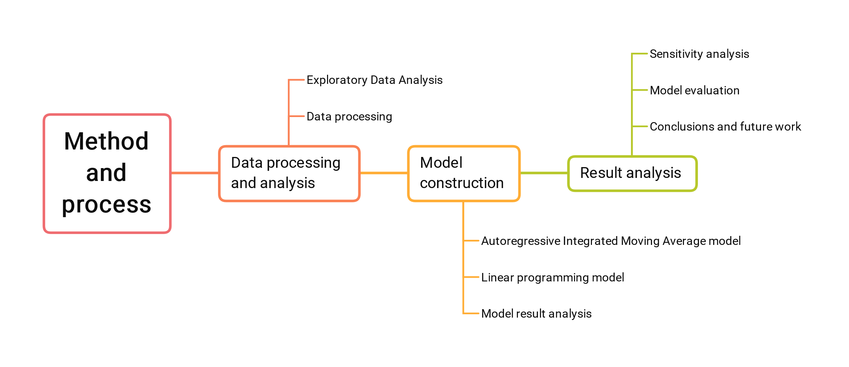

Figure 1 Method and process

# Assumptions and Justifications

1. **We assume that when predicting the trend of stocks, observing the trading market in the first n days, that is, not buying and selling stocks, will not affect the final total assets.**

Although we may miss the opportunity to buy stocks at a low price, we can predict the future trend more accurately through the observation of these n days. So we can make better decisions and get higher profits. All in all, in the big picture, the gains that may be lost in the beginning are innocuous.

# Notations

The key mathematical notations used in this paper are listed in Table 1.

Table 1: Notations used in this paper

|  |  |  |
| --- | --- | --- |
| **Symbol** | **Description** | **Unit** |
|  | Trade cost of gold as a ratio of trade value | - |
|  | Trade cost of bitcoin as a ratio of trade value | - |

# Data processing and analysis

Exploratory Data Analysis (**EDA**) is used by data scientists to analyze and investigate datasets and summarize their main characteristics, usually using data visualization methods. It helps determine how to most efficiently process data sources to get the answers they need, making it easier for data scientists to spot patterns, spot anomalies, test guesses, or test hypotheses.

We can observe the data from the Nullity matrices for gold and bitcoin, as shown in Figure 2. The Nullity matrix is a data-dense display that lets us quickly visually pick out patterns in data completion. First of all, in terms of quantity, gold has 1265 data, while Bitcoin has 1826 data. This is because Bitcoin can be traded every day, but gold can only be traded when the market is open. Second, there is no missing date value for gold, but there is a missing transaction price for gold. 10 data were missing, and the missing rate was 0.8%. Neither the date value nor the transaction price of Bitcoin is missing. Additionally, neither gold nor bitcoin has their respective dates repeated, in other words, there is no such case as two trading prices on the same date.

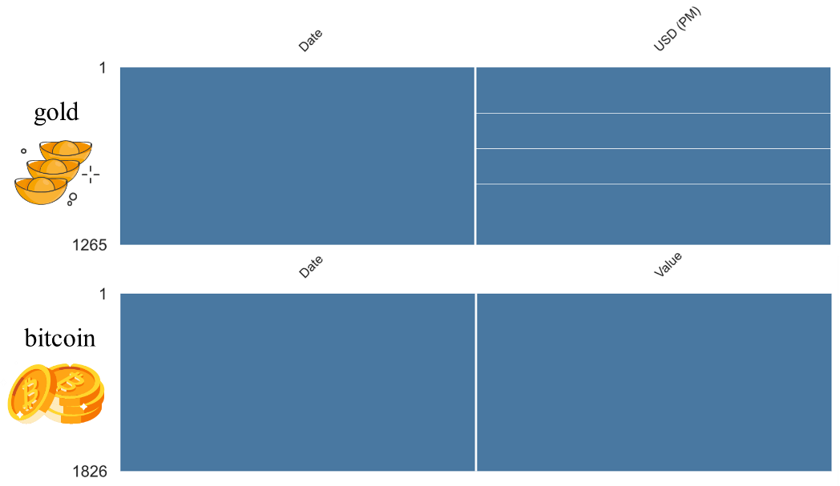

Figure 2 Nullity matrix for gold and bitcoin

We process the data based on our knowledge of Bitcoin and Gold transaction data. The date is first formatted, after which the golden missing data mentioned above is removed.

# Predicting price by ARIMA model

To solve task one, we need to develop an optimal strategy for trading each day, based on price data up to that day. We first need to predict the price of gold and bitcoin on that day to develop a more accurate strategy. Time series forecasting is an important area of forecasting, where past observations of the same variable are collected and analyzed to develop models that describe underlying relationships. The model is then used to extrapolate the time series into the future. The Autoregressive Integrated Moving Average (ARIMA) model is one of the most important and widely used time series models. [] In this section, we use the ARIMA model to predict the volatility price of gold and bitcoin.

The structure of our ARIMA model is shown in Figure 3. The steps of the model are as follows:

* **Step 1** Do the white noise test on the time series. Generally speaking, only those sequence values have a close correlation, and historical data has a certain influence on future development, can it be used for modeling to mine effective information in historical data and predict future development. Purely random sequences have no analytical value.
* **Step 2** Check the stationarity of the sequence. Only stationary time series can be modeled with ARIMA. If the sequence is non-stationary, in general, the stationarity of the time series can be achieved by the first-order difference method, and sometimes the second-order difference is required.
* **Step 3** Building the ARIMA model. It includes three processes: model identification, parameter estimation, and model checking.
* **Step 4** Using the constructed fitting model, dynamic structural analysis can be carried out to examine the operation law of the research object, adjust the input variables to control the development of the research object, and make sequence predictions for future changes.

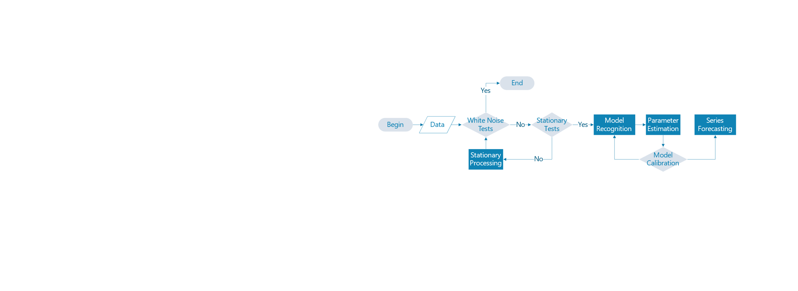

Figure 3 The structure of the ARIMA model

## Stationary Tests

Series stationarity is a prerequisite for time series analysis. So how to determine whether the series is stationary? A rigorous statistical test method is the Augmented Dickey-Fuller test (ADF). The ADF test is to determine whether the sequence has a unit root: if the sequence is stationary, there is no unit root; otherwise, there is a unit root. Therefore, the ADF test hypothesizes that there is a unit root. The hypothesis of the ADF test is that there is a unit root. If the obtained significance test statistic is less than three confidence levels (10%, 5%, 1%), it corresponds to (90%, 95, 99%) confidence to reject the null hypothesis.

We can see from Table 1 that the t-statistic value of the original Bitcoin is -0.238 which is greater than the critical value (1%) -3.434, and the p-value is 0.934 which is greater than 1%. In addition, the p-value represents the probability value corresponding to the T statistic. So the hypothesis cannot be rejected, that is, the sequence is not stable. The same is true for the original golden sequence. The t-statistic value of -0.434 is greater than the critical value (1%) -3.434, and the p-value of 0.904 is greater than 1%. So the golden sequence is also unstable.

So we need a way to make a non-stationary time series stationary—calculate the difference between adjacent observations. This method is called differencing. Its formula is as follows:

|  |  |
| --- | --- |
|  | () |

Where  refers to the price on the day ,  refers to the price on day , and  refers to the difference between the two. Thus we construct a relatively stationary difference sequence.

Therefore, we need to perform differential processing on the data, and then perform an ADF test. The test method is the same as above. Both gold and bitcoin pass the test, which shows that the series after differencing is stationary.

Table 1 The results of the ADF test

|  |  |  |  |  |
| --- | --- | --- | --- | --- |
| Inspection item | Gold test result | Bitcoin test results | Gold test result | Bitcoin test results |
| Number of difference | 0 | 0 | 1 | 1 |
| Test Statistic Value | -0.434 | -0.238 | -8.159 | -8.535 |
| p-value | 0.904 | 0.934 |  |  |
| Critical Value(1%) | -3.436 | -3.434 | -3.436 | -3.433 |
| Critical Value(5%) | -2.864 | -2.863 | -2.864 | -2.863 |
| Critical Value(10%) | -2.568 | -2.568 | -2.568 | -2.567 |

## White Noise test

We perform a white noise test on gold and bitcoin. The results are shown in Table 2. We found that the P-value of the two statistics is much smaller than the significance level of 0.05, then the null hypothesis can be rejected with a 95% confidence level, and the sequence is considered to be a non-white noise sequence. That is to say, it is not a randomly generated sequence and has a temporal correlation.

Table 2 White Noise test

|  |  |  |
| --- | --- | --- |
| Inspection item | Gold test result | Bitcoin test results |
| Test Statistic Value | -3.321 | -3.114 |
| p-value |  |  |
| Critical Value(1%) | -3.668 | -3.669 |
| Critical Value(5%) | -2.964 | -2.964 |
| Critical Value(10%) | -2.620 | -2.621 |

## Model Recognition and Parameter Estimation

The identification problem of the model is the problem of order determination, which is mainly to determine the three parameters p, d, and q in the ARIMA model, and the order d of the difference can be obtained by observing the graph. We determined p and q by ACF and PACF.

The autocorrelation function ACF (autocorrelation function) describes the linear correlation between the time series observations and their past observations. Calculated as follows:

|  |  |
| --- | --- |
|  | () |

where k is the number of lag periods.

Partial autocorrelation function PACF (partial autocorrelation function) describes the linear correlation between time series observations expected to past observations given intermediate observations.

The result is shown in Table 3. From the graphs, we can see that with more than 95% probability,  and  fall in the range of .

Table 3 The result of AFC and PAFC

|  |  |  |
| --- | --- | --- |
|  | **goal** | **bitcoin** |
| **AFC**  based on the original sequence |  |  |
| **AFC**  Based on First Order Difference Sequence |  |  |
| **PAFC**  Based on First Order Difference Sequence |  |  |

Based on the above analysis, we get multiple sets of  combinations. We determine the best set of  values according to the information criteria of AIC and BIC. The smaller the information criterion value, the better the model. The calculation formulas of AIC and BIC are as follows:

|  |  |
| --- | --- |
|  | () |
|  | () |

Where  is the maximum likelihood under the model,  is the number of data, is the number of variables in the model.

Finally, we get:

|  |  |
| --- | --- |
|  | () |
|  | () |

## Model Calibration

We restore the prediction sequence and evaluate the model intuitively by comparing the predicted data with the real data. We compare the two data together. The red curve is the real data, and the green curve is our predicted data. Analyzing Figure 4, we can find that the predicted data is very close to the real data whether it is the overall trend or the local data. From this point of view, our model predicts well.

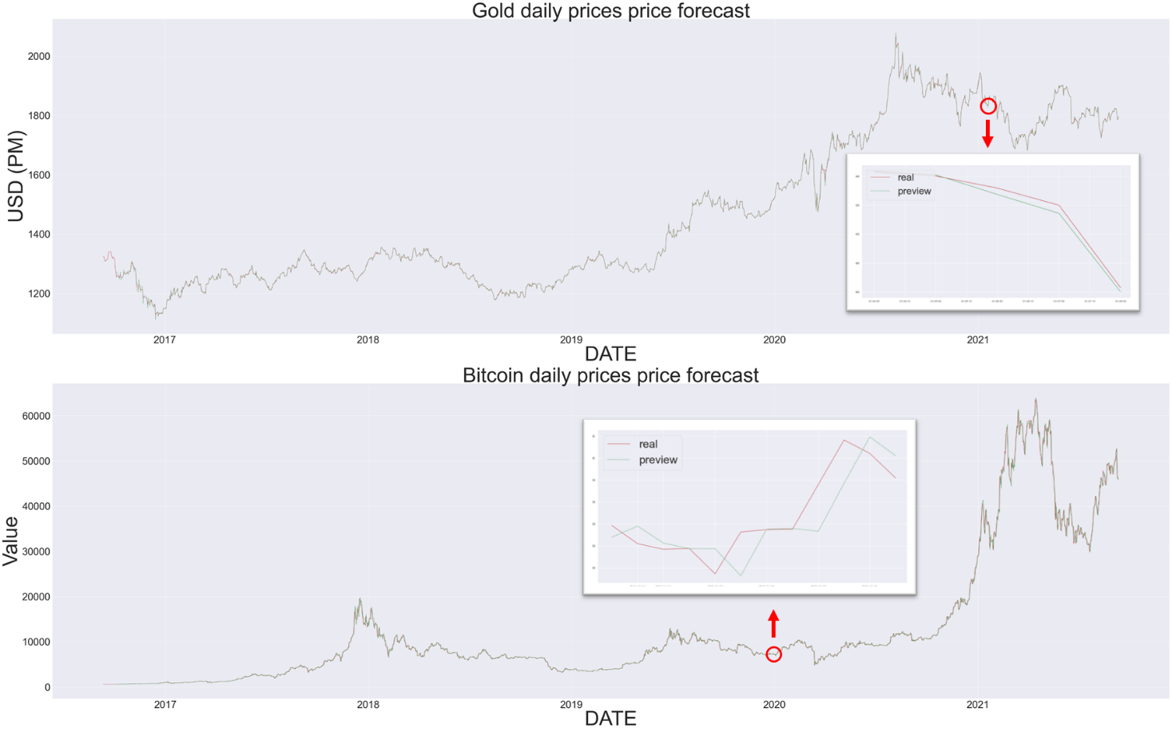

Figure 4 Comparison of predicted data with actual data

# The name of model 2

和上一个部分类似的写法。

|  |  |
| --- | --- |
| 这里插入公式 | () |

|  |  |
| --- | --- |
| 这里插入公式 | () |

# The name of model 3

和上一个部分类似的写法。

注意：大多数美赛优秀论文都是对每个问题或者每个模型作为一个一级标题，就像我们上面的这种布局；也有一部分论文建立一个大的一级标题，取名为“Models and Solutions”，然后在这个大的标题下设计每个问题或者模型对应的二级标题，这一种排版布局在国赛中用的更多。

# Sensitivity Analysis

在国赛论文写作视频中（<https://www.bilibili.com/video/BV1Na411w7c2/>），我介绍过怎么写模型的分析和检验这个部分：

模型的分析 ：在建模比赛中模型分析主要有两种，一个是灵敏度(性)分析，另一个是误差分析。灵敏度分析是研究与分析一个系统（或模型）的状态或输出变化对系统参数或周围条件变化的敏感程度的方法。其通用的步骤是：控制其他参数不变的情况下，改变模型中某个重要参数的值，然后观察模型的结果的变化情况。误差分析是指分析模型中的误差来源，或者估算模型中存在的误差，一般用于预测问题或者数值计算类问题。

模型的检验：模型检验可以分为两种，一种是使用模型之前应该进行的检验，例如层次分析法中一致性检验，灰色预测中的准指数规律的检验，这部分内容应该放在模型的建立部分；另一种是使用了模型后对模型的结果进行检验，数模中最常见的是稳定性检验，实际上这里的稳定性检验和前面的灵敏度分析非常类似，等会大家看到例子就明白了。

在美赛的写作中，写的最多的就是灵敏度分析（Sensitivity Analysis），因此这里我们的标题就直接取得是灵敏度分析；如果你既要写灵敏度分析，又要写误差分析（Error Analysis），那么你可以把标题改成： Sensitivity Analysis and Error Analysis

# Model Evaluation and Further Discussion

注：本部分的标题需要根据你的内容进行调整，例如：如果你没有写进一步讨论的话，就直接把标题写成模型的评价。（优缺点一定要写）

## Strengths

这里写论文或者模型的优点

## Weaknesses

这里写缺点：缺点写的个数一般要比优点少

## Further Discussion

进行进一步的讨论，这里可以写模型的改进和拓展：

模型的改进：主要是针对模型中缺点有哪些可以改进的地方；

模型的拓展：将原题的要求进行扩展，进一步讨论模型的实用性和可行性。

# Conclusion

结论部分，这个部分在国赛论文很少见到，但在美赛中出现的频率很高。

这个部分可以是论文中心思想的重申、研究结果或主要观点的归纳，也可以是某些启示性的解释或考虑。

有些论文把“Model Evaluation and Further Discussion”的内容放到了结论部分，这也是可以的，大家可以灵活调整。

# References

[]Zhang, G. P. (2003). Time series forecasting using a hybrid ARIMA and neural network model. Neurocomputing, 50, 159–175. doi:10.1016/s0925-2312(01)00702-0

参考文献：所有引用他人或公开资料(包括网上资料)的成果必须按照科技论文的规范列出参考文献，并在正文引用处予以标注。

一般新起一页列出参考文献，如果上一个部分的下面有很多空白，那么就不用新起一页了。

美赛中不要出现中文，如果引用中文文献请翻译过来。

# Appendices

|  |
| --- |
| Appendix 1 |
| Introduce: 这里放上附录1的介绍 |
|  |

|  |
| --- |
| Appendix 2 |
| Introduce: 这里放上附录2的介绍 |
|  |

本部分是附录部分，美赛对于附录不是特别看重，今年还限制了论文的页数（从第二页开始编号，不能超过25页）。

一般新起一页列出附录。

在不超过页数限制的条件下，附录中可以包括下面内容：

* 你们写的代码；
* 某一问题的详细证明或求解过程；
* 自己在网上找到的数据；
* 比较大的流程图；
* 较繁杂的图表或计算结果。