

Department of Computer Science

**Keeraleeya Samajam (Rejd.) Dombivli’s Model College,**

Re-accredited ‘A’ grade by NAAC

A project report on

**Virtue Art Gallery website**

Submitted by

**Mr. Vishal Shanbhag**

For the Year

**2020-2021**

Under the guidance of

**Asst. Prof Jyoti Samel**

Submitted in the fulfilment of the Requirements for qualifying

**BSC.CS Sem V Examination**

**Declaration**

I hereby declare that the project entitled, “Virtue Art Gallery website” done at Model College, under the guidance of Asst. Prof. Ms. Jyoti Samel, has not been in any case duplicated to submit to any other university for the award of any degree. To the best of my knowledge other than me, no one has submitted to any other university.

The project is done in fulfilment of the requirements for the degree of BSC. CS to be submitted as a semester V project as a part of our curriculum.

**Acknowledgement**

It gives me great pleasure to present my project on “Virtue art gallery website”. I would like to express my sincere thanks to all the teachers who helped me throughout the project. I would like to acknowledge the help and guidance provided by our Asst. Prof. Ms. Jyoti Samel in all places during the presentation of this project.

I am also thankful to our honourable principal Dr. Vinay Bhole and IT/CS In-charge Asst. Prof. Ms. Divya Premchandran for giving me an opportunity for working on this Project.

Onwards my project works, I am also thankful to the staff member of the IT/CS department for their moral support towards the project.

**Abstract**

An Online Art gallery website that helps the user to explore various types of

artworks and antiques available at the Virtue Art gallery. This website will act as a

medium between users and Virtue Art gallery to access various Art pieces. This website is developed using HTML, CSS & various Javascript Libraries for frontend and Firebase & Javascript for backend. To make this website more accessible by users it is made mobile and tablet responsive. So this website can be accessed on any platforms via a browser.

Nowadays, users are unable to visit the art gallery because of their work and can’t keep track of workshops/events or the latest art collection. This website will solve the users' problems by displaying all the artworks and antiques available at the Art gallery. Users can categorise the items via various filters. Users can also keep track of upcoming Cultural meets and workshops via the website.

**Index**

|  |  |  |
| --- | --- | --- |
| Sr. no | Description | Pg. no |
| 1 | **Introduction** | 6 |
| 2 | **Requirement specification**  Hardware requirements  Software requirements | 7 |
| 3 | **Objective of the Project**  Existing system  Proposed system | 8 |
| 4 | **System Analysis**  Software development life cycle(SDLC)  Spiral model | 9-12 |
| 5 | **System Design**  Use-case diagram  Activity diagram  Gantt chart | 13-15 |
| 6 | **Modules**  Donation form  Gallery  Workshops | 16 |
| 7 | **Results**  Screenshots  Conclusion | 17-20 |
| 8 | **References** | 21 |

**Introduction :**

Virtue Art Gallery is an online art gallery website where users can visit a variety of artworks, artifacts and other antiques from their devices. The main purpose of the website is to bring people closer to arts and culture. This website will also help you in categorizing the art pieces. It can also help you in getting information about the upcoming workshops and events. Additionally, users can donate this organization their artworks or can contribute by providing funds to the organization.

**Requirement Specification :**

**Hardware requirements :**

**Processor :** Intel i3 6th gen

**RAM :** 1GB

**System architecture :** 32/64 bit

**Mouse :** Standard PS-2 USB mouse

**Hard disk space :** 60GB

**Software requirements :**

**Operating system :** Windows 10 / Android

**Front-end :** HTML, CSS, Javascript

**Back-end :** Firebase, Javascript

**Code Editor :** Visual Studio Code**Objective of the project :**

**Existing System:**

People usually don’t visit art galleries unless they know what artworks are present over there. So, they have to rely on people's opinions and make visits to art galleries. If a new artwork or antique comes the user will not know that. They can’t segregate the art pieces into paintings, antiques and more. When a user visits an art gallery he doesn’t know what kind of things are famous there. They just visit random artworks and base their opinion. If a user wants to contribute anything such as art or money by any means, there’s no direct method.

**Proposed System:**

Virtue Art gallery has been developed for people's convenience and to solve existing pain points. This website will contain all the art pieces such as paintings, antiques, etc that is to be displayed in the art gallery. This system will help users to look at the artworks before visiting an actual art gallery. Users can also get to know about upcoming workshops and events if conducted. Users can categorize the artworks among various categories. They can also see what art pieces are trending and new in art gallery. Users can also directly contribute to art gallery if they wish to. Contributions can be in any form money, funds, artworks, etc.

**System Analysis :**

**Software Development Life Cycle (SDLC) :**

The traditional system development life cycle is divided into 5 phases.

* Planning
* Analysis
* Design
* Implementation
* Maintenance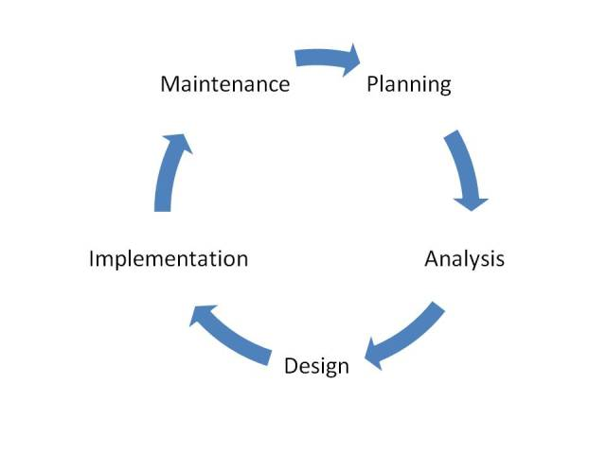

Stages of SDLC

**Planning :**

It consists of the initial assessment and feasibility study. During this, the technical aspects of Hardware and Software were determined as to which hardware and software used to develop this project. Also the cost needed to develop the project was estimated.

**Analysis :**

It consists of the user requirements, existing system and logical system design. During this stage the requirements needed by the user were estimated. A microanalysis of both the individual needs and the organizational needs were made. Logical system design was created specifying and identifying inputs, processes and expected output requirements. The existing hardware and software were also studied during this phase.

**Design :**

During this phase the complete design of the system including all the technical specifications were made.

**Implementation :**

During the initial implementation phase, the complete coding of the system was done. The actual database was created and the system was customized by creation of the tables, user authorization and so on.

**Maintenance :**

Corrective maintenance in respect to system errors. Adaptive maintenance due to changes in the business environment. Perfective maintenance to enhance the system.

**Spiral Model :**

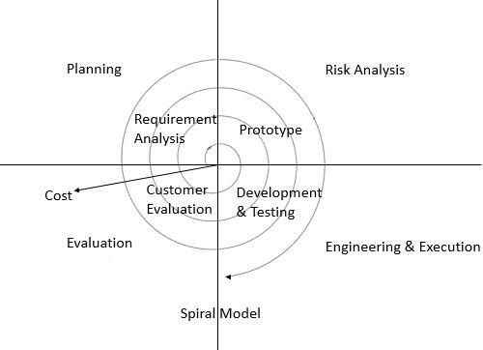

Phases of Spiral Model

**Objectives determination and identify alternative solutions :**

This phase starts with gathering the business requirements in the baseline spiral. In the subsequent spirals as the product matures, identification of system requirements, subsystem requirements and unit requirements are all done in this phase.

This phase also includes understanding the system requirements by continuous communication between the customer and the system analyst. At the end of the spiral, the product is deployed in the identified market.

**Design and prototype :**

The Design phase starts with the conceptual design in the baseline spiral and involves architectural design, logical design of modules, physical product design and the final design in the subsequent spirals.

**Develop next version of the product :**

The Construct phase refers to production of the actual software product at every spiral. In the baseline spiral, when the product is just thought of and the design is being developed a POC (Proof of Concept) is developed in this phase to get customer feedback.

Then in the subsequent spirals with higher clarity on requirements and design details a working model of the software called build is produced with a version number. These builds are sent to the customer for feedback.

**Review and plan for the next phase :**

Risk Analysis includes identifying, estimating and monitoring the technical feasibility and management risks, such as schedule slippage and cost overrun. After testing the build, at the end of the first iteration, the customer evaluates the software and provides feedback.

**System Design :**

**Use Case diagram :**

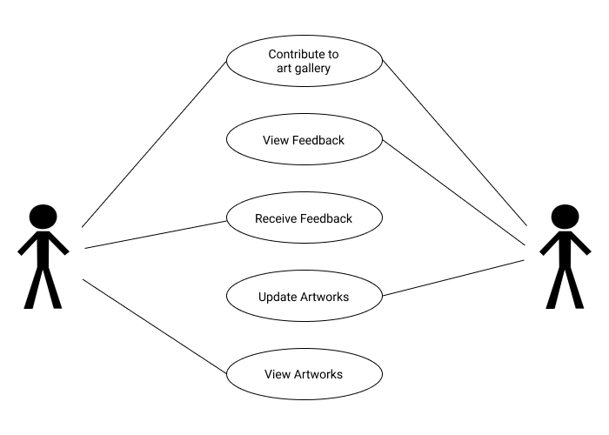

**Activity diagram :**

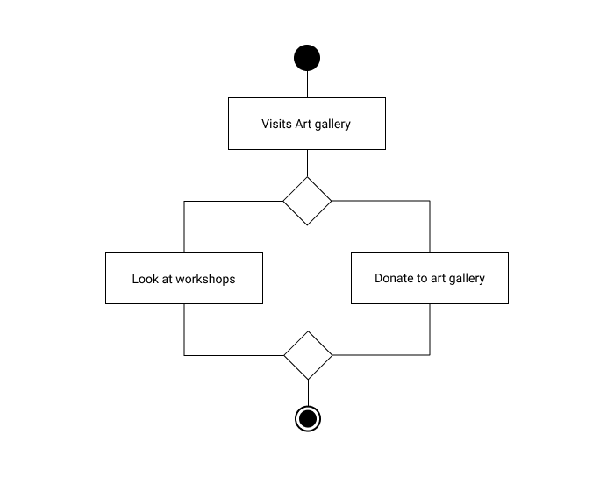

**Gantt chart :**

A Gantt chart is a visual view of tasks scheduled overtime. Gantt charts are used for planning projects of all sizes and they are a useful way of showing what work is scheduled to be done on a specific day. They also help you view the start and end dates of a project in one simple view.

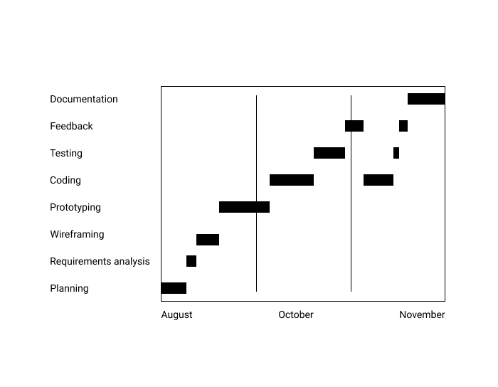

**Modules :**

**Gallery :**

This module is added so that a user can see which artworks or antiques are displayed in an art gallery. For easy access, It is placed in navigation links. It contains photos of art along with their name and collection/artist it is allotted to.Users can also categorize the items based on the genre you are interested in. It is in a masonry layout so users can see everything at a glance.

**Donation :**

This module uses a firebase database to store user data. Form collects user data such as name, email, contact, donation type and message for us. This data is sent to art gallery and they can contact and further enquire about them. It also shows a message if data is sent properly to the art gallery.

**Workshop :**

In this module, users can access the upcoming workshop timings along with the embedded map so you don't have to leave the screen and search manually. You can visit the gallery tab on the website, there you can categorize into the workshops tab to see which artworks are yet to be displayed in the upcoming workshop.

**Results :**

**Screenshots :**

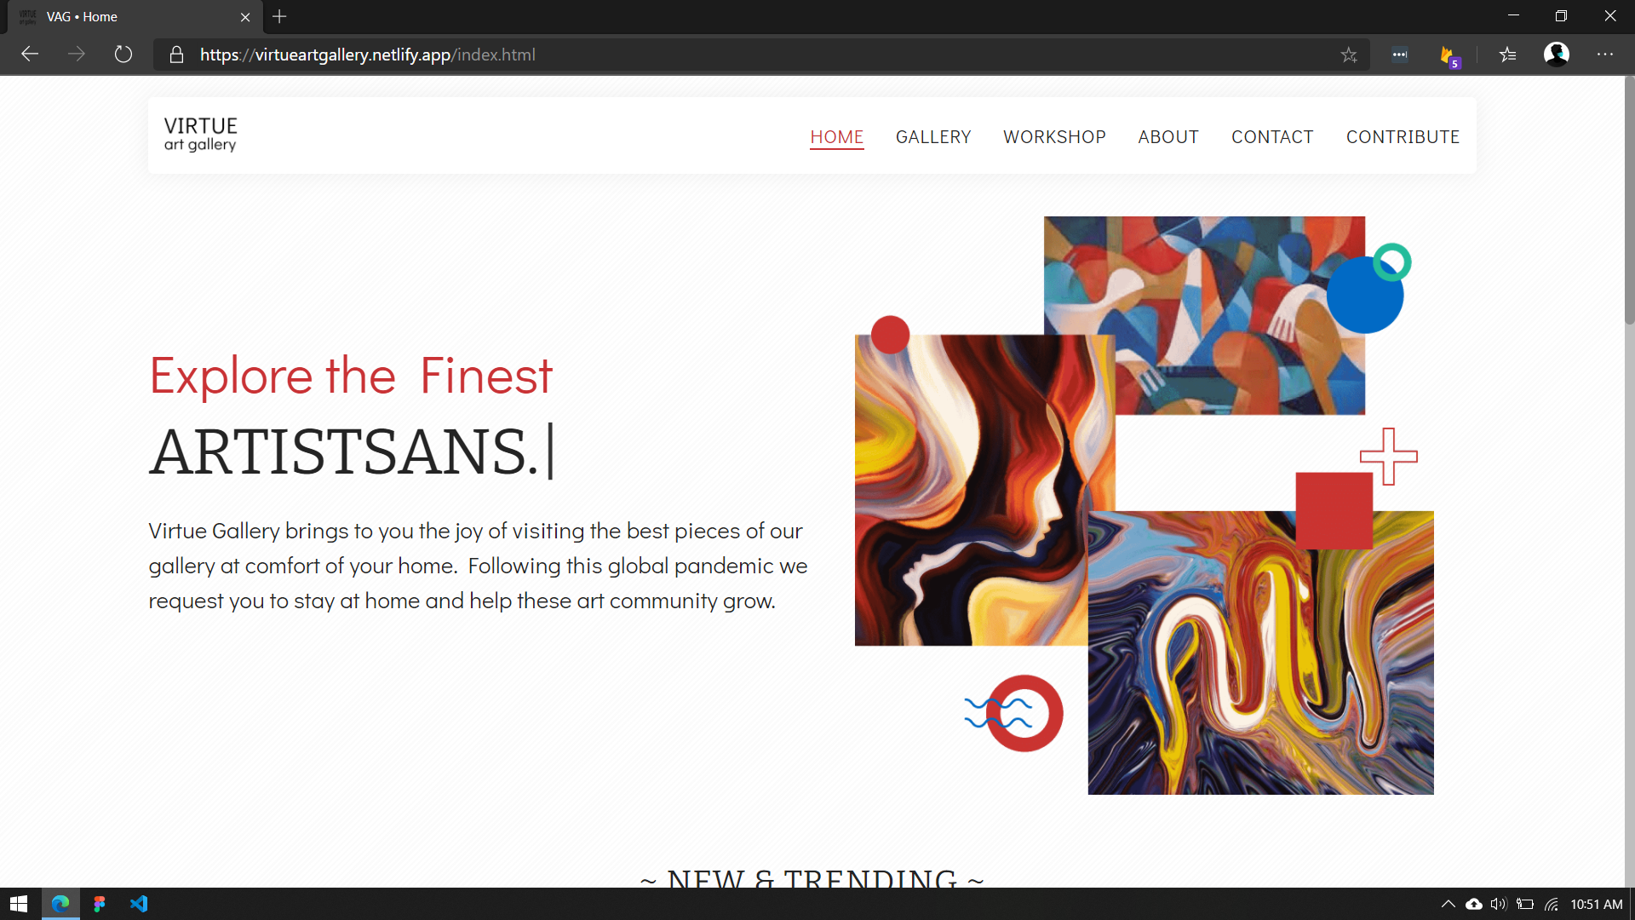

Homepage (desktop view)

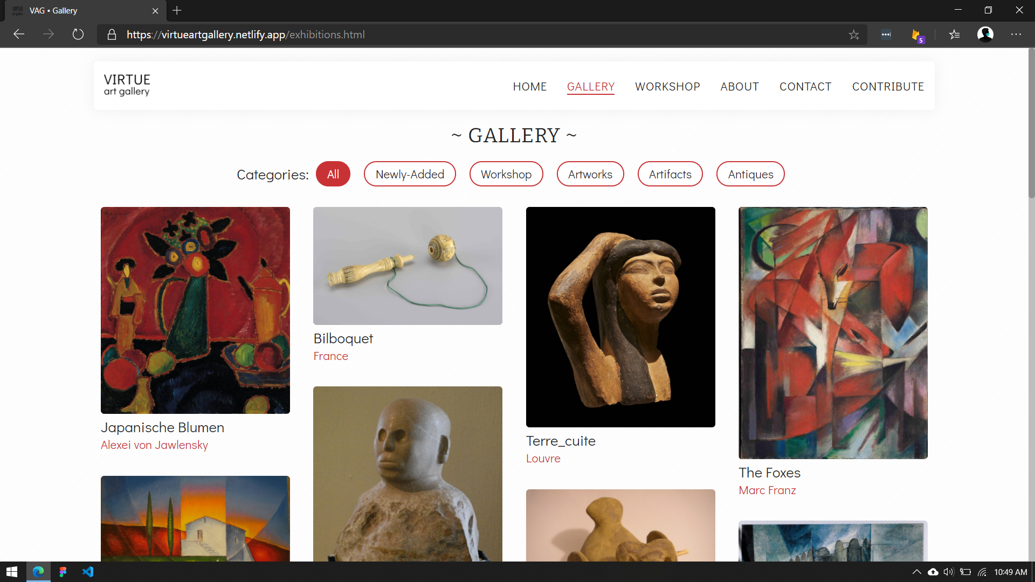

Gallery (desktop view)

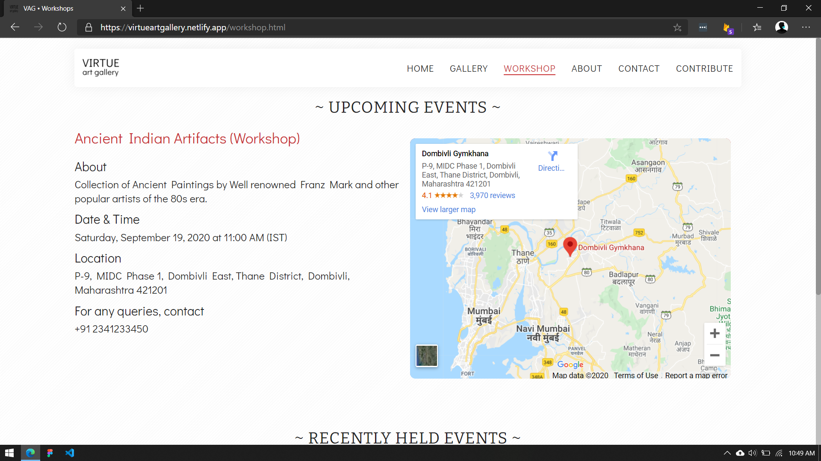

Workshops (desktop view)

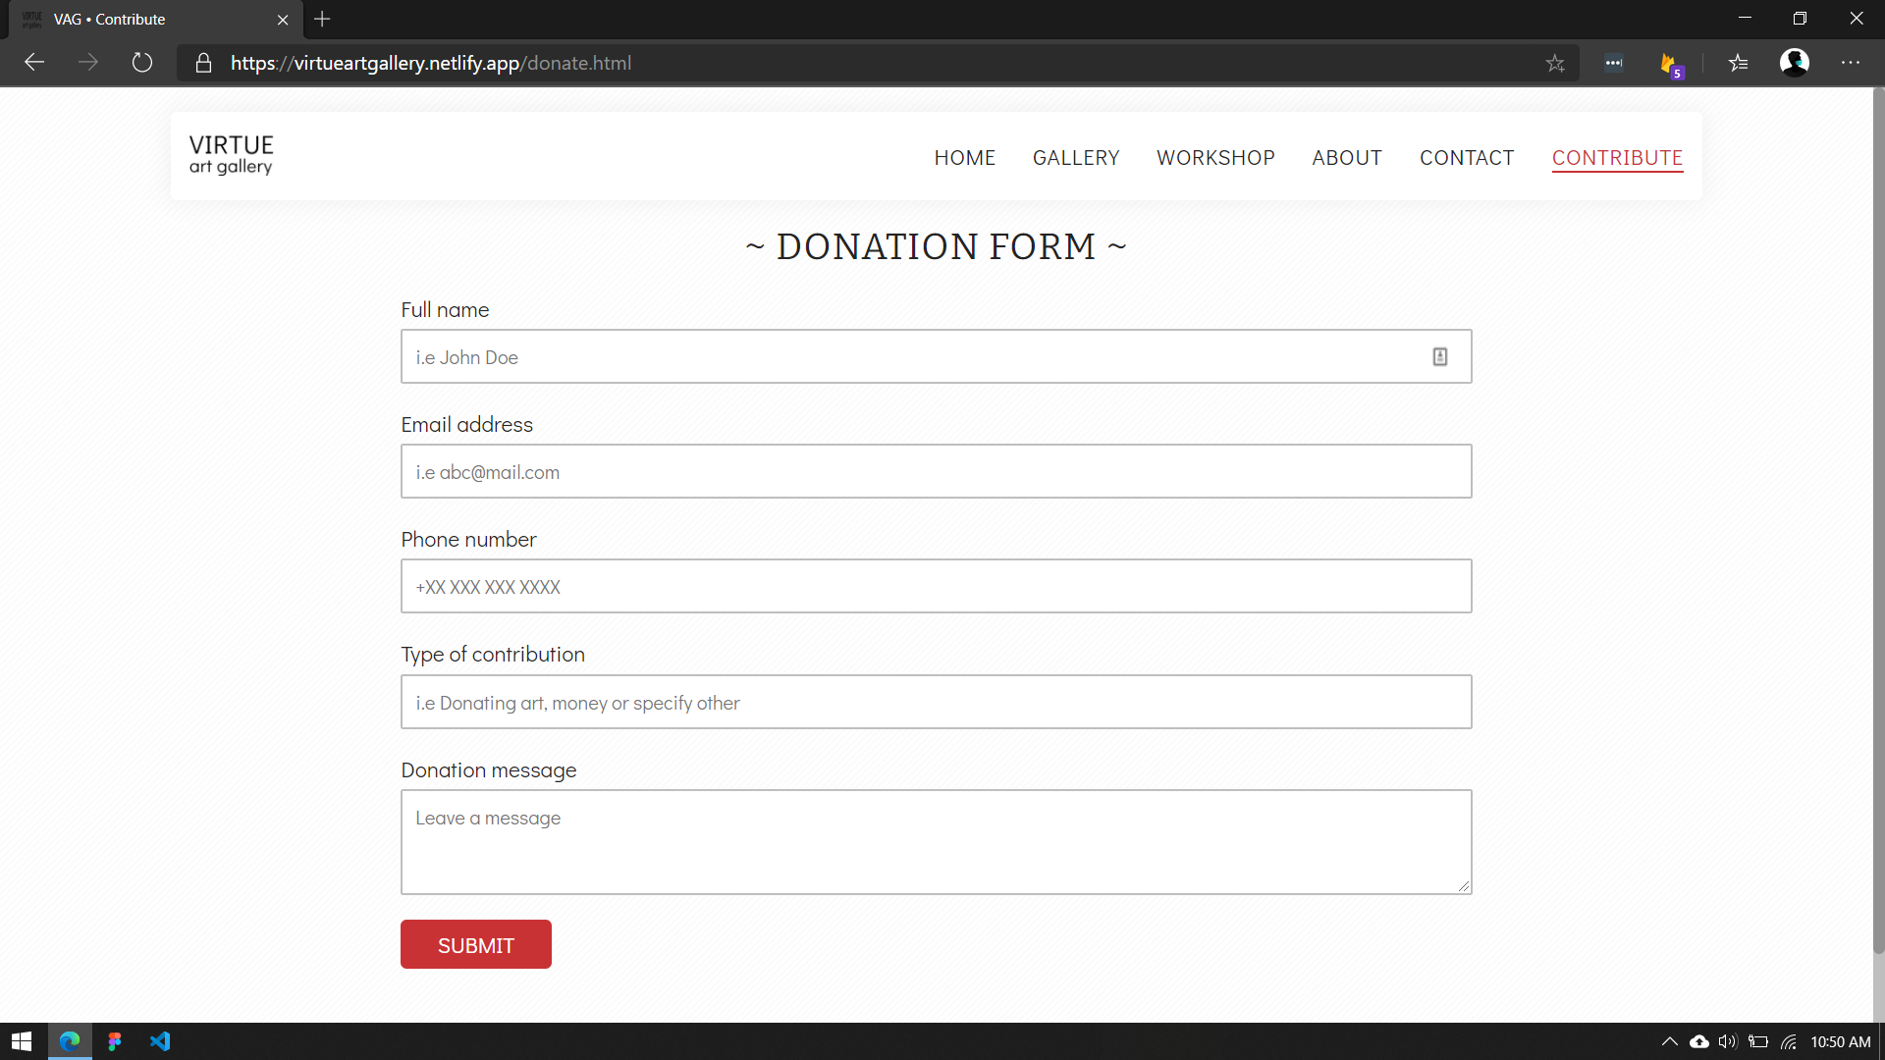

Donation form (desktop view)

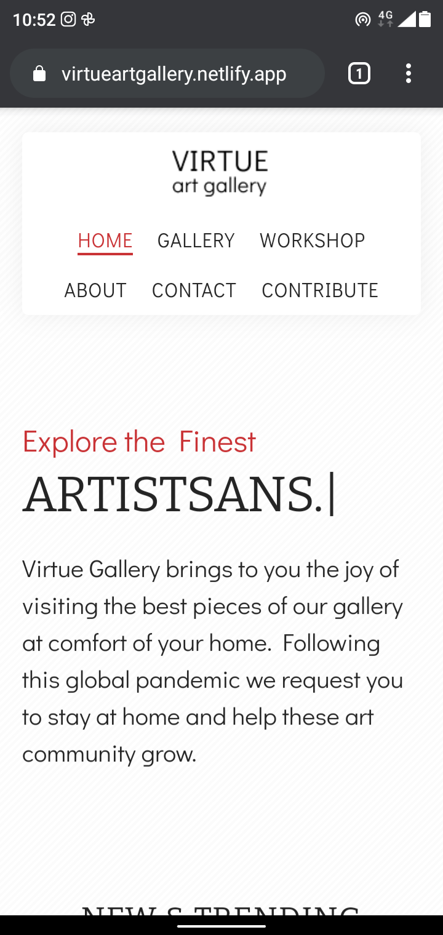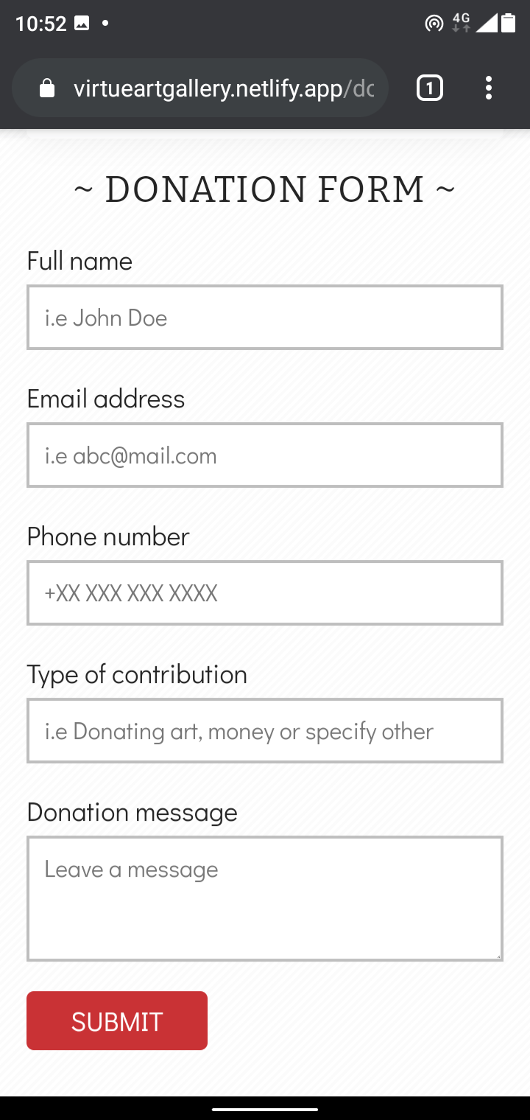

Homepage (mobile view), Donation form (mobile view)

**Conclusion :**

I have successfully designed and developed a website named “Virtue Art Gallery” where users can visit artworks, antiques and more without stepping out of their house. Users can visit websites to see which artworks are trending and which new art pieces have arrived in the art gallery. Additionally, users will also get updated about the upcoming workshops. If a user wishes to contribute, they have direct methods to donate artworks and money.

It was a great learning experience for me to showcase my design and prototyping skills as well as coding and testing skills. I learnt about new tools and technologies such as Figma, jQuery and Netlify. Using Git and Github for version control made me work on my project with confidence as there are very less chances of losing data. Testing and collecting feedback made me create better interfaces and fix some minor bugs.

Overall, I came to know what are the issues that a developer can face while creating a website and various methods to fix those issues.

**References :**

CSS layout guide :[w3schools.com/css](https://www.w3schools.com/css/)

Javascript Functions guide : [www.w3schools.com/js](http://www.w3schools.com/js)

Animations guide : [github.com/michalsnik/aos](https://github.com/michalsnik/aos)

Database guide : [firebase.google.com/docs](https://firebase.google.com/docs)

Documentation guide : [www.tutorialspoint.com](http://www.tutorialspoint.com)