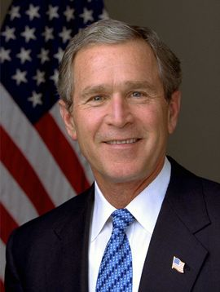
FIRST LAST
Technical Program Manager
Address: 300 Oracle Pkwy, Redwood Shores, CA 94065
Email: first.last@resumeworded.com
Mobile Phone: +1 (650) 123-4567
Home Phone: +1 (919) 123-4567

PROFESSIONAL EXPERIENCE

RESUME WORDED San Francisco, CA and New York, NY
Technical Program Manager 2014-Present
- Led multi-disciplinary 7 person team to design, develop, and launch online e-commerce store; prioritized and resolved 45+ new features and bug fixes
- Promoted within 12 months due to strong performance and organizational impact (one year ahead of schedule)
- Developed strategic insights across 5 product teams, including revenue, marketing and operations departments

Selected Project Experience
- Operations Improvement Project
- Drove redevelopment of internal tracking system in use by 125 employees, resulting in 20+ new features, reduction of 20% in save/load time and 15% operation time
- Refined outsourcing strategy, resulting in increased offshore headcount from 12 to 95 employees
- Reduced development costs by 25 percent by creating a plan to merge related products into one, more streamlined product.
- Managed a process re-engineering project to improve and consolidate end-to-end service processes; restructured communication flow among 10 departments, and cut down reporting time by 75%
- Launch of New iPhone App
- Led application design sessions with client teams on 20+ projects to develop technical requirements

GROWTHSI New York, NY
Product Manager 2012-2013
- Spearheaded a cross-functional team (Technology, Business Development, Management) to implement new ERP system; successful adoption accelerated revenue growth by 25% in 1 year
- Improved sales efficiency by leading sustainable adoption of a new CRM tool among 150 sales persons in 6 months; redesigned key sales support workflows
- Designed training and peer-mentoring programs for D&I events targeted at C-level executives; led training and awareness initiatives that were attended by over 10,000 employees in 2 years

EDUCATION

GROWTHSI San Francisco, CA
[Second Degree or Certification] 2011-2012

RESUME WORDED UNIVERSITY New York, NY
Bachelor of Engineering, Major in Computer Science; Minor in Mathematics 2007-2011

ADDITIONAL INFORMATION

- Program Management: SDLC (Software Development Life Cycle), Resource Planning, Jira, MS Project
- Technical Skills: Python, R, Microsoft SQL Server, Amazon Web Services (AWS), PRINCE2
- Certifications: Data Science Bootcamp (2016), Passed Resume Worded examinations

