Drone QKD demo: system diagram explained
Nov 8, 2026 · @Pramit

Overview
The demo proves one thing: the quality of the quantum key rises and falls with how well the ground station tracks a real, wind-blown drone. The system has three segments, and information flows through them in one direction.
- Air segment: a DJI Mini 2 SE hovers in front of a fan, carrying a small beacon or retroreflective tape.
- Ground segment: a camera on Noah's gimbal finds the drone, locks onto the beacon and measures how much it moves.
- Key segment (cyber sandbox): software on the same laptop turns that measured motion into photon loss, runs BB84 and decides whether the key is safe to keep.
Two coloured paths in the diagram are worth following:
- Blue, the jitter and drift path: wind pushes the drone, the camera measures the motion, and the error budget turns it into a loss of signal.
- Orange, the threat path: software decoy states, an Eve emulator and a gate that aborts the key when an attack shows up.
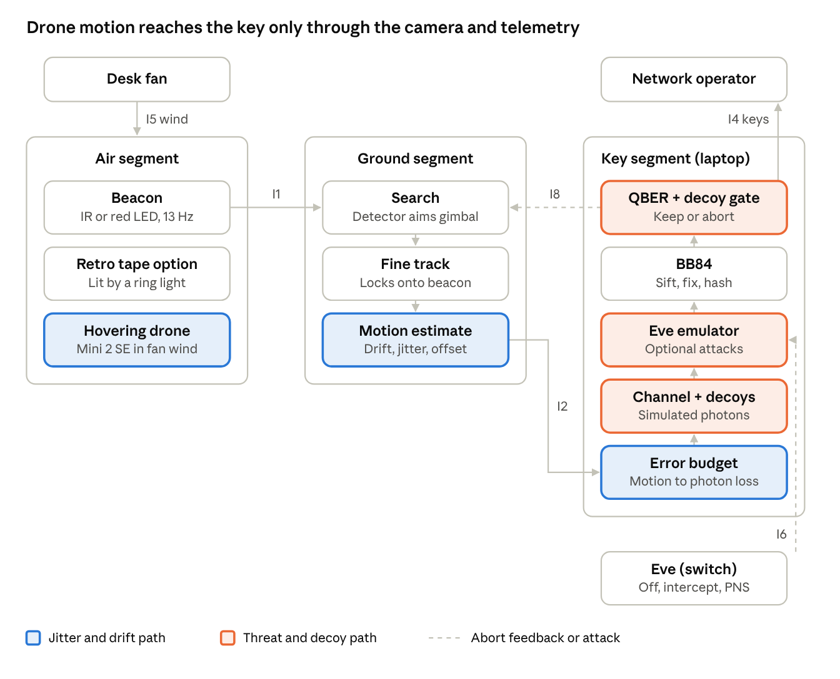
demo system · 3 segments, 8 interfaces
Read it left to right: wind moves the drone, the beacon's light (I1) carries that motion to the camera, and telemetry (I2) carries the measurements into the key segment, which works upward to the operator.
What the demo must show. Everything below is measured from the ground, through the camera, the gimbal and (if built) the photodiode. No DJI SDK or drone telemetry is needed, and that is a feature: a commercial ground station has to work with any vendor's drone.
- Causality. Fan off, low, high: QBER rises with the measured motion, shown live as the dose-response plot from test T6.
- Ground tracking matters. The receiver's virtual width is narrow enough that a few mrad of gimbal lag or jitter visibly costs signal. Otherwise QBER only follows drone lean and the tracker looks pointless.
- Two error bars on screen. Ground residual (what the gimbal and tracker failed to remove) next to drone lean (what only a drone-side steering mirror could fix). This is the D3 roadmap argument in one picture.
- Aborts work. A gust or Eve pushes QBER past 11%, the gate aborts and the tracker re-acquires.

Air segment
The drone is flown by hand, parked in a hover and left there while a fan pushes it around. That wind-driven motion is the disturbance the whole demo measures.
Part | Choice | What it does
Drone | DJI Mini 2 SE (under 249 g, 3-axis gimbal) | Holds station; its motion is the disturbance
Target | IR or red LED beacon, or retroreflective tape | Gives the ground camera one bright point to lock onto
Wind | Desk fan | Pushes the drone to create drift and jitter
Pilot | Field crew, manual flight | Launch, park in hover, recover
Where the jitter and drift numbers come from. The error budget uses three sources, from rough to exact:
- Spec sheet (before testing). Gimbal angular vibration is ±0.01°, about 175 µrad. Hover accuracy is ±0.3 m horizontal and ±0.1 m vertical with vision positioning, or ±1.5 m and ±0.5 m on GNSS (DJI Mini 2 SE specs).
- Footage analysis (after testing). Film the drone hovering in the fan, track it frame by frame in OpenCV, and measure slow drift and fast jitter. These measured values replace the spec values.
- Live measurement (during the demo). The ground camera measures the motion directly; see Motion estimate below.
Position drift matters far more than gimbal shake here. At 5 m range, ±0.3 m of hover drift is about 60 mrad, roughly 340 times the gimbal's 175 µrad.
Lean matters most for the transmitter. A drone holding station in a fan stream tilts into the wind to balance the drag. The beacon or IR LED is fixed to the body, not to the camera gimbal, so it tilts with it. Rough estimate: drag on a 249 g drone in 4 m/s of fan wind is about 0.2 N against 2.4 N of weight, a lean of about 4.5° (78 mrad). That is close to the ±5° (87 mrad) half-width of a 10° LED beam.
- Lean cannot be seen from position: a drone holding station in steady wind does not move, it only tilts.
- The ground camera measures it from an AprilTag's pose (see Motion estimate), so no drone telemetry is needed.
- Flight log (after testing). DJI Fly saves a flight log on the phone; third-party viewers such as AirData or PhantomHelp should decode it into attitude at about 10 Hz. Compare it with the camera-measured lean after the flight as an independent check, with no SDK.
Things to check:
- Tracking modes. The Mini 2 SE has QuickShots (Dronie, Helix, Rocket, Circle, Boomerang) but no subject-tracking mode like ActiveTrack (specs). Its hover accuracy is the closest built-in figure to cite.
- Indoor flight. Vision positioning needs a patterned floor, more than 15 lux of light and a height of 0.5–10 m. Over a plain floor the drone falls back to the looser figures or drifts.
- Weight. The drone is already at about 249 g, so any beacon or tape takes it over 250 g. Check the event rules and registration.

How the beacon works
The beacon is a small blinking light on the drone that the ground camera can pick out even in a bright, busy room. There are two ways to build it.
Option A: an active LED beacon.
- Hardware. Two or three LEDs sit under a ping-pong ball, which spreads the light so it glows the same from every angle. A tiny microcontroller (Seeed XIAO RP2040) drives them from its own small LiPo battery. It has no radio, so it never talks to the ground.
- The blink. Brightness switches between 100% and 40% thirteen times a second (13 Hz) and never turns fully off. At 120 fps the camera sees about 9 frames per blink, and because the spot never disappears, the tracker has it in every frame.
- How the camera finds it. Software looks for pixels that pulse at exactly 13 Hz, a trick called lock-in detection. Room lights, windows and reflections don't pulse at that rate, so they are ignored.
- Why 13 Hz. Mains lighting flickers at 100 or 120 Hz, which a 120 fps camera sees as false patterns at 0, 20, 40 or 60 Hz. 13 Hz stays clear of all of them.
 | IR (850 nm) | Red (about 630 nm)
Camera | Arducam B0332 with an 850 nm bandpass filter | Any camera: DJI Action 5 Pro or a webcam
Rejecting room light | Excellent; the filter blocks almost everything else | Weaker; competes with red objects and lights
Visible to people | No | Yes, so it is easy to check that it is on
Watch out for | Lenses with an IR-cut filter make it invisible | Nothing major
Option B: retroreflective tape.
- Hardware. A strip of retroreflective tape, or a retroreflective AprilTag of 6–8 cm weighing about 3 g, goes on the drone. Nothing on the drone needs power.
- Ring light. A retroreflector bounces light straight back towards wherever it came from. A ring light around the ground camera's lens therefore makes the tape glow brightly for that camera only.
- Same trick. Blink the ring light at 13 Hz and the same lock-in detection works. An AprilTag also tells you the drone's tilt.
- Limit. The returned light fades quickly with distance because it travels out and back. That is fine at room range.
In the commercial system, the beacon becomes a laser on a different wavelength from the quantum signal, so the tracking light never reaches the photon detectors.

Ground segment
The ground segment works in two stages. Search finds the drone anywhere in view, then fine track locks onto its beacon and keeps the gimbal pointed at it.
Stage 1: search (wide). An OpenCV drone-detection model looks at the full camera view and draws a box around the drone. A small YOLO-style detector run through OpenCV's DNN module is one way to do it. The software converts how far the box sits from the image centre into pan and tilt angles, and Noah's gimbal turns to point at the drone. Once the drone is near the centre and the beacon is visible, control passes to fine track.
Stage 2: fine track. The software stops scanning the whole image and watches a small window around the beacon. Each frame it finds the exact centre of the bright, blinking spot, to a fraction of a pixel.
- A Kalman filter smooths that position and predicts where the drone is going next.
- A control loop moves the gimbal to keep the spot centred.
- If the beacon vanishes for a moment, the tracker keeps following the prediction (coast). If it stays lost, the system goes back to search.
- With retroreflective tape, the camera needs a ring light around its lens; see the beacon section.
Part | Choice | Notes
Gimbal | Noah's pan-tilt gimbal | Points the camera; reports its own angles back
Camera, best | Arducam B0332 (OV9281, mono, global shutter) | Works with IR, red or retro; high frame rate, no motion smear. For IR, use a no-IR-cut lens and an 850 nm filter
Camera, alternative | DJI Osmo Action 5 Pro | Red beacon or retro with a visible ring light only; IR-cut filter, and webcam mode is 1080p at 30 fps with a rolling shutter
Camera, cheapest | Generic USB webcam | Red beacon or retro only; usually 30 fps with an IR-cut filter
Ring light | IR ring for the Arducam, white ring for the others | Only needed for the retroreflective option
Compute | Laptop | Also runs the cyber sandbox
Frame rate and blink rate go together. The 13 Hz blink assumes about 120 fps. A 30 fps camera can only reliably see blinks below 15 Hz, and mains flicker shows up near 10 Hz at that frame rate. So with the Action 5 Pro or a webcam, slow the blink to about 7 Hz.
Ground gimbal accuracy and jitter. The gimbal is never perfectly on target, and under the fan its lag is the largest ground error, about 2 mrad. Example sizes below assume an ST3215-class bus-servo gimbal (4096 steps per turn, 1.53 mrad per step) at 3 m; replace them with Noah's gimbal's figures from test T1.
Error source | Example size (RMS) | How to measure it
Tracking lag (drone moves before the gimbal reacts) | about 2 mrad (0.2 m/s at 3 m, 30 ms loop) | Per-stage timestamps (T5)
Step size (servo can only stop on steps) | 0.44 mrad (one step ÷ √12) | Command single steps against a fixed beacon
Backlash and deadband hunting | up to 1 step, measure | Reverse direction against a fixed beacon
Holding vibration (servo buzz) | measure | T1 with gimbal active vs locked
Camera measurement noise (NEA) | about 0.1 mrad (0.1 px, stock 70° lens) | T1, beacon on a tripod
Boresight bias after calibration | measure | Wide-to-narrow boresight calibration
These add as squares into the ground receiver's pointing error:
\sigma_{rx}^2 = \mathrm{NEA}^2 + \sigma_{step}^2 + \sigma_{backlash}^2 + \sigma_{vib}^2 + (\omega\, t_{lat})^2 + b^2
The gimbal's errors matter in two different ways:
- Pointing. Every gimbal error ends up in the tracking residual, which the camera measures optically each frame. So gimbal jitter and inaccuracy reach QBER automatically, with no model of the servos needed.
- Measuring the drone. The drone's direction is encoder angle plus pixel offset, so encoder errors leak into the drift and jitter numbers. The measurement floor is NEA, step size and any timing mismatch between encoder and frame, added as squares. Timestamp every encoder read and interpolate it to the frame time, or a fast slew shows up as false drone jitter.

Motion estimate and telemetry
The motion estimate turns the tracker's raw numbers into four plain measurements of how much the link is wobbling. Telemetry sends them to the sandbox 120 times a second.
The drone's direction is the gimbal angle plus where the spot sits in the image. From that track, the software measures four things:
Measurement | What it means | How it is computed
Drift | Slow wander of the drone in the wind | Slow-moving average of the drone's direction (changes below about 0.5 Hz)
Jitter | Fast shaking | Spread (RMS) of the fast part of the motion over about 1 s
Tracking residual | How far off the gimbal is pointing | Distance of the spot from the image centre
Intensity | How bright the beacon looks | Spot brightness compared with the preflight calibration
Three more measurements come from the same ground hardware, with no access to the drone:
Measurement | What it means | How it is computed
Lean | Drone tilt, which is where a body-mounted transmitter actually aims | AprilTag pose (cv2.solvePnP) from the narrow camera. An 8–10 cm tag spans about 90 px at 3 m on a 12 mm lens; expect about 1–2° of pose noise (check in T1). On the wide camera the tag is only about 25 px, too few for pose.
Range | Distance to the drone | Tag size in pixels: range = focal length × tag size ÷ pixels. Turns angular drift into metres.
Gimbal lag | The part of the residual caused by the gimbal falling behind | Commanded angle minus encoder angle, timestamped to the frame
With the LED beacon instead of a tag, four LEDs at known spacing give the same pose through cv2.solvePnP; two or three are not enough.
Telemetry is one small message per camera frame, sent over ZeroMQ between programs on the same laptop. For example:
{"t": 12.508, "state": "TRACK", "drift_mrad": 3.1, "jitter_mrad": 0.8, "residual_mrad": 0.4,
"gimbal_lag_mrad": 0.3, "lean_deg": 4.2, "range_m": 3.05, "intensity": 0.92,
"rx_signal": 0.88, "rx_background": 0.04}
The last two fields appear only when the IR data link is built (see Theoretical design).
This message is the only thing that crosses from the physical world into the key software: no hardcoded values and no radio link. The example values are only placeholders.
Spec, footage and live values work together. Before the flight, the error budget is pre-filled with the spec-sheet and footage-analysis numbers from the air segment, so you know the expected QBER in advance. During the demo, live telemetry replaces them, and the gap between expected and measured is itself a good result to show.

Compute and cyber sandbox software
One laptop runs everything. The tracker and the sandbox are two separate Python programs, and the only thing connecting them is the telemetry stream.
Layer | Tool
Language | Python
Vision | OpenCV, with opencv-contrib for ArUco and AprilTag; the detection model runs through OpenCV's DNN module
Gimbal | Noah's gimbal driver
Messaging | ZeroMQ on localhost
Maths | NumPy
Display | Live plots of tracking state, QBER and key rate
Inside the sandbox, each telemetry message passes through six steps:
- Error budget. Combines the tracking residual, the drone's motion and the beacon brightness into one number per frame: the transmittance, meaning the fraction of photons that would arrive. Pointing error loses light the way a spotlight drifting off a target does.
- Channel + decoys. Pretends to send a stream of single-photon pulses. Each pulse is randomly marked as signal, decoy or vacuum, and its photon count is a random (Poisson) draw. Each photon arrives with the measured transmittance. Detector noise (dark counts) and a 2% optical error are added on top.
- Eve emulator. Off by default. A switch turns on an intercept-resend attack or a photon-number-splitting (PNS) attack.
- BB84 pipeline. Sifting keeps only the bits where both sides chose the same basis. Error correction (Cascade) fixes the mismatches. Privacy amplification (Toeplitz hashing) shrinks the key down to what Eve cannot know.
- QBER + decoy gate. Keeps the key only if QBER is below 11% and the decoy check passes. Otherwise it throws the block away and tells the tracker to re-acquire.
- Key store. Holds the finished keys and hands them to the operator.
The error budget multiplies four factors: range loss, receiver pointing, drone (transmitter) pointing and brightness change. Receiver pointing uses the measured tracking residual, so the ground gimbal's lag, step size and jitter are already inside it.
\eta = \eta_{geo}(L) \cdot e^{-2\theta_{rx}^2/\theta_{fov}^2} \cdot \eta_{tx}(\theta_{tx}) \cdot \frac{I}{I_{cal}}
QBER then comes from how many real signal clicks there are compared with noise clicks.
\mathrm{QBER} = \frac{e_{opt}\,p_{sig} + p_{noise}/2}{p_{sig} + p_{noise}}, \quad p_{sig} = 1 - e^{-\mu \eta \eta_d}, \quad p_{noise} = p_{dark} + p_{bg}
Settings that keep the budget honest:
- Range loss η_geo. Receiver lens area ÷ beam spot area: about 31 dB at 5 m and 43 dB at 20 m for the IR link below. Without it, η is 1 at perfect pointing and the key rate is not tied to range.
- Drone pointing θ_tx = lean + drift ÷ range. A wide LED beam is close to evenly lit, so use a flat-topped η_tx (about 1 inside ±5°, falling at the edge). A Gaussian with an 87 mrad half-width would charge 60 mrad of drift about 4 dB that the link budget says is free. Use the same shape in both places.
- Make ground tracking count. The real receiver view (about 54 mrad half-width) keeps 99.4% of the signal at a 3 mrad residual, so set θ_fov to a scaled virtual width instead. With about 2 mrad of ground error and the mission's ratio (allowed error ≈ 0.22 of the width), θ_fov ≈ 10 mrad.
- Operating point. Choose μ, η_d and p_dark so the on-axis signal is about 10 times the noise at the demo range, as in the pointing calculator. QBER then sits near 2–3% when locked and crosses 11% after about 3.6 dB of pointing loss.
- Background p_bg. Zero in the modelled mode; from the photodiode's measured background when the IR link is built.
- Abort rule. Single frames often spike above 11% even when the average is fine. Abort on the pooled QBER of each key block, and show the 100 ms values as a live trace.
The live threat demo shows each kind of attack being caught:
Eve setting | What judges see
Off | Keys flow; QBER follows the fan speed
Intercept-resend on half the pulses | QBER jumps to about 14.5% and the gate aborts
PNS | QBER stays near 2%, but the decoy check fails and the gate aborts

Theoretical design: the IR data link
In a full build, tracking and data travel on two separate light paths. The beacon lets the two ends find and point at each other, and a second IR beam carries the bits. Today that second beam is simulated; this section is a design for building it.
One honest caveat: a 1–3 W LED sends billions of photons per bit, so this is a classical optical data link, not a quantum one. It stands in for the quantum channel: the BB84 bit stream really crosses the air, and the receiver gives a measured signal strength and error rate. The last table below shows what changes to make it truly quantum.
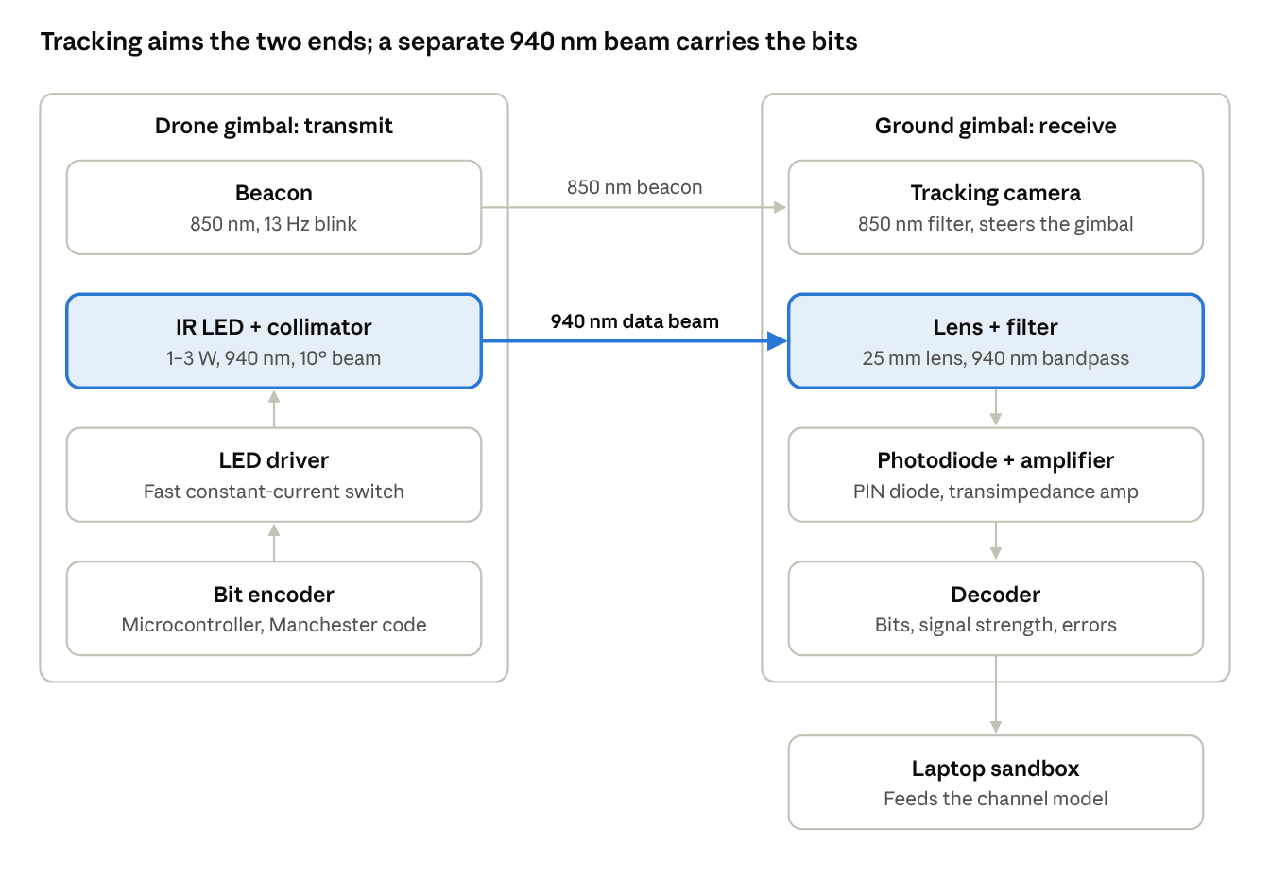
IR data link · tracking and data on separate wavelengths
The top beam lets the camera steer both gimbals onto each other; the second beam, on its own wavelength, carries the data from the drone's LED to the ground photodiode.
Transmitter, on the drone's gimbal
Part | Example choice | What it does
IR LED | 1–3 W star LED, 940 nm | Sends bits by switching on and off
Collimator | 10–15° lens or reflector for a 20 mm star | Narrows the beam so more power reaches the receiver
Driver | Constant-current driver with a fast MOSFET switch | Switches the LED at the data rate
Controller | Microcontroller; the beacon's RP2040 can do it | Packs bits into coded frames
Power | Own LiPo cell, plus a heatsink | The Mini 2 SE has no power output for payloads
Receiver, on Noah's gimbal next to the camera
Part | Example choice | What it does
Photodiode | Large-area PIN photodiode, BPW34 class (7.5 mm²) | Turns light into a small current
Lens | About 25 mm diameter | Collects more light and sets the field of view
Filter | 940 nm bandpass | Blocks room light and the 850 nm beacon
Amplifier | Transimpedance amp and comparator | Turns the current into a voltage, then into clean 1s and 0s
Decoder | Microcontroller with ADC, USB to the laptop | Reads bits and measures signal strength
How the bits travel
- The drone's microcontroller packs bits into frames: a preamble so the receiver can lock on, a sequence number, the data and a checksum.
- Each bit is sent as a light-dark or dark-light pair (Manchester coding). Average brightness stays constant, so the receiver can subtract steady background light.
- The LED flashes at roughly 10–100 kbit/s. Large power LEDs switch too slowly to go much faster.
- For each frame the receiver reports the bits, the signal strength, and the errors it found in known test bits.
- The laptop feeds those numbers into the channel model alongside the tracking telemetry, so received power is measured rather than only modelled.
For the demo, the drone sends a test pattern the laptop already knows, so errors can be counted directly. In a real system, Alice's bit records are compared over a separate classical channel.
Separate wavelengths keep the two paths apart. With the beacon at 850 nm and the data at 940 nm, each side's filter means the camera sees only the beacon and the photodiode sees only the data. Real systems do the same with their tracking and quantum signals. 940 nm has a bonus: water vapour absorbs sunlight there, so daylight background is lower.
Rough link budget. This assumes 0.5 W of light from a roughly 1.5 W LED, a 10° beam, a 25 mm receive lens and an evenly lit spot. Treat the numbers as indicative.
Range | Spot diameter | Power on receiver | Photodiode current
5 m | 0.9 m | about 0.3 mW | about 0.2 mA
20 m | 3.5 m | about 20 µW | about 11 µA
There is plenty of signal at both ranges; the hard part is pointing, not power.
Who points at whom.
- Drone side. A 10° beam must keep the ground station within ±5°, about 87 mrad. The drone's gimbal steadies it and the pilot aims it. At 5 m, the ±0.3 m hover drift is about 60 mrad, so the wide beam tolerates it. Lean is the tighter limit: about 4.5° in the fan, close to the ±5° edge (see Air segment).
- Ground side. A 2.7 mm photodiode behind a 25 mm lens sees a patch about 6° wide, and the tracker keeps the drone inside it. To make tracking visibly matter in the demo, narrow that view with a longer lens or a pinhole, so a few mrad of error drops the signal.
Practical limits.
- Weight and heat. The LED, collimator, heatsink, driver and battery add tens of grams. That is beyond the Mini 2 SE and the 250 g line, so test it on the pendulum rig or a larger drone.
- Eye safety. The beam is invisible, so nobody blinks away from it. Assess it under IEC 62471 and keep people out of the beam near the LED.
Getting a QBER from this link. A classical photodiode link cannot produce a real QBER, because QBER is a statistic of single-photon clicks. It can give a measured received power, and that makes the emulated QBER rest on a physical measurement rather than a model.
- Per frame (about 1 ms) the receiver reports signal S (mean "on" half-bit minus mean "off"), background B (the "off" level, room light through the 940 nm filter) and errors on the known test bits. Manchester coding gives both halves in every bit.
- Measured transmittance: η = η_geo(L) × S ÷ S_cal, where S_cal is recorded on-axis at a known range during preflight. S already contains every pointing loss, so it replaces the two pointing factors in the error budget rather than multiplying them.
- Measured background: p_bg = p_bg,cal × B ÷ B_cal. Turning on a lamp now raises the noise for real.
- QBER comes from the sandbox's per-pulse draws with these η and p_bg, then sifting, using the same formula as the error budget.
- Alice's bits and bases come from the drone's microcontroller and really cross the air on the LED. Bob's bases and the photon statistics are emulated.
The measured bit error rate is a link-health check, not the QBER: at 0.2 mA of signal it will be about zero. Run this link on the pendulum rig, since it does not fit on the Mini 2 SE. Stretch option: a SiPM evaluation board behind a heavy ND filter, counting pulses from the dimmed LED, would make p_sig and p_dark measured rather than modelled.
From classical stand-in to a real quantum link
This design | Real QKD link
1–3 W LED, billions of photons per bit | Pulsed laser dimmed to about 0.5 photons per pulse
Brightness carries the bits | Polarisation carries the bits, in two randomly chosen bases
PIN photodiode | Single-photon detectors behind polarising beam splitters
Measured bit error rate | Measured QBER
The LED link doesn't go to waste in the commercial system: it becomes the classical channel used for sifting and error correction.

Interfaces and the no-bypass rule
The challenge forbids hardcoded values and wireless shortcuts. The design meets that because only two arrows connect the physical world to the keys: the beacon's light (I1) and the telemetry stream (I2).
Interface | From → to | What crosses it
I1 | Drone → ground camera | Beacon light, which carries the drone's motion
I2 | Tracker → sandbox | Telemetry: drift, jitter, residual, intensity
I3 | Field crew → drone | Manual launch and flight control
I4 | Key store → operator | Finished keys
I5 | Fan and room → drone | Wind (drift and jitter), room light
I6 | Eve → sandbox | Simulated intercept-resend and PNS attacks
I7 | Regulator → system | Flight rules, eye safety
I8 | Gate → tracker | Abort and re-acquire
The drone's own radio (I3) only flies the drone. It never carries tracking data or keys.
If the IR data link is built, it adds a third physical interface, I9: drone LED to ground photodiode, carrying received signal and background. Like I1 it is light measured at the ground station, not a radio path, so the no-bypass rule still holds.

