GB4 Interim Report

Author: Nick Husic (NH543) College: Homerton Group Members: Haysen, Helen

Introduction

This report will detail our group’s progress on creating a molecular communication system that can control a drone using voice commands. See Item 1 in the Appendix for a detailed graphical overview of the system. The focus of this project is on the molecular communication between the sprayer and gas sensor. These first two weeks have mainly been spent constructing and optimising the setup (Nick and Haysen), and also configuring the speech recognition software and starting to design modulation schemes (Helen). We also fit the data to the parametric model used in [1], another paper with many similarities to this project. This report focuses on the setup. See Helen’s report for more detail on the speech recognition software.

Optimising the Configuration

The setup for the molecular communication is relatively simple, consisting of an electrical sprayer pointing towards a gas sensor (Figure 1) and spraying lemon cologne in short bursts to communicate information.

Figure 1: Image of setup

The basis of any communication system like this is the impulse response i.e., the gas sensor’s voltage response to a very short spray. There are 3 main variables that can be controlled which affect the response:

* Distance between the nozzle and gas sensor
* The nozzle setting (how misty the spray is)
* The concentration of lemon cologne

The objective of this section was to test lots of different configurations of these 3 variables to find the best impulse response. This means having a quick response time, quick recovery time and dissimilar responses for varying pulse durations (mainly useful for PWM modulation later). Having a consistent and quick impulse response allows for reliable and fast communication by reducing inter-symbol interference (ISI).

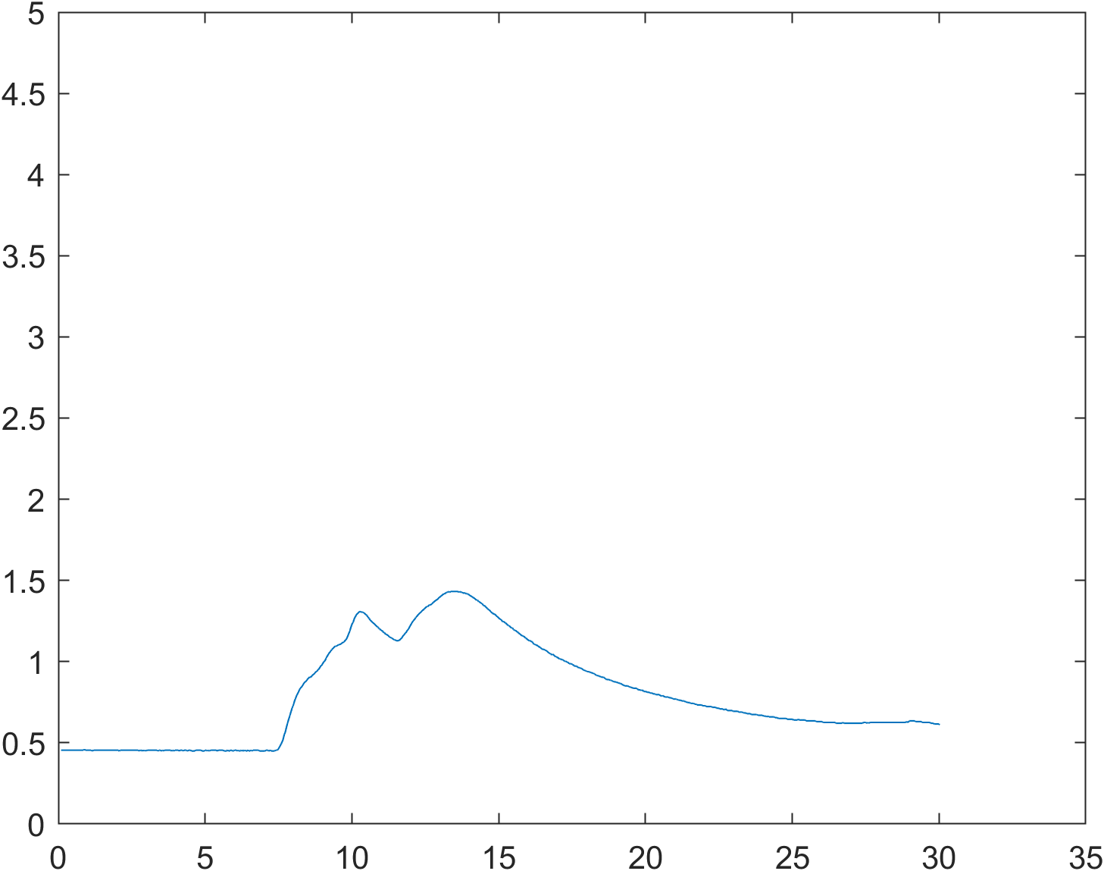The first thing we did after connecting the Arduinos and setting it up was write code that plots the gas sensor voltage in real-time and saves the plots if required. The first issue we immediately noticed was that diffusion hugely affected the response and recovery times of the sensor. Figure 2 shows this effect. It takes about 10 seconds for the molecules to diffuse over and even longer to diffuse away and recover. This effect is unacceptable due to the ISI it would introduce.

Figure 2: Impulse response from 80cm away and 100% conc.

In order to mitigate this effect, we introduced a small fan directly behind the sprayer. This decreases the response/recovery times by accelerating the molecules towards the sensor and dispersing them quicker. This is very similar to what [1] did and should in fact allow for a better curve fit to the parametric model later. Next, we discuss the results of adjusting the three variables stated above. During every test 3 pulses were done of duration 0.01s, 0.4s and 0.8s. 15s between each pulse were allowed to mostly recover the sensor.

Varying Distance:

We tested the setup on maximum misty mode, 75% concentration at 50cm, 60cm, 70cm, 80cm and 90cm.

Figure 3: Impulse Response at 50cm, 80cm and 90cm

The first thing we noticed is how much smoother and consistent the responses are with a fan. Also, the response time (rise time, not including time to travel the distance) did not change much with distance. The fan ensures that most of the molecules hit the sensor at once, producing a very sharp rise.

The features we were looking for was a fast recovery time, and a big difference in the peak amplitudes of the 0.01s and 0.4s sprays, which would make detection much easier when doing PWM. We disregard the 0.8s spray because in all the plots the difference between 0.4s and 0.8s was minimal due to the sensor’s voltage maxing out. We decided on 80cm as being the optimal distance because the recovery time was very good at around 15s, and a 1.6V difference in amplitude for the varying pulse durations.

Varying Nozzle Setting:

It was difficult to quantify the nozzle setting because it is involves turning a continuous knob. To simplify things, we defined the three modes that we tested it at: full mist, medium mist, and low mist. See Figure 3 below.

Figure 4: Impulse Response from High (Left) to Low (Right) Mist Modes

The full mist mode has the best response. This is to be expected because it is a gas sensor. Lowering the mistiness makes the bottle spray liquid and not gas. If the liquid hits the sensor, it saturates it and takes minutes to recover, as can be seeing the low mist mode response. Therefore, we decided to use full mist mode for all subsequent tests.

Varying Concentration:

We conducted 4 tests of lemon cologne diluted with water at 20%, 50%, 75% and 100% cologne concentrations from 80cm away. The plots contain 0.01s and 0.4s pulses with 15s between, except for 75% which also contains a 0.8s pulse.

Figure 5: Impulse Response at 20%, 50%, 75% and 100% Cologne Concentrations Respectively

At very low concentrations, the amplitude of the response is too low. At very high concentrations, the recovery time is slightly longer and the difference in amplitudes of the pulses is too small. 75% gave the best response, so we decided to use it. Therefore, the setup we decided to use from now on was 80cm distance, full mist mode, and 75% cologne concentration.

Modelling the Response

In this section we used the optimal 80cm, full mist mode, 75% concentration setup. We measured the impulse response 5 times and averaged out the data and used the Matlab Curve Fitter tool to match the data to equations (3) and (4) from [1].

Equation 3:

* a = 12.84

Figure 6: Fitted Curve (Blue) overlayed on impulse response for Eq (3) (Top) and Eq (4) (Bottom)

* b = 3.12
* c = -0.2176

Equation 4:

* a = 32.64
* b = 0.005911
* c = -2.498

Judging visually from the plots, equation (4) fits the curve better than (3), the same as in [1]. See [1] for more details on the equations and their applications.

Conclusion and Next Steps

In conclusion, the time spend characterising the setup and optimising it has been useful as we now have a nice impulse response with a fast response/recovery time and distinguishable amplitudes for different pulse amplitudes. This will allow use to rapidly and reliably test OOK and PWM code to find the best data rates possible and how ISI affects it. Once we can reliably communicate, we will connect the speech software and drone to complete the system.

References

[1] Farsad, N., Kim, N. R., Eckford, A. W., & Chae, C. B. (2014). Channel and noise models for nonlinear molecular communication systems. IEEE Journal on Selected Areas in Communications, 32(12), 2392-2401.

Appendix

Item 1 – Graphical Overview of System

