Technological Institute of the Philippines

938 Aurora Blvd. Cubao, Quezon City

College of Information Technology Education

IT 004– Web Systems and Technologies

Midterm Period

Developing Company Website

|  |  |
| --- | --- |
| Name: CLEDERA, ANNA MAUREEN  GARCIA, JOHN MARCUS  PEREZ, JAMES MARKELY  ROSALES, ALANIS TRIXIE | Date: NOVEMBER 11, 2020 |
| Program / Section: BSIT / IT21S4 | Instructor: Ms. Arceli F. Salo |
| Assessment Task: Project Part 3: Designing Web Pages | |

**Instructions:**

* Provide screenshots to satisfy the requirements. (note: include screenshot of source code and sample run-time output in every source code and output changes)
* Include your **FULLNAME** in every screenshot.
* You are required to provide the screenshot of your source code for each files like (.html, .css, .js, .php) and a sample output running in the browser.
* Include a brief description in each screenshot.
* Use appropriate filename in saving your files.
* Save your work as **TeamName_ProjectPart3.DOC** (Ex. TeamWeb_ProjectPart3.DOC and .PDF)

**This activity supports the attainment of Course Intended Learning Outcomes (CILOs):**

* Use client-side programming like HTML, CSS, and JavaScript in creating web pages;
* Apply different tools available such as bootstrap and jQuery in designing a website; and
* Use server-side programming script like PHP in managing the database records.

**Requirements:**

1. Open and continue your project development with your business partners.
2. You can use the Collaboration Module for you to collaborate with your business partners.
3. As a team, use a server-side script like PHP in managing your website.

* Can manage the website contents or records.
* Perform functions for File Maintenance like (add, edit, delete). **Note:** as part of your part3 requirements, make sure to apply add, edit, and delete functions.
  + *Minimum requirement:* at least one web page, as long as you perform and apply these methods in your project.

1. Working Log-in Page (User Maintenance).
2. Provide screenshots of the following:

* Source codes in each file (like html, css, js, php, etc); and
* Screenshot of myphpadmin structures
* Sample output running on any web browser.

1. Provide the specific contributions of each member. (use the template provided)
2. Acknowledge all your references

**ANSWER:**

**Source Code**

Login.php. 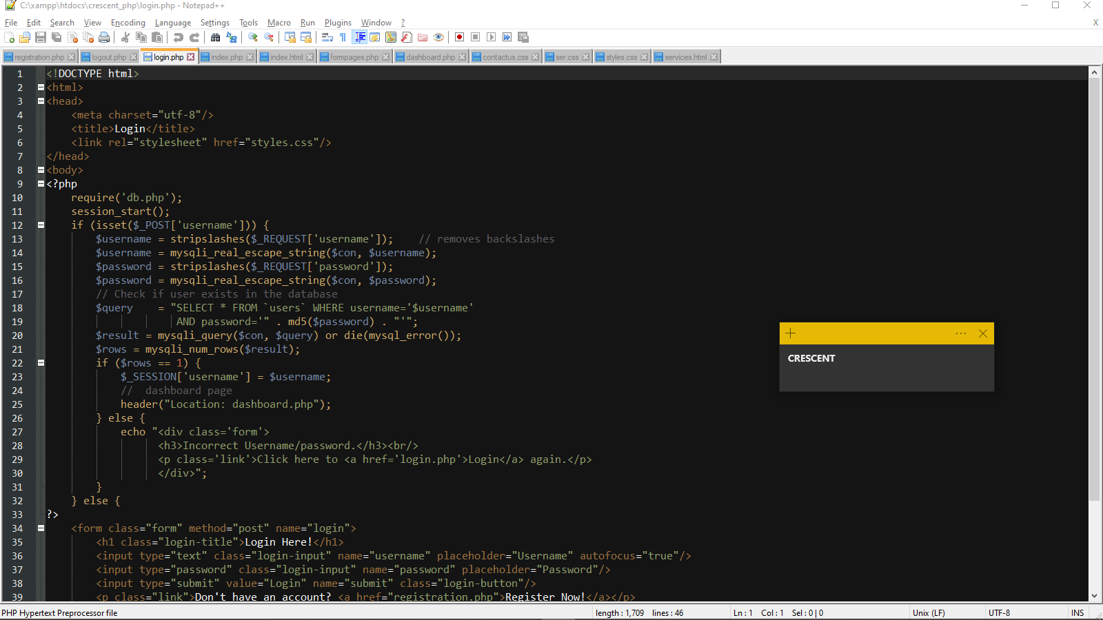

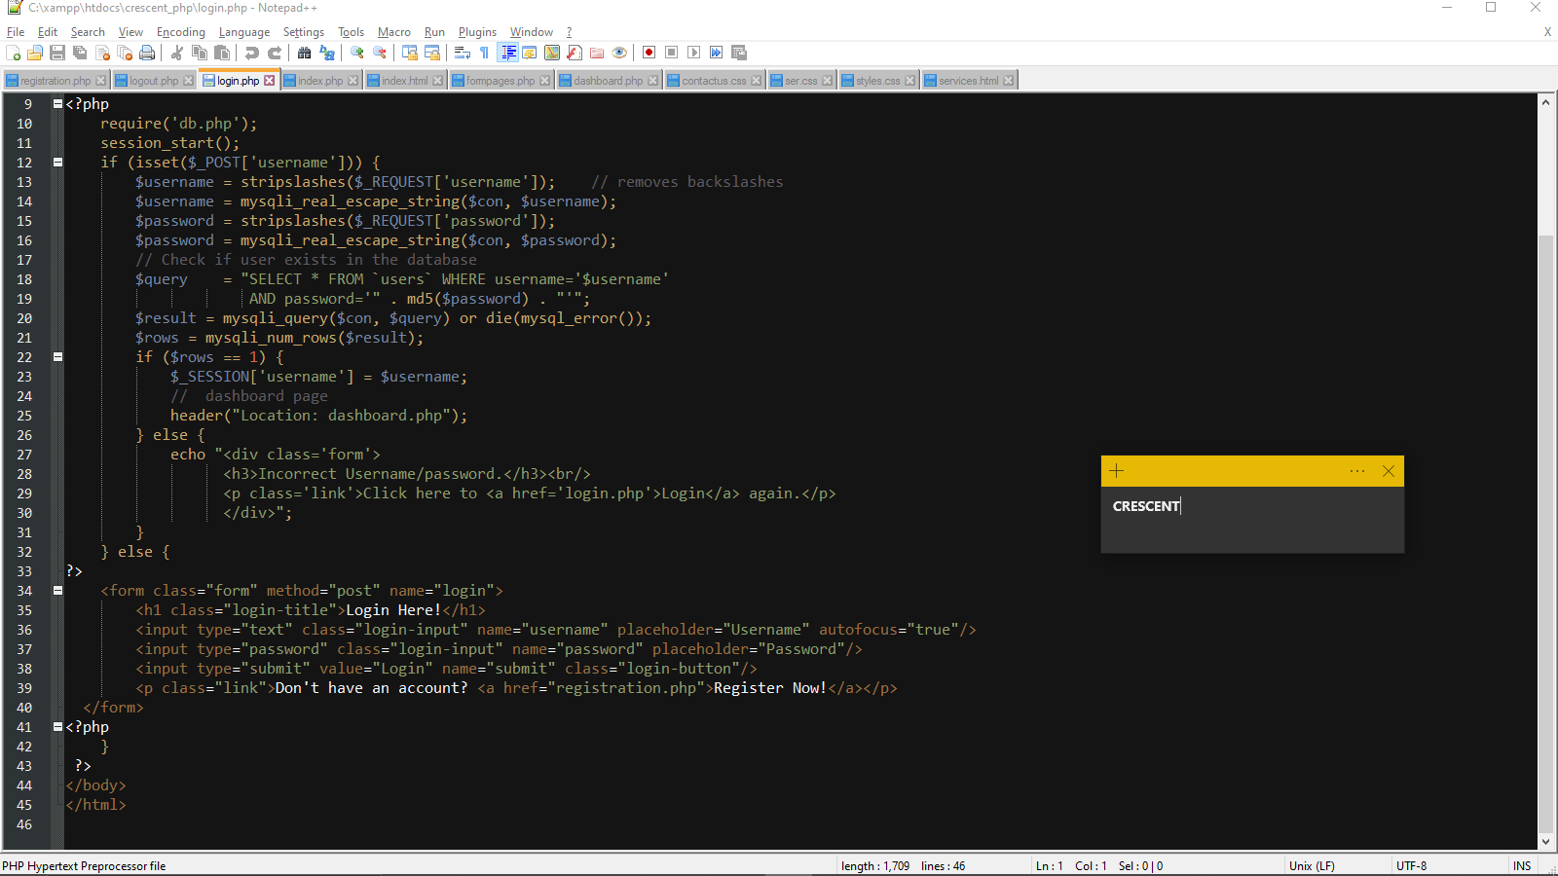

Logout.php

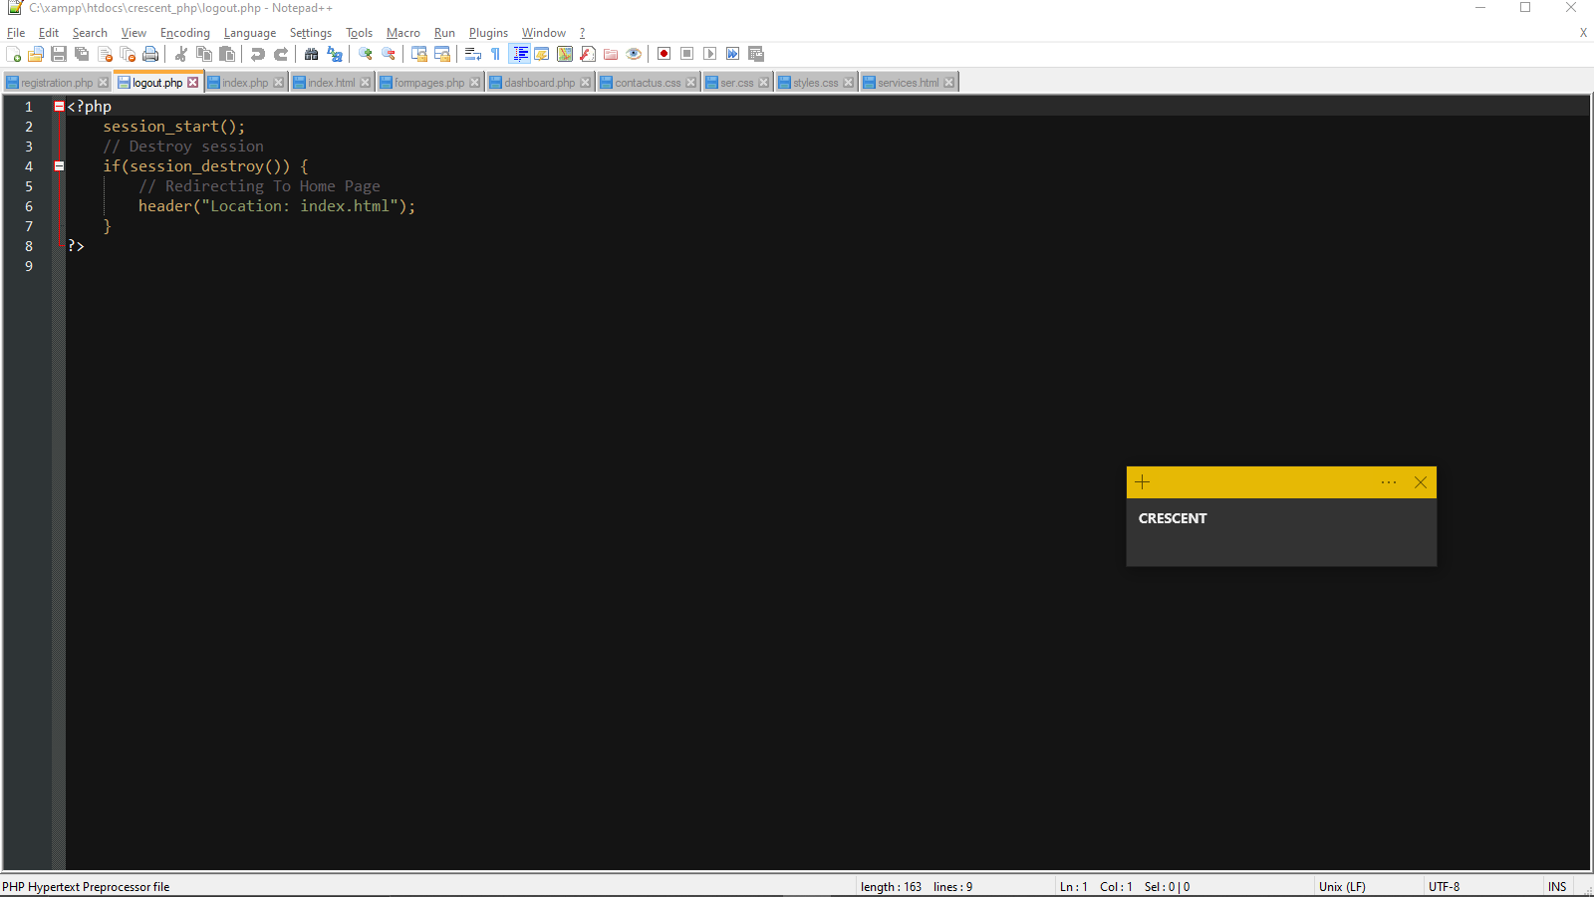

Registration.php

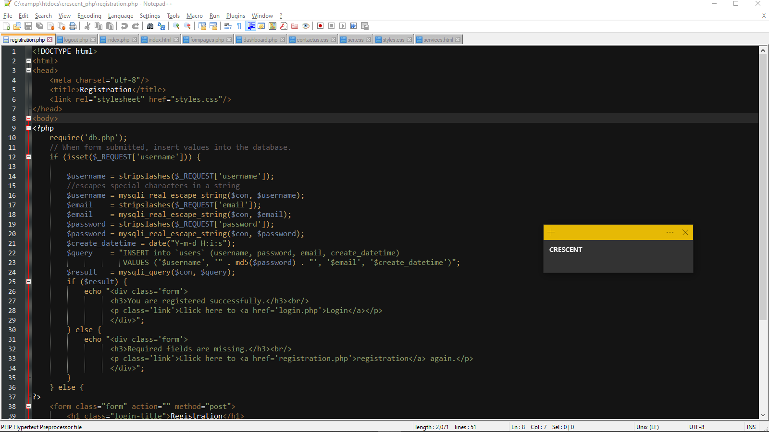

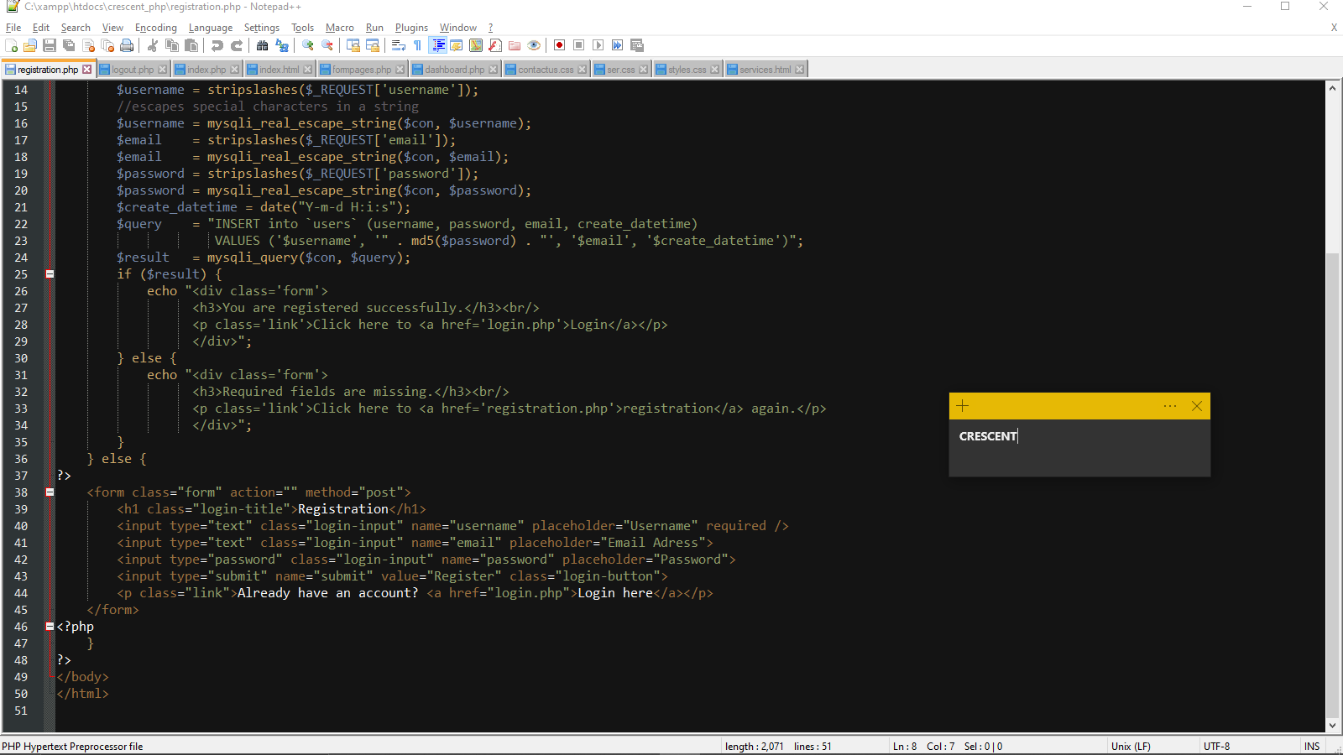

Styles.css

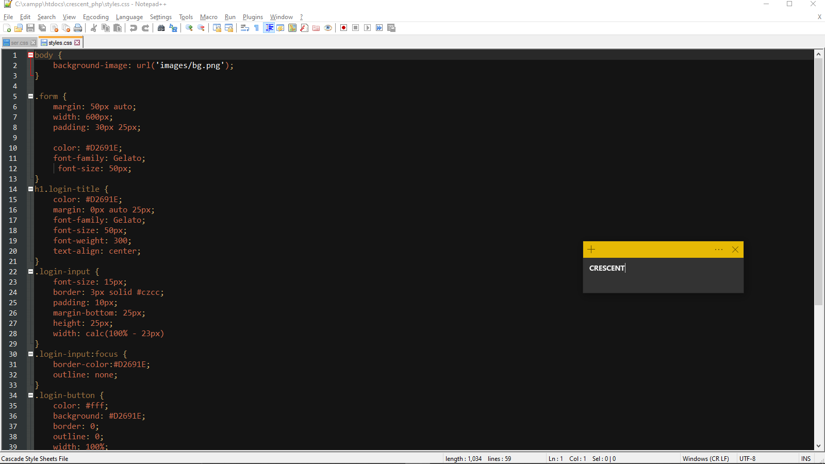

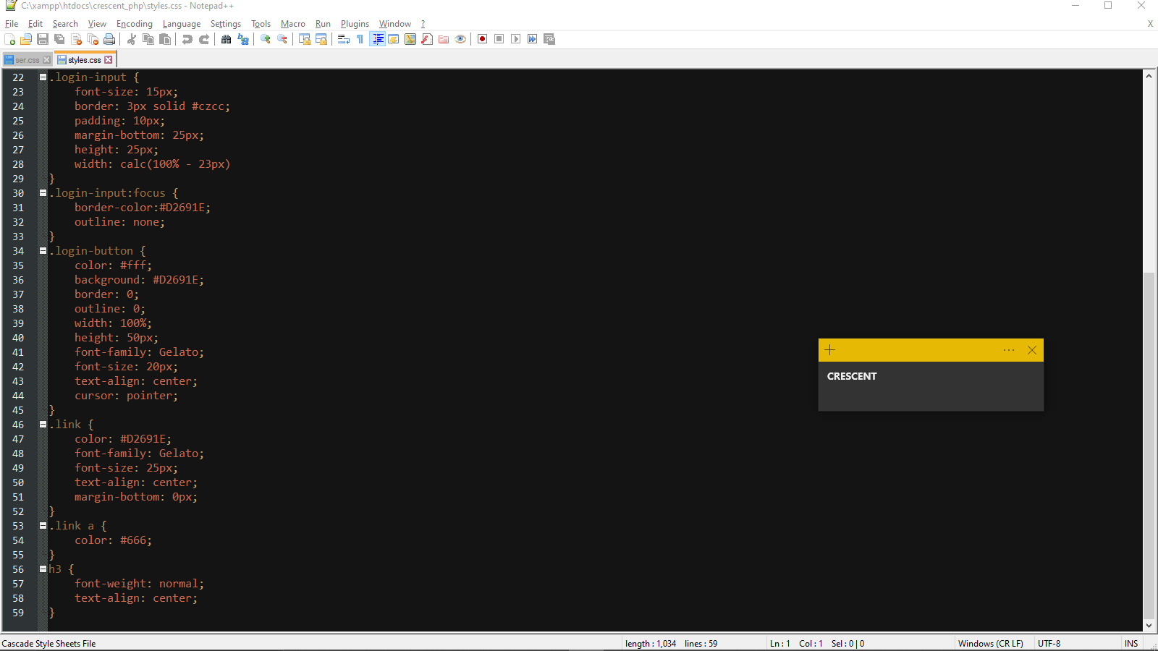

**Sample Output**

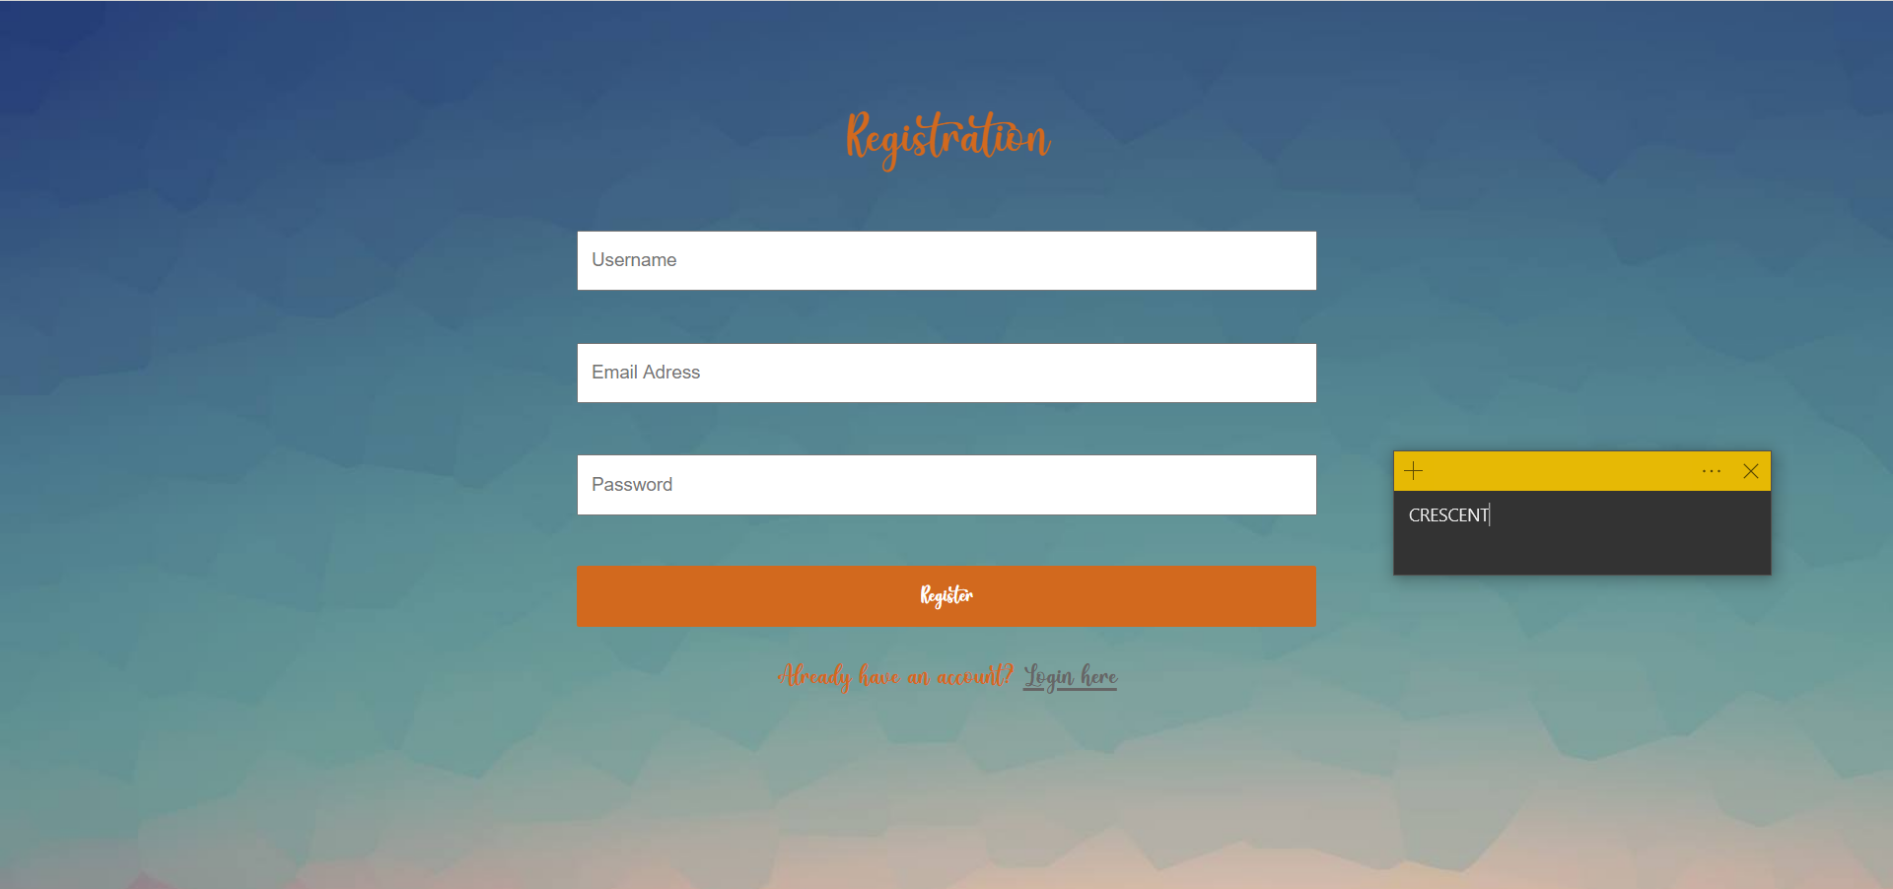

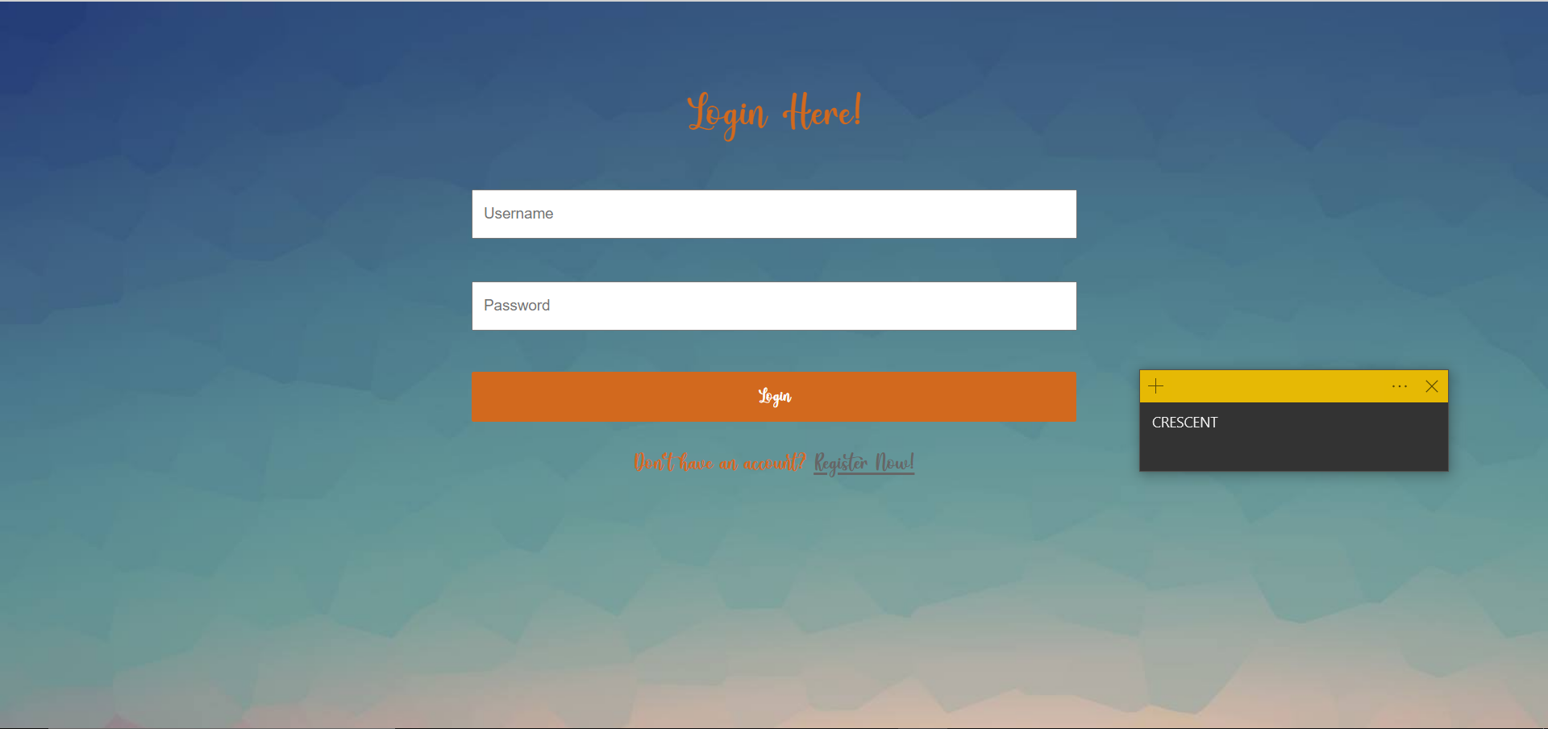

**myPHPAdmin Page**

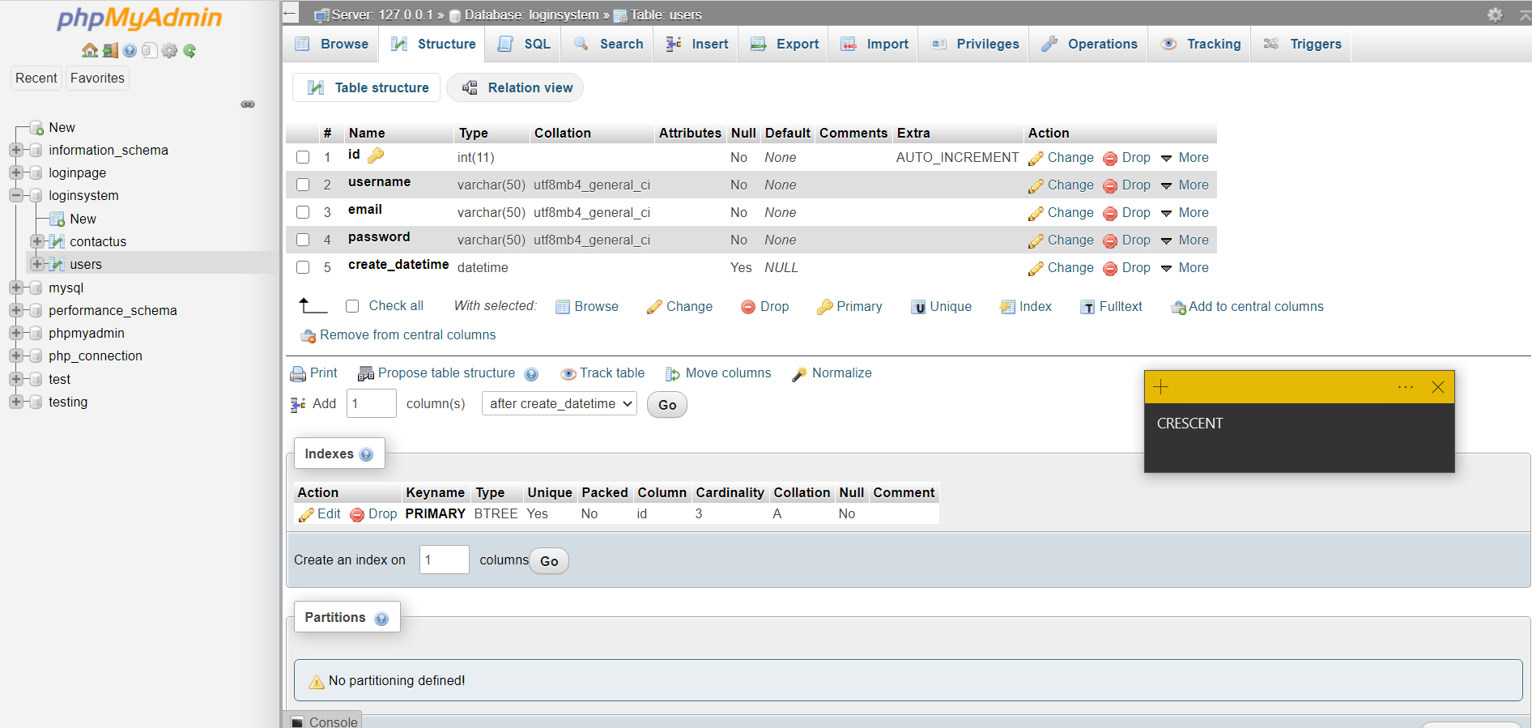

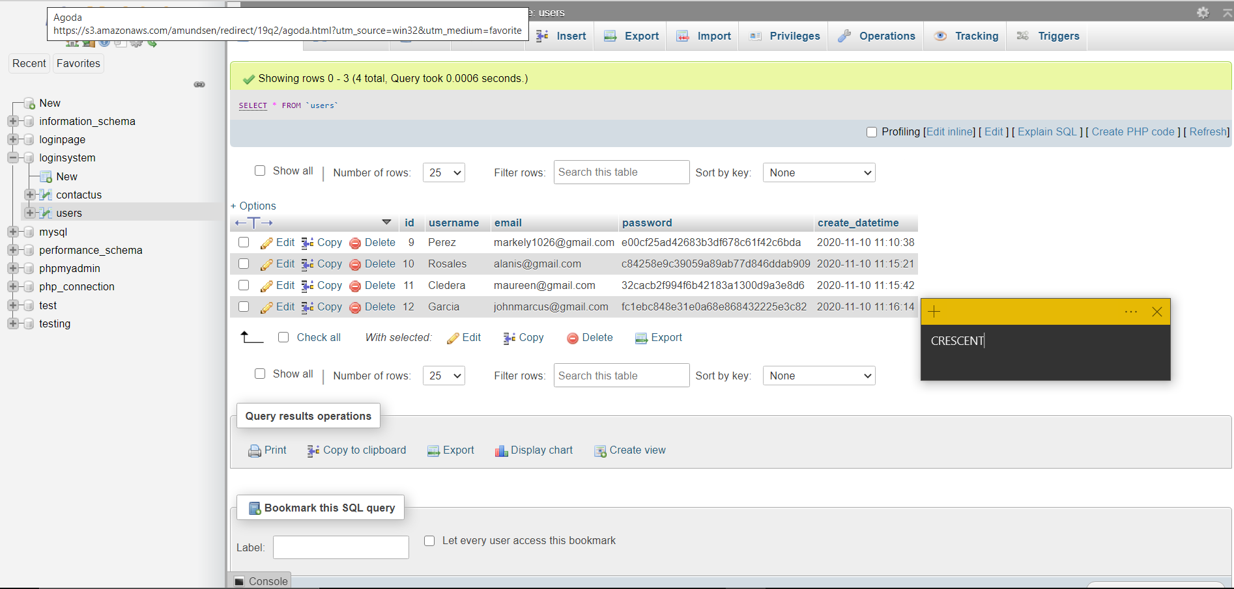

**Summary of Assigned Tasks**

|  |  |  |
| --- | --- | --- |
| **Name (SN, FN, MI.)** | **Picture** | **Detailed Contributions/Assigned Tasks:** |
| Leader's Name: |  |  |
| Member 1: |  |  |
| Member 2: |  |  |
| Member 3: |  |  |
| Member 4: |  |  |

**References:**