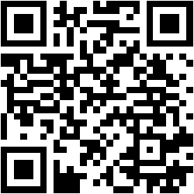

Have you ever been in this situation where you see something you want to purchase but you have no idea what exact keywords to put into a search engine? Or you only know the brand name and there are so many items you can find under that brand and you are not able to find the exact item you want? Then try out VISTA! VISTA is an Android App that can help you find the items you want with image.

With VISTA, you have the options of using the camera on your phone or an image URL! Don't feel like using the touchscreen? No problem, you speak what you want and VISTA will do the rest for you.

Features:

1. Compatible with your camera on your phone, web images, and images on your phone.
2. Built-in objects detection with voice control command.
3. Item retrieval based on edges, colors, and textures.
4. Sort result by price or relevance.

How Do I Use It?

When you open Vista, you have the option to paste a URL of an image, use your camera, and select an image from your gallery. After you selected a method, draw a bounding box on the item you want to search in the image.

You may also use the voice command option to select an object in the image. Just click on the microphone icon in the upper-right corner and say the object you want to detect such as "people" and "bag". VISTA will automatically detect objects according to what your command. You can also say "segmentation" for image segmentation to get the most salient region of the image. All of these commands will lead you to a bounding box which you can edit.

After you have a bounding box, you can click submit to upload the bounding box image to our server for item retrieval. VISTA will return a list of items in our database which are similar to the image you submitted. Each item consists of price, description, and where you can buy it.

For more information:

\* Website: <https://sites.google.com/site/hcivista/> or use QC code above.