debug说明文档
- Mem(memory)
- Mem
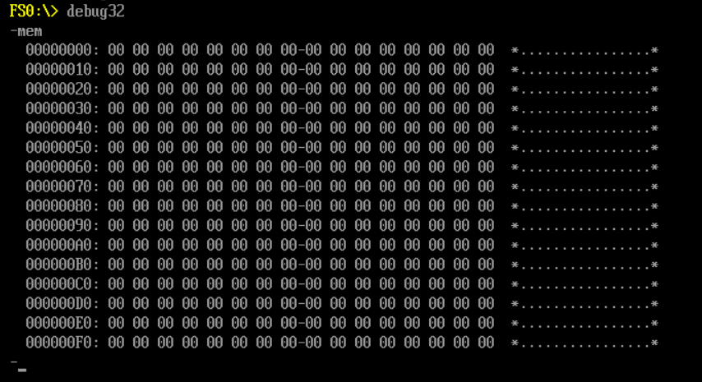
- Mem r(read) hex(address)
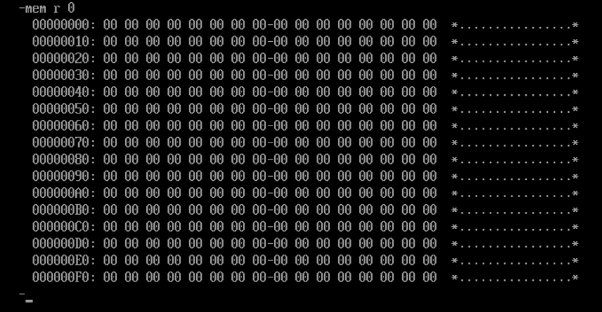
- Mem r(read) hex(address) hex(count)
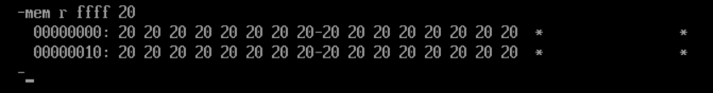
- Mem w(write) hex(address) hex(value)
- Mmio
  - Mmio
      - -mmio
  - Mmio r hex(address)
      - -mmio r 0
  - Mmio r hex(address) hex(count)
      - -mmio r ffff 20
  - Mmio w hex(address) hex(value)
      - -mmio w 0 ff
- Io
  - Io
      - -io
  - Io r hex(address)
      - -mmio r 0
  - Io r hex(address) hex(count)
      - -mmio r ffff 20
  - Io w hex(address) hex(value)
      - -mmio w 80 aa
- Pci
  - Pci
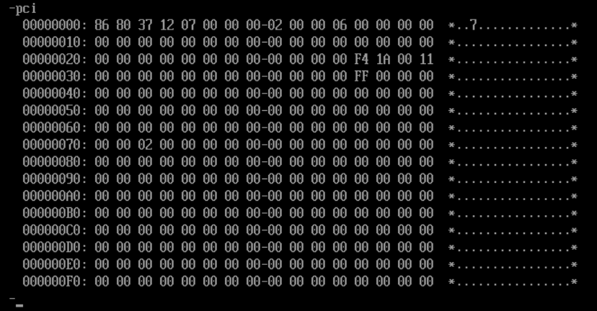

  - Pci r bbddffrr(bus,device,function,register) hex(count)
BusNum = 00;
DeviceNum = 03;
FunctionNum = 00;
RegisterIndex = 00;
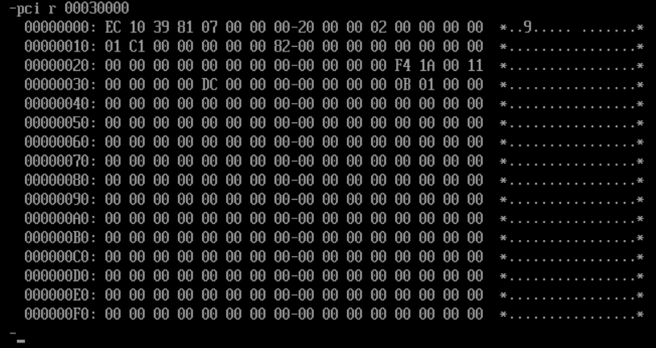
  - Pci w bbddffrr(bus,device,function,register) hex(value)
BusNum = 00;
DeviceNum = 03;
FunctionNum = 00;
RegisterOffset = C0;
Value = FF;
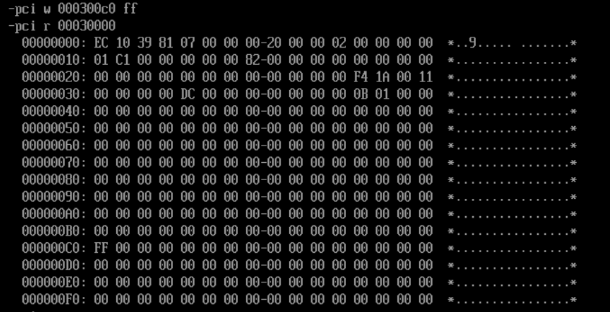
- Isa
  - Isa r iiiiddddrrrr(index port,data port, register offset)
IndexPort = 0070;
DataPort = 0071;
RegisterOffset = 0000;
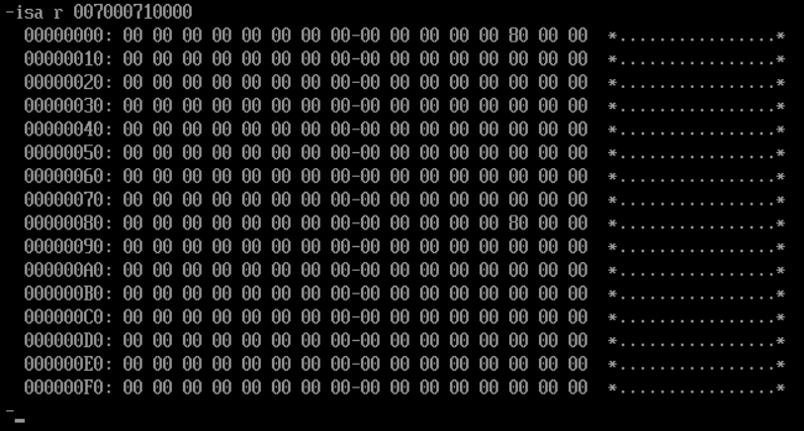
  - Isa w iiiiddddrrrr(index port,data port,register offset) hex(value)
IndexPort = 0070;
DataPort = 0071;
RegisterOffset = 0050;
Value = AA;

- Msr
  - Msr r hex(address)
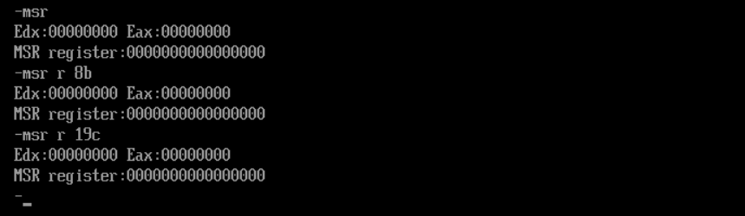
  - Msr w hex(address) hex(value)
- Smbo
  - Smbo h(handle) hex(handle number)
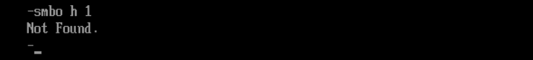
  - Smbo t(type) hex(type number) hex(instance number)
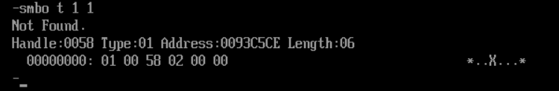
- Kbc
- Usb
- Cpuid
  - Cpuid r hex(address)
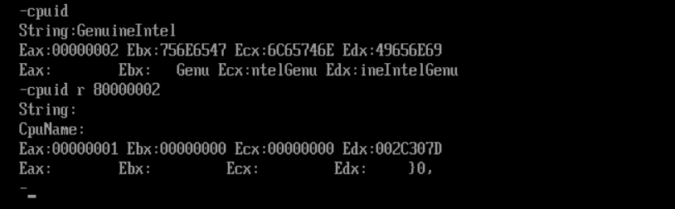
- Acpi
  - Acpi rsdp
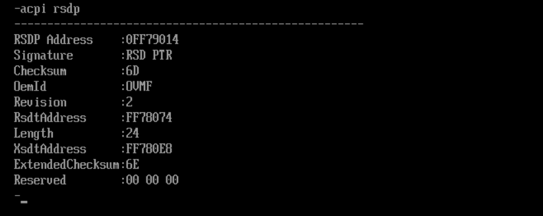
  - Acpi rsdt
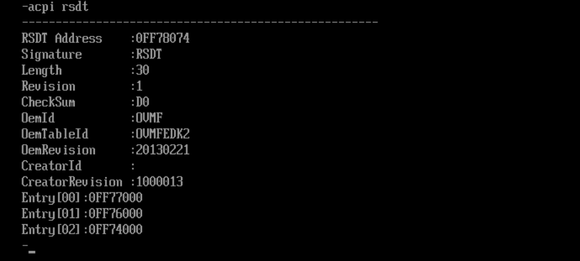
  - Acpi xsdt
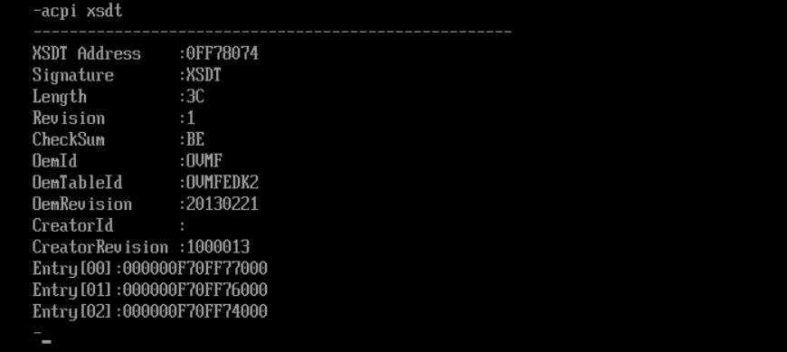
- Spd
- Ls
  - Ls var
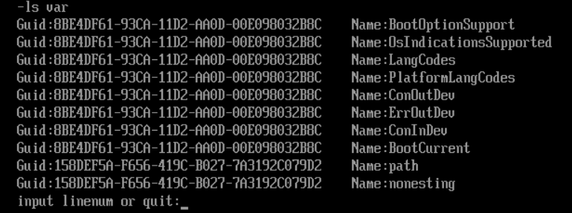
  - Ls bootdev
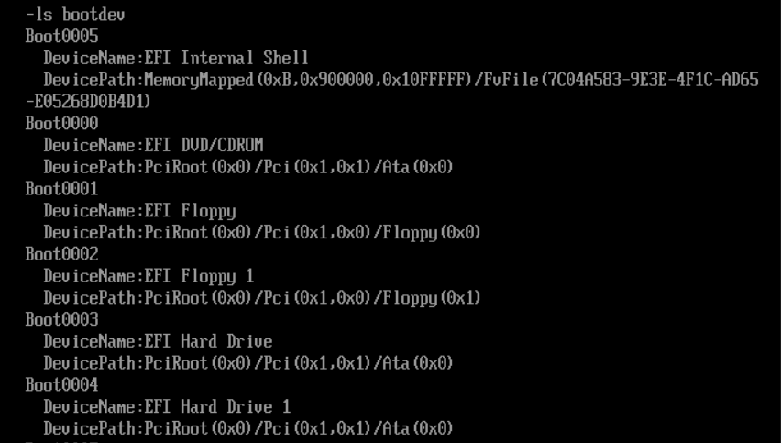
  - Ls pci
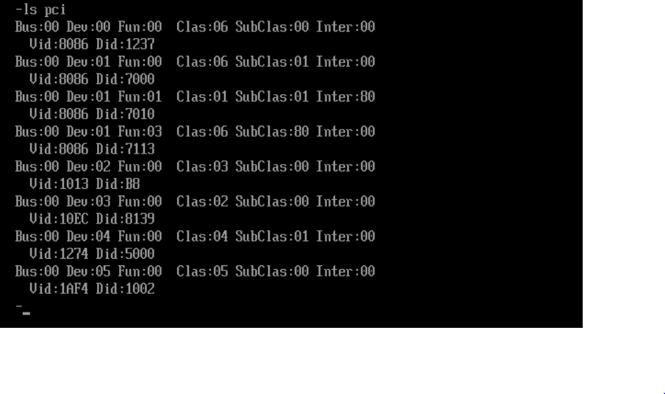
  - Ls handle
      - Ls handle
      - Ls handle guid(xxxxxxxx-xxxx-xxxx-xxxx-xxxxxxxxxxxx)
  - Ls devpath
      - Ls devpath handle(xxxxxxxx)
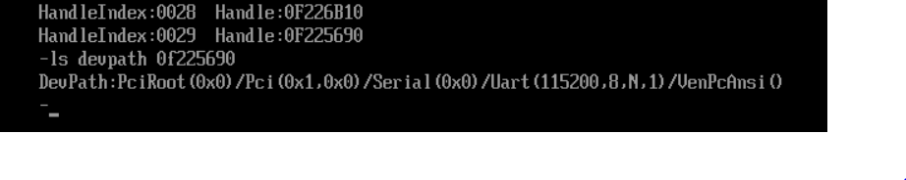
  - Ls disk

