C++小作业
Du
2015.8
All rights reserved.
目录
第一天 4
实验一第一部分 5
实验二 6
第一问 6
第二问 7
第三问 8
第五问 10
第二天 12
实验三 13
第一问 13
第二问 14
第三问 16
第四问 17
实验六 18
第一问 18
第二问 20
第三天 22
实验六 23
第三问 23
第四问 25
实验十一 26
第二问 26
第四天 28
实验四 29
第一问 29
第二问 31
第三问（选作） 34
第五天 37
实验五 38
第一问（完全是显然的嘛） 38
第二问 39
实验六 41
第五六问（合并） 41
第六天 43
实验七 44
第一问 44
第二问 45
第三问 47
第七天 49

第一天

实验一第一部分
（此处按照大作业要求采用了VS2012而非书上的2008，请明鉴。）
源代码：
#include <iostream>
using std::cout;
int main()
{
cout<<"hello!\n";
cout<<"Welcome to C++!\n";
system("pause");
return 0;
}
截屏：
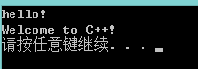

可执行文件见1_1.exe
实验二

第一问
源代码：
#include <iostream>

using std::cout;
using std::endl;

int main()
{
int i=1, sum=0;
do
{
sum += i;
i++;
} while (i<=10);
cout<<"sum="<<sum<<endl;
system("pause");
return 0;
}
截屏
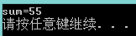

可执行文件见2_1.exe

第二问
源代码
#include <iostream>
using std::cout;
using std::endl;

int main()
{
int sum = 0;
for (int i=0; i<=10; i++)
{
sum += i;
}
cout<<"sum="<<sum<<endl;
system("pause");
return 0;
截屏
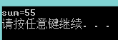
可执行文件见2_2.exe

第三问
源代码
#include <iostream>

using std::cout;
using std::cin;
using std::endl;

const float PI = 3.14;

int main()
{
int itype = -1;
float a, b, r, s;
cout<<"图形类型为？1-圆形， 2-长方形 3-正方形"<<endl;
cin>>itype;
switch (itype)
{
case 1:
cout<<"圆的半径为:";
cin>>r;
s = r * r * PI;
cout<<"面积为:"<<s<<endl;
break;
case 2:
cout<<"矩形的长为:";
cin>>a;
cout<<"矩形的宽为:";
cin>>b;
s = a * b;
cout<<"面积为:"<<s<<endl;
break;
case 3:
cout<<"正方形的边长为:";
cin>>a;
s = a * a;
cout<<"面积为:"<<s<<endl;
break;
default:
cout<<"illegal input"<<endl;
break;
}
system("pause");
return 0;
}
截屏
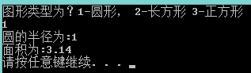
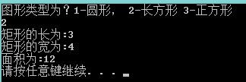
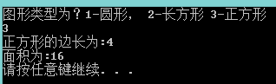
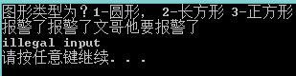
第四问略（难道要我交debug截图么。。。）

第五问
源代码(求合法性不扣分。。)
#include <iostream>

using std::cout;
using std::cin;
using std::endl;

struct Time
{
int year;
int month;
int day;
int hour;
int minute;
int second;
};

int main()
{
Time t;
cout<<"请输入年份"<<endl;
cin>>t.year;
cout<<"请输入月份"<<endl;
cin>>t.month;
cout<<"请输入日期"<<endl;
cin>>t.day;
cout<<"请输入小时数"<<endl;
cin>>t.hour;
cout<<"请输入分钟数"<<endl;
cin>>t.minute;
cout<<"请输入秒数"<<endl;
cin>>t.second;
cout<<"好的你已经输入完了，以下是你输入的结构"<<endl;
cout<<"______________________________________"<<endl;
cout<<t.year<<"年"<<t.month<<"月"<<t.day<<"日"
<<t.hour<<"点"<<t.minute<<"分"<<t.second<<"秒"<<endl;
cout<<"______________________________________"<<endl;
system("pause");
return 0;
}

截屏
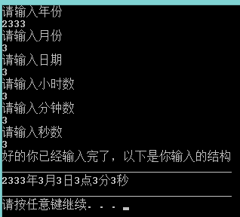
可执行文件见2_5.exe

第二天

实验三

第一问
源代码
#include <iostream>

using std::cout;
using std::cin;
using std::endl;

float Convert(float TempFer);

int main()
{
float f;
cout<<"请输入华氏度";
cin>>f;
cout<<"所得的摄氏度为："<<Convert(f)<<endl;
system("pause");
return 0;
}

float Convert(float TempFer)
{
return (TempFer-32)*5/9;
}
截屏
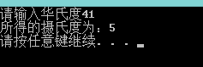
可执行文件见3_1.exe

第二问
源代码
#include <iostream>

using std::cout;
using std::cin;
using std::endl;

int Max1(int, int);
int Max1(int, int, int);
double Max1(double, double);
double Max1(double, double, double);

int Max1(int a, int b)
{
return a>b?a:b;
}

int Max1(int a, int b, int c)
{
return Max1(Max1(a, b), c);
}

double Max1(double a, double b)
{
return a>b?a:b;
}

double Max1(double a, double b, double c)
{
return Max1(Max1(a, b), c);
}

int main()
{
int ia, ib ,ic;
float fa, fb, fc;
cout<<"由于本人懒得做重复工作，请先打入三个整数再打入三个双精度数，谢谢合作"<<endl;
cin>>ia>>ib>>ic>>fa>>fb>>fc;
cout<<"前两个整数中最大的是"<<Max1(ia, ib)<<endl;
cout<<"前三个整数中最大的是"<<Max1(ia, ib, ic)<<endl;
cout<<"前两个双精度数中最大的是"<<Max1(fa, fb)<<endl;
cout<<"前三个双精度数中最大的是"<<Max1(fa, fb, fc)<<endl;
system("pause");
return 0;
}
截屏
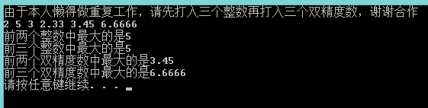
可执行文件见3_2.exe

第三问
源代码
#include <iostream>
#include <cmath>

using std::cout;
using std::cin;
using std::endl;

int main()
{
int x, y;
cout<<"请依次输入x和y"<<endl;
cin>>x>>y;
cout<<"x的y次幂是"<<pow(x, y)<<endl;
system("pause");
return 0;
}
截屏
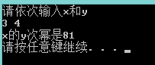
可执行文件见3_3.exe

第四问
源代码（我知道我这么写递归效率很差，应该搞个数组；但是呢，搞个数组的话就对于这一章来说超纲了，故不搞）。
#include <iostream>

using std::cout;
using std::cin;
using std::endl;

//求fib的第n项的值
int fib(int n)
{
if (n <= 2)
{
return 1;
}
else
{
return fib(n-1) + fib(n-2);
}
}

int main()
{
int n;
cout<<"请输入所想求的项数";
cin>>n;
cout<<"这一项为"<<fib(n)<<endl;
system("pause");
return 0;
}
截屏
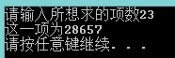
可执行文件见3_4.exe

第五问略。

实验六

第一问
源代码
#include <iostream>

using std::cout;
using std::cin;
using std::endl;

void tranform(int (*m)[3]);
void swap(int &a, int &b);

void swap(int &a, int &b)
{
int t = a;
a = b;
b = t;
return;
}

void tranform(int (*m)[3])
{
swap(m[0][1], m[1][0]);
swap(m[0][2], m[2][0]);
swap(m[2][1], m[1][2]);
}

int main()
{
int m[3][3];
for (int i=0; i<3; i++)
{
for (int j=0; j<3; j++)
{
cout<<"Input m["<<i<<"]["<<j<<"]:";
cin>>m[i][j];
}
}
cout<<"before"<<endl;
for (int i=0; i<3; i++)
{
for (int j=0; j<3; j++)
{
cout<<m[i][j]<<" ";
}
cout<<endl;
}
tranform(m);
cout<<"after"<<endl;
for (int i=0; i<3; i++)
{
for (int j=0; j<3; j++)
{
cout<<m[i][j]<<" ";
}
cout<<endl;
}
system("pause");
return 0;
}
截图
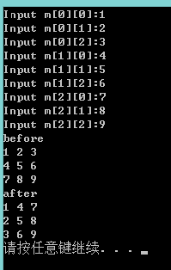
可执行文件见6_1.exe

第二问
源码
#include <iostream>

using std::cout;
using std::cin;
using std::endl;

void tranform(int **m, int d);
void swap(int &a, int &b);

void swap(int &a, int &b)
{
int t = a;
a = b;
b = t;
return;
}

void tranform(int **m, int d)
{
for (int i=0; i<d; i++)
{
for (int j=0; j<i; j++)
{
swap(m[i][j], m[j][i]);
}
}
}

int main()
{
int dim;
cout<<"Input dimention:";
cin>>dim;
int **m = new int *[dim]();
for (int i=0; i<dim; i++)
{
m[i] = new int[dim]();
}
for (int i=0; i<dim; i++)
{
for (int j=0; j<dim; j++)
{
cout<<"Input m["<<i<<"]["<<j<<"]:";
cin>>m[i][j];
}
}
cout<<"before"<<endl;
for (int i=0; i<dim; i++)
{
for (int j=0; j<dim; j++)
{
cout<<m[i][j]<<" ";
}
cout<<endl;
}
tranform(m, dim);
cout<<"after"<<endl;
for (int i=0; i<dim; i++)
{
for (int j=0; j<dim; j++)
{
cout<<m[i][j]<<" ";
}
cout<<endl;
}
for (int i=0; i<dim; i++)
{
delete m[i];
}
delete m;
system("pause");
return 0;
}
截屏
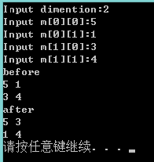
可执行文件参见6_2.exe

第三天

实验六

第三问
源代码
#include <iostream>

using std::cout;
using std::cin;
using std::endl;

char* MyStrncat(char *dest, char *source);

char* MyStrncat(char *dest, char *source)
{
char *q = dest;
while (*q != 0)
{
q++;
}
for (char *p=source; *p!=0; p++, q++)
{
*q = *p;
}
*q = 0;
return dest;
}

int main()
{
char str1[100], str2[100];
cout<<"请输入两个字符串"<<endl;
cin>>str1;
cin>>str2;
cout<<"合并结果为："<<endl<<MyStrncat(str1, str2)<<endl;
system("pause");
return 0;
}
截屏
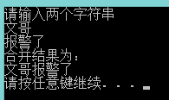
可执行文件参见6_3.exe

第四问
源代码
#include <iostream>
#include <string>

using std::cout;
using std::cin;
using std::endl;
using std::string;

int main()
{
string s1, s2;
cout<<"请输入两个字符串"<<endl;
cin>>s1>>s2;
cout<<"合并结果为："<<endl<<(s1+s2)<<endl;
system("pause");
return 0;
}
截屏
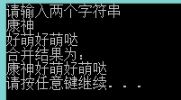
可执行文件见6_4.exe

实验十一
第一问
太长不打，输出就那样嘛

第二问
我就问个问题
二进制文件加行号有什么意义
二进制文件加行号有什么意义
二进制文件加行号有什么意义
重要的话说三遍
以下是当文本文件做的
源代码
#include <iostream>
#include <fstream>
#include <sstream>

using std::cout;
using std::cin;
using std::endl;
using std::ofstream;
using std::ios;
using std::ifstream;
using std::stringstream;

int main(int argc, char *argv[])
{
if (argc != 3)
{
cout<<"说好的带两个参数呢？WQNMLGB"<<endl;
system("pause");
return -1;
}
stringstream ss;
ifstream is(argv[1]);
ss<<is.rdbuf();
is.close();
ofstream os(argv[2]);
char buf[500] = {};
int count = 0;
while (ss.getline(buf, 500))
{
os.setf(ios::left, ios::adjustfield);
os.width(3);
os<<count;
count++;
os<<buf<<endl;
}
system("pause");
return 0;
}
截屏
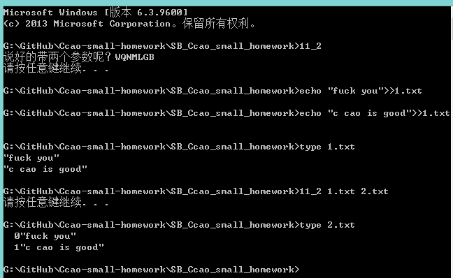
可执行文件见11_2.exe

第四天

实验四

第一问
源代码
#include <iostream>

using std::cout;
using std::cin;
using std::endl;

enum CPU_Rank
{
P1 = 1,
P2,
P3,
P4,
P5,
P6,
P7
};

class CPU
{
public:
CPU(CPU_Rank r, int f, int v)
:rank(r), frequency(f), voltage(v)
{
cout<<"cpu builded"<<endl;
}
~CPU()
{
cout<<"cpu destroyed"<<endl;
}
void run()
{
cout<<"cpu running"<<endl;
}
void stop()
{
cout<<"cpu stopped"<<endl;
}
private:
CPU_Rank rank;
int frequency;
int voltage;
};

int main()
{
int r = -1, f, v;
while ((r<1)||(r>7))
{
cout<<"Input rank, 1-P1,... 7-P7"<<endl;
cin>>r;
}
cout<<"Input frequency and voltage"<<endl;
cin>>f>>v;
CPU *c = new CPU((CPU_Rank)r, f, v);
c->run();
c->stop();
delete c;
system("pause");
return 0;
}
截屏
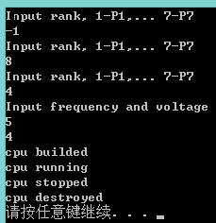
可执行文件见4_1.exe

第二问
源代码
#include <iostream>

using std::cout;
using std::cin;
using std::endl;

enum CPU_Rank
{
P1 = 1,
P2,
P3,
P4,
P5,
P6,
P7
};

class CPU
{
public:
CPU(CPU_Rank r, int f, int v)
:rank(r), frequency(f), voltage(v)
{
cout<<"cpu builded"<<endl;
}
~CPU()
{
cout<<"cpu destroyed"<<endl;
}
void run()
{
cout<<"cpu running"<<endl;
}
void stop()
{
cout<<"cpu stopped"<<endl;
}
private:
CPU_Rank rank;
int frequency;
int voltage;
};

class RAM
{
public:
RAM(){}
};

class CDROM
{
public:
CDROM(){}
};

class COMPUTER
{
public:
COMPUTER(CPU_Rank r, int f, int v)
:c(r, f, v), r(), cd()
{
cout<<"computer builded"<<endl;
}
~COMPUTER()
{
cout<<"computer destroyed"<<endl;
}
void run()
{
cout<<"computer running"<<endl;
}
void stop()
{
cout<<"computer stopped"<<endl;
}
private:
CPU c;
RAM r;
CDROM cd;
};

int main()
{
int r = -1, f, v;
while ((r<1)||(r>7))
{
cout<<"Input rank, 1-P1,... 7-P7"<<endl;
cin>>r;
}
cout<<"Input frequency and voltage"<<endl;
cin>>f>>v;
COMPUTER *c = new COMPUTER((CPU_Rank)r, f, v);
c->run();
c->stop();
delete c;
system("pause");
return 0;
}
截屏
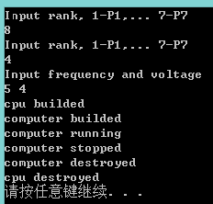
可执行文件见4_2.exe

第三问（选作）
源代码
#include <iostream>
#include <string>

using std::cout;
using std::cin;
using std::endl;
using std::string;

class Sex
{
public:
const static string sexnames[7];
Sex(int s):_s(s){;}
Sex(const Sex &s):_s(s.getsex()){;}
inline int getsex() const{return _s;}
string show() const{return sexnames[_s];}
private:
int _s;
};

const string Sex::sexnames[7] =
{
"unknown",
"male",
"female",
"Lesbians",
"Gays",
"Bisexuals",
"Transgender"
};

class People
{
public:
class Date
{
public:
Date(int y, int m, int d)
:_y(y), _m(m), _d(d){;}
Date(const Date &date)
:_y(date.getyear()), _m(date.getmonth()), _d(date.getday()){;}
void show() const{cout<<_y<<"-"<<_m<<"-"<<_d<<endl;}
inline int getyear() const{return _y;}
inline int getmonth() const{return _m;}
inline int getday() const{return _d;}
private:
int _y;
int _m;
int _d;
};
People(Sex s, string n, string i, int y, int m, int d)
:_sex(s), _number(n), _id(i), _date(y, m, d){;}
~People(){}
People(People &p)
:_sex(p.getsex()), _number(p.getnumber()), _id(p.getid()),
_date(p.getdate()){;}
void show() const;
inline string getnumber() const{return _number;}
inline string getid() const{return _id;}
inline Sex getsex() const{return _sex;}
inline Date getdate() const{return _date;}
private:
string _number;
string _id;
Sex _sex;
Date _date;
};

void People::show() const
{
cout<<_number<<" "<<_id<<_sex.show()<<endl;
_date.show();
}

int main()
{
int s = -1, y, m, d;
Sex *sex;
string n, i;
while ((s<1)||(s>6))
{
cout<<"Input sex, male=1, female=2, Lesbians=3, Gays=4, Bisexuals=5, Transgender=6"<<endl;
cin>>s;
}
cout<<"input number and id"<<endl;
cin>>n>>i;
cout<<"input year, month, and day"<<endl;
cin>>y>>m>>d;
sex = new Sex(s);
People *p = new People(*sex, n, i, y, m, d);
p->show();
delete sex;
delete p;
system("pause");
return 0;
}
截屏
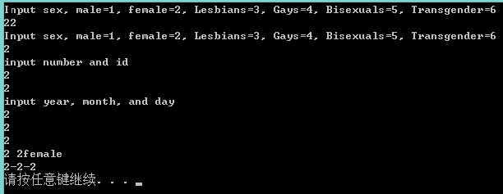
可执行文件见4_3.exe
第五天

实验五

第一问（完全是显然的嘛）
源代码
#include <iostream>
#include <string>

using std::cout;
using std::cin;
using std::endl;
using std::string;

int x=1, y=2;

int main()
{
cout<<"x="<<x<<"y="<<y<<endl;
int x=10, y=20;
cout<<"x="<<x<<"y="<<y<<endl;
{
int y=200;
cout<<"x="<<x<<"y="<<y<<endl;
}
cout<<"x="<<x<<"y="<<y<<endl;
system("pause");
return 0;
}
截屏
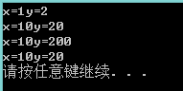
可执行文件见5_1.exe

第二问
源代码
（client.h）
#ifndef _CLIENT_H
#define _CLIENT_H

#include <iostream>
using std::cout;
using std::cin;
using std::endl;

class Client
{
public:
Client(){_clientnum++;show();}
Client(const Client &c){_clientnum++;show();}
~Client(){_clientnum--;show();}
const static char* ServerName;
void show() const;
private:
static int _clientnum;
};

#endif
(client.cpp)
#include "client.h"

int Client::_clientnum = 0;

void Client::show() const
{
cout<<"There are"<<_clientnum<<" "<<ServerName<<"in the program"<<endl;
}
(main.cpp)
#include "client.h"

const char* Client::ServerName = "Server";

int main()
{
Client c1;
Client c2 = c1;
{
Client c3;
}
system("pause");
return 0;

}
截屏
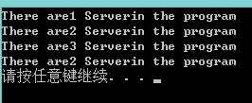
可执行文件见5_2.exe

实验六

第五六问（合并）
源代码
#include <iostream>
#include <string>

using std::cout;
using std::cin;
using std::endl;
using std::string;

class Employee
{
public:
Employee(string n, string a, string c, int p)
:_name(n), _address(a), _city(c), _postcode(p){;}
void ChangeName(string s);
void Display() const;
private:
string _name;
string _address;
string _city;
int _postcode;
};

void Employee::ChangeName(string s)
{
_name = s;
}

void Employee::Display() const
{
cout<<_name<<" "<<endl<<_address<<" "<<_city<<_postcode<<endl;
}

int main()
{
Employee *e[5] =
{
new Employee("文哥", "", "", 233333),
new Employee("文姐", "", "", 233333),
new Employee("文弟", "", "", 233333),
new Employee("文叔", "", "", 233333),
new Employee("文姨", "", "", 233333),
};
for (int i=0; i<5; i++)
{
e[i]->Display();
}
for (int i=0; i<5; i++)
{
e[i]->ChangeName("雷楼某");
}
for (int i=0; i<5; i++)
{
e[i]->Display();
}
system("pause");
return 0;
}
截图
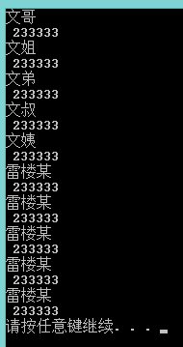
源文件见6_56.exe

第六天

实验七

第一问
- 废话当然有问题
error C2248: “Animal::age”: 无法访问 private 成员(在“Animal”类中声明)
- 源代码
#include <iostream>
#include <string>

using std::cout;
using std::cin;
using std::endl;
using std::string;

class Animal
{
public:
int age;
};

class Dog : public Animal
{
public:
void setage(int n){age = n;}
int getage() const{return age;}
};

int main()
{
Dog Du;
Du.setage(18);
cout<<Du.getage()<<endl;
system("pause");
return 0;
}
截屏
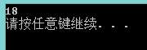
可执行文件见7_1.exe

第二问
源代码
#include <iostream>
#include <string>

using std::cout;
using std::cin;
using std::endl;
using std::string;

class BaseClass
{
public:
BaseClass(){_number++;show();}
BaseClass(const BaseClass &){_number++;show();}
~BaseClass(){_number--;show();}
void show() const{cout<<"base number:"<<_number<<endl;}
private:
static int _number;
};
int BaseClass::_number = 0;

class DerivedClass : public BaseClass
{
public:
DerivedClass():BaseClass(){cout<<"derived built"<<endl;}
DerivedClass(const DerivedClass &){cout<<"derived built"<<endl;}
~DerivedClass(){cout<<"derived destroyed"<<endl;}
private:

};

int main()
{
DerivedClass d = DerivedClass();
{
DerivedClass dd = d;
}
system("pause");
return 0;
}
截屏
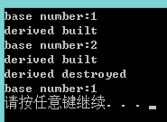
可执行文件见7_2.exe

第三问
（1）源代码
#include <iostream>
#include <string>

using std::cout;
using std::cin;
using std::endl;
using std::string;

class Vehicle
{
public:
Vehicle(){;}
virtual void Run() const{cout<<"vehicle run"<<endl;}
void Stop() const{;}
private:
int _maxspeed;
int _weight;
};

class Bicycle : virtual public Vehicle
{
public:
virtual void Run() const{cout<<"bycicle run"<<endl;}
private:
int _height;
};

class Motorcar : virtual public Vehicle
{
public:
virtual void Run() const{cout<<"motorcar run"<<endl;}
private:
int _seatnum;
};

class Motorcycle : public Bicycle, public Motorcar
{
public:
virtual void Run() const{cout<<"motorcycle run"<<endl;}
};

int main()
{
Motorcycle m;
Vehicle *v = &m;
v->Run();
system("pause");
return 0;
}
截屏
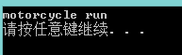
可执行文件见7_3.exe
（2）显然的，报错：（传说中的ambiguous）
error C2594: “初始化”: 从“Motorcycle *”到“Vehicle *”的转换不明确
或者我直接m.run()的话似乎没有什么问题，但是要是不在摩托车里面重载run，就会吃这样的错误（喜闻乐见）
1>main.cpp(43): error C2385: 对“Run”的访问不明确
1> 可能是“Run”(位于基“Bicycle”中)
1> 也可能是“Run”(位于基“Motorcar”中)
1>main.cpp(43): error C3861: “Run”: 找不到标识符

所以，这个故事告诉我们：
不要乱用多继承

第四问选作不做。和第三问没有什么重大区别。

第七天

