Dr = 0.001:

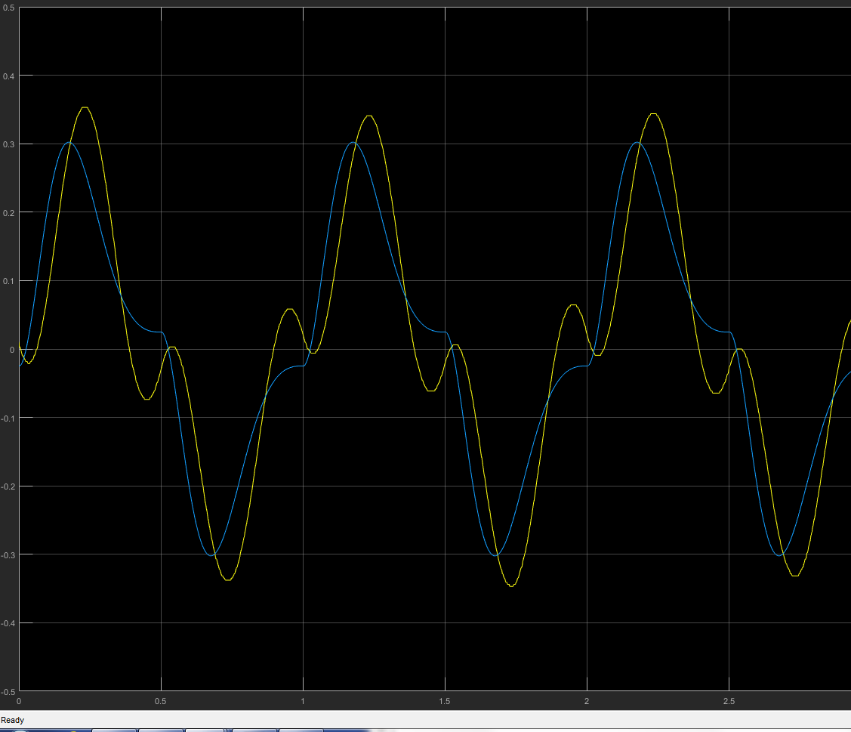

Dr = 0.0005:

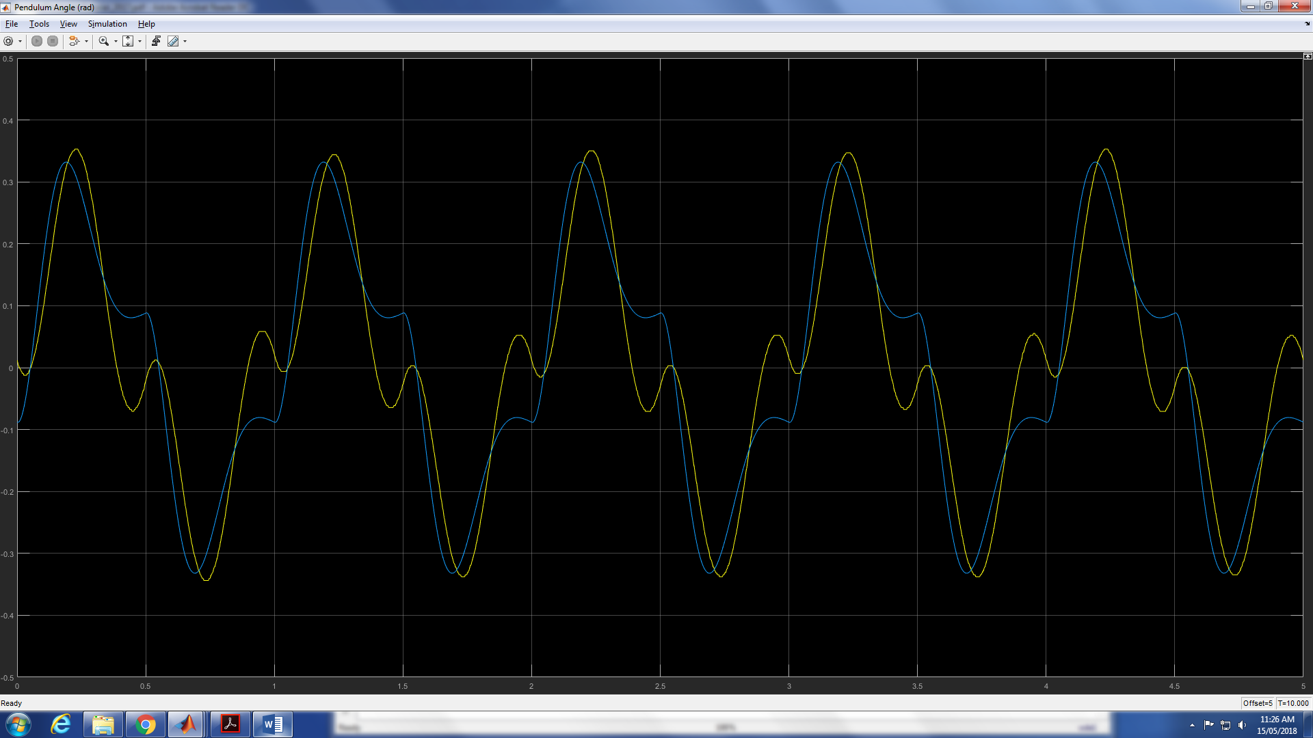

Dr = 0.0001;

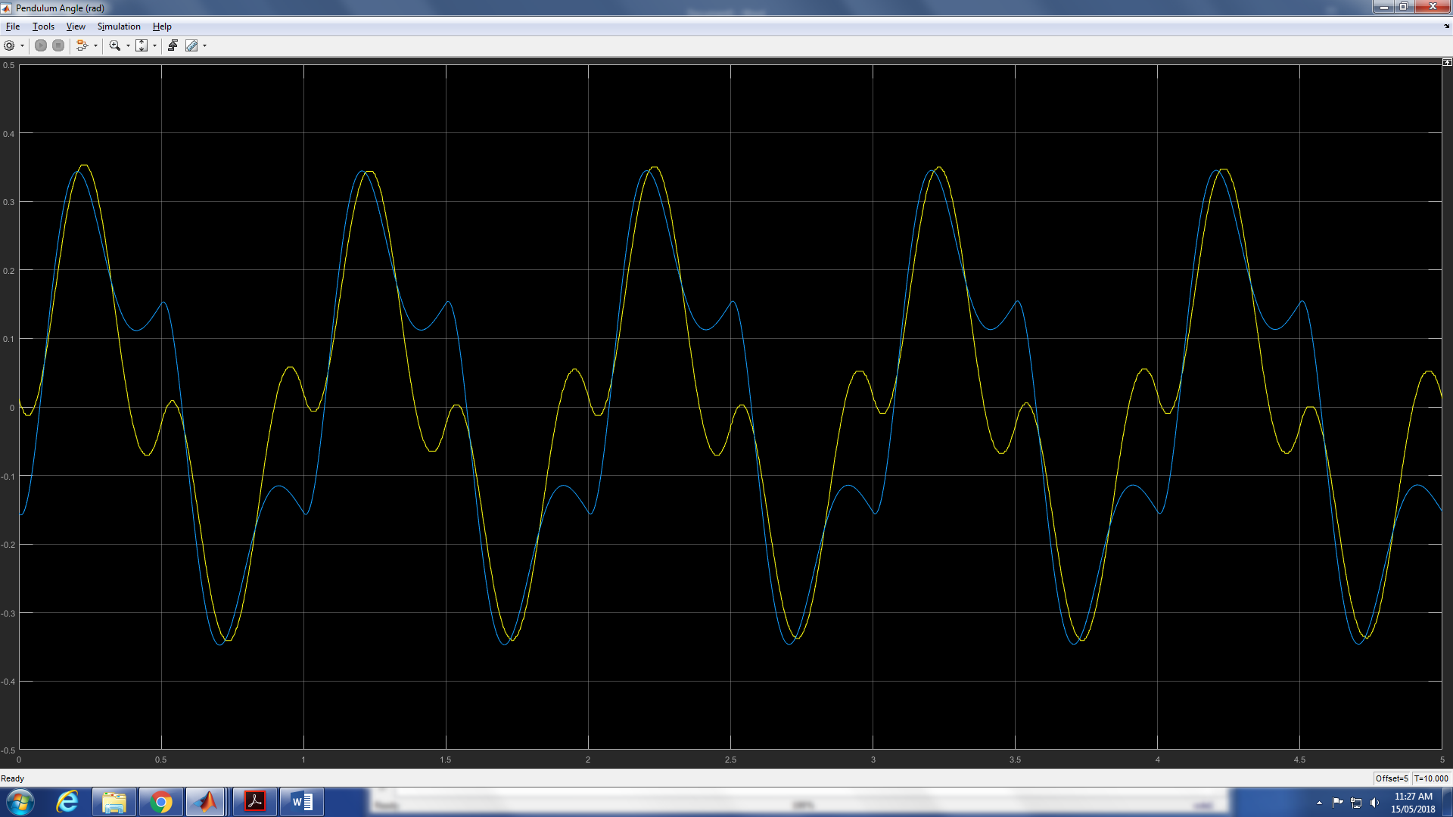

Dr = 0.0012;

Dp = 0.00009;

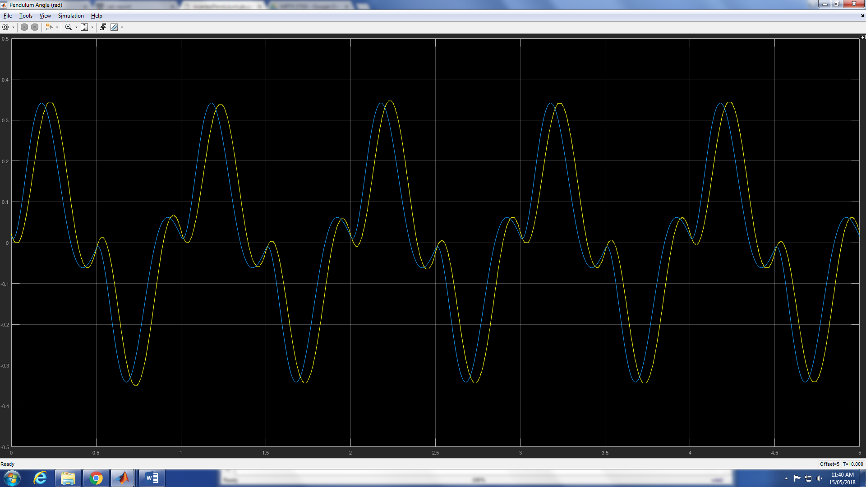

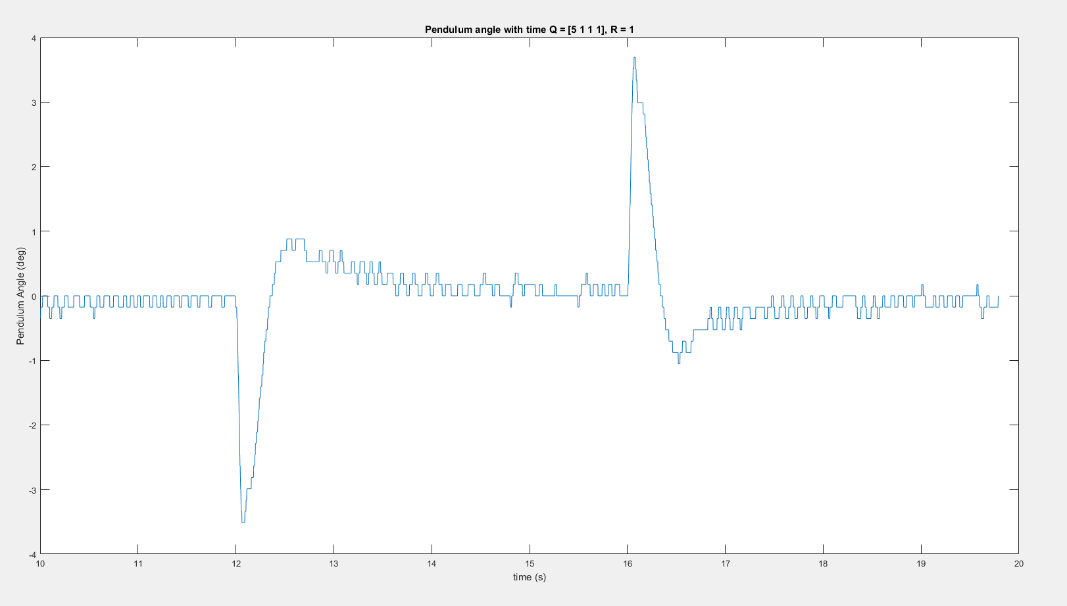

K = [ -2.23606797749979**, 39.1411324412999, -1.75609234052903, 3.40393852495070]**

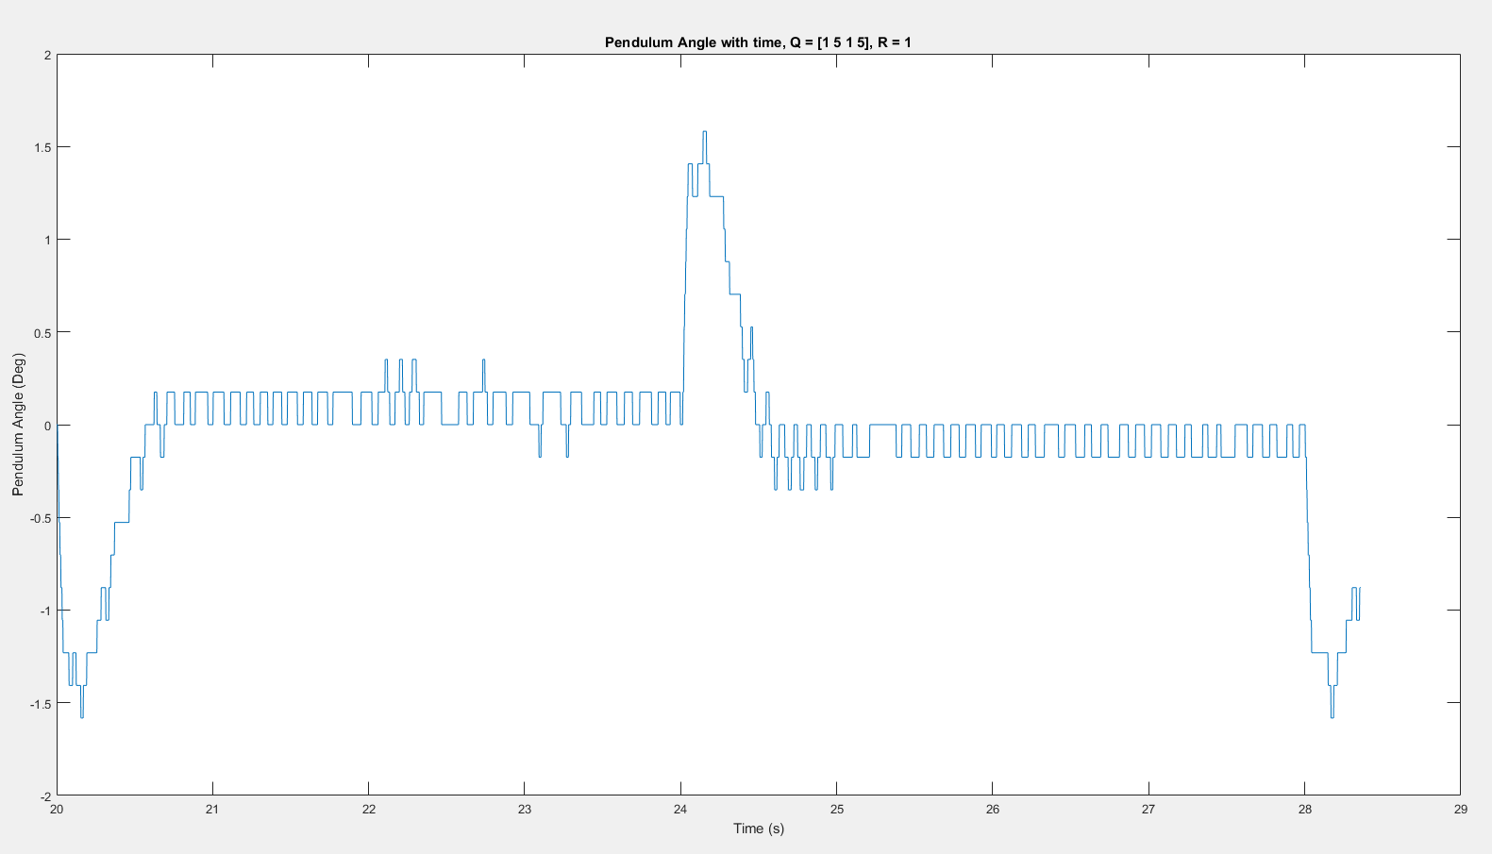

**K = [-0.999999999999922, 40.2584190192933, -1.50625110400583, 4.03430876311059]**

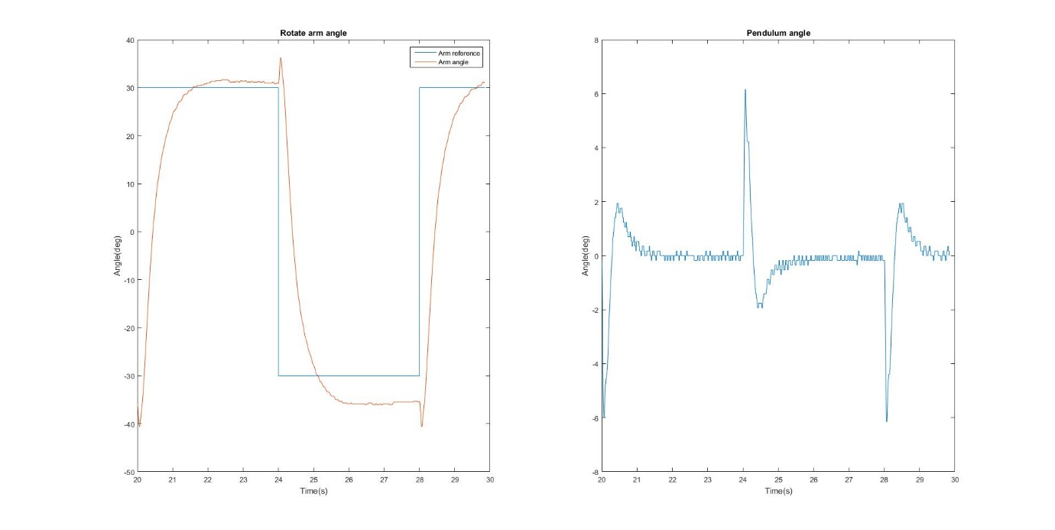

Q = [16 0 0 4;

0 1 0 0;

0 0 1 0;

4 0 0 1];

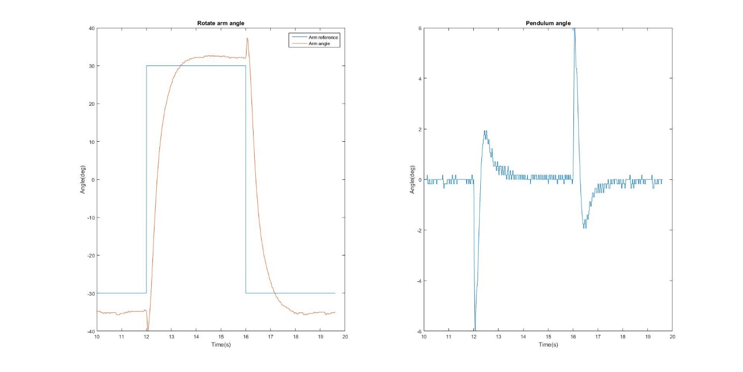

Q = [16 0 4 0;

0 1 0 0;

4 0 1 0;

0 0 0 1];

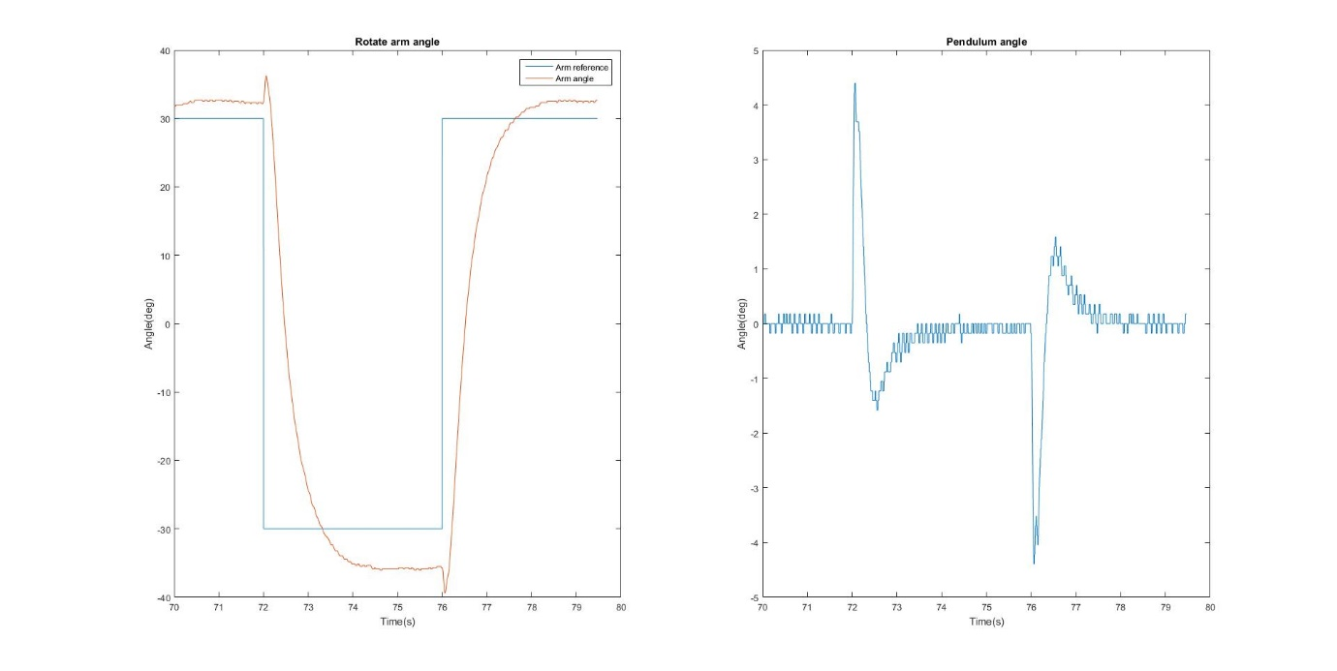

Q = [10 0 0 0;

0 5 0 0;

0 0 1 0;

0 0 0 2];

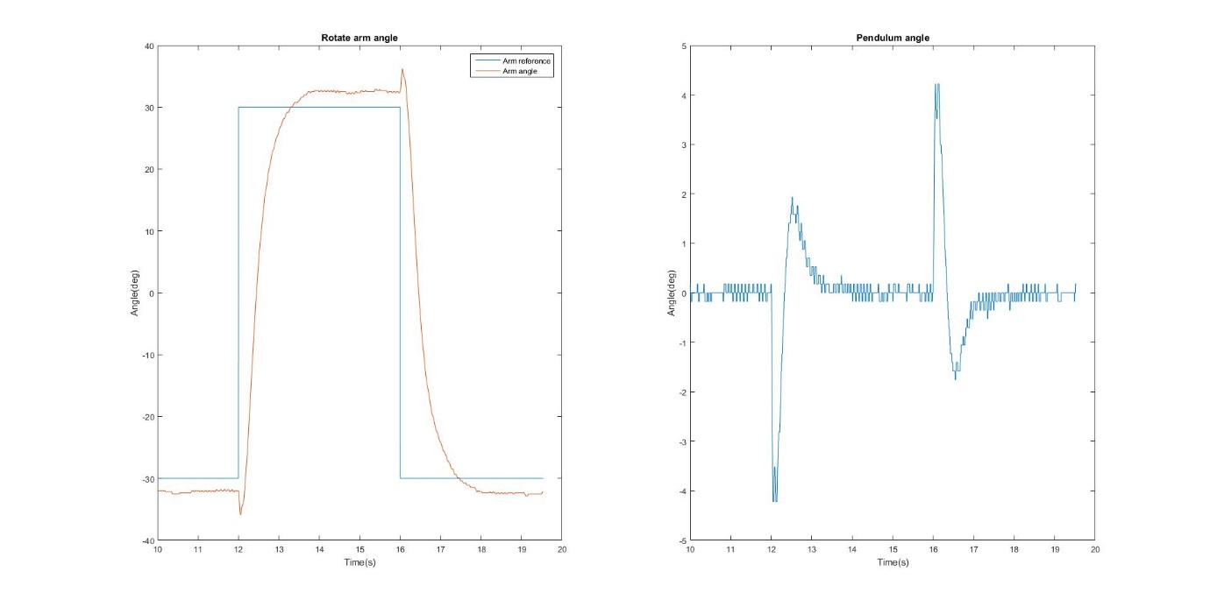

Q = [16 0 4 0;

0 10 0 0;

4 0 1 0;

0 0 0 5];

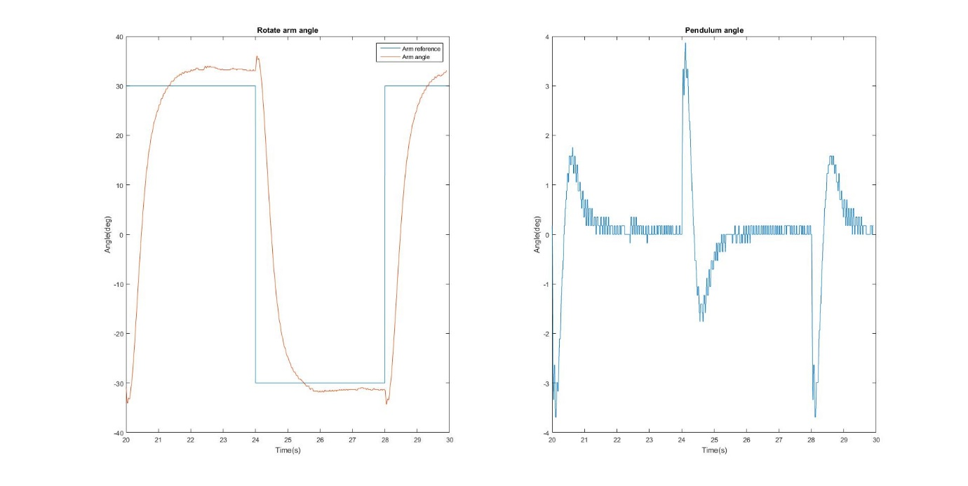

Q = [16 0 4 0;

0 1 0 0;

4 0 1 0;

0 0 0 10];

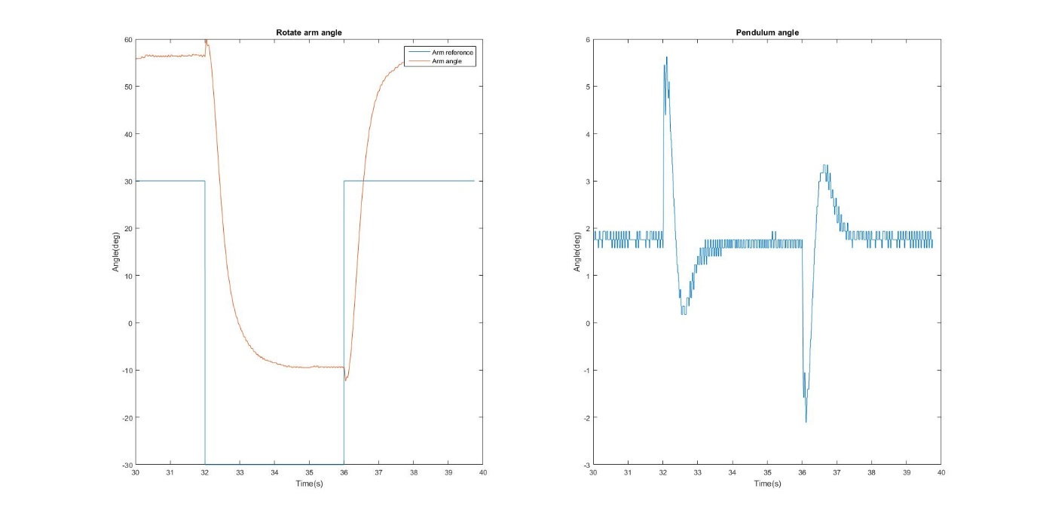

Q = [16 0 4 0;

0 10 0 0;

4 0 1 0;

0 0 0 10];