WEB SECURITY TESTING REPORT
E-commerce REST API
Node.js • Express.js • Neon PostgreSQL • Postman

Task | Web Security Fundamentals - Training Task
Repository | https://github.com/qz-jo/ecommerce-api
Test branch | task3-web-security
Test date | 2026-08-13
Environment | Local API + authorized Neon training database

STATUS: ALL 15 MANDATORY POSTMAN TESTS PASSED

1. Executive Summary
Objective. Audit and secure the REST API according to the Web Security Fundamentals task, then verify the controls using Postman against the authorized training environment.
Outcome. The secured branch implements JWT authentication, role-based authorization, ownership checks, bcrypt password hashing, input validation, parameterized SQL, Helmet, restricted CORS, rate limiting, centralized safe error handling, and security-focused logging. All 15 mandatory Postman test outcomes matched the required results during the local run.
Database verification. Read-only Neon inspection confirmed that the training customer and admin accounts created through the secured API store bcrypt cost-12 hashes (60 characters) rather than plaintext passwords. The real order ownership column is orders.user_id.
Evidence note. Representative screenshots are included in this report. The full screenshot set captured during testing should also be copied into the repository screenshots/ directory before final submission. Secrets such as .env values, database URLs, passwords, JWT secrets, and full JWT tokens must remain redacted.

2. Security Findings and Remediation
# | Finding | Severity | Remediation | Verified result
1 | Missing authentication | Critical | JWT Bearer middleware protects sensitive routes | 401 without token
2 | Missing role authorization | Critical | Admin-only middleware on privileged writes | Customer 403; admin 201
3 | IDOR / missing ownership | High | Self/admin checks and orders.user_id enforcement | Other user 403; order 404
4 | Unsafe password handling | Critical | Server-side bcrypt cost 12; no hash leakage | Login works; hash hidden
5 | Missing JWT flow | High | Register/login/me + HS256 verification | Valid 200; invalid 401
6 | Input validation gaps | High | express-validator on IDs, roles, email, price, stock, lengths | Invalid inputs 400
7 | SQL injection review | Low after review | Retained parameterized queries; ID validation | Injection-like ID 400
8 | Open CORS policy | High | CLIENT_ORIGIN allowlist and explicit methods/headers | Allowed success; blocked 403
9 | Missing security headers | Medium | Helmet before routes; X-Powered-By disabled | Required headers present
10 | Missing rate limiting | High | General API limiter + stricter failed-login limiter | 6th failed login 429
11 | Unsafe error handling | Medium | notFound + centralized errorHandler | Unknown route 404; no stack leak
12 | XSS-oriented risk | Medium | Length controls, CSP, JSON-only API guidance | XSS-like text remains data
13 | Missing security event logs | Medium | Safe failed-login / authorization event logs | Events visible without secrets
14 | TLS verification weakening | High | Removed rejectUnauthorized:false override | Neon connection works securely

3. Mandatory Postman Results
# | Test | Expected | Actual | Result
1 | Register valid user | 201 | 201 | PASS
2 | Duplicate email | 409 | 409 | PASS
3 | Correct login | 200 | 200 | PASS
4 | Wrong password | 401 | 401 | PASS
5 | Protected route without token | 401 | 401 | PASS
6 | Invalid token | 401 | 401 | PASS
7 | Customer creates product | 403 | 403 | PASS
8 | Admin creates product | 201 | 201 | PASS
9 | Negative product price | 400 | 400 | PASS
10 | Invalid email / incomplete JSON | 400 | 400 | PASS
11 | Access another user / order | 403 / 404 | 403 / 404 | PASS
12 | Login rate limit exceeded | 429 | 429 | PASS
13 | Unknown endpoint | 404 | 404 | PASS
14 | No password_hash in result | 200 without field | 200 without field | PASS
15 | Helmet response headers | Headers present | Headers present | PASS

4. Additional Validation
- Non-numeric product ID rejected with 400.
- Injection-like product ID rejected with 400.
- Invalid admin-created role rejected with 400.
- Allowed CORS origin accepted and blocked origin rejected with 403.
- CORS preflight returned the expected response.
- XSS-like text remained JSON data and was not executed by the API.
- Separate customer and admin tokens were used to verify role enforcement.

5. Representative Postman Evidence
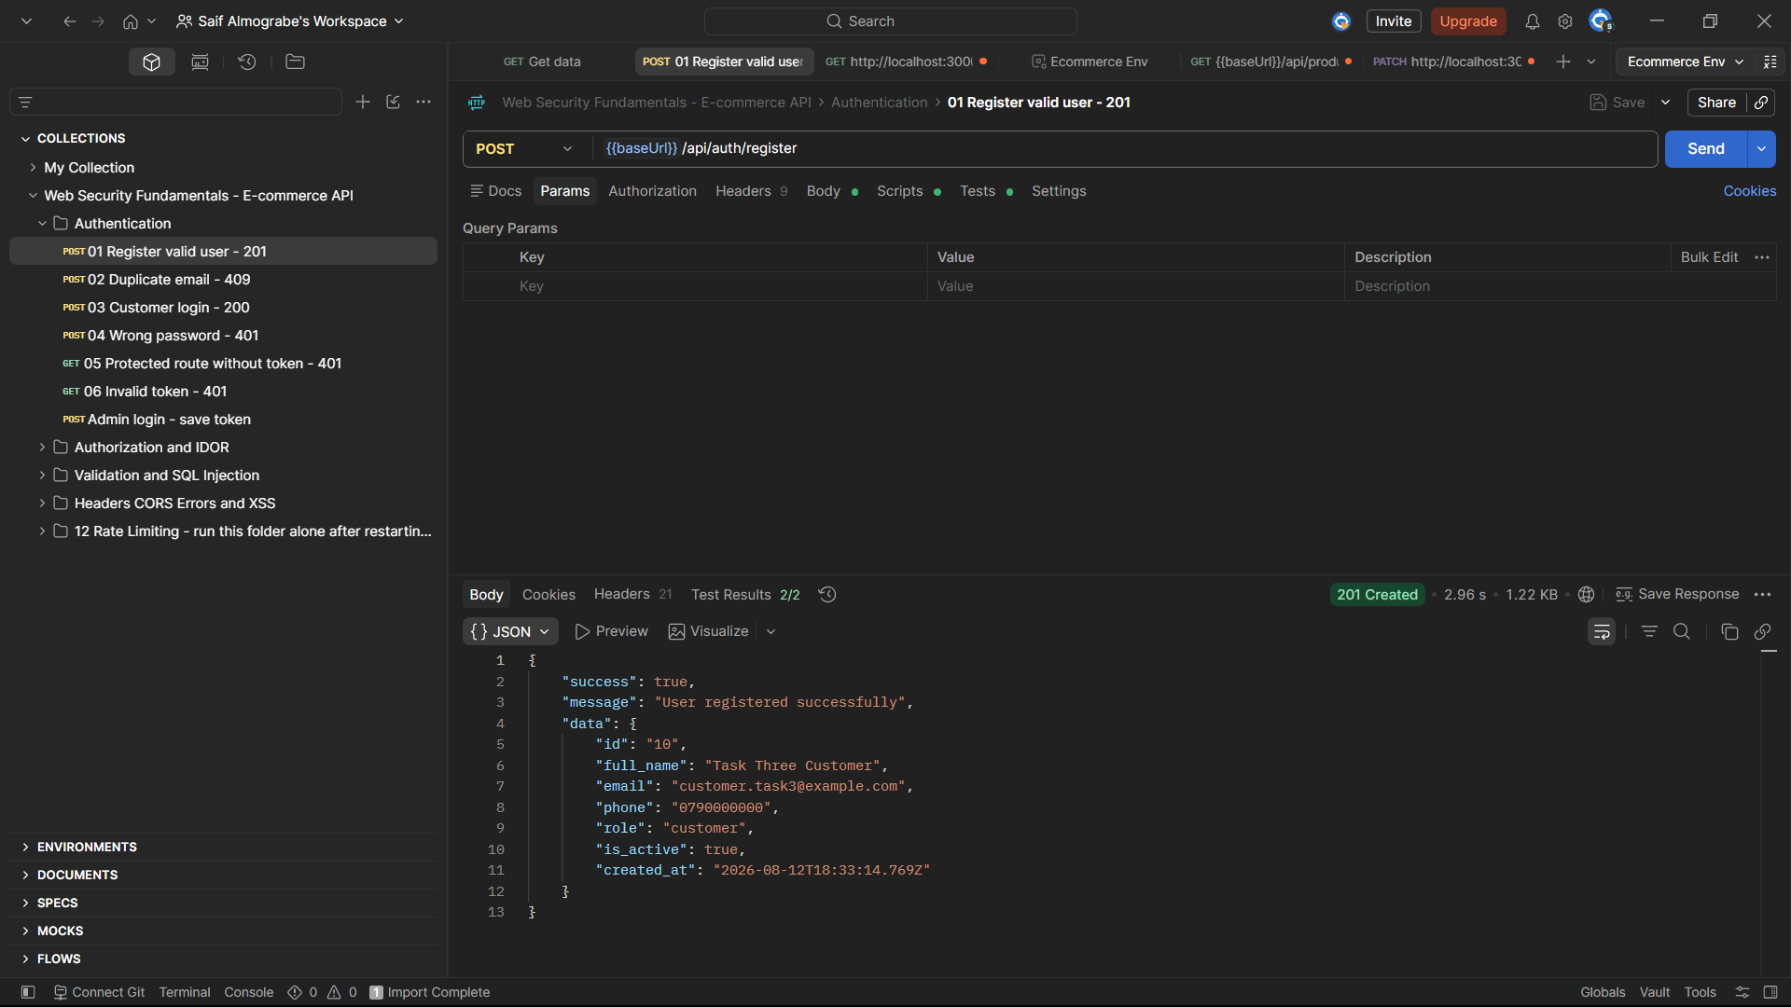
Figure 1 - Valid registration returned 201 Created and the response did not expose password_hash.
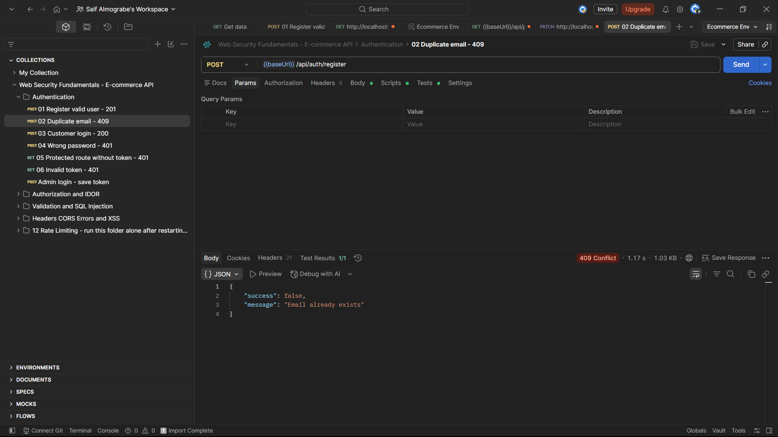
Figure 2 - Duplicate registration returned 409 Conflict.
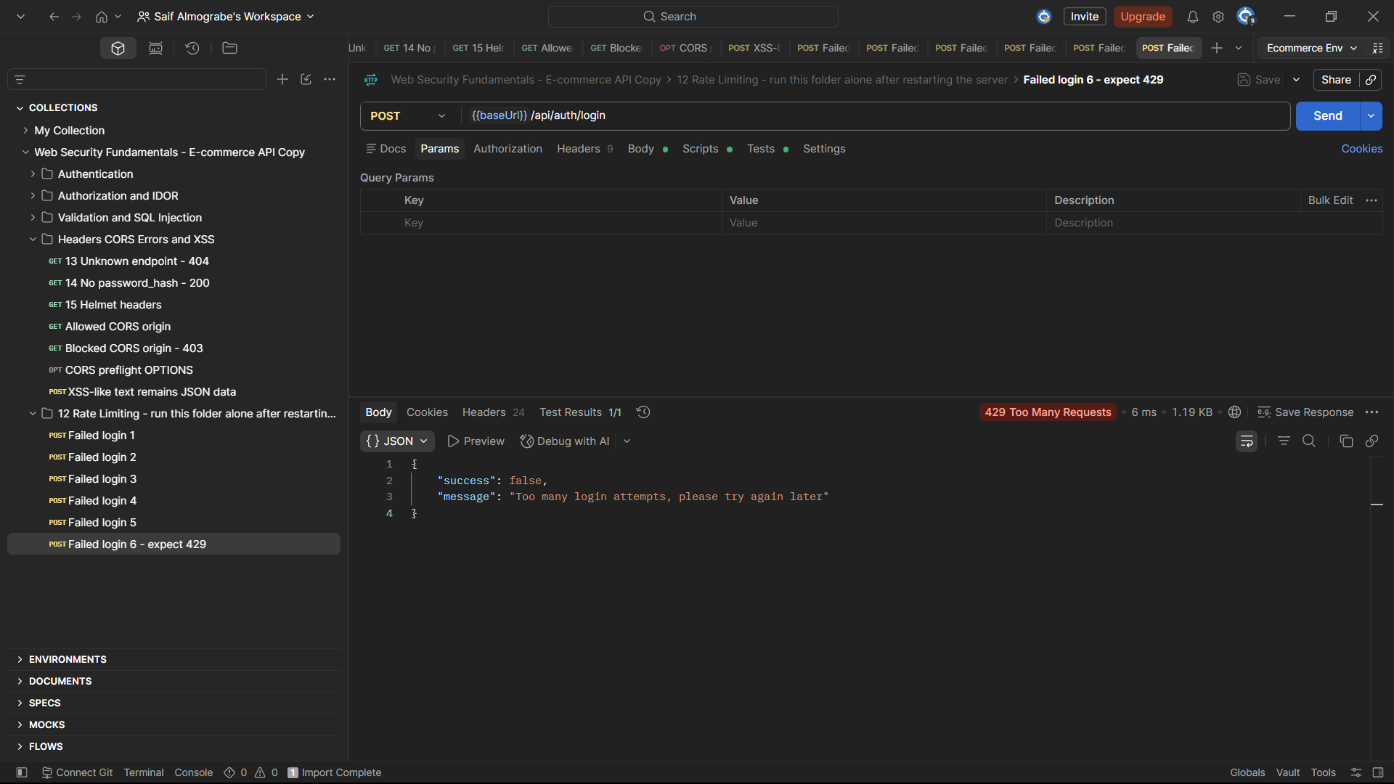
Figure 3 - Sixth failed login returned 429 Too Many Requests with Postman Test Results 1/1.

6. Final Submission Checklist
- Secured source code is on task3-web-security.
- SECURITY_REVIEW.md documents at least five real issues (14 documented).
- .env is ignored and .env.example contains placeholders only.
- Postman collection JSON is included and CI validates its JSON syntax.
- All 15 mandatory Postman outcomes passed in the local authorized environment.
- Copy the complete captured screenshot set into screenshots/ and redact secrets.
- Exported report is included as DOCX/PDF.
- Merge task3-web-security into main only after explicit approval.

