苏州科技大学

《填课程名》实验报告

院 (系) 电子与信息工程
专 业 计算机科学与技术
组 别 第 组 组 长
指导教师 傅启明

2023年 5月 11日

成绩评定表

学号 | 姓名 | 组长评分
20200107115 | 乔治

注：
组长评分为组长根据各组员贡献，如实打分（每人满分100分）；

实验一 逻辑回归
- 实验目的
- 学习并掌握常见的机器学习方法；
- 能够结合所学的python知识实现机器学习算法；
- 能够用所学的机器学习算法解决实际问题。
- 实验内容与要求
- 掌握线性回归及逻辑回归的原理；
- 根据所提供的代码，完成基本的逻辑回归；
- 能够正确输出结果。
- 实验过程及代码

train_set_x_orig, train_set_y, test_set_x_orig, test_set_y, classes = load_dataset()

m_train = train_set_y.shape[1]
m_test = test_set_y.shape[1]
num_px = train_set_x_orig.shape[1]

print("训练集的数量: m_train = " + str(m_train))
print("测试集的数量 : m_test = " + str(m_test))
print("每张图片的宽/高 : num_px = " + str(num_px))
print("每张图片的大小 : (" + str(num_px) + ", " + str(num_px) + ", 3)")
print("训练集_图片的维数 : " + str(train_set_x_orig.shape))
print("训练集_标签的维数 : " + str(train_set_y.shape))
print("测试集_图片的维数: " + str(test_set_x_orig.shape))
print("测试集_标签的维数: " + str(test_set_y.shape))

# 将训练集的维度降低并转置。
train_set_x_flatten = train_set_x_orig.reshape(train_set_x_orig.shape[0], -1).T
# 将测试集的维度降低并转置。
test_set_x_flatten = test_set_x_orig.reshape(test_set_x_orig.shape[0], -1).T

print("训练集降维最后的维度： " + str(train_set_x_flatten.shape))
print("训练集_标签的维数 : " + str(train_set_y.shape))
print("测试集降维之后的维度: " + str(test_set_x_flatten.shape))
print("测试集_标签的维数 : " + str(test_set_y.shape))

index = 11
plt.imshow(train_set_x_orig[index])
print("y = " + str(train_set_y[:, index]) + ", it's a '" + classes[np.squeeze(train_set_y[:, index])].decode(
"utf-8") + "' picture.")

train_set_x = train_set_x_flatten / 255
test_set_x = test_set_x_flatten / 255

def sigmoid(z):
s = 1 / (1 + np.exp(-z))
return s

def initialize_with_zeros(dim):
w = np.zeros(shape=(dim, 1))
b = 0
# 使用断言来确保我要的数据是正确的
assert (w.shape == (dim, 1)) # w的维度是(dim,1)
assert (isinstance(b, float) or isinstance(b, int)) # b的类型是float或者是int

return (w, b)

def propagate(w, b, X, Y):
m = X.shape[1]

# 正向传播
A = sigmoid(np.dot(w.T, X) + b)
cost = (- 1 / m) * np.sum(Y * np.log(A) + (1 - Y) * (np.log(1 - A)))

# 反向传播
dw = (1 / m) * np.dot(X, (A - Y).T)
db = (1 / m) * np.sum(A - Y)

# 使用断言确保我的数据是正确的
assert (dw.shape == w.shape)
assert (db.dtype == float)
cost = np.squeeze(cost)
assert (cost.shape == ())

# 创建一个字典，把dw和db保存起来。
grads = {
"dw": dw,
"db": db
}
return (grads, cost)

def optimize(w, b, X, Y, num_iterations, learning_rate, print_cost=False):
costs = []

for i in range(num_iterations):

grads, cost = propagate(w, b, X, Y)

dw = grads["dw"]
db = grads["db"]

w = w - learning_rate * dw
b = b - learning_rate * db

# 记录成本
if i % 100 == 0:
costs.append(cost)
# 打印成本
if (print_cost) and (i % 100 == 0):
print("迭代的次数: %i ， 误差值： %f" % (i, cost))

params = {
"w": w,
"b": b}
grads = {
"dw": dw,
"db": db}
return (params, grads, costs)

def predict(w, b, X):
m = X.shape[1] # 图片的数量
Y_prediction = np.zeros((1, m))
w = w.reshape(X.shape[0], 1)

# 计预测猫在图片中出现的概率
A = sigmoid(np.dot(w.T, X) + b)
for i in range(A.shape[1]):
# 将概率a [0，i]转换为实际预测p [0，i]
Y_prediction[0, i] = 1 if A[0, i] > 0.5 else 0
# 使用断言
assert (Y_prediction.shape == (1, m))

return Y_prediction

def model(X_train, Y_train, X_test, Y_test, num_iterations=2000, learning_rate=0.5, print_cost=False):
w, b = initialize_with_zeros(X_train.shape[0])

parameters, grads, costs = optimize(w, b, X_train, Y_train, num_iterations, learning_rate, print_cost)

# 从字典“参数”中检索参数w和b
w, b = parameters["w"], parameters["b"]

# 预测测试/训练集的例子
Y_prediction_test = predict(w, b, X_test)
Y_prediction_train = predict(w, b, X_train)

# 打印训练后的准确性
print("训练集准确性：", format(100 - np.mean(np.abs(Y_prediction_train - Y_train)) * 100), "%")
print("测试集准确性：", format(100 - np.mean(np.abs(Y_prediction_test - Y_test)) * 100), "%")

d = {
"costs": costs,
"Y_prediction_test": Y_prediction_test,
"Y_prediciton_train": Y_prediction_train,
"w": w,
"b": b,
"learning_rate": learning_rate,
"num_iterations": num_iterations}
return d

d = model(train_set_x, train_set_y, test_set_x, test_set_y, num_iterations=2000, learning_rate=0.005, print_cost=True)

# 绘制图
costs = np.squeeze(d['costs'])
plt.plot(costs)
plt.ylabel('cost')
plt.xlabel('iterations (per hundreds)')
plt.title("Learning rate =" + str(d["learning_rate"]))
plt.show()

learning_rates = [1, 0.01, 0.006, 0.0003, 0.001, 0.0006]
models = {}
for i in learning_rates:
print("learning rate is: " + str(i))
models[str(i)] = model(train_set_x, train_set_y, test_set_x, test_set_y, num_iterations=1500, learning_rate=i,
print_cost=False)
print('\n' + "-------------------------------------------------------" + '\n')

for i in learning_rates:
plt.plot(np.squeeze(models[str(i)]["costs"]), label=str(models[str(i)]["learning_rate"]))

plt.ylabel('cost')
plt.xlabel('iterations')

legend = plt.legend(loc='upper center', shadow=True)
frame = legend.get_frame()
frame.set_facecolor('0.90')
plt.show()
print("====================测试model====================")
#绘制图
costs = np.squeeze(d['costs'])
plt.plot(costs)
plt.ylabel('cost')
plt.xlabel('iterations (per hundreds)')
plt.title("Learning rate =" + str(d["learning_rate"]))
plt.show()

- 实验分析及总结
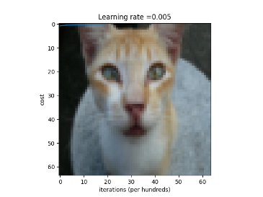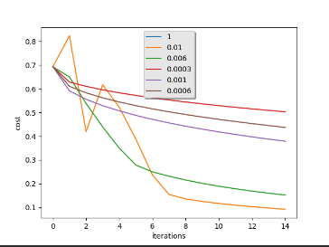
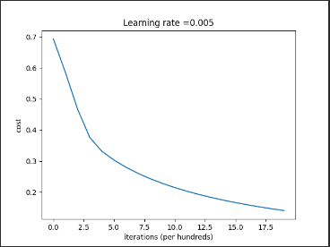

实验二 单隐层神经网络
- 实验目的
- 学习并掌握常见的机器学习方法；
- 能够结合所学的python知识实现机器学习算法；
- 能够用所学的机器学习算法解决实际问题。
- 实验内容与要求
- 掌握神经网络的基本原理，掌握并理解反向传播算法；
- 能够结合单层神经网络实现分类问题；
- 根据所提供的代码，完成基本的分类问题的代码；
- 能够正确输出结果
- 实验过程及代码
def __init__(self, input_layer, hidden_layer, output_layer):
"""
初始化神经网络，这里的隐藏层只有一层
:param input_layer: 输入层神经元个数
:param hidden_layer: 隐藏层神经元个数
:param output_layer: 输出层神经元个数
"""
self.w = []
self.b = []
self.z = []
self.a = []
self.input_layer = input_layer
self.hidden_layer = hidden_layer
self.output_layer = output_layer
self.initialize_parameters()

def initialize_parameters(self):
w1 = np.random.randn(self.hidden_layer, self.input_layer)
w2 = np.random.randn(self.output_layer, self.hidden_layer)

assert (w1.shape == (self.hidden_layer, self.input_layer))
assert (w2.shape == (self.output_layer, self.hidden_layer))

self.w = [w1, w2]

b1 = numpy.zeros(shape=(self.hidden_layer, 1))
b2 = numpy.zeros(shape=(self.output_layer, 1))

assert (b1.shape == (self.hidden_layer, 1))
assert (b2.shape == (self.output_layer, 1))

self.b = [b1, b2]

def sigmoid(self, z):
"""
sigmoid激活函数，用于output层
:param z: 输入
:return:
"""
return 1 / (1 + np.exp(-z))

def compute_loss(self, A, Y):
"""
计算损失函数
:param A: 预测结果
:param Y: 实际结果
:return:
"""
m = Y.shape[1]
total_loss = (-1) * np.multiply(Y, np.log(A)) + np.multiply((1 - Y), np.log(1 - A))
cost = (1 / m) * np.sum(total_loss)
cost = float(np.squeeze(cost))
assert (isinstance(cost, float))

return cost

def forward(self, X):
"""
前向传播
:param X: 样本集
:return:

"""
m = X.shape[1]
Z1 = np.dot(self.w[0], X) + self.b[0]
A1 = np.tanh(Z1)

Z2 = np.dot(self.w[1], A1) + self.b[1]
A2 = self.sigmoid(Z2)

self.z = [Z1, Z2]
self.a = [X, A1, A2]

def backward(self, Y, learning_rate):
"""
反向传播
:param Y: 实际标签值
:param learning_rate: 学习率
:return:
"""
sample_num = Y.shape[1]
dZ2 = self.a[2] - Y
dW2 = (1 / sample_num) * np.dot(dZ2, self.a[1].T)
db2 = (1 / sample_num) * np.sum(dZ2, axis=1, keepdims=True)

dZ1 = np.multiply(np.dot(self.w[1].T, dZ2), 1 - np.power(self.a[1], 2))
dW1 = (1 / sample_num) * np.dot(dZ1, self.a[0].T)
db1 = (1 / sample_num) * np.sum(dZ1, axis=1, keepdims=True)

self.w[0] = self.w[0] - learning_rate * dW1
self.w[1] = self.w[1] - learning_rate * dW2

self.b[0] = self.b[0] - learning_rate * db1
self.b[1] = self.b[1] - learning_rate * db2

def predict(self, X):
"""
预测函数
:param X: 输入数据
:return:
"""
self.forward(X)
return np.round(self.a[2])

def nn_model(self, X, Y, learning_rate, iterations):
"""
主控函数
:param X: 输入样本
:param Y: 实际标签值
:param learning_rate: 学习率
:param iterations: 迭代次数
:return:
"""
for i in range(0, iterations):
self.forward(X)
self.backward(Y, learning_rate)
cost = self.compute_loss(self.a[2], Y)
if i % 1000 == 0:
print("第 ", i, " 次循环，成本为：" + str(cost))
- 实验分析及总结
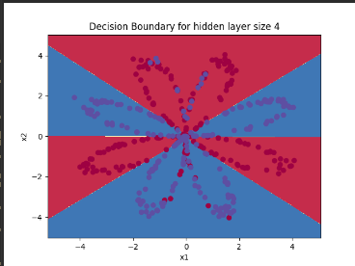
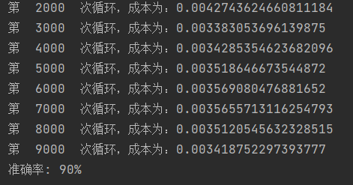

实验三 多层神经网络
- 实验目的
- 学习并掌握常见的机器学习方法；
- 能够结合所学的python知识实现机器学习算法；
- 能够用所学的机器学习算法解决实际问题。
- 实验内容与要求
- 理解多层神经网络的架构及参数更新，能够结合多层神经网络实现分类问题；
- 根据所提供的代码，完成多层神经网络的代码，能够进行分类与回归；
- 能够正确输出结果
- 实验过程及代码
import numpy as np
import h5py
import lr_utils
from PIL import Image
from matplotlib import pyplot as plt

import time
import numpy as np
import h5py
import matplotlib.pyplot as plt
import scipy
from PIL import Image
from scipy import ndimage

train_set_x_orig, train_set_y_orig, test_set_x_orig, test_set_y_orig, classes = lr_utils.load_dataset()
"""
#测试数据
index = 25 #标签数目
plt.imshow(train_set_x_orig[index])
print ("y = " + str(train_set_y_orig[:,index]) + ", it's a '" + classes[np.squeeze(test_set_y_orig[:,index])].decode("utf-8") + "' picture.")
"""
# 计算训练集、测试集的大小以及图像的大小
m_train = train_set_y_orig.shape[1]
m_test = test_set_y_orig.shape[1]
num_px = train_set_x_orig.shape[1]
print("Number of training examples: m_train = " + str(m_train))
print("Number of testing examples: m_test = " + str(m_test))
print("Height/Width of each image: num_px = " + str(num_px))
print("Each image is of size: (" + str(num_px) + ", " + str(num_px) + ", 3)")
print("train_set_x shape: " + str(train_set_x_orig.shape))
print("train_set_y shape: " + str(train_set_y_orig.shape))
print("test_set_x shape: " + str(test_set_x_orig.shape))
print("test_set_y shape: " + str(test_set_y_orig.shape))

# 转化矩阵
# 整个训练集转为一个矩阵，其中包括num_px*num_py*3行，m_train列
train_set_x_flatten = train_set_x_orig.reshape(train_set_x_orig.shape[0], -1).T
test_set_x_flatten = test_set_x_orig.reshape(test_set_x_orig.shape[0], -1).T

print("train_set_x_flatten shape: " + str(train_set_x_flatten.shape))
print("train_set_y shape: " + str(train_set_y_orig.shape))
print("test_set_x_flatten shape: " + str(test_set_x_flatten.shape))
print("test_set_y shape: " + str(test_set_y_orig.shape))
print("sanity check after reshaping: " + str(train_set_x_flatten[0:5, 0]))

# 去中心化
train_set_x = train_set_x_flatten / 255
test_set_x = test_set_x_flatten / 255
def sigmoid(Z):
A = 1 / (1 + np.exp(-Z))
cache = Z
return A, cache

# 实现反向传播的sigmoid函数
def sigmoid_backward(dA, cache):
Z = cache
s = 1 / (1 + np.exp(-Z))
dZ = dA * s * (1 - s)
assert (dZ.shape == Z.shape)
return dZ

# 实现relu函数
def relu(Z):
A = np.maximum(0, Z)
assert (A.shape == Z.shape)
cache = Z
return A, cache

# 实现反向传播的relu函数
def relu_backward(dA, cache):
Z = cache
dZ = np.array(dA, copy=True) # just converting dz to a correct object.
# When z <= 0, you should set dz to 0 as well.
dZ[Z <= 0] = 0
assert (dZ.shape == Z.shape)
return dZ

def initialize_parameters(n_x, n_h, n_y):
W1 = np.random.randn(n_h, n_x) * 0.01

b1 = np.zeros((n_h, 1))

W2 = np.random.randn(n_y, n_h) * 0.01

b2 = np.zeros((n_y, 1))

# 使用断言确保我的数据格式是正确的

assert (W1.shape == (n_h, n_x))

assert (b1.shape == (n_h, 1))

assert (W2.shape == (n_y, n_h))

assert (b2.shape == (n_y, 1))

parameters = {"W1": W1,

"b1": b1,

"W2": W2,

"b2": b2}

return parameters

def initialize_parameters_deep(layers_dims):
np.random.seed(3)

parameters = {}

L = len(layers_dims)

for l in range(1, L):
parameters["W" + str(l)] = np.random.randn(layers_dims[l], layers_dims[l - 1]) / np.sqrt(layers_dims[l - 1])

parameters["b" + str(l)] = np.zeros((layers_dims[l], 1))

# 确保我要的数据的格式是正确的

assert (parameters["W" + str(l)].shape == (layers_dims[l], layers_dims[l - 1]))

assert (parameters["b" + str(l)].shape == (layers_dims[l], 1))

return parameters

def linear_forward(A_prev, W, b):
"""

实现前向传播的线性部分。

参数：

A_prev - 来自上一层（或输入数据）的激活，维度为(上一层的节点数量，示例的数量）

W - 权重矩阵，numpy数组，维度为（当前图层的节点数量，前一图层的节点数量）

b - 偏向量，numpy向量，维度为（当前图层节点数量，1）

返回：

Z - 激活功能的输入，也称为预激活参数

cache - 一个包含“A”，“W”和“b”的字典，存储这些变量以有效地计算后向传递

"""
Z = np.dot(W, A_prev) + b
linear_cache = (A_prev, W, b)

# Please do something

return Z, linear_cache

def linear_activation_forward(A_prev, W, b, activation):
"""

实现LINEAR-> ACTIVATION 这一层的前向传播

参数：

A_prev - 来自上一层（或输入层）的激活，维度为(上一层的节点数量，示例数）

W - 权重矩阵，numpy数组，维度为（当前层的节点数量，前一层的大小）

b - 偏向量，numpy阵列，维度为（当前层的节点数量，1）

activation - 选择在此层中使用的激活函数名，字符串类型，【"sigmoid" | "relu"】

返回：

A - 激活函数的输出，也称为激活后的值

cache - 一个包含“linear_cache”和“activation_cache”的字典，我们需要存储它以有效地计算后向传递

"""
if activation == "sigmoid":
Z, linear_cache = linear_forward(A_prev, W, b)
A, activation_cache = sigmoid(Z)
elif activation == "relu":
Z, linear_cache = linear_forward(A_prev, W, b)
A, activation_cache = relu(Z)
cache = (linear_cache, activation_cache)

# Please do something

return A, cache

def L_model_forward(X, parameters):
"""

实现[LINEAR-> RELU] *（L-1） - > LINEAR-> SIGMOID计算前向传播，也就是多层网络的前向传播，为后面每一层都执行LINEAR和ACTIVATION

参数：

X - 数据，numpy数组，维度为（输入节点数量，示例数）

parameters - initialize_parameters_deep（）的输出

返回：

AL - 最后的激活值

caches - 包含以下内容的缓存列表：

linear_relu_forward（）的每个cache（有L-1个，索引为从0到L-2）

linear_sigmoid_forward（）的cache（只有一个，索引为L-1）

"""

# Please do something
caches = []
A = X
L = len(parameters) // 2
for l in range(1, L):
A_prev = A
A, cache = linear_activation_forward(A_prev, parameters['W' + str(l)], parameters['b' + str(l)],
activation="relu")
caches.append(cache)
AL, cache = linear_activation_forward(A, parameters['W' + str(L)], parameters['b' + str(L)], activation="sigmoid")
caches.append(cache)
assert (AL.shape == (1, X.shape[1]))

return AL, caches

def compute_cost(AL, Y):
"""

交叉熵误差函数，定义成本函数。

参数：

AL - 与标签预测相对应的概率向量，维度为（1，示例数量）

Y - 标签向量（例如：如果不是猫，则为0，如果是猫则为1），维度为（1，数量）

返回：

cost - 交叉熵成本

"""
m = Y.shape[1]

cost = (1. / m) * (-np.dot(Y, np.log(AL).T) - np.dot(1 - Y, np.log(1 - AL).T))
cost = np.squeeze(cost)

# Please do something

return cost

def linear_backward(dZ, linear_cache):
"""

为单层实现反向传播的线性部分（第L层）

参数：

dZ - 相对于（当前第l层的）线性输出的成本梯度

cache - 来自当前层前向传播的值的元组（A_prev，W，b）

返回：

dA_prev - 相对于激活（前一层l-1）的成本梯度，与A_prev维度相同

dW - 相对于W（当前层l）的成本梯度，与W的维度相同

db - 相对于b（当前层l）的成本梯度，与b维度相同

"""

# Please do something
A_prev, W, b = linear_cache
m = A_prev.shape[1]
dW = np.dot(dZ, A_prev.T) / m
db = np.sum(dZ, axis=1, keepdims=True) / m
dA_prev = np.dot(W.T, dZ)

return dA_prev, dW, db

def linear_activation_backward(dA, cache, activation="relu"):
"""
实现LINEAR-> ACTIVATION层的后向传播。

参数：
dA - 当前层l的激活后的梯度值
cache - 我们存储的用于有效计算反向传播的值的元组（值为linear_cache，activation_cache）
activation - 要在此层中使用的激活函数名，字符串类型，【"sigmoid" | "relu"】
返回：
dA_prev - 相对于激活（前一层l-1）的成本梯度值，与A_prev维度相同
dW - 相对于W（当前层l）的成本梯度值，与W的维度相同
db - 相对于b（当前层l）的成本梯度值，与b的维度相同
"""
# Please do something
linear_cache, activation_cache = cache
if activation == "relu":
dZ = relu_backward(dA, activation_cache)
dA_prev, dW, db = linear_backward(dZ, linear_cache)
elif activation == "sigmoid":
dZ = sigmoid_backward(dA, activation_cache)
dA_prev, dW, db = linear_backward(dZ, linear_cache)

return dA_prev, dW, db

def L_model_backward(AL, Y, caches):
"""

对[LINEAR-> RELU] *（L-1） - > LINEAR - > SIGMOID组执行反向传播，就是多层网络的向后传播

参数：

AL - 概率向量，正向传播的输出（L_model_forward（））

Y - 标签向量（例如：如果不是猫，则为0，如果是猫则为1），维度为（1，数量）

caches - 包含以下内容的cache列表：

linear_activation_forward（"relu"）的cache，不包含输出层

linear_activation_forward（"sigmoid"）的cache

返回：

grads - 具有梯度值的字典

grads [“dA”+ str（l）] = ...

grads [“dW”+ str（l）] = ...

grads [“db”+ str（l）] = ...

"""

# Please do something
grads = {}
L = len(caches)
m = AL.shape[1]
Y = Y.reshape(AL.shape)
dAL = -(np.divide(Y, AL) - np.divide(1 - Y, 1 - AL))
current_cache = caches[L - 1]
grads["dA" + str(L)], grads["dW" + str(L)], grads["db" + str(L)] = linear_activation_backward(dAL, current_cache,
activation="sigmoid")
for l in reversed(range(L - 1)):
current_cache = caches[l]
dA_prev_temp, dW_temp, db_temp = linear_activation_backward(grads["dA" + str(l + 2)], current_cache,
activation="relu")
grads["dA" + str(l + 1)] = dA_prev_temp
grads["dW" + str(l + 1)] = dW_temp
grads["db" + str(l + 1)] = db_temp

return grads

def update_parameters(parameters, grads, learning_rate):
L = len(parameters) // 2 # 整除
for l in range(L):
parameters["W" + str(l + 1)] = parameters["W" + str(l + 1)] - learning_rate * grads["dW" + str(l + 1)]
parameters["b" + str(l + 1)] = parameters["b" + str(l + 1)] - learning_rate * grads["db" + str(l + 1)]
return parameters

def two_layer_model(X, Y, layers_dims, learning_rate=0.0075, num_iterations=3000, print_cost=False, isPlot=True):
np.random.seed(1)
costs = []
parameters = initialize_parameters_deep(layers_dims)
for i in range(0, num_iterations):
AL, caches = L_model_forward(X, parameters)
cost = compute_cost(AL, Y)
grads = L_model_backward(AL, Y, caches)
parameters = update_parameters(parameters, grads, learning_rate)

if isPlot and i % 100 == 0:
print("loop %i cost value: %f" % (i, cost))
if isPlot and i % 100 == 0:
costs.append(cost)
plt.plot(np.squeeze(costs))
plt.ylabel('cost')
plt.xlabel('iterations (per tens)')
plt.title("Learning rate =" + str(learning_rate))
plt.show()
# 返回parameters
return parameters

def predict(X, y, parameters):
m = X.shape[1]
n = len(parameters) // 2 # 神经网络的层数
p = np.zeros((1, m))
# 根据参数前向传播
probas, caches = L_model_forward(X, parameters)

for i in range(0, probas.shape[1]):
if probas[0, i] > 0.5:
p[0, i] = 1
else:
p[0, i] = 0
print("准确度为: " + str(float(np.sum((p == y)) / m)))
return p

def L_layer_model(X, Y, layers_dims, learning_rate=0.0075, num_iterations=3000, print_cost=False, isPlot=True):
np.random.seed(1)
costs = [] # keep track of cost
parameters = initialize_parameters_deep(layers_dims)
for i in range(0, num_iterations):
AL, caches = L_model_forward(X, parameters)
cost = compute_cost(AL, Y)
grads = L_model_backward(AL, Y, caches)
parameters = update_parameters(parameters, grads, learning_rate)
if print_cost and i % 100 == 0:
print("Cost after iteration %i: %f" % (i, cost))
if print_cost and i % 100 == 0:
costs.append(cost)
# plot the cost
plt.plot(np.squeeze(costs))
plt.ylabel('cost')
plt.xlabel('iterations (per tens)')
plt.title("Learning rate =" + str(learning_rate))
plt.show()

return parameters

def print_mislabeled_images(classes, X, y, p):
"""
绘制预测和实际不同的图像。
X - 数据集
y - 实际的标签
p - 预测
"""
a = p + y
mislabeled_indices = np.asarray(np.where(a == 1))
plt.rcParams['figure.figsize'] = (40.0, 40.0) # set default size of plots
num_images = len(mislabeled_indices[0])
for i in range(num_images):
index = mislabeled_indices[1][i]

plt.subplot(2, num_images, i + 1)
plt.imshow(X[:, index].reshape(64, 64, 3), interpolation='nearest')
plt.axis('off')
plt.title("Prediction: " + classes[int(p[0, index])].decode("utf-8") + " \n Class: " + classes[
y[0, index]].decode("utf-8"))

plt.ylabel('cost')
plt.xlabel('iterations (per tens)')
plt.show()

train_set_x_orig, train_set_y, test_set_x_orig, test_set_y, classes = lr_utils.load_dataset()
train_set_x_orig.shape
train_set_y.shape
n_x = 12288
n_h = 7
n_y = 1
layers_dims = (n_x, n_h, n_y)

parameters = two_layer_model(train_set_x, train_set_y_orig, layers_dims=(n_x, n_h, n_y), num_iterations=2500,
print_cost=True, isPlot=True)

train_x_flatten = train_set_x_orig.reshape(train_set_x_orig.shape[0], -1).T
test_x_flatten = test_set_x_orig.reshape(test_set_x_orig.shape[0], -1).T

train_x = train_x_flatten / 255
train_y = train_set_y_orig
test_x = test_x_flatten / 255
test_y = test_set_y_orig

layers_dims = [12288, 20, 7, 5, 1] # 5-layer model
parameters = L_layer_model(train_x, train_y, layers_dims, num_iterations=2500, print_cost=True, isPlot=True)

def myPredict(img_file_path, label, width, height):
img = lr_utils.myLoadImgAndResize(img_file_path, width, height)
plt.imshow(img)

plt.ylabel('cost')
plt.xlabel('iterations (per tens)')
plt.show()
my_image_x = img.reshape(1, -1).T
my_image_y = [label]

predic_res = predict(my_image_x, my_image_y, parameters)
print(predic_res)
print("y = " + str(np.squeeze(predic_res)) + ", your L-layer model predicts a \"" + classes[
int(np.squeeze(predic_res)),].decode("utf-8") + "\" picture")

img_file_path = "datasets/myCat4.jpg"
num_px = 64
myPredict(img_file_path, 1, num_px, num_px)
print("=================训练完成==================")

- 实验分析及总结
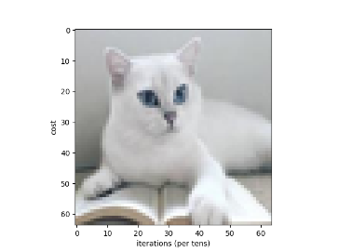

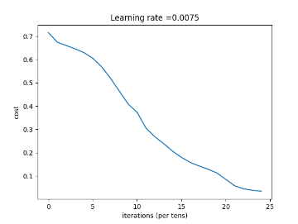

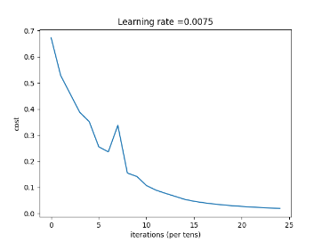
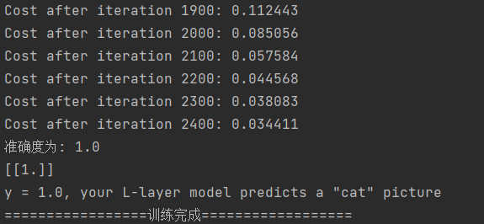

实验四 强化学习
- 实验目的
- 学习并掌握常见的机器学习方法；
- 能够结合所学的python知识实现机器学习算法；
- 能够用所学的机器学习算法解决实际问题。
- 实验内容与要求
- 掌握动态算法基本思想，以及策略估计和策略改进过程；
- 理解状态值函数的含义及迭代求解公式；
- 了解如何对问题进行建模处理，包括环境、状态、动作、奖惩值的初始化；
- 能够正确输出策略评估结果
- 实验过程及代码
GridWorld
# 引入所需要的库文件
import numpy as np
from plot_utils_TD import plot_values,plot_values_change
import xml.dom.minidom

创建一个xml文件
# 在内存中创建一个空的文档
doc = xml.dom.minidom.Document()
# 创建一个根节点Managers对象
root = doc.createElement('Begin')
doc.appendChild(root)

定义世界的一些基本参数，世界的长和宽需要用户手动输入：
world_h = int(input("Enter a world_h: ")) # 5
world_w = int(input("Enter a world_w: ")) # 6
length = world_h * world_w
gamma = 1
state = [i for i in range(length)]
action = ['n', 'e', 's', 'w']
ds_action = {'n': -world_w, 'e': 1, 's': world_w, 'w': -1}
value = [0 for i in range(length)]

#定义回报函数
def reward(s):
return 0 if s in [0, length - 1] else -1

#动态回归需要的备忘录
def next_states(s, a):
next_state = s
if (s < world_w and a == 'n') or (s % world_w == 0 and a == 'w') \
or (s > length - world_w - 1 and a == 's') or (s % (world_w - 1) == 0 and a == 'e' and s != 0):
pass
else:
next_state = s + ds_action[a]
return next_state

#过程函数
def getsuccessor(s):
successor = []
for a in action:
next = next_states(s, a)
nodeName = doc.createElement('next')
# 给叶子节点name设置一个文本节点，用于显示文本内容
nodeName.appendChild(doc.createTextNode(str(next)))
root.appendChild(nodeName)

successor.append(next)
return successor
# 状态更新函数
def value_update(s):
value_new = 0
if s in [0, length - 1]:
pass
else:
successor = getsuccessor(s)
rewards = reward(s)
for next_state in successor:
value_new += 1.00 / len(action) * (rewards + gamma * value[next_state])
nodevalue = doc.createElement('value_new')
# 给叶子节点name设置一个文本节点，用于显示文本内容
nodevalue.appendChild(doc.createTextNode(str(value_new)))
nodeReward = doc.createElement('reward')
nodeReward.appendChild(doc.createTextNode(str(rewards)))
root.appendChild(nodevalue)
root.appendChild(nodeReward)
return value_new
# 调用上述方法
def main():
max_iter = 10
global value
v = np.array(value).reshape(world_h, world_w)
print(v)
iter = 0
while iter < max_iter:
new_value = [0 for i in range(length)]
for s in state:
new_value[s] = value_update(s)
value = new_value
v = np.array(value).reshape(world_h, world_w)
print(v)
plot_values_change(value,world_h,world_w)
iter += 1
# 开始写xml文档
fp = open('E:\大三学期\大三下学期\机器学习\实验\机器学习-实验\实验4-强化学习\GridWorld.xml', 'w')
doc.writexml(fp, indent='\t', addindent='\t', newl='\n', encoding="utf-8")

WindyGridWorld
#导入需要的库文件
import numpy as np
import matplotlib
matplotlib.use('TkAgg') #show fig
import matplotlib.pyplot as plt
from plot_utils_TD import plot_values,plot_values_change
import xml.dom.minidom

创建一个空的文档
# 在内存中创建一个空的文档
doc = xml.dom.minidom.Document()
# 创建一个根节点Managers对象
root = doc.createElement('Begin')
doc.appendChild(root)

# 对格子世界进行初始化
# world height
WORLD_HEIGHT = int(input("Enter a WORLD_HEIGHT: "))

# world width
WORLD_WIDTH = int(input("Enter a WORLD_WIDTH: "))

# wind strength for each column
WIND = []
for i in range(WORLD_WIDTH):
WIND.append(int(input("Enter Wind：")))

# possible actions
ACTION_UP = 0
ACTION_DOWN = 1
ACTION_LEFT = 2
ACTION_RIGHT = 3

MOVE = ["UP", "DOWN", "LEFT", "RIGHT"]
# probability for exploration
EPSILON = 0.1

# Sarsa step size
ALPHA = 0.5

# reward for each step
REWARD = -1.0

START = [3, 0]
GOAL = [3, 7]
ACTIONS = [ACTION_UP, ACTION_DOWN, ACTION_LEFT, ACTION_RIGHT]

# 实现状态函数，根据当前位置和下一步的动作返回下一步的位置信息
def step(state, action):
i, j = state
if action == ACTION_UP:
return [max(i - 1 - WIND[j], 0), j]
elif action == ACTION_DOWN:
return [max(min(i + 1 - WIND[j], WORLD_HEIGHT - 1), 0), j]
elif action == ACTION_LEFT:
return [max(i - WIND[j], 0), max(j - 1, 0)]
elif action == ACTION_RIGHT:
return [max(i - WIND[j], 0), min(j + 1, WORLD_WIDTH - 1)]
else:
assert False
# 时间函数
# play for an episode
def episode(q_value):
# track the total time steps in this episode
time = 0

# initialize state
state = START

# choose an action based on epsilon-greedy algorithm
if np.random.binomial(1, EPSILON) == 1:
action = np.random.choice(ACTIONS)
else:
values_ = q_value[state[0], state[1], :]
action = np.random.choice([action_ for action_, value_ in enumerate(values_) if value_ == np.max(values_)])

# keep going until get to the goal state
while state != GOAL:
next_state = step(state, action)
if np.random.binomial(1, EPSILON) == 1:
next_action = np.random.choice(ACTIONS)
else:
values_ = q_value[next_state[0], next_state[1], :]
next_action = np.random.choice([action_ for action_, value_ in enumerate(values_) if value_ == np.max(values_)])

# Sarsa update
q_value[state[0], state[1], action] += \
ALPHA * (REWARD + q_value[next_state[0], next_state[1], next_action] -
q_value[state[0], state[1], action])
state = next_state
action = next_action

nodeName = doc.createElement('Next_Action')
# 给叶子节点name设置一个文本节点，用于显示文本内容
nodeName.appendChild(doc.createTextNode(MOVE[action]))
nodeReward = doc.createElement('Reward')
# 给叶子节点name设置一个文本节点，用于显示文本内容
nodeReward.appendChild(doc.createTextNode(str(-time)))
root.appendChild(nodeName)
root.appendChild(nodeReward)
time += 1 # 时间就是回报

return time
#调用上述方法
def figure_6_3():
q_value = np.zeros((WORLD_HEIGHT, WORLD_WIDTH, 4))
episode_limit = 500

steps = []
ep = 0
while ep < episode_limit:
steps.append(episode(q_value))
# time = episode(q_value)
# episodes.extend([ep] * time)
ep += 1

steps = np.add.accumulate(steps)

plt.plot(steps, np.arange(1, len(steps) + 1))
plt.xlabel('Time steps')
plt.ylabel('Episodes')

# plt.savefig('../images/figure_6_3.png')
# plt.close()
plt.show()

# display the optimal policy
optimal_policy = []
for i in range(0, WORLD_HEIGHT):
optimal_policy.append([])
for j in range(0, WORLD_WIDTH):
if [i, j] == GOAL:
optimal_policy[-1].append('G')
continue
bestAction = np.argmax(q_value[i, j, :])
if bestAction == ACTION_UP:
optimal_policy[-1].append('U')
elif bestAction == ACTION_DOWN:
optimal_policy[-1].append('D')
elif bestAction == ACTION_LEFT:
optimal_policy[-1].append('L')
elif bestAction == ACTION_RIGHT:
optimal_policy[-1].append('R')
print('Optimal policy is:')
for row in optimal_policy:
print(row)
print('Wind strength for each column:\n{}'.format([str(w) for w in WIND]))
# 开始写xml文档
fp = open('E:\大三学期\大三下学期\机器学习\实验\机器学习-实验\实验4-强化学习\WindyGridWorld .xml', 'w')
doc.writexml(fp, indent='\t', addindent='\t', newl='\n', encoding="utf-8")

#最后执行封装好的方法
if __name__ == "__main__":
figure_6_3()

CliffWalking
#导入需要的库
import sys
import gym
import numpy as np
import random
import math
from collections import defaultdict, deque
import matplotlib.pyplot as plt
from plot_utils_TD import *
import xml.dom.minidom

# 因为程序的运行设计两种方法，所以在程序中创建两个空的文档
# 在内存中创建一个空的文档
doc = xml.dom.minidom.Document()
# 创建一个根节点Managers对象
root = doc.createElement('Begin')
doc.appendChild(root)

# 在内存中创建另一个空的文档
doc2 = xml.dom.minidom.Document()
# 创建一个根节点Managers对象
root2 = doc2.createElement('Begin')
doc2.appendChild(root2)

#初始化世界
# world height
WORLD_HEIGHT = int(input("Enter a WORLD_HEIGHT: "))

# world width
WORLD_WIDTH = int(input("Enter a WORLD_WIDTH: "))

# 使用Sarsa方法求解
def update_Q_sarsa(alpha, gamma, Q, state, action, reward, next_state=None, next_action=None):
"""
返回根据当前位置的最新的Q表值
:param alpha: 学习率
:param gamma: 折扣率
:param Q: Q表
:param state: 当前状态
:param action: 当前动作
:param reward: 回报
:param next_state: 下个时间步的状态
:param next_action: 下个时间步的动作
:return: 新的Q值
"""
current = Q[state][action] # 在Q表中的预测 (对于当前的状态-动作对)
# 得到下一个时间步的状态-动作对的值
# 详情参考公式(5.7)
Qsa_next = Q[next_state][next_action] if next_state is not None else 0
target = reward + (gamma * Qsa_next) # 构建TD目标
new_value = current + (alpha * (target - current))

nodeManager = doc.createElement('Sarsa')
nodeName = doc.createElement('next_action')
# 给叶子节点name设置一个文本节点，用于显示文本内容
nodeName.appendChild(doc.createTextNode(str(next_action)))
nodeReward = doc.createElement('Reward')
nodeReward.appendChild(doc.createTextNode(str(reward)))
nodeManager.appendChild(nodeName)
nodeManager.appendChild(nodeReward)
root.appendChild(nodeManager)

return new_value

def epsilon_greedy(Q, state, nA, eps):
"""
为提供的状态选择epsilon-贪婪动作
:param Q: (dictionary)动作价值函数
:param state: (int)当前状态
:param nA: (int)环境中的动作数
:param eps: epsilon
"""
if random.random() > eps: # 选择概率为epsilon的贪婪动作
return np.argmax(Q[state])
else:
return random.choice(np.arange(env.action_space.n))

def sarsa(env, num_episodes, alpha, gamma=1.0, plot_every=100):
nA = env.action_space.n # 动作的数量
Q = defaultdict(lambda: np.zeros(nA)) # 初始化数组的空字典
# 性能监控
tmp_scores = deque(maxlen=plot_every) # 建立关于分数双向队列对象
avg_scores = deque(maxlen=num_episodes) # 建立平均分数的双向队列对象
for i_episode in range(1, num_episodes+1):
# 过程跟踪
if i_episode % 100 == 0:
print("\rEpisode {}/{}".format(i_episode, num_episodes), end="")
sys.stdout.flush()
score = 0 # 初始化分数
state = env.reset() # 开始一个事件
eps = 1.0 / i_episode # 设置epsilon的值
action = epsilon_greedy(Q, state, nA, eps) # 采取 epsilon-贪婪动作
while True:
next_state, reward, done, info = env.step(action) # take action A, observe R, S'
score += reward # 给智能体的分数中添加奖励
if not done:
next_action = epsilon_greedy(Q, next_state, nA, eps) # 采取 epsilon-贪婪 动作
Q[state][action] = update_Q_sarsa(alpha, gamma, Q,state, action, reward, next_state, next_action) # 更新Q表
state = next_state # S <- S'
action = next_action # A <- A'
if done:
Q[state][action] = update_Q_sarsa(alpha, gamma, Q, state, action, reward)
tmp_scores.append(score) # 添加分数
break
# 更新平均分数
if (i_episode % plot_every == 0):
avg_scores.append(np.mean(tmp_scores))

# plot performance
plt.plot(np.linspace(0, num_episodes, len(avg_scores), endpoint=False), np.asarray(avg_scores))
plt.xlabel('Episode Number')
plt.ylabel('Average Reward (Over Next %d Episodes)' % plot_every)
plt.show()
# print best 100-episode performance
print(('\nBest Average Reward over %d Episodes: ' % plot_every), np.max(avg_scores))
return Q

#使用Q-Learn方法求解
# Part2: TD Control: Q-学习
def update_Q_sarsamax(alpha, gamma, Q, state, action, reward, next_state=None):
""" Return updated Q-value for the most recent experience """
current = Q[state][action] # estimate in Q-table (for current state, action pair)
Qsa_next = np.max(Q[next_state]) if next_state is not None else 0 # 选择最大状态价值
target = reward + (gamma * Qsa_next) # 构建 TD 目标
new_value = current + (alpha * (target - current)) # get updated value

nodeManager = doc2.createElement('Q_Learn')
nodeName = doc2.createElement('next_state')
# 给叶子节点name设置一个文本节点，用于显示文本内容
nodeName.appendChild(doc2.createTextNode(str(next_state)))
nodeReward = doc2.createElement('Reward')
nodeReward.appendChild(doc2.createTextNode(str(reward)))
nodeManager.appendChild(nodeName)
nodeManager.appendChild(nodeReward)
root2.appendChild(nodeManager)

return new_value

def q_learning(env, num_episodes, alpha, gamma=1.0, plot_every=100):
"""
Q-Learning - TD Control
:param num_episodes: (int) number of episodes to run the algorithm
:param alpha: (float)学习率
:param gamma: (float)折扣率
:param plot_every: (int) 在计算平均分数时使用的集数
"""
nA = env.action_space.n # 动作数
Q = defaultdict(lambda: np.zeros(nA)) # 初始化数组的空字典

# monitor performance
tmp_scores = deque(maxlen=plot_every) # 记录分数的deque
avg_scores = deque(maxlen=num_episodes) # 每固定集的平均得分

for i_episode in range(1, num_episodes+1):
# monitor process
if i_episode % 100 == 0:
print("\rEpisode {}/{}".format(i_episode, num_episodes), end='')
sys.stdout.flush()
score = 0
state = env.reset()
eps = 1.0 / i_episode

while True:
action = epsilon_greedy(Q, state, nA, eps)
next_state, reward, done, info = env.step(action)
score += reward
Q[state][action] = update_Q_sarsamax(alpha, gamma, Q, state, action, reward, next_state)

state = next_state
if done:
tmp_scores.append(score)
break
if (i_episode % plot_every == 0):
avg_scores.append(np.mean(tmp_scores))

# plot performance
plt.plot(np.linspace(0,num_episodes,len(avg_scores),endpoint=False), np.asarray(avg_scores))
plt.xlabel('Episode Number')
plt.ylabel('Average Reward (Over Next %d Episodes)' % plot_every)
plt.show()
# print best 100-episode performance
print(('Best Average Reward over %d Episodes: ' % plot_every), np.max(avg_scores))
return Q
'''Part 1: TD Control: Sarsa'''
# 得到估计的最优策略和相应的行动-价值函数
Q_sarsa = sarsa(env, 5000, .01)
print(Q_sarsa.items())

# 输出估计的最优策略
policy_sarsa = np.array([np.argmax(Q_sarsa[key]) if key in Q_sarsa else -1 for key in np.arange(WORLD_HEIGHT * WORLD_WIDTH)]).reshape(WORLD_HEIGHT, WORLD_WIDTH)
print("\nEstimated Optimal Policy (UP = 0, RIGHT = 1, DOWN = 2, LEFT = 3, N/A = -1):")
print(policy_sarsa)

# 绘制估计的最优状态价值函数
V_sarsa = ([np.max(Q_sarsa[key]) if key in Q_sarsa else 0 for key in np.arange(WORLD_HEIGHT * WORLD_WIDTH)])
plot_values_change(V_sarsa,WORLD_HEIGHT,WORLD_WIDTH)
# 开始写xml文档
fp = open('E:\大三学期\大三下学期\机器学习\实验\机器学习-实验\实验4-强化学习\cliffWalking.xml', 'w')
doc.writexml(fp, indent='\t', addindent='\t', newl='\n', encoding="utf-8")

# 使用Q-Learn方法
'''Part 2: TD Control: Q-learning'''
# obtain the estimated optimal policy and corresponding action-value function
Q_sarsamax = q_learning(env, 5000, .01)
# print the estimated optimal policy
policy_sarsamax = np.array(
[np.argmax(Q_sarsamax[key]) if key in Q_sarsamax else -1 for key in np.arange(WORLD_HEIGHT * WORLD_WIDTH)]).reshape((WORLD_HEIGHT, WORLD_WIDTH))
print("\nEstimated Optimal Policy (UP = 0, RIGHT = 1, DOWN = 2, LEFT = 3, N/A = -1):")
print(policy_sarsamax)
# plot the estimated optimal state-value function
plot_values_change([np.max(Q_sarsamax[key]) if key in Q_sarsamax else 0 for key in np.arange(WORLD_HEIGHT * WORLD_WIDTH)],WORLD_HEIGHT,WORLD_WIDTH)
fp = open('E:\大三学期\大三下学期\机器学习\实验\机器学习-实验\实验4-强化学习\cliffWalking_Q.xml', 'w')
doc2.writexml(fp, indent='\t', addindent='\t', newl='\n', encoding="utf-8")

#图像处理工具程序
sns.set_style("white")
def plot_values_change(V,world_h,world_w):
# reshape the state-value function
V = np.reshape(V, (world_h, world_w))
# plot the state-value function
fig = plt.figure(figsize=(15, 5))
ax = fig.add_subplot(111)
im = ax.imshow(V, cmap='cool')
for (j, i), label in np.ndenumerate(V):
ax.text(i, j, np.round(label, 3), ha='center', va='center', fontsize=14)
plt.tick_params(bottom='off', left='off', labelbottom='off', labelleft='off')
plt.title('State-Value Function')
plt.show()

- 实验分析及总结
GridWorld
初始化世界长宽
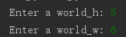
打印每一次行动后的状态，并将关键数据保存到xml文件中
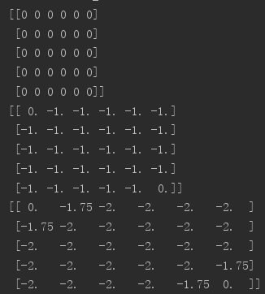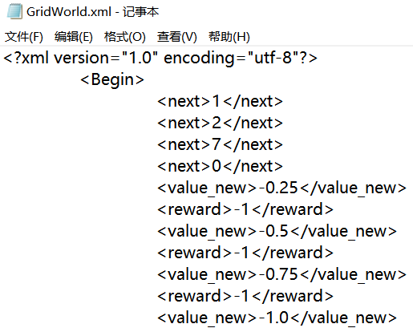
对状态进行可视化，每次状态更新都打印一张图片
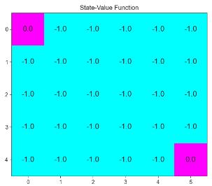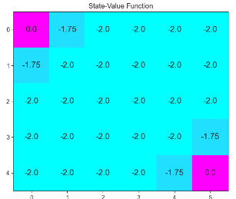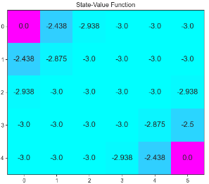
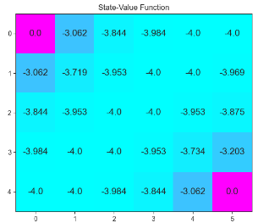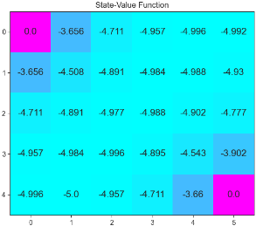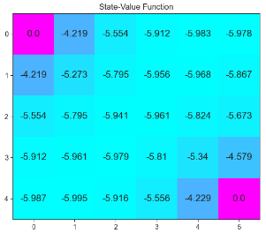
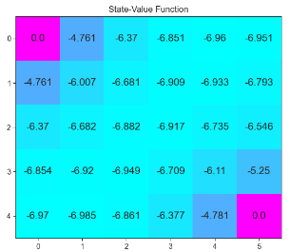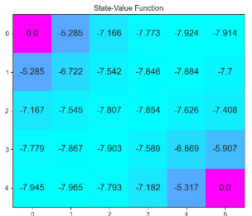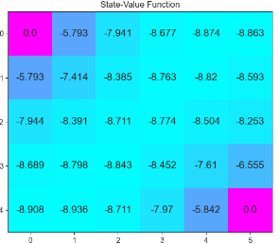
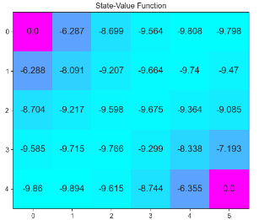
WindyGridWorld
输入格子世界的长宽，以及每一列的风力强度
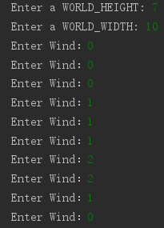
打印出最后获得的路线矩阵
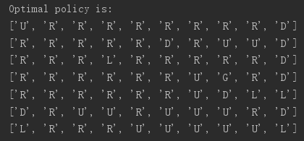
打印出每一列风的强度
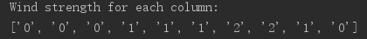
结果可视化处理
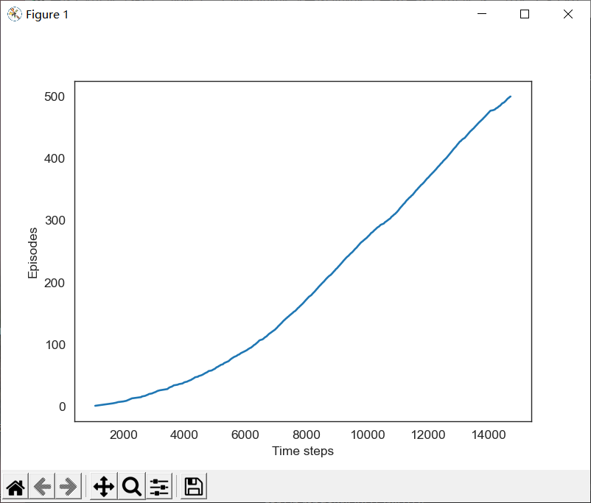

CliffWalking
初始化世界的长宽
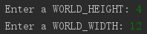
打印操作数组空间和活动空间
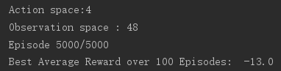
Sarsa方法打印的结果，记录xml文件
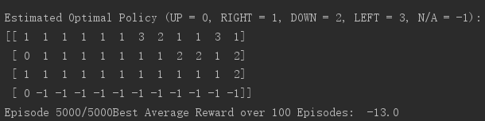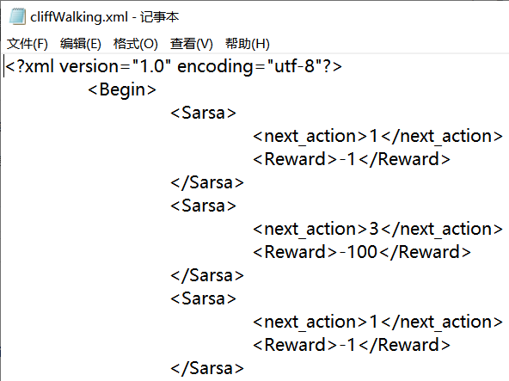
- Learn方法打印的结果，记录xml文件
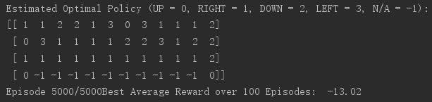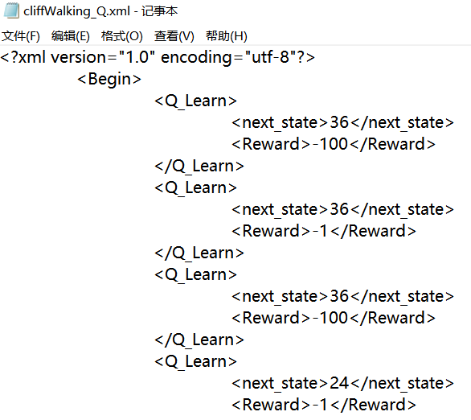
Sarsa结果可视化
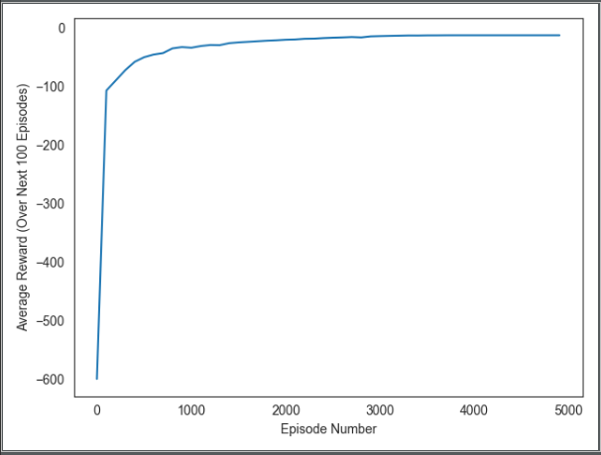
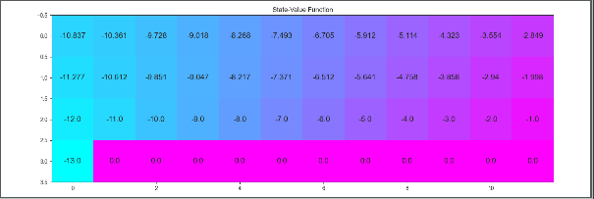

- Learn结果可视化
