Downloading data from [https://storage.googleapis.com/tensorflow/tf-keras-datasets/mnist.npz](https://storage.googleapis.com/tensorflow/tf-keras-datasets/mnist.npz" \t "https://6tp740w7p36-496ff2e9c6d22116-0-colab.googleusercontent.com/_blank)

11490434/11490434 [==============================] - 0s 0us/step

Epoch 1/10

938/938 [==============================] - 14s 4ms/step - loss: -2.7531 - accuracy: 0.1046

Epoch 2/10

938/938 [==============================] - 5s 5ms/step - loss: -2.7531 - accuracy: 0.1011

Epoch 3/10

938/938 [==============================] - 4s 4ms/step - loss: -2.7531 - accuracy: 0.1010

Epoch 4/10

938/938 [==============================] - 4s 4ms/step - loss: -2.7531 - accuracy: 0.1001

Epoch 5/10

938/938 [==============================] - 5s 5ms/step - loss: -2.7531 - accuracy: 0.1023

Epoch 6/10

938/938 [==============================] - 4s 4ms/step - loss: -2.7531 - accuracy: 0.1010

Epoch 7/10

938/938 [==============================] - 4s 4ms/step - loss: -2.7531 - accuracy: 0.0999

Epoch 8/10

938/938 [==============================] - 5s 5ms/step - loss: -2.7531 - accuracy: 0.1005

Epoch 9/10

938/938 [==============================] - 4s 5ms/step - loss: -2.7531 - accuracy: 0.1004

Epoch 10/10

938/938 [==============================] - 4s 4ms/step - loss: -2.7531 - accuracy: 0.0997

1875/1875 [==============================] - 3s 2ms/step

313/313 [==============================] - 1s 2ms/step

<ipython-input-1-2b5f0c34f612>:60: MatplotlibDeprecationWarning: The get_cmap function was deprecated in Matplotlib 3.7 and will be removed two minor releases later. Use ``matplotlib.colormaps[name]`` or ``matplotlib.colormaps.get_cmap(obj)`` instead.

plt.scatter(tsne_results[:, 0], tsne_results[:, 1], c=labels, cmap=plt.cm.get_cmap("jet", 10))

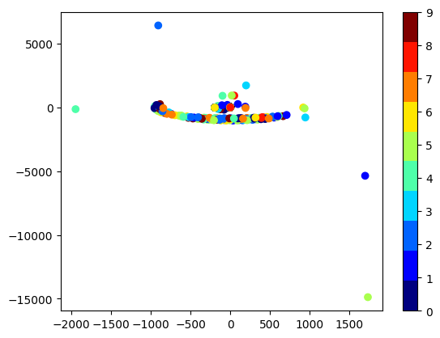

Epoch 1/10

844/844 [==============================] - 4s 3ms/step - loss: 2.3014 - accuracy: 0.1122 - val_loss: 2.3021 - val_accuracy: 0.1050

Epoch 2/10

844/844 [==============================] - 3s 3ms/step - loss: 2.3013 - accuracy: 0.1132 - val_loss: 2.3020 - val_accuracy: 0.1050

Epoch 3/10

844/844 [==============================] - 3s 4ms/step - loss: 2.3013 - accuracy: 0.1132 - val_loss: 2.3018 - val_accuracy: 0.1050

Epoch 4/10

844/844 [==============================] - 3s 4ms/step - loss: 2.3013 - accuracy: 0.1132 - val_loss: 2.3019 - val_accuracy: 0.1050

Epoch 5/10

844/844 [==============================] - 3s 3ms/step - loss: 2.3013 - accuracy: 0.1132 - val_loss: 2.3020 - val_accuracy: 0.1050

Epoch 6/10

844/844 [==============================] - 3s 3ms/step - loss: 2.3013 - accuracy: 0.1132 - val_loss: 2.3020 - val_accuracy: 0.1050

Epoch 7/10

844/844 [==============================] - 3s 3ms/step - loss: 2.3013 - accuracy: 0.1132 - val_loss: 2.3021 - val_accuracy: 0.1050

Epoch 8/10

844/844 [==============================] - 4s 4ms/step - loss: 2.3013 - accuracy: 0.1132 - val_loss: 2.3021 - val_accuracy: 0.1050

Epoch 9/10

844/844 [==============================] - 3s 3ms/step - loss: 2.3012 - accuracy: 0.1132 - val_loss: 2.3020 - val_accuracy: 0.1050

Epoch 10/10

844/844 [==============================] - 3s 3ms/step - loss: 2.3013 - accuracy: 0.1132 - val_loss: 2.3019 - val_accuracy: 0.1050

Test accuracy: 11.35%