MONASH UNIVERSITY
Exploratory Data Analysis
FIT5196 Data Wrangling
Assessment 1 - Stage 1
Group050
Xingao Zhan - 36354775
Yu Wang - 34652442
Keshu Zhang - 36436763
Qingzhuo Zhao - 26662841
Semester 2, 2026
Melbourne technology retailer historical sales data

Contents
1. Problem Context and data scope 1
2. Data-preparation assurance 2
3. Assessed Visualisations (8 figures) 3
4. Evidence-Based 10 Findings 7
5. Future Machine-Learning 5 Questions 8
6. Limitations and recommended next steps 9
Conclusion 10
References 11

1. Problem Context and data scope
Group050 integrated two historical exports from different operational systems used by a Melbourne technology retailer: a nested JSON commerce source and an XML operations source. Together, the sources describe customers, products, transactions, deliveries and customer reviews. After within- and cross-source reconciliation, the data were organised into six analysis-ready relational tables while preserving their intended entity grains. The canonical orders span the 2018 calendar year, with linked fulfilment and review activity occurring subsequently where applicable. The submitted tables contain 5000 completed orders, 15711 order items, 500 customers, 5000 deliveries, 1000 products and 7000 reviews. The EDA examines order value, customer segmentation, temporal revenue, delivery performance and review behaviour with the aim to identify patterns in order value, customer behaviour, revenue timing, delivery performance and reviews that may inform operational, marketing and product-quality decisions. All reported statistics are derived from the submitted standardised files.
5,000 | 15,711 | 500 | 5,000 | 1,000 | 7,000
orders | order items | customers | deliveries | products | reviews

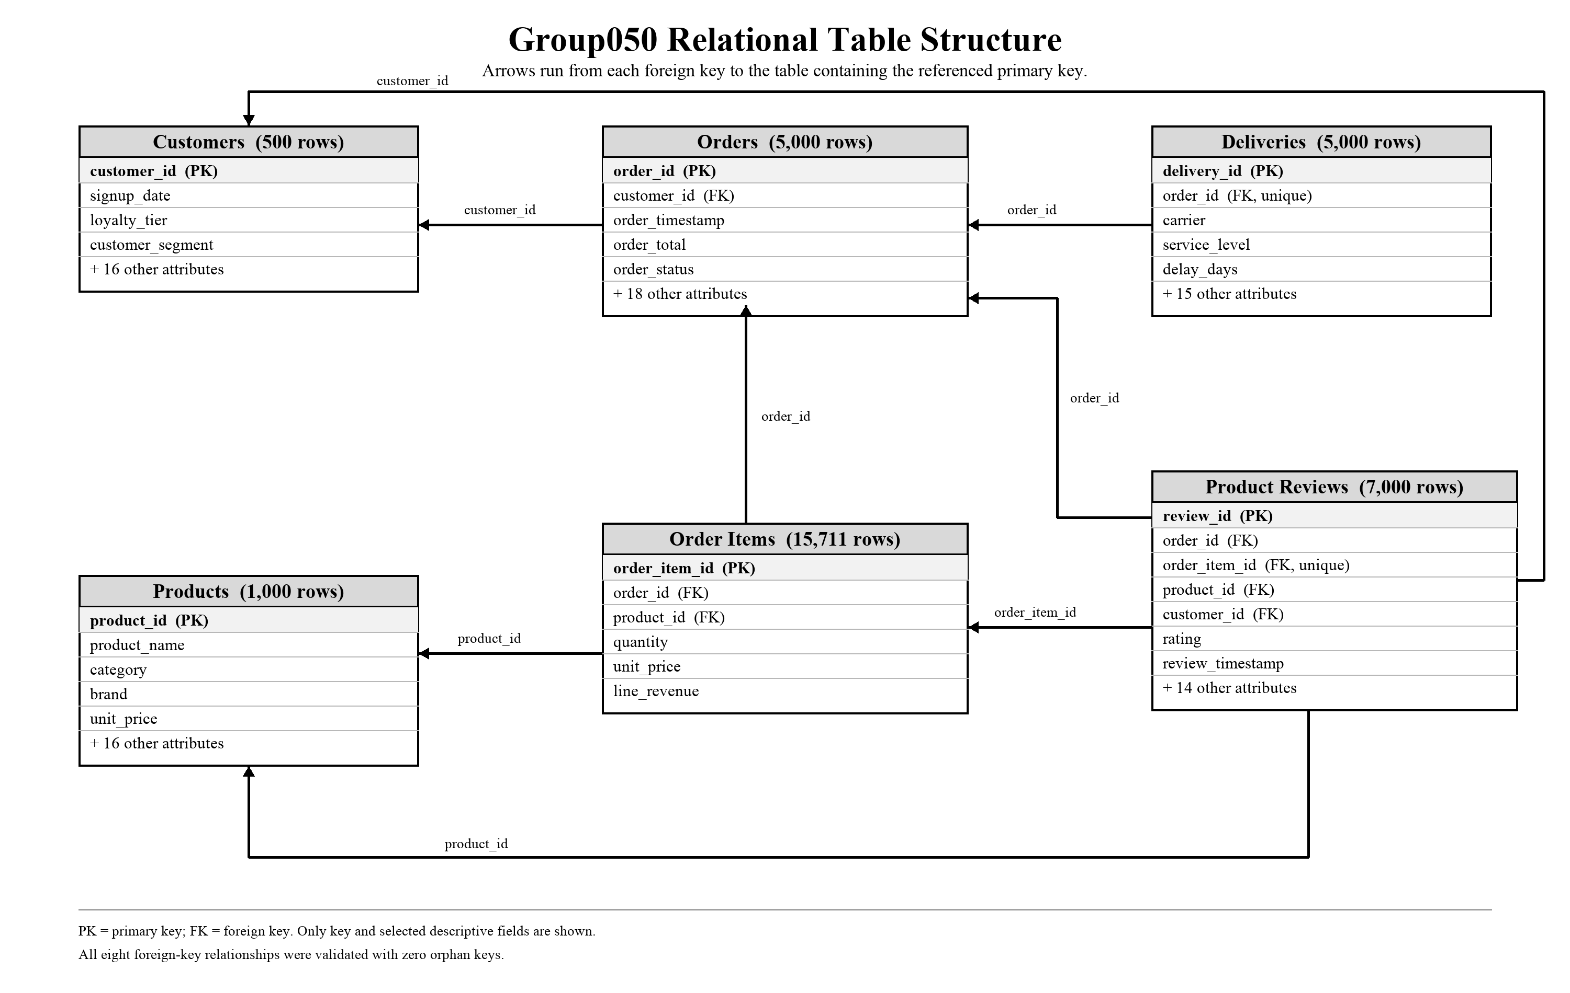

Table 1: Relational schema of the six standardised tables
Table 1 summarises the primary-key (PK) and foreign-key (FK) relationships among the six standardised relational tables. customers.customer_id and products.product_id are the primary keys of the customers and products tables, respectively. In orders, order_id is the primary key and customer_id is a foreign key referencing customers.customer_id. In order_items, order_item_id is the primary key, while order_id and product_id are foreign keys referencing orders.order_id and products.product_id, respectively. In deliveries, delivery_id is the primary key and order_id is a foreign key referencing orders.order_id; the relationship is one-to-one because each canonical order has exactly one matching delivery record. product_reviews uses review_id as its primary key and contains four foreign keys linking each review to its corresponding order, order item, product and customer. The arrows show each foreign key pointing to the primary key of its parent table. All eight required foreign-key relationships were validated successfully, with no orphan keys detected.

2. Data-preparation assurance
JSON and XML were parsed structurally before narrative regular expressions were applied, ensuring that the original hierarchy and the intended relational grains of the six target tables were preserved. Stable business keys were normalised before within-source deduplication and cross-source reconciliation so that equivalent records could be compared consistently across the two source systems (MAP-orders-01; MAP-deliveries-01). Monetary fields were also derived using the published arithmetic rules: rounded line revenue was aggregated to produce order_price, included GST was calculated as order_price/11, and the applicable discount and delivery charge were then used to derive order_total (MAP-orders-10, MAP-orders-14, MAP-orders-15). Identifiers retained their original case and leading zeros, while dates, timestamps, booleans and numeric fields were standardised according to the public data dictionary. For review text, valid Unicode characters were preserved during cleaning, while Latin-script analysis and non-Latin indicators were derived separately, with literal "NaN" used where the specification required a string missing-value sentinel (MAP-product_reviews-10, MAP-product_reviews-11, MAP-product_reviews-16).

Material validation results
Area | Validation ID | Observed result
Schema | VAL-SCHEMA-01 to VAL-SCHEMA-06 | Exact fields and field order for all six tables.
Keys | VAL-PK-ORDERS-01; VAL-FK-ORDER-ITEMS-01 | Complete/unique keys; required foreign keys have zero orphans.
Source flow | VAL-FLOW-01; VAL-FLOW-02 | 5,000 orders and 15,711 items equal source-key unions after overlap.
Arithmetic | VAL-ARITH-02; -03; -04 | 5,000 orders checked; zero price, total or included-GST mismatches.
Temporal | VAL-TIME-04 | 7,000 reviews matched deliveries; none preceded delivery.
Text | VAL-TEXT-TEST-01; VAL-TEXT-MULTI-01 | 18/18 public, 21/21 additional and 6/6 interface tests; zero derivation mismatches.
Complete validation register: 66 PASS, 0 FAIL

3. Assessed Visualisations (8 figures)
Figure 1. Distribution of completed order value
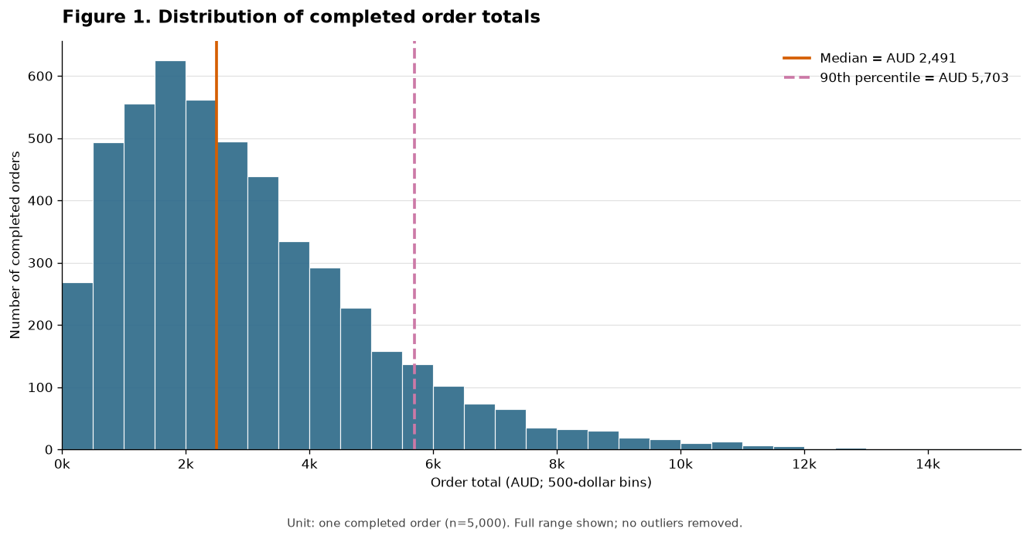
Analytical question: How are completed order totals distributed, and where does the high-value tail begin?
Observation Unit: one canonical completed order
Denominator and measure unit: All 5000 rows in orders table; monetary values are AUD
Tables used: orders; no join.
Join Keys: No join: order_id is checked as the primary key.
Result: The distribution is right-skewed. The median is $2491.42, the middle 50% spans between $1449.17 and $3951.42, and the 90th percentile is $5702.77 with 500 orders form the upper decile.
Limitation: order_total combines merchandise, tax, delivery and discounts. The figure cannot identify which component or product mix produces the tail, and completed orders do not represent cancelled or abandoned demand.
Figure 2. Basket units and completed order value
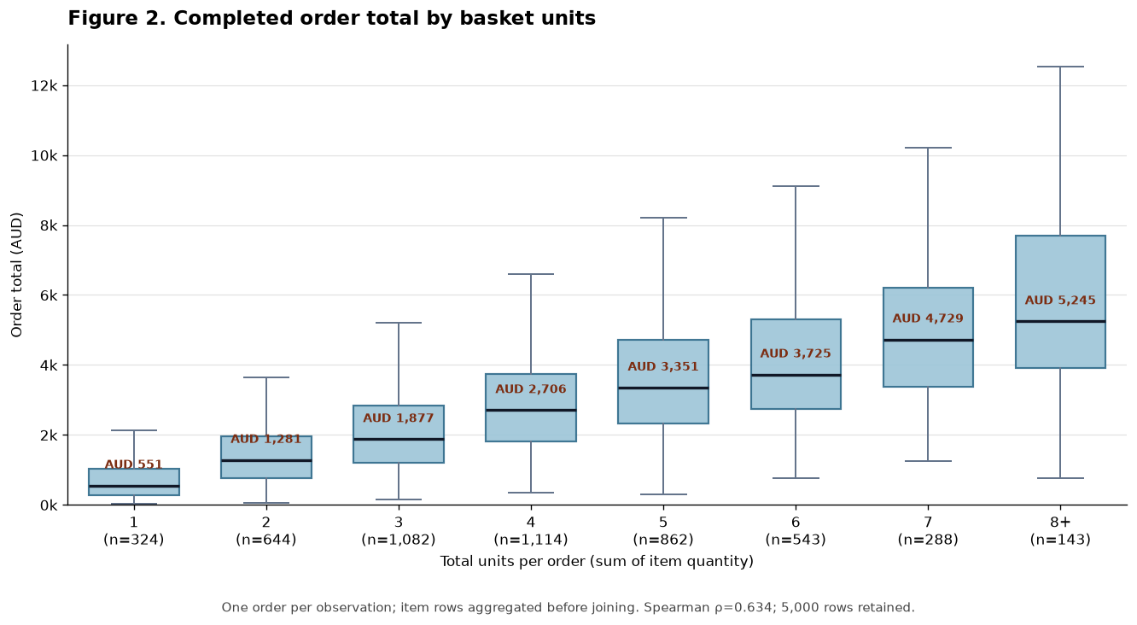
Analytical Question: How does completed order total differ as the number of purchased units increases?
Observation Unit and denominator: One canonical completed order after aggregating its order-item rows.
Denominator: All 5,000 orders with matched items; total_units is the sum of quantity per order_id.
Tables used: orders and order_items tables are used.
Join keys: Aggregate order_items by order_id, then join to orders.order_id.
Join multiplication check: validate = one_to_one retains 5000 rows and 5000 unique orders; all 15711 item rows contribute only through their order-level aggregate.
Result: Median order total rises from $551.08 for one-unit orders (n=324) to $5245.05 for 8+ units (n=143); Spearman ρ=0.634 indicates a moderately strong positive association.
Material limitation: Part of the association is mechanical because additional units add value. Product category, unit price, discount, tax and delivery charges are not controlled, while 8+ combines several sparse basket sizes.
Figure 3. Order value by customer segment
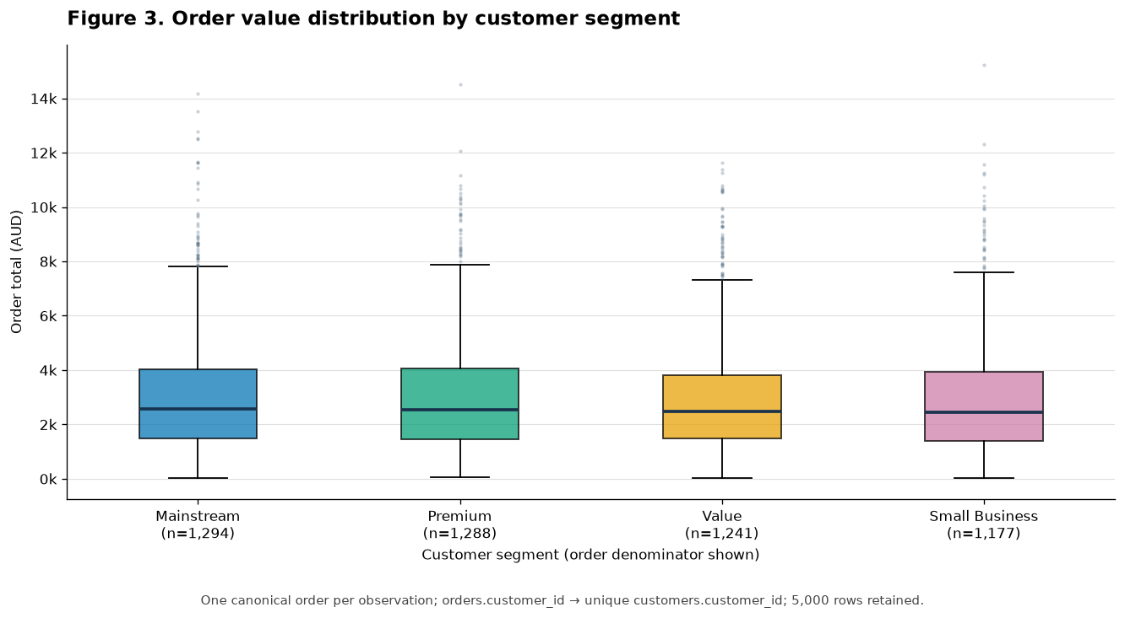
Question: How does canonical order value differ across customer segments?
Unit and denominator: one order; n=5,000. Join: orders.customer_id to customers.customer_id (many-to-one).
Result: Mainstream has the highest median at A$2,561.43 and Small Business the lowest at A$2,440.52, a difference of about 5.0%.
Limitation: The distributions overlap strongly, and segment may proxy product mix, tenure or purchase frequency. The result is not causal.

Figure 4. Monthly revenue by customer segment
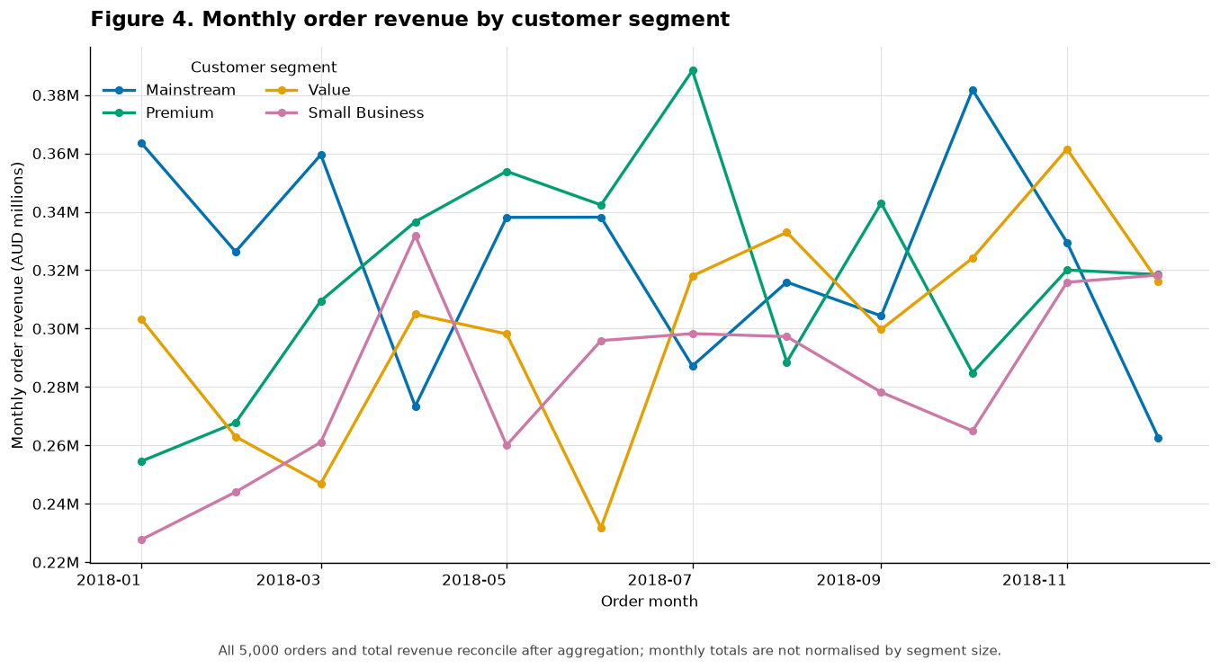
Question: How did canonical order revenue change over time, and did patterns differ by segment?
Unit and denominator: segment-month aggregate; 48 groups reconcile to all 5000 orders. Join: orders.customer_id to customers.customer_id.
Result: Revenue peaks are not synchronised: Mainstream peaks in October, Premium in July, Small Business in April and Value in November.
Limitation: Only one year is observed. Revenue also combines segment size, order frequency and order value.

Figure 5. Late-delivery risk by service level and carrier
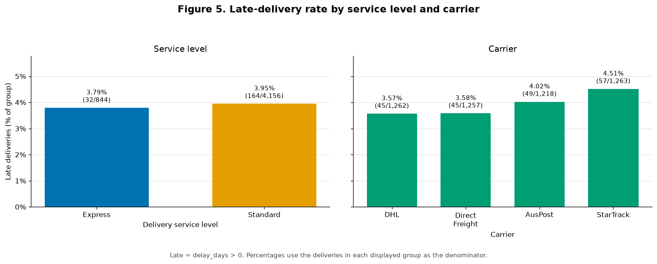
Question: Where is late-delivery risk concentrated across service levels and carriers?
Unit and denominator: one canonical delivery within each group; n=5000. Table: deliveries; late means delay_days > 0.
Result: Express has a 3.79% late rate and Standard 3.95%. StarTrack is highest at 4.51% and DHL lowest at 3.57%.
Limitation: These rates are unadjusted for route, warehouse or service mix, and only 196 deliveries are late.

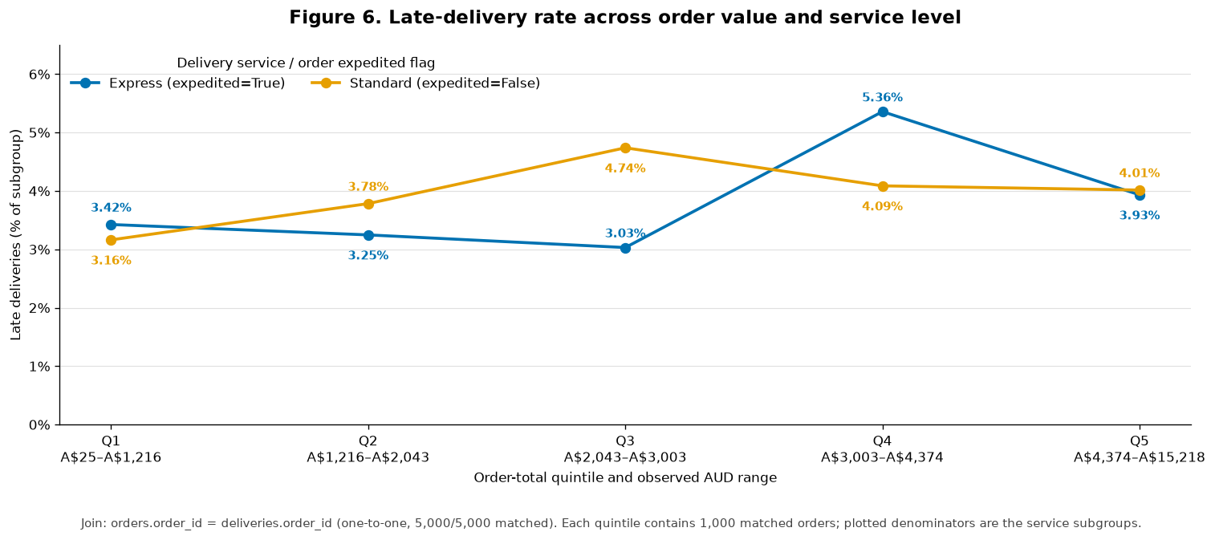
Figure 6. Order value, service level and late risk

Question: How is late-delivery risk associated with order value and expedited/service status?
Unit and denominator: one order-delivery pair; n=5,000. Join: orders.order_id to deliveries.order_id (one-to-one).
Result: Late rates are non-monotonic across value quintiles. Express ranges from 3.03%-5.36% and Standard from 3.16%-4.74%.
Limitation: Value bands are sample-specific, operational mix is uncontrolled and Express cells contain only 5-9 late events.

Figure 7. Review rating and text behaviour
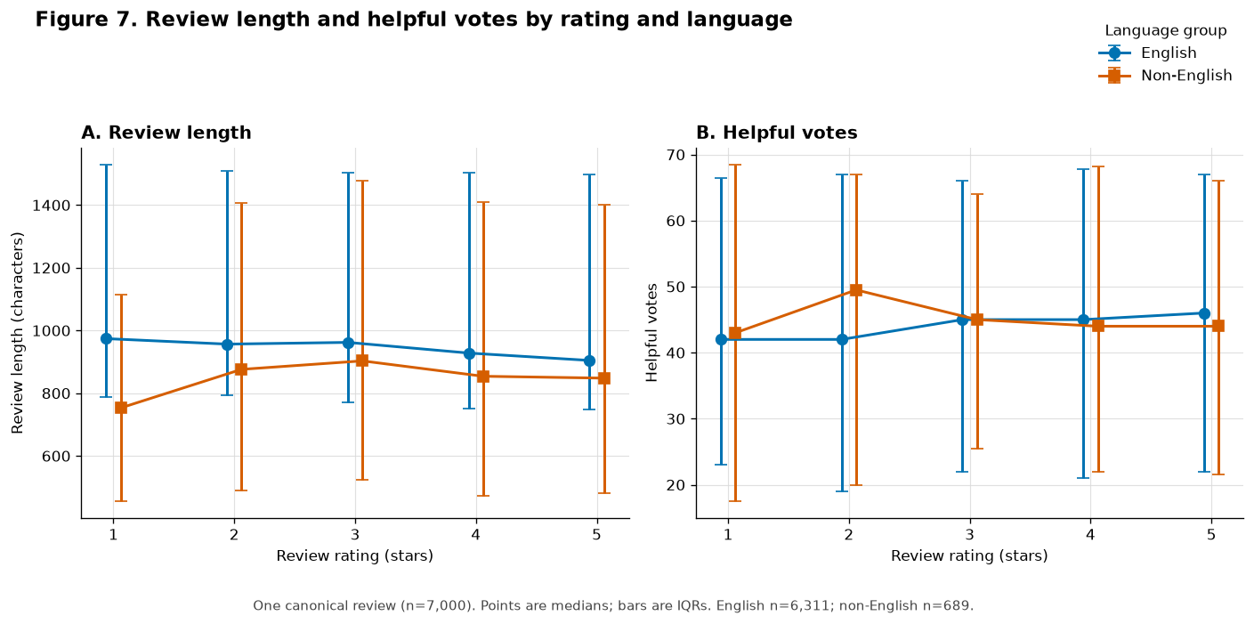
Question: How do review length and helpful votes vary across rating and language groups?
Unit and denominator: one canonical review; n=7,000 (6,311 English and 689 non-English). Table: product_reviews.
Result: English median length declines from 974 characters at 1 star to about 905 at 5 stars; helpful-vote medians remain around 42-50.
Limitation: Language groups are unequal, non-English combines scripts and helpful votes depend on unavailable exposure time.

Figure 8. Product category and review outcomes
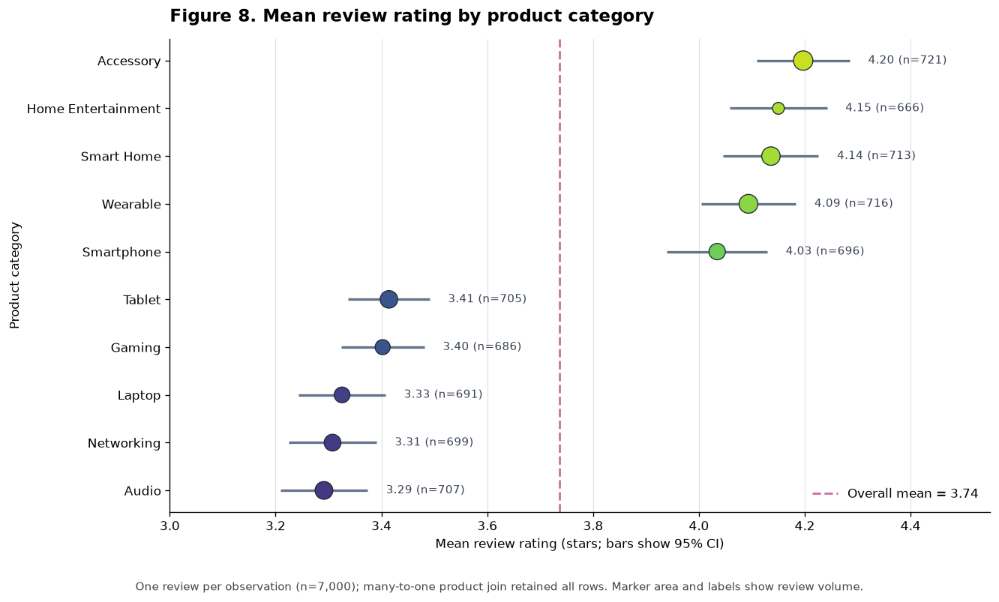
Question: How do ratings differ by category, and does review volume explain the category result?
Unit and denominator: one review; n=7,000. Join: product_reviews.product_id to products.product_id (many-to-one).
Result: Mean rating ranges from 3.29 for Audio to 4.20 for Accessory. Review volume is balanced and weakly related to mean rating (r=0.156).
Limitation: Category means may reflect product mix, reviewer selection, price, brand, fulfilment or timing.

4. Evidence-Based 10 Findings
1. At the one-order grain, Figure 1 shows a right-skewed distribution across 5000 completed orders: the median is $2,491.42 and the IQR is $1,449.17 – $3,951.42. Percentiles therefore provide a more useful description of a typical transaction than the extreme tail for retail planning. Product-price heterogeneity may explain much of the spread; category-adjusted totals should be examined before setting operational benchmarks.

2. Exactly 500/5000 orders (10%) are at or above $5702.77 in Figure 1. These orders may merit priority service or review, but premium products and larger baskets are legitimate explanations. Basket mix and customer history should be checked before an order is treated as anomalous.

3. After aggregating 15711 item rows to 5000 orders, Figure 2 shows median order total rising from $551.08 for 1 unit (n=324) to $5245.05 for 8+ units (n=143), with Spearman ρ=0.634. The relationship supports basket-aware planning but is partly mechanical and confounded by price and mix; category and unit price should therefore be considered before bundle decisions.

4. At the one-order grain, Figure 3 compares all 5000 matched orders. Mainstream has the highest median order total ($2561.43) and Small Business the lowest ($2440.52), a difference of $120.91 or 5.0%; IQRs overlap substantially. Segment alone offers limited value separation, so test product mix, tenure and frequency before broad segment-specific offers.

5. Figure 4 aggregates 5000 orders into 48 segment/month observations. Revenue peaks differ—Mainstream in October, Premium in July, Small Business in April and Value in November—potentially informing campaign timing. However, totals combine segment size, frequency and order value, and only one year is observed; validate the pattern with additional years or controlled campaigns.

6. At the delivery grain, Figure 5 reports 196/5000 late deliveries (3.92%), so 96.08% were not late. This is a useful service baseline but creates a highly imbalanced prediction target. Because the snapshot covers about one year, it may not represent future operations; monitor the rate over time and use imbalance-sensitive model metrics rather than accuracy alone.
7. Figure 5 shows StarTrack with the highest carrier late rate, 4.51% (57/1263), and DHL the lowest, 3.57% (45/1262), a 0.95-point spread. This identifies a review priority, not a causal carrier ranking: distance, warehouse, service mix and random variation remain plausible. Compare like-for-like deliveries and quantify uncertainty before reallocating volume.

8. Figure 6 uses 5000 one-to-one order–delivery pairs in five value bands of 1000. Late rates are non-monotonic, while overall Express and Standard rates are close (3.79% versus 3.95%). Express cells contain only 5–9 late events and operational mix is uncontrolled; test value and service as predictors rather than causal allocation rules.

9. At the one-review grain, Figure 7 covers 6311 English and 689 non-English reviews. English median length falls from 974 characters at 1 star to 904.5 at 5 stars, while helpful-vote medians across rating/language cells stay within 42–49.5. Script differences, unequal group size and review exposure may explain the pattern; compare token-normalised length and exposure-adjusted helpfulness before changing support policy.

10. Figure 8 shows mean rating from 3.291 for Audio (n=707) to 4.197 for Accessory (n=721), a 0.906-star gap. Category counts are balanced at 666–721 and correlate weakly with mean rating (r=0.156), so volume alone does not explain the ordering. Reviewer selection and product mix remain plausible; use product-level, time-aware adjusted comparisons before supplier or assortment decisions.

5. Future Machine-Learning 5 Questions

Question 1. Which completed orders have anomalous value given basket composition?
Evidence: Evidence: Figures 1–2 show a right-skewed value tail and wide variation within basket-size groups; 500/5000 orders are at or above the 90th-percentile threshold of $5702.77.
Decision and unit: Prioritise orders for fraud or data-quality review without blocking legitimate premium purchases; one submitted order after item aggregation.
Type and objective: Unsupervised anomaly detection; score order value conditional on basket size and item-price composition.
Predictors: Order total, units, line count, price summaries, discount, delivery charge, tax, channel and submission time.
Validation: Train on earlier orders and assess a later holdout; precision@k after adjudication and flag-rate stability.
Risks: No initial labels; premium products may be false positives. Exclude post-review fields, monitor drift and require human review with reason codes

Question 2. How much will each customer spend next month?
Evidence: Figures 3-4 show overlapping order values but different segment-month revenue peaks, so timing and behaviour may add signal.
Decision and unit: Support retention planning and budgeting; one customer at a month-end snapshot.
Type and target: Regression; total order_total generated during the following calendar month.
Predictors: Prior order count, recency, mean value, prior-12-month orders, lifetime value, segment, tier and channel mix at cutoff.
Validation: Rolling-origin validation using earlier months only; MAE and RMSE.
Risks: Future orders, updated lifetime value and post-cutoff fields cause temporal leakage. Audit errors across customer segments.

Question 3. Can late-delivery risk be predicted at dispatch?
Evidence: Figures 5-6 show 196/5000 late deliveries and modest variation by carrier, service and value band.
Decision and unit: Prioritise alerts or intervention; one dispatched delivery joined one-to-one to its order.
Type and target: Binary classification; delivered after promised date (delay_days > 0).
Predictors: Carrier, service, promised window, distance, fulfilment hours, warehouse, basket and dispatch-calendar features.
Validation: Chronological 70/15/15 split; PR-AUC, recall at alert capacity and calibration.
Risks: Exclude final delivery/tracking fields; audit by carrier, service, warehouse and geography; monitor alert fatigue and drift.

Question 4. Which delivered items are at risk of a low review?
Evidence: Figures 7-8 show 1166/7000 reviews (16.7%) at 1-2 stars and category/language variation.
Decision and unit: Target capacity-limited service recovery; one delivered order item eligible for review.
Type and target: Binary classification; subsequent canonical review rating <= 2.
Predictors: Product and item attributes, customer history, channel, carrier, service and realised delivery delay available at delivery.
Validation: Rolling-origin holdout; PR-AUC, capacity-based recall/precision and calibration.
Risks: Exclude review text/rating/helpful votes. Reviewer selection causes bias; monitor subgroup calibration and intervention burden.

Question 5. Can products be grouped into stable review profiles?
Evidence: Figures 7-8 show a 0.906-star category gap; product histories are sparse (median 7 reviews, range 1-8).
Decision and unit: Support quality and supplier investigation; one product at an analysis snapshot.
Type and objective: Unsupervised clustering of interpretable product and historical review-behaviour features.
Predictors: Rating level/variability, text length, helpfulness, low-rating/language shares, review count, price, warranty and category.
Validation: Earlier/later review windows plus bootstraps; silhouette and adjusted Rand/Jaccard stability.
Risks: Sparse histories and scaling may dominate; language can proxy demographics. Treat clusters as descriptive and human reviewed.

6. Limitations and recommended next steps

Limitations
The results are descriptive and observational and therefore cannot establish that customer segment, carrier, service level, order value or product category causes an observed outcome. The canonical order data cover one historical order year (2018) and contain 5000 completed orders with corresponding delivered records; linked delivery and review activity may occur shortly after the end of the order year. Transactions not represented in the submitted canonical tables, such as abandoned, cancelled or returned activity, cannot be analysed, so the data do not capture the retailer's complete demand and post-purchase funnel. Carrier and service-level comparisons are also unadjusted for factors such as route, warehouse, season and product mix.
The temporal analysis is further limited by the single historical order year. Consequently, the segment-specific monthly revenue peaks in Figure 4 may reflect one-off promotions, holidays or random variation rather than recurring seasonal patterns. The analysis cannot establish that the same timing differences will persist in future years, so they should not be used alone for long-term forecasting or campaign scheduling. Additional years of customer-order data would be needed to assess whether these patterns are persistent. The current results are therefore most appropriately treated as descriptive evidence for further investigation of segment-specific timing strategies.
Delivery comparisons are uncertain because only 196 of 5000 deliveries were late, with just five to nine late events in some Express-by-value cells. Review analyses represent submitted reviewers rather than all purchasers or all 15711 purchased items, so self-selection may bias comparisons. English reviews dominate (6,311/7000), while the 689 non-English reviews combine several languages and scripts, making raw character length imperfectly comparable across language groups. Helpful-vote counts also lack exposure-time information. In addition, order_total measures transaction value rather than profitability, and several subgroup comparisons do not include formal uncertainty intervals. Stronger decisions would therefore require additional historical periods, broader information on abandoned, cancelled and returned activity, margin and promotion data, review-exposure information, and time-aware adjusted analyses.

Recommended next steps
These limitations indicate several priorities for future analysis. Because high-value orders may reflect legitimate differences in product category and basket composition, future high-value order-review benchmarks should account for category and basket characteristics rather than relying on a single universal threshold. Similarly, carrier and service-level comparisons should be conducted within more comparable operational contexts, including route, warehouse and service mix, with uncertainty reported given the relatively small number of late deliveries. Finally, additional historical periods and more complete review-eligibility and exposure information would support more robust evaluation before operational deployment of revenue, delivery or review models, particularly for assessing whether temporal patterns persist and for reducing bias arising from review selection and unequal exposure.

Conclusion
The relational EDA identifies three principal themes. First, order value is positively associated with basket size, while customer-segment medians differ only modestly. Second, late delivery is uncommon and observed service-level differences are small relative to subgroup uncertainty, suggesting that any operational intervention should rely on calibrated, capacity-aware risk estimates rather than simple rules. Third, review behaviour varies by rating and language, while mean ratings differ across product categories; however, reviewer selection, exposure and product mix limit interpretation and prevent causal conclusions. Overall, the evidence supports targeted follow-up analyses and five candidate machine-learning questions, provided future work uses chronological validation, decision-time predictors, leakage controls, subgroup evaluation and human oversight. No model was trained in this assessment.

References

