Deploying, Launching and Removing Gitlab on Dockers guide

Table of Contents
1. Docker, Docker-Compose 2
1.1 The first tool to install is Docker itself. 2
1.2 Install docker-compose 5
2. Launch/Stop Gitlab using Docker-compose on offline client 5
2.1 Preparation and setup 5
2.2 Setting up HTTPS for Gitlab with host/a client that is as Cert Authority 7
3. Configuring Gitlab to startup on reboot 8
4. Starting Gitlab 8
5. Enabling/Disabling of SSH access to Gitlab and Disabling Gravatar 11
6. Creating Gitlab account for new users (non-AD integrated) 14
7. Integrating LDAP 17
8. Git clone, push and pull via terminal from external clients 17
9 Data migration for Gitlab 20

1. Docker, Docker-Compose

1.1 The first tool to install is Docker itself.
If you have local repository installed, you can install via apt-get method.
$ sudo apt-get install docker

Alternatively on a internet connected machine, open a terminal window and issue the command:
$ sudo apt-get download $(apt-rdepends docker | grep -v "^ ")
If you encounter the message(s): “Can't select candidate version from package <package name> as it has no candidate”. You need to filter out those packages via adding “ | grep -v "^<NAME> "” to the back of the command above for each package name.

Copy over the dependencies that are downloaded to your offline machine and install them if you want to install docker in air-gapped environment/client.

Once Docker is installed, you would want to add your user to the docker group with the command to elevate your account to run docker without the need for sudo (Optional):
$ sudo usermod -aG docker $USER

Please configure the /etc/docker/daemon.json file to include the lines in red to avoid problems with nginx container errors in GoHarbor during installation:
$ sudo gedit /etc/docker/daemon.json
{
…
"exec-opts": ["native.cgroupdriver=systemd"],
"log-driver": "json-file",
"log-opts" : {
"max-size": "100m"
}
}

Changing docker repository from /var/lib/docker to some other files
Method A) Via service file
A1) Stop docker service daemon and modify systemd docker start up as shown
$ systemctl stop docker
$ gedit /lib/systemd/system/docker/service
ExecStart=/usr/bin/dockerd -g /new/path/docker -H fd:// --containerd=/run/containerd/containerd.sock

A2) Check that the docker daemon is completely stopped
$ ps aux | grep -i docker | grep -v grep
#No output should be expected.

A3) Reload systemd daemon
$ systemctl daemon-reload

A4) Create specified directory and rsync current docker data to new directory
$ mkdir /new/path/docker
$ rsync -aqxP /var/lib/docker/ /new/path/docker

Note: If /new/path/docker is a mounted directory from a separate disk partition, please do the following steps.
$ systemctl list-units --type=mount #List all existing mounts
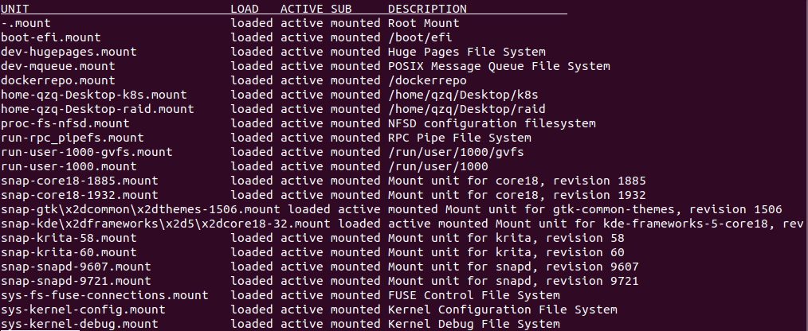
Example: If your /path/to/your/docker is /raid:
To identify the mount name, locate the row where the “DESCRIPTION” column shows /raid and find the corresponding unit name under “UNIT” column. In our case, it should be raid.mount with “ACTIVE” status being active.

$ systemctl status <xxx.mount>
$ sudo gedit /lib/systemd/system/docker.service
...
After = network.target … <xxx.mount> #name of the mount
...

$ sudo systemctl daemon-reload

A5) Start docker service daemon and confirm docker runs within new data directory
$ systemctl start docker
$ ps aux | grep -i docker | grep -v grep
root 2552 2.1 0.3 8053228 109652 ? Ssl 12:02 1:19 /usr/bin/dockerd -g /new/path/docker -H fd:// --containerd=/run/containerd/containerd.sock

Method B) Via daemon.json (Preferred)
B1) Stop docker daemon
$ sudo service docker stop

B2) Modify /etc/docker/daemon.json and add the contents in red below.
$ sudo gedit /etc/docker/daemon.json
{
...
"exec-opts": ["native.cgroupdriver=systemd"],
"log-driver": "json-file",
"log-opts": {
"max-size": "100m"
},
“graph”: “<path>/docker”
}

B3) Copy current data directory to new one
$ sudo rsync -aP /var/lib/docker/ /path/to/your/docker

Note: If /new/path/docker is a mounted directory from a separate disk partition, please do the following steps.
$ systemctl list-units --type=mount #List all existing mounts
Example: If your /path/to/your/docker is /raid:
To identify the mount name, locate the row where the “DESCRIPTION” column shows /raid and find the corresponding unit name under “UNIT” column. In our case, it should be raid.mount with “ACTIVE” status being active.

$ systemctl status <xxx.mount> #Check status of specified mount unit
$ sudo gedit /lib/systemd/system/docker.service
...
After = network.target … <xxx.mount>
...

B4) Reload systemd daemon and Rename old docker directory and restart docker daemon
$ sudo mv /var/lib/docker /var/lib/docker.old
$ sudo service docker start

B5) Delete old directory if everything is ok
$ sudo rm -rf /var/lib/docker.old

1.2 Install docker-compose
On internet machine, copy the following command on internet facing machine to get the docker-compose binary. The version we are using is 1.25.5.
$ wget https://github.com/docker/compose/releases/download/1.25.5/docker-compose-uname -s-uname -m -o docker-compose
Copy over the docker-compose binary into offline machine and put in /usr/local/bin/ . Convert docker-compose binary as an executable:
$ sudo chmod u+x /usr/local/bin/docker-compose

2. Launch/Stop Gitlab using Docker-compose on offline client

2.1 Preparation and setup
Step 1. [Host Client] Create a working folder for gitlab on any clients with docker installed. This folder will be your directory.
$ mkdir gitlab_docker
$ cd gitlab_docker

Step 2. [Host Client] Get the gitlab community edition image from docker hub via internet machine.
- gitlab/gitlab-ce:13.0.6-ce.0
$ docker pull gitlab/gitlab-ce:13.0.6-ce.0

Pull the Gitlab image required from an internet machine and transfer it to the offline client to be loaded into client’s docker repository.

Step 3. [Host Client] Create a docker-compose.yaml file with the following contents.
$ vim docker-compose.yaml
version: '3'
services:
gitlab:
image: 'gitlab/gitlab-ce:13.0.6-ce.0'
container_name: 'gitlab-ce'
restart: always
hostname: '<preferred_hostname>'
environment:
GITLAB_OMNIBUS_CONFIG: |
external_url 'https://gitlab.io’ #For HTTPS implementation, otherwise use http and its relevant port
prometheus['listen_address'] = '0.0.0.0:9090'
prometheus['enable'] = true
gitaly['prometheus_listen_addr'] = "0.0.0.0:9236" #Requires gitlab_exporter env below:
gitlab_exporter['enable']=true
node_exporter['listen_address'] = '0.0.0.0:9100'
redis_exporter['listen_address'] = '0.0.0.0:9121'
postgres_exporter['listen_address'] = '0.0.0.0:9187'
gitlab_rails['time_zone'] = 'Asia/Singapore'
gitlab_rails['backup_keep_time'] = 172800
nginx['listen_port'] = 443
nginx['redirect_http_to_https'] = true
nginx['ssl_certificate'] = "/etc/ssl/certs/gitlab/gitlab.io.crt" #Must match the generated cert name
nginx['ssl_certificate_key'] = "/etc/ssl/certs/gitlab/gitlab.io.key" #Must match the generated cert name
nginx['ssl_protocols'] = "TLSv1.1 TLSv1.2"
nginx[‘client_max_body_size’] = ‘0’ #Remove file-size limit checks for git push to gitlab
# Add any other gitlab.rb configuration here, each on its own line. Pem files name must match the pem files provided in the mounted volume.

ports:
#Inclusion of Host IP is to tie Gitlab and its relevant services to a particular IP address, especially if host is configured to have multiple IP addresses on the same network card.
- '<Host IP>:80:80'
- '<Host IP>:443:443'
- '<Host IP>:3322:22'
- '<Host IP>:9090:9090' #Prometheus UI
- '<Host IP>:9168:9168' #Gitlab exporter
- '<Host IP>:9236:9236' #Prometheus exporter
- '<Host IP>:9100:9100' #Node exporter
- '<Host IP>:9121:9121' #Redis exporter
- '<Host IP>:9187:9187' #Psql exporter
- '<Host IP>:8060:8060' #Nginx health check endpoint
- '<Host IP>:8082:8082' #Sidekiq exporter
volumes:
- '<path/to>/gitlab_docker/config:/etc/gitlab'
- '<path/to>/gitlab_docker/logs:/var/log/gitlab'
- '<path/to>/gitlab_docker/data:/var/opt/gitlab'
- '<path/to>/gitlab_docker/volume_data/ssl:/etc/ssl/certs/gitlab'

2.2 Setting up HTTPS for Gitlab with host/a client that is as Cert Authority
Note: Steps 1 and 2 can be skipped if you intend to use the relevant CA key and pem file generated from other clients. Otherwise, to make your host as CA, please execute steps 1 and 2. You just need the relevant .key and .pem/.csr file for subsequent steps 3 to 5.

Step 1. [Host Client] Be a cert authority(CA) by generating secret key. Enter the pass phrase for the key.
$ sudo openssl genrsa -des3 -out myCA.key

Step 2. [Host Client] Generate root certificate for CA.
$ sudo openssl req -x509 -new -nodes -key myCA.key -sha256 -days 3650 -out myCA.pem

Step 3. [Host Client] Generate a secure server key.
$ sudo openssl genrsa -out gitlab.io.key 4096

Step 4. [Host Client] Generate the certificate signing request with a openssl configuration file.
Note that the answer for Common Name must be the domain name used for Gitlab to be accessed. Otherwise, your certificate signing would be invalid.
$ sudo gedit req.conf
[req]
distinguished_name = req_distinguished_name
req_extensions = v3_req
prompt = no
[req_distinguished_name]
C = SG
ST = SG
L = SG
O = Gitlab
OU = Gitlab
CN = gitlab.io # Must match the domain name for gitlab
[v3_req]
keyUsage = keyEncipherment, dataEncipherment
extendedKeyUsage = serverAuth

[alt_names]
DNS.1 = gitlab.io
DNS.2 = *.gitlab.io

$ sudo openssl req -new -key gitlab.io.key -out gitlab.io.csr -config req.conf

Step 5. [Host Client] Create the signed certificate and copy the certs to mounted directory.
$ sudo openssl x509 -req -in gitlab.io.csr -CA myCA.pem -Cakey myCA.key -Cacreateserial -out gitlab.io.crt -days 3650 -sha256

Step 6. [Host Client] Copy the .crt and .key to mounted directory for Gitlab.
$ mkdir -p ./volume_data/ssl
$ cp gitlab.io.crt gitlab.io.key ../volume_data/ssl #Must match the highlighted path in compose yaml file. Make sure the files have read permissions.

3. Configuring Gitlab to startup on reboot
Step 1. [Host Client] Add the following service file and script: (Please modify the path to gitlab directory accordingly as indicated with <PATH/TO> below)
$ sudo gedit /etc/systemd/system/gitlab.service
[Unit]
Description=Gitlab Service
After=docker.service systemd-networkd.service systemd-resolved.service <xxx.mount>
Requires=docker.service <xxx.mount> #Add <xxx.mount> if your docker repo is on a mounted dir.

[Service]
Type=simple
Restart=on-failure
RestartSec=5
WorkingDirectory=<PATH/TO>/gitlab_docker
ExecStart=/usr/local/bin/docker-compose up --remove-orphans
TimeoutStopSec=1200
RemainAfterExit=yes

[Install]
WantedBy=multi-user.target

Step 2. [Host Client] Reload daemon and enable Gitlab service:
$ sudo systemctl daemon-reload
$ sudo systemctl enable gitlab.service
$ sudo systemctl start gitlab.service

An example of a proper running gitlab service
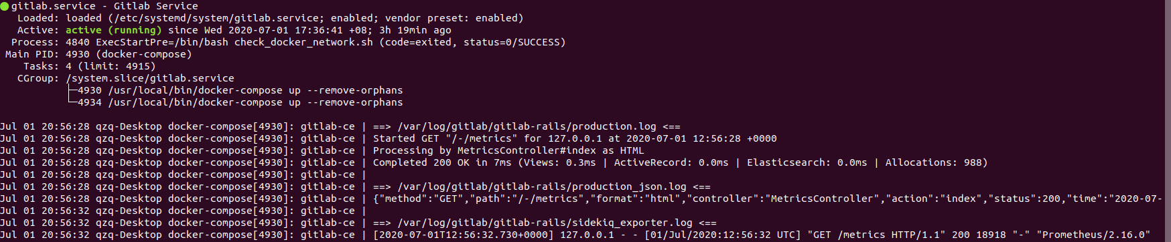
Note: For a manual restart of Gitlab, execute either of the following commands:
1) in your Gitlab installation folder <PATH/TO>/gitlab_docker
$ sudo docker-compose start

OR 2) Via service file
$ sudo systemctl restart gitlab

4. Starting Gitlab
Step 1. [Host Client] Start Gitlab with docker network create and docker-compose
$ cd <PATH/TO>/gitlab_docker
$ sudo docker-compose up

The end output should like this in the terminal screen:
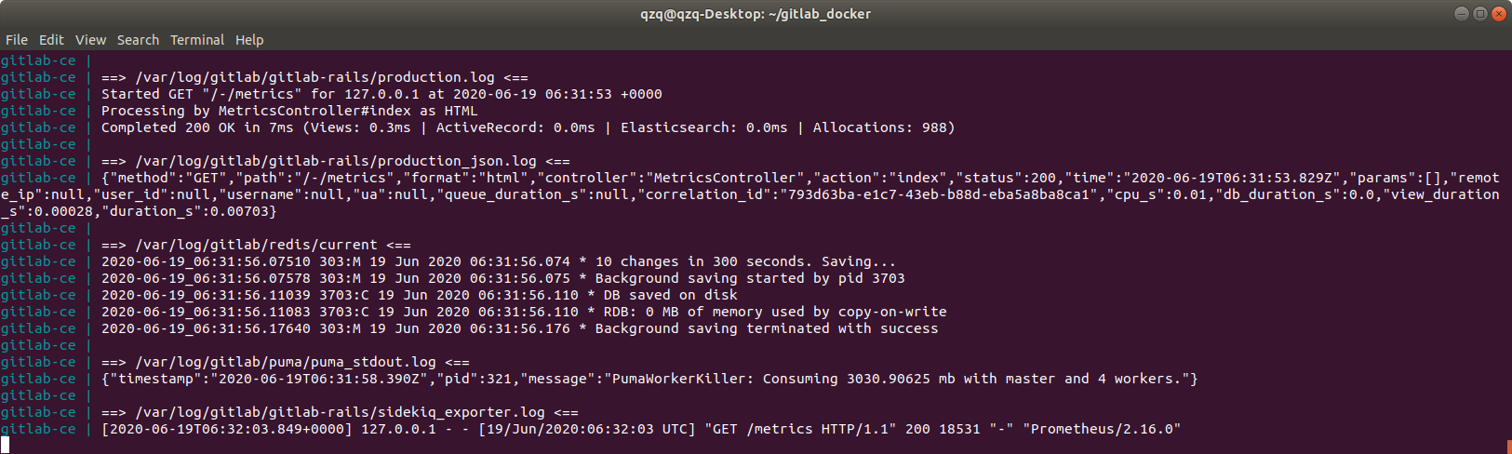
Step 2. [Host Client] Access the Gitlab page from any client in the network by typing https://gitlab.io . Key in a new password for the root account and click on “Change your password”.

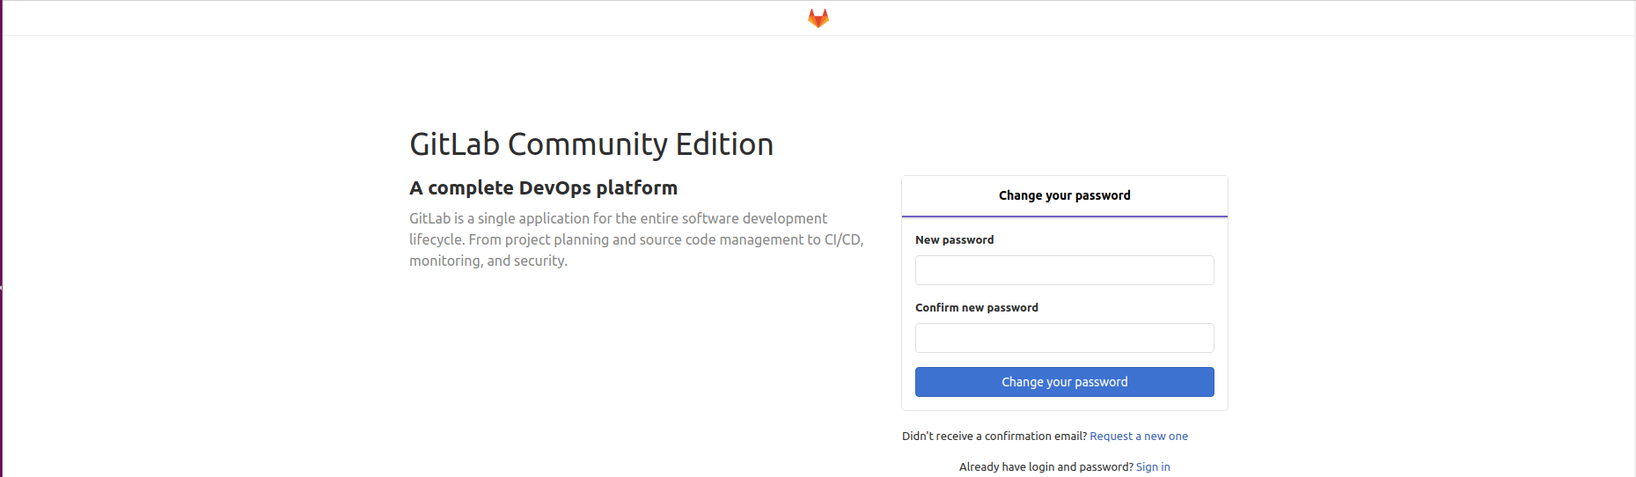
You will be redirected to the login page as seen below. Login with following credentials:
- Username: root
- Password: <Your new password in previous step>
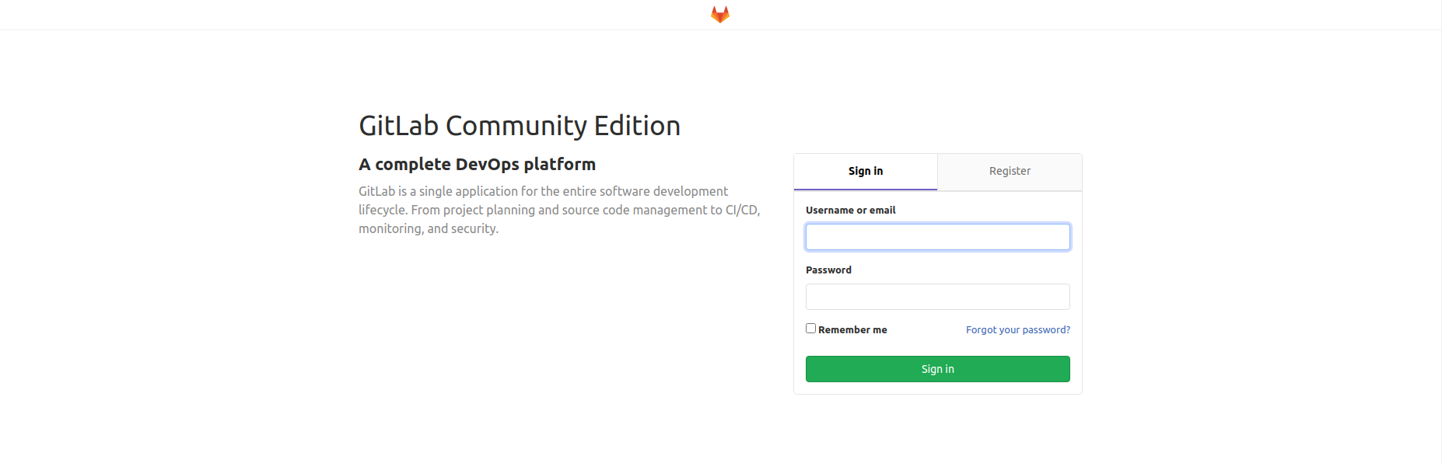

Note: At first login instance for root account, you may see a Gitlab 404 error page below, as there are no repositories.

Just click on the “Search” button and you would be redirected to main gitlab page shown below.
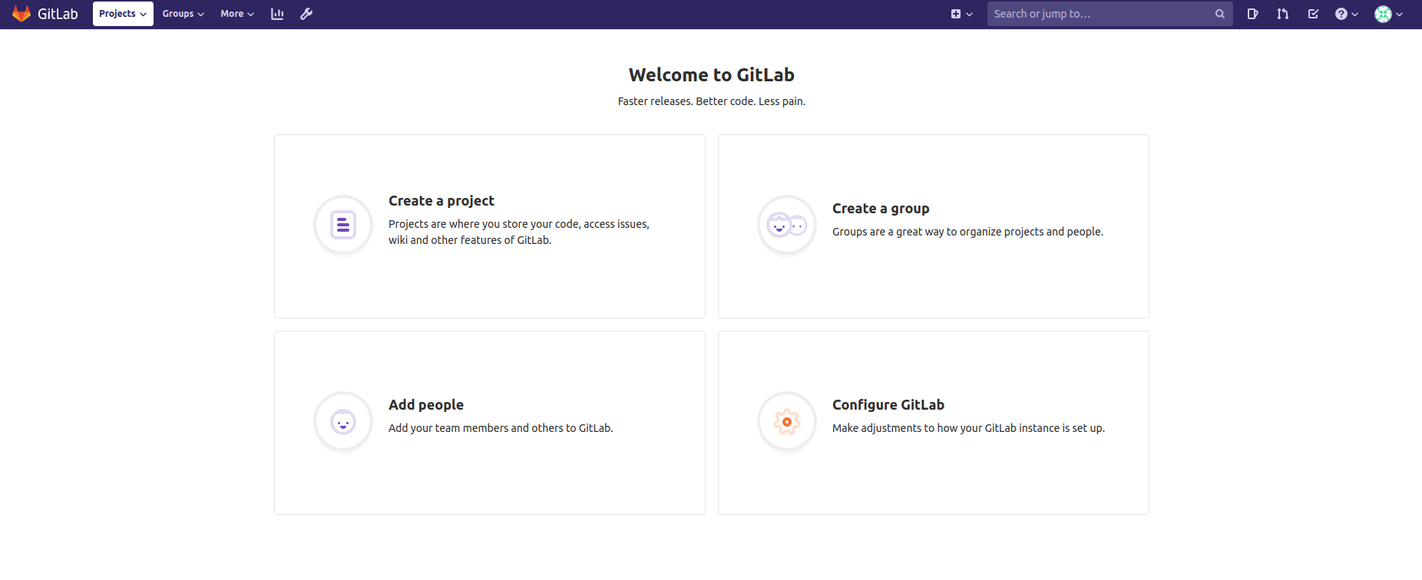
For cert replacement or Gitlab termination:
[Host Client] Stop Gitlab with docker-compose or via service file
$ sudo docker-compose down
OR
$ sudo systemctl stop gitlab

Remember to bring up Gitlab service via either commands after replacing the certificates.
$ sudo docker-compose up
OR
$ sudo systemctl start gitlab
**NOTE: Replacing of cert should not result in any loss of accounts or repositories. It has been tested on my personal setup.**

5. Enabling/Disabling of SSH access to Gitlab and Disabling Gravatar
Step 1. Login using the “root” account of Gitlab.

Step 2. Click on the icon on the navigation panel at the top to access “Admin Area” as shown below.

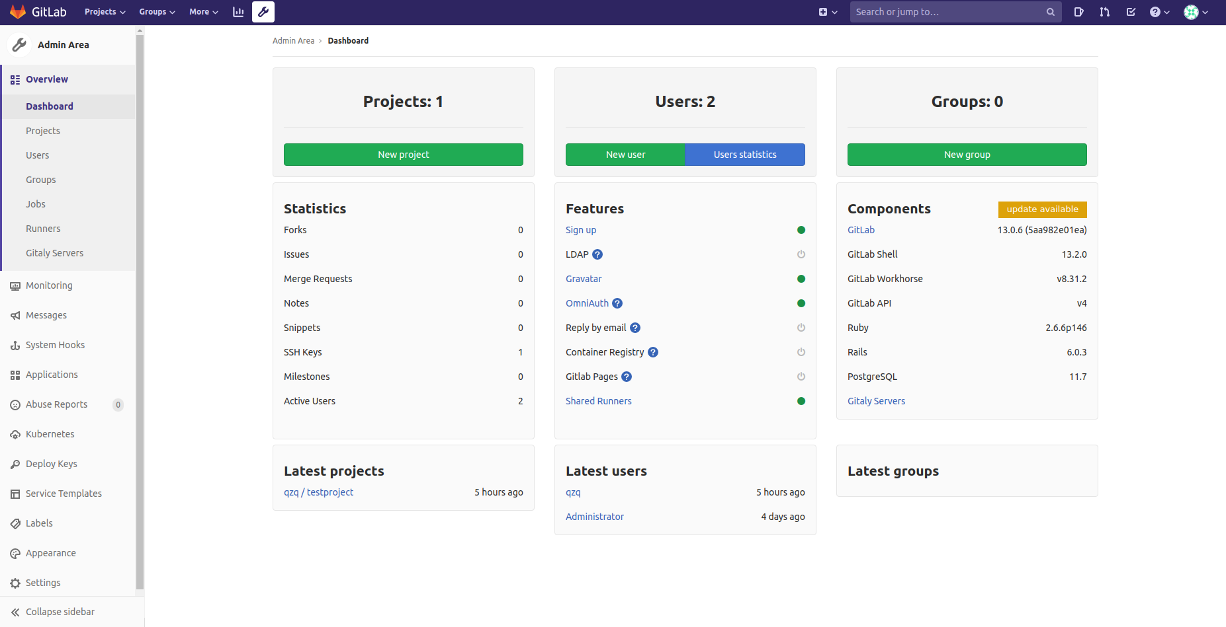

Step 3. Click on the “General” under the Settings tab on the left navigation panel and click on “Expand” beside “Visibility and access controls” as shown below.

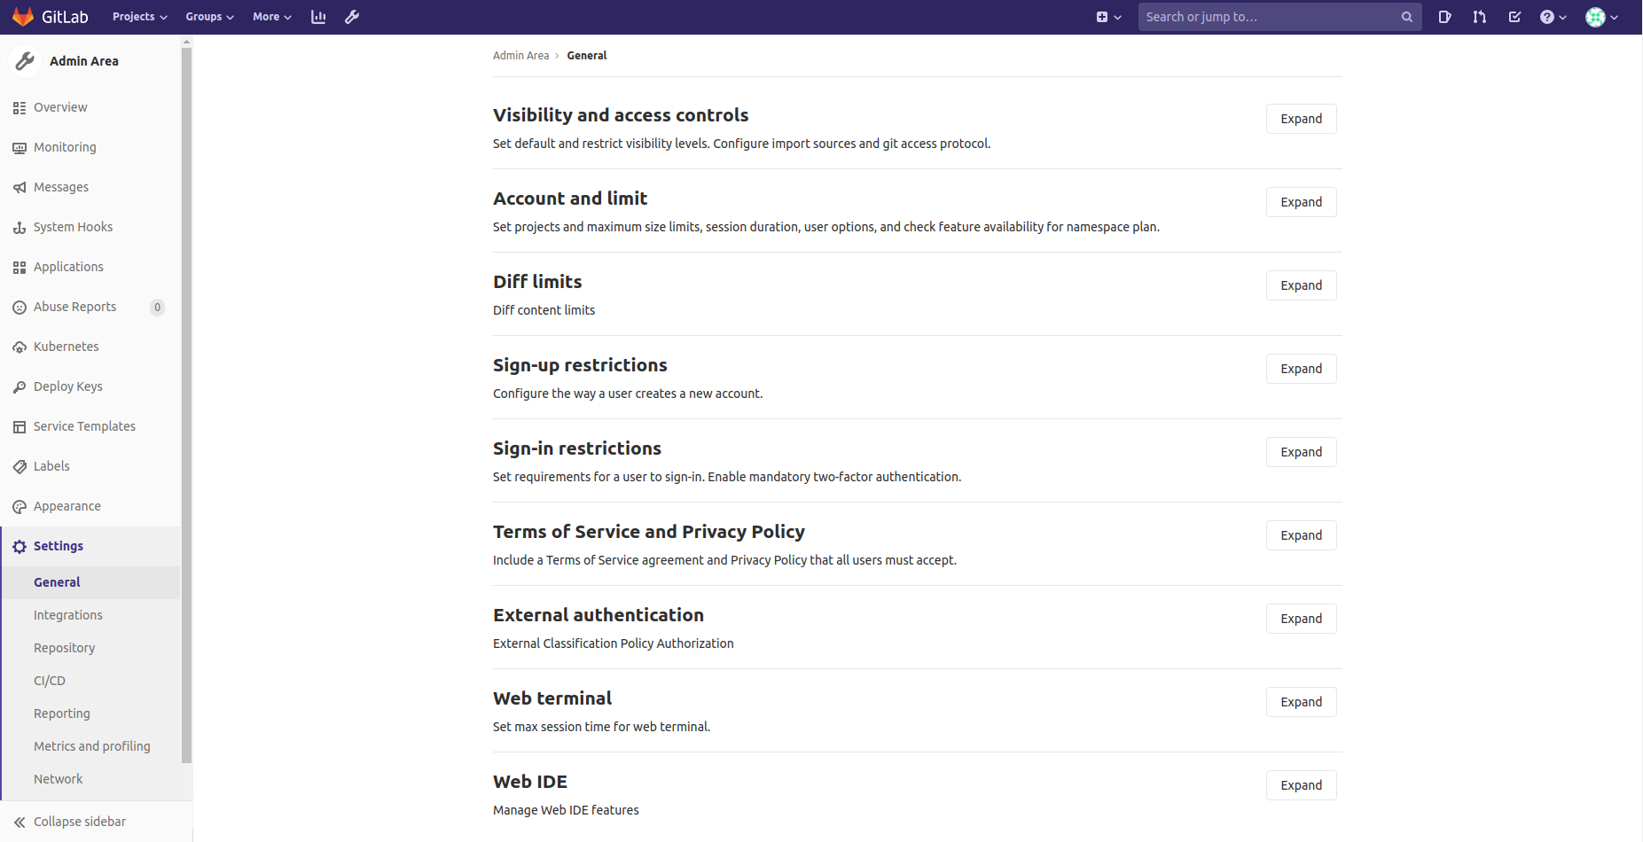

Step 4. In the “Enabled Git Access Protocols”, select from the dropdown: only HTTP(S) protocol. Save the changes when you are done.
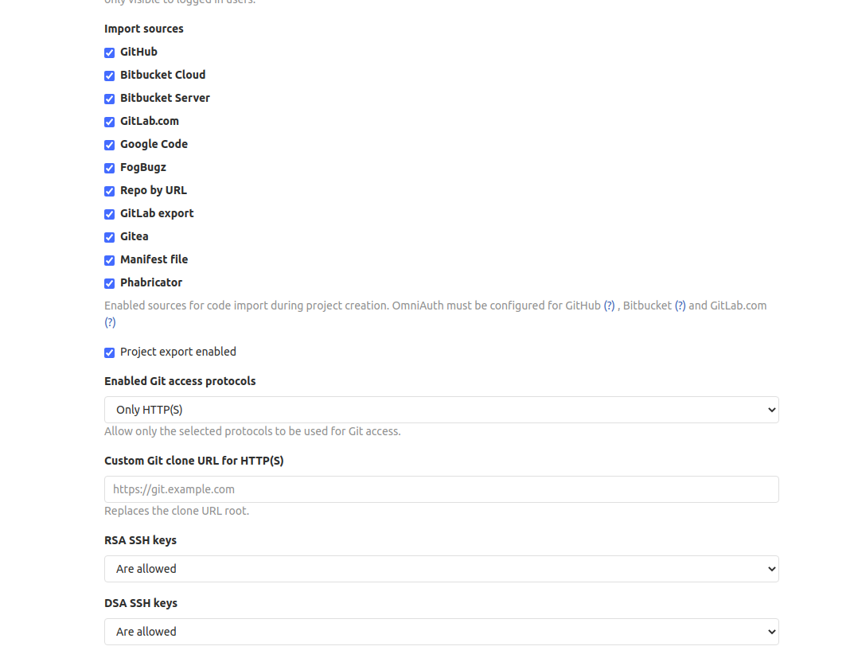
Step 5. To disable gravatar: Under “Admin Area” which is assessed as per step 2, click on “Settings” > “General” at the left navigation panel and click “Expand” under “Account and limit” section as shown.

Uncheck the checkbox beside “Gravatar disabled” as shown.
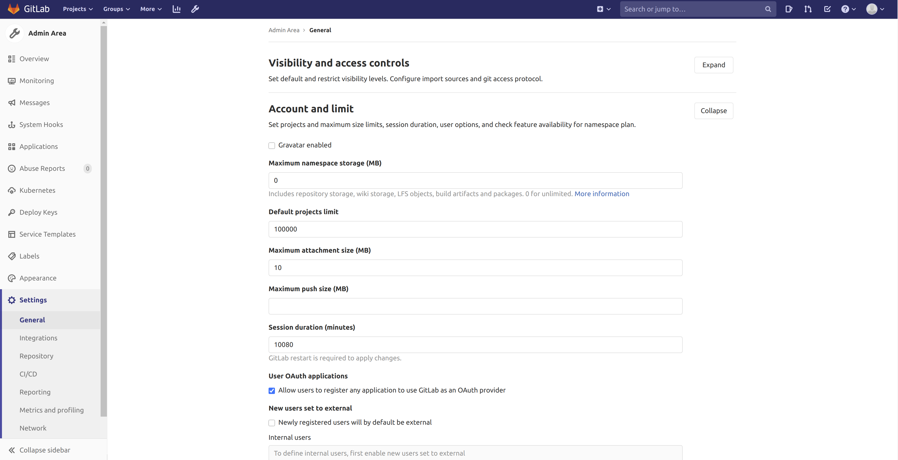

6. Creating Gitlab account for new users (non-AD integrated)
Step 1. Click on Register tab as shown.
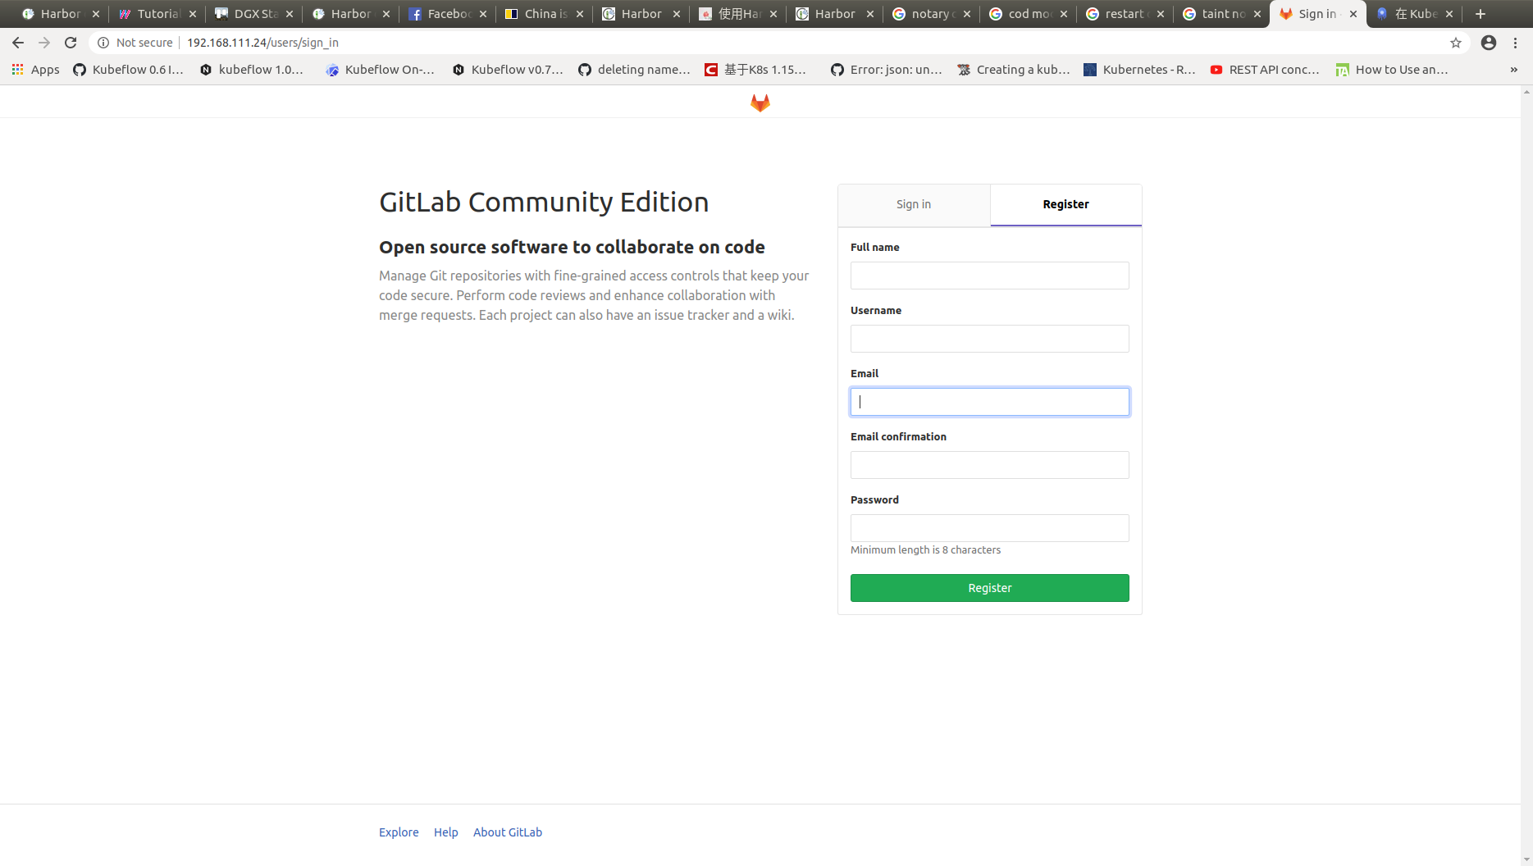
Step 2. Fill in the details. For email and email confirmation, just key in some arbitrary input. Upon completion, click on “Register”. It would lead you to the following page.

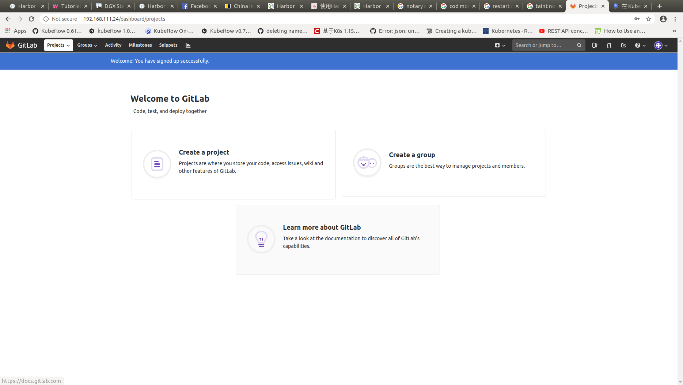

Step 3. Clicking on “Creating a project” leads to the following page:

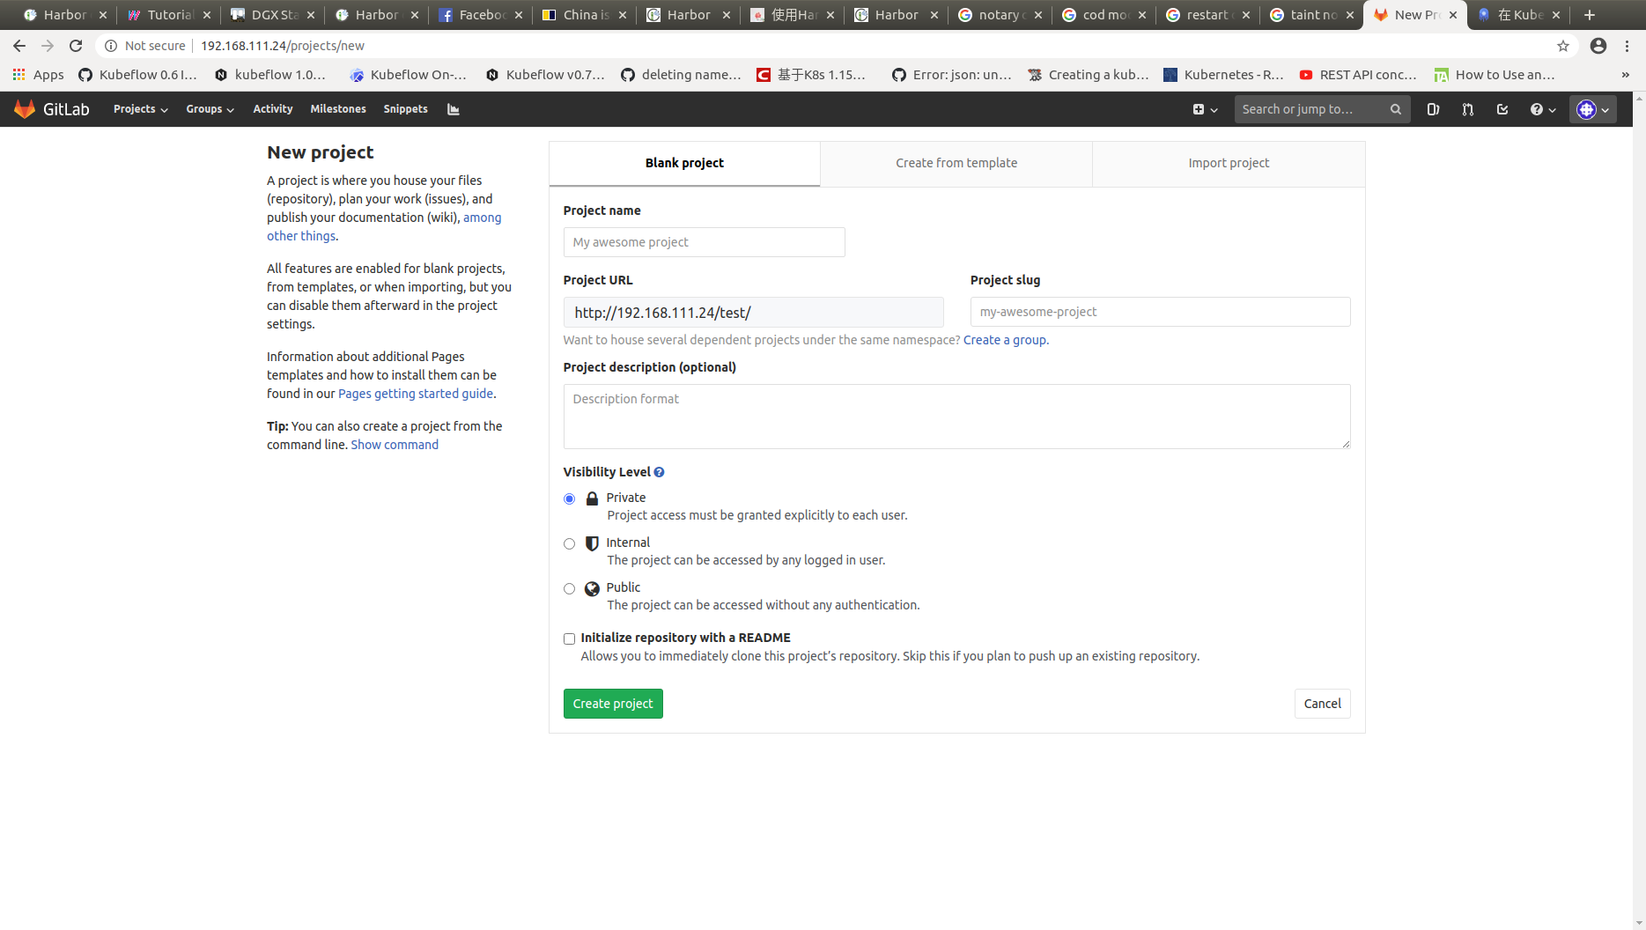

Step 4. As a example, fill in your project name and select the suitable visibility level. Once done, click on “Create project”. As an example, a test repo with private visibility level is created which is shown below.
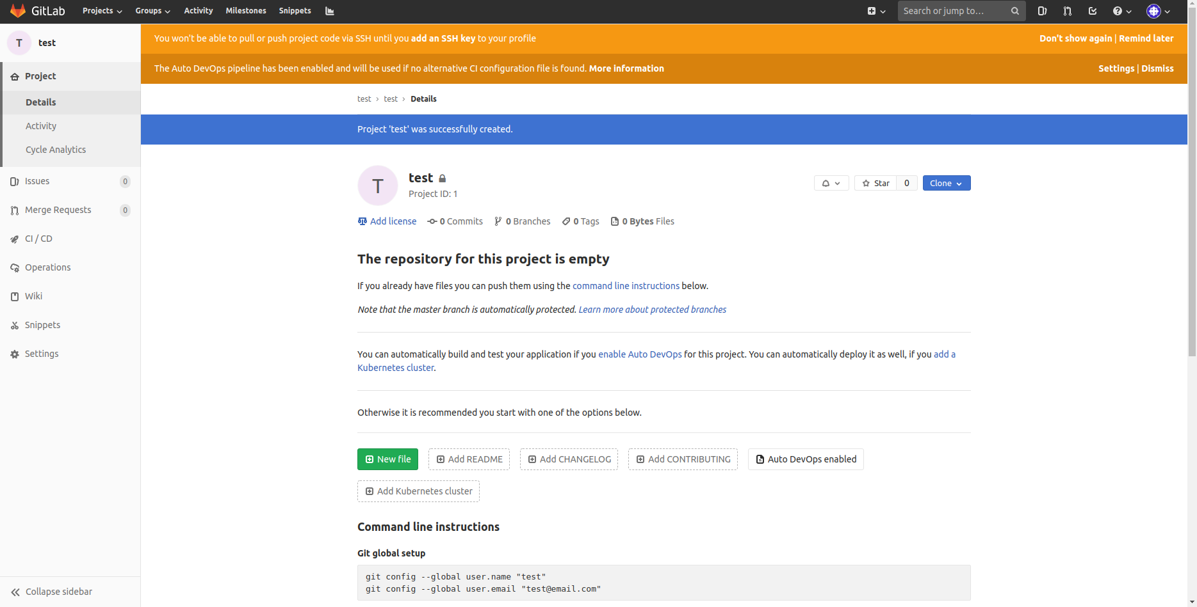
Some of the commands that you can make with the repositories are indicated in the command line instructions section as shown:
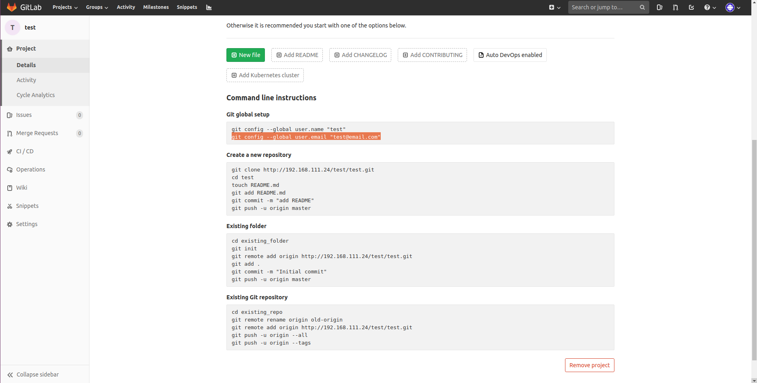
Step 5. Following the “Create a new repository” example, you should see in the repository a README file like the following.
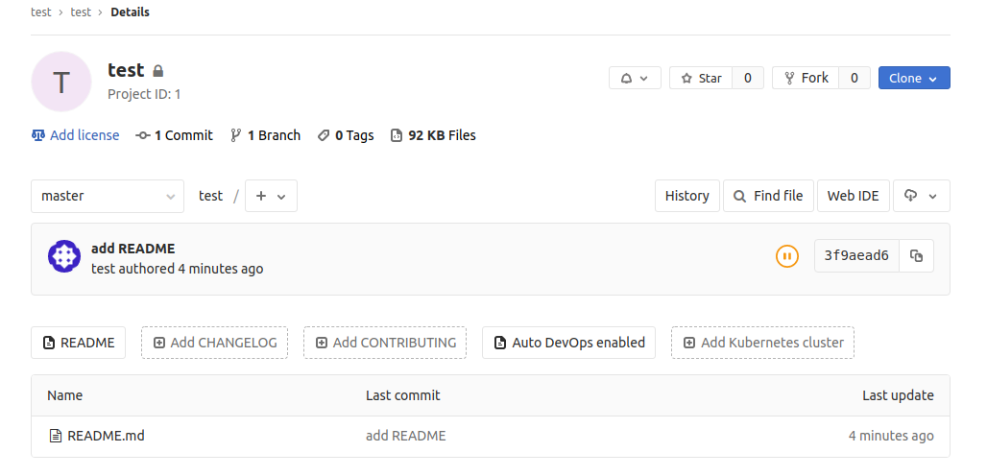

7. Integrating LDAP
Step 1. Access the gitlab.rb file in the config folder of your Gitlab directory. Add in the information as shown in red below.
$ sudo gedit <Gitlab directory>/config/gitlab.rb
...
### LDAP Settings
###! Docs: https://docs.gitlab.com/omnibus/settings/ldap.html
###! **Be careful not to break the indentation in the ldap_servers block. It is
###! in yaml format and the spaces must be retained. Using tabs will not work.**

gitlab_rails['ldap_enabled'] = true
# gitlab_rails['prevent_ldap_sign_in'] = false

###! **remember to close this block with 'EOS' below**
gitlab_rails['ldap_servers'] = YAML.load <<-'EOS'
main: # 'main' is the GitLab 'provider ID' of this LDAP server
label: 'LDAP'
host: '<hostname of Windows AD>'
port: 389
uid: 'sAMAccountName'
bind_dn: 'CN=<Common name of Windows AD>,CN=<Common name of Windows user account>,DC=<value>,DC=<value>'
password: '<Password of Windows AD>'
encryption: 'plain' # "start_tls" or "simple_tls" or "plain"
verify_certificates: true
smartcard_auth: false
active_directory: true
allow_username_or_email_login: false
lowercase_usernames: false
block_auto_created_users: false
base: 'DC=<value>,DC=<value>' #Multiple DC values for multiple level of domain
# user_filter: ''
attributes:
username: sAMAccountName
idAttr: sAMAccountName
emailAttr: userPrincipalName
nameAttr: givenName
...

Step 2. Restart Gitlab after modification.

8. Git clone, push and pull via terminal from external clients
Step 1. [External Client] Make a directory in /usr/share/ca-certificates/ and copy either Gitlab certificate (gitlab.io.crt) OR Certificate Authority certificate (myCA.crt) from the host client where gitlab is hosted and place it in the created directory.
$ mkdir /usr/share/ca-certificates/<name of directory>
$ scp <path/to/gitlab/myCA.crt> /usr/share/ca-certificates/<name of directory>

Step 2. [External Client] Reconfigure ca-certificates for the client certificates to include the added certificates. Select yes and press enter when you see the screen below
$ sudo dpkg-reconfigure ca-certificates

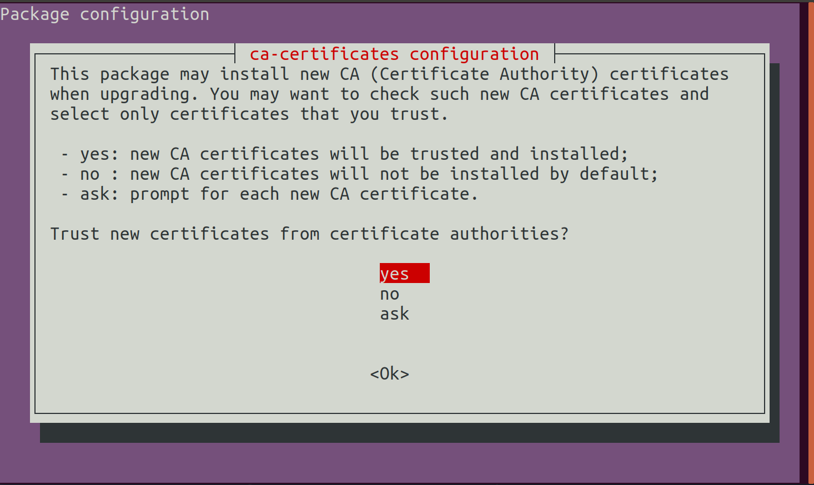
Check the added certificates and activate them. Select “ok” once the done.
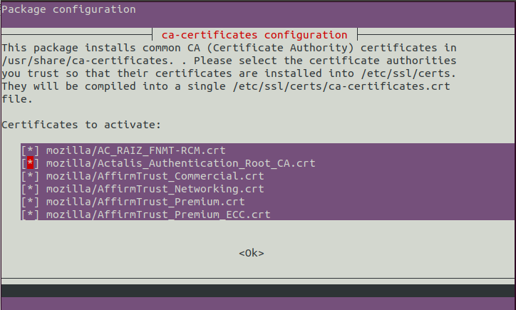
You should see from the terminal output that it is updating certificate as follows:
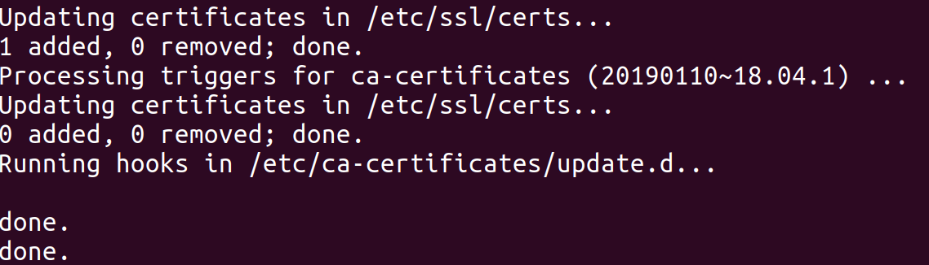
Step 3. [External Client] Login to any registered account and repository. An example using testproject repository is shown below.
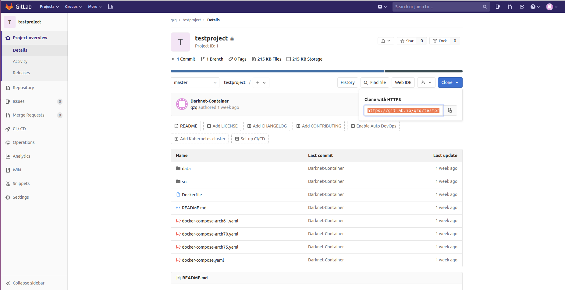

Step 4. [External Client] Click on the “Clone” icon in blue and copy the link in terminal. A successful example is as shown below.
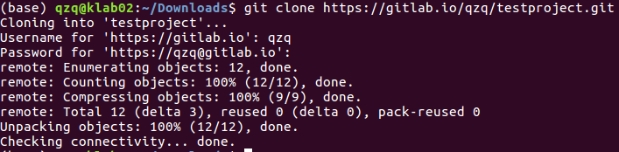
Step 5. [External Client] Pushing updated repository in client to Gitlab. As an example, we added an image to the cloned repository on the client, a successful push is as shown below.
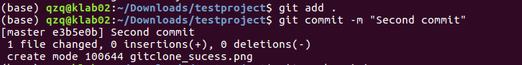
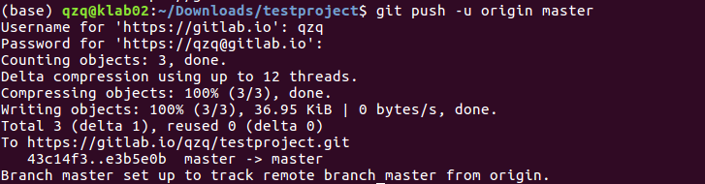
Step 6. [External Client] Pulling existing repository from an empty local git repository on client. A successful pull is shown below.
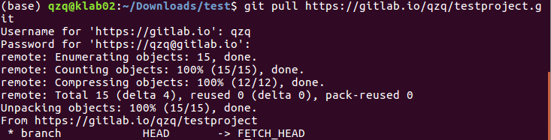
Note: For other possible commands and settings with Gitlab, please visit https://docs.gitlab.com/ for more details.

9. Data migration for Gitlab
Step 1: Access your Gitlab working directory.

Step 2: Open a terminal and execute the following command to stop existing gitlab application:
current_user@Current VM: <Current Gitlabdirectory>$ sudo docker-compose down

Step 3: Copy over the entire gitlab directory to new working directory using rsync to preserve all permissions and do the installation. Load the gitlab docker image that is being copied over (assuming docker is installed).
current_user@Current VM: <Current Gitlab directory>$ sudo rsync -a gitlab user@newVM:<PATH/TO/new_Gitlab_directory>

user@newVM:<PATH/TO/new_Gitlab_directory>$ docker load -i gitlab_ce_13.0.6.tar

Step 4: Modify the volumes: section in the docker-compose.yml file to prepare for docker-compose up execution. Update Windows AD DNS service if the new VM is assigned with different IP address.
user@newVM:<PATH/TO/new_Gitlab_directory>$ sudo gedit docker-compose.yml
...
services:
gitlab:
image: 'gitlab/gitlab-ce:13.0.6-ce.0'
container_name: 'gitlab-ce'
restart: always
hostname: 'gitlab'
environment:
GITLAB_OMNIBUS_CONFIG: |
external_url 'https://gitlab.io'
prometheus['listen_address'] = '0.0.0.0:9090'
prometheus['enable'] = true
gitaly['prometheus_listen_addr'] = "0.0.0.0:9236"
node_exporter['listen_address'] = '0.0.0.0:9100'
redis_exporter['listen_address'] = '0.0.0.0:9121'
postgres_exporter['listen_address'] = '0.0.0.0:9187'
gitlab_rails['time_zone'] = 'Asia/Singapore'
gitlab_rails['backup_keep_time'] = 172800
grafana['admin_password'] = 'Passw0rd'
grafana['enable'] = true
letsencrypt['enable'] = false
letsencrypt['auto_renew'] = false
nginx['listen_port'] = 443
nginx['redirect_http_to_https'] = true
nginx['ssl_certificate'] = "/etc/ssl/certs/gitlab/gitlab.io.crt"
nginx['ssl_certificate_key'] = "/etc/ssl/certs/gitlab/gitlab.io.key"
volumes:
- '<PATH/TO/new_Gitlab_directory>/config:/etc/gitlab'
- '<PATH/TO/new_Gitlab_directory>/logs:/var/log/gitlab'
- '<PATH/TO/new_Gitlab_directory>/data:/var/opt/gitlab'
- '<PATH/TO/new_Gitlab_directory>/volume_data/ssl:/etc/ssl/certs/gitlab'
Note: Ensure the files in <PATH/TO/new_Gitlab_directory>/volume_data/ssl directory has the following permissions as shown.
File | Permissions required | Command to execute to achieve required permissions
gitlab.io.crt | -rw-r--r-- | sudo chmod 644 gitlab.io.crt
gitlab.io.key | -rw------- | sudo chmod 600 gitlab.io.key

Step 5: Create a Gitlab service file and edit the path shown in red to point to the docker-compose.yml in the new Gitlab directory. Execute a daemon-reload command and enable the service afterwards.
user@newVM:~$ sudo gedit /etc/systemd/system/gitlab.service
[Unit]
Description=Gitlab Service
After=docker.service systemd-networkd.service systemd-resolved.service raid.mount
Requires=docker.service raid.mount

[Service]
Type=simple
Restart=on-failure
RestartSec=5
WorkingDirectory= <PATH/TO/new_Gitlab_directory>
ExecStart=/usr/local/bin/docker-compose up
TimeoutStopSec=180 #Time in seconds to wait for service itself to stop before force termination by SIGKILL command
RemainAfterExit=no

[Install]
WantedBy=multi-user.target
Note that raid.mount in service file refers to the mounted drive(separate disk added to the VM) is required if you are running Gitlab files on this mounted drive. (Tells service to start only after secondary drive is mounted)
Step 6: Bring up Gitlab via docker-compose or service file
user@newVM:<PATH/TO/new_Gitlab_directory>$ sudo docker-compose up
OR
user@newVM:<PATH/TO/new_Gitlab_directory>$ sudo systemctl start gitlab

