Guide to Installing GoHarbor on Ubuntu 18.04

Table of Contents
1. Introduction 2
2. Docker, Docker-Compose 3
2.1 The first tool to install is Docker itself. 3
2.2 Install docker-compose 6
3. Download Harbor 6
3.1 Download Harbor package 6
3.2 Setting up HTTPS for GoHarbor using a client that is Cert Authority(CA). 6
4. Configuring Harbor for setup 7
5. Installing Harbor 8
6. Configuring Harbor to be persist on reboot 9
7. Accessing GoHarbor 10
7.1 Test login to GoHarbor 10
7.2 Creation of users by admin (without AD integration) 11
7.3 Disabling self-registration on GoHarbor 12
7.4 Deleting users (Non-AD users) 13
7.5 LDAP integration 14
8. Login from external clients via terminal prompt 15
9. Pulling and pushing of images 16
9.1 Pushing of images 16
9.2 Pulling of images 17
10. Deletion of docker images, projects repository in GoHarbor 18
10.1 Delete docker image in project 18
11. Import Vulnerability Data on Offline instance 19
11.1 Preparation 19
12. Data migration without version upgrade 20

1. Introduction
GoHarbor is suitable to serve as an on-premises Docker image registry. GoHarbor also offers the ability (along with the addition of the Clair) of scanning your images for vulnerabilities.

The key features of Harbor include:
- Security and vulnerability analysis
- Content signing and validation
- Extensible API and web UI
- Image replication
- Role-based access control
- Multi-tenant

2. Docker, Docker-Compose

2.1 The first tool to install is Docker itself.
If you have local repository installed, you can install via apt-get method.
$ sudo apt-get install docker

Alternatively on a internet connected machine, open a terminal window and issue the command:
$ sudo apt-get download $(apt-rdepends docker | grep -v "^ ")
If you encounter the message(s): “Can't select candidate version from package <package name> as it has no candidate”. You need to filter out those packages via adding “ | grep -v "^<NAME> "” to the back of the command above for each package name.

Copy over the dependencies that are downloaded to your offline machine and install them if you want to install docker in air-gapped environment/client.

Once Docker is installed, you would want to add your user to the docker group with the command to elevate your account to run docker without the need for sudo (Optional):
$ sudo usermod -aG docker $USER

Please configure the /etc/docker/daemon.json file to include the lines in red to avoid problems with nginx container errors in GoHarbor during installation:
$ sudo gedit /etc/docker/daemon.json
{
…
"exec-opts": ["native.cgroupdriver=systemd"],
"log-driver": "json-file",
"log-opts" : {
"max-size": "100m"
}
}

Changing docker repository from /var/lib/docker to some other files
Method A) Via service file
A1) Stop docker service daemon and modify systemd docker start up as shown
$ systemctl stop docker
$ gedit /lib/systemd/system/docker/service
ExecStart=/usr/bin/dockerd -g /new/path/docker -H fd:// --containerd=/run/containerd/containerd.sock

A2) Check that the docker daemon is completely stopped
$ ps aux | grep -i docker | grep -v grep
#No output should be expected.

A3) Reload systemd daemon
$ systemctl daemon-reload

A4) Create specified directory and rsync current docker data to new directory
$ mkdir /new/path/docker
$ rsync -aqxP /var/lib/docker/ /new/path/docker

Note: If /new/path/docker is a mounted directory from a separate disk partition, please do the following steps.
$ systemctl list-units --type=mount #List all existing mounts
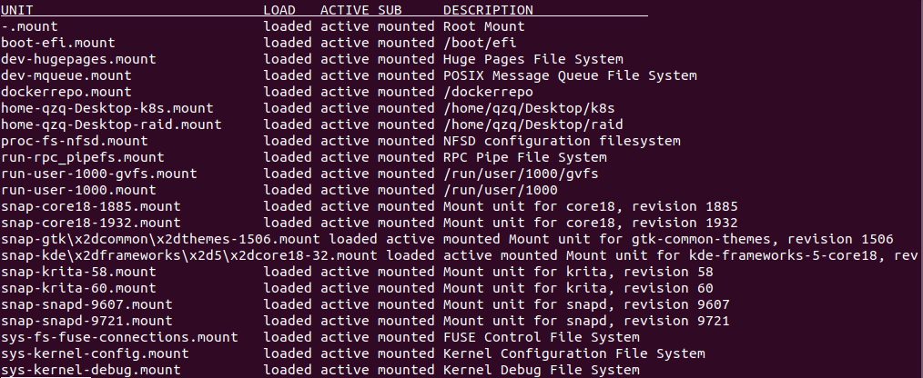
Example: If your /path/to/your/docker is /raid:
To identify the mount name, locate the row where the “DESCRIPTION” column shows /raid and find the corresponding unit name under “UNIT” column. In our case, it should be raid.mount with “ACTIVE” status being active.

$ systemctl status <xxx.mount>
$ sudo gedit /lib/systemd/system/docker.service
...
After = network.target … <xxx.mount> #name of the mount
...

$ sudo systemctl daemon-reload

A5) Start docker service daemon and confirm docker runs within new data directory
$ systemctl start docker
$ ps aux | grep -i docker | grep -v grep
root 2552 2.1 0.3 8053228 109652 ? Ssl 12:02 1:19 /usr/bin/dockerd -g /new/path/docker -H fd:// --containerd=/run/containerd/containerd.sock

Method B) Via daemon.json (Preferred)
B1) Stop docker daemon
$ sudo service docker stop

B2) Modify /etc/docker/daemon.json and add the contents in red below.
$ sudo gedit /etc/docker/daemon.json
{
...
"exec-opts": ["native.cgroupdriver=systemd"],
"log-driver": "json-file",
"log-opts": {
"max-size": "100m"
},
“graph”: “<path>/docker”
}

B3) Copy current data directory to new one
$ sudo rsync -aP /var/lib/docker/ /path/to/your/docker

Note: If /new/path/docker is a mounted directory from a separate disk partition, please do the following steps.
$ systemctl list-units --type=mount #List all existing mounts
Example: If your /path/to/your/docker is /raid:
To identify the mount name, locate the row where the “DESCRIPTION” column shows /raid and find the corresponding unit name under “UNIT” column. In our case, it should be raid.mount with “ACTIVE” status being active.

$ systemctl status <xxx.mount> #Check status of specified mount unit
$ sudo gedit /lib/systemd/system/docker.service
...
After = network.target … <xxx.mount>
...

B4) Reload systemd daemon and Rename old docker directory and restart docker daemon
$ sudo mv /var/lib/docker /var/lib/docker.old
$ sudo service docker start

B5) Delete old directory if everything is ok
$ sudo rm -rf /var/lib/docker.old

2.2 Install docker-compose
On internet machine, copy the following command on internet facing machine to get the docker-compose binary. The version we are using is 1.25.5.
$ wget https://github.com/docker/compose/releases/download/1.25.5/docker-compose-uname -s-uname -m -o docker-compose
Copy over the docker-compose binary into offline machine and put in /usr/local/bin/ . Convert docker-compose binary as an executable:
$ sudo chmod u+x /usr/local/bin/docker-compose

3. Download Harbor

3.1 Download Harbor package
On internet machine download the offline installer which would be transferred to your offline machine.
$ wget https://storage.googleapis.com/harbor-releases/release-1.8.0/harbor-offline-installer-v1.8.1.tgz --no-check-certificate

Untar the tgz file on your offline machine
$ tar -xzvf <PATH/TO>/harbor-offline-installer-v1.8.1.tgz
$ cd <PATH/TO>/harbor-offline-installer-v1.8.1/harbor

3.2 Setting up HTTPS for GoHarbor using a client that is Cert Authority(CA).
Note: Steps 3.3.1, 3.3.2 can be skipped if you intend to re-use the relevant CA key and pem file generated from other clients. Otherwise, to make your host as CA, please execute steps 1 and 2. You just need the relevant .key and .pem/.csr file for subsequent steps 3 and 4.
Step 1. [Host Client] Be a cert authority(CA) by generating secret key. Enter the pass phrase for the key.
$ sudo openssl genrsa -des3 -out myCA.key

Step 2. [Host Client] Generate root certificate for CA
$ sudo openssl req -x509 -new -nodes -key myCA.key -sha256 -days 3650 -out myCA.pem

Step 3. [Host Client] Generate a secure server key for GoHarbor in the GoHarbor directory.
$ cd <harbor working directory>
$ sudo openssl genrsa -out goharbor.io.key 4096

Step 4. [Host Client] Generate the certificate signing request. Prepare a config file to be used as input.
$ sudo gedit req.conf
[req]
distinguished_name = req_distinguished_name
req_extensions = v3_req
prompt = no
[req_distinguished_name]
C = SG
ST = SG
L = SG
O = Harbor
OU = Harbor
CN = goharbor.io
[v3_req]
keyUsage = keyEncipherment, dataEncipherment
extendedKeyUsage = serverAuth

[alt_names]
DNS.1 = goharbor.io
DNS.2 = *.goharbor.io
Note: Common Name must be the domain name used for GoHarbor. Otherwise, your certificate signing would be invalid for the site.

$ sudo openssl req -new -key goharbor.io.key -out goharbor.io.csr -config req.conf

Step 5. [Host Client] Create the signed certificate and copy the certs to mounted directory.
$ sudo openssl x509 -req -in goharbor.io.csr -CA myCA.pem -Cakey myCA.key -Cacreateserial -out goharbor.io.crt -days 3650 -sha256

3.4 Putting generated certificates into correct directory

Step 1. [Host Client] With the key generation complete, we need to copy the newly-generated certificates into the proper directory. First, create the directory with the command:
$ sudo mkdir -p /etc/docker/certs.d/goharbor.io

Step 2. [Host Client] Copy the .crt and .key with the command to the above directory (Ref: https://docs.docker.com/engine/security/certificates/)
$ sudo cp goharbor.io.crt goharbor.io.key /etc/docker/certs.d/goharbor.io

4. Configuring Harbor for setup
[Host Client] Before running the installation command, a few edits must be made to the harbor.yml file. Open that file for editing with the command:
$ gedit harbor.yml
hostname: goharbor.io #The hostname(url) should be mapped to the client that is hosting this service.
http:
# port for http, default is 80. If https enabled, this port will redirect to https port
port: 80 #Please use other port if it is not available. Append the port number to hostname if differ from 80
https:
port: <any available port>
certificate: </path/to>/goharbor.io.crt #Please name the cert name the same as hostname
private_key: </path/to>/goharbor.io.key #Please name the key name the same as hostname
…

harbor_admin_password: Harbor12345 #Change if you want to use other password

database:
password: root123 # The password for the root user of Harbor DB

datavolume: <preferred_path to store goharbor data>
…
log:
…
location: <preferred_path to store goharbor logs>
The following options must be edited:
- hostname — set this to a domain name (eg. goharbor.io)
- port — set this any available port number
- harbor_admin_password (optional)
- database password (optional)
- datavolume — set this preferably to goharbor working directory
- log location — set this preferably to goharbor working directory

The SSL section should look similar to that shown in below.
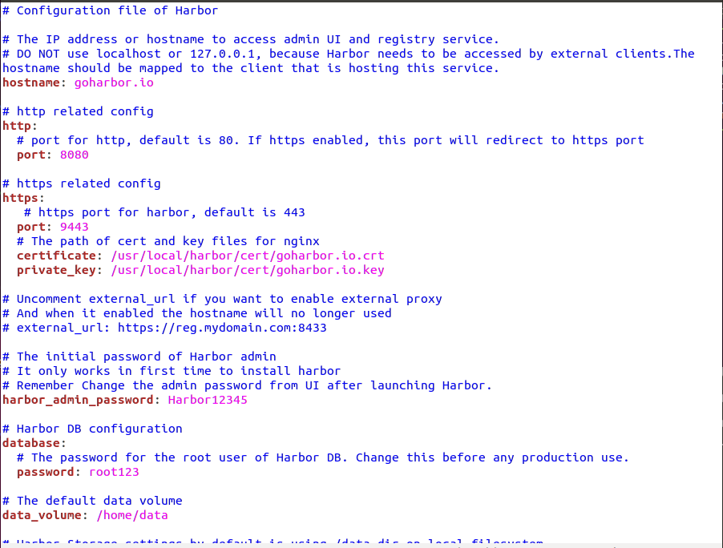

5. Installing Harbor
[Host Client] We’ll be installing the service with Clair, Notary and Chartmuseum support (for the scanning of vulnerabilities). To do this, issue the command:
$ sudo ./install.sh --with-clair --with-notary --with-chartmuseum
Note: If you intend to only selective install additional option support provided such as notary and chartmuseum as well, please modify the switches as necessary. Reinstallation can be done with the same command as well.

The installation takes a bit of time (as shown in picture below), so be patient until the harbor services are started.
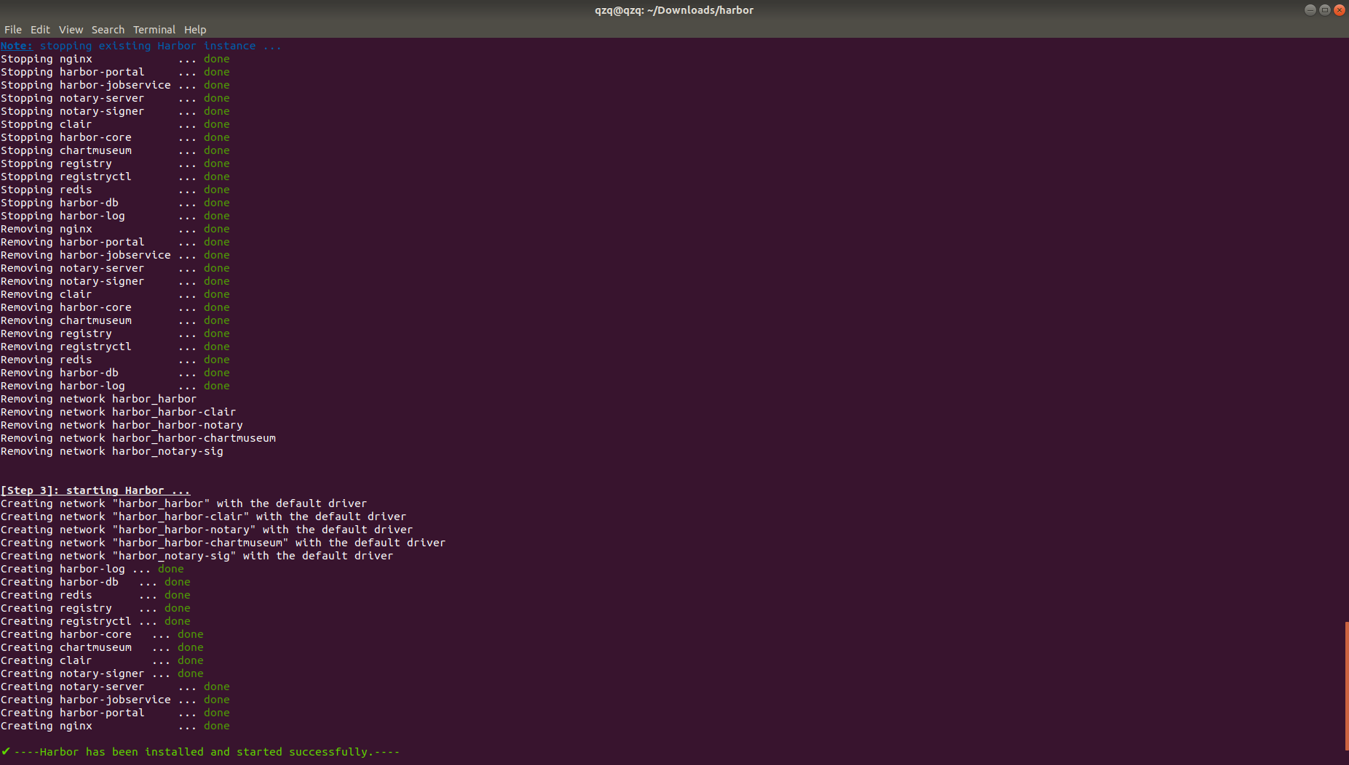
If you execute docker-compose up, you should see the following output as shown:
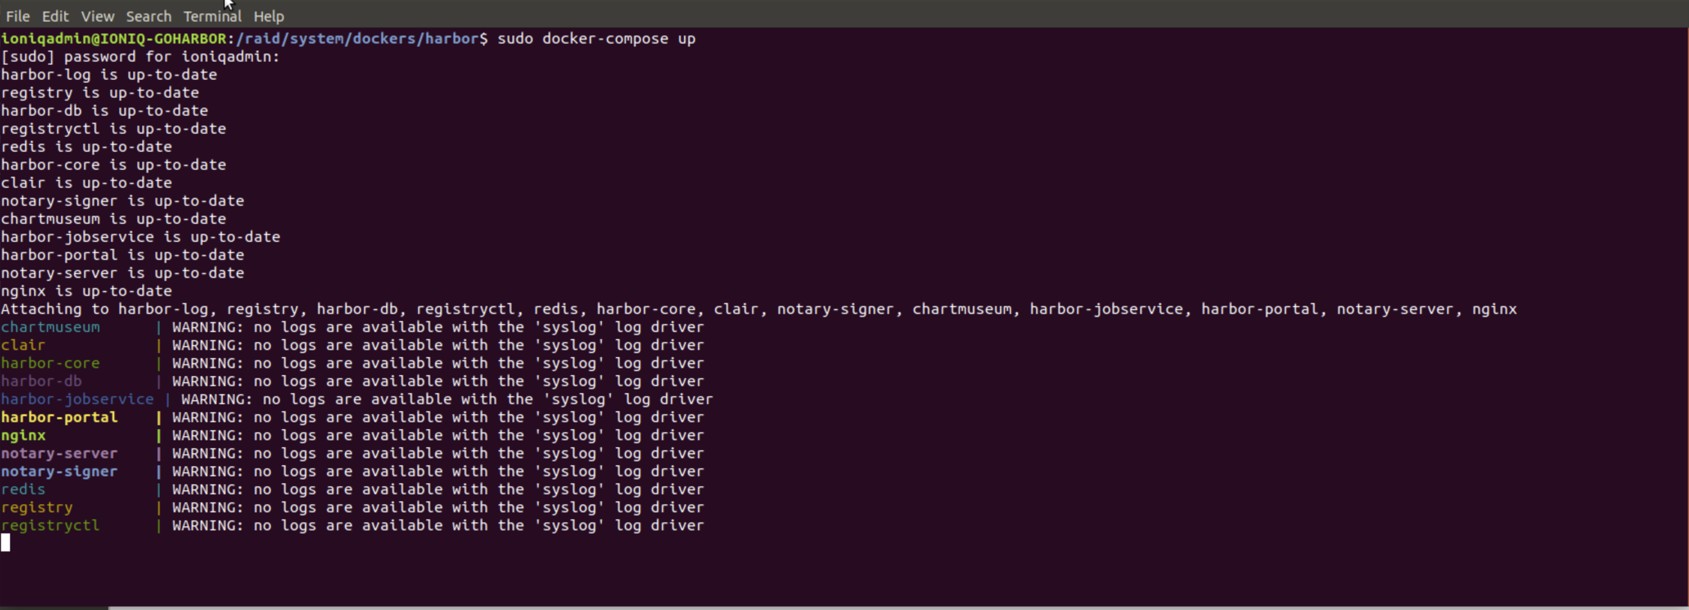

6. Configuring Harbor to be persist on reboot
Step 1. [Host Client] Add the following service file:
$ sudo gedit /etc/systemd/system/harbor.service
[Unit]
Description=Harbor
After=docker.service systemd-networkd.service systemd-resolved.service <xxx.mount>
Requires=docker.service <xxx.mount> #Add <xxx.mount> if your docker repo is on a mounted dir.
Documentation=http://github.com/vmware/harbor

[Service]
Type=simple
Restart=on-failure
RestartSec=5
ExecStart=/usr/local/bin/docker-compose -f <PATH/TO>/harbor/docker-compose.yml up
TimeoutStopSec= 180 #Kill the service after 180 seconds if graceful shutdown cannot be finished in time.
RemainAfterExit=no

[Install]
WantedBy=multi-user.target

Step 2. [Host Client] Reload daemon and enable harbor service:
$ sudo systemctl daemon-reload
$ sudo systemctl start harbor
$ sudo systemctl enable harbor

Note: For a manual restart of Harbor, execute either of the following commands:
1) in your harbor installation folder <PATH/TO>/harbor
$ sudo docker-compose start

OR 2) Via service file
$ sudo systemctl restart harbor

7. Accessing GoHarbor

7.1 Test login to GoHarbor
Step 1. Open a browser and access via the url : https://goharbor.io (the hostname specified in harbor.yml) and you will see the following page.
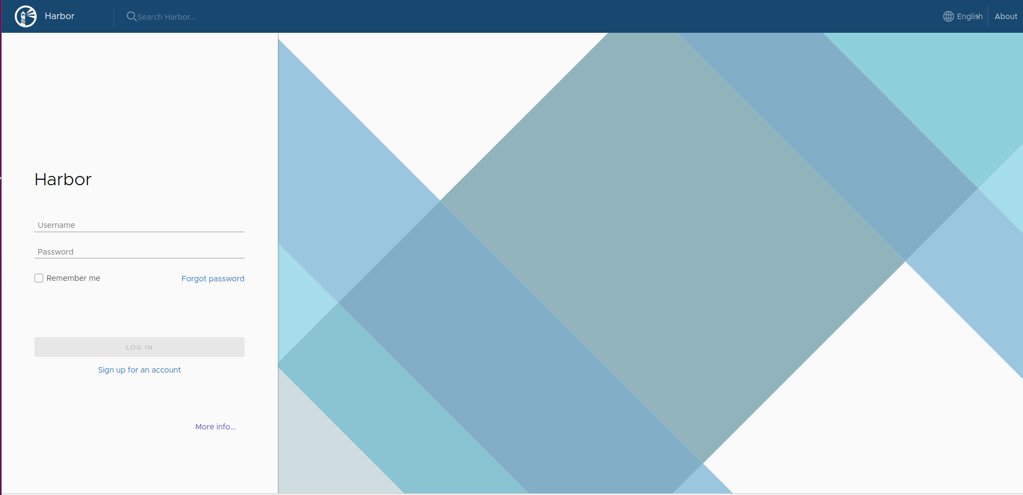
Step 2: Enter login credentials and you should see the page below:
- username: admin
- password: <harbor_admin_password indicated in harbor.yml>

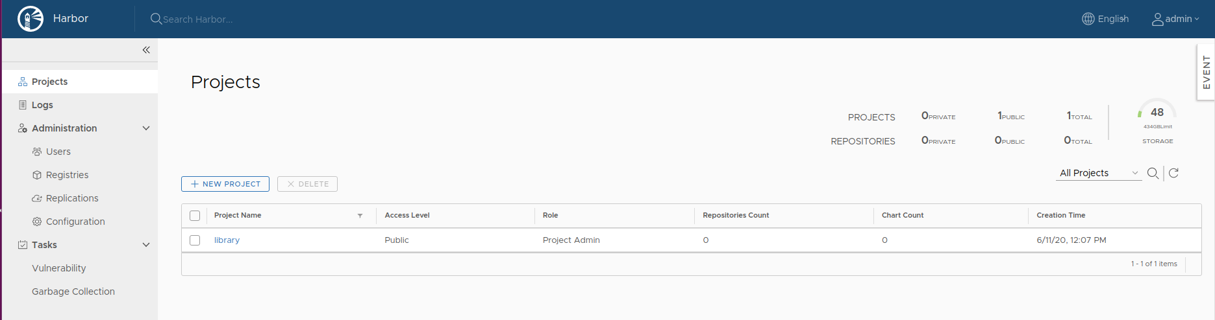
Note: A default library project is created upon installation.

7.2 Creation of users by admin (without AD integration)
Step 1: Access the following page under Administration>Users.
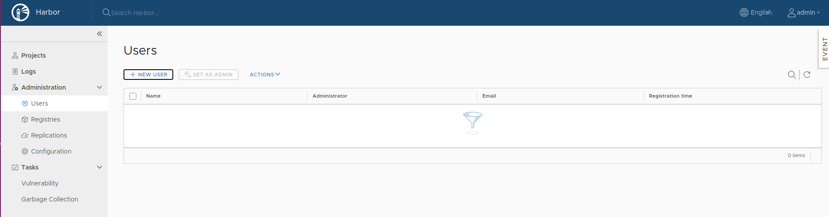
Step 2: Click on “+ New User” button and you should see a popout window as follows. Fill in the details as required. We are going to create a new user called “test”
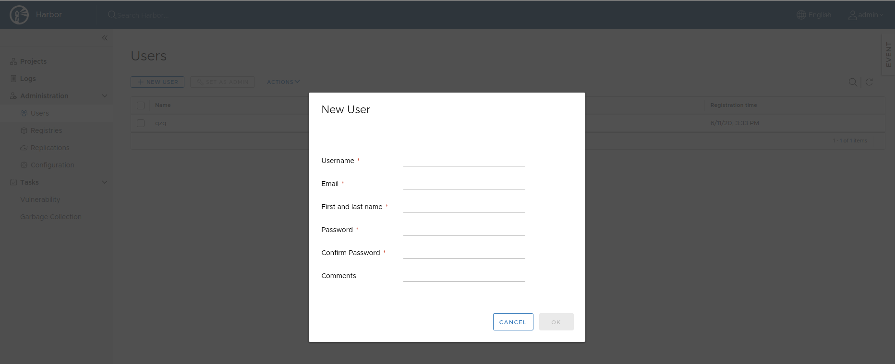
Upon completion of user creation, which in this case is a user named “test”:
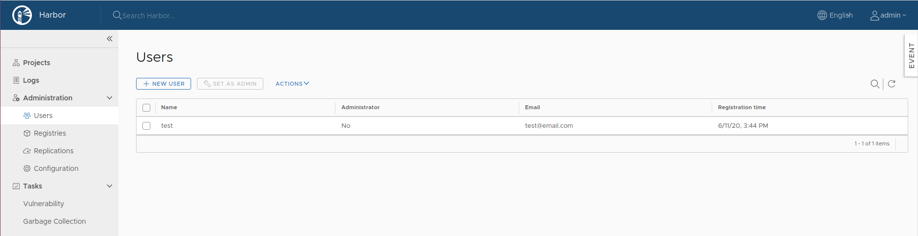
Step 3: Try login using the created user account subsequently.
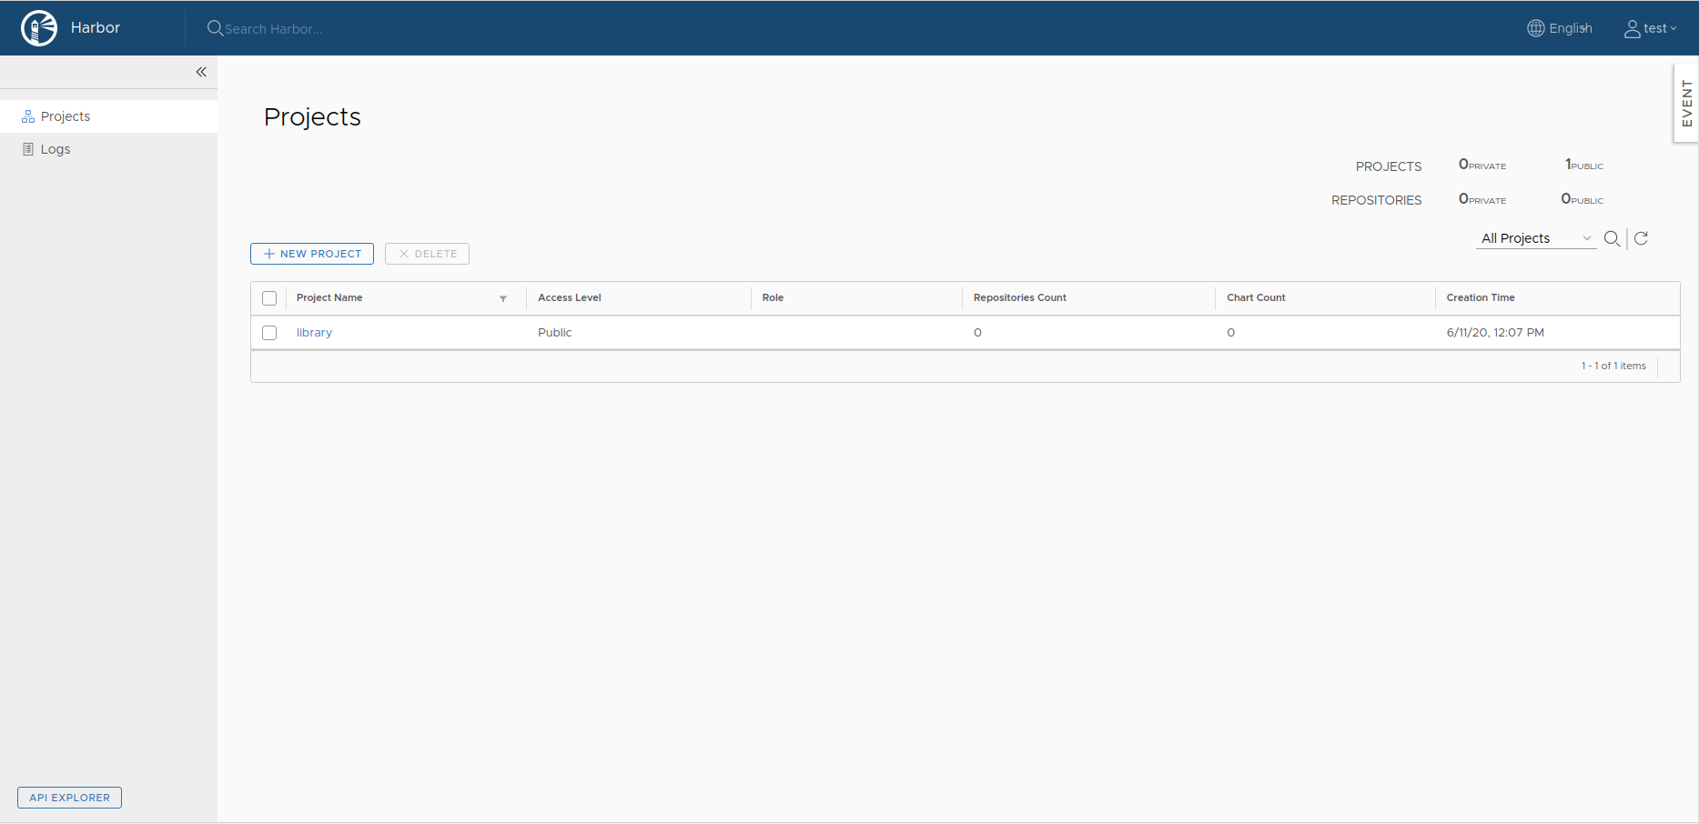

7.3 Disabling self-registration on GoHarbor
Step 1: Login GoHarbor as admin account, uncheck the self registration checkbox section as box in red below and click the save button below as shown.
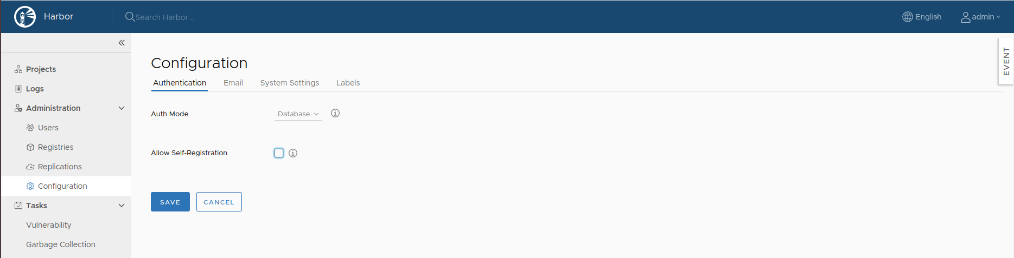
Step 2: Logout to see the change effected. The login page should not show “signup for account” link.
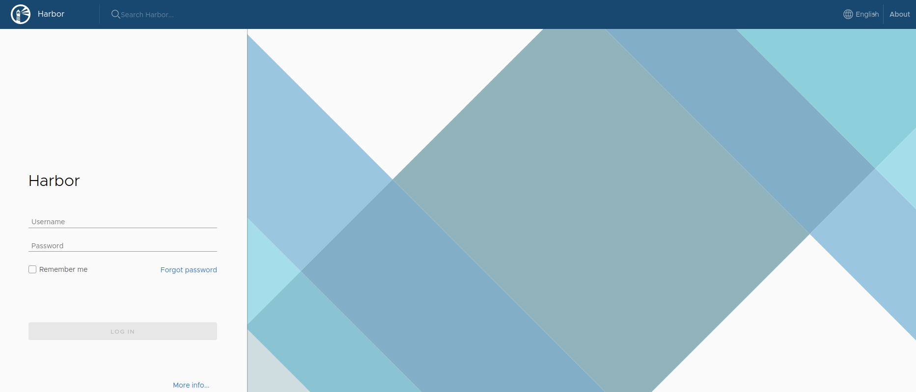

7.4 Deleting users (Non-AD users)
Step 1: Login GoHarbor as admin account, click on “users” on the left panel. Click on the user that you want to delete and select “delete” from the “actions” dropdown label. Note that this action does not remove the user data from GoHarbor backend database.
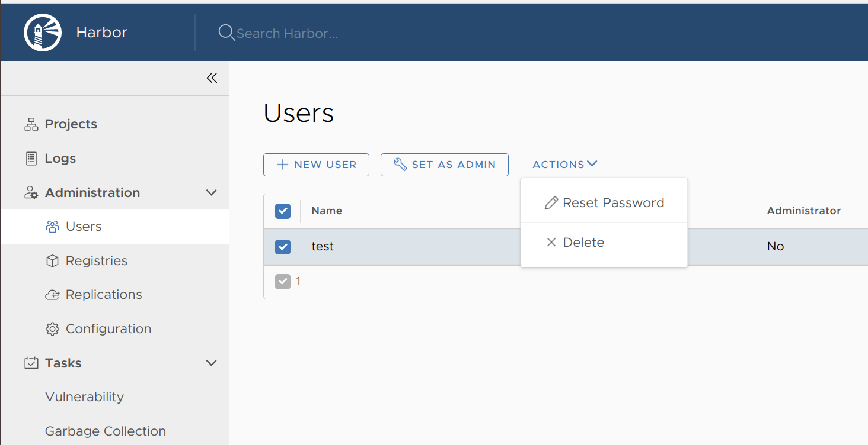
Step 2: To delete the user data from backend, we need to access into the harbor-db container that is running postgres database.
$ docker exec -it harbor-db bash
root [ / ]# psql -U postgres
postgres=# \c registry
registry=# select * from harbor_user;
registry=# delete from harbor_user where user_id = <id number of the username in database>;

7.5 LDAP integration
Please note that prior to configuration for LDAP integration, there should be no local users that have been added to the database. If there is at least one user other than admin in the Harbor database, you cannot change the authentication mode.
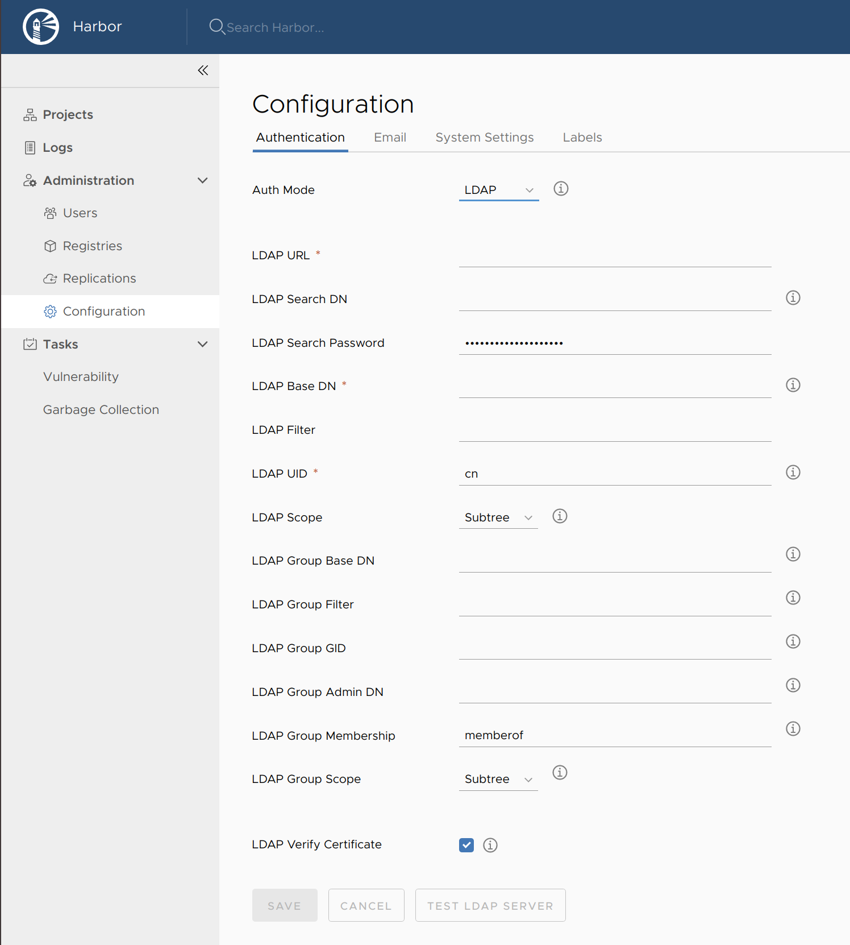
Step 1. Login with admin account into GoHarbor. Access the Configuration page and set “auth mode” to LDAP via the drop down icon. Fill in the details and click on the “save”. button below.

In case there is a need to convert from database authentication mode to LDAP. You need to remove all existing local users except for admin account. Do the following steps:
$ docker exec -it harbor-db bash
root [ / ]# psql -U postgres
postgres=# \c registry
registry=# select * from harbor_user;
registry=# delete from harbor_user where user_id > 2;
Refresh the Harbor web console > Configurations, then you can change the auth_mode.

8. Login from external clients via terminal prompt
Step 1. [Other Clients] To login to user accounts, the client machine requires a certificate. Without a certificate, you would see the output as shown:
# docker login goharbor.io
Username: test
Password:
Error response from daemon: Get https://goharbor.io/v2/: x509: certificate signed by unknown authority.

Step 2. [Host Client] Copy the .crt file to other clients’ /usr/local/share/ca-certificates and /etc/docker/certs.d directory for command line access to GoHarbor and update certificate.
$ sudo scp /path/to/goharbor.io.crt <user@clientIP>:~/Desktop
[other client] $ sudo mkdir -p /etc/docker/certs.d/goharbor.io/ /usr/share/ca-certificates/goharbor.io/
[other client] $ sudo scp ~/Desktop/goharbor.io.crt /etc/docker/certs.d/goharbor.io
[other client] $ sudo scp ~/Desktop/goharbor.io.crt /usr/share/ca-certificates/goharbor.io/
[other client] $ sudo dpkg-reconfigure ca-certificates
[other client] $ sudo systemctl restart docker.service
Note: If you have a Certificate Authority(CA) certificate which goharbor.io.crt is signed from, you can use it in place of goharbor.io.crt instead

Step 3. [Other Clients] Reload daemon.
$ sudo systemctl daemon-reload

Step 4. [Other Clients] Edit your /etc/network/interfaces (Ubuntu 16.04) or /etc/netplan/01-network-manager-all.yaml (Ubuntu 18.04).

For Ubuntu 16.04: Add the following line in red to point to the machine hosting DNS server that maps the FQDN domain name to IP address in the corresponding interfaces.
$ vim /etc/network/interfaces
…
auto <interface>
iface <interface> inet static
address <assigned address>
netmask <assigned netmask>
gateway <assigned gateway>
dns-nameservers <DNS server addr>
...
Reboot to apply changes.

For Ubuntu 18.04: Add the following detail in red to point to the machine hosting DNS server that maps the FQDN domain name to IP address under the corresponding interfaces
$ sudo vim /etc/netplan/01-network-manager-all.yaml #Filename may differ across setup
network:
version: 2
renderer: NetworkManager
ethernets:
<interface>:
dhcp4: no
addressses:
- <assigned address>/<assigned netmask>
gateway4: <assigned gateway>
nameservers:
addresses: [dnsmasq addr/Windows AD addr ,xxx , yyy]

Apply changes immediately:
$ sudo netplan apply

Step 5. [Other Clients] Try login the created account via terminal:
$ docker login goharbor.io
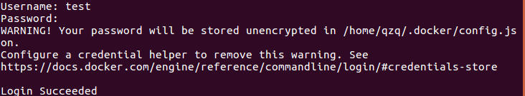
Step 6. [Other Clients] To logout of goharbor accessed via terminal:
$ docker logout goharbor.io

9. Pulling and pushing of images

9.1 Pushing of images
Step 1: To push your image, you need to retag the image that you want to push in the following format: goharbor.io/<project_repository>/<imagename>
An example with pushing an image to your project repository named test-project (assume it was created in the repository) with Ubuntu:18.04 image.
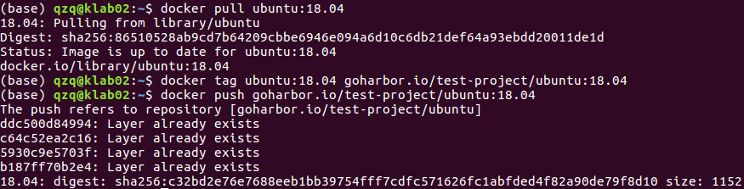
Note: A successful operation should show a digest value.
Step 2: Verify on GoHarbor that the images has been pushed successfully.
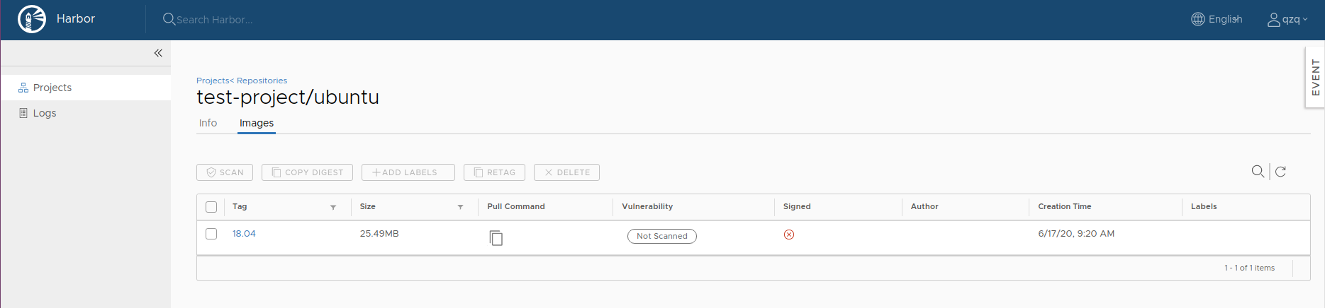

9.2 Pulling of images
Step 1: Delete the same image in your local docker repository and pull from GoHarbor. An example with pulling an Ubuntu:18.04 image from your repository named test2 (assume it was created in the repository).
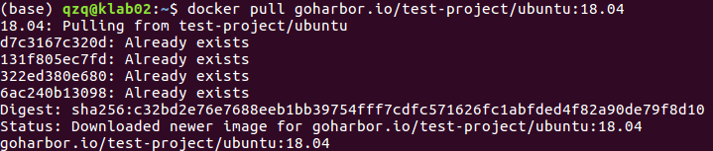

Basic troubleshooting on encountering retrying error:
Solution:
1. Check network connectivity and ensure it is up.
2. Check that the image is tagged in the form of <goharbor_url>/<project_repository_name>/<image:tag>. Alternatively, go to projects > [project_repository] > push image to get command reference for pushing image to the corresponding repository.
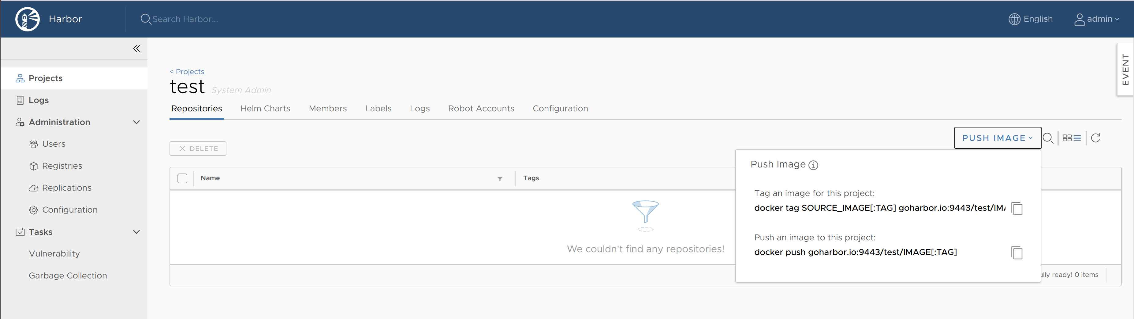
3. Uncheck “Automatically scan images” in the vulnerability scanning on push in the ‘Configuration’ tab as shown below.
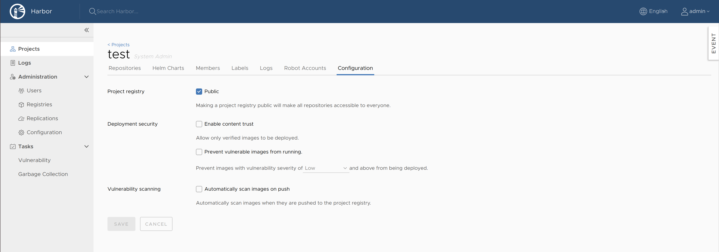

10. Deletion of docker images, projects repository in GoHarbor

10.1 Delete docker image in project
Go to Projects > [project_repository]. Select the repository(docker image) to be deleted by clicking on the checkbox and click the delete button as shown below.
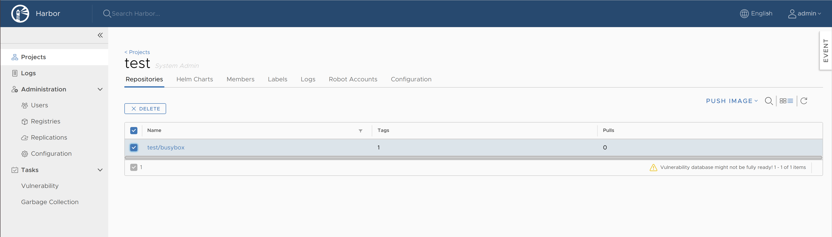
10.2 Delete project repository
Step 1: Go to Projects > [project_repository]. Delete all repositories(docker images).
Step 2: Go back to the project page and delete the project. Please note that you cannot delete a project repository with images inside directly. Attempts to try will result in error.
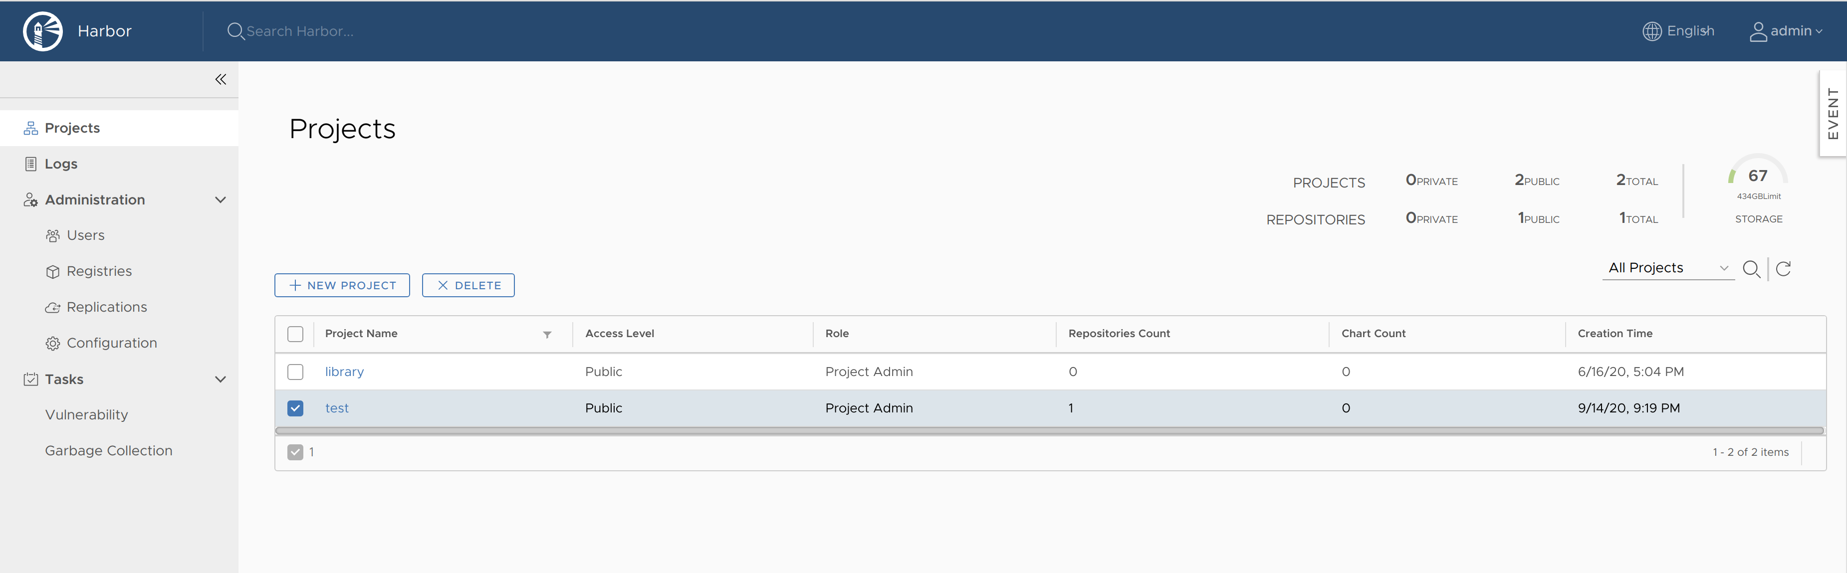

11. Import Vulnerability Data on Offline instance

11.1 Preparation
Ensure you have a GoHarbor instance running on a internet-connected host. Check whether your Clair instance has already updated its vulnerability database to the latest version with the following steps.

Step 1: Access the log folder in GoHarbor working directory, open up clair.log and look for logs. Locate the logs that look similar to the example below
Jul 3 20:40:45 172.18.0.1 clair[3516]: {"Event":"finished fetching","Level":"info","Location":"updater.go:227","Time":"2017-07-04 03:40:45.890364","updater name":"rhel"}
Jul 3 20:40:46 172.18.0.1 clair[3516]: {"Event":"finished fetching","Level":"info","Location":"updater.go:227","Time":"2017-07-04 03:40:46.768924","updater name":"alpine"}
Jul 3 20:40:47 172.18.0.1 clair[3516]: {"Event":"finished fetching","Level":"info","Location":"updater.go:227","Time":"2017-07-04 03:40:47.190982","updater name":"oracle"}
Jul 3 20:41:07 172.18.0.1 clair[3516]: {"Event":"Debian buster is not mapped to any version number (eg. Jessie-\u003e8). Please update me.","Level":"warning","Location":"debian.go:128","Time":"2017-07-04 03:41:07.833720"}
Jul 3 20:41:07 172.18.0.1 clair[3516]: {"Event":"finished fetching","Level":"info","Location":"updater.go:227","Time":"2017-07-04 03:41:07.833975","updater name":"debian"}
Jul 4 00:26:17 172.18.0.1 clair[3516]: {"Event":"finished fetching","Level":"info","Location":"updater.go:227","Time":"2017-07-04 07:26:17.596986","updater name":"ubuntu"}
Jul 4 00:26:18 172.18.0.1 clair[3516]: {"Event":"adding metadata to vulnerabilities","Level":"info","Location":"updater.go:253","Time":"2017-07-04 07:26:18.060810"}
Jul 4 00:38:05 172.18.0.1 clair[3516]: {"Event":"update finished","Level":"info","Location":"updater.go:198","Time":"2017-07-04 07:38:05.251580"}
Note: The phrase “finished fetching” indicates that Clair has finished a round of vulnerability updates from an endpoint. Make sure all of the rhel, alpine, oracle, debian, and ubuntu endpoints are updated correctly. If they have not, wait for Clair to get the data. If the logs are too long, you can delete it by bringing down the internet-connected GoHarbor first.

Step 2. Dump Vulnerability Data
Login to the host that is connected to Internet on which the Postgres Clair database is running. Dump Clair’s vulnerability database by running the following commands.
$ docker exec harbor-db /bin/sh -c "pg_dump -U postgres -a -t feature -t keyvalue -t namespace -t schema_migrations -t vulnerability -t vulnerability_fixedin_feature" > vulnerability.sql
$ docker exec harbor-db /bin/sh -c "pg_dump -U postgres -c -s" > clear.sql
The files vulnerability.sql and clear.sql are generated.

Backup the GoHarbor Clair Database if necessary using the following command
$ docker exec harbor-db /bin/sh -c "pg_dump -U postgres -c" > all.sql

Step 3. Update the offline GoHarbor Clair Database
Copy the vulnerability.sql and clear.sql files to the offline host which GoHarbor is running.
Run the following commands to import the data to Clair database.
$ docker exec -i harbor-db psql -U postgres < clear.sql
$ docker exec -i harbor-db psql -U postgres < vulnerability.sql

Step 4. Rescan the images with the updated database.

12. Data migration without version upgrade
Assumption: Migration is done to another VM.
Step 1: Access existing goharbor working directory
Step 2: Open a terminal and execute the following command to bring down the existing goharbor application:
current_user@Current VM: <Current GoHarbor directory> $ sudo docker-compose down

Step 3: Copy over the installer and the “Create_CA” folder(which contains certs required for https protocol) to new working directory and do the installation. The installation would generate a docker-compose.yml file. Bring down the new goharbor application temporarily to allow data migration from old to new directory.
current_user@Current VM: <Current GoHarbor directory>$ sudo cp -r harbor-offline-installer-v1.8.1.tgz Create_CA user@newVM:<PATH/TO/new_GoHarbor_directory>

current_user@Current VM:<Current GoHarbor directory> $ tar -xzvf <PATH/TO/new_GoHarbor_directory>/harbor-offline-installer-v1.8.1.tgz

user@newVM:<PATH/TO/new_GoHarbor_directory>$ cd <PATH/TO/new_GoHarbor_directory>/harbor-offline-installer-v1.8.1/harbor

Step 4: Please edit the harbor.yml before installing GoHarbor. The installation would generate a docker-compose.yml file. Bring down the new goharbor application temporarily to allow data migration from old to new directory.
A section of the yml file is shown with the necessary changes required for new GoHarbor directory are highlighted in red. Update Windows AD DNS service if the new VM is assigned with different IP address.
# Configuration file of Harbor

# The IP address or hostname to access admin UI and registry service.
# DO NOT use localhost or 127.0.0.1, because Harbor needs to be accessed by external clients.The hostname should be mapped to the client that is hosting this service.
hostname: goharbor.io

# http related config
http:
# port for http, default is 80. If https enabled, this port will redirect to https port
port: 80 #Ensure this port is free

# https related config
https:
# https port for harbor, default is 443
port: 443 #Ensure this port is free
# The path of cert and key files for nginx
certificate: <PATH/TO/goharbor.io.crt>
private_key: <PATH/TO/goharbor.io.crt>

# Uncomment external_url if you want to enable external proxy
# And when it enabled the hostname will no longer used
# external_url: https://reg.mydomain.com:8433

# The initial password of Harbor admin
# It only works in first time to install harbor
# Remember Change the admin password from UI after launching Harbor.
harbor_admin_password: <preferred one time password>

# Harbor DB configuration
database:
# The password for the root user of Harbor DB. Change this before any production use.
password: root123

# The default data volume
data_volume: <PATH/TO/new_GoHarbor_directory>/harbor-offline-installer-v1.8.1/harbor/data
...

Install GoHarbor and bring down the service afterwards on the new VM.
user@newVM:<PATH/TO/new_GoHarbor_directory>/harbor-offline-installer-v1.8.1/harbor$ sudo ./install.sh --with-clair --with-notary --with-chartmuseum

user@newVM:<PATH/TO/new_GoHarbor_directory>/harbor-offline-installer-v1.8.1/harbor$ sudo docker-compose down

Step 5: Copy over the “data” and “common” folder from /raid/system/docker/goharbor using rsync to the migrated directory and replace the generated “data” and “common” folders in the new directory.
Execute command “sudo docker-compose up” in the same directory via terminal and check if GoHarbor can run properly without errors. You do not need to copy over “logs” folder.
current_user@Current VM: <Current GoHarbor directory>$ sudo rsync -a /raid/system/dockers/harbor/data user@newVM:<PATH/TO/new_GoHarbor_directory>/harbor-offline-installer-v1.8.1/harbor

current_user@Current VM: <Current GoHarbor directory>$ sudo rsync -a /raid/system/dockers/harbor/common user@newVM:<PATH/TO/new_GoHarbor_directory>/harbor-offline-installer-v1.8.1/harbor

user@newVM:<PATH/TO/new_GoHarbor_directory>/harbor-offline-installer-v1.8.1/harbor$ sudo docker-compose up

Step 6: Create a GoHarbor service file and edit the path shown in red to point to the docker-compose.yml in the new GoHarbor directory. Execute a daemon-reload command and enable the service afterwards.
user@newVM:~$ sudo gedit /etc/systemd/system/goharbor.service
[Unit]
Description=Harbor
After=docker.service systemd-networkd.service systemd-resolved.service raid.mount
Requires=docker.service raid.mount
Documentation=http://github.com/vmware/harbor

[Service]
Type=simple
Restart=on-failure
RestartSec=5
ExecStart=/usr/local/bin/docker-compose -f <PATH/TO/new_GoHarbor_directory>/harbor-offline-installer-v1.8.1/harbor/docker-compose.yml up
TimeoutStopSec=180 #Time in seconds to wait for service itself to stop before force termination by SIGKILL command
RemainAfterExit=no

[Install]
WantedBy=multi-user.target
Note that raid.mount in service file refers to the mounted drive(separate disk added to the VM) is required if you are running GoHarbor files on this mounted drive. (Tells service to start only after secondary drive is mounted)
user@newVM:~$ sudo systemctl daemon-reload
user@newVM:~$ sudo systemctl enable goharbor

Troubleshooting:
If you encounter the following errors generated:
a) Notary-server exited with code 1
b) Registry exited with code 2
Do the following:
user@newVM:<PATH/TO/new_GoHarbor_directory>/harbor-offline-installer-v1.8.1/harbor$ sudo docker-compose down

user@newVM:<PATH/TO/new_GoHarbor_directory>/harbor-offline-installer-v1.8.1/harbor$ sudo chmod 644 -R data/secret/notary data/secret/registry data/secret/core data/secret/keys

user@newVM:<PATH/TO/new_GoHarbor_directory>/harbor-offline-installer-v1.8.1/harbor$ sudo docker-compose up

GoHarbor should be running without any error code being output.

