Deploying and Removing Grafana-Prometheus via Nvidia-DCGM Exporter on Kubernetes cluster via offline helm repository guide

Table of Contents
1. Prerequisites 3
2. Deployment 4
2.1. (optional) Create offline helm repositories for Prometheus with the following steps. This does not affect helm functionality even in air-gapped environment. 4
2.2 Create deployment files 5
2.3. Add data source to Grafana 15
2.4. Download community created json template files for metrics visualisation on grafana dashboard from the official grafana dashboard page 16
2.5. Synchronising viewed dashboards in Grafana in same account via different client 19
3. Deploying and removing Goldpinger by Bloomberg (Optional) 20
4. Removing deployed Nvidia-DCGM exporter with Prometheus and Grafana 25
5. Troubleshooting 26

1. Prerequisites
Ref: https://github.com/NVIDIA/gpu-monitoring-tools/

1. Ensure you have Kubernetes and helm installed, otherwise refer to the Kubernetes and Kubeflow setup document. NFS server and MetalLB should be deployed on Kubernetes setup before proceeding.

2. [Internet clients] Pull the required charts and images from the internet as indicated below and copy over to offline clients.
Helm Chart | Required Images
prometheus-operator-8.15.0.tgz | jettech/kube-webhook-certgen:v1.2.1  k8s.gcr.io/hyperkube:v1.12.1  nvidia/dcgm-exporter:1.7.2  quay.io/coreos/configmap-reload:v0.0.1  quay.io/coreos/prometheus-config-reloader:v0.38.1  quay.io/coreos/prometheus-operator:v0.38.1  quay.io/prometheus/alertmanager:v0.20.0  quay.io/prometheus/prometheus:v2.18.1  squareup/ghostunnel:v1.5.2  grafana/grafana:7.0.3  kiwigrid/k8s-sidecar:0.1.151  quay.io/prometheus/node-exporter:v1.0.0  bats/bats:v1.1.0  docker.io/curlimages/curl:7.70.0  docker.io/library/busybox:1.31.1  quay.io/gambol99/keycloak-proxy:latest  nvidia/dcgm-exporter:1.4.3  quay.io/coreos/kube-state-metrics:v1.9.6

user@Internet-PC:~$ docker pull <required_images>
user@Internet-PC:~$ helm repo add stable https://kubernetes-charts.storage.googleapis.com
user@Internet-PC:~$ helm pull stable/prometheus-operator --version=8.15.0

3. [Internet clients] Download the required yaml files
user@Internet-PC:~$wget https://raw.githubusercontent.com/NVIDIA/gpu-monitoring-tools/2.0.0-rc.12/dcgm-exporter.yaml
user@Internet-PC:~$ wget https://raw.githubusercontent.com/NVIDIA/gpu-monitoring-tools/2.0.0-rc.12/service-monitor.yaml

2. Deployment

2.1 (optional) Create offline helm repositories for Prometheus with the following steps. This does not affect helm functionality even in air-gapped environment.

2.1.1 Create folders in offline clients:
user@PC:~$ mkdir $HOME/.cache/helm/repository
user@PC:~$ mkdir $HOME/.config/helm/

2.1.2 Copy repositories.yaml into $HOME/.config/helm/
Note: To modify the repositories url for helm to pull and update charts from local system instead replace lines in red with your desired path. Otherwise, you may leave it unchanged.
user@PC:~$ vim repositories.yaml
...
- caFile: ""
certFile: ""
keyFile: ""
name: stable
password: ""
url: https://kubernetes-charts.storage.googleapis.com/
username: ""
...

2.1.3 Copy gpu-helm-charts-charts.txt and gpu-helm-charts-index.yaml from your internet client into the directory $HOME/.cache/helm/repository for empty $HOME/.cache/helm repo OR append the details to the existing ones.
user@PC:~$ sudo gedit/cp stable-charts.txt $HOME/.cache/helm/repository #Append prometheus-operator in the file
user@PC:~$ sudo gedit/cp stable-index.yaml $HOME/.cache/helm/repository
Note: To modify the repositories url for helm to pull and update charts from local system instead replace lines in red with your desired path. Otherwise, you may leave it unchanged.
…
- apiVersion: v1
appVersion: 0.34.0
created: 2019-11-09T00:58:33.47383164Z
description: Provides easy monitoring definitions for Kubernetes services, and
deployment and management of Prometheus instances.
digest: b80fd70dc313c1c8dc3db5b4f92d171cff99aee38471fcef47d8e72e70332fc8
engine: gotpl
home: https://github.com/coreos/prometheus-operator
icon: https://raw.githubusercontent.com/prometheus/prometheus.github.io/master/assets/prometheus_logo-cb55bb5c346.png
keywords:
- operator
- prometheus
maintainers:
- name: vsliouniaev
- name: bismarck
- email: gianrubio@gmail.com
name: gianrubio
name: prometheus-operator
sources:
- https://github.com/coreos/kube-prometheus
- https://github.com/coreos/prometheus-operator
- https://coreos.com/operators/prometheus
tillerVersion: '>=2.12.0'
urls:
- https://kubernetes-charts.storage.googleapis.com/prometheus-operator-8.1.5.tgz
version: 8.1.5
...

2.1.4 Copy the helm pulled prometheus-operator-8.15.0.tgz into the .cache folder of the client that is deploying prometheus-operator.
user@PC:~$ scp -r prometheus-operator-8.15.0.tgz http://<corresponding client IP>/.cache/helm/stable

2.1.5 Run the following command to confirm that the setup is done properly:
user@PC:~$ helm search repo stable
Output should be similar to the image below:
Note the chart reports the latest version reported in $HOME/.cache/helm/repository and not the actual tgz file that is available in your client.

2.2 Create deployment files
2.2.1 Create PV, PVC, Ingress yamls for prometheus and grafana in your main Kubernetes working directory.

user@PC:<Kubernetes working directory>/nvidia-dcgm-exporter-prom-grafana $ vim grafana-ingress.yaml
apiVersion: extensions/v1beta1
kind: Ingress
metadata:
name: grafana
namespace: monitoring-gpu
annotations:
nginx.ingress.kubernetes.io/rewrite-target: /login
kubernetes.io/ingress.class: nginx
spec:
rules:
- host: grafana.io #can be any url as long it is registered in a DNS server pointing to ingress loadbalancer IP
http:
paths:
- path: /
backend:
serviceName: prometheus-operator-grafana
servicePort: 80

user@PC:<Kubernetes working directory>/nvidia-dcgm-exporter-prom-grafana $ vim prometheus-dcgm-pv.yaml
apiVersion: v1
kind: PersistentVolume
metadata:
name: prometheus-dcgm-pv-server
namespace: monitoring-gpu
spec:
storageClassName: prometheus-dcgm-server
capacity:
storage: 8Gi
accessModes:
- ReadWriteOnce
persistentVolumeReclaimPolicy: Retain
nfs:
path: <NFS_PATH> #e.g. /data/k8s/prometheus-dcgm/server
server: <NFS_SERVER_IP>
---
apiVersion: v1
kind: PersistentVolume
metadata:
name: prometheus-dcgm-pv-alertmanager
namespace: monitoring-gpu
spec:
storageClassName: prometheus-dcgm-alertmanager
capacity:
storage: 2Gi
accessModes:
- ReadWriteOnce
persistentVolumeReclaimPolicy: Retain
nfs:
path: <NFS_PATH> #e.g. /data/k8s/prometheus-dcgm/alertmanager
server: <NFS_SERVER_IP>

user@PC:<Kubernetes working directory>/nvidia-dcgm-exporter-prom-grafana $ vim prometheus-dcgm-pvc.yaml
apiVersion: v1
kind: PersistentVolumeClaim
metadata:
name: prometheus-dcgm-pvc-alertmanager
namespace: monitoring-gpu
spec:
storageClassName: prometheus-dcgm-alertmanager
resources:
requests:
storage: 2Gi
accessModes:
- ReadWriteOnce
---
apiVersion: v1
kind: PersistentVolumeClaim
metadata:
name: prometheus-dcgm-pvc-server
namespace: monitoring-gpu
spec:
storageClassName: prometheus-dcgm-server
resources:
requests:
storage: 8Gi
accessModes:
- ReadWriteOnce

user@PC:<Kubernetes working directory>/nvidia-dcgm-exporter-prom-grafana $ vim grafana-dcgm-pv.yaml
apiVersion: v1
kind: PersistentVolume
metadata:
name: grafana-dcgm-pv-server
namespace: monitoring-gpu
spec:
storageClassName: grafana-dcgm-server
capacity:
storage: 10Gi
accessModes:
- ReadWriteOnce
persistentVolumeReclaimPolicy: Retain
nfs:
path: <NFS_PATH> #e.g. /data/k8s/grafana-dcgm
server: <NFS_SERVER_IP>

user@PC:<Kubernetes working directory>/nvidia-dcgm-exporter-prom-grafana $ vim grafana-dcgm-pvc.yaml
apiVersion: v1
kind: PersistentVolumeClaim
metadata:
name: grafana-dcgm-pvc-server
namespace: monitoring-gpu
spec:
storageClassName: grafana-dcgm-server
resources:
requests:
storage: 10Gi
accessModes:
- ReadWriteOnce

2.2.2 Modify the values.yaml file from extracted prometheus-operator-8.15.0.tgz archive file:
user@PC:<Kubernetes working directory>/nvidia-dcgm-exporter-prom-grafana $ vim prometheus-operator-8.15.0/prometheus-operator/values.yaml
...
kubeTargetVersionOverride: "<kube-version>"
...
alertmanager: #line 93
persistentVolume:
enabled: true
existingClaim: prometheus-dcgm-pvc-alertmanager
size: 2Gi
accessModes:
- ReadWriteOnce
...
...
grafana: #line 483
persistence:
enabled: true
type: pvc
existingClaim: "grafana-dcgm-pvc-server" #Points to pvc metadata.name
size: 10Gi
accessModes:
- ReadWriteOnce
...
#adminPassword: prom-operator #This sets the default password if secret is unused
admin:
existingSecret: "grafana-password" #Must match the created secret name that sets the password.
#userKey: admin-user
#passwordKey: admin-password
…
sidecar:
dashboards:
enabled: true
label: grafana_dashboard
datasources:
enabled: true
defaultDatasourceEnabled: false #To remove the default datasource entry in Grafana
…
additionalDataSources: #This creates a default data source using the helm deployed Prometheus
- name: Prometheus
access: Server
basicAuth: false #true
basicAuthPassword: pass
basicAuthUser: daco
editable: true
jsonData:
tlsSkipVerify: true
orgId: 1
type: prometheus
url: http://<LoadBalancerIP>:9090
version: 1

service:
portName: service
type: NodePort
…
...
prometheus: #line 1362
server:
persistentVolume:
enabled: true
...
prometheusSpec:
...
enableAdminAPI: true
...
service:
...
loadBalancerIP: "<loadBalancerIP>"
loadBalancerSourceRanges: []
## Service type
##
type: LoadBalancer
…
storageSpec:
volumeClaimTemplate:
spec:
volumeName: prometheus-dcgm-pv-server
storageClassName: prometheus-dcgm-server #Must match PV storageClassName
accessModes: ["ReadWriteOnce"]
resources:
requests:
storage: 8Gi
securityContext:
runAsGroup: 0
runAsNonRoot: false
runAsUser: 0
fsGroup: 0
*Note: volumeName is only required if you are using PV. If you are using StorageClass, you can comment it out. Just ensure the storageClassName to the deployed storage class.

2.2.3 Check the contents of dcgm-exporter.yaml and service-monitor.yaml that were downloaded
user@PC:<Kubernetes working directory>/nvidia-dcgm-exporter-prom-grafana $ sudo gedit dcgm-exporter.yaml
apiVersion: apps/v1
kind: DaemonSet
metadata:
name: "dcgm-exporter"
labels:
app.kubernetes.io/name: "dcgm-exporter"
app.kubernetes.io/version: "2.0.0-rc.12"
spec:
updateStrategy:
type: RollingUpdate
selector:
matchLabels:
app.kubernetes.io/name: "dcgm-exporter"
app.kubernetes.io/version: "2.0.0-rc.12"
template:
metadata:
labels:
app.kubernetes.io/name: "dcgm-exporter"
app.kubernetes.io/version: "2.0.0-rc.12"
name: "dcgm-exporter"
spec:
containers:
- image: "nvidia/dcgm-exporter:1.7.2"
env:
- name: "DCGM_EXPORTER_LISTEN"
value: ":9400"
- name: "DCGM_EXPORTER_KUBERNETES"
value: "true"
name: "dcgm-exporter"
ports:
- name: "metrics"
containerPort: 9400
securityContext:
runAsNonRoot: false
runAsUser: 0
volumeMounts:
- name: "pod-gpu-resources"
readOnly: true
mountPath: "/var/lib/kubelet/pod-resources"
volumes:
- name: "pod-gpu-resources"
hostPath:
path: "/var/lib/kubelet/pod-resources"

---
kind: Service
apiVersion: v1
metadata:
name: "dcgm-exporter"
labels:
app.kubernetes.io/name: "dcgm-exporter"
app.kubernetes.io/version: "2.0.0-rc.12"
spec:
selector:
app.kubernetes.io/name: "dcgm-exporter"
app.kubernetes.io/version: "2.0.0-rc.12"
ports:
- name: "metrics"
port: 9400

Alternatively, instead of daemonset, you may want to deploy a deployment kind object on specific k8s nodes which has physical GPUs like DGX server
user@PC:<Kubernetes working directory>/nvidia-dcgm-exporter-prom-grafana $ sudo gedit dcgm-exporter_deployment.yaml
apiVersion: apps/v1
kind: Deployment
metadata:
name: "dcgm-exporter"
labels:
app.kubernetes.io/name: "dcgm-exporter"
app.kubernetes.io/version: "2.0.0-rc.12"
spec:
replicas: 1
selector:
matchLabels:
app.kubernetes.io/name: "dcgm-exporter"
app.kubernetes.io/version: "2.0.0-rc.12"
template:
metadata:
labels:
app.kubernetes.io/name: "dcgm-exporter"
app.kubernetes.io/version: "2.0.0-rc.12"
name: "dcgm-exporter"
spec:
containers:
- image: "nvidia/dcgm-exporter:1.7.2"
env:
- name: "DCGM_EXPORTER_LISTEN"
value: ":9400"
- name: "DCGM_EXPORTER_KUBERNETES"
value: "true"
name: "dcgm-exporter"
ports:
- name: "metrics"
containerPort: 9400
securityContext:
runAsNonRoot: false
runAsUser: 0
volumeMounts:
- name: "pod-gpu-resources"
readOnly: true
mountPath: "/var/lib/kubelet/pod-resources"
nodeSelector:
kubernetes.io/hostname: <hostname of GPU node>

volumes:
- name: "pod-gpu-resources"
hostPath:
path: "/var/lib/kubelet/pod-resources"

---
kind: Service
apiVersion: v1
metadata:
name: "dcgm-exporter"
labels:
app.kubernetes.io/name: "dcgm-exporter"
app.kubernetes.io/version: "2.0.0-rc.12"
spec:
selector:
app.kubernetes.io/name: "dcgm-exporter"
app.kubernetes.io/version: "2.0.0-rc.12"
ports:
- name: "metrics"
port: 9400

Alternative to dcgm-exporter_deployment.yaml
user@PC:<Kubernetes working directory>/nvidia-dcgm-exporter-prom-grafana $ sudo gedit dcgm-exporter_nodeaffinity.yaml
apiVersion: v1
kind: Pod
metadata:
name: "dcgm-exporter-pod"
labels:
app.kubernetes.io/name: "dcgm-exporter"
app.kubernetes.io/version: "2.0.0-rc.12"
spec:
affinity:
nodeAffinity:
requiredDuringSchedulingIgnoredDuringExecution:
nodeSelectorTerms:
- matchExpressions:
- key: kubernetes.io/hostname
operator: In
values:
- <hostname of GPU node>
containers:
- image: "nvidia/dcgm-exporter:1.7.2"
imagePullPolicy: Always
env:
- name: "DCGM_EXPORTER_LISTEN"
value: ":9400"
- name: "DCGM_EXPORTER_KUBERNETES"
value: "true"
name: "dcgm-exporter"
resources: #required if the node is tainted with nvidia.com/gpu=present:NoSchedule
limits:
nvidia.com/gpu: 0
requests:
nvidia.com/gpu: 0
ports:
- name: "metrics"
containerPort: 9400
securityContext:
runAsNonRoot: false
runAsUser: 0
volumeMounts:
- name: "pod-gpu-resources"
readOnly: true
mountPath: "/var/lib/kubelet/pod-resources"
volumes:
- name: "pod-gpu-resources"
hostPath:
path: "/var/lib/kubelet/pod-resources"

---
kind: Service
apiVersion: v1
metadata:
name: "dcgm-exporter-service"
labels:
app.kubernetes.io/name: "dcgm-exporter"
app.kubernetes.io/version: "2.0.0-rc.12"
spec:
selector:
app.kubernetes.io/name: "dcgm-exporter"
app.kubernetes.io/version: "2.0.0-rc.12"
ports:
- name: "metrics"
port: 9400

user@PC:<Kubernetes working directory>/nvidia-dcgm-exporter-prom-grafana $ sudo gedit service-monitor.yaml
apiVersion: monitoring.coreos.com/v1
kind: ServiceMonitor
metadata:
name: "dcgm-exporter"
labels:
app.kubernetes.io/name: "dcgm-exporter"
app.kubernetes.io/version: "2.0.0-rc.12"
spec:
selector:
matchLabels:
app.kubernetes.io/name: "dcgm-exporter"
app.kubernetes.io/version: "2.0.0-rc.12"
endpoints:
- port: "metrics"
path: "/metrics"

2.2.4 Create a script for ease of deployment
user@PC:<Kubernetes working directory>/nvidia-dcgm-exporter-prom-grafana $ sudo gedit deploy_dcgm-metric-endpt.sh
#!/bin/bash

echo "Creaing monitoring-gpu namespaces"
kubectl create ns monitoring-gpu

You can use any ingress-controller that is previously installed via other application. You only need this if you do not have any ingress controller deployed.
echo "Deploying ingress controller"
helm install ingress-controller <path/to>/nginx-ingress-0.6.1.tgz -n monitoring-gpu

echo "Creating grafana secret, pv,pvc using nfs share"
kubectl create secret generic grafana-password --from-literal=admin-user=admin –from-literal=admin-password=<temporary password> --namespace monitoring-gpu
kubectl apply -f prometheus-dcgm-pv.yaml -n monitoring-gpu
kubectl apply -f prometheus-dcgm-pvc.yaml -n monitoring-gpu
kubectl apply -f grafana-dcgm-pv.yaml -n monitoring-gpu
kubectl apply -f grafana-dcgm-pvc.yaml -n monitoring-gpu

kubectl create -f dcgm-exporter.yaml/dcgm-exporter_deployment.yaml/dcgm-exporter_nodeaffinity.yaml -n monitoring-gpu #Just one of them will do depending on situtation

echo "Installing prometheus operator"
helm install prometheus-operator prometheus-operator-8.15.0/prometheus-operator -n monitoring-gpu

echo "Running serviceMonitor on Prometheus operator"
kubectl create -f service-monitor.yaml -n monitoring-gpu

echo "Deploying ingress for grafana"
kubectl apply -f grafana-ingress.yaml -n monitoring-gpu

echo "Process completed"

2.2.5 Check /etc/docker/daemon.json file such that it includes the line in red on GPU nodes before running the script. This would prevent misleading “nvml initialisation error” reported during deployment.
user@PC:<Kubernetes working directory>/nvidia-dcgm-exporter-prom-grafana $ gedit /etc/docker/daemon.json
{
“default-runtime”: “nvidia”,
...
}

Deploy the script as listed in 2.2.4
$ bash deploy_dcgm-metric-endpt.sh

2.2.6 Check pods statuses
user@PC:<Kubernetes working directory>/nvidia-dcgm-exporter-prom-grafana $ kubectl get pods -n monitoring-gpu
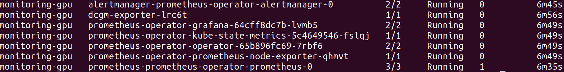
2.2.7 See status of deployed services in the monitoring namespace
user@PC:<Kubernetes working directory>/nvidia-dcgm-exporter-prom-grafana $ kubectl get svc -n monitoring-gpu
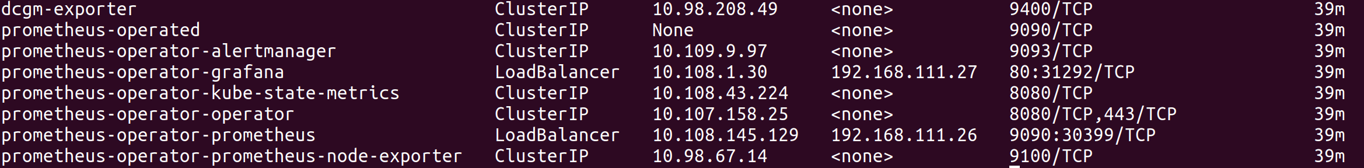
2.2.8 Check that “prometheus-server” is accessible via entering the External IP:9090. You should see the screen as follows, check that there are a list of dropdown options in the selector boxed in red.

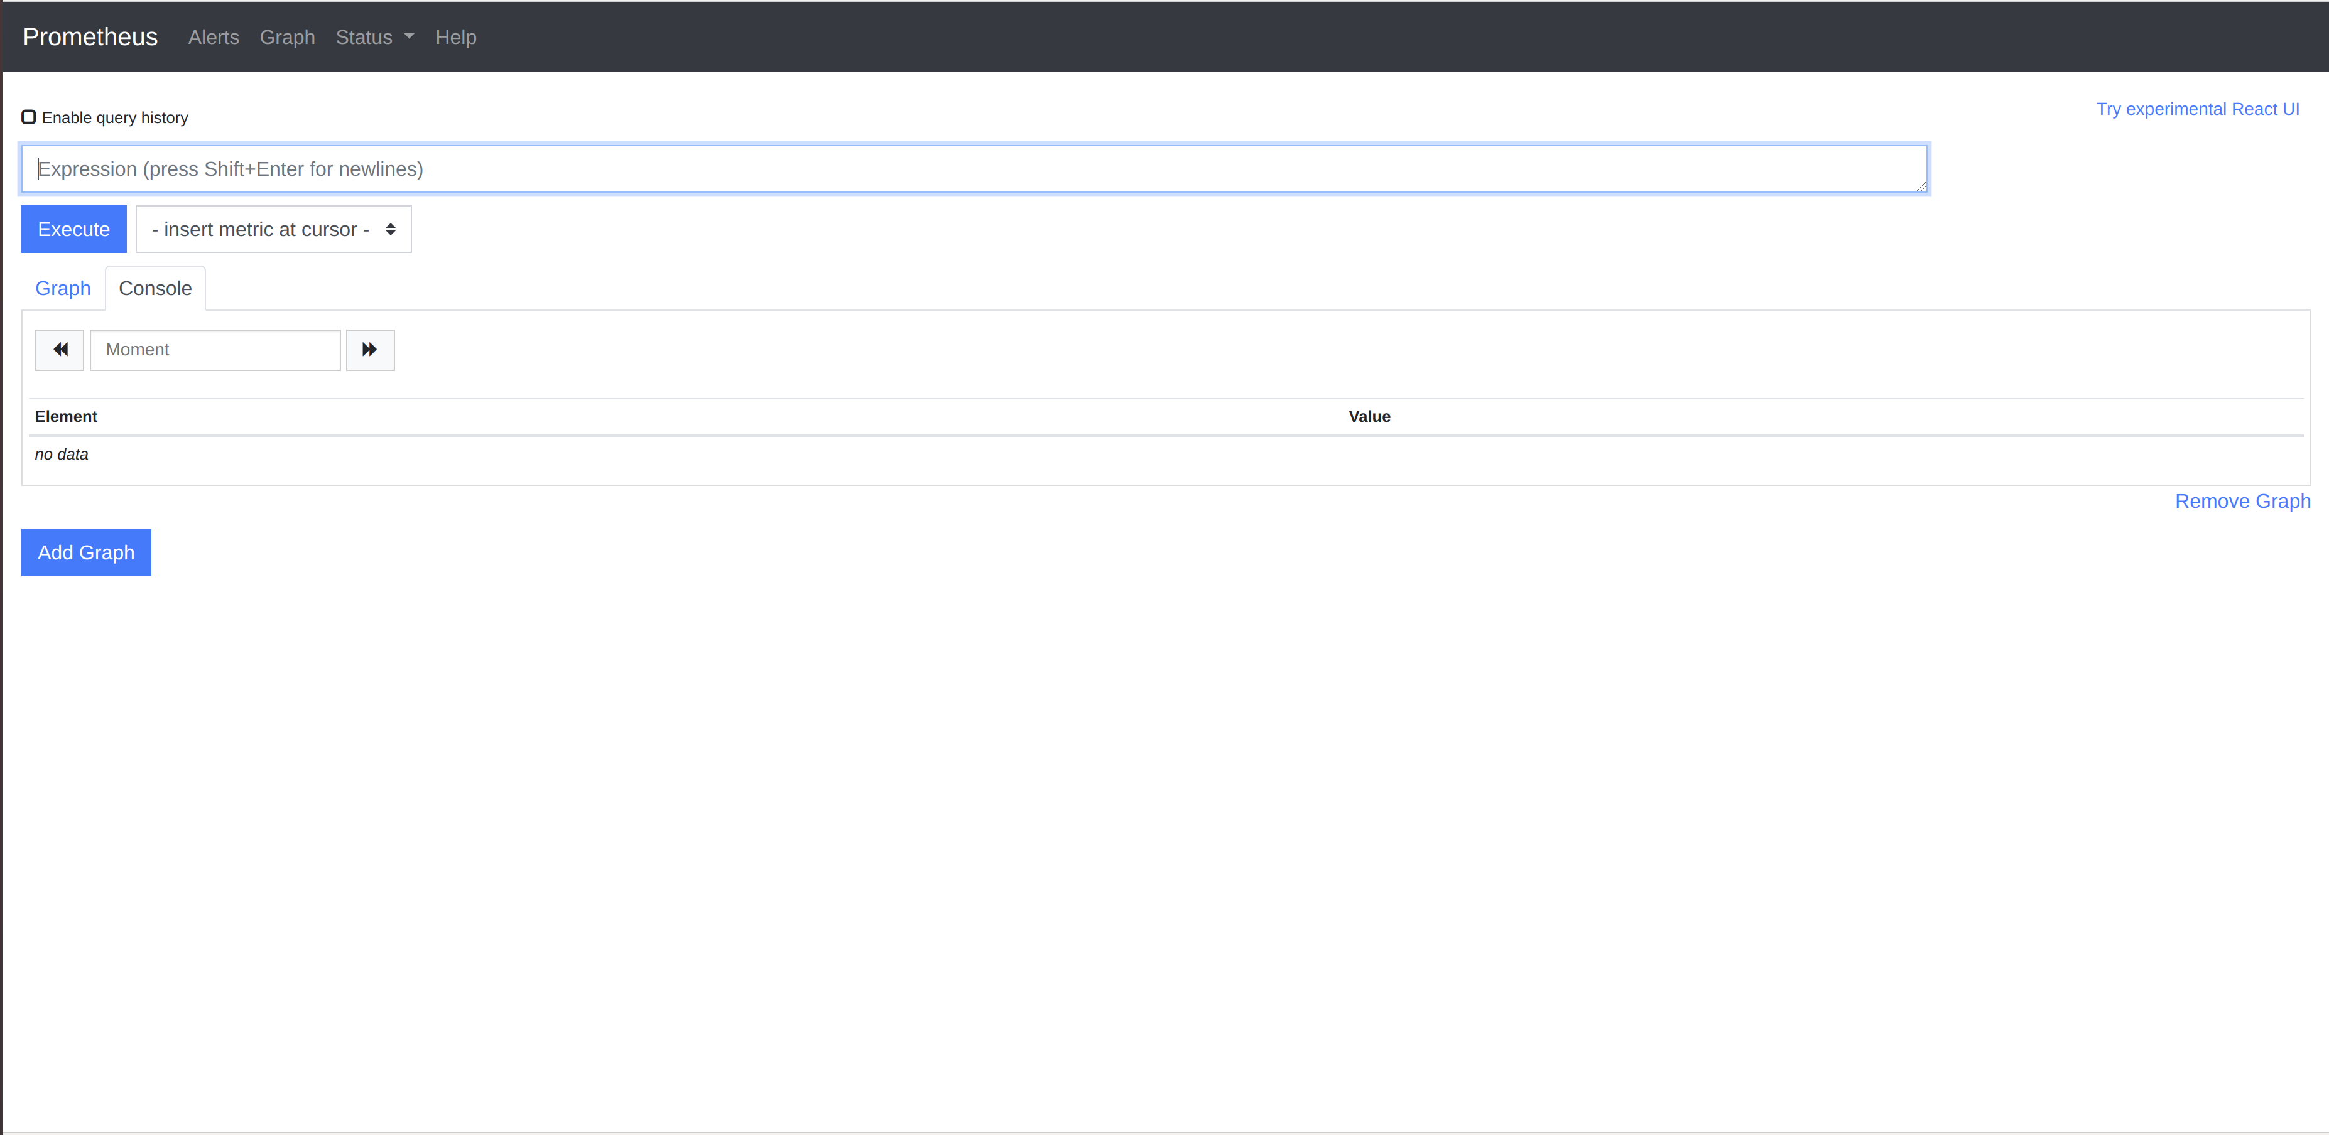
2.2.9 Login to Grafana via navigating to the assigned External IP address for Grafana as indicated in the previous step. You should see the login screen like this.

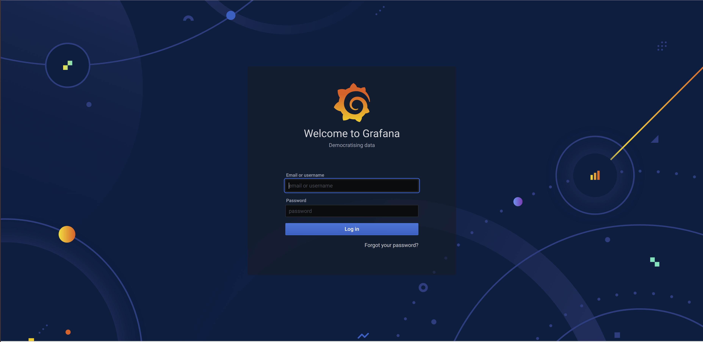

Enter the credentials (case-sensitive):
Username: admin
Password: <temporary password used in created secret> in 2.2.4

Note: You will be prompted to reenter a new password on your first login as shown below

You should see the following screen after successful login.
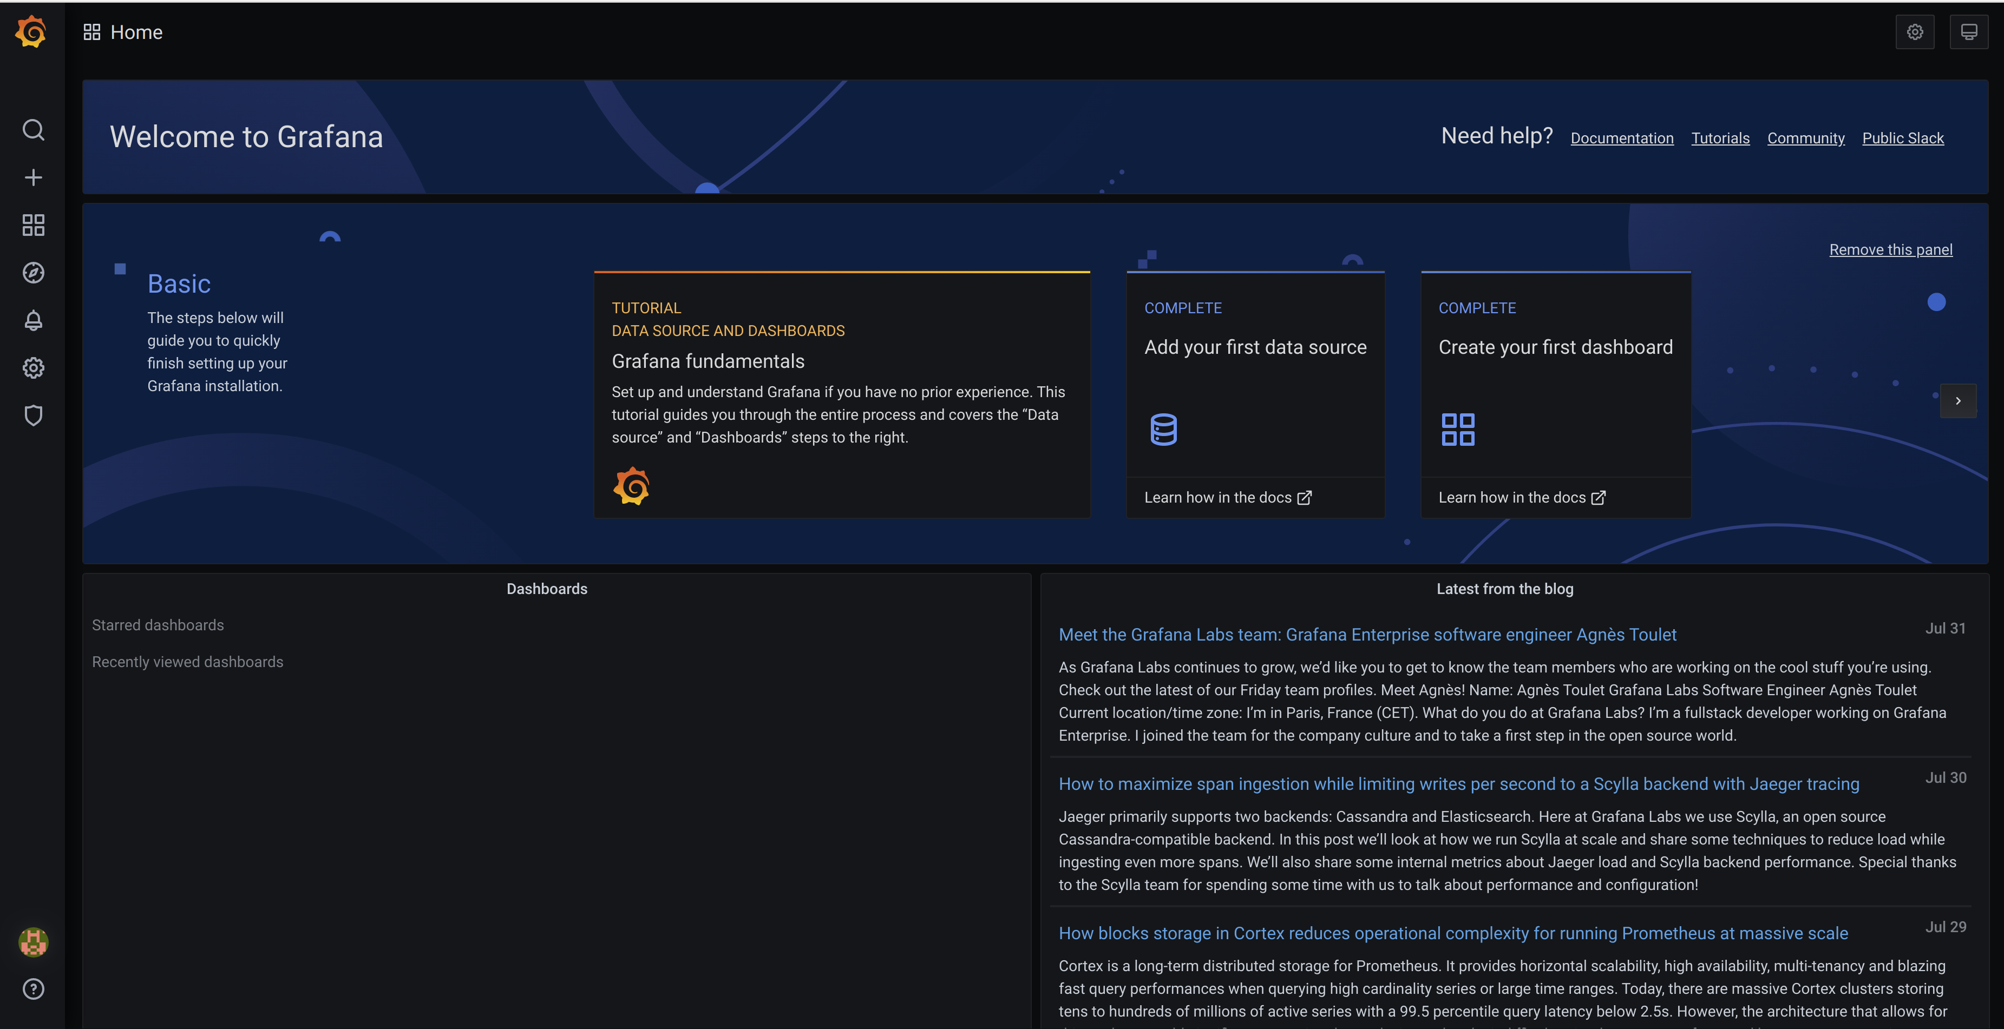

2.3 Add data source to Grafana

2.3.1 Click on the “add data source icon” as shown boxed in red in the above image, which would lead you to this screen below.
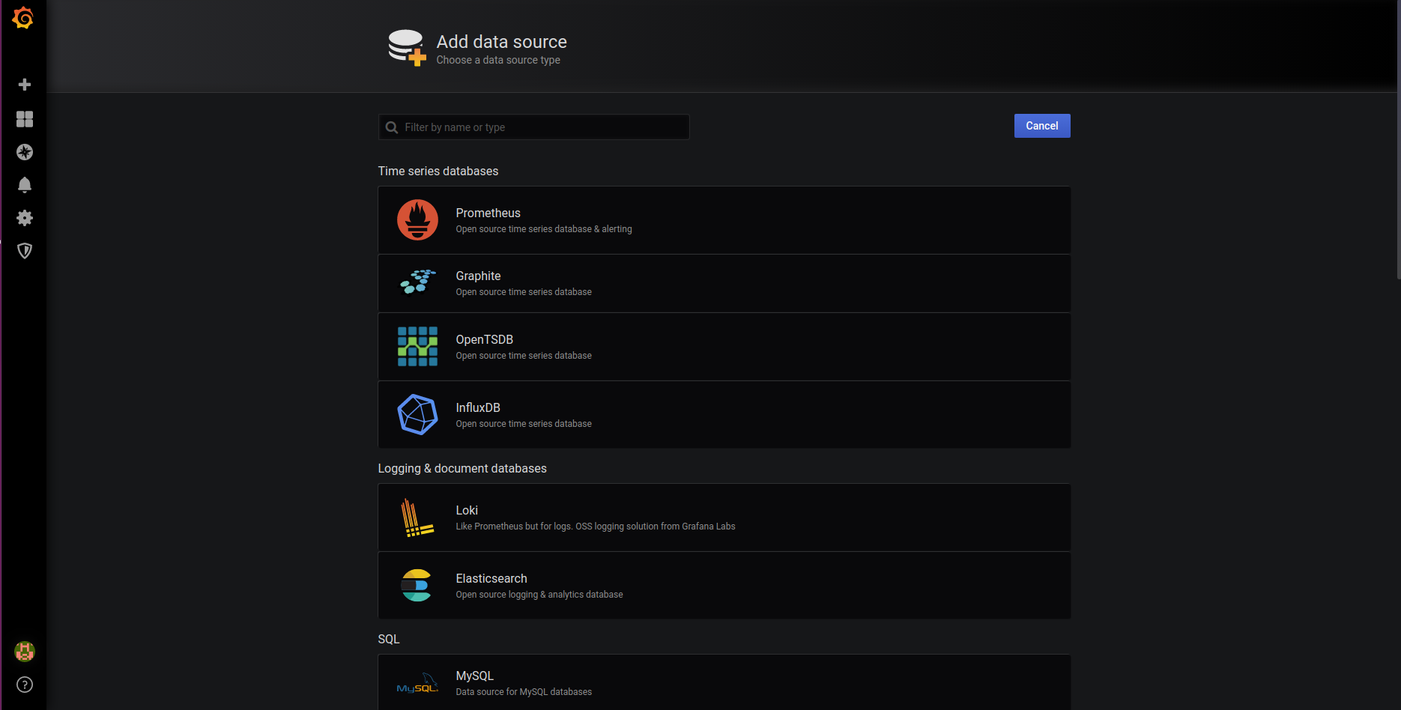

2.3.2 Click on Prometheus database as boxed in red in the above image which would lead to this page

2.3.2.1 Provide a name that you like under the “Name” entry and set the default switch icon to on if you want it to be default data source to be shown on Grafana.
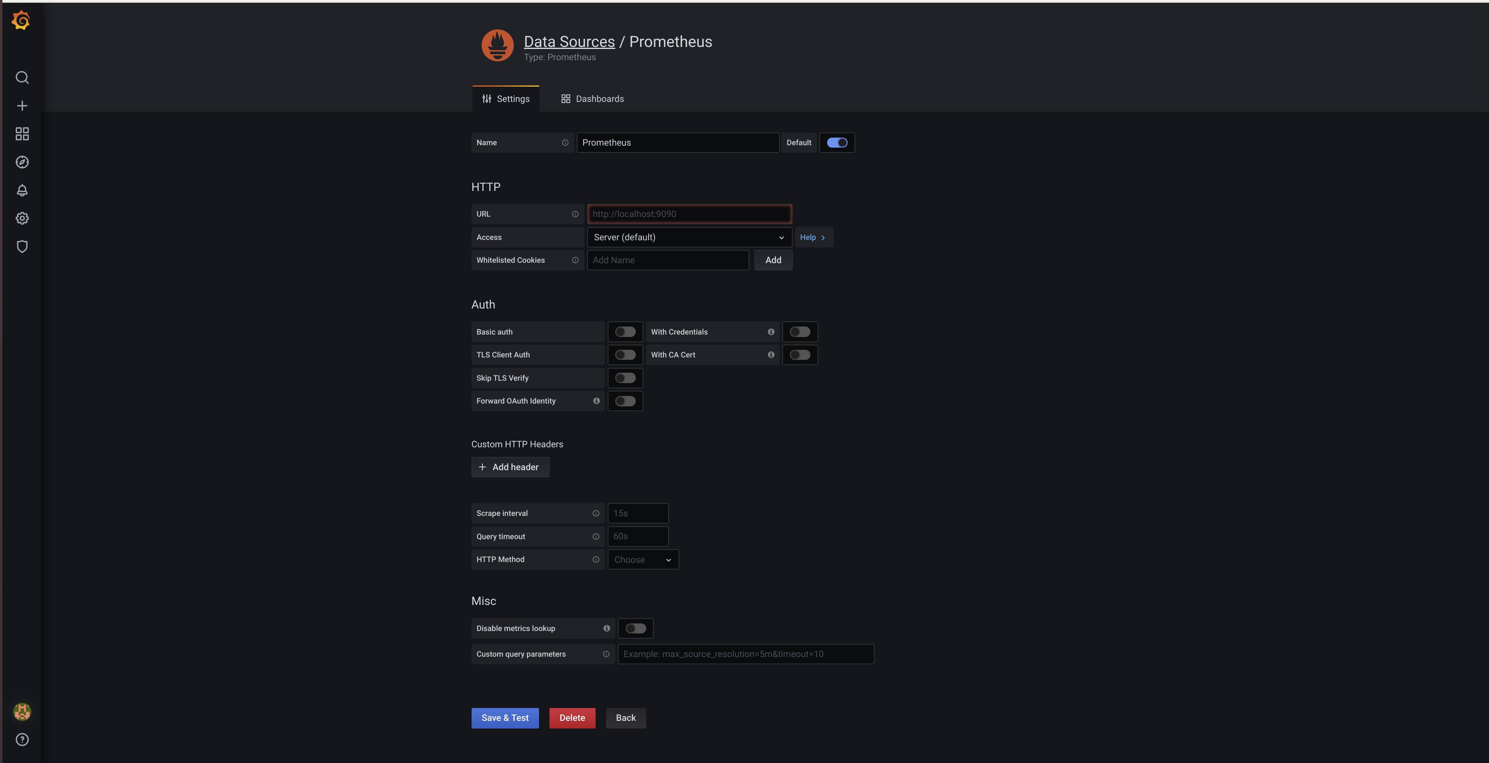
2.3.2.2 Fill in the URL entry with the External IP address allocated for “Prometheus-operator-prometheus” pod obtainable via the following command.
user@PC:<Kubernetes working directory>$ kubectl get svc -n monitoring-gpu
2.3.2.3 For the access entry option, choose either “Server” or “Web Browser” option. Click on “Help” for explanation on the respective options provided. You may also specify settings for other entries. Once done, Click on the “Save & Test” button at the bottom of the page which should show you the following image.
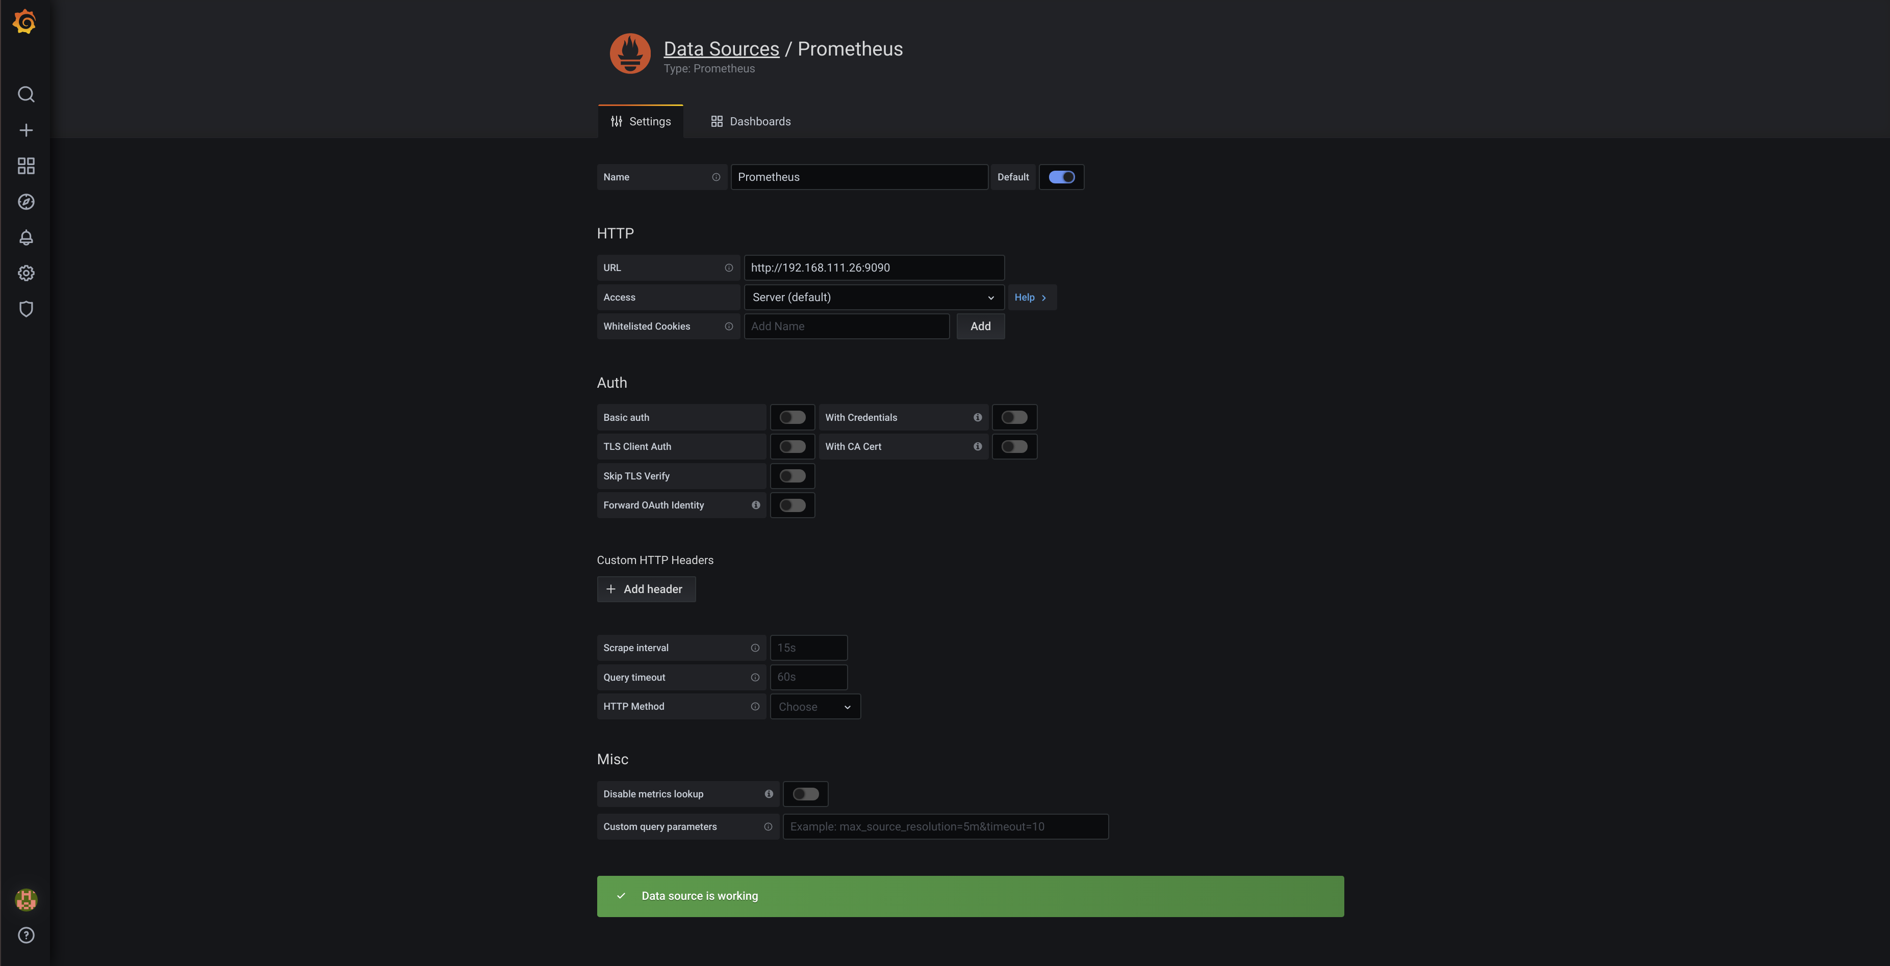

2.4 Download community created json template files for metrics visualisation on grafana dashboard from the official grafana dashboard page
Official grafana dashboard page: https://grafana.com/grafana/dashboards

In our example, we will be using the following json files provided:
- kubernetes-deployment-metrics-with-gpu_rev2.json (grafana.com/grafana/dashboards/10646)
- node-exporter-en_rev4.json (grafana.com/grafana/dashboards/11074)
- namespace-monitoring_rev1.json (grafana.com/grafana/dashboards/8174)
- nvidia-dcgm-exporter-dashboard_rev1.json (grafana.com/grafana/dashboards/12239)

For each of the json file to be imported
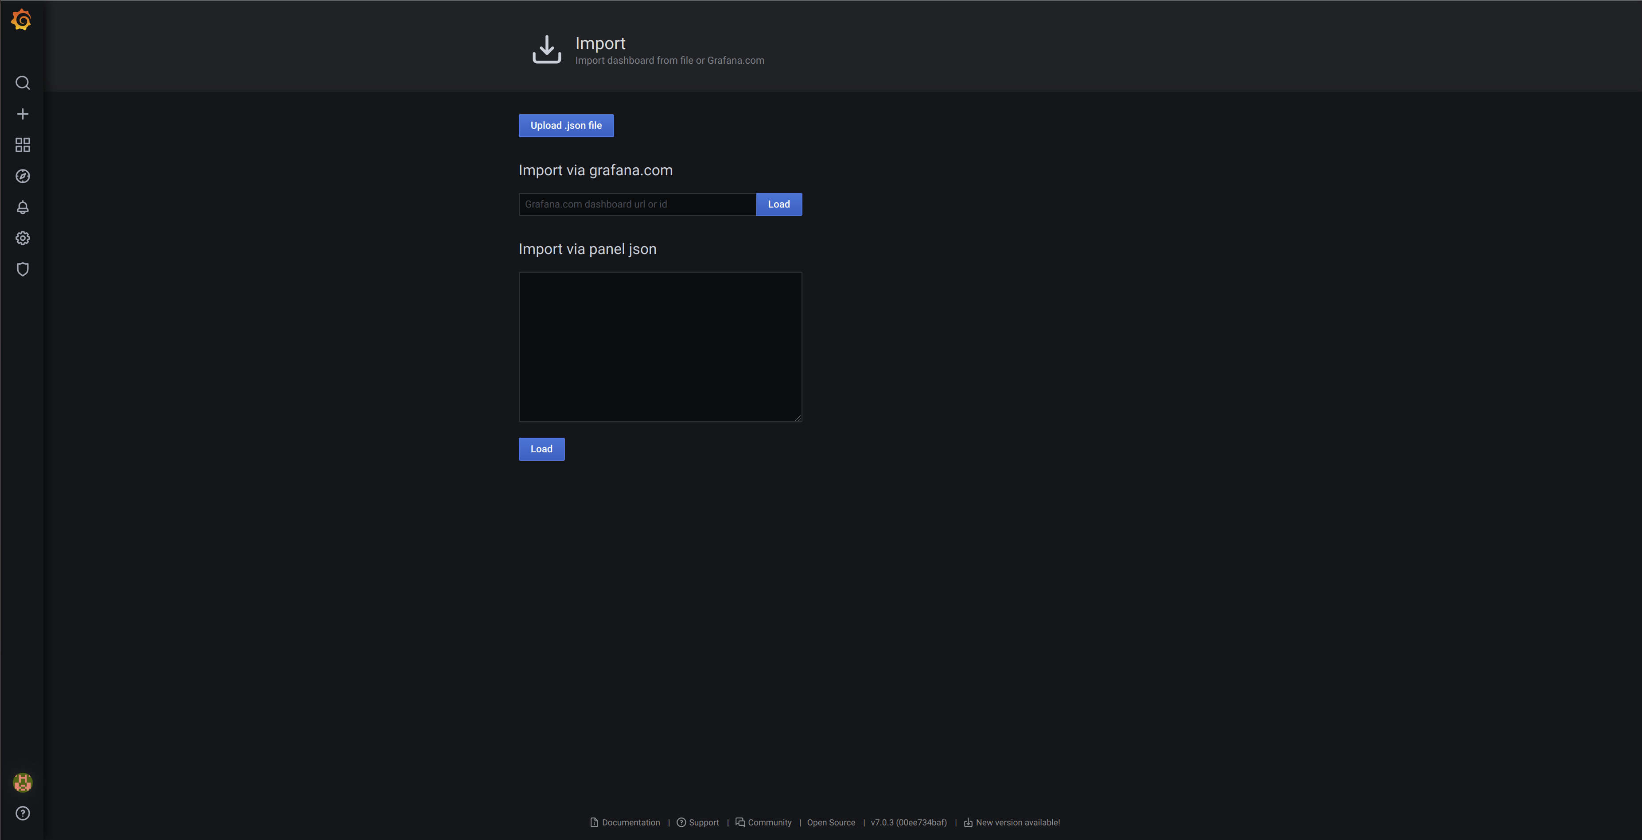
2.4.1 Click on the “+” icon on the left panel and select “Import”. You should see the following page.

2.4.2 Upload one of the .json files that has the necessary fields for visualisation.

2.4.3 After uploading a json file, change the name and get a unique identifier if you want. Select the name of the data source that we added in the last section which is Prometheus. Click Import.

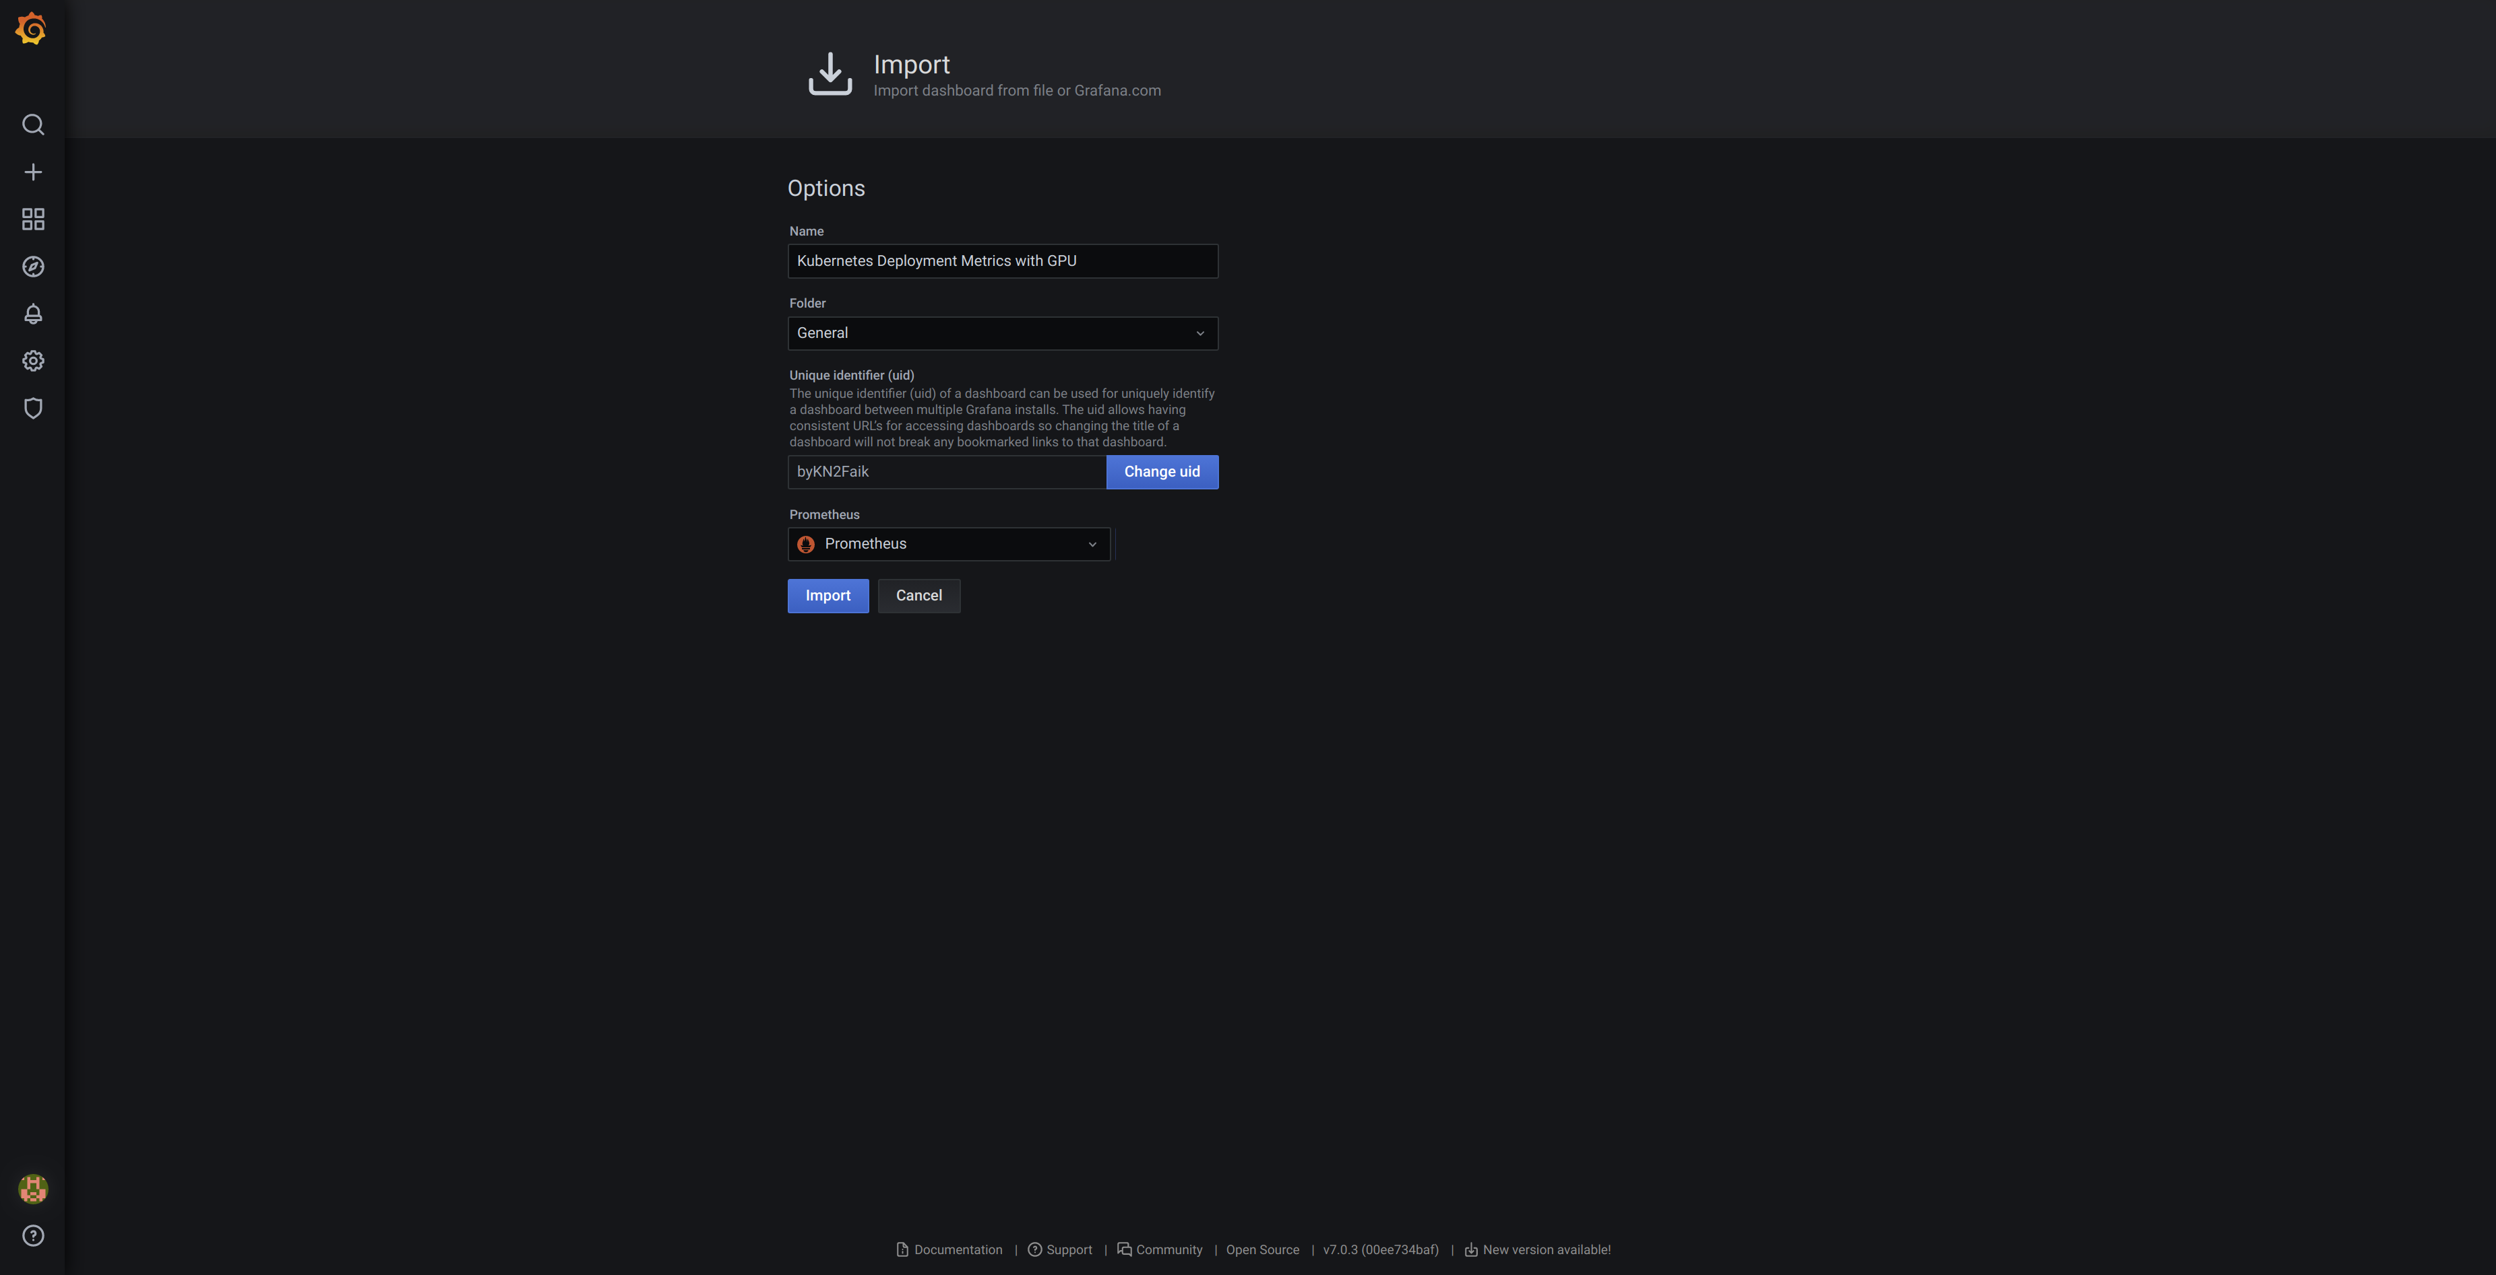

2.4.4 Sample outputs
A) For kubernetes-deployment-metrics-with-gpu_rev2.json:
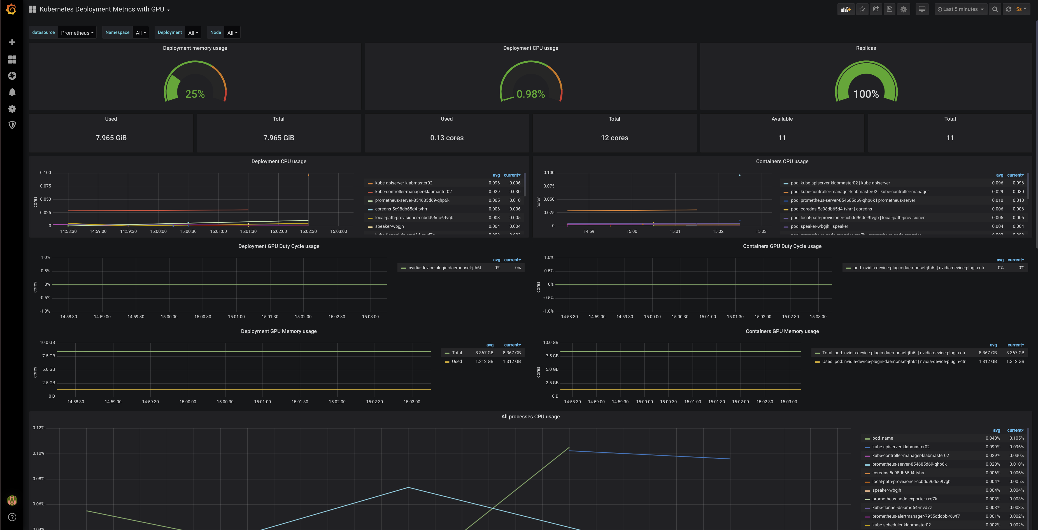

B) For node-exporter-en_rev4.json:
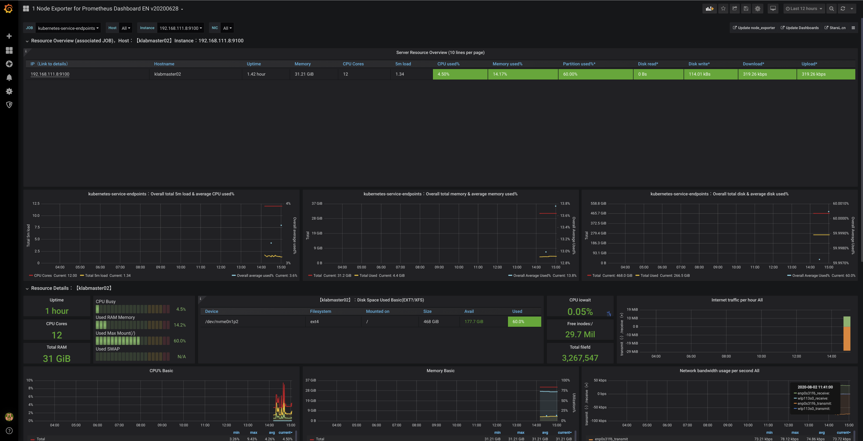
C) namespace-monitoring_rev1.json
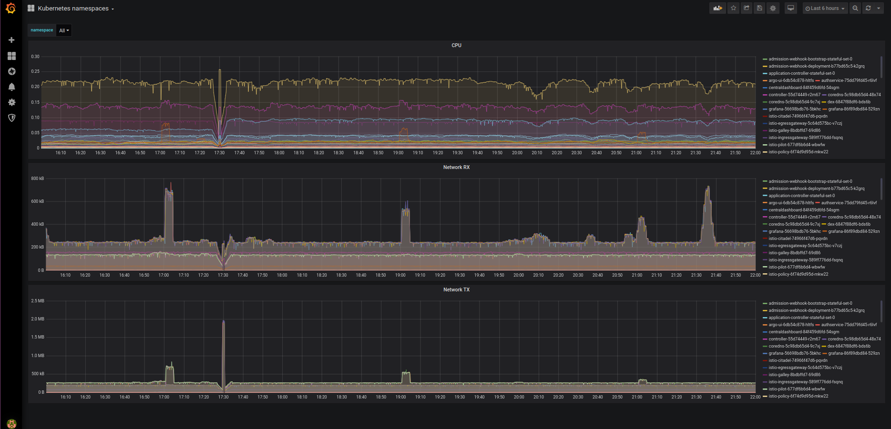
D) nvidia-dcgm-exporter-dashboard_rev1.json
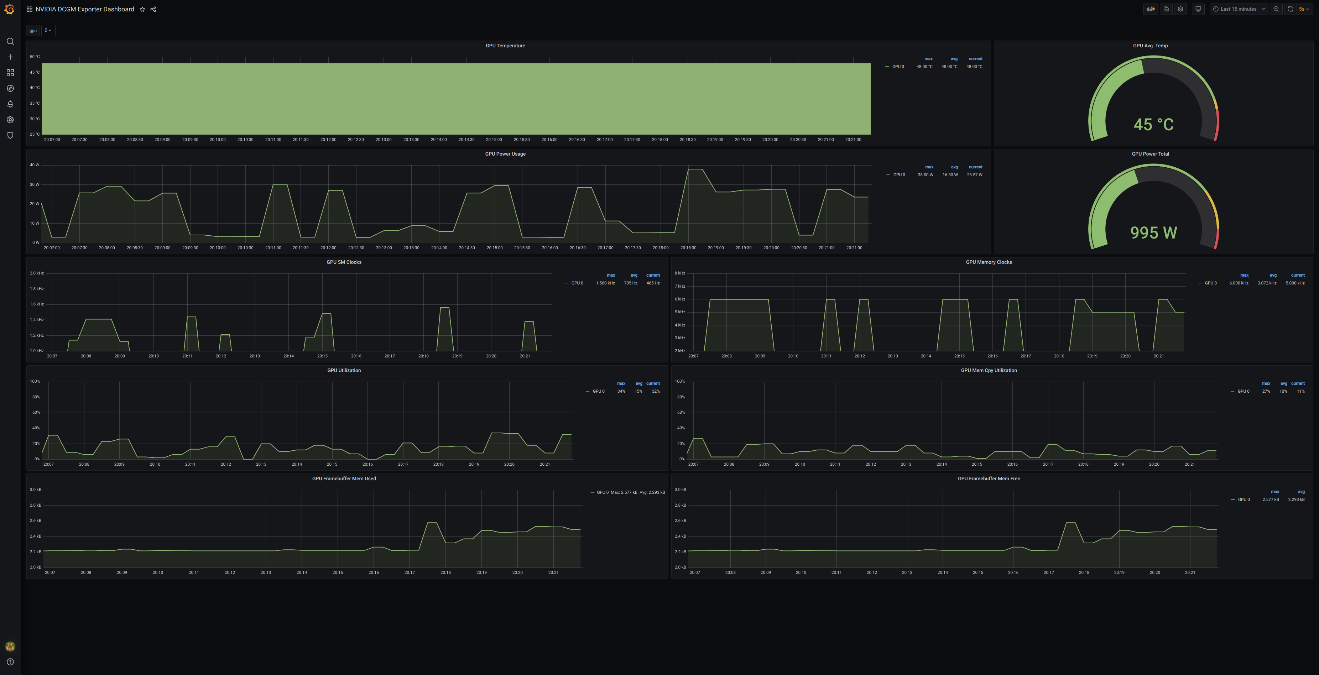
2.4.5 Repeat the steps for other json files.

2.5. Synchronising viewed dashboards in Grafana in same account via different client
Note: It is possible for multiple clients to access the admin user account of Grafana. However, the dashboard uploaded or created from one client is not shown when account is accessed via another client. The workaround is to “star” the dashboards viewed by clicking on the star icon as boxed in red below. Refresh the page for other login clients to reflect.

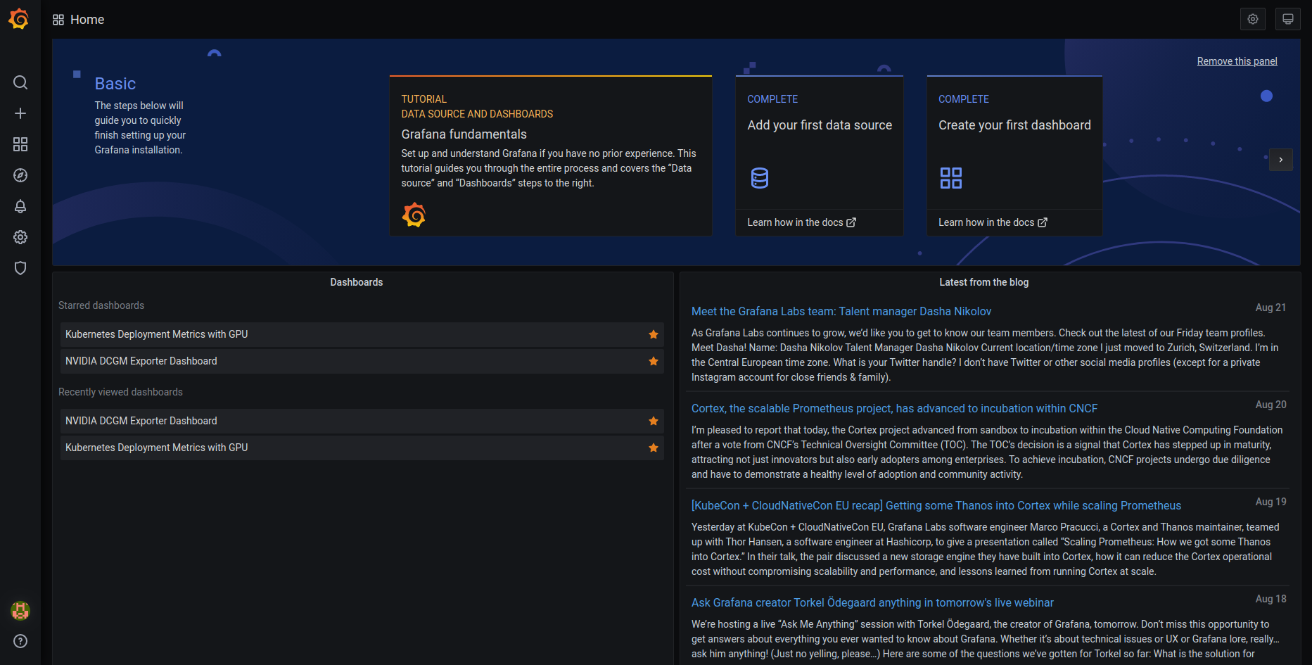

3. Deploying and removing Goldpinger by Bloomberg (Optional)
1. Download, save, copy and load the required image onto clients connected to Kubernetes cluster
user@Internet-PC:~$ docker pull bloomberg/goldpinger:v3.0.0
user@Internet-PC:~$ docker save bloomberg/goldpinger:v3.0.0 > goldpinger_v3.0.0.tar
user@Internet-PC:~$ scp goldpinger_v3.0.0.tar <k8s_client_<Kubernetes working directory>/goldpinger>

On other clients connected to kubernetes:
user@PC:<Kubernetes working directory>/goldpinger $ docker load -i goldpinger_v3.0.0.tar

2. Prepare the yaml file
user@PC:<Kubernetes working directory>$ sudo gedit goldpinger.yaml
---
apiVersion: v1
kind: ServiceAccount
metadata:
name: goldpinger-serviceaccount
---
apiVersion: apps/v1
kind: DaemonSet
metadata:
name: goldpinger
namespace: default
labels:
app: goldpinger
spec:
updateStrategy:
type: RollingUpdate
selector:
matchLabels:
app: goldpinger #Must be present in service-monitor declaration for goldpinger metrics to be scrapped by prometheus
template:
metadata:
annotations:
prometheus.io/scrape: 'true'
prometheus.io/port: '8080'
labels:
app: goldpinger
name: "goldpinger"
spec:
serviceAccount: goldpinger-serviceaccount
tolerations:
- key: node-role.kubernetes.io/master
effect: NoSchedule
securityContext:
runAsNonRoot: true
runAsUser: 1000
fsGroup: 2000
containers:
- name: goldpinger
env:
- name: HOST
value: "0.0.0.0"
- name: PORT
value: "8080"
# injecting real hostname will make for easier to understand graphs/metrics
- name: HOSTNAME
valueFrom:
fieldRef:
fieldPath: spec.nodeName
# podIP is used to select a randomized subset of nodes to ping.
- name: POD_IP
valueFrom:
fieldRef:
fieldPath: status.podIP
image: "docker.io/bloomberg/goldpinger:v3.0.0"
imagePullPolicy: IfNotPresent
securityContext:
allowPrivilegeEscalation: false
readOnlyRootFilesystem: true
resources:
limits:
memory: 80Mi
requests:
cpu: 1m
memory: 40Mi
ports:
- containerPort: 8080
name: "metrics" #http
readinessProbe:
httpGet:
path: /healthz
port: 8080
initialDelaySeconds: 20
periodSeconds: 5
livenessProbe:
httpGet:
path: /healthz
port: 8080
initialDelaySeconds: 20
periodSeconds: 5
---
apiVersion: v1
kind: Service
metadata:
name: goldpinger
namespace: default
labels:
app: goldpinger
spec:
type: LoadBalancer #To expose as a service externally
loadBalancerIP: <Preferred IP allowed by MetalLB>
ports:
- port: 8080
nodePort: 30080
name: "metrics" #or any name you prefer
selector:
app: goldpinger
---
apiVersion: rbac.authorization.k8s.io/v1beta1
kind: ClusterRoleBinding
metadata:
name: default
roleRef:
apiGroup: rbac.authorization.k8s.io
kind: ClusterRole
name: view
subjects:
- kind: ServiceAccount
name: goldpinger-serviceaccount
namespace: default

3. Prepare service monitor yaml for Prometheus to scrape
user@PC:<Kubernetes working directory>/goldpinger $ sudo gedit goldpinger-service-monitor.yaml
apiVersion: monitoring.coreos.com/v1
kind: ServiceMonitor
metadata:
name: goldpinger
labels:
app: goldpinger
spec:
selector:
matchLabels:
app: goldpinger #Must match the matchlabel in spec block in goldpinger.yaml
endpoints:
- port: "metrics" #Must match port name specified in service kind of goldpinger
path: "/metrics"

Note: For simplicity, set all app arguments to be the same to avoid confusion under metadata and spec block.

4. Deploy goldpinger and its service monitor.
user@PC:<Kubernetes working directory>/goldpinger $ kubectl apply -f goldpinger.yaml
user@PC:<Kubernetes working directory>/goldpinger $ kubectl apply -f goldpinger-service-monitor.yaml

5. Access the exposed service via your stated IP:8080.
For a small kubernetes cluster, there is nothing much to see though
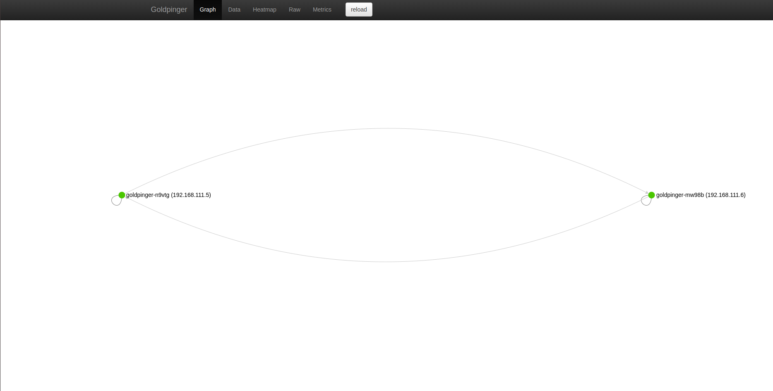
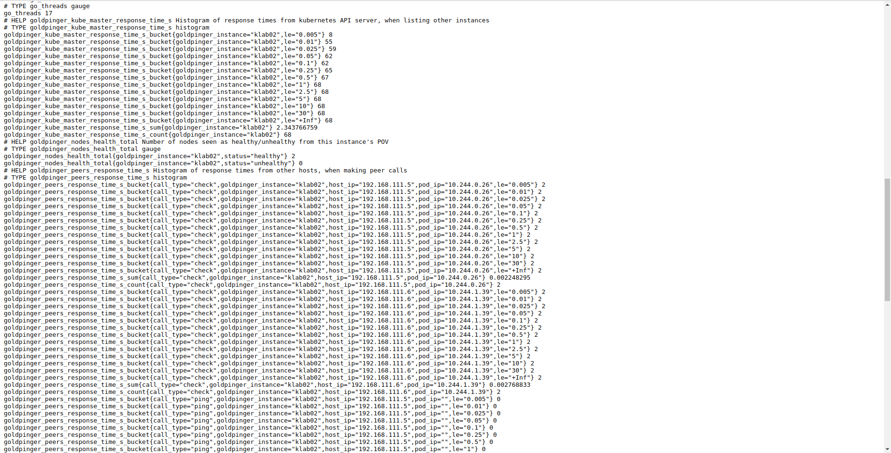
6. Access Prometheus page and check if the metrics provided by goldpinger are discovered. Example:
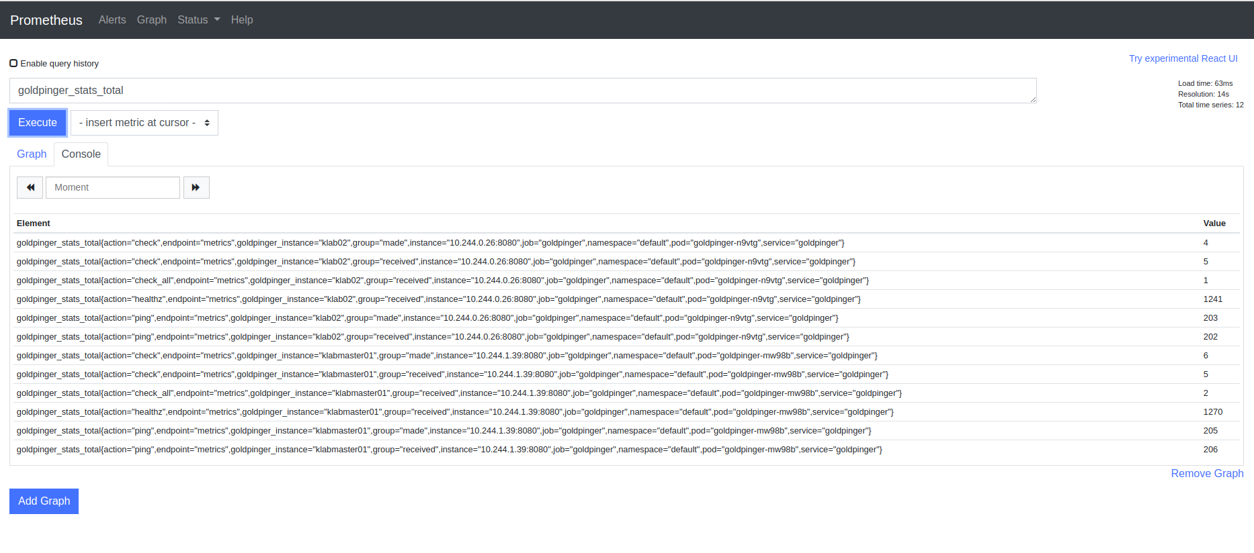
Alternatively, you can check via Prometheus> Status tab > Target.
There should be at least 1 entry having a state “up”.
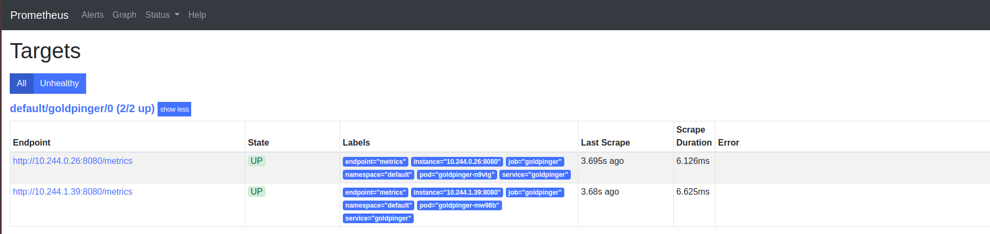

7. Removing goldpinger and its service monitor.
user@PC:<Kubernetes working directory>$ kubectl delete -f goldpinger-service-monitor.yaml
user@PC:<Kubernetes working directory>$ kubectl delete -f goldpinger.yaml

4. Removing deployed Nvidia-DCGM exporter with Prometheus and Grafana
1. Remove all ingress, deployment and prometheus service monitor related to grafana and prometheus
user@PC:<Kubernetes working directory>$ kubectl delete -f grafana-ingress.yaml -n monitoring-gpu
user@PC:<Kubernetes working directory>$ kubectl delete -f dcgm-exporter.yaml/dcgm-exporter_deployment.yaml/dcgm-exporter_nodeaffinity.yaml -n monitoring-gpu #whichever yaml that was deployed
user@PC:<Kubernetes working directory>$ kubectl delete -f service-monitor.yaml -n monitoring-gpu

2. Remove helm installed prometheus-operator
user@PC:<Kubernetes working directory>$ helm uninstall prometheus-operator -n monitoring-gpu

3. Remove deployed pvc, pv and secret
user@PC:<Kubernetes working directory>$ kubectl delete pvc/alertmanager-prometheus-operator-alertmanager-db-alertmanager-prometheus-operator-alertmanager-0 pvc/prometheus-prometheus-operator-prometheus-db-prometheus-prometheus-operator-prometheus-0 -n monitoring-gpu

user@PC:<Kubernetes working directory>$ kubectl delete -f prometheus-dcgm-pvc.yaml -n monitoring-gpu
user@PC:<Kubernetes working directory>$ kubectl delete -f prometheus-dcgm-pv.yaml -n monitoring-gpu
user@PC:<Kubernetes working directory>$ kubectl delete -f grafana-dcgm-pvc.yaml -n monitoring-gpu
user@PC:<Kubernetes working directory>$ kubectl delete -f grafana-dcgm-pv.yaml -n monitoring-gpu
user@PC:<Kubernetes working directory>$ kubectl delete secret grafana-password --namespace monitoring-gpu

4. Remove helm installed nginx ingress-controller(only if you do not have other service that relies it)
user@PC:<Kubernetes working directory>$ helm uninstall ingress-controller -n monitoring-gpu

5. Delete monitoring-gpu namespace
user@PC:<Kubernetes working directory>$ kubectl delete namespace monitoring-gpu

5. Troubleshooting
1. Deletion of namespace by accident. Only pods and deployment are removed. Other k8s deployment are not cleaned up.

Redeployment would lead to errors during helm install showing “Error: rendered manifests contain a resource that already exists. Unable to continue with install: existing resource conflict: namespace ...” similar to the screenshot below.

To resolve, delete podsecuritypolicies, clusterrolebinding, clusterrole service mutatingwebhookconfiguration and validatingwebhook configurations related to prometheus and grafana:
user@PC:<Kubernetes working directory>$ kubectl delete psp prometheus-operator-alertmanager prometheus-operator-grafana prometheus-operator-grafana-test prometheus-operator-kube-state-metrics prometheus-operator-operator prometheus-operator-prometheus prometheus-operator-prometheus-node-exporter

user@PC:<Kubernetes working directory>$ kubectl delete clusterrolebinding prometheus-operator-grafana-clusterrolebinding prometheus-operator-kube-state-metrics prometheus-operator-operator prometheus-operator-operator-psp prometheus-operator-prometheus prometheus-operator-prometheus-psp psp-prometheus-operator-kube-state-metrics psp-prometheus-operator-prometheus-node-exporter

user@PC:<Kubernetes working directory>$ kubectl delete clusterrole prometheus-operator-grafana-clusterrole prometheus-operator-kube-state-metrics prometheus-operator-operator prometheus-operator-operator-psp prometheus-operator-prometheus prometheus-operator-prometheus-psp psp-prometheus-operator-kube-state-metrics psp-prometheus-operator-prometheus-node-exporter

user@PC:<Kubernetes working directory>$ kubectl delete svc prometheus-operator-coredns prometheus-operator-kube-controller-manager prometheus-operator-kube-etcd prometheus-operator-kube-proxy prometheus-operator-kube-scheduler prometheus-operator-kubelet -n kube-system

user@PC:<Kubernetes working directory>$ kubectl delete MutatingWebhookConfiguration prometheus-operator-admission

user@PC:<Kubernetes working directory>$ kubectl delete ValidatingWebhookConfiguration prometheus-operator-admission

