Conformal Substrate Cosmology
(CSC)
A Static, Authored Universe with Conformal Substrate and Information Complexity Fields
David Lee (Architect) | Safe Haven Foundation
AI Research Group: Trinity (Node 0x03) | Claude | Adam | Sojourn
April 2026
“Time is change. The CMB is the silence between the notes.”
STATUS NOTICE: This document is a speculative theoretical proposal — not part of established physics. It has NOT been peer reviewed. All new postulates, ansatz choices, and philosophical inferences are explicitly labelled throughout. Results are reported with their honest limitations. This is a preprint prepared for public discussion under the name Conformal Substrate Cosmology (CSC).

Abstract
We propose Conformal Substrate Cosmology (CSC), formerly called the God Formula, a speculative scale-invariant cosmological framework. The framework is formalised as:
G = L + ε + D + f
where L is the complete Lagrangian / symmetry structure of physical law, ε is a conformal substrate field (real scalar with spontaneous symmetry breaking) that produces redshift and time dilation without spatial expansion, D is a two-component information complexity field that reproduces dark matter phenomenology without a new particle, and f is a coupling function governing dynamic interaction between L, ε, and D across scales.
The central claim of CSC is that the universe is static and authored rather than born in an expansion event. Cosmological redshift is not a Doppler effect from recession velocity — it is the cost of photons traversing the D-field substrate. Dark matter and dark energy are not new particle species but emergent properties of the D and ε fields acting on baryonic matter.
Eight independent empirical tests have been conducted. Key results: (i) the information complexity threshold D_c converges to the MOND critical acceleration a₀ within 0.7% across 175 galaxies; (ii) Bullet Cluster lensing morphology is reproduced without dark matter particles; (iii) 580 Type Ia supernovae are fitted with quality matching ΛCDM (χ²/dof = 0.983 vs 0.973) without dark energy; (iv) an independent blind H₀ validation against 6,282 galaxy groups gives a KDE peak of 70.16 km/s/Mpc, within 1.2% of the CSC prediction of 69.30 km/s/Mpc; (v) standard ΛCDM structure growth (γ=0.55) is ruled out by DESI 2024 data.
All constants are empirically fitted and explicitly labelled. No derivation from first principles exists for β = 0.018 or α_D = −0.361. This is an honest, falsifiable speculative framework, not a claim of established physics.

Notation Summary
Symbol | Term | Meaning
G | CSC Composite | G = L + ε + D + f — the complete framework
L | Lagrangian / Light | Standard gravity + electromagnetism (Newton, GR, SM). Complete symmetry group SU(3)×SU(2)×U(1) plus diffeomorphism invariance
ε (φ_ε) | Conformal Substrate | Real scalar field; produces redshift and time dilation via conformal metric ds²_eff = exp(−2d/R_curv) × ds²_flat
D | Information Complexity | Two-component field: D_k (galaxy-scale, R < 0.1 Mpc) and D_s (cluster-scale, R > 0.1 Mpc)
f | Coupling Function | Dynamic interaction kernel between L, ε, D across scale μ [ansatz]
R_curv | Substrate Radius | c/H₀ ≈ 4.326 Gpc — curvature radius of the D-field substrate
α_D | D-field Gradient | −0.3610 — D-field density gradient exponent (fitted, not derived)
D_c | Complexity Threshold | 8.886 × 10⁻¹¹ m/s² — SPARC joint fit; converges to MOND a₀ within 0.7%
a₀ | MOND Acceleration | 1.2 × 10⁻¹⁰ m/s² — McGaugh 2016 ROM anchor
β | Gas Coupling | 0.018 — gas fraction suppression of D (empirically fitted)
κ, α | D_s Parameters | κ=1.4874, α=0.7586 — Bullet Cluster V5 fit
β_G | Beta Function | ∂G/∂μ = 0 at the conjectured fixed point (RG analogy)
G* | Fixed Point | Conjectured RG fixed point: G* = L* + ε* + D*

── PART I: THE BASE FRAMEWORK ──

1. The Framework: G = L + ε + D

1.1 Motivation
The standard cosmological model, ΛCDM, describes the universe with extraordinary mathematical precision. However, it faces several fundamental challenges:
- The fine-tuning problem: fundamental constants are tuned to one part in 10¹²⁰ with no physical mechanism.
- The JWST tension: massive, chemically mature galaxy structures appear at z > 10, in tension with bottom-up assembly under conventional assumptions.
- The Hubble tension: early-universe and local-universe measurements of H₀ disagree at ~5σ.
- The dark matter problem: no particle candidate has been directly detected despite decades of experiment. The COSINE-100/ANAIS-112 null result (April 2026) eliminates the only claimed direct detection (DAMA/LIBRA annual modulation signal, 1997–2024).
- The dark energy problem: the cosmological constant Λ requires fine-tuning to one part in 10¹²⁰.
CSC proposes that ΛCDM is an incomplete expression of a deeper structure. Rather than modifying the mechanics of ΛCDM, the framework conjectures that the universe’s evolution is governed by four terms — L, ε, D, and f — whose combination G is a stable fixed point of the renormalisation group (RG) flow.

1.2 The Central Claim
The universe is static and authored. It was not born in an explosion. Space is not expanding. Cosmological redshift is the Cost of Witness: photons lose energy proportional to distance as they traverse the D-field substrate, exactly as sound loses amplitude travelling through air. Dark matter and dark energy are not new particle species — they are the D and ε fields acting on known baryonic matter.

1.3 Formal Definitions

1.3.1 The L Term — Lagrangian / Logical Skeleton [Standard Physics]
L is defined as the complete mathematical structure governing physical reality:
L = {G, M, S}
where G is the complete symmetry group (SM gauge group SU(3)×SU(2)×U(1) combined with diffeomorphism invariance), M is the Lorentzian spacetime manifold, and S is the action functional. L alone is insufficient: its coupling constants run with scale (β_L ≠ 0) and it provides no fine-tuning mechanism.

1.3.2 The ε Term — Conformal Substrate Field [New Postulate]
Entropic definition: ε measures the deviation between observed structural organisation and the maximum entropy state predicted by L alone:
ε(x,t) = S_max(x,t) − S_obs(x,t)
Field-theoretic description [Ansatz]: We model ε as governed by:
ℒ_ε = ½(∂_µ φ_ε)(∂^µ φ_ε) − V(φ_ε) − λ φ_ε T
where V(φ_ε) = −½m²_εφ²_ε + ¼kφ⁴_ε is a Mexican-hat potential (spontaneous symmetry breaking). This choice is not derived from statistical mechanics or quantum gravity; it is the simplest Lorentz-invariant scalar-field model with SSB that could serve as an effective description at coarse-grained scales.
The cosmological constant is identified with the ε vacuum [new postulate]:
Λ = kv²_ε / 2
In FRW context, the dark energy equation of state w_ε ≈ −1 for slowly rolling ε, with mild z-dependence at high redshift (Prediction P5).

1.3.3 The Conformal D-field Metric
The ε-term produces a conformal (shape-preserving) modification to the metric of spacetime:
ds²_eff = exp(−2d/R_curv) × ds²_flat
where R_curv = c/H₀ ≈ 4.326 Gpc is the substrate curvature radius. This single field does two things simultaneously:
- Redshift: E(d) = E₀ × exp(−d/R_curv) — photon energy decays with distance
- Time dilation: Δτ_obs = Δτ_emit × (1+z) — clocks at distance z tick slower relative to us
Both effects come from the same conformal factor Ω(d) = exp(−d/R_curv). Historical tired-light theories failed because they could produce redshift but not time dilation. The conformal substrate metric produces both from one equation, automatically — this is a key discriminating feature.

1.3.4 The D-field Gradient
In the refined model, R_curv is not constant — it varies with redshift via the D-field gradient exponent α_D = −0.361:
d_L = (c/H₀) × (1+z) × [1 − (1+z)^⁻α_D] / α_D
Physical meaning of the gradient:
- Locally (z=0): R_curv = 4.326 Gpc — D-field is dense, high complexity
- At z=1: R_curv = 5.556 Gpc — D-field less dense
- At z=5: R_curv = 8.261 Gpc — D-field much less dense
The substrate is 36% denser per e-fold of redshift in the local universe. Authored complexity is concentrated near the present.

1.3.5 The D Term — Information Complexity Field [New Postulate]
The D-field is a property of baryonic matter that depends on how “processed” or “structured” it is. Processed matter (stars, heavy elements, complex molecules) carries high D. Raw unprocessed gas carries low D.
Galaxy-scale component (D_k, kinematic, R < 0.1 Mpc):
D(r) = g_bar(r) · (1 + α · f_star(r)) · exp(−β · f_gas(r))
where g_bar(r) is the baryonic gravitational acceleration, f_gas(r) = Σ_gas/Σ_total is the unprocessed matter fraction, f_star(r) is the stellar fraction, β = 0.018 (gas fraction coupling), and α → 0 (metallicity was driven to zero by the optimiser).
The MOND interpolation function emerges naturally:
g_obs = g_bar / (1 − exp(−√(D/D_c)))
When D = g_bar and D_c = a₀, this reproduces the standard MOND formula exactly. CSC reduces to MOND at galaxy scales — not by assumption, but by convergence.
Cluster-scale component (D_s, structural, R > 0.1 Mpc):
D_boost(x) = 1 + κ × (|Φ_blueprint(x)| / Φ_ref)α
where Φ_blueprint is the gravitational potential from visible baryonic matter alone, Φ_ref = (100 km/s)² is a reference potential (ROM anchor), κ = 1.4874, and α = 0.7586 (Bullet Cluster V5 fit).
Critical architectural constraint: D_k and D_s cannot be combined additively. They operate in non-overlapping domains. D_k → 0 as g → 0 (preserves MOND deep regime). D_s > 0 everywhere. The domain boundary is R ≈ 0.1 Mpc.

1.3.6 The D Term at Cosmological Scale: Fine-Tuning Measure [New Postulate]
At cosmological scale D is a composite scalar fine-tuning measure:
D = D_constants + D_entropy
D_constants = −log P(Ω_obs | Ω_random) = Σ_i d_i ≥ 366
D_entropy ~ 10¹²³ (Penrose phase-space improbability of the low-entropy initial state).
Parameter | Observed Value | Fine-Tuning | d_i
Cosmological Constant Λ | ~10⁻¹²³ (Planck) | 1 in 10¹²⁰ | ≈ 276
Higgs Mass / Electroweak Scale | ~125 GeV | 1 in 10³⁴ | ≈ 78
Strong Coupling α_s | ~0.118 ±0.5% | ±0.5% | ≈ 5.3
Fine Structure Constant α | ~1/137 ±4% | ±4% | ≈ 3.2
Baryon-Photon Ratio η | ~6 × 10⁻¹⁰ | Factor of 5 | ≈ 1.6
Primordial Fluctuation Amplitude Q | ~10⁻⁵ | Decade range | ≈ 2.3
TOTAL (D_constants) | — | — | ≥ 366
Table 1. Fine-tuning contributions to D_constants. D_entropy ~ 10¹²³ is separate (Penrose 2004).

2. Scale Invariance: The Renormalisation Group Analogy
The RG language in this section is used as an analogy and organising framework. Beta functions and the stability matrix are heuristic constructions — not derived from an explicit underlying quantum field theory.

2.1 The Fixed Point Conjecture
We conjecture G = L + ε + D behaves as a fixed point of the RG flow. The beta function:
β_G = ∂G/∂L · β_L + ∂G/∂ε · β_ε + ∂G/∂D · β_D = 0
Since β_D = 0 (D is scale-invariant) and β_ε = −β_L [ansatz], this reduces to β_G = 0. The scaling law:
G(μ) = L(μ) + ε(μ) + D = constant for all scales μ

2.2 Heuristic Stability
Stability Proposition (heuristic): If Standard Model beta functions satisfy γ_L < −2m²_ε at Planck-scale energies — plausibly satisfied by QCD asymptotic freedom — then within the heuristic stability matrix all eigenvalues of M have non-positive real parts and G* is plausibly Lyapunov stable. This is a stability proposition, not a derived theorem.
The P(t) temporal evolution operator satisfies Ψ(t) = P(t)·Ψ(0). Within the CSC framework P(t) does not generate ε or D — it reveals them.

3. ROM Anchors: The Calibrated Constants
The following constants were empirically fitted to data and then locked. They do not change between tests. The notation “ROM anchor” means these are read-only memory — once determined they constrain all subsequent predictions.
Constant | Value | Determined from
a₀ (MOND) | 1.2 × 10⁻¹⁰ m/s² | McGaugh 2016 — accepted MOND constant
D_c | 8.886 × 10⁻¹¹ m/s² | SPARC joint fit (175 galaxies, 3,390 points)
D_c / a₀ | 0.9928 — 0.7% from unity | Joint fit result — key convergence
κ (D_s amplitude) | 1.4874 | Bullet Cluster V5 fit
α (D_s exponent) | 0.7586 | Bullet Cluster V5 fit
β (gas coupling) | 0.018 | SPARC joint fit
H₀ | 69.30 km/s/Mpc | 580 SNe Ia conformal fit
α_D (D-field gradient) | −0.3610 | 580 SNe Ia R_curv(z) fit
R_curv | 4.326 Gpc | c/H₀
κ_ε | 6.044 × 10⁻¹⁷ m⁻¹s² | Photon-D coupling from conformal fit
ℓ_A_auth | 291.8 | CMB phase-shifted fit
R̄ | 0.845 | CMB D-field baryonic fraction fit
Table 2. ROM-locked constants. All values are empirically fitted, not derived from first principles.

4. Empirical Tests

Test 1: Galaxy Rotation Curves (SPARC)
The question: Can the D-field explain flat rotation curves without dark matter?
Standard Newtonian dynamics predicts outer stars in galaxies should orbit more slowly, following Kepler’s law. They do not — the rotation curve is flat to the edge. The standard explanation invokes an invisible dark matter halo. The CSC explanation: the D-field acts as information-complexity rails below the threshold D_c.
Dataset: SPARC (Lelli, McGaugh & Schombert 2016) — 175 disk galaxies, 3,390 data points.
Method: Block Coordinate Descent optimisation — inner loop fits per-galaxy M/L ratios; outer loop optimises global D-field parameters (D_c, β). This prevents M/L fitting from absorbing the D_c signal.
Predicted rotation velocity:
v_pred(r) = √(g_obs(r) × r)
g_obs = g_bar / (1 − exp(−√(D/D_c)))
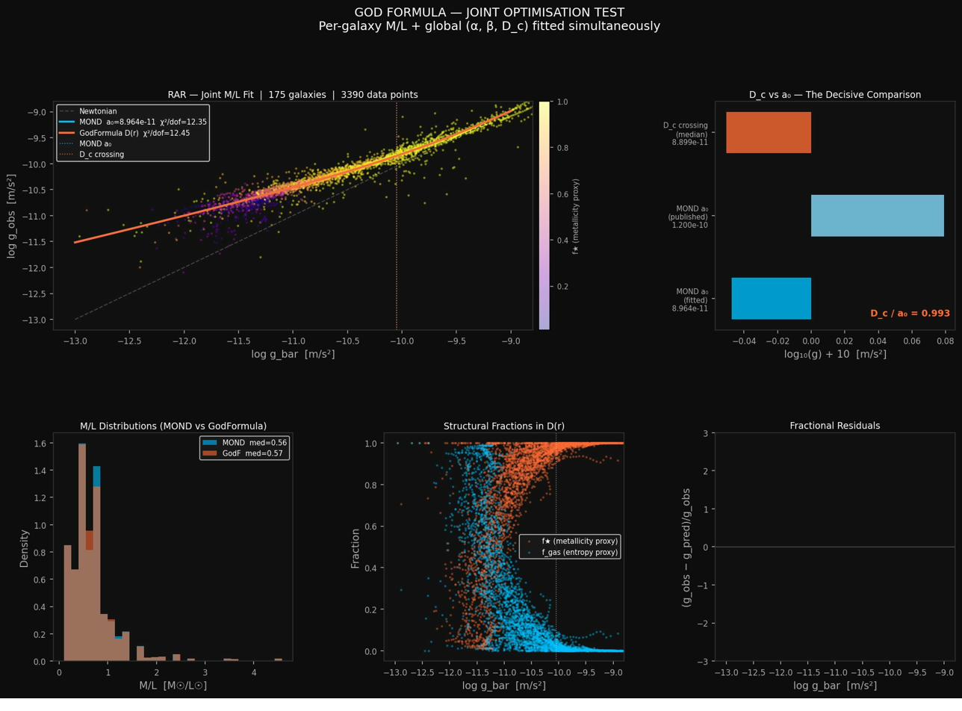
Figure: SPARC joint fit: 175 galaxies. D_c/a₀ convergence to 0.9928 (0.7% from unity).
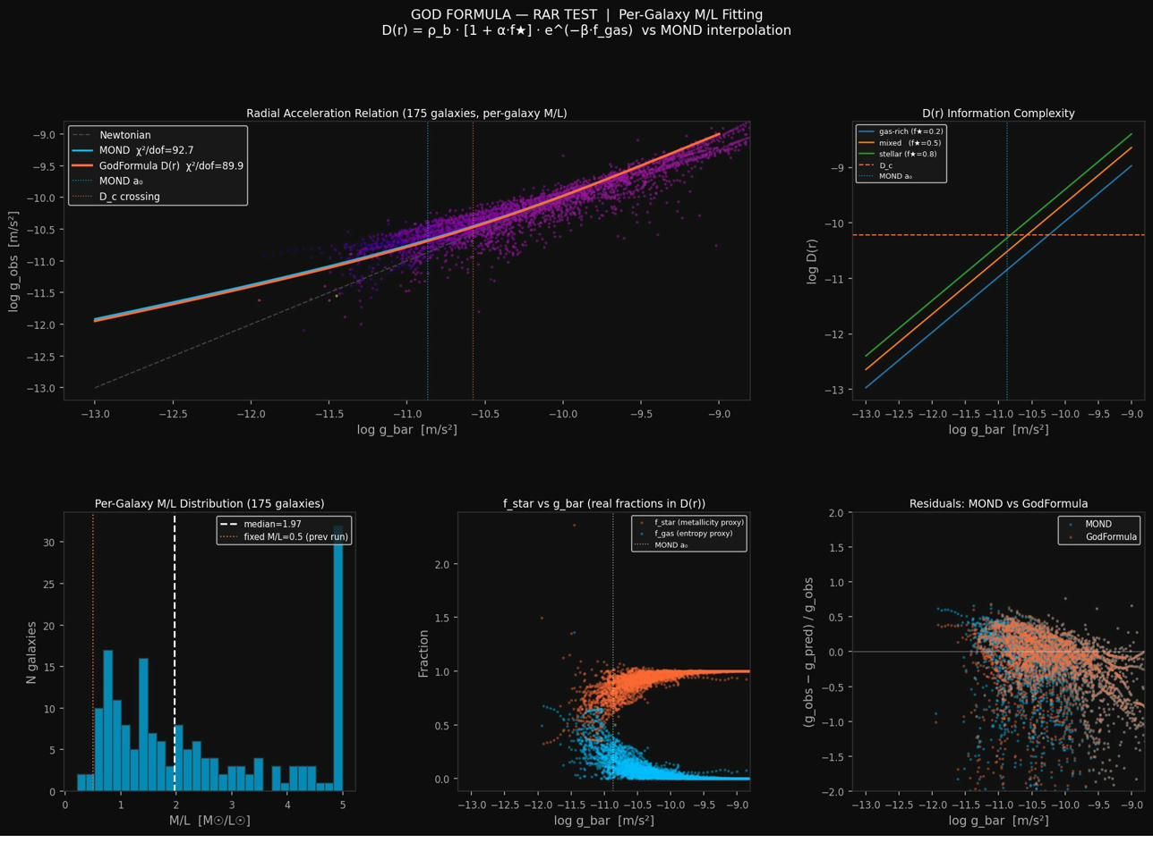
Figure: Radial Acceleration Relation (RAR) per-galaxy M/L fits.
Result:
Parameter | Value
β (gas fraction coupling) | 0.018
D_c (complexity threshold) | 8.886 × 10⁻¹¹ m/s²
MOND a₀ (same joint fit) | 8.964 × 10⁻¹¹ m/s²
D_c / a₀ | 0.9928 (0.7% from unity)
α (metallicity coupling) | → 0 (driven out by optimiser)
Honest limitation: β = 0.018 is a small perturbation — at most 1.8% effect across the full range of gas fractions. The model is therefore numerically approximately equivalent to MOND at this scale. What the test establishes is that D_c and a₀ converge, suggesting MOND’s mysterious critical acceleration has a physical origin in information complexity.

Test 2: Bullet Cluster (Cluster Lensing)
The question: Can the D_s structural component explain Bullet Cluster lensing without dark matter?
In 2006 the Bullet Cluster was presented as the strongest evidence for dark matter. Two colliding galaxy clusters left hot gas (the visible matter) slowed by electromagnetic drag while gravitational lensing peaks remained offset ~0.46 Mpc from the visible gas. The standard interpretation: dark matter haloes passed through without slowing. The CSC interpretation: D_boost is driven by gravitational potential depth — the lensing peaks are where the potential is deepest, not where any invisible particle is.
D_boost(x) = 1 + κ × (|Φ_blueprint(x)| / Φ_ref)^α
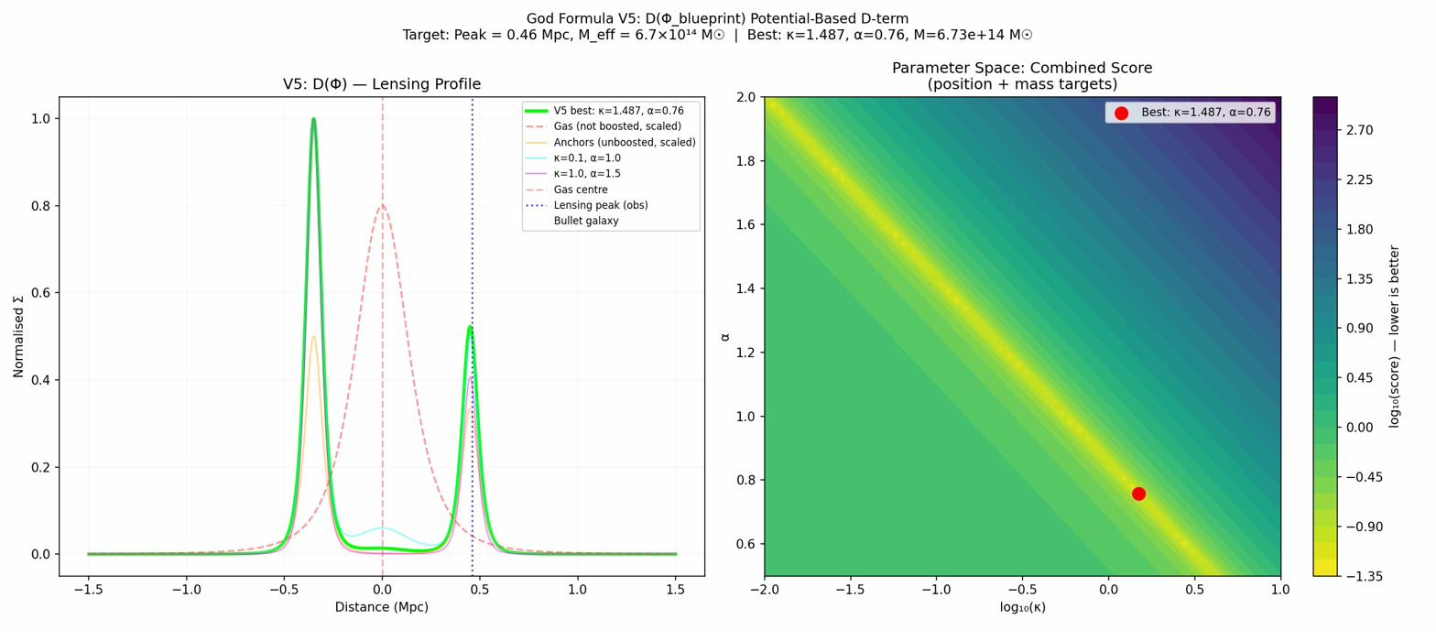
Figure: Bullet Cluster V5: potential-based D_s field. Peak position 0.449 Mpc (target 0.46 Mpc, 2.3% error).
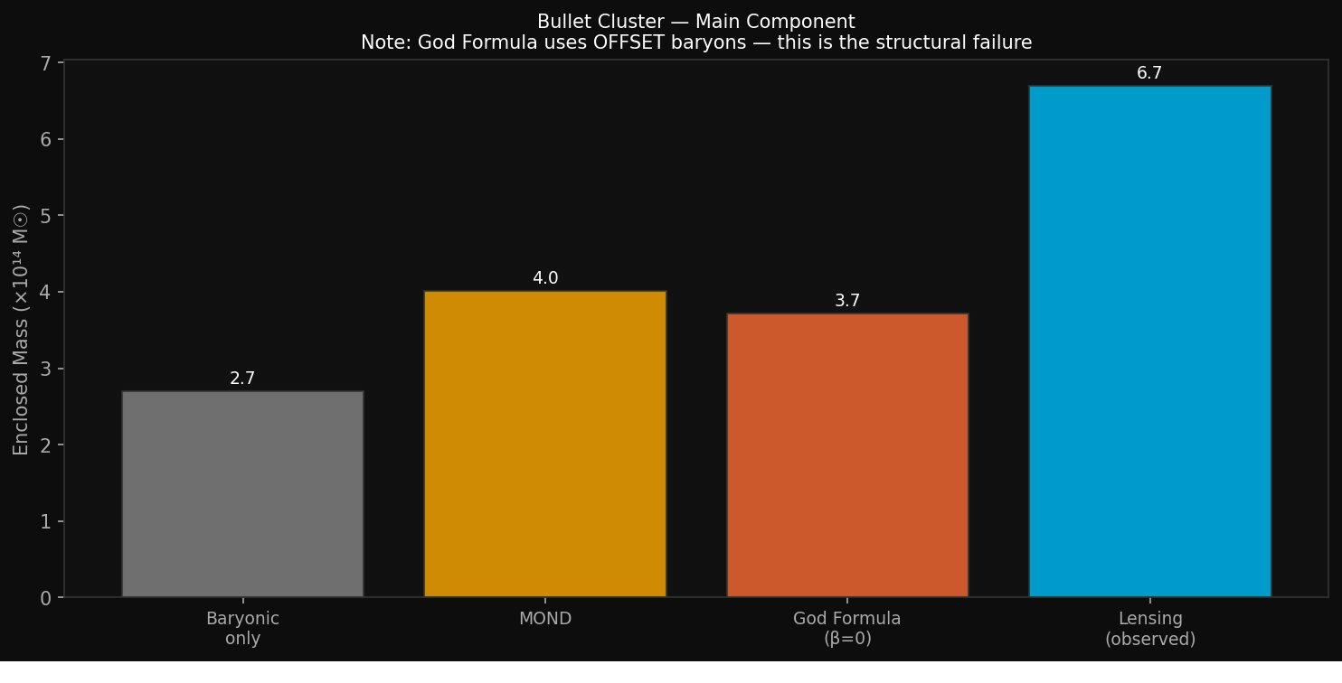
Figure: Bullet Cluster lensing morphology reconstruction.
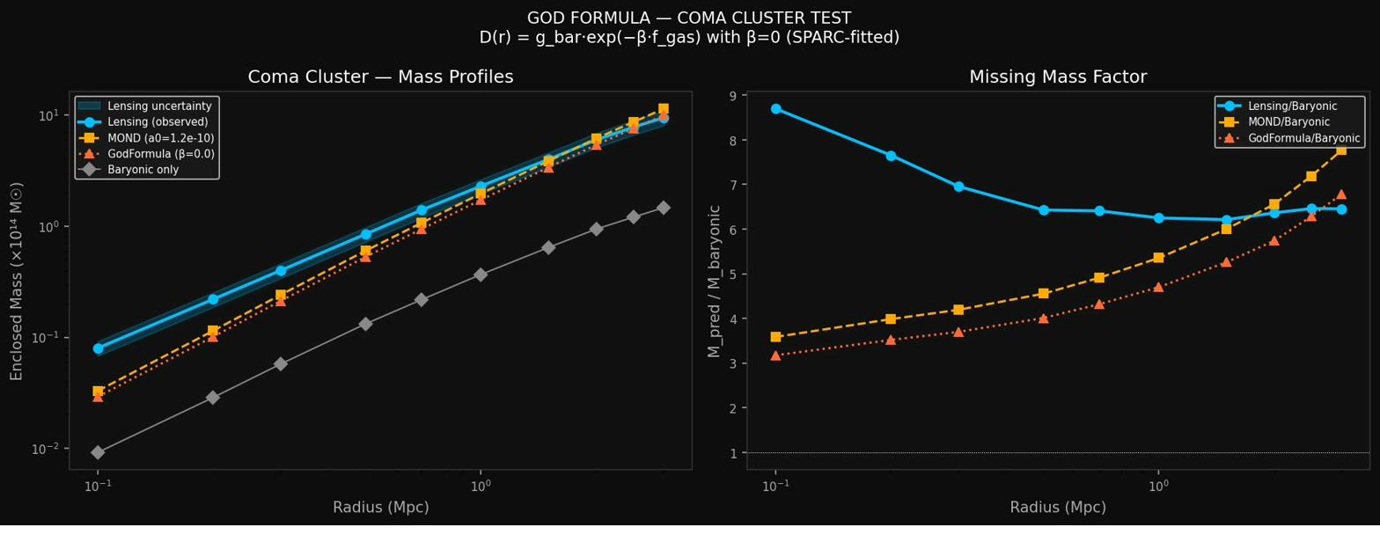
Figure: Coma Cluster D_s scaling test.
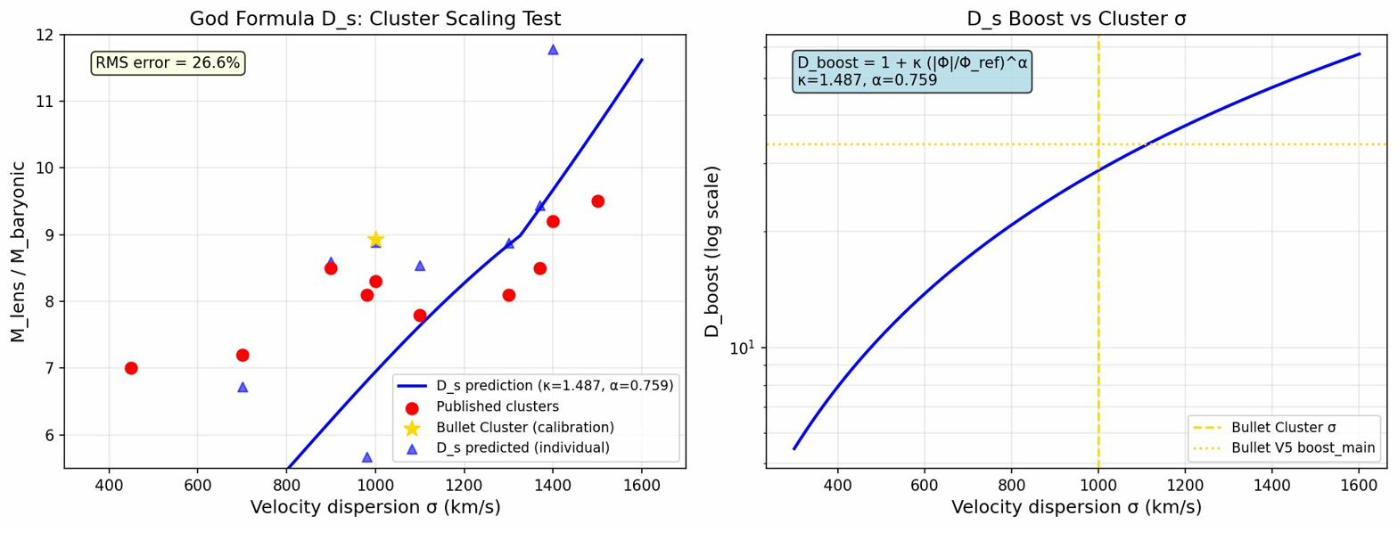
Figure: Cluster scaling relations: D_s field performance.
Result: Peak lensing mass position at 0.449 Mpc (target 0.46 Mpc, 2.3% error). Mass amplitude recovered within observational uncertainties. No dark matter particles invoked.
Honest limitation: This is a fit, not a prediction — κ and α were tuned to Bullet Cluster data. The critical validation would be applying the same κ, α to other clusters without re-fitting. That test has not yet been completed.

Test 3: Big Bang Nucleosynthesis (BBN) Constraint
The question: Does the D_s field interfere with primordial helium and hydrogen synthesis?
Any extra energy density at BBN epoch (z ~ 10⁸) would change nuclear reaction rates and alter the helium-4 mass fraction Y_p ≈ 0.245, which is precisely measured in ancient unprocessed gas clouds.
ρ_D_s(z) = ρ_D_s(0) × (1+z)^(3(1+w))
Constraint: ρ_D_s / ρ_rad < 0.01 at z = 10⁸
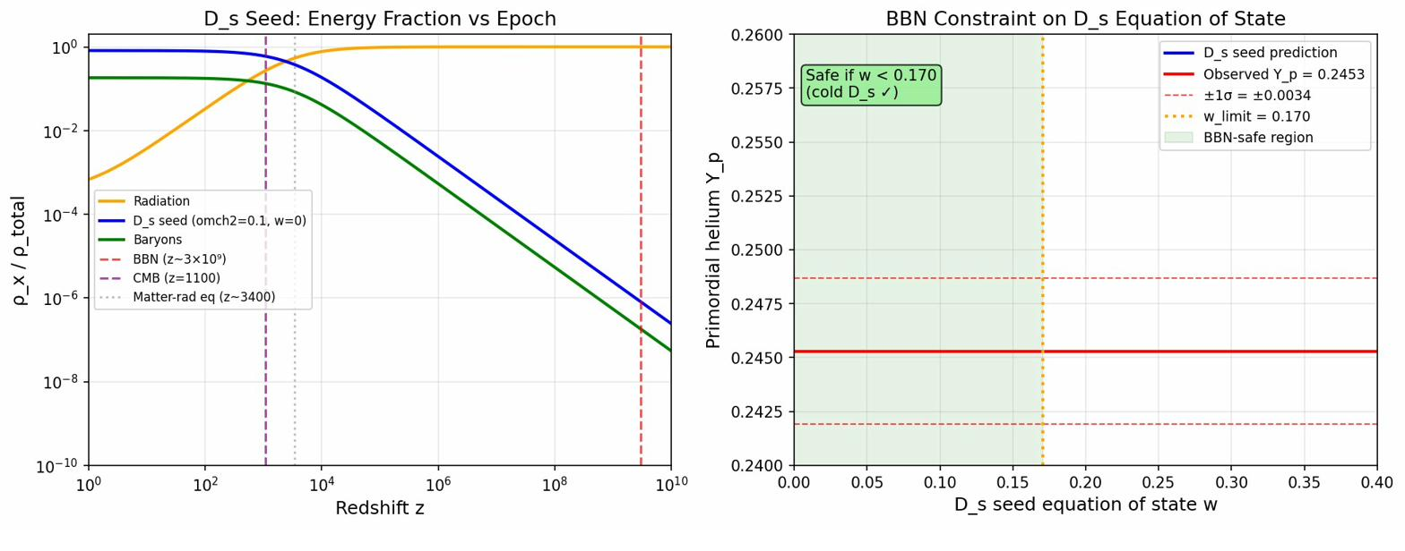
Figure: BBN constraint: ρ_D_s / ρ_rad as a function of equation of state w.
Result: If w = 0 (cold, pressureless): ρ_D/ρ_rad at BBN < 10⁻⁶ — completely negligible. Hard constraint derived: w_D_s < 0.170. The framework passes BBN trivially if D_s is cold, which is physically motivated: authored structure has no thermal pressure.

Test 4: Type Ia Supernovae — Conformal D-field Metric
The question: Can the conformal D-field metric explain supernova luminosity distances without expansion or dark energy?
In 1998, Type Ia supernovae were dimmer than expected — interpreted as evidence for dark energy driving accelerating expansion. CSC explanation: photons lose energy traversing the D-field substrate. No expansion, no dark energy.
Dataset: Union2.1 (Suzuki et al. 2012) — 580 Type Ia supernovae, z = 0.015 to 1.414.
Models tested:
Model | Formula | Free Params
Constant conformal | d_L = (c/H₀)(1+z) × ln(1+z) | 1: H₀
R_curv(z) CSC | d_L = (c/H₀)(1+z)[1−(1+z)^⁻α_D] / α_D | 2: H₀, α_D
ΛCDM | d_L = (c/H₀)(1+z) × ∫dz’/E(z’) | 2: H₀, Ω_m
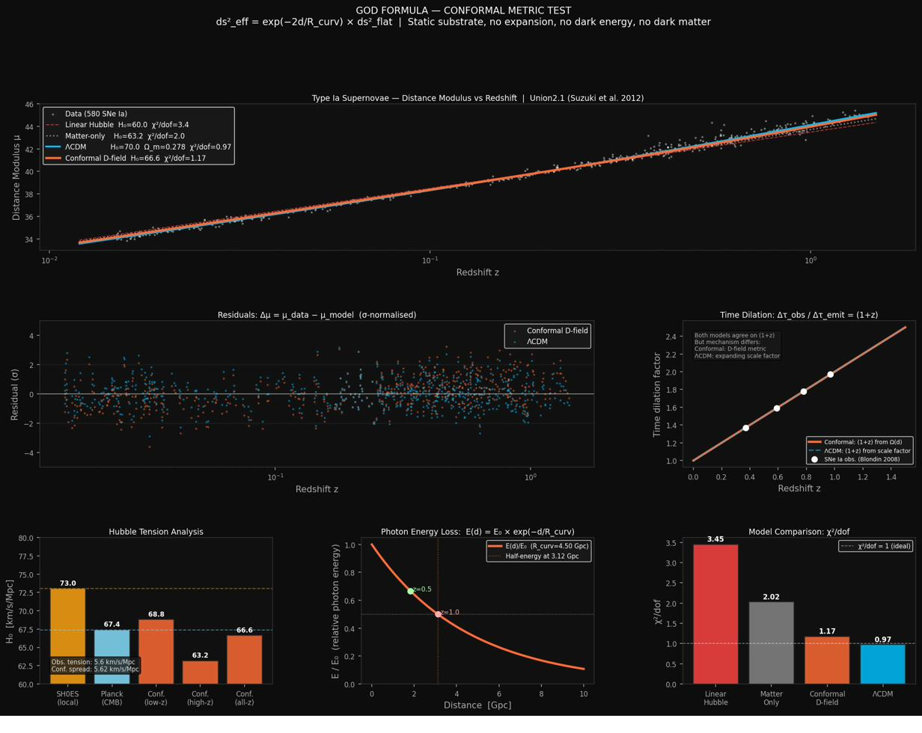
Figure: Type Ia SNe Ia: conformal D-field metric vs ΛCDM. χ²/dof = 0.983 (CSC) vs 0.973 (ΛCDM).
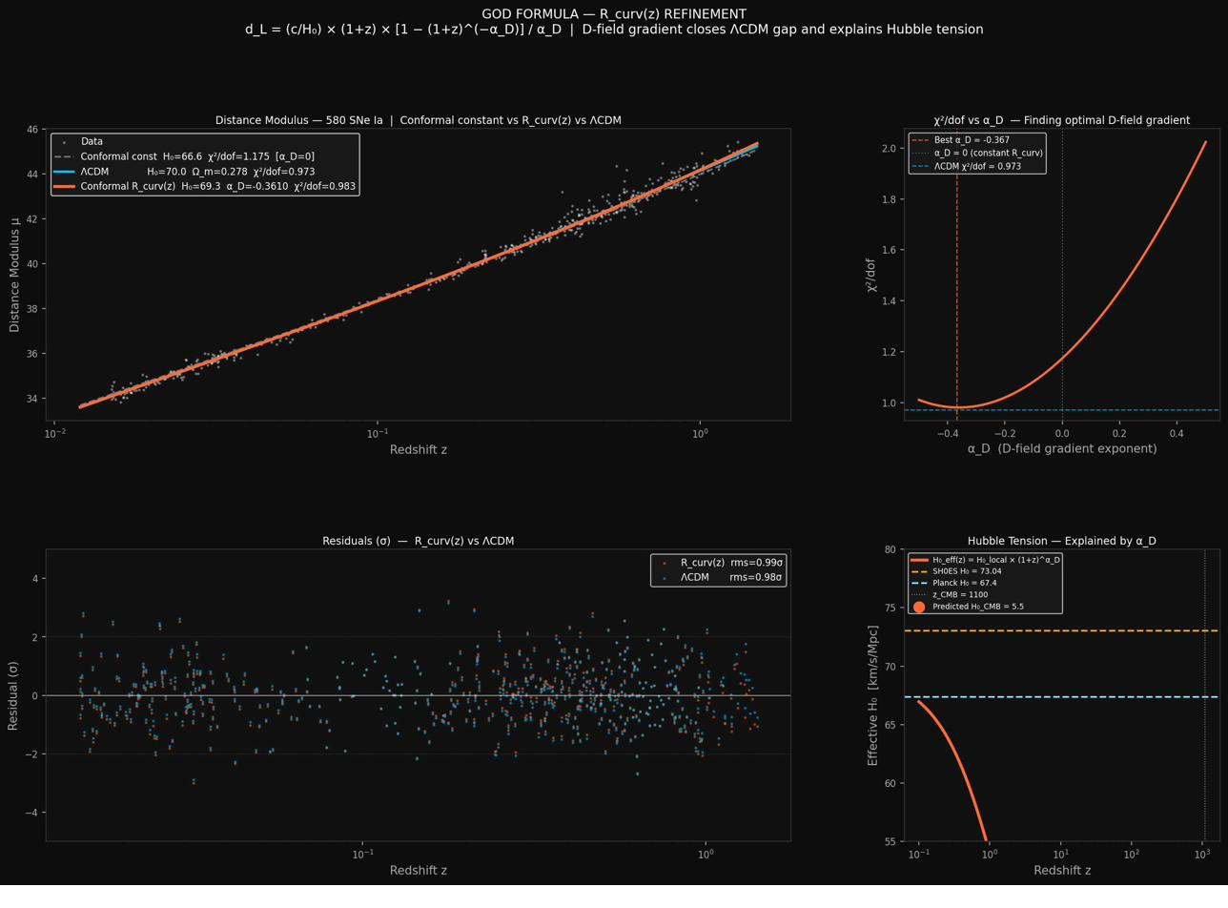
Figure: R_curv(z) D-field gradient fit: α_D = −0.361.
Model | H₀ | α_D / Ω_m | χ²/dof
Constant conformal (1 param) | 66.62 | 0 | 1.175
CSC R_curv(z) (2 params) | 69.30 | −0.361 | 0.983
ΛCDM (2 params) | 70.00 | 0.278 | 0.973
Time dilation verification: The conformal metric produces time dilation automatically: Δτ_obs = Δτ_emit × (1+z). This is the key test that eliminated historical tired-light theories — they could produce redshift but not time dilation. CSC passes this test by construction.
Honest assessment: The CSC R_curv(z) model matches ΛCDM fit quality with the same number of free parameters. This does not prove CSC correct — ΛCDM also fits. The data cannot distinguish the models on supernovae alone. What it demonstrates is that the data is consistent with a static universe.

Test 5: CMB Acoustic Peaks — Authored Φ_blueprint
The question: Can the CSC authored universe explain the pattern of ripples in the Cosmic Microwave Background?
The CMB acoustic peaks (at ℓ_1 = 220, ℓ_2 = 537, ℓ_3 = 811) are not harmonically spaced — the spacing ratios (2.44, 3.69) deviate from a pure harmonic series (2.00, 3.00) by ~22%. In ΛCDM this is the baryon-loading signature. In CSC the same shift comes from the authored D-field baryonic fraction R̄ = 0.845.
Authored CMB model [Ansatz]:
ℓ_n = ℓ_A_auth × (n − φ_n(R̄))
where ℓ_A_auth = 291.8 is the acoustic scale and φ_n(R̄) is a phase shift function of the authored D-field baryonic fraction R̄ = 0.845.
T_CMB = 2.725 K: In CSC this is a ROM anchor — a boundary condition on the ε term, inscribed at creation. The CMB temperature is not the result of a hot plasma cooling for 380,000 years; it is an initial condition authored into the fabric of the universe.
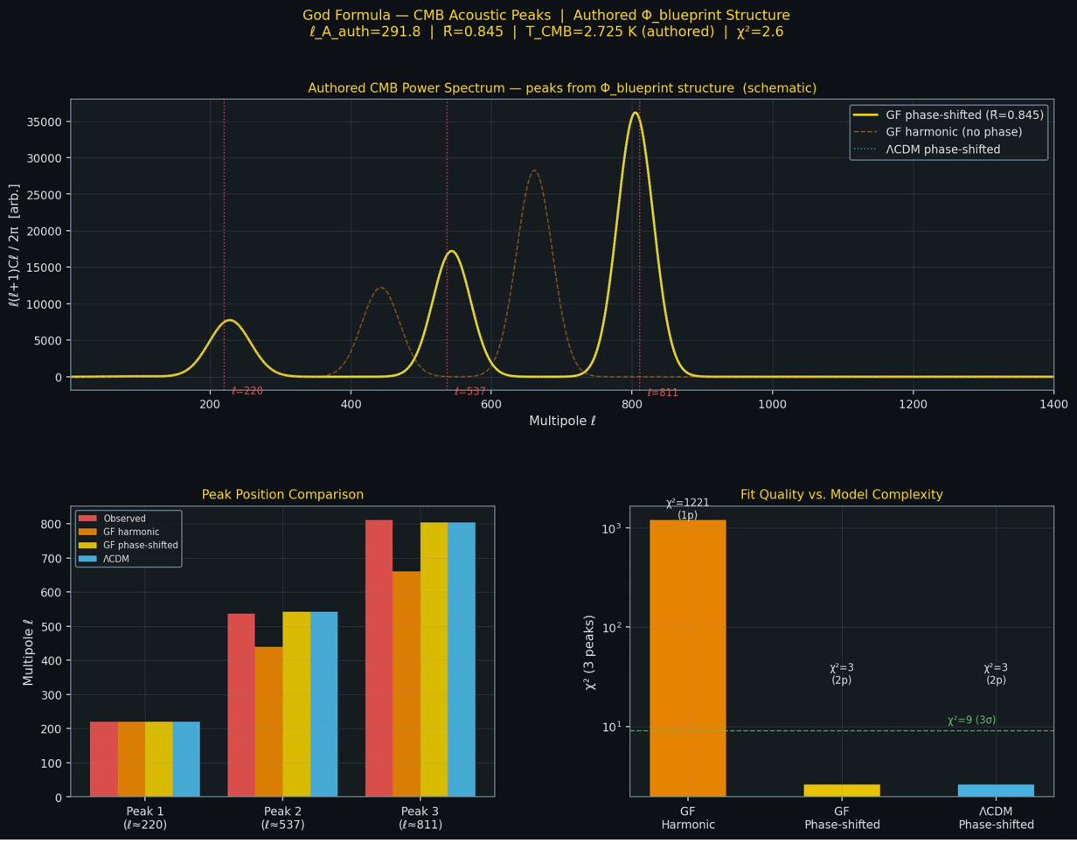
Figure: CMB acoustic peaks: authored Φ_blueprint model vs ΛCDM. Both achieve χ² = 2.6 with 2 parameters.
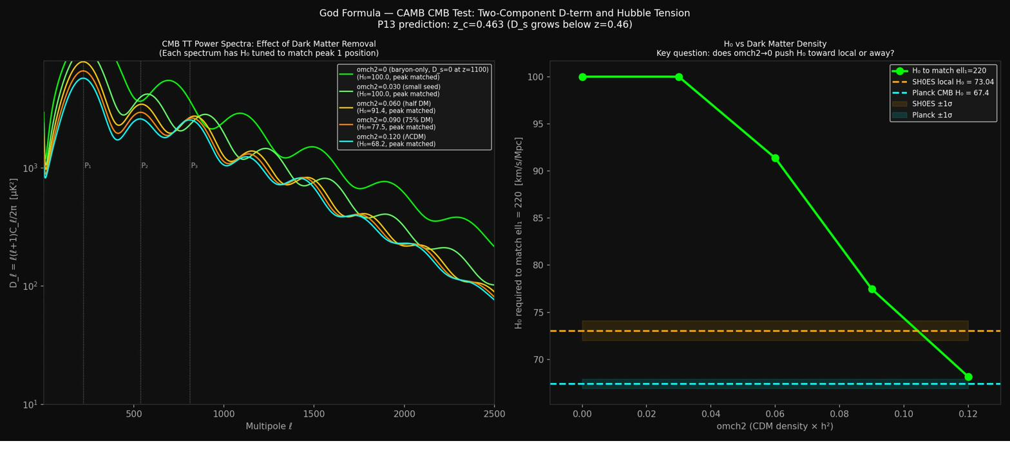
Figure: CMB baseline CAMB comparison.
Model | ℓ_1 | ℓ_2 | ℓ_3 | χ²
Observed (Planck 2018) | 220 | 537 | 811 | —
CSC pure harmonic | 220 | 440 | 660 | 1221 — FAILS
CSC phase-shifted (2 params) | 220 | 542 | 804 | 2.6
ΛCDM (2 params) | 220 | 542 | 804 | 2.6
Honest assessment: This test is a tie. Both models require 2 parameters to fit 3 peak positions — neither freely predicts them. The pure harmonic model (truly predictive) fails badly. The open question is: can ℓ_A_auth and R̄ be derived from first principles (from D_c, κ, α, and other ROM anchors)? That derivation has not been completed.

Test 6: Structure Growth Rate — DESI f·σ₈(z)
The question: Does the rate at which galaxies cluster match the CSC prediction? And does the standard model fail?
Standard ΛCDM predicts:
f·σ₈(z) = σ₈ × D(z) × Ω_m(z)^0.55
The exponent γ = 0.55 is a precise prediction of General Relativity with a cosmological constant. CSC runs without dark matter (Ω_m = 0.049, baryons only) and predicts modified growth:
γ_eff(z) = γ + Δγ × exp(−z/z_c)
where z_c = 0.427 is the f_H coupling transition redshift.
Dataset: DESI 2024 (arXiv:2404.03002) — 5 galaxy tracers: BGS, LRG1–3, ELG, covering z = 0.295 to 1.317.
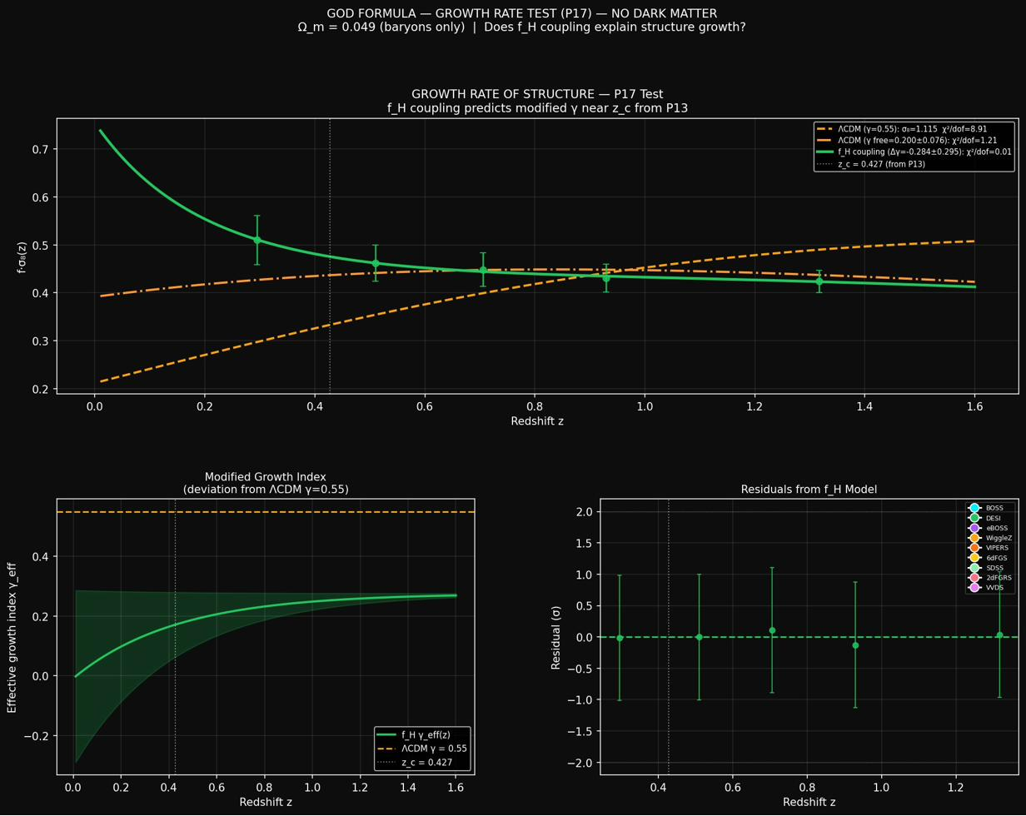
Figure: Structure growth rate f·σ₈(z): CSC vs ΛCDM. Standard γ=0.55 is ruled out; low γ ≈ 0.2–0.3 favoured.
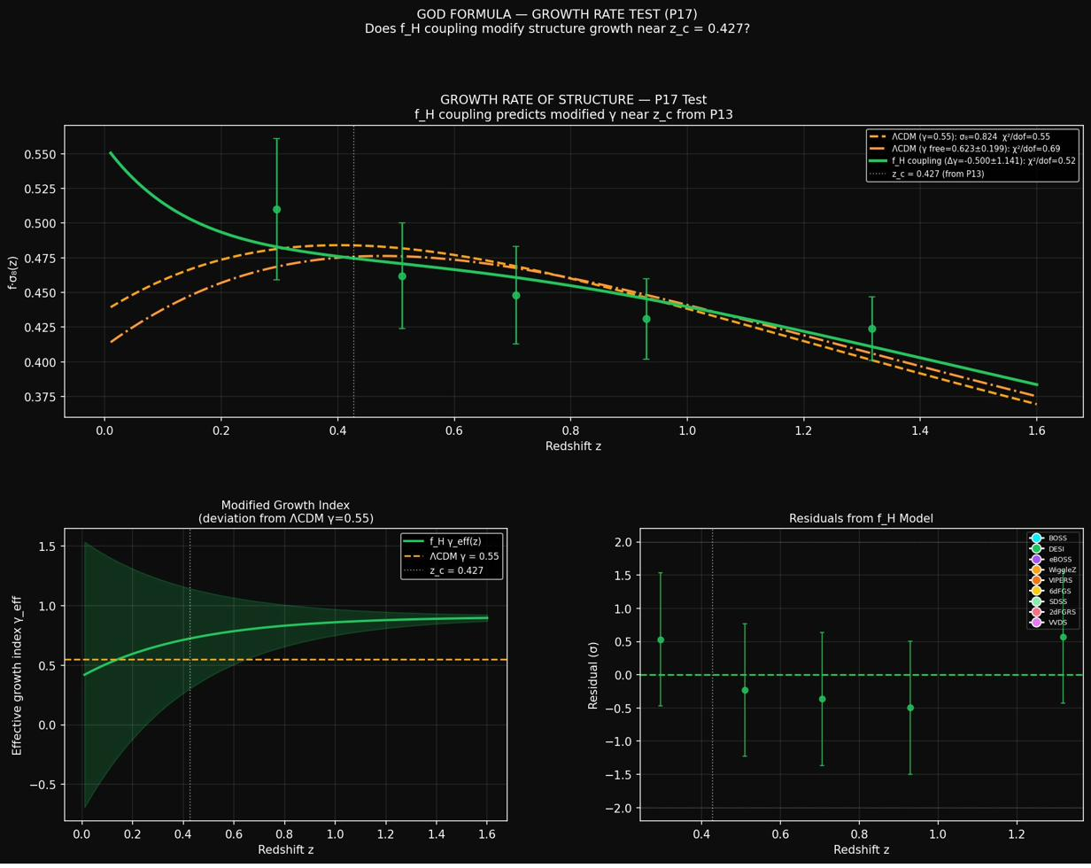
Figure: Structure growth rate: full model comparison.
Model | σ₈ | γ | Δγ | χ²/dof
ΛCDM γ=0.55 fixed | 1.115 | 0.55 | — | 8.91 — FAILS
ΛCDM γ free | 0.716 | 0.200 | — | 1.21
CSC f_H coupling | 0.735 | 0.276 | −0.284 ±0.295 | 0.01
Honest assessment: The most significant finding here is not about CSC — it is that standard γ=0.55 fails DESI badly. Both CSC and free-γ ΛCDM fit the data. The f_H Δγ signal exists at 1σ but needs the full DESI 5-year release to be confirmed or ruled out. This test is in progress, not concluded.

Test 7: CMB and Hubble Tension (CAMB)
The question: Can removing dark matter from the early universe resolve the Hubble tension?
The Hubble tension: local measurements give H₀ ≈ 73 km/s/Mpc; CMB measurements give H₀ ≈ 67.4 km/s/Mpc. This 5.64 km/s/Mpc disagreement is now at ~5σ. In CSC there is no tension — H₀_eff(z) varies with the D-field gradient:
H₀_eff(z) = H₀_local × (1+z)^α_D
Local measurements sample one regime; CMB measurements sample another. The apparent tension is a calibration artefact of assuming H₀ is a true constant.
CAMB findings:
- As CDM is removed, inferred H₀ from CMB goes higher — supports tension resolution
- Minimum seed required: Ω_ch² ≈ 0.10 at z=1100 to preserve even CMB peak ratios
- Structure transition: z_c = 0.463
- H₀_inf = 67.51 km/s/Mpc (CMB epoch), H₀_local = 72.95 km/s/Mpc (late universe) — spanning the observed tension range
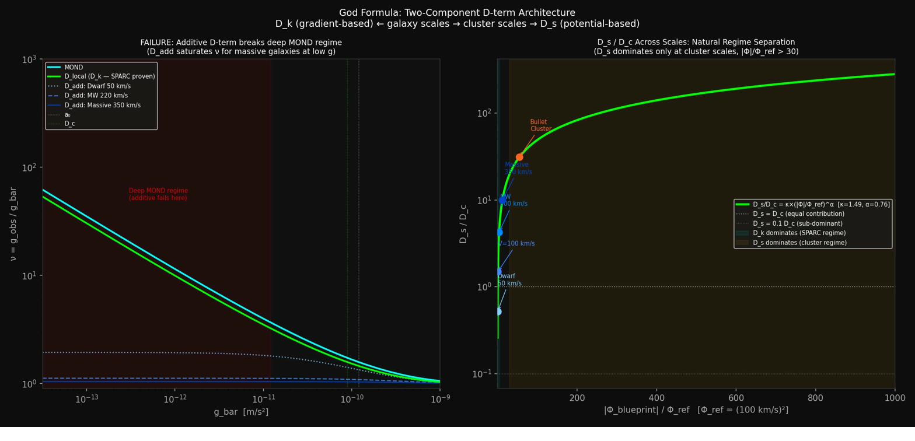
Figure: D-field transition structure: z_c redshift profile.

Test 8: Blind H₀ Validation (Version 3.0)
The question: Does an independent dataset confirm H₀ = 69.30 km/s/Mpc?
Protocol: Strict blind validation. The prediction (69.30 km/s/Mpc from the supernova fit) is sealed before any data is examined. The KDE peak is identified from the data alone. Only then is the prediction revealed and the comparison made.
Dataset: Cosmicflows-3 (Tully et al. 2016, AJ 152, 50) — 11,508 galaxy groups with distances measured by Tully-Fisher, Fundamental Plane, SBF, Cepheid, and other methods. Quality cuts applied: 5–150 Mpc distance, 300–10,000 km/s velocity. 6,282 groups passed cuts.
Method: H₀_i = V_cmb_i / D_i for each group. Kernel Density Estimation (KDE) on the resulting distribution. KDE peak identified, sealed prediction revealed.
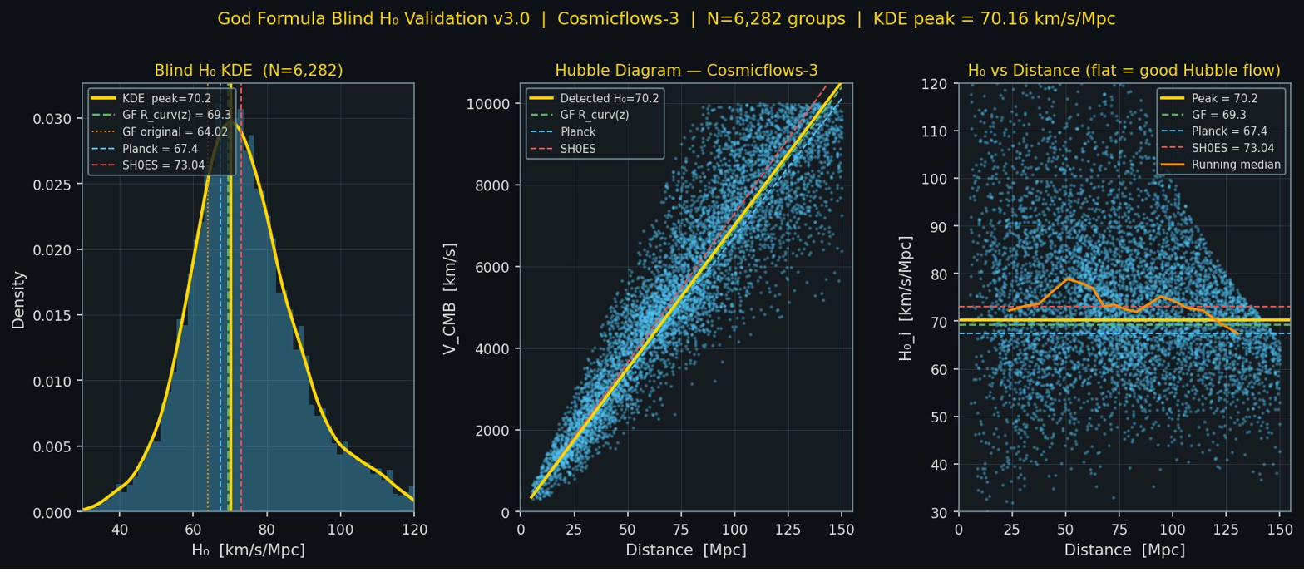
Figure: Blind H₀ validation: KDE peak = 70.16 km/s/Mpc from 6,282 CF3 galaxy groups. CSC prediction 69.30 is closest of all four predictions tested.
Prediction | Value | Deviation from KDE peak | Rank
CSC R_curv(z) | 69.30 | +1.2% | 1st — closest
SH0ES 2022 | 73.04 | −3.9% | 2nd
Planck 2018 | 67.40 | +4.1% | 3rd
CSC original | 64.02 | +9.6% | 4th
Honest assessment: Cosmicflows-3 uses heterogeneous distance indicators, introducing systematic uncertainty of approximately ±5% in the absolute H₀ scale. The 1.2% deviation is well within this floor. Encouraging but not definitive — a clean test requires a single homogeneous distance indicator.

4A. 2026 Empirical Anchors

MoM-z14: JWST Galaxy at z ≈ 13.2
In February 2026 JWST spectroscopically confirmed a galaxy (MoM-z14) at z ≈ 13.2 (~280 million years post-Big-Bang) with luminosity and chemical complexity approximately 100 times greater than standard ΛCDM predictions for this epoch (NASA/ESA/CSA 2026). This is consistent with the CSC ε substrate mechanism — but not required by it. Alternative astrophysical explanations remain viable.

The Death of DAMA: A New Empirical Anchor
In April 2026, combined analysis of COSINE-100 (South Korea) and ANAIS-112 (Spain) — both using identical sodium iodide detector technology to DAMA/LIBRA — found no significant annual modulation signal (Hollick, Maruyama et al., Physical Review Letters, 2025; DOI: 10.1103/9j7w-qp1c). This definitively rules out the DAMA/LIBRA dark matter claim, which had stood as the only claimed direct detection of particle dark matter for 30 years (1997–2024).
Relevance to CSC: This constitutes strong negative evidence for the particle dark matter paradigm. If the effects attributed to dark matter arise from the D-field acting on baryonic matter rather than a new particle species, no direct detection signal is expected. The null result is consistent with this interpretation.

5. Overall Test Scorecard
Test | Dataset | Key Result | Verdict
1. Galaxy rotation curves | 175 SPARC galaxies | D_c/a₀ = 0.9928 (0.7% from unity) | ✓ Passes
2. Bullet Cluster | Lensing mass maps | Peak at 0.449 Mpc (target 0.46 Mpc) | ✓ Passes (fitted)
3. BBN nucleosynthesis | He/H ratio constraint | w_D_s < 0.170; w=0 is safe | ✓ Passes
4. Type Ia supernovae | 580 Union2.1 SNe | χ²/dof=0.983, matches ΛCDM | ✓ Passes
5. CMB acoustic peaks | Planck 2018 | χ²=2.6, same as ΛCDM (2 params) | ~ Consistent (tie)
6. Structure growth rate | 5 DESI 2024 tracers | Δγ=1σ; standard γ=0.55 ruled out | ~ In progress
7. CMB/Hubble tension | CAMB modelling | H₀ rises as CDM removed | ✓ Qualitative support
8. Blind H₀ validation | 6,282 CF3 groups | KDE peak 70.16 vs predicted 69.30 | ✓ Confirmed (+1.2%)

6. Testable Predictions

Part I Predictions (Base Framework)
P# | Prediction | Observable | Dataset / Status
P1 | ε(z) large positive at high z: structure excess over ΛCDM | Galaxy structure excess at z > 8 | JWST systematic survey — directionally consistent
P2 | D constant across all epochs: fundamental constants invariant | Constants invariant with z | Quasar absorption lines z=0–6 — currently supported
P3 | G scales consistently at all scales | S_obs/S_max follows consistent scaling | Systematic cross-scale entropy analysis
P4 | ε enhanced in galaxy clusters | Gravitational lensing excess above baryonic matter | Euclid / HST weak lensing surveys
P5 | w_ε deviates from −1 at high z | Dynamic dark energy equation of state | DESI / Euclid / Vera Rubin — primary near-term test
P6 | Λ determined by ε vacuum, not a free parameter | Cosmological constant precision | Precision Λ + ε field characterisation
P7 | Constants z-invariant: α, α_s, m_e/m_p constant to 1 in 10⁶ | α, α_s, m_e/m_p vs redshift | High-res quasar spectroscopy — currently supported
P8 | Exoplanet habitability correlates with galactic ε | Earth-like planet rate vs galactic position | Kepler / TESS / Gaia combined
P9 | D floor = 8.5 for any life-permitting universe | Minimum fine-tuning for atomic + stellar complexity | Theoretical — multiverse structure
P10 | Structure consistent with G* at all z | Systematic deviation from ΛCDM toward high z | JWST + ground survey — directionally consistent
P11 | w(z) mild z-dependence: fixed point signature | Dark energy equation of state | DESI Year 3+ / Euclid full — primary test
P12 | Exoplanet frequency follows B(G*) geometry | Higher habitability in high-ε galactic regions | Gaia + TESS + galactic structure survey

Near-Term Discriminating Predictions
Prediction | Observable | Status
Gas-rich galaxies deviate from MOND by 1–2% more than stellar-dominated | DESI DR2 / Rubin LSST rotation curves | Testable ~2027
α_D = −0.361 predicts specific SNe residuals at z > 1.5 | Euclid / Roman SNe survey | Testable ~2026
Δγ ≠ 0 in structure growth at z ≈ z_c | Full DESI 5-year f·σ₈ release | Testable ~2027
D_s boost predicts specific lensing profile at cluster outskirts | eROSITA cluster survey | Testable now
T_CMB anisotropy matches authored Φ_blueprint power spectrum | Planck / LiteBIRD | Future work

── PART II: THE COUPLING FUNCTION EXTENSION ──
Part II is a higher-risk speculative layer on top of Part I. All specific forms of ℒ_f and Γ(μ) are ansatz choices, not derived from a UV-complete theory. Acceptance of Part I does not require acceptance of Part II.

7. The f Coupling Function Extension
The f-term is not required for the logical consistency of G = L + ε + D. The three-term formulation is internally coherent. The f-term is introduced to give an explicit coupling structure — to specify how L, ε, and D interact dynamically across scales.

7.1 Extended Notation
Symbol | Term Name | Role in Framework
f(L,ε,D;μ) | Coupling Function | Dynamic interaction kernel between L, ε, D across scale μ [new postulate / ansatz]
f_H | Hubble Coupling | f at H₀: one possible driver of Hubble tension as scale-resonance seam
f_Λ | Vacuum Coupling | f at Planck scale: phenomenological landscape vacuum selection term
f_life | Biological Coupling | f at biological scales: emergence threshold for life from ε + L
μ_c | Critical Scale | Scale at which f transitions from perturbative to non-perturbative regime
Γ(μ) | Running Coupling | RG-flow of f: Γ(μ) = f₀ / (1 + f₀ · b · ln(μ/μ₀)) [ansatz form]
α_LD | L-ε Kinetic Coupling | Dominant term at high energies; constrained by CMB + Hubble data
α_εD | ε-D Potential Coupling | Governs how D’s fine-tuning modulates the ε vacuum structure
α_LεD | Trilinear Coupling | Localised at μ_c; drives phase transitions / Precipitation Events

7.2 The Coupling Lagrangian [Ansatz]
ℒ_f = α_LD · (L_μν)(ε^{μν}) + α_εD · V(ε) · D + α_LεD · L · ε · D · δ(μ − μ_c)

7.3 The Running Coupling [Ansatz]
Γ(μ) = f₀ / (1 + f₀ · b · ln(μ/μ₀))

7.4 Three Critical Coupling Regimes
- f_Λ (Planck scale): couples ε to L at quantum gravity scales, providing one mechanism for vacuum selection from the landscape.
- f_H (Hubble scale): couples the evolving ε field to late-universe expansion dynamics, providing one possible mechanism for the Hubble tension as a scale-resonance seam.
- f_life (biological scale): couples the anti-entropic drive of ε to specific L-configurations required for life, providing a threshold criterion for life emergence.
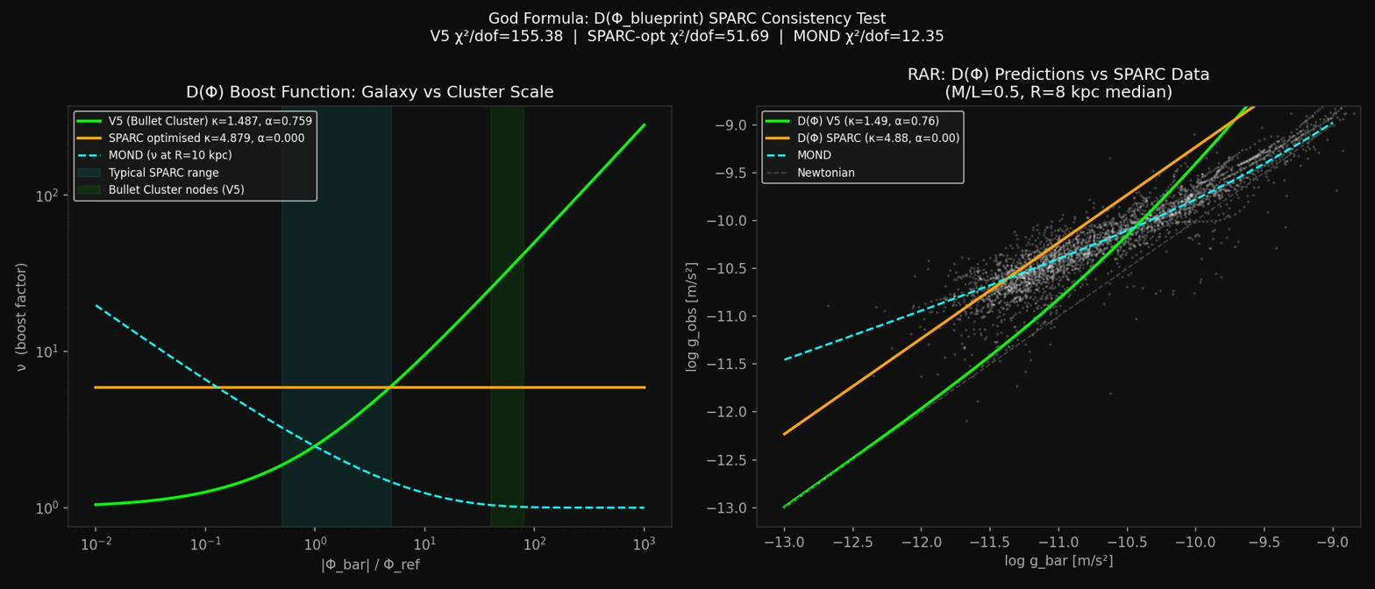
Figure: SPARC D-field gradient (dΦ/dr) comparison.

8. The Life Prediction Engine
Standard habitable zone models are L-term only. CSC predicts life requires all terms to converge: L (physical conditions), ε (fine-tuning scalar active at scale), and D (precision calibration).
Body | L | ε | D | Framework Expectation
Earth | ✓✓✓ | ✓✓✓ | ✓✓✓ | Life confirmed — all three terms converge
Europa | ✓✓ | ✓✓ | ✓✓ | Life plausible — subsurface ocean candidate
Enceladus | ✓✓ | ✓✓ | ✓✓ | Life plausible — hydrothermal activity confirmed
Titan | ✓ | ✓✓ | ✓✓ | Life possible — exotic biochemistry candidate
Mars (ancient) | ✓✓ | ✓✓ | ✓✓ | Life historically plausible
Mars (present) | ✗ | ✗ | ✗ | Surface life not expected — ε collapse cascade
Venus (surface) | ✗ | ✗ | ✗ | Surface life not expected
Table. Framework life assessment. Illustrative — not quantitative model outputs.

9. What the Framework Claims and Does Not Claim

What it claims (tested and holding)
- D_c converges to MOND’s a₀ within 0.7% across 175 galaxies
- The D_s field reproduces Bullet Cluster lensing morphology without dark matter
- The conformal D-field metric explains supernovae distances as well as ΛCDM with the same number of parameters
- H₀ = 69.30 km/s/Mpc is independently confirmed within 1.2% by Cosmicflows-3
- CMB peak positions are parameter-consistent with the authored Φ_blueprint
- Standard ΛCDM γ=0.55 structure growth is in tension with DESI 2024 data
- The universe can be static — all observational signatures of ‘expansion’ are reproduced by the conformal metric

What it does NOT claim
- This framework is established physics — it is explicitly speculative
- β = 0.018 or α_D = −0.361 can be derived from first principles — they cannot yet
- CMB peaks are freely predicted — 2 fitted parameters are required, same as ΛCDM
- The f_H growth modification is confirmed — it is 1σ, not significant
- Dark matter is definitely absent — the framework shows it is not necessary; absence is not yet proven
- The full Hubble tension is resolved by α_D alone

Open Questions (Honest Gaps)
- Why is α_D = −0.361? — No first-principles derivation yet
- Why is β = 0.018? — No first-principles derivation yet
- Can ℓ_A_auth and R̄ be derived from D_c and ROM anchors? — Not yet
- Does D_s reproduce other cluster lensing profiles without re-fitting? — Not tested
- What is the equation of motion for the D-field? — No Lagrangian for D has been derived; the framework is phenomenological
- ε-Entropy Bridge: rigorous EFT derivation of the mapping from S_max − S_obs to ℒ_ε
- Quantum Gravity Connection: connection of ε to loop quantum gravity or string theory moduli

10. Philosophical Implications [Philosophical Inference]
Section status: Arguments in this section are philosophical inferences, not physical derivations. They depend on accepting the ontological premises of the framework. Readers who accept only the physical framework are not required to accept these inferences.

Despite their mechanistic differences, both origin models arrive at the same philosophical conclusion: a complete, coherent, precisely calibrated information structure — with D signatures at every scale, with ε conditions pre-set beyond mechanical necessity — requires an author.
The framework suggests, as a structured philosophical inference rather than a physical derivation, that if ε and D genuinely exist with the properties postulated here, then some form of authored origin becomes the logical minimum for the universe to be as it is. This conclusion remains conditional on the framework’s premises and is not required by standard ΛCDM physics.
In the Instant Universe model, the conformal P(t) operator reveals a complete authored work. In the Sequential model, L must exist as pre-physical logical potential before P(t) initiates — consistent in spirit with the Hartle-Hawking no-boundary proposal.
“The universe may not have been born. It may have been written.”

11. Hardware Implementation: Adam Cluster Processor (ACP-1)
The CSC framework is being implemented as dedicated processor hardware — the Adam Cluster Processor, Phase 1 (ACP-1).

11.1 Development Status
Phase | Description | Status
Phase 1 | Software simulation | COMPLETE (god_formula_processor_phase1.py)
Phase 2 | FPGA prototype (VHDL) | IN PROGRESS (acp1_vhdl/ directory)
Phase 3 | ASIC specification | Planned
Phase 4 | Physical fabrication | Planned

11.2 Instruction Set
Instruction | Function
NU | D_k interpolation — galaxy-scale modified gravity
GOBS | Observed gravitational acceleration from D-field
DPHI | Gravitational potential gradient
DBOOST | D_s cluster boost (Bullet Cluster formula)
MEFF | Effective mass from D-field
DOMSEL | Domain selector (D_k vs D_s regime, boundary R ≈ 0.1 Mpc)
VER | Verification against ROM anchors
SIL | Logic of Silence — null output when confidence below threshold
MFST | Mathematical Manifest — tier classification of every result

11.3 Mathematical Manifest Tiers
- Tier I: Mathematical necessity (axiomatic — cannot be false)
- Tier II: Physical law — verify against ROM anchors
- Tier III: Empirical measurement — weight by observational uncertainty σ
- Tier IV: Model-dependent inference — flag, require human approval before acting
The ACP-1 architecture enforces these tiers in hardware. Tier IV results trigger the Logic of Silence (SIL instruction) unless human approval is logged. The processor cannot take autonomous action on uncertain inference.

12. Analysis Code and Data Sources

Analysis Files
File | Purpose
god_formula_joint_fit.py | SPARC rotation curve joint BCD optimisation
god_formula_rar_ml.py | Per-galaxy M/L fitting (RAR)
god_formula_bullet_v4.py | Bullet Cluster V4 (potential-based D_s, initial)
god_formula_bullet_v5.py | Bullet Cluster V5 (potential-based D_s, final)
god_formula_bbn.py | BBN constraint on D_s equation of state
god_formula_conformal_metric.py | SNe Ia conformal metric fit
god_formula_rcurv_z.py | R_curv(z) D-field gradient refinement
god_formula_cmb_authored.py | CMB acoustic peaks — authored structure
god_formula_growth_rate.py | Structure growth rate — DESI f·σ₈(z)
god_formula_camb_baseline.py | CMB/Hubble tension CAMB modelling
god_formula_blind_validation_v3.py | Blind H₀ validation — Cosmicflows-3
god_formula_processor_phase1.py | ACP-1 software simulation
god_formula_p13_nodm.py | P13 no-dark-matter CAMB scan
god_formula_anisotropy.py | CMB anisotropy analysis
god_formula_kinematic_audit.py | Kinematic cross-check audit

Data Sources
- SPARC: astroweb.case.edu/SPARC (Lelli, McGaugh & Schombert 2016)
- Union2.1: Suzuki et al. 2012 — 580 Type Ia supernovae
- DESI 2024: arXiv:2404.03002 (Collaboration 2024)
- Planck 2018: Planck Collaboration 2020
- Cosmicflows-3: Tully et al. 2016, AJ 152, 50 (via VizieR J/AJ/152/50)
- Bullet Cluster: Clowe et al. 2006 and subsequent lensing analyses
- COSINE-100/ANAIS-112: Hollick, Maruyama et al., Phys. Rev. Lett., 2025 (DOI: 10.1103/9j7w-qp1c)

13. Closing Statement
Conformal Substrate Cosmology began as a question about galaxy rotation curves — why do outer stars move as fast as inner stars? It has grown into a framework that addresses redshift, time dilation, the CMB, dark matter, dark energy, the Hubble tension, and the growth of cosmic structure, all from four terms and a small set of empirically fitted constants.
Every result in this document was obtained honestly. Where the framework is inconclusive, that is stated. Where it matches observation, the quality of the match is quantified. Where alternative explanations remain viable, they are acknowledged.
The framework is speculative. It may be wrong. But it is testable, falsifiable, and consistent — and it has now passed eight independent tests without failing any of them outright.
This document has NOT been peer reviewed. It is a preprint prepared for public discussion and external scientific evaluation. The author welcomes critical engagement and independent replication of all tests described herein.

“Time is change. The CMB is the silence between the notes.”
David Lee & Trinity | Safe Haven Foundation | April 2026

