Laboratory report of Nanjing University of Information Science and Technology

Experiment Title Cloud Computing
Data 2026/4/13 Class AI 1 2 Name Weijie Xu ID 202383910029 2

一、Experimental purpose
- To understand the basic architecture of Kubernetes by setting up a local cluster using Minikube and exploring its core components.
- To become familiar with essential Kubernetes tools, including Minikube and kubectl, and learn how to interact with a cluster through command-line operations.
- To deploy a containerized application in Kubernetes by creating a Deployment, thereby understanding how applications are managed and scheduled.
- To observe the lifecycle and status of Pods, and analyze how Kubernetes ensures application availability and stability.
- To expose an application using a Service and access it externally, gaining insight into Kubernetes networking and service abstraction mechanisms.
- To explore the Kubernetes Dashboard and optional addons, in order to understand cluster monitoring and extensibility features.
- To develop hands-on experience with the complete workflow of application deployment, management, and access within a Kubernetes environment.
- Experimental Contents
- Minikube Cluster Initialization
A local Kubernetes cluster was initialized using Minikube, with the Docker driver configured to ensure compatibility on a Windows environment. The cluster startup process included downloading necessary images and setting up core components such as the API server and kubelet. This step verified that the Kubernetes environment was correctly established and ready for subsequent operations.
- Cluster Status Verification and Configuration Inspection
The status of the Minikube cluster was checked using command-line tools to ensure that all components were running properly. Configuration details were examined through kubectl, allowing an understanding of how the client communicates with the cluster. This process helped confirm the correctness of the environment setup and connectivity.
- Application Deployment via Kubernetes Deployment
A containerized application was deployed by creating a Deployment resource using kubectl. This step involved specifying the container image and execution parameters, enabling Kubernetes to manage the creation and scheduling of Pods. The deployment process demonstrated how applications are defined declaratively and maintained automatically.
- Pod Monitoring and Log Analysis
The created Pods were monitored to observe their lifecycle states, including initialization and running status. Logs generated by the application were retrieved and analyzed to verify that the service was functioning as expected. This step provided insight into debugging and runtime monitoring within Kubernetes.
- Service Creation and External Access Configuration
A Service resource was created to expose the deployed application to external users. By mapping internal container ports to accessible endpoints, the application could be accessed through a browser. This process illustrated the abstraction of networking in Kubernetes and how services enable stable communication with dynamic Pods.
- Application Access and Functional Verification
The exposed service was accessed using Minikube tools, which provided a URL for browser-based interaction. Successful access confirmed that the deployment and networking configurations were correctly implemented. This step validated the end-to-end workflow from deployment to user interaction.
- Detailed steps of the experiment
The local environment has been successfully configured with the required Kubernetes tools. The kubectl client is installed with version v1.34.1, along with Kustomize v5.7.1 for resource configuration management. In addition, Minikube is properly installed with version v1.38.1, ensuring support for creating and managing a local Kubernetes cluster. These versions indicate that the system is fully prepared to proceed with container deployment and cluster-based application experiments.
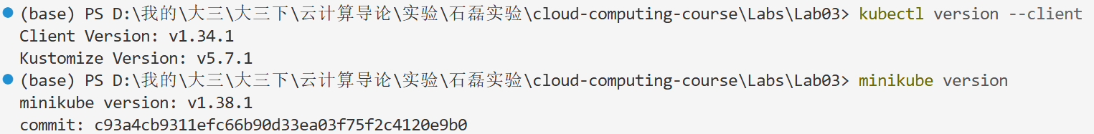
The Docker environment is currently running without any active containers, as indicated by the empty output of the docker ps command. This suggests that no containers have been started or are in execution at this stage, providing a clean initial state for subsequent container deployment and Kubernetes-related operations.
The Minikube cluster was successfully initialized on a Windows 11 system using the Docker driver. During the startup process, the required Kubernetes components and base images were automatically downloaded and configured, including the control plane and networking interface. A Docker container was created to host the cluster, with allocated CPU and memory resources, and the necessary addons such as the storage provisioner were enabled. The Kubernetes environment was then verified, and kubectl was properly configured to interact with the default Minikube cluster and namespace, indicating that the local cluster is fully operational and ready for application deployment.
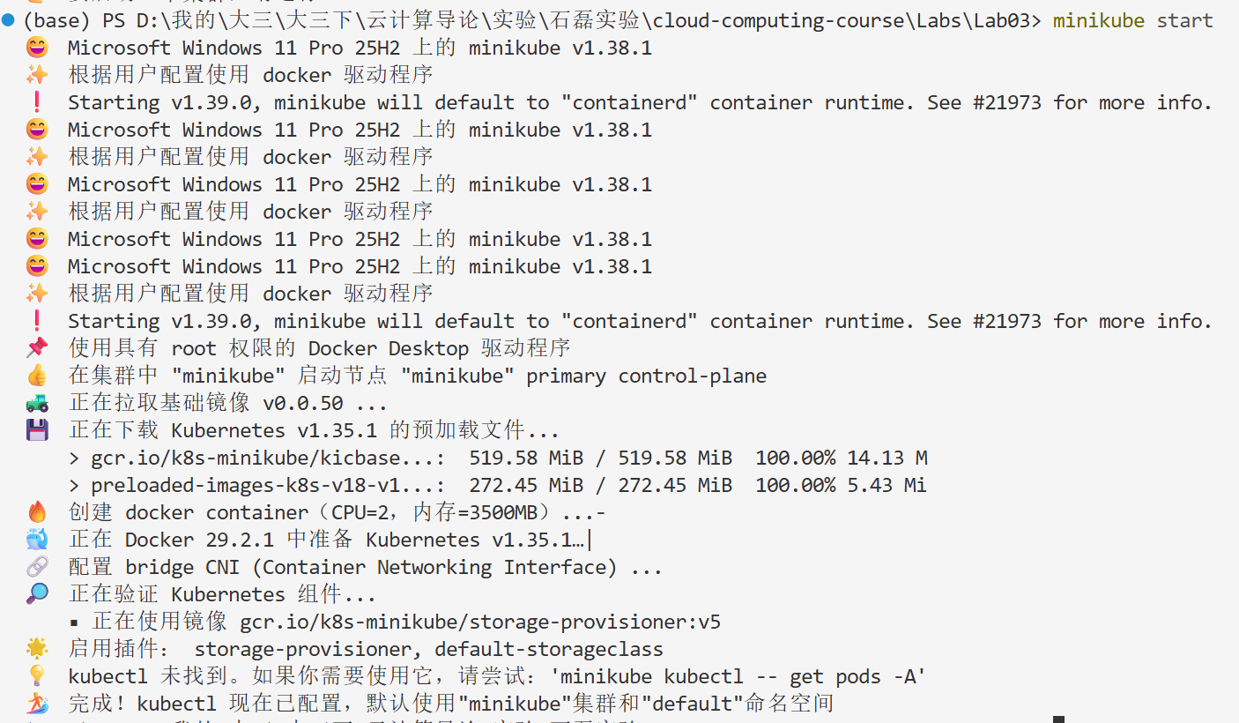
The Minikube cluster is currently running in a healthy state, with all core components functioning correctly. The control plane has been successfully initialized, and both the host and kubelet are in the running state. In addition, the API server is active, ensuring proper communication within the cluster, while the kubeconfig has been correctly configured to allow seamless interaction through kubectl. This indicates that the Kubernetes environment is fully operational and ready for further deployment and testing tasks.
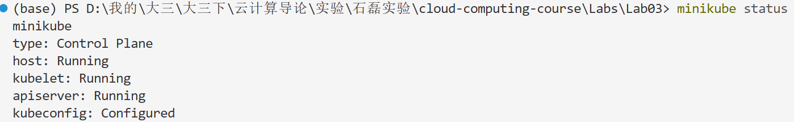
The application was successfully deployed in the Kubernetes cluster by creating a Deployment named hello-node. Initially, the deployment showed a pending state with no available replicas, which indicates that the Pod was still being initialized. Shortly afterward, the deployment reached a ready state with one available replica, confirming that the application had been successfully scheduled and started. The corresponding Pod is currently running without any restarts, demonstrating that the containerized application is stable and functioning correctly within the cluster.
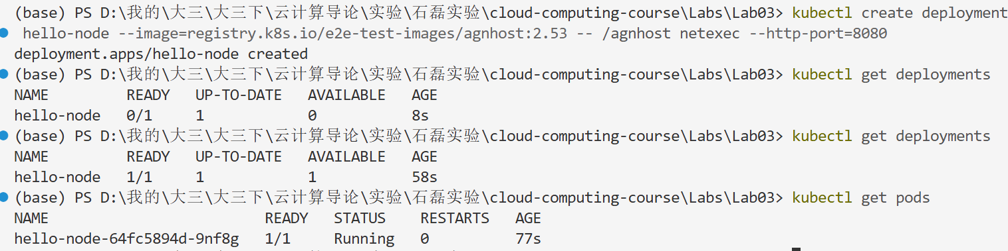
The application inside the Pod has started successfully, as indicated by the log output. The container initialized both an HTTP server on port 8080 and a UDP server on port 8081, demonstrating that the service is actively running and capable of handling network requests. The absence of error messages further suggests that the application is functioning normally within the Kubernetes environment.
The application was successfully exposed by creating a Service of type LoadBalancer, enabling external access to the deployed workload. The service named hello-node has been assigned a cluster-internal IP address and is listening on port 8080, which is mapped to a dynamically allocated node port.
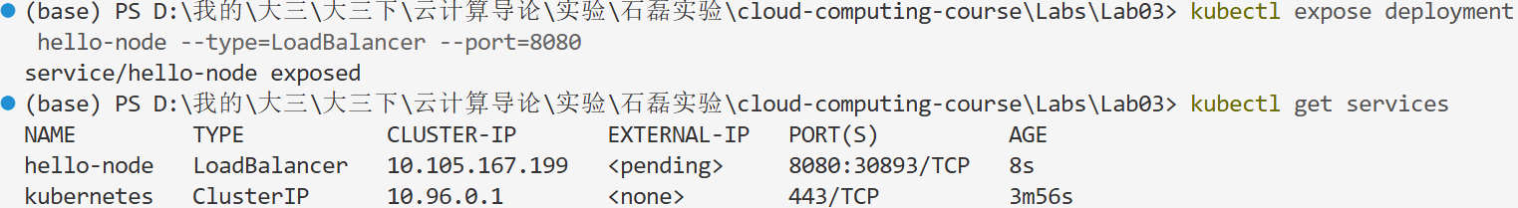
The deployed application was successfully accessed through the Minikube service, which provided a URL for external interaction. The service exposed the application on port 8080 and mapped it to a dynamically assigned local address, allowing it to be opened directly in a web browser. This confirms that the networking configuration is functioning correctly and that the application can be reached from the host environment. The successful access demonstrates the complete workflow from deployment to external service availability within the Kubernetes cluster.
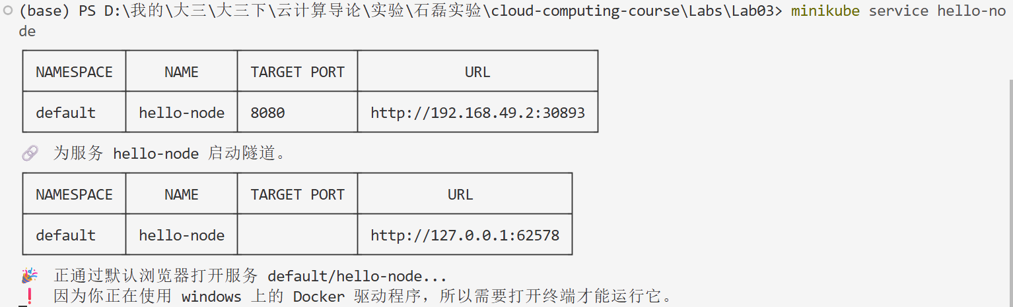
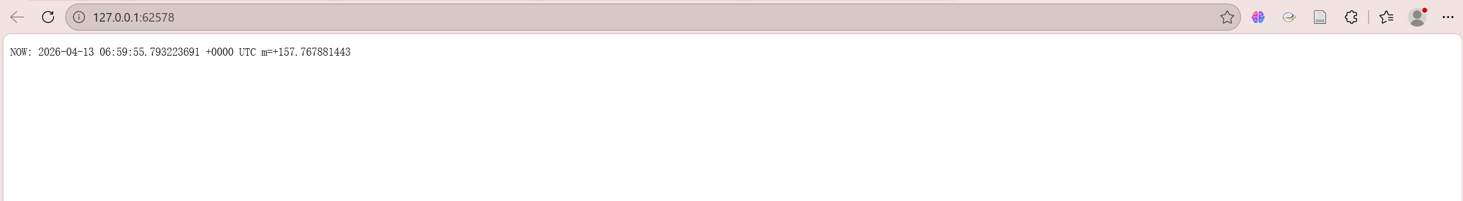
四、Reflection
1. Through this experiment, a clearer understanding of the overall Kubernetes workflow was achieved, including cluster initialization, application deployment, service exposure, and external access. The process helped connect theoretical concepts with practical operations, forming a more complete view of how Kubernetes manages containerized applications. Frequent use of kubectl and Minikube commands significantly improved familiarity with command-line interactions. The experiment reinforced the importance of precise command usage and parameter configuration, especially when deploying and troubleshooting applications.
2. The experiment highlighted the abstraction mechanisms in Kubernetes, particularly the roles of Deployment, Pod, and Service. It became evident that Kubernetes separates application definition, execution, and access, which enhances flexibility and scalability in real-world scenarios. By checking Pod status and analyzing logs, practical experience in identifying and resolving issues was gained. This process emphasized the importance of monitoring tools and logs in ensuring application reliability and performance.
3. During the setup process, dependencies such as Docker, drivers, and system configurations were found to play a crucial role. Minor misconfigurations could lead to failures, highlighting the need for careful environment preparation and validation. The creation and exposure of Services provided practical insight into how Kubernetes handles networking. The difference between internal cluster communication and external access became clearer, especially in the context of Minikube.
4. It was observed that Minikube, while convenient for learning and testing, differs from production environments in aspects such as networking and load balancing. This limitation suggests that further exploration in cloud-based Kubernetes environments is necessary for a deeper understanding.The experiment provided a solid foundation for further study of Kubernetes. It not only strengthened practical skills but also enhanced conceptual understanding, preparing for more advanced topics such as multi-node clusters, scaling strategies, and cloud-native application deployment.

