Laboratory report of Nanjing University of Information Science and Technology

Experiment Title Cloud Computing
Data 2026/3/19 Class AI 1 2 Name Weijie Xu ID 202383910029 2

一、Experimental purpose
- To understand the fundamental concepts of containerization and lightweight service deployment. Gain a basic understanding of container-based virtualization, including the principles of Docker, image management, container orchestration, and the workflow of deploying services in an isolated environment.
- To acquire practical skills in deploying and managing Git services using Docker. Learn how to install and configure Gitea in a containerized environment, including service initialization, user management, and repository operations, and develop hands-on experience in deploying self-hosted version control platforms.
- Experimental Contents
- Install Docker Desktop and verify the functionality of the container environment through basic commands and test containers.
- Deploy a Gitea service using Docker Compose, configure essential parameters such as ports, storage volumes, and service settings, and complete the initialization of the web-based interface.
- Create and manage user accounts in Gitea, and establish a new repository for version control operations.
- Enable and configure Git LFS support in Gitea, including setting the LFS service and storage path.
- Initialize a local Git repository, configure Git LFS tracking rules, and associate the repository with the Gitea remote server.
- Generate and manage a large file exceeding 1GB, and upload it to the Gitea repository using Git LFS to validate large file handling capability.
- Verify the correctness of LFS functionality by observing the upload process and repository contents, ensuring that large files are stored and retrieved properly.
- Explore repository operations such as cloning, committing, pushing, and pulling, and evaluate system behavior when handling large-scale data.
- Detailed steps of the experiment
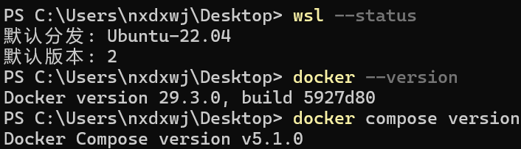

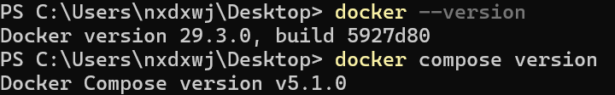
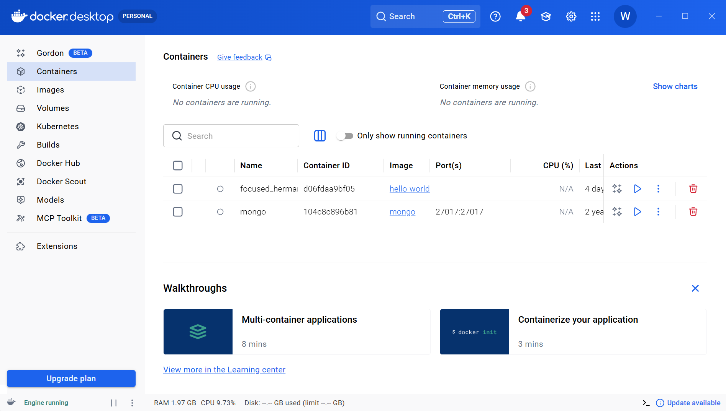
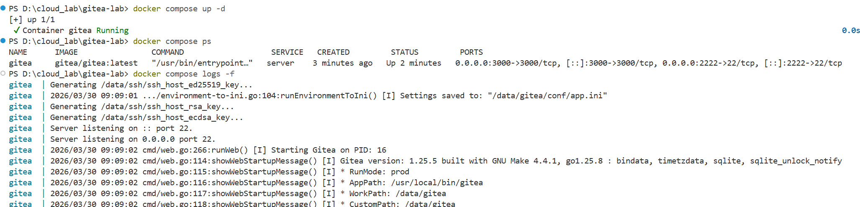

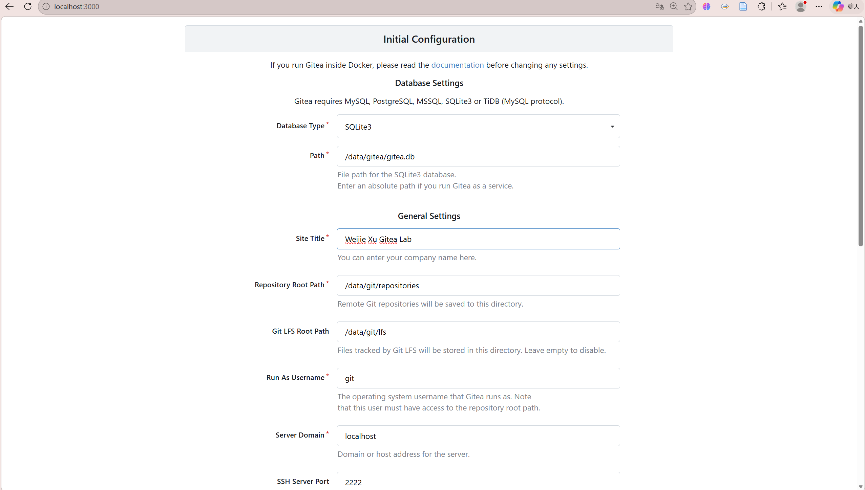

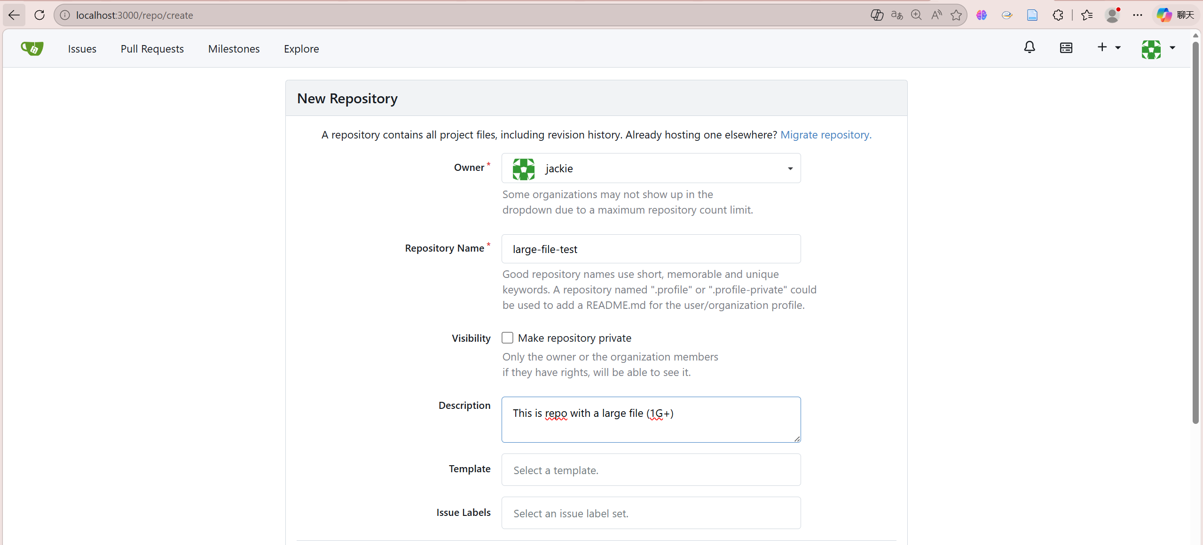
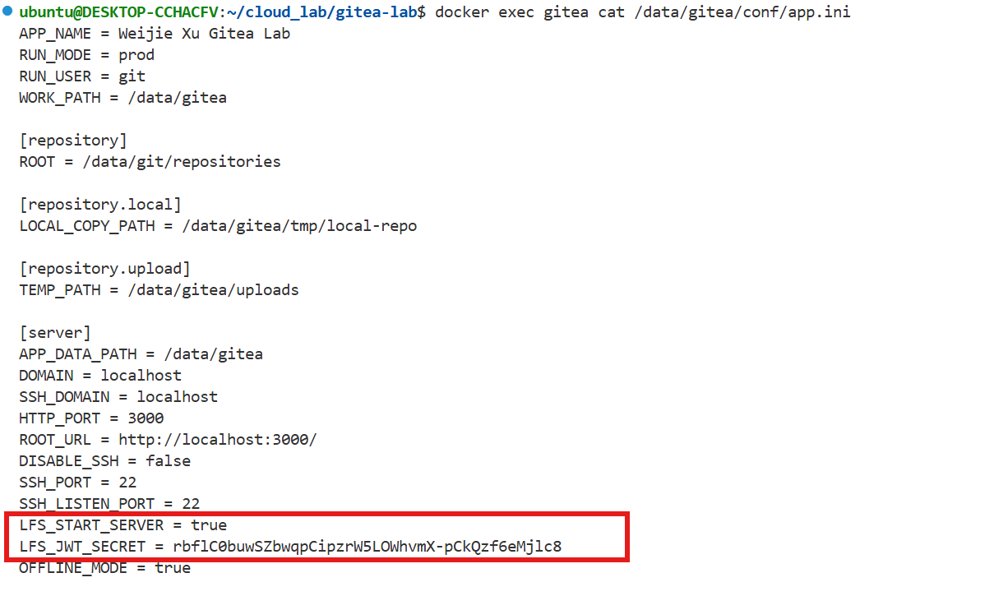

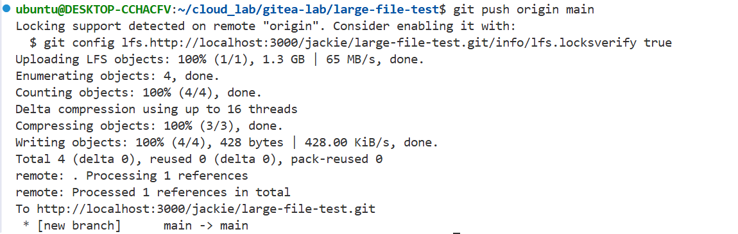

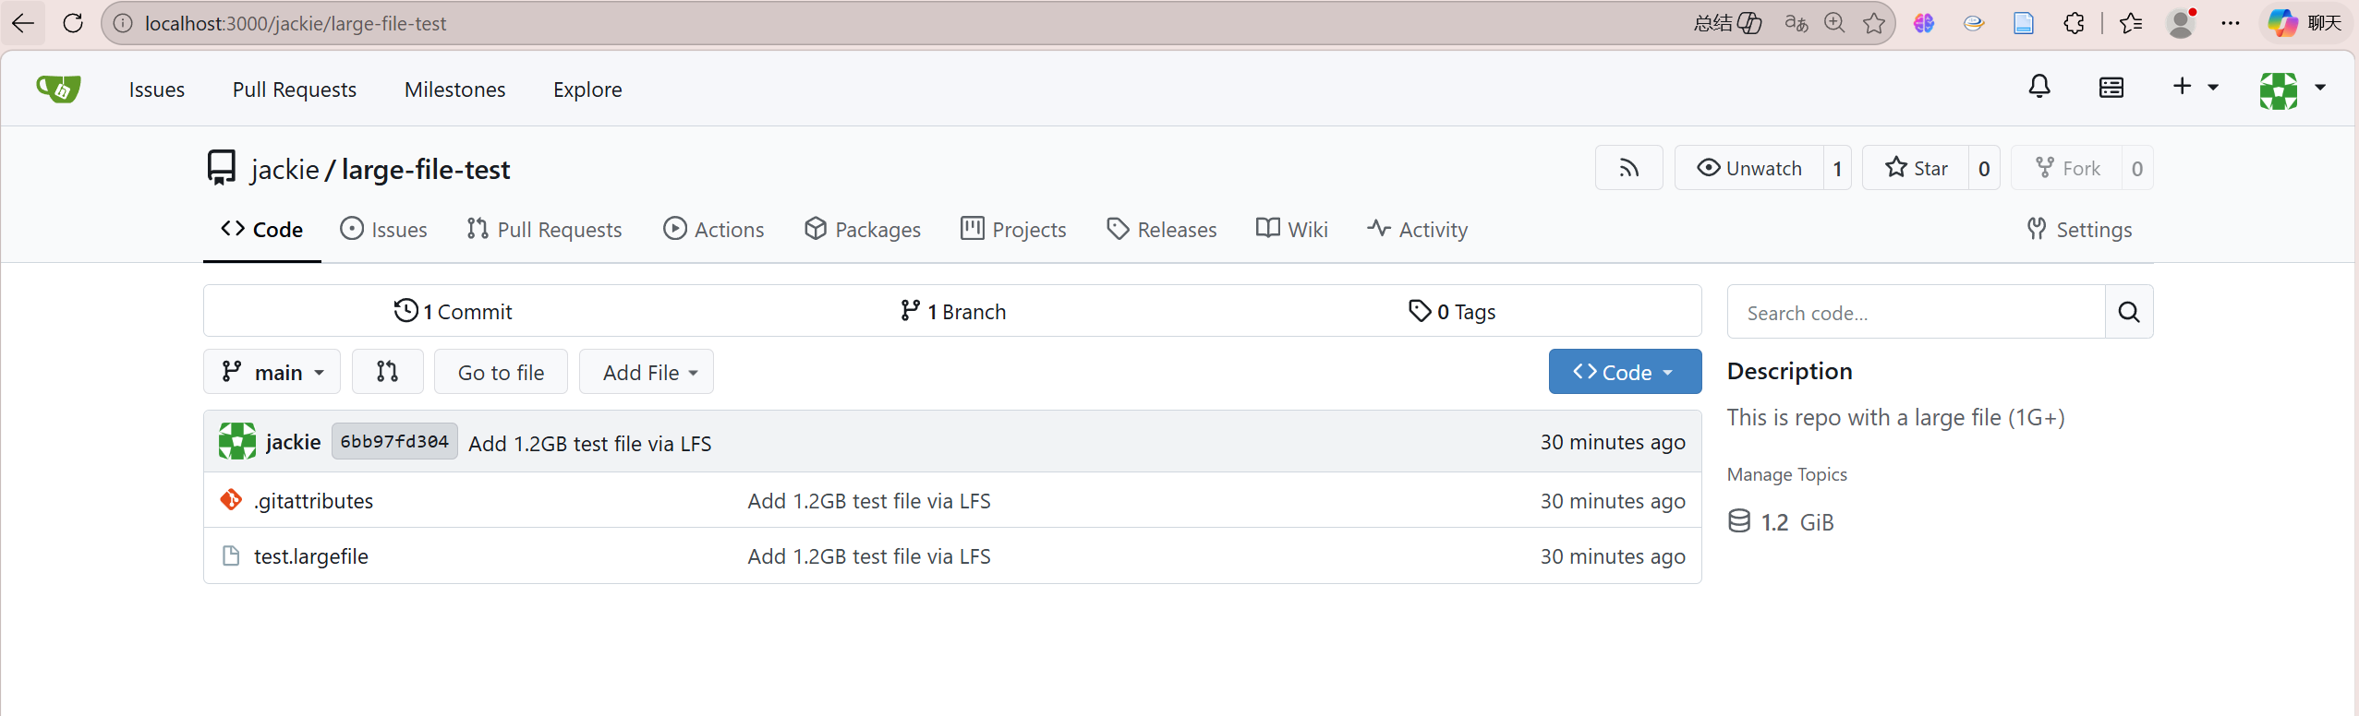
四、Reflection
1. This experiment provided a clear and practical understanding of containerized service deployment. By installing Docker Desktop and deploying Gitea through Docker Compose, the process of transforming theoretical concepts of cloud computing into an executable workflow became more concrete. The experience of configuring ports, volumes, and environment variables helped clarify how services are isolated, managed, and exposed in a container-based environment.
2. The experiment also highlighted the importance of network configuration and system environment in real-world deployments. Issues such as Docker engine startup failures and TLS handshake timeouts during image pulling revealed that successful deployment is not only dependent on correct commands, but also on stable networking, proper mirror configuration, and system-level dependencies like WSL.
3. In addition, working with Git LFS to manage large files deepened my understanding of the limitations of traditional Git and the necessity of specialized mechanisms for handling large-scale data. By successfully tracking and uploading a 1GB+ file, I observed how LFS separates large file storage from standard Git objects, which enhances efficiency and scalability. This experiment strengthened my overall understanding of version control in data-intensive scenarios and its relevance in cloud-based development environments.

