Laboratory report of Nanjing University of Information Science and Technology

Experiment Title Getting Started with Compute Simulation Instructions Data 2026/3/19 Class AI 1 2 Name Weijie Xu ID 202383910029 2

一、Experimental purpose
- To understand the fundamental concepts of AWS
Gain a basic understanding of cloud computing principles and AWS architecture, including core services, resource management, and the overall workflow of deploying cloud-based applications.
- To acquire practical skills in using AWS instances
Learn how to create, configure, manage, and monitor EC2 instances, and develop hands-on experience in handling instance operations under different usage scenarios.
- Experiment Contents
- Launch an Amazon EC2 instance with termination protection enabled to ensure safe deployment and prevent accidental deletion.
- Monitor the operational status and performance metrics of the EC2 instance using AWS monitoring tools.
- Configure and update the security group settings to allow inbound HTTP traffic, enabling external access to the deployed web server.
- Establish a remote connection to the EC2 instance through AWS Systems Manager Fleet Manager for convenient management without SSH.
- Manage the lifecycle of the EC2 instance, including starting, stopping, and terminating operations.
- Modify the instance type to adjust computing resources based on workload requirements.
- Verify and evaluate the effectiveness of termination protection by attempting instance termination under different settings.
- Explore the service limits and constraints of Amazon EC2 to understand resource boundaries and scalability considerations.
- Detailed steps of the experiment
- Task 1: Launching an EC2 Instance
In this task, I successfully launched an EC2 instance with termination protection enabled. During the configuration process, I selected the appropriate Amazon Machine Image, instance type, and network settings, and deployed a web server using a user data script. This task helped me understand the basic workflow of creating a virtual server in AWS and the importance of initial configuration in ensuring proper functionality and security.
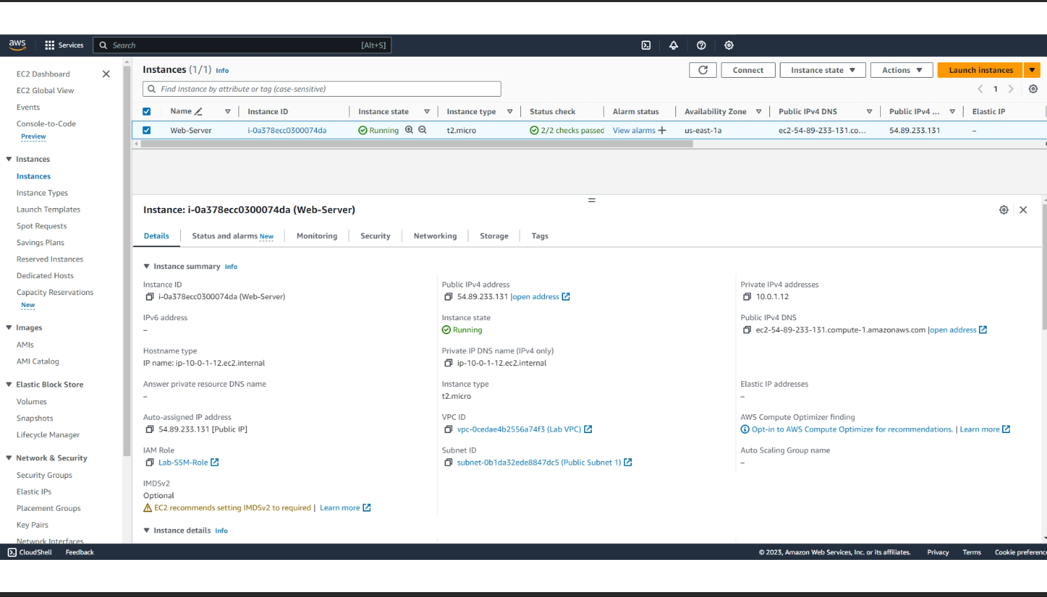
- Task 2: Monitoring the EC2 Instance
In this task, I monitored the status and performance of the EC2 instance using AWS monitoring tools. By examining system status checks, logs, and CloudWatch metrics, I gained insights into the operational health and performance of the instance. This process highlighted the importance of continuous monitoring for maintaining system reliability and detecting potential issues in a timely manner.
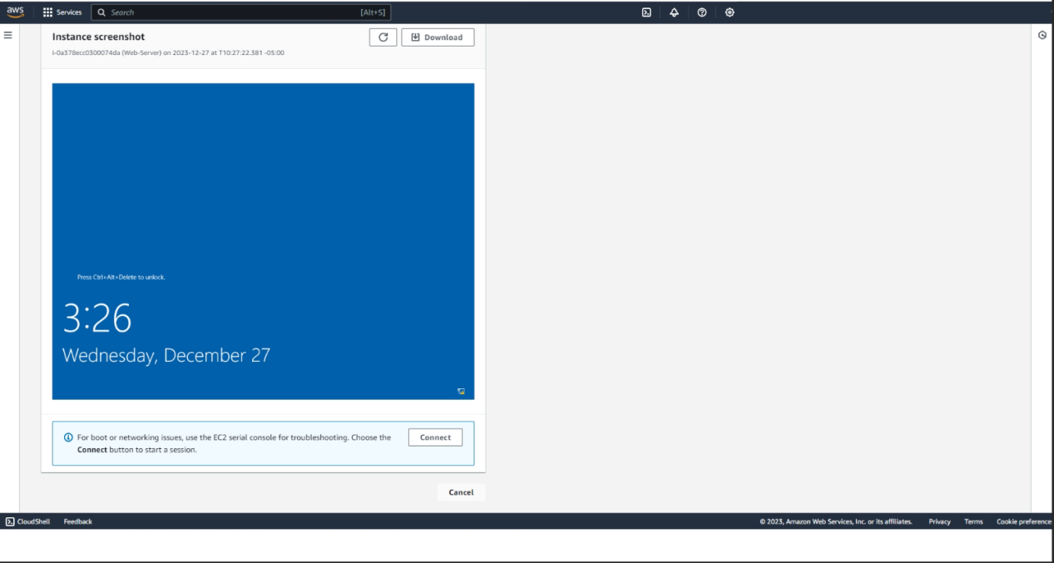
- Task 3: Updating Security Group and Accessing the Web Server
In this task, I modified the security group to allow inbound HTTP traffic, which enabled access to the deployed web server. This step demonstrated how security groups act as virtual firewalls to control network traffic. It also emphasized the balance between accessibility and security when configuring network rules in a cloud environment.
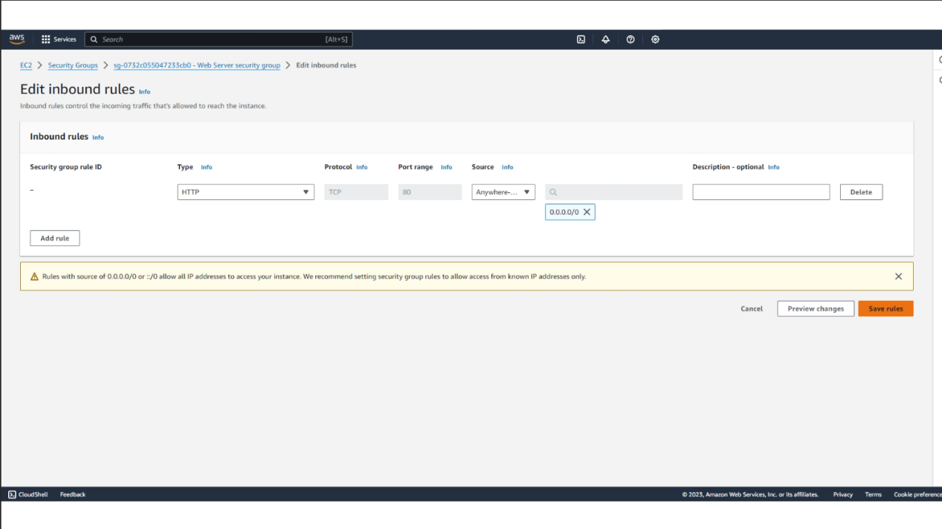
- Task 4: Connecting to the Instance via Fleet Manager
In this task, I connected to the EC2 instance using AWS Systems Manager Fleet Manager. By accessing the instance through a browser-based remote desktop, I was able to manage the system without relying on traditional SSH or RDP configurations. This task showed the convenience and security benefits of using AWS-managed tools for remote instance management.
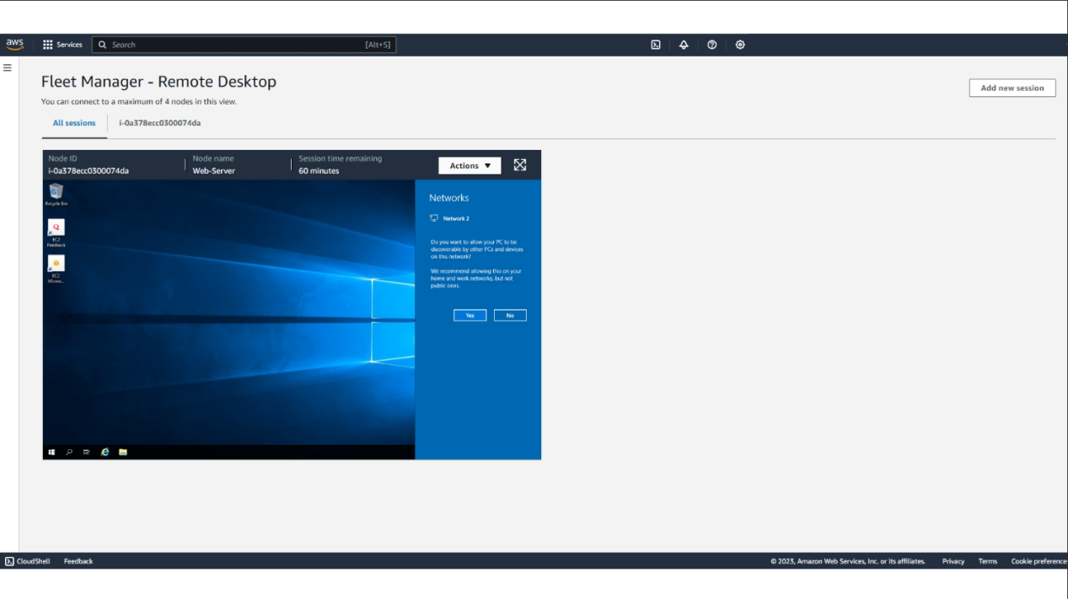

- Task 5: Resizing the EC2 Instance
In this task, I changed the instance type after stopping the EC2 instance. This process demonstrated how computing resources such as CPU and memory can be adjusted according to workload requirements. It provided practical insight into the flexibility and scalability of cloud computing, allowing resources to be optimized dynamically.
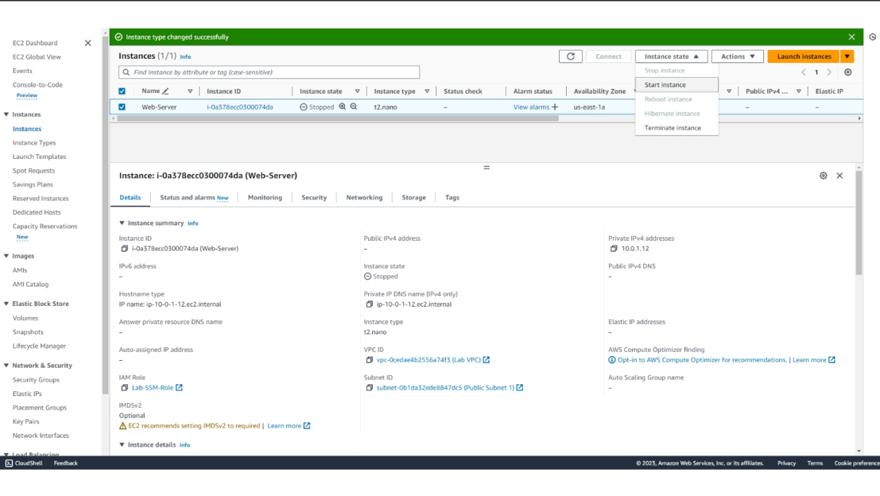
- Task 6: Testing Termination Protection
In this task, I tested the termination protection feature by attempting to terminate the instance. Initially, the operation was blocked due to protection settings. After disabling the protection, I successfully terminated the instance. This task highlighted the importance of safeguards in preventing accidental deletion of critical resources in cloud environments.
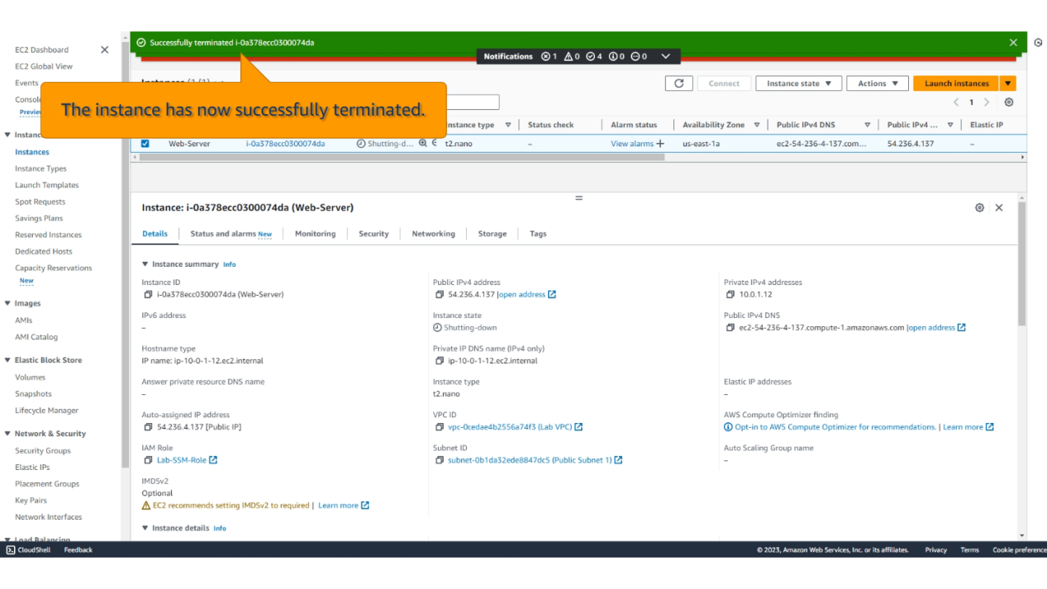
四、Reflection
1. What is an EC2 instance essentially?
An EC2 instance is essentially a virtual server running in the cloud. It is created using virtualization technology on physical hardware in AWS data centers, allowing users to obtain computing resources such as CPU, memory, storage, and networking without owning physical machines. From a functional perspective, it behaves like a traditional server, but with greater flexibility, scalability, and on-demand availability.
- What is the main advantage of server virtualization?
The main advantage of server virtualization is resource efficiency and flexibility. By abstracting physical hardware into multiple virtual machines, it allows multiple isolated environments to run on a single physical server, improving hardware utilization. At the same time, it enables rapid provisioning, easier management, and better scalability, which significantly reduces cost and operational complexity.
- Why can cloud computing create servers quickly?
Cloud computing can create servers quickly because it relies on pre-configured virtual machine images and automated orchestration systems. Instead of assembling physical hardware, the cloud platform simply allocates virtualized resources and deploys an instance based on predefined templates. This process is highly automated and can be completed within minutes, enabling rapid deployment and scaling of computing resources.

