Laboratory report of Nanjing University of Information Science and Technology

Experiment Title Cloud Computing
Data 2026/4/2 Class AI 1 2 Name Weijie Xu ID 202383910029 2

一、Experimental purpose
- To develop a systematic understanding of Docker container behavior, including how containers run based on a single main process and terminate immediately when the process fails or exits. This helps clarify the lifecycle of containers and the importance of correct configuration.
- To learn how to expose container services to external users by publishing ports, and understand the mapping relationship between host and container ports, which enables communication between local systems and containerized applications.
- To explore how to customize container runtime behavior without modifying the image, including overriding default configurations such as environment variables, resource limits, and startup commands, thereby improving flexibility in deployment.
- To understand data management in Docker by comparing ephemeral container storage with persistent storage mechanisms such as volumes, and analyzing how data can be preserved independently of container lifecycles.
- To investigate file sharing between the host and containers through bind mounts, and understand how real-time synchronization supports development and debugging workflows.
- To build and analyze a multi-container application, including service composition (Nginx, Node.js, Redis), container networking, and inter-service communication using network aliases instead of IP addresses.
- To understand reverse proxy and load balancing mechanisms in containerized environments, and analyze how misconfigurations (e.g.incorrect upstream service names) can lead to container startup failures.
- To enhance practical debugging skills by analyzing container logs, identifying service dependency issues, and troubleshooting common errors such as failed connections, incorrect network configurations, and misaligned service naming.
- Experimental Contents
- Container Deployment and Port Publishing
Containers were created and executed using Docker commands, and port publishing was configured to enable external access. By mapping host ports to container ports, services running inside containers could be accessed through the browser, verifying the mechanism of communication between the host system and containerized applications.
- Overriding Container Defaults
Different runtime configurations were applied to containers without modifying the original images. This included setting environment variables, adjusting port mappings, and customizing startup commands. These operations demonstrated how container behavior can be dynamically controlled at runtime, improving flexibility in deployment and configuration management.
- Data Persistence with Volumes
Docker volumes were created and mounted to containers to store data outside the container filesystem. Data was written into the container, and after removing and recreating the container, the stored data remained unchanged. This experiment verified that volumes provide persistent storage independent of container lifecycles.
- File Sharing with Bind Mounts
Local directories from the host system were mounted into containers using bind mounts. Files created and modified on the host were immediately reflected inside the container, demonstrating real-time synchronization. This approach is particularly useful for development scenarios where frequent file updates are required.
- Multi-container Application Setup
A multi-container system was constructed, including a web application container, a Redis database container, and an Nginx reverse proxy container. A user-defined network was created to enable communication between containers, and service discovery was implemented using network aliases instead of IP addresses.
- Service Communication and Reverse Proxy Configuration
Nginx was configured as a reverse proxy to forward client requests to backend services. Load balancing strategies were explored by defining multiple upstream servers. The experiment also involved troubleshooting configuration errors, such as incorrect service names or ports, which could cause container startup failures.
- Detailed steps of the experiment
The system downloads the docker/welcome-to-docker image from Docker Hub and starts a container in detached mode, mapping port 8080 on the host to port 80 in the container, enabling access to the application through a web browser.
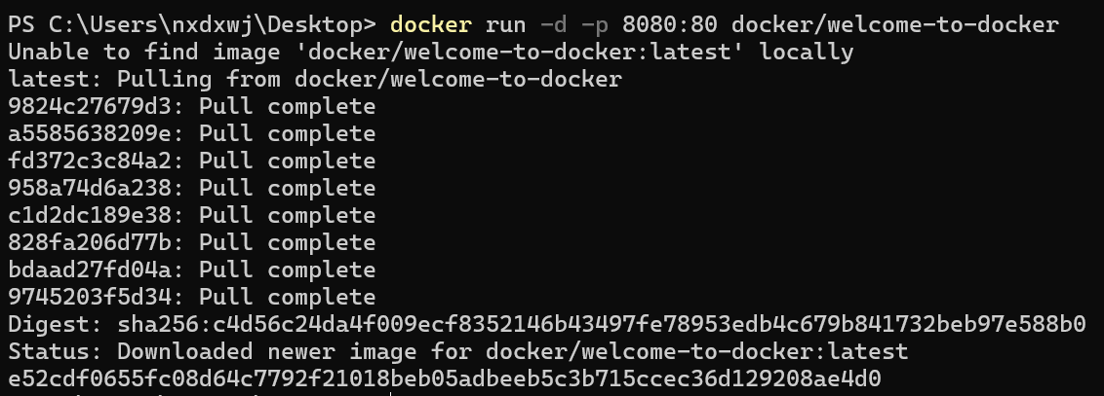
A Docker container has been successfully deployed and accessed via a local browser. The displayed page confirms that the containerized web application is running correctly and the port mapping is functioning as expected.
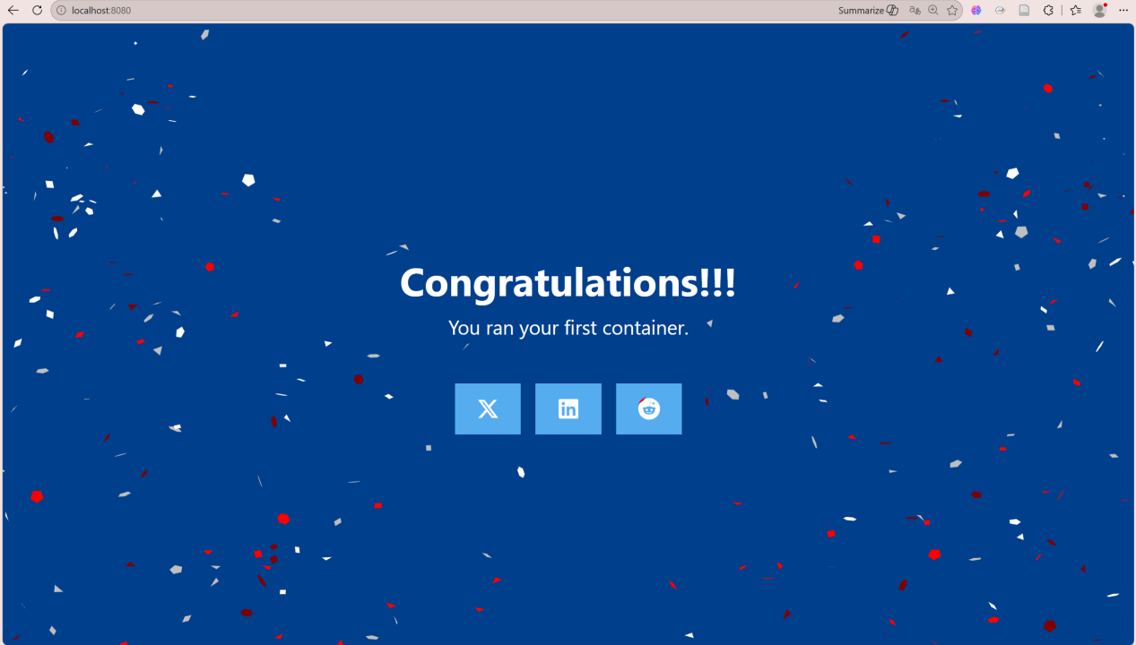
Docker Desktop interface showing multiple containers, including a running container with port 8080 mapped to 80, confirming successful deployment and management of containerized applications.
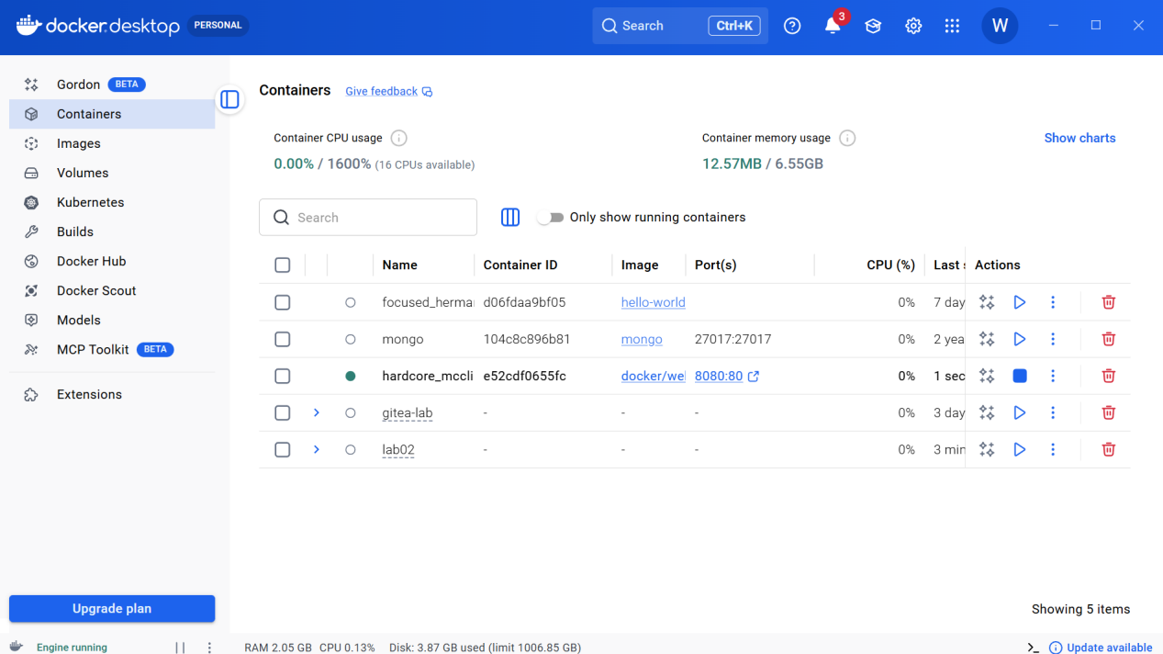
The docker compose up command is starting a containerized service, with logs showing Nginx initialization, configuration loading, and successful startup of worker processes, indicating the application is running normally.
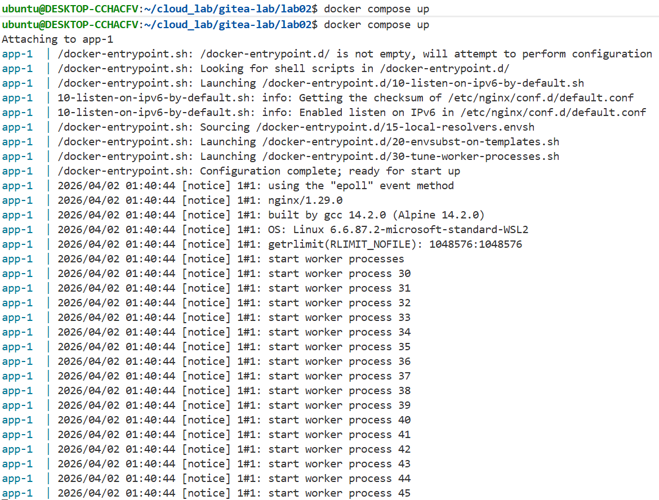
The command is pulling the postgres image from Docker Hub and preparing to run a PostgreSQL container, with logs showing the download and extraction of image layers, indicating successful image retrieval.
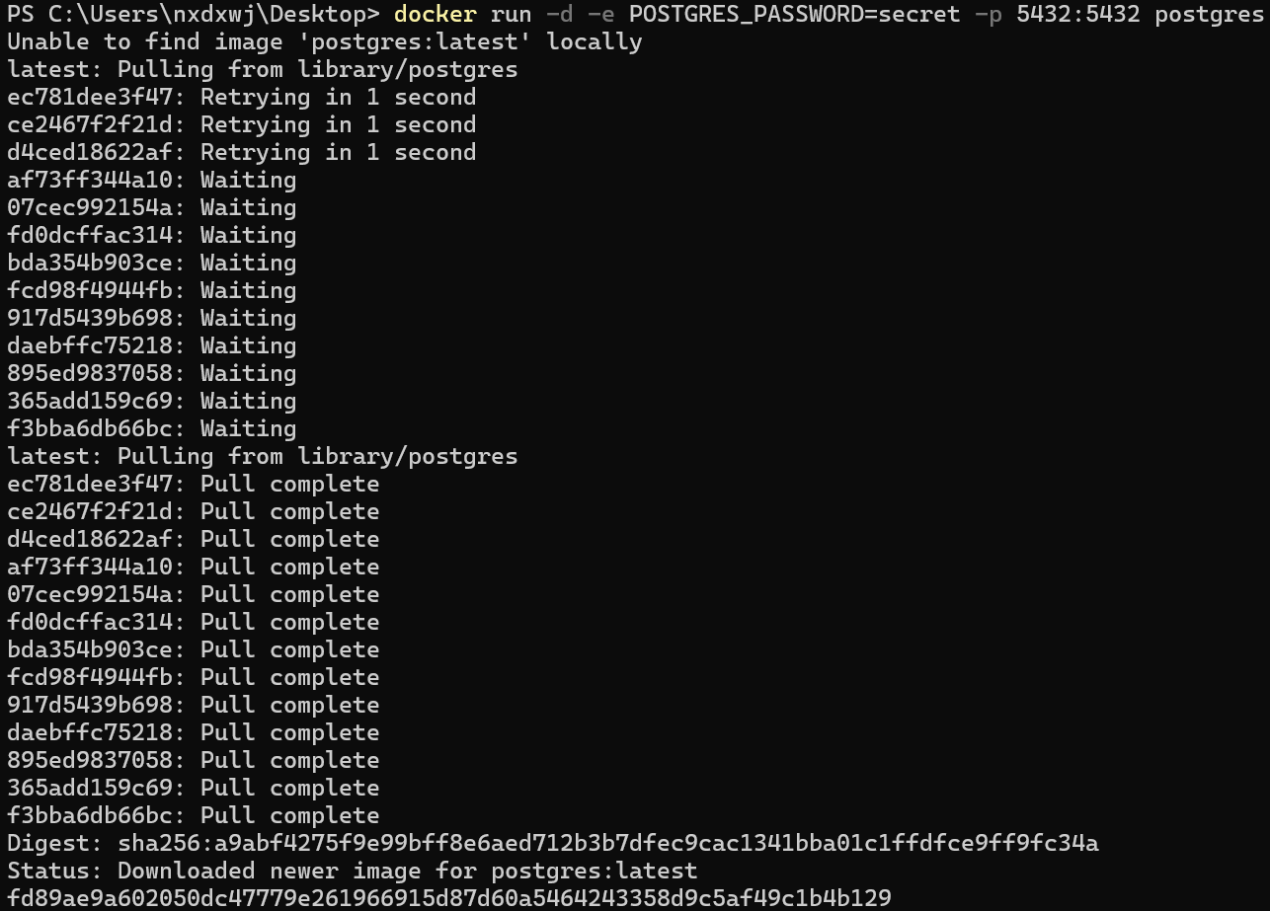
A PostgreSQL container is successfully started in detached mode, with environment variables configured and port 5433 on the host mapped to port 5432 in the container.
The command runs a PostgreSQL container to display environment variables, showing system configurations and confirming that the custom variable foo=bar has been successfully passed into the container.
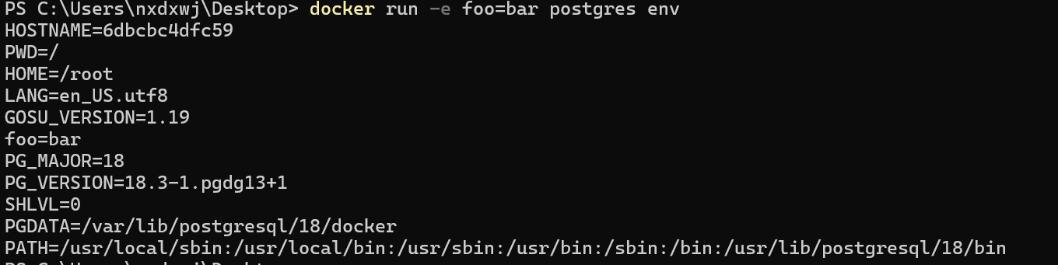
A PostgreSQL container is launched in detached mode with resource limits applied, including 512 MB memory and 0.5 CPU, demonstrating controlled allocation of system resources.
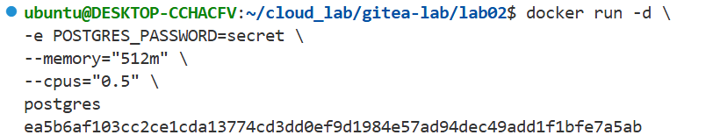
The docker stats output displays real-time resource usage of multiple containers, including CPU, memory, network, and I/O metrics, providing insight into container performance and system utilization.
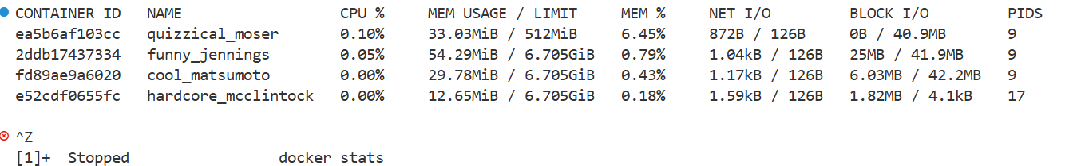
A custom Docker network is created and listed, followed by launching a PostgreSQL container connected to this network with port mapping configured, enabling inter-container communication and controlled networking.
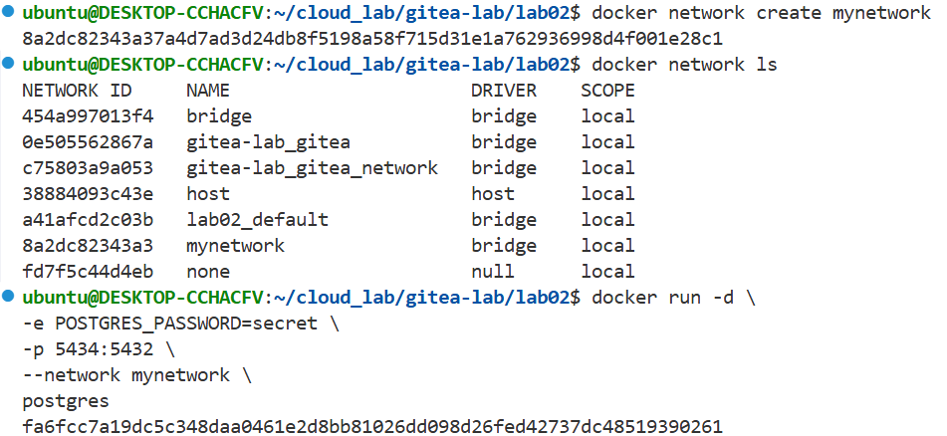
A Docker bridge network is created and verified, then a PostgreSQL container is started and attached to this custom network with port mapping configured, enabling isolated and flexible container networking.
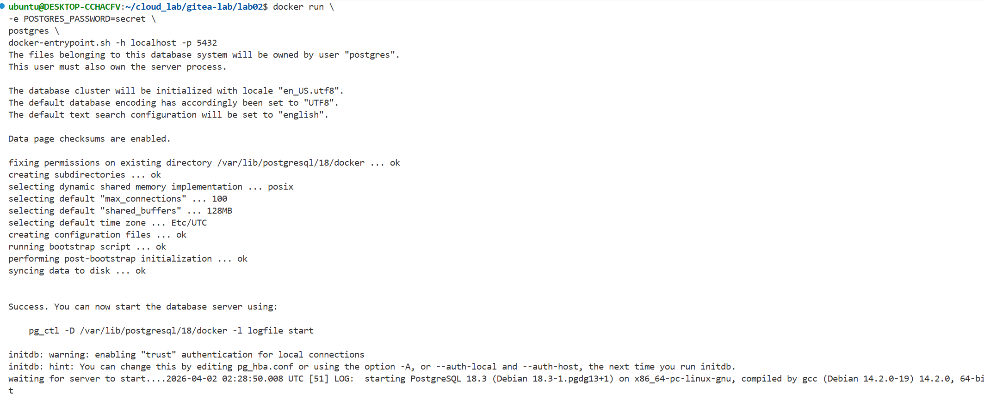
A Docker volume is created and mounted into a container to store data, where a file is written and verified inside the container, demonstrating persistent storage even after the container is removed.
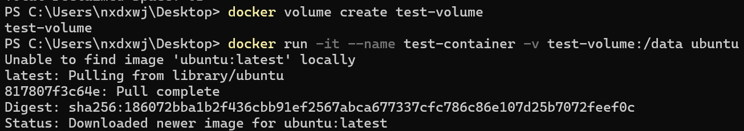
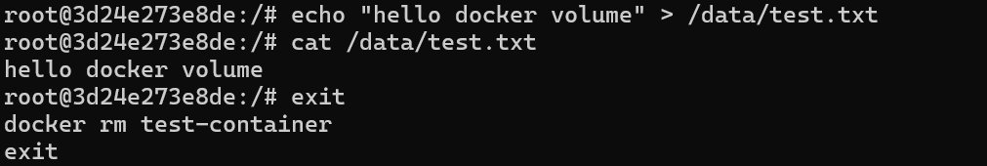
A new container is started with the same Docker volume mounted, and the previously created file is successfully read, confirming data persistence across containers.
A local directory is created and mounted into an Nginx container as a volume, allowing the container to serve a custom HTML file from the host, demonstrating host–container file sharing.
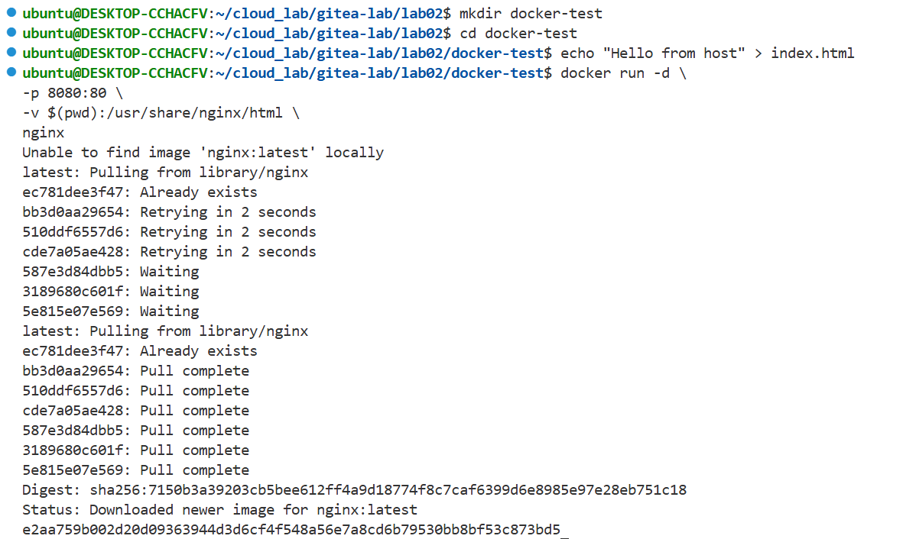
The browser successfully displays content served by the Nginx container, confirming that the host-mounted HTML file is correctly accessed and delivered.
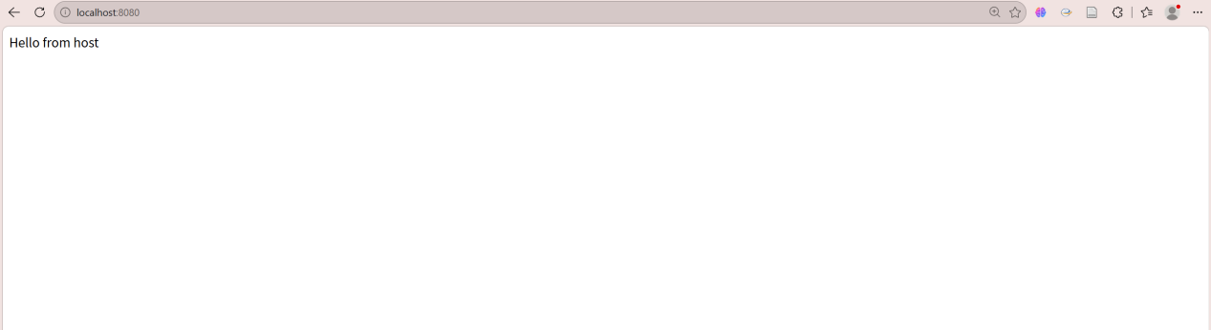
A custom HTML page with CSS styling and interactive elements is created and served through an Nginx container, confirming successful deployment of a dynamic web interface using Docker.
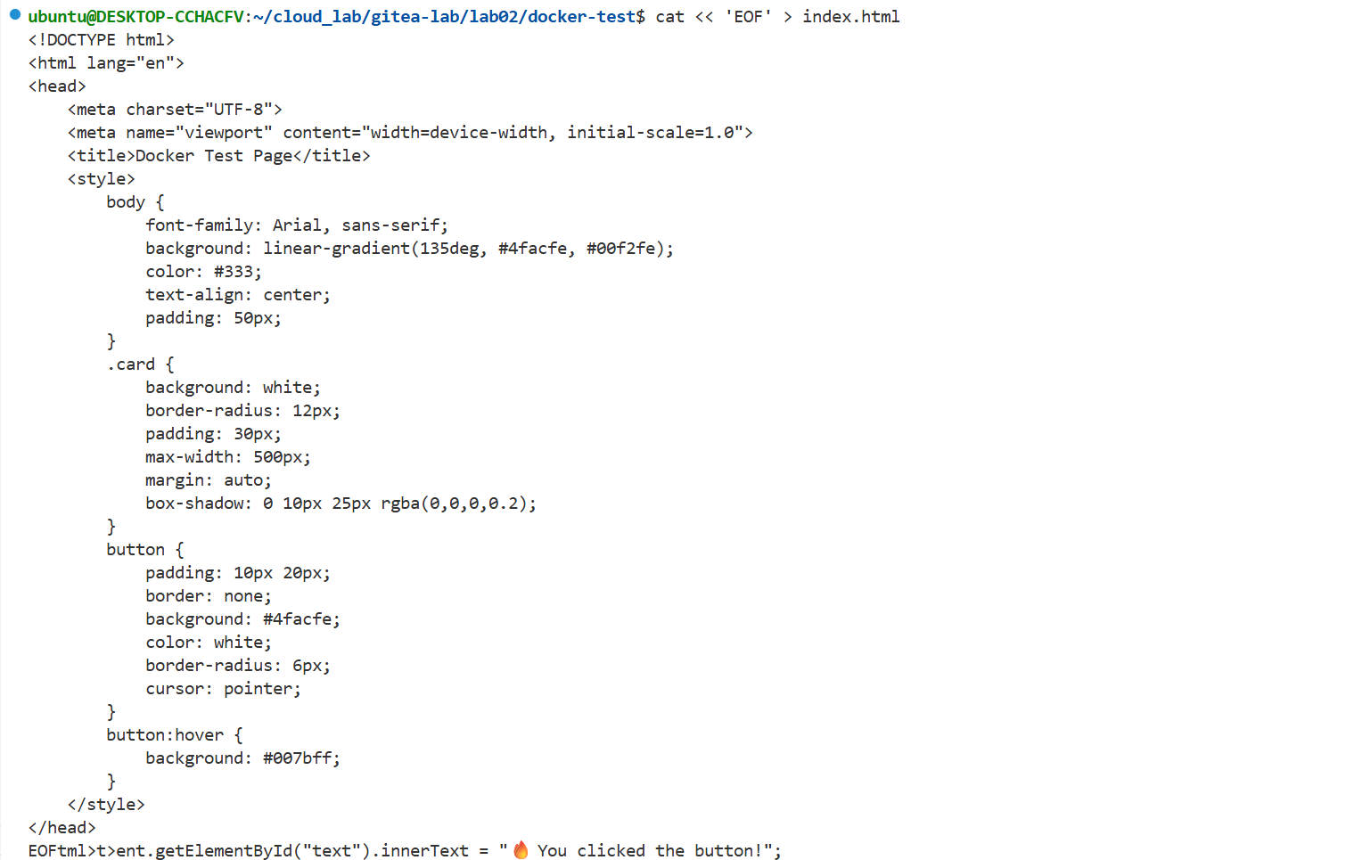
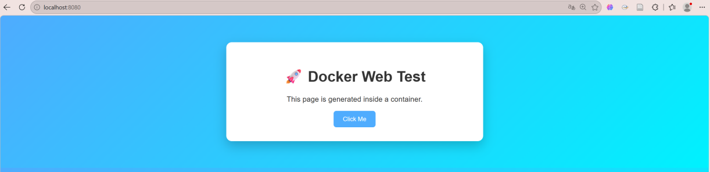
A custom Docker network is created, and a Redis container is launched within this network with a network alias assigned, enabling service discovery and communication in a multi-container setup.

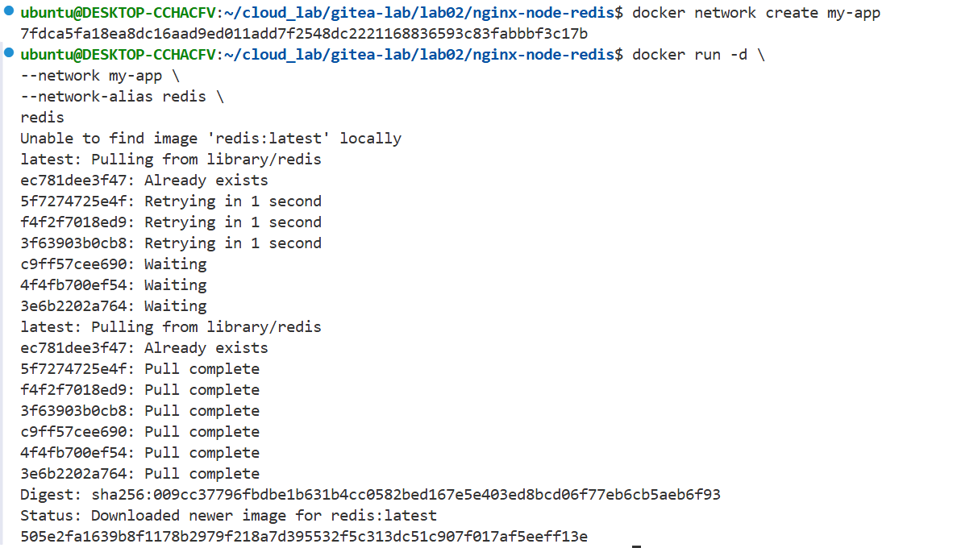
A custom Docker image is built from a Node.js based Dockerfile, with steps including loading dependencies, installing packages, and packaging application code, resulting in a ready-to-run web service image.
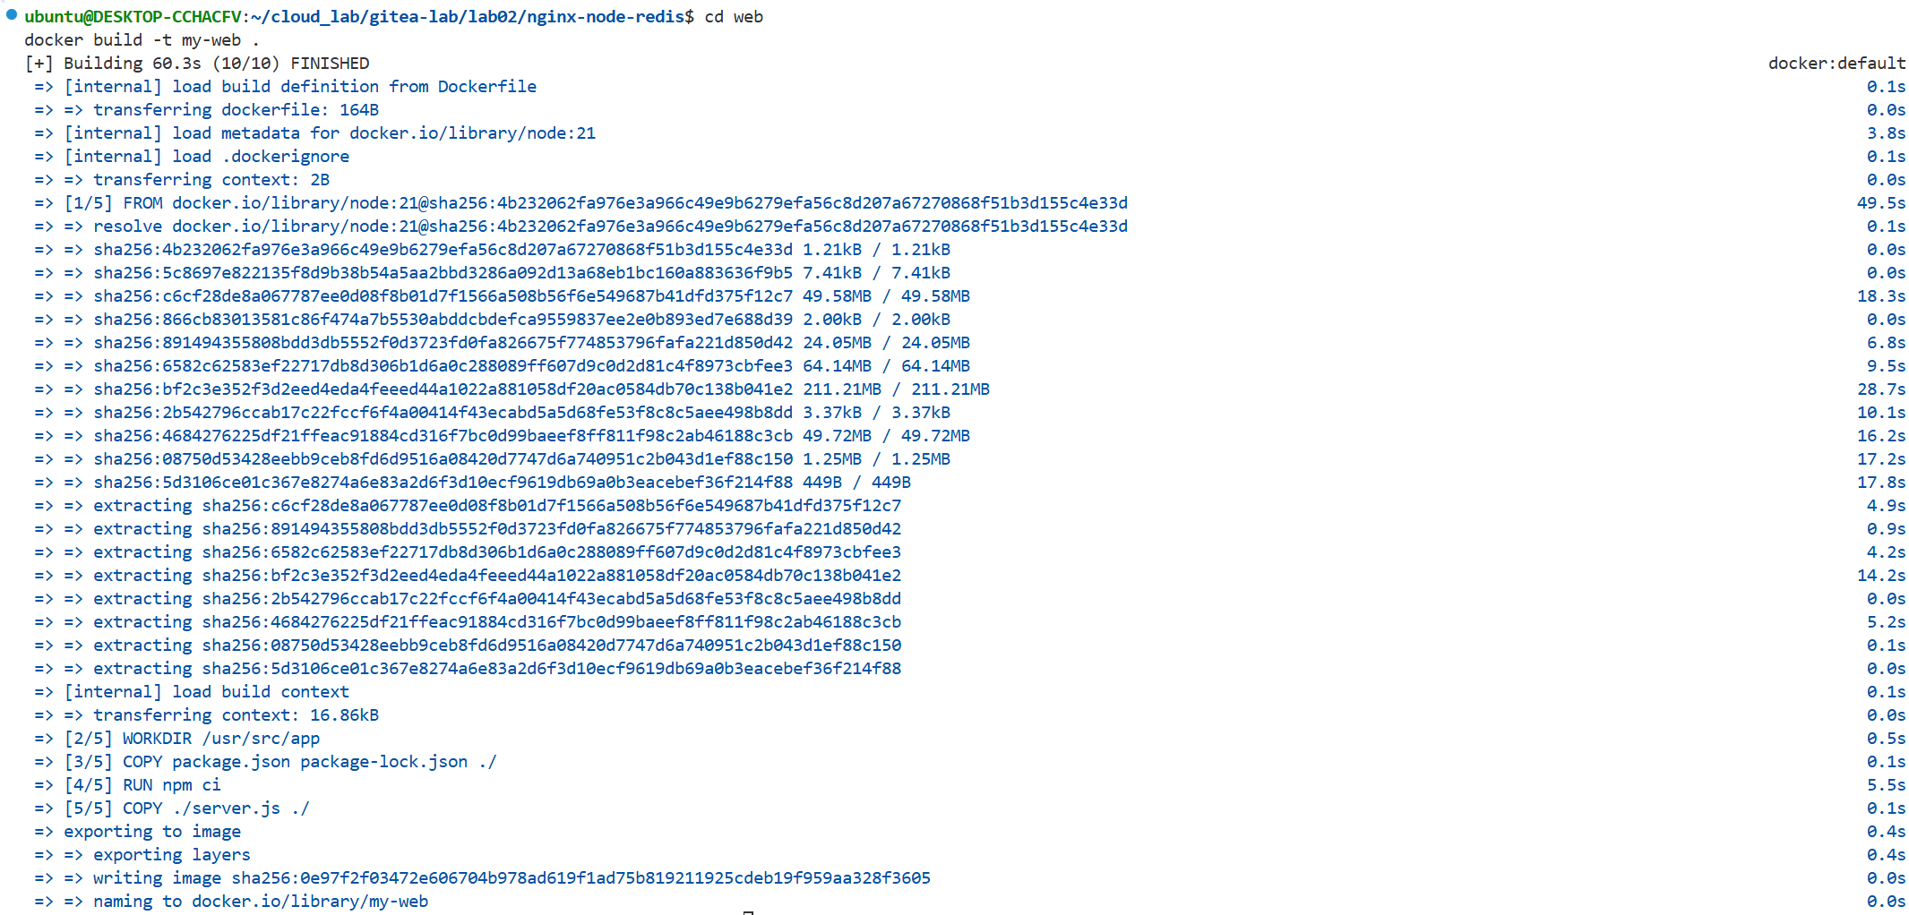
A custom Nginx Docker image is built using a Dockerfile, including copying a configuration file, resulting in a tailored web server image ready for deployment.
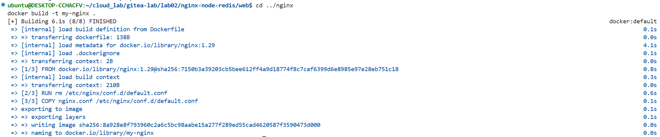
四、Reflection
1. Through this experiment, it became clear that a Docker container is tightly coupled with its main process. If the main process fails to start or exits unexpectedly, the container will terminate immediately. This helped deepen the understanding that many container stops are not normal behavior, but are often caused by configuration errors or service startup failures, especially in cases such as incorrect Nginx configurations.
2. The experiment highlighted how sensitive containerized systems are to configuration consistency. For example, mismatched service names in Nginx upstream settings or incorrect environment variables can cause the entire application to fail. It also demonstrated that multi-container applications rely heavily on correct service dependencies, where failure in one container (e.g. web service) directly affects others (e.g. reverse proxy).
3. By building a multi-container application, the role of Docker networks became much clearer. Containers communicate through user-defined networks and service names rather than fixed IP addresses. This reinforced the concept of service discovery and showed how network aliases are essential for enabling stable communication between containers.
4. Beyond basic Docker usage, the experiment provided insights into broader system design principles, including microservices architecture, reverse proxy, and load balancing. It demonstrated how complex applications can be decomposed into independent services, each running in its own container and communicating through well-defined interfaces.

