MainActivity如下: 2
SimpleGraph如下: 6
AdvancedGraph如下: 11
AdvancedMultipleSeriesGraph如下: 15
RealtimeGraph如下: 18
StylesGraph如下: 23
RemoveAddSeries如下: 28
CustomLabelFormatterActivity如下: 30
OwnModelAsData如下: 35

以下使用的是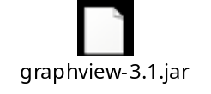包，其演示项目在github上面都有。

MainActivity如下:
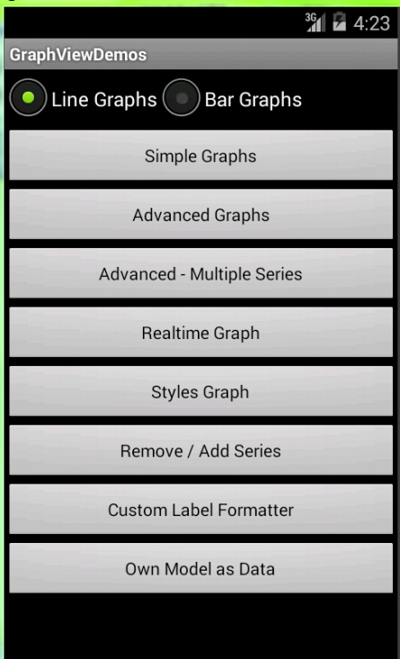

public class MainActivity extends Activity
{
@Override
protected void onCreate(Bundle savedInstanceState)
{
super.onCreate(savedInstanceState);
setContentView(R.layout.main);

// Simple Graphs
((Button) findViewById(R.id.btn_simple))
.setOnClickListener(new OnClickListener()
{
@Override
public void onClick(View v)
{
startGraphActivity(SimpleGraph.class);
}
});

// Advanced Graphs
((Button) findViewById(R.id.btn_advanced))
.setOnClickListener(new OnClickListener()
{
@Override
public void onClick(View v)
{
startGraphActivity(AdvancedGraph.class);
}
});

// Advanced - Multiple Series
((Button) findViewById(R.id.btn_muliple_series))
.setOnClickListener(new OnClickListener()
{
@Override
public void onClick(View v)
{
startGraphActivity(AdvancedMultipleSeriesGraph.class);
}
});

// RealtimeGraph
((Button) findViewById(R.id.btn_realtime))
.setOnClickListener(new OnClickListener()
{
@Override
public void onClick(View v)
{
startGraphActivity(RealtimeGraph.class);
}
});

// StylesGraph
((Button) findViewById(R.id.btn_styles))
.setOnClickListener(new OnClickListener()
{
@Override
public void onClick(View v)
{
startGraphActivity(StylesGraph.class);
}
});

// RemoveAddSeries
((Button) findViewById(R.id.btn_removeadd))
.setOnClickListener(new OnClickListener()
{
@Override
public void onClick(View v)
{
startGraphActivity(RemoveAddSeries.class);
}
});

// Custom Label Formatter
((Button) findViewById(R.id.btn_customlabelformatter))
.setOnClickListener(new OnClickListener()
{
@Override
public void onClick(View v)
{
startGraphActivity(CustomLabelFormatterActivity.class);
}
});

// Own Model as Data
((Button) findViewById(R.id.btn_ownmodelasdata))
.setOnClickListener(new OnClickListener()
{
@Override
public void onClick(View v)
{
startGraphActivity(OwnModelAsData.class);
}
});
}

private void startGraphActivity(Class<? extends Activity> activity)
{
// 执行跳转
Intent intent = new Intent(MainActivity.this, activity);

// 如果选择的是直方图
if (((RadioButton) findViewById(R.id.radio_bar)).isChecked())
{
// 如果是 Advanced - Multiple Series界面，就跳出Toast
if (activity == AdvancedMultipleSeriesGraph.class)
{
Toast.makeText(
this,
"Bar Charts are not implemented for multiple series, yet.",
Toast.LENGTH_LONG).show();

return;
}

// 否则传递bar到新界面
intent.putExtra("type", "bar");

} else
{
// 否则传递line到新界面
intent.putExtra("type", "line");
}

// 启动界面
startActivity(intent);
}

// 定义返回键的功能
@Override
public void onBackPressed()
{
Intent intent = new Intent(Intent.ACTION_MAIN);
intent.setFlags(Intent.FLAG_ACTIVITY_NEW_TASK);
intent.addCategory(Intent.CATEGORY_HOME);
startActivity(intent);
}
}

SimpleGraph如下:
折线图:
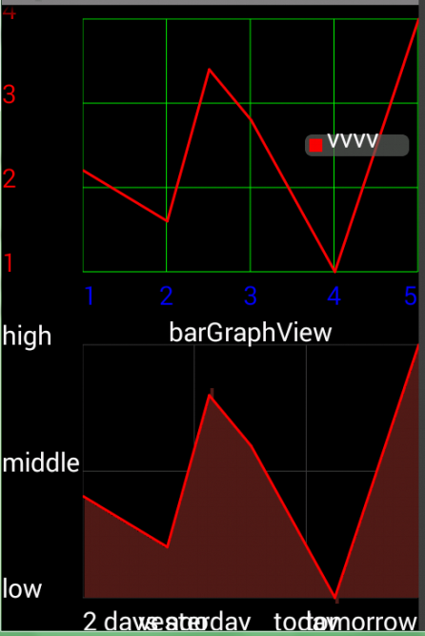

直方图:
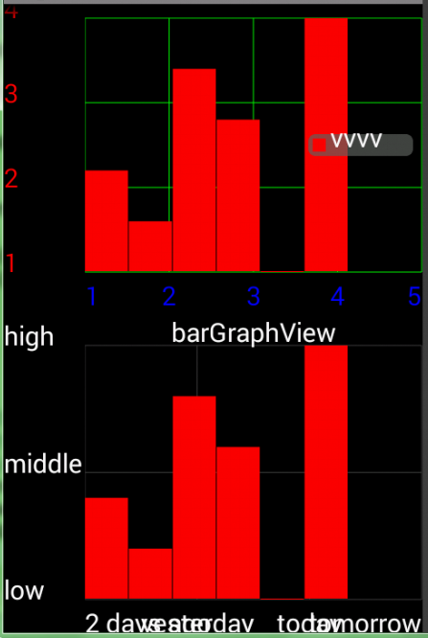

public class SimpleGraph extends Activity
{
@Override
public void onCreate(Bundle savedInstanceState)
{
super.onCreate(savedInstanceState);
setContentView(R.layout.graphs);
// graphs其中就只有两个线性布局，放上下两个图表

/**
* 第一个图表：
*/

// 第一个参数:折线图描述
// 第二个参数:折线的显示样式，包含其颜色和宽度(折线粗细程度)
// 第三个参数： 折线点数据，把这些点连接起来就能形成折线
GraphViewSeries exampleSeries = new GraphViewSeries("vvvv",
new GraphViewSeriesStyle(0xffff0000, 3), new GraphViewData[]
{ new GraphViewData(1, 2.0d), new GraphViewData(2, 1.5d),
new GraphViewData(2.5, 3.0d),
new GraphViewData(3, 2.5d), new GraphViewData(4, 1.0d),
new GraphViewData(5, 3.5d) });

GraphView graphView;
if (getIntent().getStringExtra("type").equals("bar"))
{// 显示条形直方图

// 两个参数分别是上下文和折线图标题
graphView = new BarGraphView(this, "");

} else
{// 显示线性折线图

// 两个参数分别是上下文和折线图标题
graphView = new LineGraphView(this, "");
}

// 显示折线图描述
graphView.setShowLegend(true);

// 设置水平坐标点的值：从左到右
graphView.setHorizontalLabels(new String[]
{ "1", "2", "3", "4", "5" });

// 设置垂直坐标点的值：从上到下
graphView.setVerticalLabels(new String[]
{ "4", "3", "2", "1" });

// 设置折线图背景色
graphView.setBackgroundColor(0x00000000);

// 第一个参数：垂直坐标值的颜色
// 第二个参数：水平坐标值的颜色
// 第三个参数：坐标表格的颜色
GraphViewStyle graphViewStyle = new GraphViewStyle(0xffff0000,
0xff0000ff, 0xff00ff00);

// 设置坐标值字体的大小
graphViewStyle.setTextSize(30);

// 将graphViewStyle设置给graphView
graphView.setGraphViewStyle(graphViewStyle);

// 将exampleSeries数据设置给graphView
graphView.addSeries(exampleSeries);

// 添加graphView到layout
LinearLayout layout = (LinearLayout) findViewById(R.id.graph1);
layout.addView(graphView);

/**
* 第二个图表：
*/
// 自定义坐标值和折线图背景的折线图
if (getIntent().getStringExtra("type").equals("bar"))
{
// 设置折线图标题为barGraphView。并且图形形状不变
graphView = new BarGraphView(this, "barGraphView");

} else
{
// 设置折线图标题为barGraphView。改变折线图形状
graphView = new LineGraphView(this, "barGraphView");

// 设置能绘画折线图背景
((LineGraphView) graphView).setDrawBackground(true);

// 设置折线图背景色
((LineGraphView) graphView).setBackgroundColor(Color
.rgb(80, 30, 30));
}

// 自定义坐标轴的值和添加数据
graphView.setHorizontalLabels(new String[]
{ "2 days ago", "yesterday", "today", "tomorrow" });

graphView.setVerticalLabels(new String[]
{ "high", "middle", "low" });

graphView.addSeries(exampleSeries);

layout = (LinearLayout) findViewById(R.id.graph2);
layout.addView(graphView);
}
}

AdvancedGraph如下:
折线图如下：
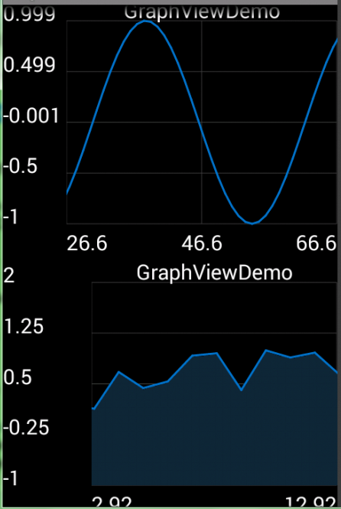

直方图如下：
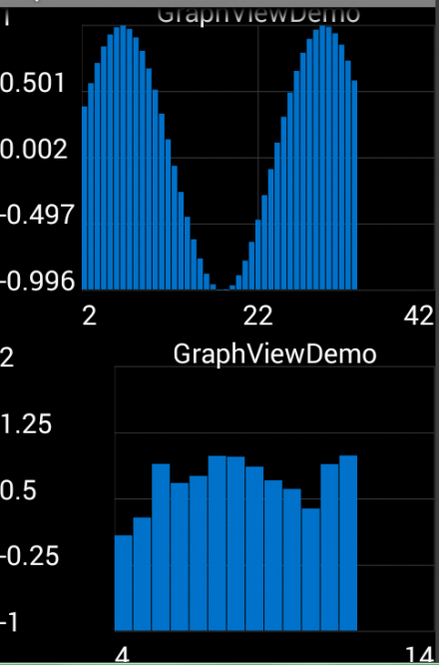

public class AdvancedGraph extends Activity
{
@Override
public void onCreate(Bundle savedInstanceState)
{
super.onCreate(savedInstanceState);
requestWindowFeature(Window.FEATURE_NO_TITLE);
setContentView(R.layout.graphs);
// graphs中就只有两个线性布局，放上下两个图表

/**
* 第一步：画正弦曲线
*/
int num = 1500;// 设定采样取值个数为1500个数据
GraphViewData[] data = new GraphViewData[num];// 创建一个容量为1500的数组

// 定义sin函数自变量为v
double v = 0;
for (int i = 0; i < num; i++)
{
v += 0.2;
// v每次增加0.2

// 两个参数分别是x坐标值和y坐标值
data[i] = new GraphViewData(v, Math.sin(v));
}

// 判断是要绘制直方图还是线形图
GraphView graphView;
if (getIntent().getStringExtra("type").equals("bar"))
{
graphView = new BarGraphView(this, "GraphViewDemo");

} else
{
graphView = new LineGraphView(this, "GraphViewDemo");

}

// 将数据添加到graphView中去
graphView.addSeries(new GraphViewSeries(data));

// 设定当前屏幕要显示的图像范围：x坐标值从2~40的范围，后面的再往右拖可看到
graphView.setViewPort(2, 40);

// 设置图表可左右滚动
graphView.setScrollable(true);

// 将graphView添加到线性布局
LinearLayout layout = (LinearLayout) findViewById(R.id.graph1);
layout.addView(graphView);

/**
* 第二步：画随机函数曲线
*/
num = 1500;
data = new GraphViewData[num];
v = 0;
for (int i = 0; i < num; i++)
{
v += 0.2;
data[i] = new GraphViewData(v, Math.sin(Math.random() * v));
}

// 设置画直方图还是线形图
if (getIntent().getStringExtra("type").equals("bar"))
{
graphView = new BarGraphView(this, "GraphViewDemo");

} else
{
graphView = new LineGraphView(this, "GraphViewDemo");
((LineGraphView) graphView).setDrawBackground(true);// 画出曲线背景
}

// 添加数据
graphView.addSeries(new GraphViewSeries(data));

// 设定当前屏幕要显示的图像范围：x坐标值从2~40的范围，后面的再往右拖可看到
graphView.setViewPort(4, 10);

// 设置图表可左右滚动
graphView.setScalable(true);

// 设定y轴范围
graphView.setManualYAxisBounds(2, -1);

// 将graphView添加到线性布局
layout = (LinearLayout) findViewById(R.id.graph2);
layout.addView(graphView);
}
}

AdvancedMultipleSeriesGraph如下:
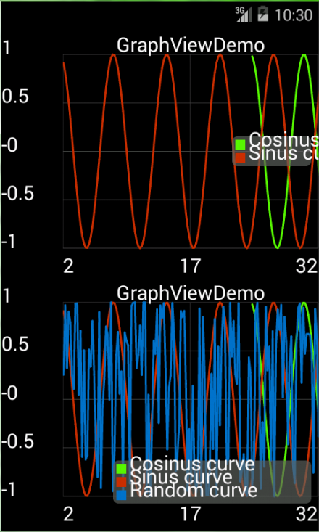

public class AdvancedMultipleSeriesGraph extends Activity
{
@Override
public void onCreate(Bundle savedInstanceState)
{
super.onCreate(savedInstanceState);
requestWindowFeature(Window.FEATURE_NO_TITLE);
setContentView(R.layout.graphs);

// 画正弦函数
int num = 1500;
GraphViewData[] data = new GraphViewData[num];
double v = 0;
for (int i = 0; i < num; i++)
{
v += 0.2;
data[i] = new GraphViewData(v, Math.sin(v));
}

// 设置正弦函数的描述，样式和数据
GraphViewSeries seriesSin = new GraphViewSeries("Sinus curve",
new GraphViewSeriesStyle(Color.rgb(200, 50, 00), 3), data);

// 画余弦函数
num = 1500;
data = new GraphViewData[num];
v = 0;
for (int i = 0; i < num; i++)
{
v += 0.2;
data[i] = new GraphViewData(v + 24, Math.cos(v));
}

// 设置余弦函数的描述，样式和数据
GraphViewSeries seriesCos = new GraphViewSeries("Cosinus curve",
new GraphViewSeriesStyle(Color.rgb(90, 250, 00), 3), data);

// 画随机函数
num = 1500;
data = new GraphViewData[num];
v = 0;
for (int i = 0; i < num; i++)
{
v += 0.2;
data[i] = new GraphViewData(v, Math.sin(Math.random() * v));
}

// 设置随机函数的描述，样式和数据
GraphViewSeries seriesRnd = new GraphViewSeries("Random curve", null,
data);

// 画第一个线形图，注意：此界面没有直方图
LineGraphView graphView = new LineGraphView(this, "GraphViewDemo");

// 添加数据
graphView.addSeries(seriesCos);
graphView.addSeries(seriesSin);

// 设置图例
graphView.setShowLegend(true);

graphView.setViewPort(2, 50);
graphView.setScrollable(true);

LinearLayout layout = (LinearLayout) findViewById(R.id.graph1);
layout.addView(graphView);

// 画第二个线形图：
graphView = new LineGraphView(this, "GraphViewDemo");

graphView.addSeries(seriesCos);
graphView.addSeries(seriesSin);
graphView.addSeries(seriesRnd);

// 设置图例
graphView.setShowLegend(true);
graphView.setLegendAlign(LegendAlign.BOTTOM);// 图例对齐方式
graphView.setLegendWidth(300);// 图例宽度

graphView.setViewPort(2, 50);
graphView.setScalable(true);

layout = (LinearLayout) findViewById(R.id.graph2);
layout.addView(graphView);
}
}

RealtimeGraph如下:
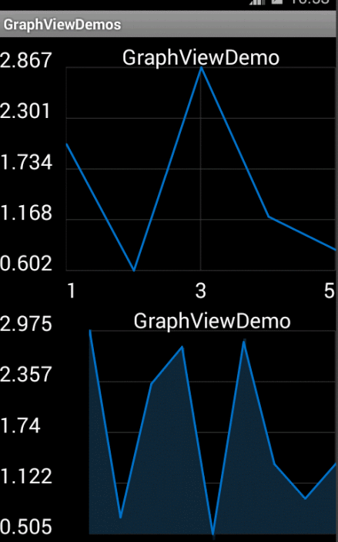
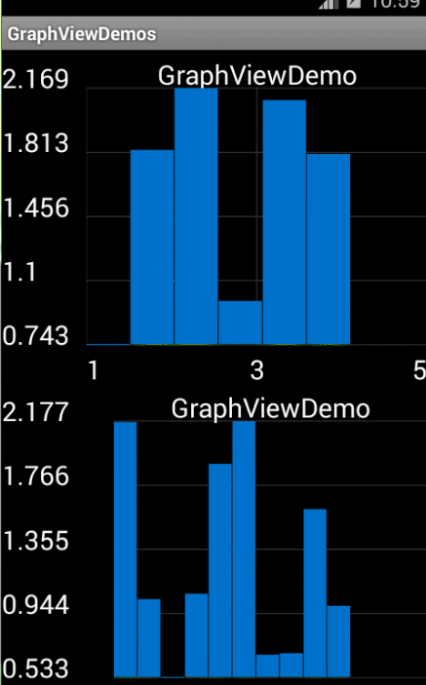
public class RealtimeGraph extends Activity
{
private final Handler mHandler = new Handler();

private Runnable mTimer1;
private Runnable mTimer2;

private GraphView graphView;

private GraphViewSeries exampleSeries1;
private GraphViewSeries exampleSeries2;

private double graph2LastXValue = 5d;

/**
* 获取随机值
*/
private double getRandom()
{
double high = 3;
double low = 0.5;
return Math.random() * (high - low) + low;
}

@Override
public void onCreate(Bundle savedInstanceState)
{
super.onCreate(savedInstanceState);
setContentView(R.layout.graphs);

/**
* 第一个图像
*/
exampleSeries1 = new GraphViewSeries(new GraphViewData[]
{ new GraphViewData(1, 2.0d), new GraphViewData(2, 1.5d),
new GraphViewData(2.5, 3.0d), new GraphViewData(3, 2.5d),
new GraphViewData(4, 1.0d), new GraphViewData(5, 3.0d) });

if (getIntent().getStringExtra("type").equals("bar"))
{
graphView = new BarGraphView(this, "GraphViewDemo");

} else
{
graphView = new LineGraphView(this, "GraphViewDemo");
}

graphView.addSeries(exampleSeries1);

LinearLayout layout = (LinearLayout) findViewById(R.id.graph1);
layout.addView(graphView);

/**
* 第二个图像
*/
exampleSeries2 = new GraphViewSeries(new GraphViewData[]
{ new GraphViewData(1, 2.0d), new GraphViewData(2, 1.5d),
new GraphViewData(2.5, 3.0d), new GraphViewData(3, 2.5d),
new GraphViewData(4, 1.0d), new GraphViewData(5, 3.0d) });

if (getIntent().getStringExtra("type").equals("bar"))
{
graphView = new BarGraphView(this, "GraphViewDemo");

} else
{
graphView = new LineGraphView(this, "GraphViewDemo");
((LineGraphView) graphView).setDrawBackground(true);
}

graphView.addSeries(exampleSeries2);

graphView.setViewPort(1, 8);
graphView.setScalable(true);

layout = (LinearLayout) findViewById(R.id.graph2);
layout.addView(graphView);
}

@Override
protected void onPause()
{
super.onPause();

mHandler.removeCallbacks(mTimer1);
mHandler.removeCallbacks(mTimer2);
}

@Override
protected void onResume()
{
super.onResume();

mTimer1 = new Runnable()
{
@Override
public void run()
{
// exampleSeries1重置数据
exampleSeries1.resetData(new GraphViewData[]
{ new GraphViewData(1, getRandom()),
new GraphViewData(2, getRandom()),
new GraphViewData(2.5, getRandom()),
new GraphViewData(3, getRandom()),
new GraphViewData(4, getRandom()),
new GraphViewData(5, getRandom()) });

mHandler.postDelayed(this, 500);
}
};

mHandler.postDelayed(mTimer1, 500);

mTimer2 = new Runnable()
{
@Override
public void run()
{
graph2LastXValue += 1d;

// exampleSeries2追加数据
// 第二个参数是是否能划到最后
// 第三个参数是最大可增加多少个数据
exampleSeries2.appendData(new GraphViewData(graph2LastXValue,
getRandom()), true, 10);

mHandler.postDelayed(this, 800);
}
};
mHandler.postDelayed(mTimer2, 1000);
}
}

StylesGraph如下:
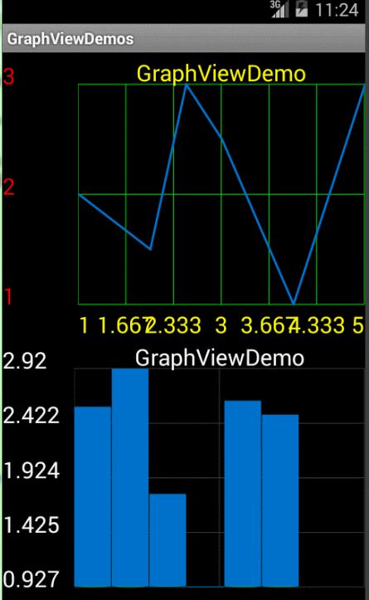
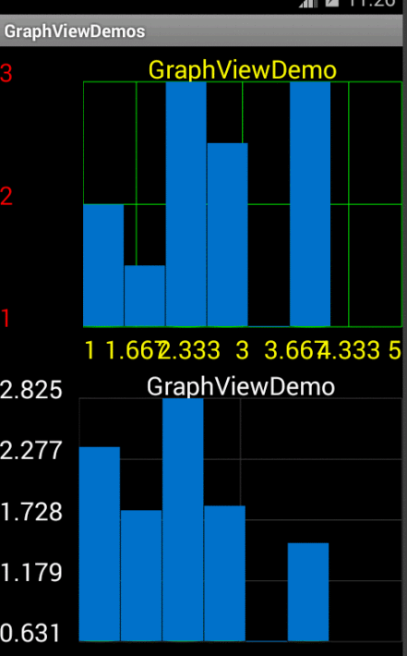
public class StylesGraph extends Activity
{
private final Handler mHandler = new Handler();

private Runnable mTimer;

private GraphViewSeries exampleSeries2;

private double getRandom()
{
double high = 3;
double low = 0.5;
return Math.random() * (high - low) + low;
}

@Override
public void onCreate(Bundle savedInstanceState)
{
super.onCreate(savedInstanceState);
setContentView(R.layout.graphs);

/**
* 第一个图表：设置图表的其他属性
*/
GraphViewSeries exampleSeries = new GraphViewSeries(new GraphViewData[]
{ new GraphViewData(1, 2.0d), new GraphViewData(2, 1.5d),
new GraphViewData(2.5, 3.0d), new GraphViewData(3, 2.5d),
new GraphViewData(4, 1.0d), new GraphViewData(5, 3.0d) });

GraphView graphView;
if (getIntent().getStringExtra("type").equals("bar"))
{
graphView = new BarGraphView(this, "GraphViewDemo");

} else
{
graphView = new LineGraphView(this, "GraphViewDemo");
}

// 设置图表样式

// 设置表格颜色
graphView.getGraphViewStyle().setGridColor(Color.GREEN);

// 设置x轴和y轴数字颜色
graphView.getGraphViewStyle().setHorizontalLabelsColor(Color.YELLOW);
graphView.getGraphViewStyle().setVerticalLabelsColor(Color.RED);

// 设置文本大小
graphView.getGraphViewStyle().setTextSize(30);

// 设置当前屏幕上x轴和y轴要显示多少个单位长度
graphView.getGraphViewStyle().setNumHorizontalLabels(7);
graphView.getGraphViewStyle().setNumVerticalLabels(3);

// 表格距离y轴数字的距离
graphView.getGraphViewStyle().setVerticalLabelsWidth(100);

graphView.addSeries(exampleSeries);

LinearLayout layout = (LinearLayout) findViewById(R.id.graph1);
layout.addView(graphView);

/**
* 第二个图表：
*/
GraphViewSeriesStyle seriesStyle = new GraphViewSeriesStyle();

exampleSeries2 = new GraphViewSeries("aaa", seriesStyle,
new GraphViewData[]
{ new GraphViewData(1, 2.0d), new GraphViewData(2, 1.5d),
new GraphViewData(2.5, 3.0d),
new GraphViewData(3, 2.5d), new GraphViewData(4, 1.0d),
new GraphViewData(5, 3.0d) });

graphView = new BarGraphView(this, "GraphViewDemo");
graphView.addSeries(exampleSeries2);

layout = (LinearLayout) findViewById(R.id.graph2);
layout.addView(graphView);

}

@Override
protected void onPause()
{
super.onPause();

mHandler.removeCallbacks(mTimer);
}

@Override
protected void onResume()
{
super.onResume();

mTimer = new Runnable()
{
@Override
public void run()
{
// 重置数据
exampleSeries2.resetData(new GraphViewData[]
{ new GraphViewData(1, getRandom()),
new GraphViewData(2, getRandom()),
new GraphViewData(2.5, getRandom()),
new GraphViewData(3, getRandom()),
new GraphViewData(4, getRandom()),
new GraphViewData(5, getRandom()) });

mHandler.postDelayed(this, 300);
}
};

mHandler.postDelayed(mTimer, 300);
}

RemoveAddSeries如下:
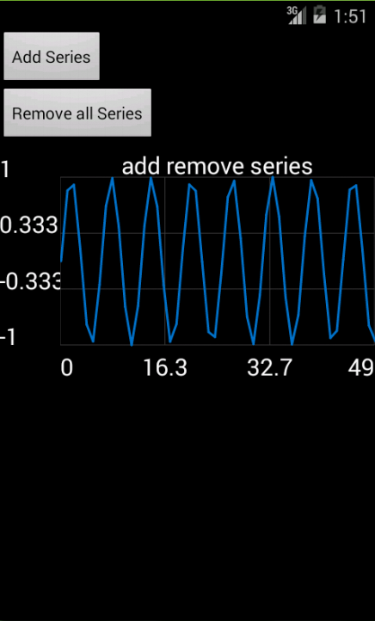

public class RemoveAddSeries extends Activity
{
private GraphView graphView;

@Override
protected void onCreate(Bundle savedInstanceState)
{
super.onCreate(savedInstanceState);
requestWindowFeature(Window.FEATURE_NO_TITLE);
setContentView(R.layout.graph_buttons);

Button b1 = (Button) findViewById(R.id.button1);
b1.setOnClickListener(new OnClickListener()
{
@Override
public void onClick(View arg0)
{

// x坐标的范围 0~30
int count = 50;

GraphViewData[] values = new GraphViewData[count];

for (int i = 0; i < count; i++)
{

double y = Math.sin(i);

values[i] = new GraphViewData(i, y);
}

GraphViewSeries series = new GraphViewSeries(values);

graphView.addSeries(series);
}
});

Button b2 = (Button) findViewById(R.id.button2);
b2.setOnClickListener(new OnClickListener()
{
@Override
public void onClick(View v)
{
graphView.removeAllSeries();
}
});

graphView = new LineGraphView(this, "add remove series");

LinearLayout ll = (LinearLayout) findViewById(R.id.linearLayout);
ll.addView(graphView);
}
}

CustomLabelFormatterActivity如下:
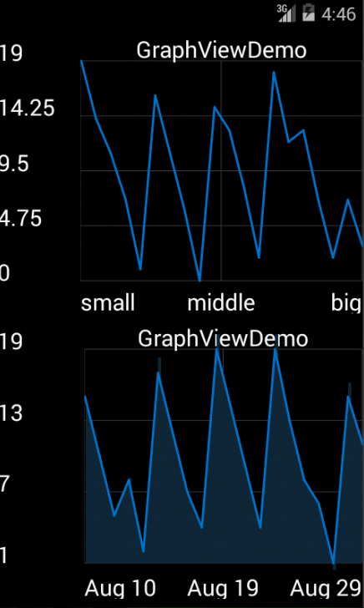
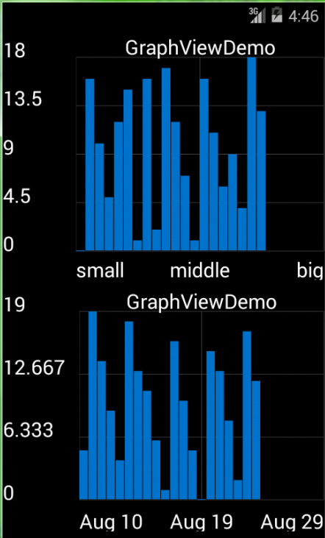
public class CustomLabelFormatterActivity extends Activity
{
@Override
public void onCreate(Bundle savedInstanceState)
{
super.onCreate(savedInstanceState);
requestWindowFeature(Window.FEATURE_NO_TITLE);
setContentView(R.layout.graphs);

int size = 20;
GraphViewData[] data = new GraphViewData[size];
for (int i = 0; i < size; i++)
{
data[i] = new GraphViewData(i, new Random().nextInt(20));
}

GraphViewSeries exampleSeries = new GraphViewSeries(data);

GraphView graphView;
if (getIntent().getStringExtra("type").equals("bar"))
{
graphView = new BarGraphView(this, "GraphViewDemo");
} else
{
graphView = new LineGraphView(this, "GraphViewDemo");
}

graphView.addSeries(exampleSeries);

// 自定义坐标轴的值
graphView.setCustomLabelFormatter(new CustomLabelFormatter()
{
@Override
public String formatLabel(double value, boolean isValueX)
{
if (isValueX)
{
// 根据x轴的值的大小赋予相应的值
if (value < 5)
{
return "small";

} else if (value < 15)
{
return "middle";

} else
{
return "big";
}
}

return null; // 让graphView为我们生成y轴标签
}
});

LinearLayout layout = (LinearLayout) findViewById(R.id.graph1);
layout.addView(graphView);

/**
* x轴为日期
*/
// 获取当前时间
long now = new Date().getTime();

data = new GraphViewData[size];
for (int i = 0; i < size; i++)
{
data[i] = new GraphViewData(now + (i * 60 * 60 * 24 * 1000),
new Random().nextInt(20)); // 第二天
}

exampleSeries = new GraphViewSeries(data);

if (getIntent().getStringExtra("type").equals("bar"))
{
graphView = new BarGraphView(this, "GraphViewDemo");

} else
{
graphView = new LineGraphView(this, "GraphViewDemo");

((LineGraphView) graphView).setDrawBackground(true);
}

graphView.addSeries(exampleSeries);

final SimpleDateFormat dateFormat = new SimpleDateFormat("MMM d");

graphView.setCustomLabelFormatter(new CustomLabelFormatter()
{
@Override
public String formatLabel(double value, boolean isValueX)
{
if (isValueX)
{
Date d = new Date((long) value);

return dateFormat.format(d);
}

return null; // 让graphView为我们生成y轴标签
}
});

layout = (LinearLayout) findViewById(R.id.graph2);
layout.addView(graphView);
}
}

OwnModelAsData如下:
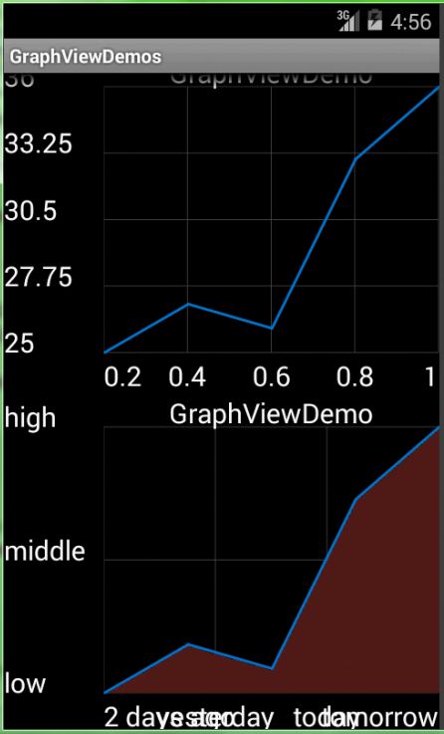
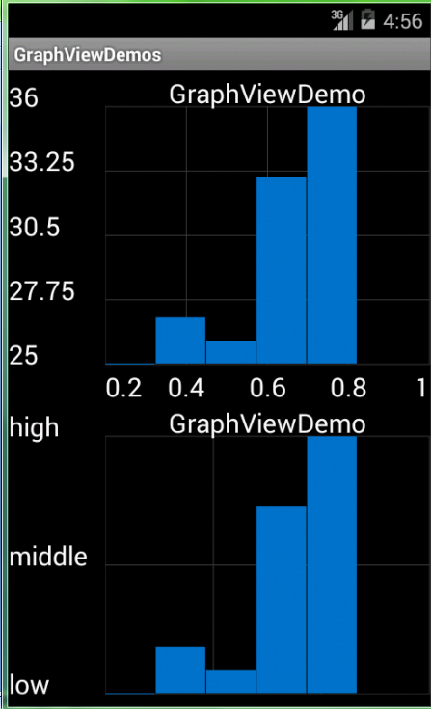
public class OwnModelAsData extends Activity
{
static public class ServerTemperature implements GraphViewDataInterface
{
private final int day;
private final int temp;

public ServerTemperature(int day, int temp)
{
this.day = day;
this.temp = temp;
}

@Override
public double getX()
{
return day / 5d; // just return something
}

@Override
public double getY()
{
return temp + 5d; // just return something
}
}

@Override
public void onCreate(Bundle savedInstanceState)
{
super.onCreate(savedInstanceState);
setContentView(R.layout.graphs);

GraphViewSeries exampleSeries = new GraphViewSeries(
new ServerTemperature[]
{ new ServerTemperature(1, 20), new ServerTemperature(2, 22),
new ServerTemperature(3, 21),
new ServerTemperature(4, 28),
new ServerTemperature(5, 31) });

GraphView graphView;
if (getIntent().getStringExtra("type").equals("bar"))
{
graphView = new BarGraphView(this, "GraphViewDemo");

} else
{
graphView = new LineGraphView(this, "GraphViewDemo");
}

graphView.getGraphViewStyle().setNumHorizontalLabels(5);

graphView.addSeries(exampleSeries);

LinearLayout layout = (LinearLayout) findViewById(R.id.graph1);
layout.addView(graphView);

// 自定义标签和背景图
if (getIntent().getStringExtra("type").equals("bar"))
{
graphView = new BarGraphView(this, "GraphViewDemo");

} else
{
graphView = new LineGraphView(this, "GraphViewDemo");

((LineGraphView) graphView).setDrawBackground(true);
((LineGraphView) graphView).setBackgroundColor(Color
.rgb(80, 30, 30));
}

// 自定义静态标签
graphView.setHorizontalLabels(new String[]
{ "2 days ago", "yesterday", "today", "tomorrow" });
graphView.setVerticalLabels(new String[]
{ "high", "middle", "low" });

graphView.addSeries(exampleSeries);

layout = (LinearLayout) findViewById(R.id.graph2);
layout.addView(graphView);
}
}

