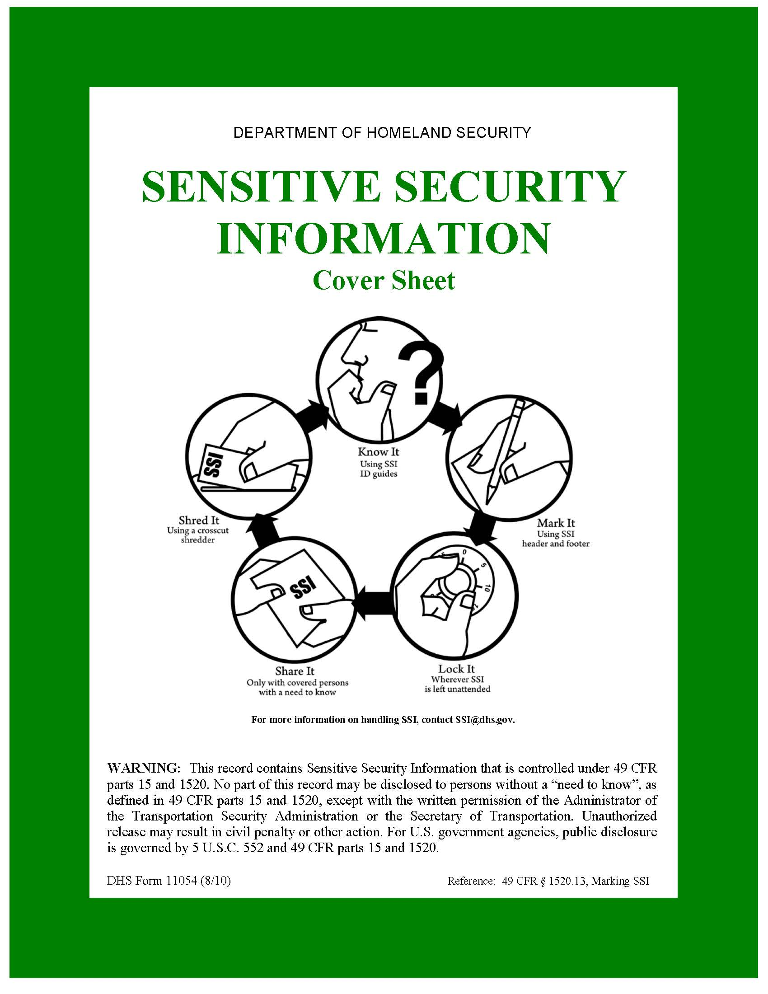

**AIRPORT NAME**

**ENTER AIRPORT ABBREVIATION**

**Explosives Risk Management Program**

**Full Report**



**Conducted:** **Enter Date (Month Date, Year)**

This document is protected by 49 CFR Part 1520.**CONTROL PAGE**

|  |  |
| --- | --- |
| **1. ADD** | **2. DELETE** |
|  |  |
|  |  |
|  |  |
|  |  |
|  |  |
|  |  |
|  |  |
|  |  |
|  |  |

Approved by: ______________________ Date: ______________

NAME

Federal Security Director

Contents

1. Introduction 6

2. TSS-E Overview 6

3. Purpose 6

4. Applicability 6

5. Distribution 6

6. Abbreviations [alphabetized] 6

7. Products 7

7.1 EVAAT Executive Summary 7

7.2 Asset Overview 7

7.3 Vulnerability Dashboard per Terminal 7

7.4 Vulnerability Dashboard per Overall Airport Assets 7

8. General Airport Information 8

9. Regional and Local Explosive Threats 8

10. Explosive Threats 8

10.1 Placed IEDs 8

10.2 Vehicle-Borne IEDs (VBIEDs) 8

11. Adversarial Targeting 9

12. Risk Assessment 11

12.1 Threat 12

12.2 Consequence 13

12.3 Vulnerability 13

13. Top 5 Assets Threatened by Placed IEDs 14

13.1 Asset 1: Asset Name 15

13.1.1 Asset 1: e.g., Terminal A – Ticketing – Options for Consideration 15

14. Top 5 Assets Threatened by VBIEDs 16

14.1 Asset 1: e.g., Terminal A – Departure Curbside 16

14.1.1 Asset 1: e.g., Terminal A – Departure Curbside – Options for Consideration 17

15. All Airport Assets 17

Appendix A: Top 5 Assets Threatened by Placed IEDs – Target Area Analysis 18

A.1 Asset 1 Target Area 1: e.g., Terminal A – Ticketing – Target Area 1 (Starbucks) 18

Appendix B: Top 5 Assets Threatened by VBIEDs – Target Area Analysis 21

B.1 Asset 1 Target Area 1: e.g., Terminal A - Departure Curbside - Staging Area 1 21

# Tables

Table 1 Applicable Deterrence Measures by Assets for a Placed IED Threat 8

Table 2 Applicable Deterrence Measures by Asset for a VBIED Threat 9

Table 3 Risk Assessment at Airport Terminal Assets 10

Table 4 Risk Assessment for Supporting Assets 11

Table A-2 IED Threat Scenarios 19

Table B-2 VBIED Threat Scenarios 22

# Figures

Figure 2 Asset Name Asset 1 Target Areas for Placed IEDs 14

Figure 7 Asset Name Asset 1 Target Areas for VBIEDs 15

# 

**Explosives Risk Management Program Overview**

# 1. Introduction

The Transportation Security Administration Transportation Security Specialist – Explosive (TSS-E), Enter TSS-E Name, conducted a full Explosive Vulnerability Assessment (EVA) from Enter Date(s) (month to month year). The assessment focused specifically on the vulnerabilities of airport operations, countermeasures, security awareness, and response planning to explosive attacks. As part of a new National Transportation Security Administration (TSA) EVA methodology and applicable checklists, the Adversarial Targeting was completed by select teams coordinated by the TSS-E and the Risk Assessment was completed by the TSS-E. Current threat intelligence was reviewed and considered by the TSS-E in consultation with airport staff and external stakeholders.

## 1.1 Adversarial Targeting Teams

Adversarial Targeting Teams are role playing surveillance teams assembled by the TSS-E in order to collect the target area data at each asset around the airport. These teams consist of individuals with specific backgrounds in Physical Security, IED/WMD, Terrorist Tactics/Assault Planner, Surveillance/Counter Surveillance, Law Enforcement, or Other depending on the needs of the TSS-E. The composition of the teams is intended to be built from Federal, State and local security partners within the Federal Security Director’s areas of responsibility. As a rule-of-thumb, these role players should not work within the airport or have in depth knowledge of airport operations. The reason for this is to mimic as closely as possible the general knowledge of terrorists as they conduct their phases of pre-operational surveillance and target selection.

**VISITED AREAS**

* e.g., Terminal 1

# 2. TSS-E Overview

*TSS-E, please provide an overview of the entire EVA process here:* TSSEs should talk about the EVA overview in regards to adversarial targeting teams, assets reviewed, scenarios, risk assessment, etc. The security awareness of the airport from the totality of their experience, adversarial targeting team feedback and scenarios/surveys conducted .

# 3. Purpose

The EVA process is to identify areas in the airport’s operations and facilities that may be susceptible to explosive attacks. While there are an infinite number of ways that explosives can be used to attack a target, this EVA serves to highlight only those vulnerabilities which, based on explosive attacks, may be likely or probable. The areas of concern identified in the report are based upon areas where a successful attack would significantly impact lives or hinder airport operations.

# 4. Applicability

In accordance with 49 CFR 1542.101, the provisions of this document are for use by the [##Airport Abbreviation##] TSA Federal Security Director (FSD) to use in cooperation with [##Airport Abbreviation##] transportation stakeholders and partners.

# 5. Distribution

The final report of this assessment will be issued to the FSD for review and approval. The FSD will then disseminate as appropriate. Copies of this document may be distributed to stakeholders and tenants of the airport as required.

# 6. Abbreviations [alphabetized]

|  |  |
| --- | --- |
| **CCTV** | Closed-Circuit Television |
| **EOC** | Emergency Operation Center |
| **EVA** | Explosive Vulnerability Assessment |
| **EVAAT** | Explosive Vulnerability Assessment and Analysis Tool |
| **FSD** | Federal Security Director |
| **IDS** | Intrusion Detection System |
| **IED** | Improvised Explosive Device |
| **TSA** | Transportation Security Administration |
| **TSS-E** | Transportation Security Specialist – Explosives |
| **TSSRA** | Transportation Sector Security Risk Assessment |
| **VBIED** | Vehicle-Borne Improvised Explosive Device |

# 7. Products

Including the Explosive Vulnerability Assessment and Analysis Tool (EVAAT) Report, the products listed below are also produced by EVAAT from additional analysis completed through use of the tool.

## 7.1 Explosives Risk Management Program Executive Summary

The EVAAT Executive Summary is a document intended for a quick review of the Risk Score Table by Asset, Situational Awareness Charts by Asset, and top 5 most important options for consideration for the airport determined by the TSS-E.

**7.2 Explosives Risk Management Program Stakeholder Report**

The EVAAT Executive Summary is a shortened version of this full report. It addresses only the top five improvised explosive device (IED) assets and top five vehicle-borne IED (VBIED) assets.

## 7.3 Asset Overview

The Asset Overview addresses all assets completed by the adversarial targeting teams. Each asset is shown in totality and then broken down to include all of the data collected per target area. This product also includes graphs and charts for each target area, such as a blast analysis map, deterrence measures, and options for consideration.

# 8. General Airport Information

[##Airport Abbreviation##] is a Category (X) commercial aviation airport located at [##Airport Address##] and serving Enter the following information: primary hub (e.g., Alaska Airlines), regional subsidiary (e.g., Horizon Air), and airport service destinations (e.g., North America, Europe).

The following is an overview of this airport, including aspects of its operations and/or relevant operating statistics: Enter description of airport (e.g., runways, terminal(s) description, average aircraft operations, other relevant statistics).

The terminal layout is demonstrated in Figure 1. A brief description is as follows: Enter terminal layout (e.g., "the terminal and four concourses are designed in an open layout with good lines of sight for routine surveillance and security activities.").

***Airport/Terminal Layout***

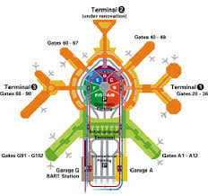 [Layout Image]

# 9. Regional and Local Explosive Threats

The Joint Terrorism Task Force, [##Airport City##] Division of the Federal Bureau of Investigation and Fusion Center have determined there is *a general heightened state of awareness and preparedness in accordance with the current national threat level, but no specific threat exists at this time to the airport.*

# 10. Explosive Threats

Two explosive scenarios (threats) were applied to the Explosive Vulnerability Assessment for identifying vulnerabilities.

## 10.1 Placed IEDs

This type of threat refers to the method by which an IED would be used. Placed IEDs usually involve less than 50 lbs of explosive and are concealed such that they can be placed in areas near a target without being noticed.

## 10.2 Vehicle-Borne IEDs (VBIEDs)

VBIEDs are typically IEDs located in cars, vans, or trucks. The quantities of explosives in these types of IEDs are often hundreds to several thousand pounds.

# 11. Adversarial Targeting

Each asset within the airport underwent an assessment from the viewpoint of an adversary. The goal of this assessment was to discover details about each asset to include the following:

* Identification and characterization of potential target areas within the asset,
* Identification and characterization of the critical paths associated with each target area,
* Identification of observation points for each target area, and
* Customer throughput information at target areas.

When analysts use a decision analytic approach based on multi-attribute utility theory, all information collected at an asset is aggregated into a number that is indicative of the attractiveness of that potential target to an adversary. This number, in turn, was used to adjust the baseline threat that had been pre-established for the airport (see Section 12.1). The differences in attractiveness of each of the assets direct the airport management toward those assets (and their associated target areas) that need particular attention in the prevention and/or detection of an explosive threat. The following sections will focus on the pieces that are used to determine the attractiveness of an asset to an adversary.

*Identification and Characterization of Deterrence Measures at Potential Target Areas*

For each asset, adversarial targeting teams identified potential target areas.[1] For each of the identified target areas, the team was asked to identify and characterize the deterrence measures in place at the target area, selecting from a specific list of deterrence measures that had been identified previously. The list of deterrence measures was determined by the type of threat that is applicable at that target area. Table 1 represents the list of available deterrence measures by asset type for a placed IED. Notice that there are some measures that do not relate specifically to this particular threat type, such as barriers.

Table 1 Applicable Deterrence Measures by Assets for a Placed IED Threat



For the VBIED threat, the applicable list of deterrence measures is slightly different. Table 2 details these differences. Note that the grayed-out columns in Tables 1 and 2 indicate that the threat does not apply for those assets.

Table 2 Applicable Deterrence Measures by Asset for a VBIED Threat



Once the deterrence measures were identified for each of the target areas within the assets, the effectiveness of these deterrence measures was captured. The effectiveness of deterrence measures is determined by two factors: detection of behaviors and threat-specific scenarios.

*Identification and Characterization of Critical Paths Associated with All Potential Target Areas*

For each target area within an asset, adversarial targeting teams identified critical paths that could lead to these target areas. Each team was asked to provide a description of the critical path, as well as information that was used to determine the effectiveness of the deterrence measures in place along the critical path. This information was aggregated to identify the two most likely critical paths to the target area.

*Identification of Observation Points for Each Target Area*

Other items of information that are collected for each target area are the observation points that are used by the adversarial targeting team during their surveillance period. The information collected in this section is a description of the numbered observations points and any photos that the team uploaded. In addition to entry into the data collection system, there is the ability to add observation points and target areas to a map of the asset, which is used to augment the final EVA report to the airport stakeholders to which it is being presented.

*Customer Throughput Information at Target Areas*

The final piece of information gathered at the target areas is the customer throughput information. The term “customer” here is used as a catchall for any people within the immediate vicinity of the target area (e.g., within a 50-foot “bubble” for a placed IED); thus, customers can include members of the general public, law enforcement, airport employees, etc. Upon extended observations of the target area over time, the TSS-E will mark down the “worst case” throughput number for that target area that was observed on an average day.  For example, if the TSS-E observes the target area over multiple months and different days and has found, in general, that Mondays at 6am is the most highly populated time period, he will use that day and time to select the approximate number of people at that target area.  Note that this information will capture throughput on an average day – it is not intended to represent peak times (i.e. holidays, special events, etc.)  In order to make data collection more efficient, the TSS-E has a choice of five bins that he can enter choose from to input this high volume throughput.  These throughput numbers can be used to inform the consequence numbers providing more fidelity on the potential consequence at each target area with an asset.

|  |
| --- |
| **Population Observation Bins** |
| **0-24** |
| **25-49** |
| **50-74** |
| **75-99** |
| **100 or more** |

# 12. EVA Risk Overview

The EVA focuses exclusively on explosive-type threats; therefore, only two threat streams are considered: the placed improvised explosive device (IED) and the placed vehicle-borne improvised explosive device (VBIED). Initially, a baseline risk number is determined for each asset within an airport by using conventional risk methodologies, committee-generated national-level threat data, a completed on-site vulnerability assessment, and committee-generated national-level consequence data.

To add fidelity to the data derived from the just-mentioned conventional assessment methodology, additional data was gathered during covert adversarial targeting (simulated) scenarios and stakeholder interviews to adjust the threat and consequence scores up or down from the baseline, by asset. This approach provides higher-fidelity data because it incorporates site-specific threat and consequence data as well as site-specific vulnerability data.

The following tables provide at-risk scores associated with explosive attacks against the various assets found within the airport terminal (Table 3) and those found at other at-risk airport locations (Table 4). These scores are a rollup of identified attack points or “targets” within each asset. The top five at-risk targets of an explosives attack as derived from the full-spectrum risk assessment (EVA) performed at BNA are indicated in Table 5, shown in the summary.

Additional information highlights the level of situational awareness present at the various assets as well as associated explosives risk mitigation options for management’s consideration. The options for consideration specifically address the identified target’s vulnerabilities.

Tables 3 and 4 provide risk scores by asset and location. The data in the national and regional columns represent the national and regional averages for “like” airports (i.e., Cat. X is compared only to another Cat. X) for the indicated asset. They will remain blank until enough data is collected to represent each respective category.

Table 3: Risk Scores for Terminal Assets

|  |  |  |  |  |  |  |
| --- | --- | --- | --- | --- | --- | --- |
|  | **Terminal 1** |  | **National** |  | **Regional** |  |
|  | **IED** | **VBIED** | **IED** | **VBIED** | **IED** | **VBIED** |
| **Departure Curbside** | 2 | 3 |  |  |  |  |
| **Arrival Curbside** | 1 | 1 |  |  |  |  |
| **Ticketing** | 35 | N/A |  |  |  |  |
| **Baggage Claim** | 88 | N/A |  |  |  |  |
| **Checkpoint Queue** | 14 | N/A |  |  |  |  |
| **Other Public Areas** | 1 | N/A |  |  |  |  |

Table 4: Risk Scores for Supporting Assets

|  |  |  |  |  |  |  |
| --- | --- | --- | --- | --- | --- | --- |
| **Supporting Assets** | **BNA** | | **National** | | **Regional** | |
|  | **IED** | **VBIED** | **IED** | **VBIED** | **IED** | **VBIED** |
| **Flight Control Tower** | 1 | 1 |  |  |  |  |
| **Fuel Farm** | 1 | 1 |  |  |  |  |
| **Command and Control** | 1 | 1 |  |  |  |  |
| **Parking** | 1 | 1 |  |  |  |  |
| **Perimeter** | 1 | 1 |  |  |  |  |

# 12.1. Situational Awareness

Figure 2 provides a snapshot of the effectiveness of situational awareness, in aggregate, at each airport asset (Terminal/Other Assets). A “situational awareness event” is captured in the tool in one of two ways: 1) surveillance detection (i.e., a role player detected during simulated surveillance operations) or 2) an unattended baggage/vehicle dry run (i.e., the identification of a potential (simulated) threat involving a placed or vehicle IED). Please see Section 11 for a more detailed explanation. The BLUE BAR shows the total number of situational awareness events conducted within the asset. The RED situational awareness bar represents the number of situational awareness events that were not detected (i.e., the role player was not caught or the unattended bag/vehicle was not questioned), suggesting low situational awareness. The YELLOW situational awareness (moderate situational awareness) bar represents the number of situational awareness events where either the role player was eventually approached by airport employees that are not law enforcement personnel or it took a moderate amount of time for the unattended baggage/vehicle to be questioned (between 5 and 10 minutes). The GREEN high situational awareness bar represents the number of situational awareness events where either the role player was approached by law enforcement personnel or the presence of the unattended bag/vehicle was questioned almost immediately (i.e., less than 5 minutes).

# 12.2. Top Five Targets Ranked by Attractiveness

This section highlights the top five targets in the airport ranked by their attractiveness to an adversary. This attractiveness is constructed with information provided by the adversarial targeting teams and consists of a characterization of deterrence measures at a target, the situational awareness of the facility staff to both surveillance activities and unattended bag/vehicle simulated scenarios, and the potential human consequences at the target.

Table 5 lists the top five targets within the airport based on this attractiveness and identifies the threat that contributes to the attractiveness rating. For example, Green Bean Coffee, in Terminal 1 - Baggage Claim is the most attractive target in the airport, specifically from a placed IED threat.

**Table 5: Top Five Targets Ranked by Attractiveness**

|  |  |  |  |
| --- | --- | --- | --- |
| Terminal or Supporting Asset | Asset Name | Target Name | IED |
| Terminal 1 | Baggage | Green Beans Coffee | X |
| Terminal 1 | Ticketing | Southwest Airlines | X |
| Terminal 1 | Baggage | Information Booth | X |
| Terminal 1 | Baggage | North Baggage Claim | X |
| Terminal 1 | Ticketing | United Airlines | X |

Figures 3 and 4 depict the relative situational awareness of airport personnel at each of the targets identified as being most attractive. The figure illustrates the situational awareness at each of the top 5 target areas, whether it be high, marginal, or low.

## 12.3 Threat Overview

Each asset within the airport underwent an assessment from the viewpoint of an adversary. The goal of this assessment was to discover details about each asset to include the following:

* Identification and characterization of potential target areas within the asset,
* Identification and characterization of the critical paths associated with each target area,
* Identification of surveillance points for each target area, and
* Customer throughput information at target areas.

A baseline threat was established for two threat types that apply at airports: a placed IED (~50-lb bag) and a VBIED (~1,000-lb explosive). This threat value is a function of intent and capability and was determined through subject matter expert elicitation techniques.

## 12.4 Vulnerability Overview

The vulnerability score was derived from a vulnerability question set created by subject matter experts. The TSS-E conducts an overt assessment on the plans and procedures, security awareness, protective measures, and security presence that relate to an IED or VBIED threat. Data on these measures are captured for each of the 11 assets, as follows: for each asset per terminal, which would include departure curbside, arrival curbside, ticketing, baggage claim, checkpoint queue, and other public areas; and each asset related to the airport as a whole, which would include plans and procedures, fuel farm, command and control, flight control tower, parking, and perimeter.

The vulnerability score that represents each asset mentioned above is a quantitative value using a 0–100 scale that is applied to specific elements and attributes. Most assets are broken down into three categories: procedures, physical security, and electronic security. These are further broken down to include the following components:

*These elements are only included in the assets to which they pertain. (Note: CCTV = closed-circuit television; IDS = intrusion detection system.)

Plans and procedures, parking, and perimeter do not follow the framework presented above and include the following components:

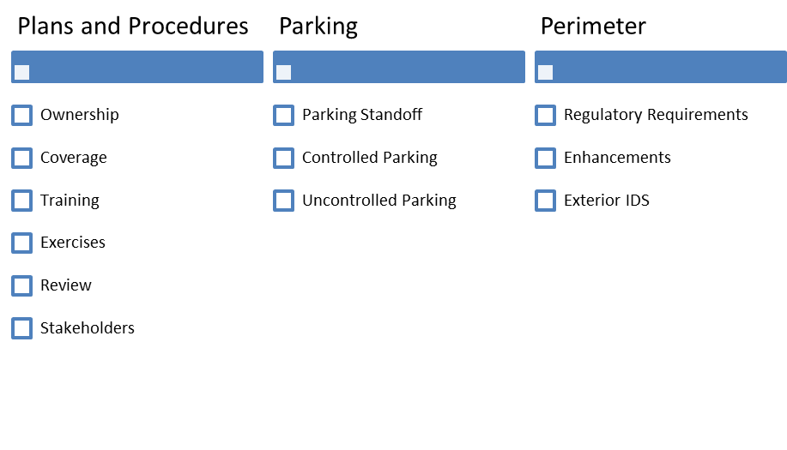

Question sets were developed for each component listed above. All questions were tailored to the specific asset and weighted against one another in an elicitation conducted by Argonne National Laboratory.

## 12.5 Consequence Overview

Consequences used in the calculation of risk are typically binned into the following four categories human health, economic, psychological and governance.  In practice, if is extremely difficult to capture all of these components quantitatively.  In addition to the four components of consequence, there exists a time component, typically referred to as direct and indirect consequences.  Direct consequences are most easily thought of as consequences that are realized immediately after an incident has happened (i.e., deaths and injuries, immediate economic impacts.) Indirect consequences are typically thought of as those consequences that happen over an extended time frame and are often secondary and tertiary consequences, or cascading consequences.  These can be challenging to conceptualize and capture quantitatively as well.  Because of the complexity involved in capturing the consequences of an incident, for the purpose of this study, the EVA risk score incorporates only direct consequences. The direct consequences for a threat type include the human health consequences (e.g., fatalities and severe injuries) based on blast curve analysis performed for TSA for the specific threats at the target areas as well a direct economic cost captured as public infrastructure and property loss.

**Risk Overview**

# 13. Top Five Assets Ranked by Risk of IED Threat

On the basis of the results from the adversarial targeting and vulnerability assessment, the five assets that are most vulnerable to a placed IED attack have been identified. Assets are shown from highest to lowest vulnerability for the airport overall.

1. Terminal A – Ticketing

Each of these assets is described below, along with a list of their associated target areas. For additional information on the target areas, please refer to Appendix A.

## 13.1 Terminal A – Departure Curbside

Asset Name contains the following target areas, which are identified in Figure 2 by red markers:

Target Area 1 – e.g., Starbucks

Target Area 2 – e.g., United Ticket Counter

Target Area 3 – e.g., Security Entry Point

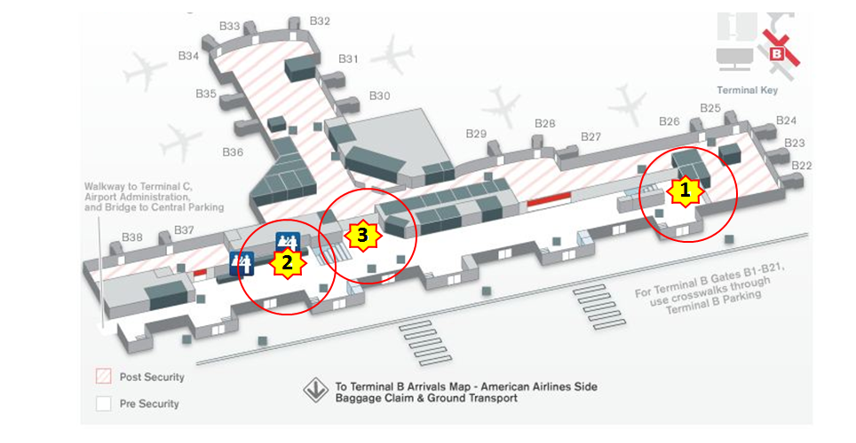

Figure 2 Asset Name Asset 1 Target Areas for Placed IEDs

*TSS-E, please provide a paragraph about this asset:* TSSEs should talk about the overview of what the security awareness is in this asset area as informed by the totality of their experience, the role players AT feedback and the scenarios run in this area of the airport.

# 14. Top Five Assets Ranked by Risk of VBIED Threat

On the basis of results from the adversarial targeting and vulnerability assessment, the five assets most vulnerable to a VBIED attack have been identified. Assets are shown from highest to lowest vulnerability for the airport overall.

1. Terminal A – Departure Curbside

Each of these assets is described below, along with a list of their associated target areas. For additional information on the target areas, please refer to Appendix B.

## 14.1 Terminal A – Departure Curbside

Asset Name contains the following target areas, which are identified in Figure 7 by red markers:

Target Area 1 –

Target Area 2 –

Target Area 3 –

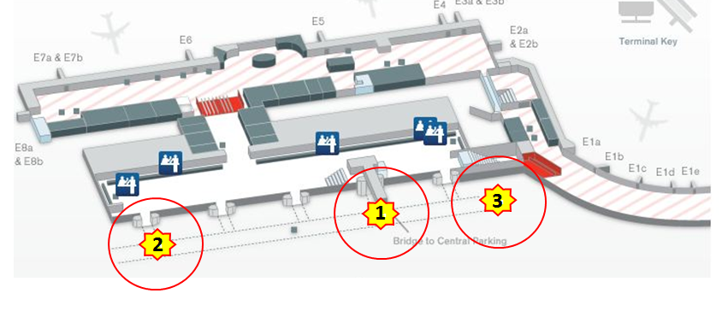

Figure 7 Asset Name Asset 1 Target Areas for VBIEDs

*TSS-E, please provide a paragraph about this asset:* TSSEs should talk about the overview of what the security awareness is in this asset area as informed by the totality of their experience, the role players AT feedback and the scenarios run in this area of the airport.

# 15. All Airport Assets

The following assets have also been identified as having target areas. Please refer to the Asset Overview document for the target area analysis for all assets.

* Terminal C – Baggage Claim

# Appendix A: Top Five Assets Ranked by Risk of IED Threat – Target Area Analysis

In the executive summary, target areas were identified during the Explosive Vulnerability Assessment (EVA). On the basis of results from the adversarial targeting and risk assessment, the five assets most vulnerable to an improvised explosive device (IED) threat have been identified as follows.

1. Asset 1: e.g., Terminal A – Ticketing
2. Asset 2: e.g., Terminal C – Checkpoint Queue
3. Asset 3: e.g., Terminal B – Baggage Claim
4. Asset 4: e.g., Terminal B – Other Public Areas
5. Asset 5: e.g., Terminal A – Baggage Claim

Each of these target areas is described below, and their locations are shown on facility maps. The target area is identified with a red star, whereas observation points are shown as green triangles. The orange ring on each map shows the threshold within which fatalities may occur, the pink ring shows the injury threshold, the red ring shows the mandatory evacuation distance, and the green ring shows the shelter-in-place distance (if it falls within the map scale). The blue lines show the critical paths that have been identified to reach the target area.

**A.1 Target Area 1: Terminal A – Ticketing – Starbucks**

### 

Figure 3 IED_Target_Area_Blast_Image

|  |
| --- |
| **Why was this Target Area chosen? :**  i.e. Large vendor area adjacent to C/D Concourse Arrivals Exit Lane. Leather Chairs have a 2 inch clearance below limiting IED concealment. Mostly open with ¾ inch Plexiglas floor to ceiling windows preventing access to sterile area. Etc. |

|  |  |
| --- | --- |
| # | Target Area # |
|  | Surveillance Point(s) |
|  | Critical Path(s) |
|  | Fatalities Threshold |
|  | Injury Threshold |
|  | Mandatory Evacuation Distance |
|  | Recommended Evacuation Distance (if shown) |

Figure 3 shows the deterrence measure's effectiveness towards influencing an adversary's decision to attack the target.



**Options for Consideration/Mitigation Strategies:**

The following options for consideration are provided for mitigation strategy in relation to this target area:

* Option for Consideration #1
* Option for Consideration #2
* Option for Consideration #3

# Appendix B: Top Five Assets Ranked by Risk of VBIED Threat – Target Area Analysis

In the executive summary, target areas were identified during the Explosive Vulnerability Assessment (EVA). On the basis of results from the adversarial targeting and risk assessment, the five assets most vulnerable to a vehicle-borne improvised explosive device (VBIED) threat have been identified as follows.

1. Asset 1: e.g., Terminal A – Departure Curbside
2. Asset 2: e.g., Terminal C – Arrival Curbside
3. Asset 3: e.g., Terminal B – Departure Curbside
4. Asset 4: e.g., Terminal B – Arrival Curbside
5. Asset 5: e.g., Terminal A – Arrival Curbside

Each of these target areas is described below, and their locations are shown on facility maps. The target area is identified with a red star, whereas observation points are shown as green triangles. The orange ring on each map shows the threshold within which fatalities may occur, the pink ring shows the injury threshold, the red ring shows the mandatory evacuation distance, and the green ring shows the shelter-in-place distance (if it falls within the map scale). The blue lines show the critical paths that have been identified to reach the target area.

**B.1 Target Area 1: Terminal A – Ticketing – Starbucks**

### 

Figure 3 IED_Target_Area_Blast_Image

|  |
| --- |
| **Why was this Target Area chosen? :**  i.e. Large vendor area adjacent to C/D Concourse Arrivals Exit Lane. Leather Chairs have a 2 inch clearance below limiting IED concealment. Mostly open with ¾ inch Plexiglas floor to ceiling windows preventing access to sterile area. Etc. |

|  |  |  |
| --- | --- | --- |
| # | Target Area # |  |
|  | Surveillance Point(s) |  |
|  | Critical Path(s) |  |
|  | Fatalities Threshold |  |
|  | Injury Threshold |  |
|  | Mandatory Evacuation Distance |  |
|  | Recommended Evacuation Distance (if shown) |  |

Figure 3 shows the deterrence measure's effectiveness towards influencing an adversary's decision to attack the target.



**Options for Consideration/Mitigation Strategies:**

The following options for consideration are provided for mitigation strategy in relation to this target area:

* Option for Consideration #1
* Option for Consideration #2
* Option for Consideration #3

1.