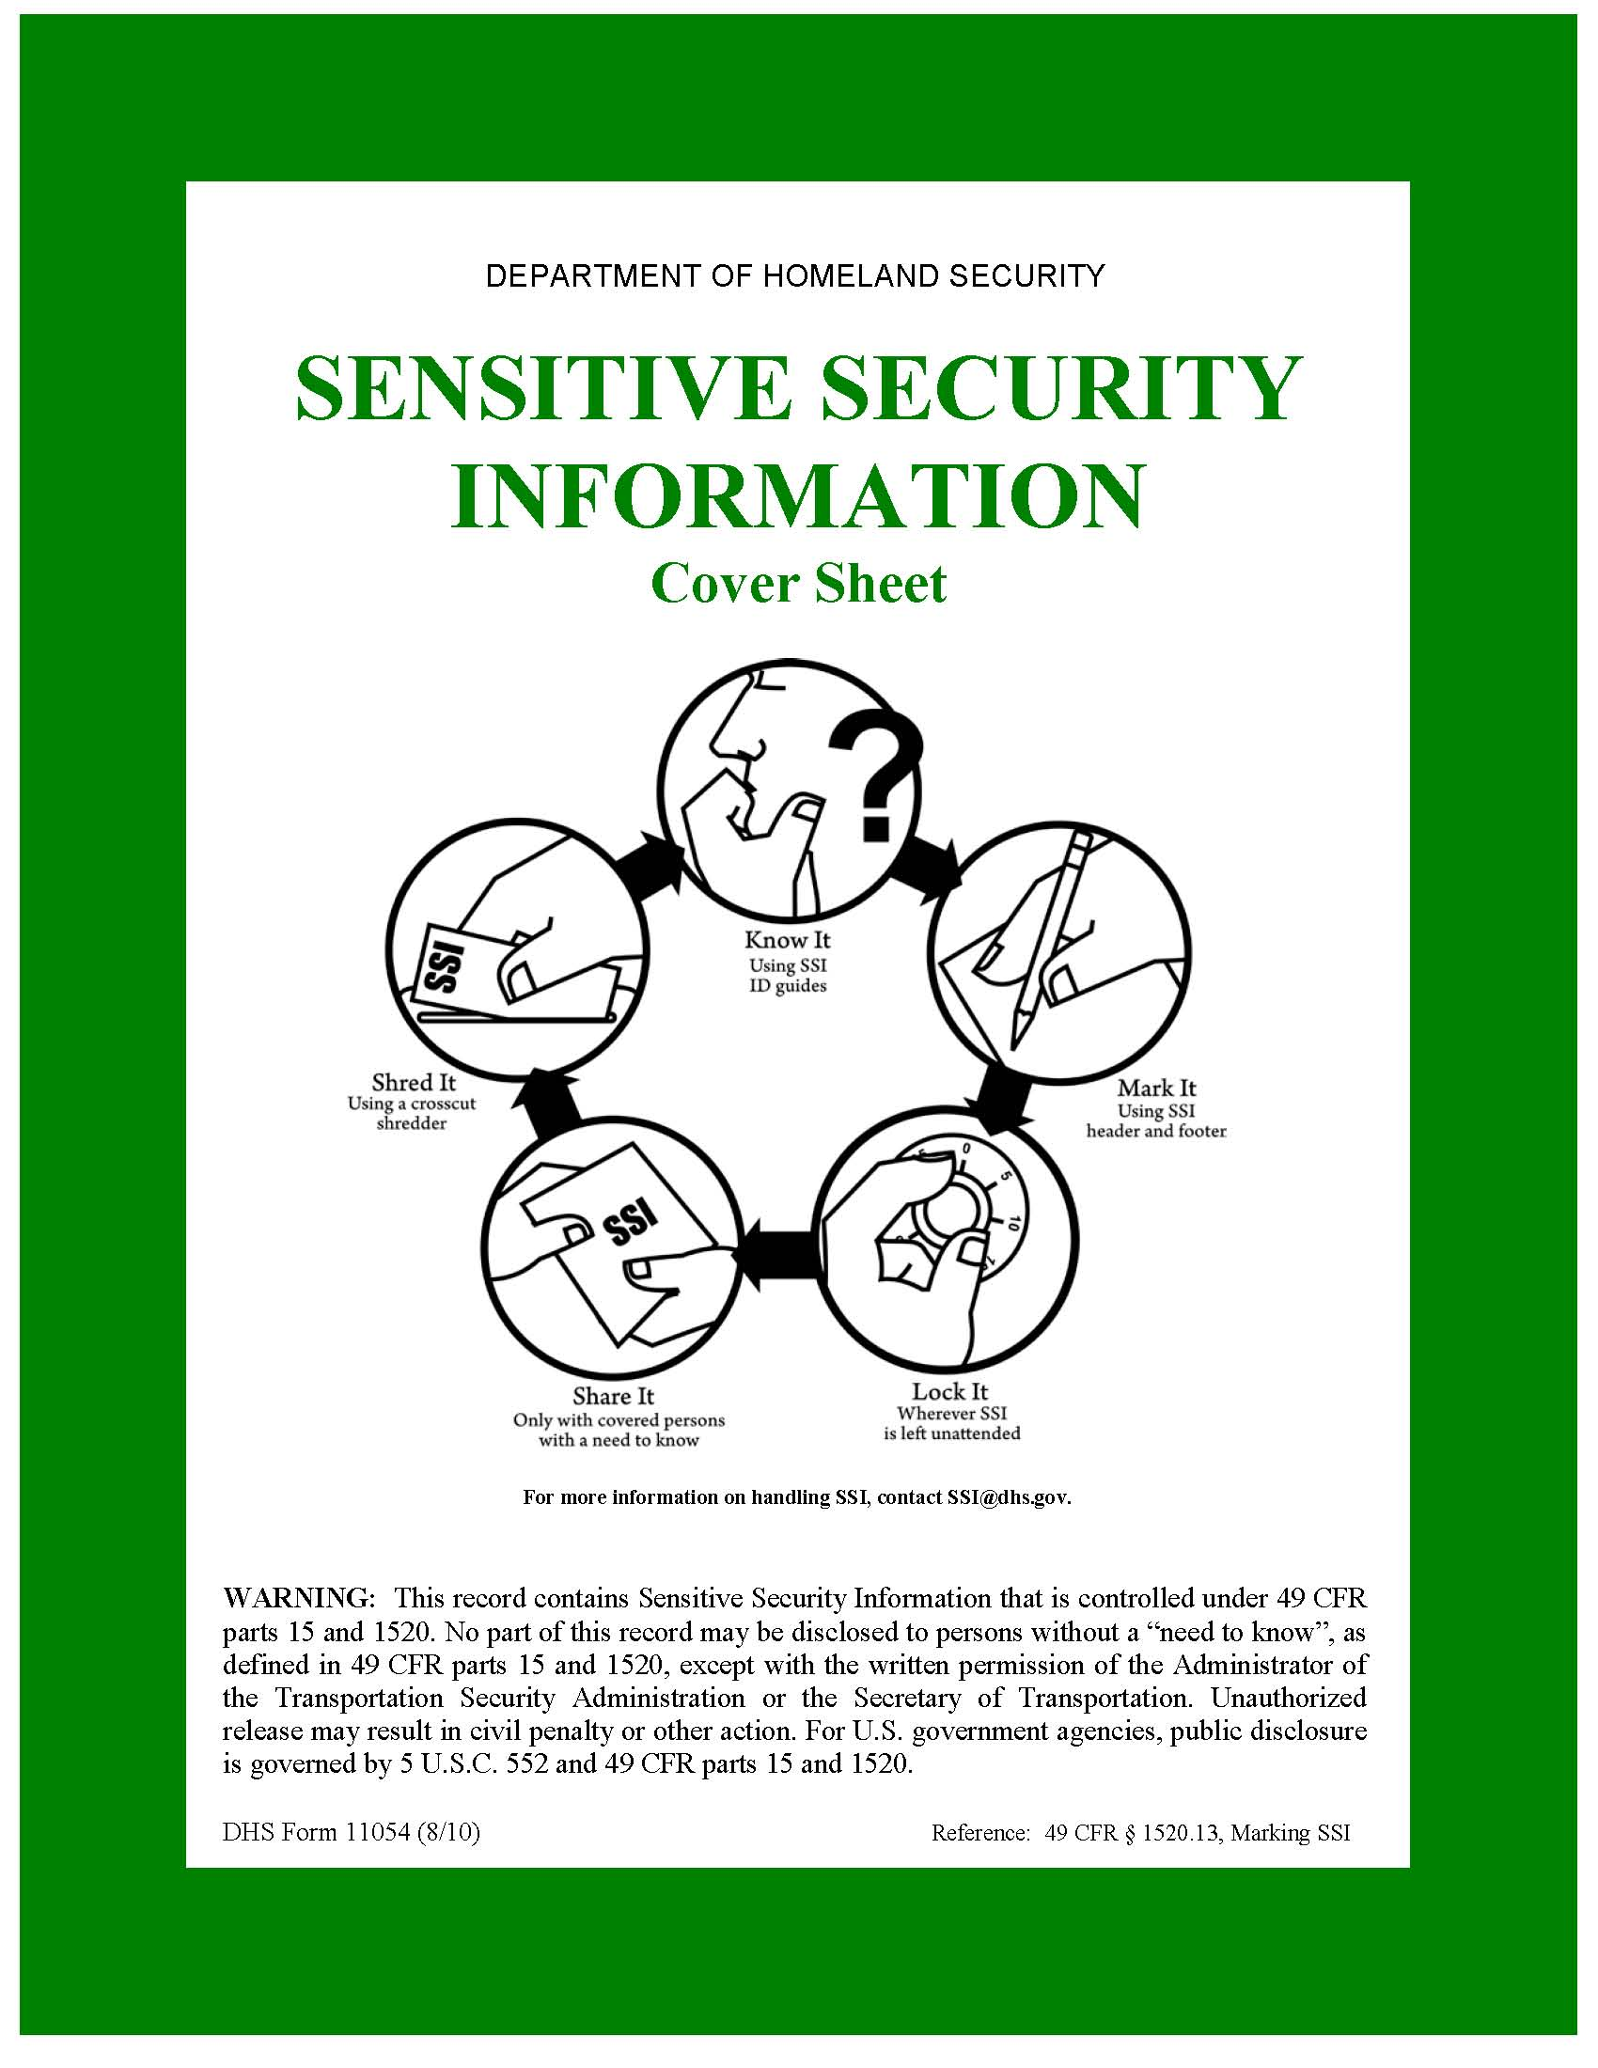

**AIRPORT NAME**

**ENTER AIRPORT ABBREVIATION**

**Explosives Risk Management Program**

**Stakeholder Report**



**Conducted:** **Month Year Range**

This document is protected by 49 CFR Part 1520.**CONTROL PAGE**

|  |  |
| --- | --- |
| **1. ADD** | **2. DELETE** |
|  |  |
|  |  |
|  |  |
|  |  |
|  |  |
|  |  |
|  |  |
|  |  |
|  |  |

Approved by: ______________________ Date: ______________

NAME

Federal Security Director

# Contents

Contents 4

Figures 4

Tables 4

1. Introduction 5

1.1 Adversarial Targeting Teams 5

2. TSS-E Overview 5

3. EVA Risk Overview 5

4. Situational Awareness 7

5. Top Five Targets Ranked by Attractiveness 9

6. Threat Overview 10

7. Vulnerability Overview 10

8. Consequence Overview 11

9. Products 11

10. Top Five Assets Ranked by Risk of IED Threat 12

10.1 Terminal A – Departure Curbside 13

11. Top Five Assets Ranked by Risk of VBIED Threat 16

11.1 Terminal A – Departure Curbside 17

# Figures

Figure 1 Asset Name Target Areas [Asset Map Image goes here] 13

Figure 6 Asset Name Target Areas 17

# Tables

Table 1: Risk Scores for Terminal Assets 7

Table 2: Risk Scores for Supporting Assets 7

**Explosives Risk Management Program Overview**

# 1. Introduction

The Transportation Security Administration Transportation Security Specialist – Explosive (TSS-E), Eric Bollinger, conducted a full Explosives Vulnerability Assessment (EVA) from Mar 2013 to Oct 2013. The assessment focused specifically on the vulnerabilities of airport operations, countermeasures, security awareness, and response planning to explosive attacks. As part of a new National Transportation Security Administration (TSA) EVA methodology and applicable checklists, the Adversarial Targeting was completed by select teams coordinated by the TSS-E and the Vulnerability Assessment was completed by the TSS-E. Current threat intelligence was reviewed and considered by the TSS-E in consultation with airport staff and external stakeholders.

## 1.1 Adversarial Targeting Teams

Adversarial Targeting Teams are role playing surveillance teams assembled by the TSS-E in order to collect the target area data at each asset around the airport. These teams consist of individuals with specific backgrounds in Physical Security, IED/WMD, Terrorist Tactics/Assault Planner, Surveillance/Counter Surveillance, Law Enforcement, or Other depending on the needs of the TSS-E. The composition of the teams is intended to be built from Federal, State and local security partners within the Federal Security Director’s areas of responsibility. As a rule-of-thumb, these role players should not work within the airport or have in depth knowledge of airport operations. The reason for this is to mimic as closely as possible the general knowledge of terrorists as they conduct their phases of pre-operational surveillance and target selection.

# 2. TSS-E Overview

TSS-E, please provide an overview of the entire EVA process here: TSSEs should talk about the EVA overview in regards to adversarial targeting teams, assets reviewed, scenarios, risk assessment, etc. The security awareness of the airport from the totality of their experience, adversarial targeting team feedback and scenarios/surveys conducted.

# 3. EVA Risk Overview

The EVA focuses exclusively on explosive-type threats; therefore, only two threat streams are considered: the placed improvised explosive device (IED) and the placed vehicle-borne improvised explosive device (VBIED). Initially, a baseline risk number is determined for each asset within an airport by using conventional risk methodologies, committee-generated national-level threat data, a completed on-site vulnerability assessment, and committee-generated national-level consequence data.

To add fidelity to the data derived from the just-mentioned conventional assessment methodology, additional data was gathered during covert adversarial targeting (simulated) scenarios and stakeholder interviews to adjust the threat and consequence scores up or down from the baseline, by asset. This approach provides higher-fidelity data because it incorporates site-specific threat and consequence data as well as site-specific vulnerability data.

The following tables provide at-risk scores associated with explosive attacks against the various assets found within the airport terminal (Table 1) and those found at other at-risk airport locations (Table 2). These scores are a rollup of identified attack points or “targets” within each asset. The top five at-risk targets of an explosives attack as derived from the full-spectrum risk assessment (EVA) performed at BNA are indicated in Table 3, shown in the summary.

Additional information highlights the level of situational awareness present at the various assets as well as associated explosives risk mitigation options for management’s consideration. The options for consideration specifically address the identified target’s vulnerabilities.

Tables 1 and 2 provide risk scores by asset and location. The data in the national and regional columns represent the national and regional averages for “like” airports (i.e., Cat. X is compared only to another Cat. X) for the indicated asset. They will remain blank until enough data is collected to represent each respective category. Risk scores are highlighted using the following colors:

|  |  |
| --- | --- |
| 70 – 100 |  |
| 30 – 69 |  |
| 1 – 29 |  |

Table 1: Risk Scores for Terminal Assets

|  |  |  |  |  |  |  |
| --- | --- | --- | --- | --- | --- | --- |
|  | **Terminal 1** |  | **National** |  | **Regional** |  |
|  | **IED** | **VBIED** | **IED** | **VBIED** | **IED** | **VBIED** |
| **Departure Curbside** | 2 | 3 |  |  |  |  |
| **Arrival Curbside** | 1 | 1 |  |  |  |  |
| **Ticketing** | 35 | N/A |  |  |  |  |
| **Baggage Claim** | 88 | N/A |  |  |  |  |
| **Checkpoint Queue** | 14 | N/A |  |  |  |  |
| **Other Public Areas** | 1 | N/A |  |  |  |  |

Table 2: Risk Scores for Supporting Assets

|  |  |  |  |  |  |  |
| --- | --- | --- | --- | --- | --- | --- |
| **Supporting Assets** | **BNA** | | **National** | | **Regional** | |
|  | **IED** | **VBIED** | **IED** | **VBIED** | **IED** | **VBIED** |
| **Flight Control Tower** | 1 | 1 |  |  |  |  |
| **Fuel Farm** | 1 | 1 |  |  |  |  |
| **Command and Control** | 1 | 1 |  |  |  |  |
| **Parking** | 1 | 1 |  |  |  |  |
| **Perimeter** | 1 | 1 |  |  |  |  |

# 4. Situational Awareness

Figure 1 provides a snapshot of the effectiveness of situational awareness, in aggregate, at each airport asset (Terminal/Other Assets). A “situational awareness event” is captured in the tool in one of two ways: 1) surveillance detection (i.e., a role player detected during simulated surveillance operations) or 2) an unattended baggage/vehicle dry run (i.e., the identification of a potential (simulated) threat involving a placed or vehicle IED). Please see Section 11 in the full report for a more detailed explanation. The BLUE BAR shows the total number of situational awareness events conducted within the asset. The RED situational awareness bar represents the number of situational awareness events that were not detected (i.e., the role player was not caught or the unattended bag/vehicle was not questioned), suggesting low situational awareness. The YELLOW situational awareness (moderate situational awareness) bar represents the number of situational awareness events where either the role player was eventually approached by airport employees that are not law enforcement personnel or it took a moderate amount of time for the unattended baggage/vehicle to be questioned (between 5 and 10 minutes). The GREEN high situational awareness bar represents the number of situational awareness events where either the role player was approached by law enforcement personnel or the presence of the unattended bag/vehicle was questioned almost immediately (i.e., less than 5 minutes).

# 5. Top Five Targets Ranked by Attractiveness

This section highlights the top five targets in the airport ranked by their attractiveness to an adversary. This attractiveness is constructed with information provided by the adversarial targeting teams and consists of a characterization of deterrence measures at a target, the situational awareness of the facility staff to both surveillance activities and unattended bag/vehicle simulated scenarios, and the potential human consequences at the target.

Table 3 lists the top five targets within the airport based on this attractiveness and identifies the threat that contributes to the attractiveness rating. For example, Green Bean Coffee, in Terminal 1 - Baggage Claim is the most attractive target in the airport, specifically from a placed IED threat.

**Table 3: Top Five Targets Ranked by Attractiveness**

|  |  |  |  |
| --- | --- | --- | --- |
| Terminal or Supporting Asset | Asset Name | Target Name | IED |
| Terminal 1 | Baggage | Green Beans Coffee | X |
| Terminal 1 | Ticketing | Southwest Airlines | X |
| Terminal 1 | Baggage | Information Booth | X |
| Terminal 1 | Baggage | North Baggage Claim | X |
| Terminal 1 | Ticketing | United Airlines | X |

Figures 2 and 3 depict the relative situational awareness of airport personnel at each of the targets identified as being most attractive. The figure illustrates the situational awareness at each of the top 5 target areas, whether it be high, marginal, or low.

# 6. Threat Overview

Each asset within the airport underwent an assessment from the viewpoint of an adversary. The goal of this assessment was to discover details about each asset to include the following:

* Identification and characterization of potential target areas within the asset,
* Identification and characterization of the critical paths associated with each target area,
* Identification of surveillance points for each target area, and
* Customer throughput information at target areas.

A baseline threat was established for two threat types that apply at airports: a placed IED (~50-lb bag) and a VBIED (~1,000-lb explosive). This threat value is a function of intent and capability and was determined through subject matter expert elicitation techniques.

# 7. Vulnerability Overview

The vulnerability score was derived from a vulnerability question set created by subject matter experts. The TSS-E conducts an overt assessment on the plans and procedures, security awareness, protective measures, and security presence that relate to an IED or VBIED threat. These data points are captured for each of the 11 assets; each asset per terminal, which would include Departure Curbside, Arrival Curbside, Ticketing, Baggage Claim, Checkpoint Queue, and Other Public Areas; and each asset related to the Airport as a whole, which would include Plans and Procedures, Fuel Farm, Command and Control, Flight Control Tower, Parking, and Perimeter. If more information on this subject is required, please request and read Section 12.4 of the Full Report for a more detailed explanation of EVA Vulnerability.

# 8. Consequence Overview

Consequences used in the calculation of risk are typically binned into the following four categories human health, economic, psychological and governance.  In practice, if is extremely difficult to capture all of these components quantitatively.  In addition to the four components of consequence, there exists a time component, typically referred to as direct and indirect consequences.  Direct consequences are most easily thought of as consequences that are realized immediately after an incident has happened (i.e., deaths and injuries, immediate economic impacts.) Indirect consequences are typically thought of as those consequences that happen over an extended time frame and are often secondary and tertiary consequences, or cascading consequences.  These can be challenging to conceptualize and capture quantitatively as well.  Because of the complexity involved in capturing the consequences of an incident, for the purpose of this study, the EVA risk score incorporates only direct consequences. The direct consequences for a threat type include the human health consequences (e.g., fatalities and severe injuries) based on blast curve analysis performed for TSA for the specific threats at the target areas as well a direct economic cost captured as public infrastructure and property loss.

# 9. Products

The reports listed below are the total compilation that can be produced by the EVAAT from analysis completed in the tool. Each report is customized to provide the correct level of content for varying levels of leadership/management and stakeholder engagement. For a more detailed explanation of each product, please see Section 7 of the Full Report.

* Explosives Risk Management Program Executive Summary
* Explosives Risk Management Program Stakeholder Report
* Explosives Risk Management Program Full Report
* Asset Overview

**Risk Overview**

# 10. Top Five Assets Ranked by Risk of IED Threat

On the basis of the results from the adversarial targeting and vulnerability assessment, the five most vulnerable assets to an IED attack have been identified. Assets are shown from highest to lowest risk for the airport overall.

1. Terminal A – Ticketing

Each of these assets is described below, along with their associated target areas. The target area is identified with a red star, whereas surveillance points are shown as green triangles. The orange ring on each map shows the threshold within which fatalities may occur, the pink ring shows the injury threshold, the red ring shows the mandatory evacuation distance, and the green ring shows the shelter-in-place distance (if it falls within the map scale). The blue lines show the critical paths that have been identified to reach the target area.

## 10.1 Terminal A – Departure Curbside

Asset Name contains the following target areas, which are identified in Figure 2 by red markers:

Target Area 1 - e.g, Starbucks

Target Area 2 - e.g., United Ticket Counter

Target Area 3 - e.g., Security Entry Point

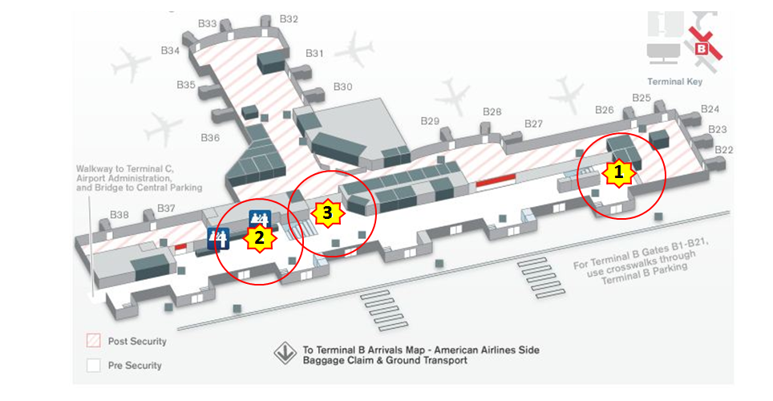

Figure 1 Asset Name Target Areas [Asset Map Image goes here]

*TSS-E, please provide a paragraph about this asset:* TSSEs should talk about the overview of what the security awareness is in this asset area as informed by the totality of their experience, the role players AT feedback and the scenarios run in this area of the airport.

**10.1.1 Target Area 1: Terminal A – Ticketing – Starbucks**

### 

Figure 2 Target Blast Image

|  |
| --- |
| **Why was this Target Area chosen? :**  i.e. Large vendor area adjacent to C/D Concourse Arrivals Exit Lane. Leather Chairs have a 2 inch clearance below limiting IED concealment. Mostly open with ¾ inch Plexiglas floor to ceiling windows preventing access to sterile area. Etc. |

|  |  |
| --- | --- |
| # | Target Area # |
|  | Surveillance Point(s) |
|  | Critical Path(s) |
|  | Fatalities Threshold |
|  | Injury Threshold |
|  | Mandatory Evacuation Distance |
|  | Recommended Evacuation Distance (if shown) |

Figure 3 shows the deterrence measure's effectiveness towards influencing an adversary's decision to attack the target.

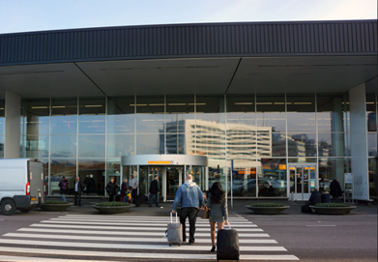

**Options for Consideration/Mitigation Strategies:**

The following options for consideration are provided for mitigation strategy in relation to this target area:

* Option for Consideration #1
* Option for Consideration #2
* Option for Consideration #3

# 11. Top Five Assets Ranked by Risk of VBIED Threat

On the basis of the results from the adversarial targeting and vulnerability assessment, the five most vulnerable assets to a VBIED attach have been identified. Assets are shown from highest to lowest risk for the airport overall.

1. Terminal A – Departure Curbside

Each of these assets is described below, along with their associated target areas. The target area is identified with a red star, whereas surveillance points are shown as green triangles. The orange ring on each map shows the threshold within which fatalities may occur, the pink ring shows the injury threshold, the red ring shows the mandatory evacuation distance, and the green ring shows the shelter-in-place distance (if it falls within the map scale). The blue lines show the critical paths that have been identified to reach the target area.

## 11.1 Terminal A – Departure Curbside

Asset Name contains the following target areas, which are identified in Figure 6 by red markers:

Target Area 1 -

Target Area 2 -

Target Area 3 -

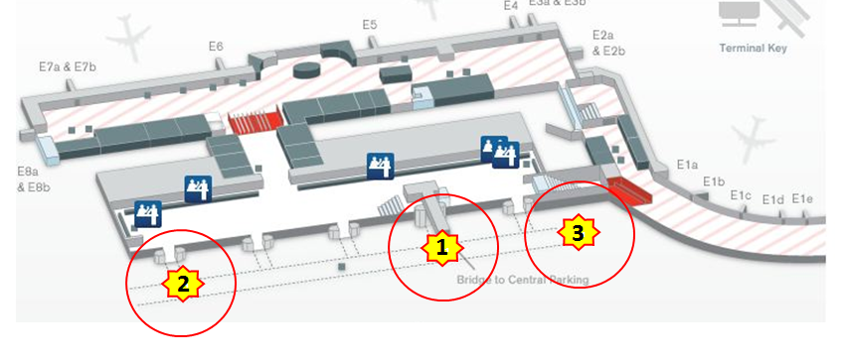

Figure 6 Asset Name Target Areas

*TSS-E, please provide a paragraph about this asset:* TSSEs should talk about the overview of what the security awareness is in this asset area as informed by the totality of their experience, the role players AT feedback and the scenarios run in this area of the airport.

**11.1.1 Target Area 1: Terminal A – Ticketing – Starbucks**

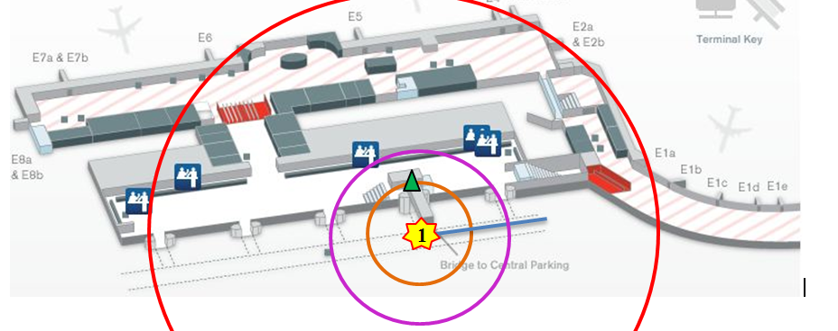

|  |
| --- |
| **Why was this Target Area chosen? :**  i.e. Large vendor area adjacent to C/D Concourse Arrivals Exit Lane. Leather Chairs have a 2 inch clearance below limiting IED concealment. Mostly open with ¾ inch Plexiglas floor to ceiling windows preventing access to sterile area. Etc. |

|  |  |
| --- | --- |
| # | **Target Area #** |
|  | Surveillance Point(s) |
|  | Critical Path(s) |
|  | Fatalities Threshold |
|  | Injury Threshold |
|  | Mandatory Evacuation Distance |
|  | Recommended Evacuation Distance (if shown) |

Figure 4 shows the deterrence measure's effectiveness towards influencing an adversary's decision to attack the target.



**Options for Consideration/Mitigation Strategies:**

The following options for consideration are provided for mitigation strategy in relation to this target area:

* Option for Consideration #1
* Option for Consideration #2
* Option for Consideration #3