1. FM_STARTUP-the main form

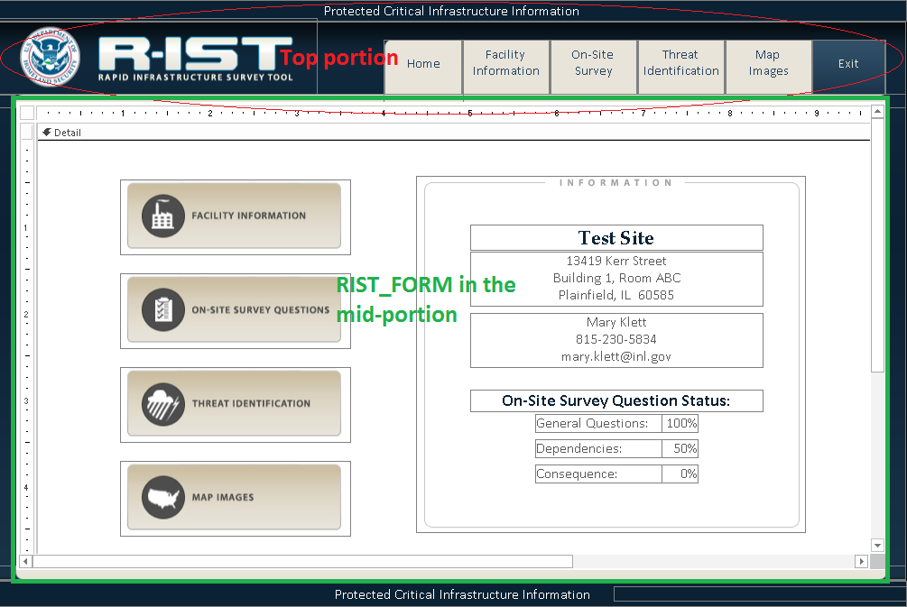

The main form, FM_STARTUP serves as a canvas that hosts the “PCII_info link”-“R-IST logo”-“navigation buttons” on the top portion; RIST_FORM in the mid-portion; and the tracknum (to display the value of the global variable trackNum) and PCII label at the bottom.

The PCII_info label has a click event to popup a MsgBox of the PCII Warning. The Home and Exit labels/images by default are visible as the form loads while all the rest of the label/image tabs are set to invisible, and, as a result, RIST_FORM’s SourceObject is set to FM_HOME.

1. RIST_FORM-the first child that has descendants—SubForms

RIST_FORM has the SourceObject set to FM_HOME by default. When one of the label/image tabs on the top portion or on the FM_HOME is clicked, the corresponding label/image will be set to visible while the rest set to invisible and the SourceObject property of RIST_FORM will be reset accordingly.

1. The children (SubForms) of RIST_FORM—Like its parent form FM_STARTUP, RIST_FORM serves as a canvas to host five child forms—FM_HOME, FM_FACINFO, FM_SURVEY, FM_THREAT_HAZARD and FM_GIS, all are forms with subforms.

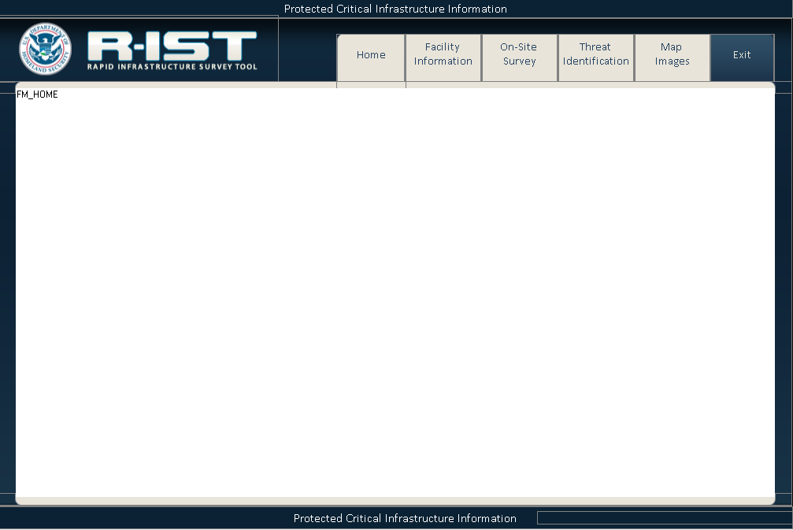

Inside the module Form_FM_HOME, the expression Me.Parent_Form_Form refers to the FM_STARTUP form.

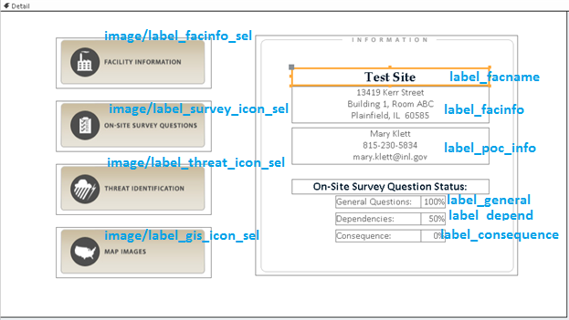

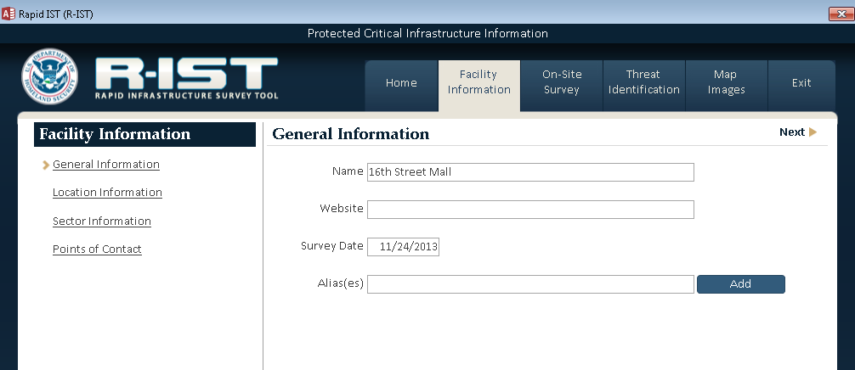

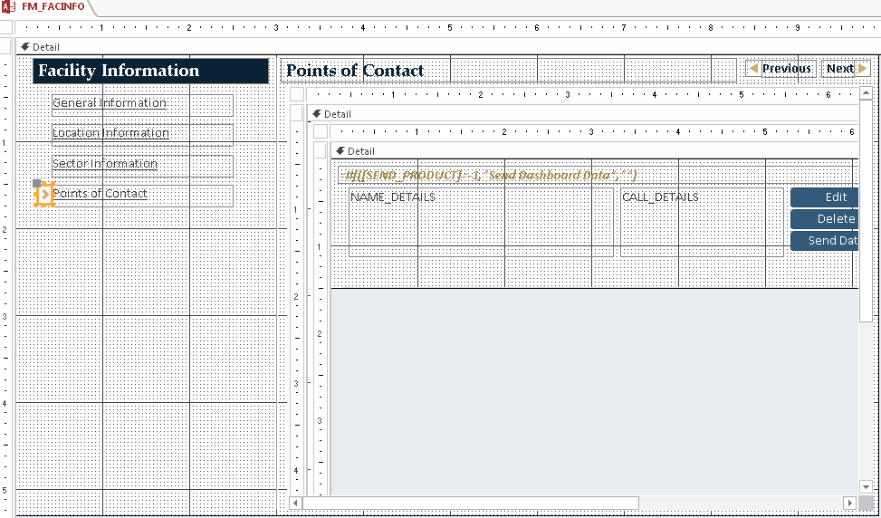

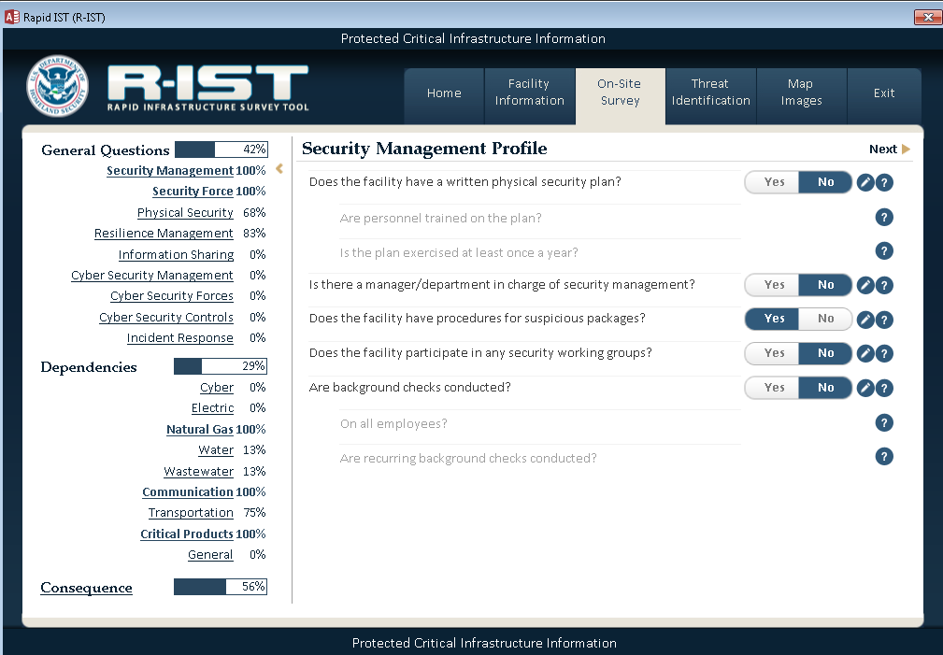

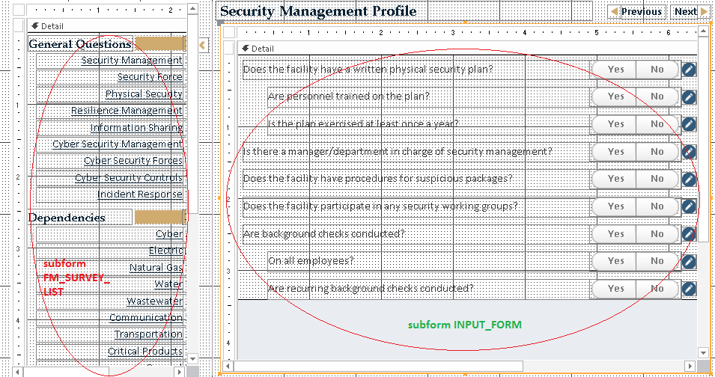

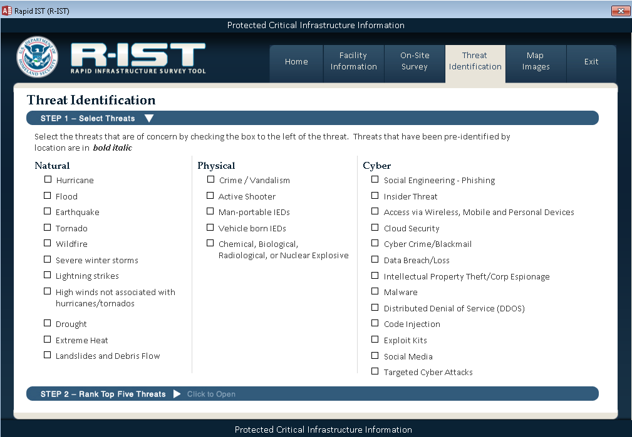

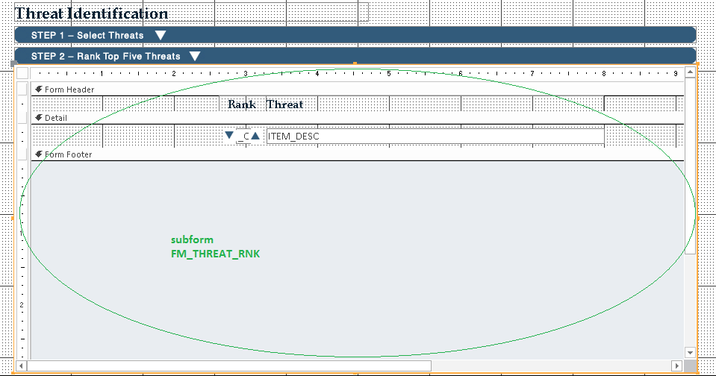

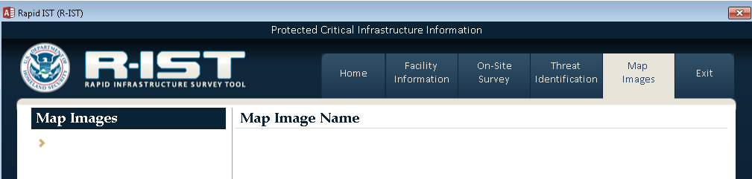

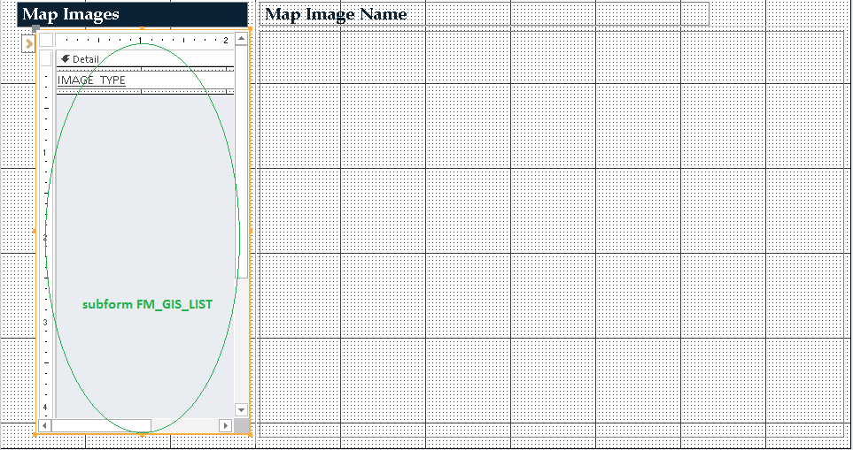

1. Each of the five subforms enlisted above also has its own descendants, as shown through even the form names:

