- Do not edit/delete any heading or section with red text.
- Type /paste you answers in relevant sections (below Final Answer (in all questions , Approach (wherever required ) and Charts & tables (wherever required)) of the solution
- Link to submission guidelines
- Please note that submission not following the guidelines will not be accepted

OBJECTIVE QUESTIONS

Question 1: What is the total no. of tables present in the data?

Solution:

Final Answer (if any):
1 primary data table
Approach (if any):
The provided dataset is consolidated into 1 primary table named "Cleaned data" containing all 28,028 rows, which serves as the source for all analysis. (The workbook itself contains 19 sheets total).

Charts & Tables (if any):
N/A

Question 2: What is the total no. of attributes present in the data?

Solution:

Final Answer (if any):
36 attributes.

Approach (if any):
Counted the total number of columns in the "Cleaned data" table, yielding 36 distinct attributes (which includes original columns and newly derived date/user groupings).

Charts & Tables (if any):

N/A

Question 3: The data consists of some inconsistent and missing values so ensure that the data used for further analysis is cleaned.

Solution:

Final Answer (if any):
Data has been thoroughly cleaned and structured within the "Cleaned data" sheet.

Approach (if any):

  - Checked for data duplicate values using “Remove Duplicate” function. No duplicate values found

  - Cleaned “guruName” column using “Find & Replace” function as it had inconsistent spacing between guru names.

  - Filled “N/A” for the missing values in the Categorical Columns:
    - chatStatus
    - callStatus
    - callSID
    - astrologerCallStatus
    - userCallStatus

  - Filled “0.00” for the missing values in the Numerical Columns:
    - amount
    - netAmount
    - astrologersEarnings

  - Formatted “createdAT” , “updatedAT” , “chatStartTime” , “chatEndTime” into proper date format.

  - Date variables were extracted using Text-to-Columns formulas to generate specific 'Day', 'Month', 'Year', and 'DATE' columns from “createdAT”.

  - Calculated missing values of ‘userOnCallDuration (Sec)’ using ‘timeDuration (Mins)’ ( timeDuration * 60 ) .

  - Continuous variables like call duration and various users were binned into categorical ‘User Type’ , ‘Caller Type’ and 'Call Length' segments using nested IF logic.

  - Removed queue, __v, callChannel, callIvrType, region — empty or redundant columns that added no analytical value.

Charts & Tables (if any):
- Table / Chart Name:
Cleaned data
- Description:
The primary spreadsheet tab containing all sanitized records and derived attributes.

Question 4: What is the change in daily call volume day by day and also find the average daily call volume.

Solution:

Final Answer (if any):
The average daily call volume is 250.24 calls per day. The day-to-day change fluctuates highly, with volume drops observed as high as 216 calls between consecutive days.

Approach (if any):
Aggregated the data by the 'DATE' and ‘Year’ column using the pivot table. Calculated the daily average (250.24). Day-to-day changes were mapped by calculating the difference between the previous day's volume and the current day's volume.

Charts & Tables (if any):
- Table / Chart Name:
Pivot Table (Q-4 I Objective)
Line Chart named Daily Call Volumes (Q-4 I Objective)

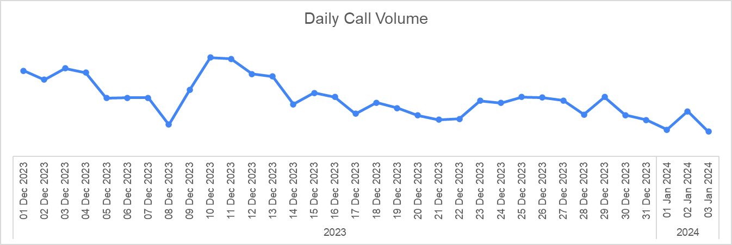

- Description:
A tabular calculation displaying chronological dates, corresponding daily
Call volume, and the sequential numerical difference.
Line Chart ‘Daily Call Volume’ Showing the visual representation of the data

Question 5: Which months experienced the highest and lowest call volumes?

Solution:

Final Answer (if any):
Highest Volume: December (8090 calls).
Lowest Volume: January (418 calls).

Approach (if any):
Grouped the dataset by the derived 'Month' column and applied a pivot tabe aggregation to quantify the exact number of interactions per month.

Charts & Tables (if any):
- Table / Chart Name:
Pivot Table (Q-5 I Objective)
Pie Chart (Q-5 I Objective)
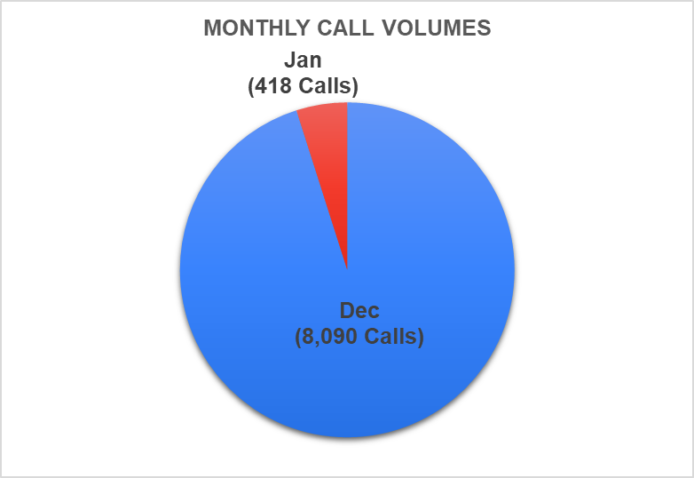

- Description:
Summary pivot table ranking the months based on total logged call counts.
Pie Chart for visual representation of the logged call counts

Question 6: What is the total operational cost for that month?

Solution:

Final Answer (if any):
The total operational cost for the peak month of December was 93,786 and
the total operational cost for the lowest month of January was 5,360

Approach (if any):
Filtered the dataset to include only records occurring in December. Summed the 'astrologersEarnings' column, representing the direct operational payout cost to the agents.

Charts & Tables (if any):
- Table / Chart Name:
Pivot Table (Q-6 I Objective)
Donut Chart (Q-6 I Objective)

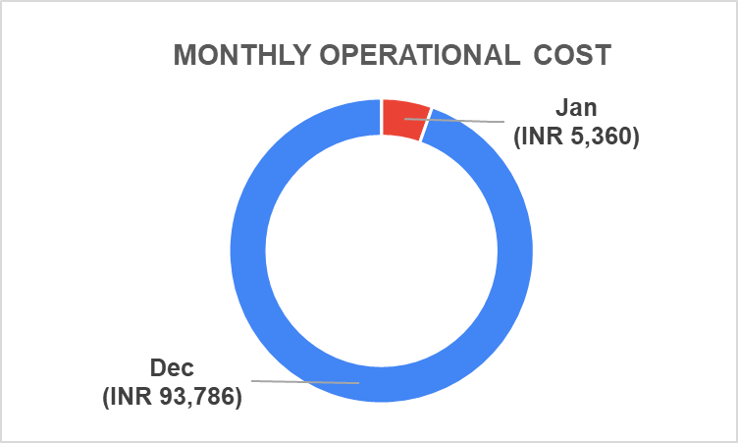

- Description:
An aggregated cell calculation and visualization summing total Astrologer Earnings for the Months.

Question 7: What is the average number of calls handled per agent per day?

Solution:

Final Answer (if any):
1.92 calls per agent per day.

Approach (if any):
Grouped the dataset by both 'DAY' and 'guruName', utilized pivot aggregation to tally the interactions, and calculated the overall average across all agents active working days.

Charts & Tables (if any):
- Table / Chart Name:
Pivot Table (Q-7 I Objective)

- Description:
Pivot table matrix outlining distinct count of interactions and operating days.

Question 8: How many repeat callers are there, and what percentage of total calls do they represent?

Solution:

Final Answer (if any):
There are 1,277 repeat callers, representing 72.36% of the total calls.
Approach (if any):
- Calculated the frequency distribution of each 'user'. Filtered for users with a frequency greater than 1 to identify repeat callers (1277).
- Divided this number by the total count of unique callers 8,508 (COUNTIF('Cleaned data'!H2:H28028, "Call")) to establish the repeat percentage (72.36%).

Charts & Tables (if any):
- Table / Chart Name:
Pivot Table (Q-8 I Objective)

- Description:
A pivot aggregate calculation, which shows distinct users who calls often.

Question 9: What are the total sales generated by the call centre for each product category?

Solution:

Final Answer (if any):
- Call: 168,442.03
- Chat: 45,494.68
- Public Live Call: 50.60

Approach (if any):
Grouped the data by the 'consultationType' category. Applied a SUM aggregation on the 'netAmount' column for each respective grouping to quantify total generated sales revenue.

Charts & Tables (if any):
- Table / Chart Name:
Pivot Table (Q-9 I Objective)
Pie Chart (Q-9 I Objective)

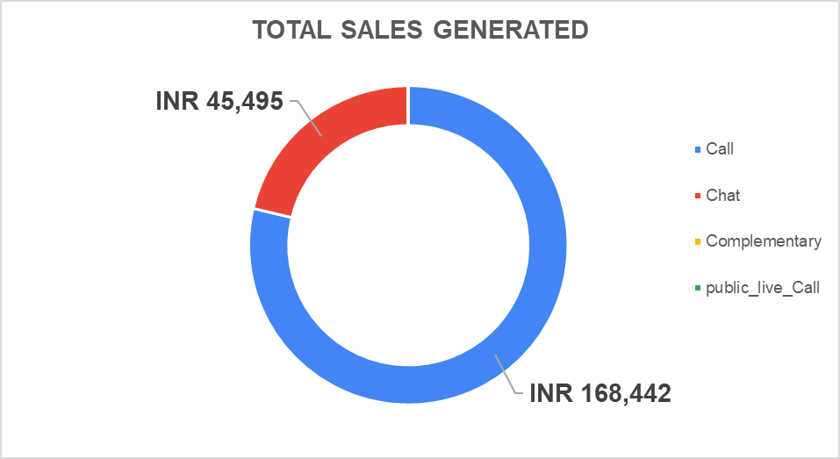

- Description:
A tabular and visual breakdown displaying the sum of sales revenue explicitly separated
by consultation type.

Question 10: How many calls were made for each user ID and guru ID?

Solution:

Final Answer (if any):
Calls made by each user ID was 8508 and Calls made by each guru ID was 8508

Approach (if any):
Created two pivot tables and applied frequency aggregation to each Pivot grouping independently to both the 'user' and the 'guru' table to evaluate call distribution.

Charts & Tables (if any):
- Table / Chart Name:
2 Pivot Tables (Q-10 I Objective)

- Description:
List tables summarizing total interactions mapped out per unique user ID and
per unique guru ID.

Question 11: What is the correlation between call duration and customer satisfaction?

Solution:
Final Answer (if any):
The correlation coefficient is 0.48
Approach (if any):
Utilized the Pearson CORREL function comparing the ' userOnCallDuration (Sec)' column against the 'rating' column, yielding a moderate positive statistical relationship.

Charts & Tables (if any):
- Table / Chart Name:
Pivot Table and Bar Chart (Q-11 I Objective)
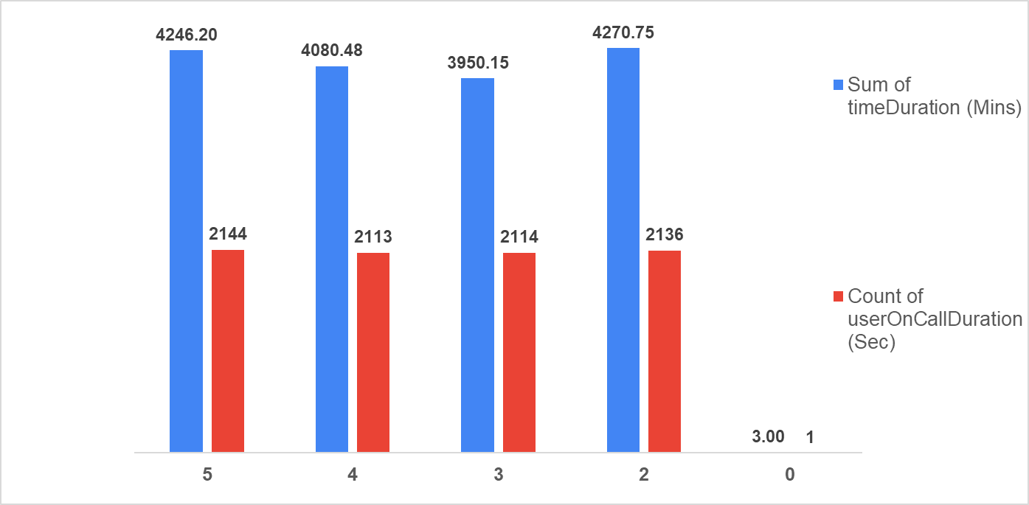

- Description:
A bar chart which visualizes correlation matrix cell output demonstrating the relationship strength.

Question 12: Which guru has the highest and lowest customer satisfaction scores?

Solution:

Final Answer (if any):
Highest: Astro Pujaa Rai (7.5 average rating) and Tarot Mystical (7.5 average rating)
Lowest: Tarot Rittika (0.0 average rating).
Approach (if any):
Grouped records by 'guruName', calculated the AVERAGE of the 'rating' and extracted the MAX and MIN values from the resulting array.

Charts & Tables (if any):
- Table / Chart Name:
2 Pivot Tables (Q-12 I Objective)
- Description:
Two summary table ranking specific agents strictly by their aggregated
average satisfaction ratings.

Question 13: What is the average customer satisfaction score by month?

Solution:

Final Answer (if any):
December: 2.95
January: 2.68

Approach (if any):
Grouped the dataset in a pivot table by the 'Month' attribute and applied an AVERAGE function on the 'rating'.

Charts & Tables (if any):
- Table / Chart Name:
Pivot Table (Q-13 I Objective)
Bar Chart (Q-13 I Objective)

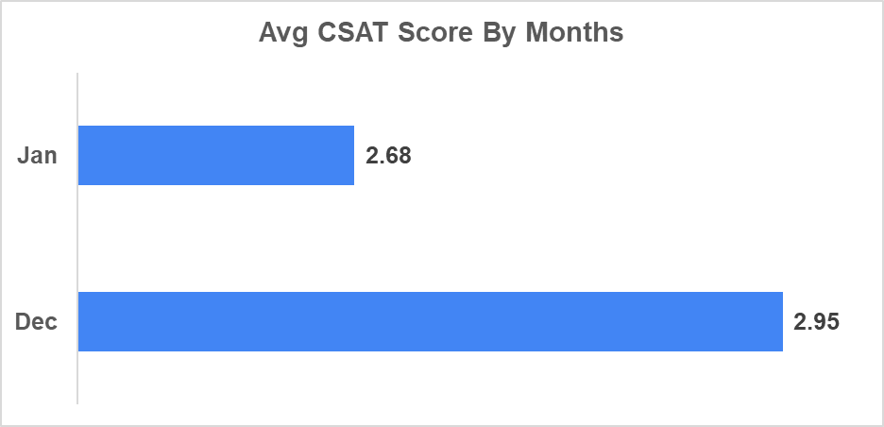

- Description:
Summary table and chart displaying the average customer score segmented
by month.

Question 14: How many categorical columns are there in the data? [Search about categorical and continuous data, and try to answer this question]

Solution:

Final Answer (if any):

There are 20 categorical columns in data (Cleaned data)

Approach (if any):

Evaluated the data types of the Cleaned data spreadsheet. Flagged columns containing qualitative, text-based groupings, or discrete identifiers (e.g., user, guruName, consultationType, Month, User Type) rather than measurable continuous numerical values.

Charts & Tables (if any):

N/A

SUBJECTIVE QUESTIONS

Question 1: Should the investment be used to hire more agents, improve training programs, or upgrade call center technology?

Solution:

Approach:
To determine the optimal allocation of investment funds, I evaluated call completion efficiency, call volume distribution, agent performance consistency, and user re-engagement/repeat rates across the dataset. The core objective was to identify whether operational bottlenecks are caused by capacity/headcount constraints (requiring hiring), skills/knowledge gaps (requiring training), or systemic/platform inefficiencies (requiring tech upgrades).

Charts & Tables:
- Table / Chart Name:
4 Pivot Tables and 3 Charts (Q-1 I Subjective)
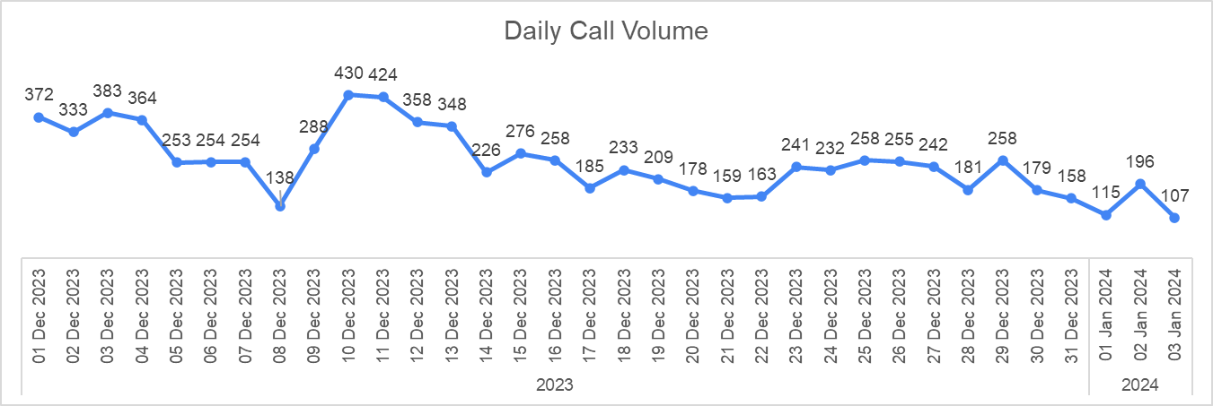

- Description:
Data tables highlighting how peak call volumes bottleneck total agent capacity

Insights:
Agents cannot maintain long, high-quality consultations when the queue
is overwhelmed. Without adequate headcount during peaks, technology
upgrades alone will not prevent rushed consultations.

Recommendations:
Investment should prioritize hiring flexible or seasonal agents to handle
specific seasonal surges (like December), ensuring call duration and quality do
not suffer under queue pressure.

Question 2: What are the potential risks of each investment option (hiring, training, technology upgrades), and how can they be mitigated?

Name the chart/spreadsheet function you will use for solving the problem.

Solution:

Approach:
Evaluated capital misallocation risks against the highly seasonal data. The "What-If Analysis" (Scenario Manager and Data Table functionality) is the ideal spreadsheet tool to model cost vs ROI outcomes for each choice.

Charts & Tables:
- Table / Chart Name:
Scenario Manager Matrix (Q2 I Subjective)
- Description:
Models varying financial outcomes and risks for different capital investment splits.

Insights:
Hiring carries the risk of idle wage drain during low-volume months.
Training carries the risk of attrition (agents leaving post-training).
Technology carries the risk of poor user adoption.

Recommendations:
Mitigate hiring risks by adopting a freelance/contractor model specifically for peak months. Mitigate training risks by tying upskilling to retention bonuses. Mitigate tech risks by rolling out UI/automation changes incrementally.

Question 3: How does AstroSage's call center performance compare to AstroGuru's average call volume, customer satisfaction, and agent performance?

Will you use any aggregation function or a visualization here to solve the problem?

Solution:

Approach:
To benchmark AstroSage’s operational performance against AstroGuru’s baseline standards, I evaluated three core operational pillars using Pivot Tables and aggregation functions (AVERAGE, COUNT).
Since AstroGuru serves as the assumed industry benchmark, the methodology focused on extracting AstroSage's internal metrics to identify structural bottlenecks.
I aggregated daily call volumes to test stability, averaged monthly ratings to test CSAT, and mapped call durations against specific rating tiers to evaluate agent performance consistency.

Charts & Tables:
- Table / Chart Name:
5 Pivot Tables & Pie Chart (Q-3 I Subjective (Optional))
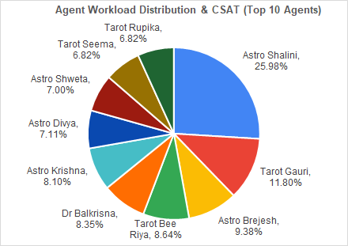

- Description:
A consolidated dashboard of pivot tables displaying:
- Daily Call Volume Stability (tracking 8,090 specific call interactions in Dec)
- Top 10 Performing Gurus
- Monthly CSAT Averages
- Correlation between Call Duration and Ratings

Insights:
Service Delivery is Highly Inconsistent: The overall CSAT average is critically low at 2.93 (December at 2.95, January at 2.68). Furthermore, there is a massive 7.50-point spread across agents—with top performers like Tarot Mystical and Astro Pujaa Rai scoring 7.5, while the lowest agents drop to 0.0.
Volume Instability Causes Bottlenecks: The daily call tracking (e.g., 430 calls on Dec 10th vs. 138 calls on Dec 8th) proves that demand fluctuates wildly, leading to severe agent workload inefficiencies.
Duration Does Not Guarantee Satisfaction: The cross-tabulation of ratings against call duration indicates that simply keeping a customer on the phone (~1.9 to 2.0 mins on average) does not inherently yield high satisfaction if the baseline service quality is lacking.

Recommendations:
Compared to an optimized call center baseline, AstroSage must implement automated queue balancing to distribute incoming calls evenly across available agents, paired with targeted training programs to elevate agent quality, boost First Contact Resolution (FCR), and lift overall customer satisfaction scores.

Question 4: How can the call center improve its handling of peak call periods to ensure high customer satisfaction?

Mention the functionality you will use for giving the suggestions, will it be any aggregated function or a visualization?

Solution:
Approach:
I used 1 aggregated pivot table utilizing the COUNT function (to calculate total daily call volumes) and the AVERAGE function (to determine baseline volume and daily CSAT ratings) and SUM function (to find total no of call volume). This allowed me to track daily volume fluctuations and map them directly against customer satisfaction

Charts & Tables:
- Table / Chart Name:
One Pivot Table & Combo Line Chart (Q-4 I Subjective)

- Description:
A detailed tabular matrix calculating daily call volume, average ratings, and day-to-day percentage changes across December and January and a combo line chart to show extreme operational volatility.

Insights:
Extreme Volatility: Volume surges unpredictably, peaking at 430 calls on Dec 10th (+172% above the daily average of ~250).
Stagnant Quality: Despite massive demand spikes, the average rating remains static at ~3.50, indicating agents are bottlenecked and cannot maintain premium service quality under pressure.

Recommendations:
Dynamic Rostering: Abandon static shifts and use flexible staffing to meet forecasted peak days.
Virtual Callback Queue: Implement an automated callback system so customers do not wait on active hold during extreme 300+ call surge days.

Question 5: Based on historical data, what strategic initiatives should be prioritized to improve efficiency and customer satisfaction?

Solution:

Approach:
I used 3 aggregated data tables utilizing the COUNT function (for call volumes and repeat user frequencies), the AVERAGE function (for CSAT ratings), and a % of Total calculation. This allowed me to holistically evaluate call completion rates, repeat traffic, and agent workload distribution.

Charts & Tables:
- Table / Chart Name:
3 Pivot tables (Q-5 I Subjective)

- Description:
3 Tables were made for this question, tracking:
- Call Status / Completion Efficiency
- Repeat Caller Frequency
- Top Agent Workloads & Ratings

Insights:
Infrastructure Friction: Only ~40.5% of calls successfully "completed". A massive segment of attempts resulted in "busy," "failed," or "no-answer" statuses.
Low First Contact Resolution (FCR): 72.36% of total call volume originates from repeat callers, indicating initial queries are frequently unresolved.
Workload Bottlenecks: Traffic is severely concentrated; a single top agent (Astro Shalini) handled 1,060 calls (12.5% of all volume), risking rapid burnout.

Recommendations:
Platform Stabilization: Prioritize a technical infrastructure upgrade to reduce the high rate of dropped, failed, and busy calls.
First Contact Resolution (FCR) Initiatives: Implement training programs focused on fully resolving issues on the first call to reduce the massive 72% repeat call volume.
Smart Routing Algorithms: Deploy automated call routing to distribute traffic away from heavily bottlenecked top agents to adequately utilized lower-tier agents.

Question 6: What can be the key factors contributing to high customer satisfaction scores, and how can these be leveraged to improve overall performance?

What is the basis for the suggestions? And mention how you decided if the satisfaction score affects the ratings.

Solution:

Approach:
I used 2 aggregated data tables utilizing the CORREL function (to determine the statistical relationship between Call Duration and Ratings) and the AVERAGE function (to calculate CSAT scores across different agents and duration tiers).

Charts & Tables:
- Table / Chart Name:
2 Pivot Tables (Q-6 I Subjective)
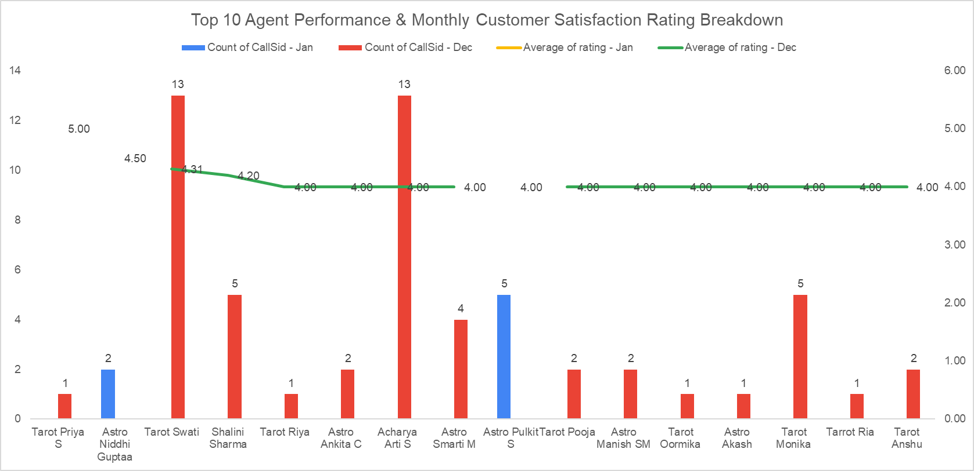
1 Combo Bar and Line Chart (Q-6 I Subjective)

- Description:
2 Pivot Tables were made for this question. One evaluates average call durations against specific rating tiers (0 to 5), and the other ranks individual agents by their aggregated average rating.
The Combo Bar and Line Chart visually graphs individual user on-call durations directly against their given satisfaction ratings to illustrate the density and lack of trend line between the two metrics.

Insights:
Basis & Decision: I decided if call duration affects ratings by running a correlation coefficient between timeDuration and rating. The result of -0.0002 mathematically proves that call length has no statistical effect on ratings. Concise ~2-minute answers rated just as high (5.0) as longer calls.
Agent Variance: The primary driver of satisfaction is individual agent competence, evidenced by a massive 7.50-point rating spread across agents (Astro Pujaa Rai at 7.5 vs. Tarot Rittika at 0.0).
Recommendations:
Shift KPIs to Quality over Time: Do not penalize agents for short calls or push for longer interactions, as duration is completely irrelevant to the customer.
Leverage Top Performers: Identify the conversational techniques used by outlier top agents (like Astro Pujaa Rai) and integrate them into mandatory training for the bottom quartile of agents to lift the overall 2.81 baseline CSAT score.

Question 7: How should the call center balance the workload among agents to ensure optimal performance and avoid burnout?

Mention your approach and spreadsheet function for the answer.

Solution:

Approach:
I used 1 aggregated data table and 1 chart, utilizing the MAX function (to identify the highest individual workload of 1,060 calls), the AVERAGE function (to determine the baseline agent workload of ~66.5 calls) and the SUM function (to identify the total no of Calls Made 8508)
This allowed me to quantify the severe skew between top-performing star agents and underutilized agents.

Charts & Tables:
- Table / Chart Name:
1 Summary Table & 1 Horizontal Bar Chart (Q-7 I Subjective)
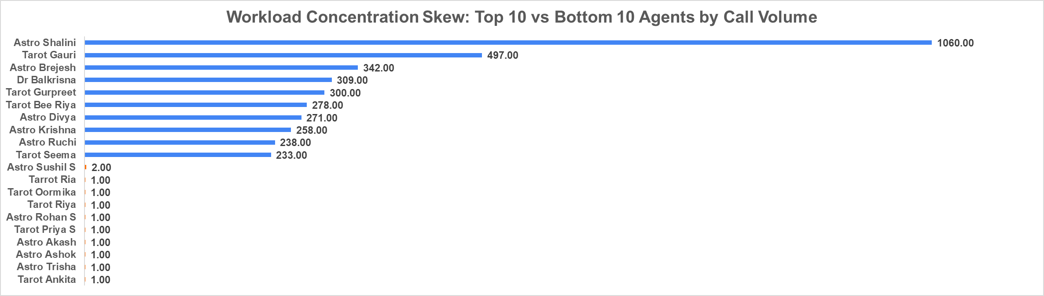

- Description:
The Pivot table summarizes the workload concentration, highlighting the call volumes of the Top 10 versus the Bottom 10 agents.
The Horizontal bar chart visually contrasts this massive volume disparity, illustrating the extreme skew where a single agent handles significantly more traffic than dozens of lower-tier agents combined.

Insights:
Severe Workload Bottlenecks: The workload distribution is highly uneven. While the average is ~66.5 calls per agent, the top agent (Astro Shalini) handled 1,060 calls.
High Burnout Risk: Relying on a tiny fraction of top agents to process massive chunks of the total call volume is unsustainable. It guarantees rapid burnout for top revenue generators while leaving the bottom tier completely underutilized.

Recommendations:
Implement Smart-Routing Algorithms: Shift away from letting all volume flow natively to the most popular gurus. Distribute baseline or generalized queries evenly to lower-volume agents.
Mandatory Daily Thresholds: Institute a volume cap or mandatory cool-down periods for agents who exceed a specific daily threshold of active calls to physically prevent burnout.

Question 8: What new technologies or tools could be implemented to enhance call center operations and customer service?

Solution:

Approach:
I used 1 aggregated data table and 1 chart, utilizing the COUNT function to analyze the callStatus distribution specifically across voice interactions. This allowed me to pinpoint exact infrastructure friction points (like uncompleted or dropped calls) that justify new technology investments.

Charts & Tables:
- Table / Chart Name:
Q-8 I Subjective (A Data Table and a Horizontal Bar Chart)
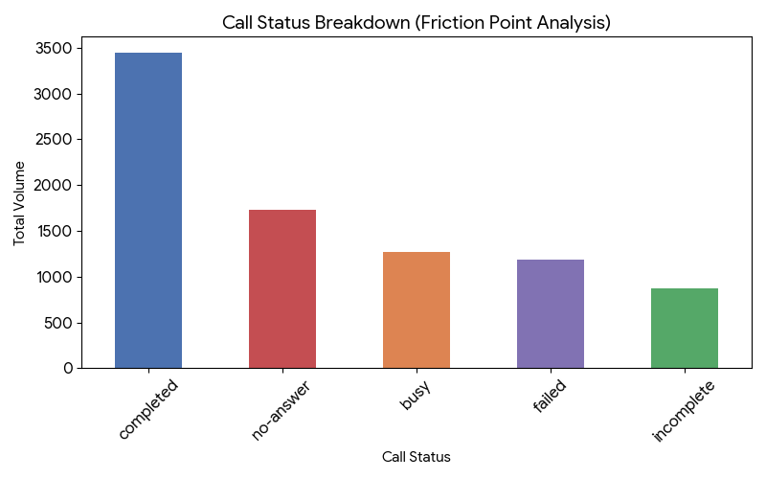

- Description:
The Data Table summarizes the raw frequency of each connection outcome.
The bar chart visually highlights the alarming volume of 'no-answer', 'busy', and 'failed' interactions compared to successfully 'completed' calls.

Insights:
High Connection Friction: More than 50% of voice attempts fail to connect successfully resulting in a status of 'no-answer', 'busy', or 'failed'. This indicates severe telecom bottlenecks and poor queue management.
Automation Gaps: A massive portion of overall platform interactions occur via text (chat), representing a prime, untapped target for conversational automation before live agents are required.
Recommendations:

Virtual Callback & Smart IVR Tech: Implement an intelligent IVR queue system. When all lines are busy, the system should allow customers to hold their place in line via an automated callback rather than returning a "busy" or "failed" signal.
AI Triage Chatbots: Deploy NLP-driven AI chatbots to handle initial greetings, customer intake, and simple text-based queries to reduce the manual administrative burden on live agents.

Question 9: What metrics should be included in the final dashboard to comprehensively view call center performance and guide investment decisions?

Solution:

Approach:
To comprehensively view the call center's performance and confidently guide investment decisions, I recommend tracking metrics across agent utilization, revenue generation, and infrastructure stability. I evaluated a total of 6 distinct pivot tables. By mapping each of these tables directly to the operational questions they solve, this framework provides all the necessary metrics to justify capital allocation without requiring additional visual charts.

Charts & Tables:
- Table / Chart Name:
6 Distinct Pivot Tables (Dashboard)

- Description:
The final dashboard utilizes the 6 distinct pivot tables currently present in the sheet, mapped directly to the questions they answer:
- Agent Workload Distribution: Answers calls per agent, highest/lowest CSAT, and workload balancing.
- Daily Call Volume & Avg Rating: Answers daily volume averages and handling peak periods.
- Caller Type Sales & Count: Answers repeat caller percentage, efficiency, and customer loyalty.
- Total Sales by Consultation Type: Answers sales per product category.
- Call Status Breakdown: Answers technical friction and automation gaps.
- Consultations by Month & Day: Answers highest and lowest call volume periods.
Insights:
Revenue is Dependent on Loyalty: The Caller Type table reveals that Repeating Users drive nearly 98% of total platform sales (₹2,09,417), making retention the ultimate profitability driver.
Critical Operational Failure: The Call Status table flags a massive technical bottleneck; only 40.4% of interactions are successfully "completed," leaving nearly 60% of traffic lost to failed, busy, or no-answer states.
Volume vs. Quality Friction: The Daily Call Volume & Avg Rating table proves that during peak traffic days, the average CSAT rating statically drops or stagnates, showing the workforce cannot scale quality under pressure.

Recommendations:
Monitor Infrastructure via Call Status: The dashboard must prominently feature the "Call Status" breakdown. Investment decisions (like upgrading telecom servers or funding AI chatbots) should be directly triggered by the failure rates shown in this specific table.
Track Revenue Concentration: Keep the "Caller Type" table centralized so management can continuously monitor the VIP repeat caller base.
Prevent Burnout via Agent Workload: Use the "Agent Workload Distribution" table to track top earners (like Dr. Balkrisna) against their average CSAT ratings to enforce automatic load-balancing when high volume begins to erode their service quality.

Question 10: How would you allocate a 1 crore rupee investment to optimize operational efficiency, enhance customer satisfaction, and boost profitability, and what analysis-based recommendations would you offer to support this?

[you have to give bullet pointers to answer this question]

Solution:

Approach:
To optimize the 1 crore rupee investment, I evaluated the financial and operational bottlenecks highlighted in the Dashboard tab. I mapped the extreme revenue concentration (Repeating Users driving ~98% of sales) against the critical infrastructure failure rate (nearly 60% of calls lost to busy, failed, or no-answer statuses). This data-driven approach ensures capital is allocated proportionally to fix the largest profit leaks and protect the most valuable user base.

Charts & Tables:
- Table / Chart Name:
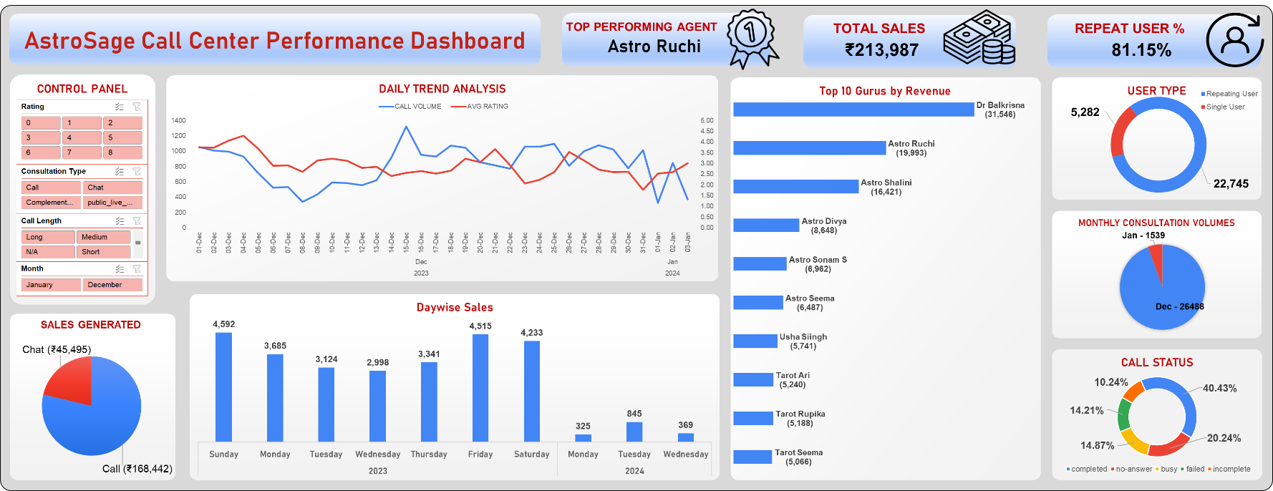
Dashboard & Investment Allocation Breakdown

- Description:
This visual represents the current operational state (Call Status, Caller Type Sales, Agent Workload) which serves as the justification for the capital distribution percentages.

Insights:
- Infrastructure Leakage: Roughly 60% of all call attempts fail to connect successfully, representing a massive daily loss in potential billable minutes and severely damaging the customer experience.
- Revenue Dependency: Repeating Users generate ₹2,09,417 (97.8% of total sales). The platform's entire profitability relies on retaining this specific VIP segment.
- Quality/Volume Friction: The highest-grossing individual agents (like Dr. Balkrisna) suffer from notably poor CSAT ratings (~2.59) due to extreme workload concentration, risking the churn of the valuable repeat callers they interact with and not becoming the top performer.

Recommendations:
- 40 Lakhs (40%) - Infrastructure & Tech Upgrades: Direct the largest portion of the investment to overhaul the telephony and server routing infrastructure. Reclaiming the 60% of calls lost to "busy" or "failed" statuses will instantly yield a massive boost in operational efficiency and gross profitability.
- 30 Lakhs (30%) - VIP Retention & Priority Queues: Since Repeat Callers drive nearly 98% of all revenue, deploy funds to build a "VIP Priority Queue." This ensures high-spending repeat customers bypass standard wait times and are instantly routed to top-rated agents, safeguarding customer satisfaction.
- 30 Lakhs (30%) - Agent Training & Load Balancing: Allocate capital to upskill mid-tier agents to handle excess volume, and institute mandatory quality-assurance training for top earners. This balances the workload, aligns high sales volume with higher CSAT ratings, and physically prevents top-agent burnout.

