Automated Oracle OEM Alert Management & Resolution
A Proposal for Acknowledgement, Verification, Triage, Resolution, and Corrective Action Automation
Prepared for: DB Platform Engineering
Scope: Oracle Enterprise Manager (OEM) fleet-wide alert lifecycle automation
August 2026

Table of Contents
Table of Contents 2
1. Executive Summary 4
2. Purpose & Objectives 4
3. Current State vs. Proposed State 4
4. OEM Alert Severity Model 6
5. Automated Alert Lifecycle 7
5.1 Acknowledgement 7
5.2 Verification 7
5.3 Triage 7
5.4 Resolution 7
5.5 Corrective Action 7
6. Alert Catalog & Resolution Routes 8
6.1 Availability & Connectivity Alerts 8
6.2 Space Management Alerts 9
6.3 Performance Alerts 11
6.4 Alert Log & Internal Error Alerts 13
6.5 Backup & Recovery Alerts 15
6.6 Data Guard Alerts 17
6.7 Job & Scheduler Alerts 19
6.8 Security & Compliance Alerts 21
6.9 Host / Infrastructure Alerts 23
6.10 Exadata Alerts 25
7. Oracle on AWS RDS Alert Management (via OEM) 29
7.1 Monitoring Model & Deployment-Type Differences 29
7.2 Alert Sources for RDS 29
7.3 RDS Alert Catalog & Resolution Routes 29
7.4 Automated Resolution Architecture for RDS 32
7.5 Governance Note for RDS 33
8. Severity-Based Response & Escalation Matrix 34
9. Proposed Automated Resolution Architecture 35
10. Governance & Approval Workflow 35
11. Corrective Action & Continuous Improvement 36
12. KPIs & Success Metrics 36
13. Implementation Roadmap 36
14. Risks & Mitigations 37
15. Recommendation 37

1. Executive Summary
Today, some Oracle OEM alerts across the database fleet are acknowledged, investigated, and resolved manually — a model that scales poorly as the fleet grows and consumes DBA time on repetitive, pattern-based issues that do not require judgment. This proposal defines a phased, automated alert management system that acknowledges alerts the instant they fire, re-verifies the underlying condition before acting, classifies each alert by risk and confidence, filters out the alerts already in “being resolved” state, resolves the well-understood cases automatically within a governed approval framework, and routes everything else to the right human with the right context already attached.
The system uses its shepherd-status intake pattern, approval gating, case-insensitive workflow transitions, and automatic failure follow-up tasks. It does not introduce a new toolchain; it extends a proven one to a new domain.
The goal is measurable: reduce mean time to acknowledge and resolve, cut duplication of alert management and resolution efforts for already being-handled alerts, cut after-hours alert noise reaching on-call staff, and free personnel time from repetitive remediation so it can be spent on the higher-value platform engineering and consolidation work already underway.

2. Purpose & Objectives
- Reduce Mean Time to Acknowledge (MTTA) and Mean Time to Resolve (MTTR) for common, well-understood Oracle alert conditions.
- Reduce redundant alert/resolution handling
- Reduce alert noise and after-hours paging by auto-resolving self-clearing and low-risk conditions before they reach an on-call human.
- Standardize triage and severity handling across the full database fleet, removing inconsistency between how different DBAs currently respond to the same alert type.
- Preserve human judgment and approval for anything medium-risk, high-risk, or ambiguous — automation extends the team's capacity, it does not replace DBA decision-making.
- Create a continuous feedback loop so the auto-resolvable scope widens over time as outcomes are reviewed and trusted patterns are confirmed.
- Directly support the FY goals of reducing vendor-managed services dependency and delivering automation that reduces operational support effort.

3. Current State vs. Proposed State
Dimension | Current State | Proposed State
Acknowledgement | Some manual, on operator availability | Automatic at alert trigger via EM CLI / webhook
Verification | Manual re-check by whoever picks up the alert | Automated live re-query of the underlying metric before any action
Triage | Ad hoc, inconsistent across DBAs | Standardized severity + risk classification, same logic every time
Distinctness validation | Absent, all alerts treated as new even if there are hundreds a minute apart | Putting alerts for the same asset, the same type of issue with a recent alert not being closed and still in resolution in a “duplicate queue”
Resolution | 90% manual | Auto-resolved for whitelisted low-risk patterns; approval-gated for medium risk; escalate-only for high risk
Corrective action | Inconsistent, often skipped under time pressure | Mandatory follow-up review task generated for every auto-resolved alert
Auditability | Scattered across email/OEM console | Full lifecycle logged in ServiceNow ticket with worklog and uploaded logs for error and resolution/corrective action

4. OEM Alert Severity Model
OEM classifies metric alerts into two primary severities — Warning and Critical — plus supporting states for target reachability and metric collection health. This proposal maps each severity to a distinct automation and escalation posture rather than treating all alerts uniformly.
Severity | OEM Definition | Automation Posture
Critical | Immediate action required; the target is non-functional or failure is imminent | Attempt only pre-approved, whitelisted remediation; always notify on-call in parallel, never rely on automation alone
Warning | Attention required, but the target remains functional | Auto-remediate if on the approved low-risk list; otherwise queue for next-business-day DBA review
Clear | Condition has returned to normal | Log outcome and close; no human action unless part of a recurring pattern
Agent Unreachable | Management agent is not responding — target health is unknown, not necessarily bad | Treat as an infrastructure alert; restart agent once, then route to infrastructure, not DBA, if unresolved
Metric Error | The metric collection itself failed (script/permissions/timeout) | Auto-retry collection; escalate only if the metric consistently fails to collect, since this masks the real alert state

5. Automated Alert Lifecycle
Every alert moves through the same intake-to-close pattern five-stage lifecycle.

5.1 Acknowledgement
The moment an alert fires, an automated listener (EM CLI polling or an OEM webhook to the automation control node) acknowledges it in OEM and opens a ticket in ServiceNow, so it stops re-notifying while the pipeline works it and there is a single system of record from the first second.

5.2 Verification
Before any action is taken, the responsible playbook re-queries the live database/host state — never acts on the alert payload alone, since OEM alerts can be stale, flapping, or already self-resolved by the time automation picks them up.

5.3 Triage
Each verified alert is classified along two axes: severity (Critical/Warning) and remediation confidence (auto-resolvable / approval-required / escalate-only). This classification, not the raw OEM severity alone, determines what happens next.

5.4 Resolution
Auto-resolvable alerts execute a pre-approved playbook action and log the outcome. Approval-required alerts pause in a Pending Approval until a DBA authorizes the action. Escalate-only alerts skip remediation entirely and route straight to a human with full diagnostic context attached.

5.5 Corrective Action
Every auto-resolved alert spawns a mandatory follow-up review task, reusing the existing COMMON_jira_create_followup_task.yml pattern already deployed for playbook failures. Recurring alert signatures are flagged for root-cause review rather than being auto-fixed indefinitely, and outcomes feed back into the whitelist tuning process described later in this section.

6. Alert Catalog & Resolution Routes
The tables below cover the alert categories that account for the overwhelming majority of OEM alert volume on a typical Oracle fleet. Thresholds shown are typical OEM defaults; actual values should be tuned per database class using historical alert data before Phase 1 goes live.

6.1 Availability & Connectivity Alerts
Alert / Metric | Warning Threshold | Critical Threshold | Verification Step | Automated Resolution Action | Escalation / Corrective Action
Database Instance Down / Unreachable | N/A | Instance not responding to ping/connect | Attempt SQL*Net connect; check pmon process and alert log for ORA-01034/ORA-27101; confirm host is up via OS ping | If instance is down but host is up and no corruption indicators in alert log: attempt SRVCTL/startup via Ansible; verify open state after start | If startup fails twice, or corruption/ORA-600 present: page on-call DBA immediately, attach alert log tail, do not retry further
Listener Down / Not Responding | Response time > 80ms | Response time > 100ms or status DOWN | Run lsnrctl status against target host; confirm listener.ora is present and port is reachable | Restart listener via lsnrctl start; re-check status and log a successful service registration | If restart fails or recurs more than twice in 24h: escalate to network/host team, check firewall and port bind conflicts
Agent Unreachable | N/A | Agent heartbeat missed 3 consecutive cycles | Ping host; check agent process (emctl status agent); check disk space on agent home | Restart agent via emctl; clear agent-side upload backlog if disk was the cause | If host itself is unreachable: escalate to infrastructure/network team as a host-down incident, not a DB incident
RAC Instance / Node Down | N/A | One or more instances down in a multi-instance database | Check CRS/GI status (crsctl status resource -t); confirm whether this is a planned rolling operation | If unplanned and CRS is healthy: attempt srvctl start instance; verify VIP/SCAN failover distributed sessions correctly | If CRS/clusterware itself is impacted, or node eviction is suspected: escalate immediately to on-call DBA and Data Center Ops, treat as Sev-1

Decision Workflow
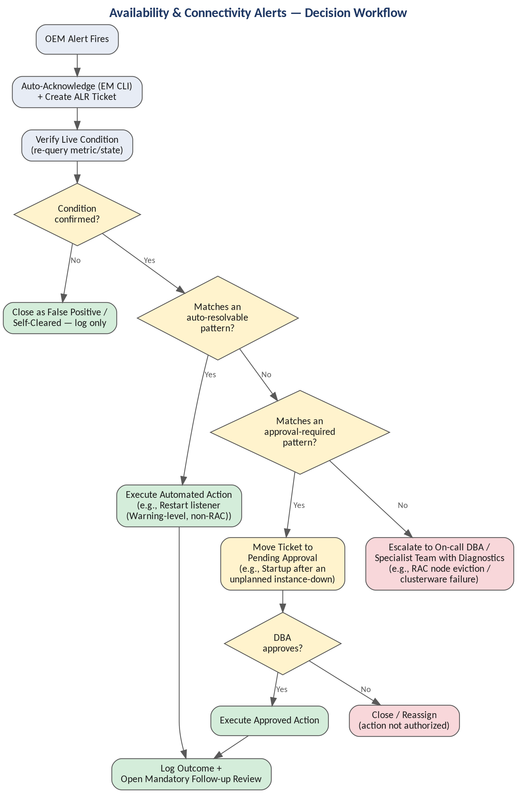

6.2 Space Management Alerts
Alert / Metric | Warning Threshold | Critical Threshold | Verification Step | Automated Resolution Action | Escalation / Corrective Action
Tablespace Usage (%) | > 80% used | > 90% used (or projected full within autoextend ceiling) | Query DBA_TABLESPACE_USAGE_METRICS for current % and autoextend/max size settings | If autoextend is on and headroom exists below the pre-approved growth ceiling: no action, log only. If near max size: extend datafile or add a datafile within policy limits | If growth would exceed the approved ceiling, or tablespace is non-autoextend: open approval-gated ticket for DBA sizing decision
ASM Diskgroup Usage | > 75% used | > 85% used (or FREE_MB below 2x largest datafile) | Query V$ASM_DISKGROUP for USABLE_FILE_MB and redundancy; confirm rebalance is not already in progress | If additional ASM disks are pre-provisioned and available: add disks and trigger rebalance | If no spare capacity exists: escalate to storage team with capacity forecast attached; freeze non-critical growth operations
Archive Log Destination Full / Archiver Stuck (ORA-00257) | > 80% used | Archiver hung / destination 100% full | Confirm ARCHIVELOG mode; check RMAN retention policy and last successful archive log backup timestamp | Run RMAN 'delete archivelog until' per the approved retention policy, then re-check free space and confirm archiver resumes | If deletion does not free sufficient space (e.g., backups themselves are behind), escalate to backup/storage team as Sev-1 — database will hang writes if unresolved
Flash Recovery Area (FRA) Usage | > 80% used | > 95% used | Query V$RECOVERY_FILE_DEST and V$FLASH_RECOVERY_AREA_USAGE to identify what's consuming space (backups, archivelogs, flashback logs) | Purge obsolete RMAN backups per retention policy (RMAN 'delete obsolete'); disable flashback temporarily only if pre-approved | If FRA is undersized structurally, escalate for a sizing change request rather than repeated automated purges
Filesystem / Mount Point Usage (Host) | > 80% used | > 90% used | df -h on affected mount; identify largest consumers (trace/audit/log directories) via du | Purge aged trace files, audit files, and listener logs per retention policy using adrci/find; compress old logs | If growth is from database files (not logs/traces), escalate to storage team for LVM extension

Decision Workflow
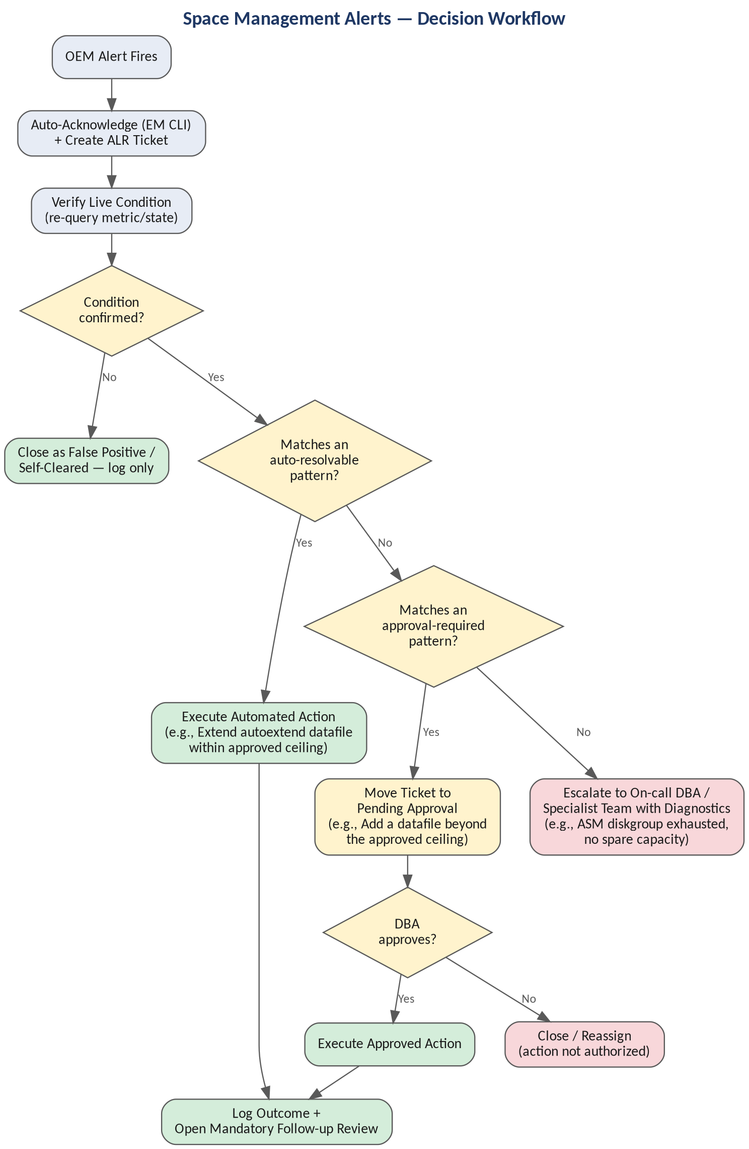

6.3 Performance Alerts
Alert / Metric | Warning Threshold | Critical Threshold | Verification Step | Automated Resolution Action | Escalation / Corrective Action
Host CPU Utilization | > 80% sustained 15 min | > 90% sustained 15 min | Check top consuming processes on host; confirm whether load is DB-driven or another co-located process | If a runaway session/SQL is identified with a low business-impact profile (e.g., ad-hoc report): notify session owner; do not auto-kill by default | If sustained and impacting SLA: escalate to on-call DBA for manual session/SQL intervention decision
Wait Event Spike (e.g., log file sync, buffer busy waits) | Wait class > baseline threshold | Wait class severely elevated, blocking throughput | Capture ASH/AWR snapshot for the alert window; identify top wait events and top sessions/SQL_IDs | Attach ASH/AWR extract to the ticket automatically; no direct remediation — this requires DBA performance review | Route to on-call DBA with the captured diagnostic bundle; do not auto-remediate performance/wait alerts
Blocking Locks / Enqueue Waits | Blocking > 5 min | Blocking > 15 min or blocking a critical service | Query V$LOCK / GV$SESSION to confirm blocker is still active and identify the blocking session's origin (app, batch, ad-hoc) | If the blocking session matches a pre-approved 'safe to kill' pattern (e.g., idle app-pool session with no open transaction): auto-kill and log | If blocker does not match a safe pattern, or blocks a business-critical service: notify session/application owner and on-call DBA for a manual decision
Long-Running SQL / Session | > 30 min elapsed | > 60 min elapsed or exceeds historical baseline by 5x | Query V$SESSION_LONGOPS and V$SQL to confirm the session is still active and identify SQL_ID and module | Capture SQL execution plan and bind variables to the ticket; no automatic kill | Escalate to the application/business owner and DBA for a joint decision on whether to allow completion or terminate
SGA / PGA Memory Pressure | > 85% allocated | > 95% allocated or ORA-04031 in alert log | Query V$SGA_TARGET_ADVICE / V$PGASTAT; check alert log for ORA-04031 shared pool errors | If within AMM/ASMM auto-tune bounds, log for trend only; if ORA-04031 recurring, flush shared pool only if pre-approved for that database class | Escalate for a memory sizing review if pressure is structural rather than transient

Decision Workflow
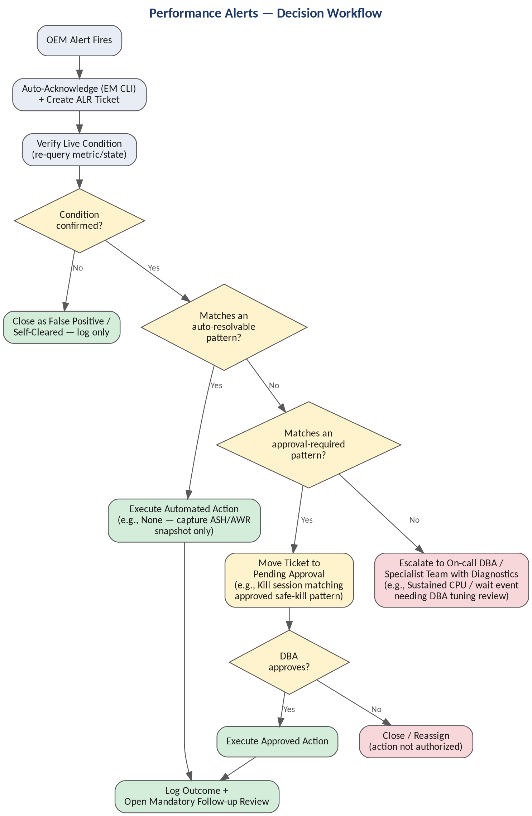

6.4 Alert Log & Internal Error Alerts
Alert / Metric | Warning Threshold | Critical Threshold | Verification Step | Automated Resolution Action | Escalation / Corrective Action
ORA-600 / ORA-7445 Internal Error | N/A — always significant | Always Critical | Extract the full error stack and associated trace file from the alert log via ADRCI | None — never auto-remediate internal errors. Automatically package alert log excerpt, trace file, and DB version into the ticket | Immediate escalation to on-call DBA; open an Oracle Support SR automatically if the error signature matches a known bug pattern
Data Block Corruption | N/A | Always Critical | Run RMAN 'validate database' or 'validate datafile' on the affected file to confirm scope of corruption | None — no automated repair. Automatically snapshot current backup status and corruption scope into the ticket | Immediate Sev-1 escalation to on-call DBA and backup team; assess RMAN block recovery vs. restore options manually
Session Terminated (Alert Log) | Occasional, isolated | Repeated terminations in short window | Correlate timestamp with resource pressure (memory, CPU) or a specific failing session/module | Log occurrence for trend; if correlated with a known safe pattern (e.g., app connection pool recycle), no action | If terminations are frequent/unexplained, escalate to DBA for root-cause review
Generic ORA-xxxxx Errors in Alert Log | Isolated occurrence | Recurring / matches critical error watchlist | Classify error code against a maintained watchlist (space, permissions, corruption, internal) | For known benign/space-related codes, route to the matching space-alert workflow above automatically | For anything not on the known-safe watchlist, default to escalation rather than guessing at remediation

Decision Workflow
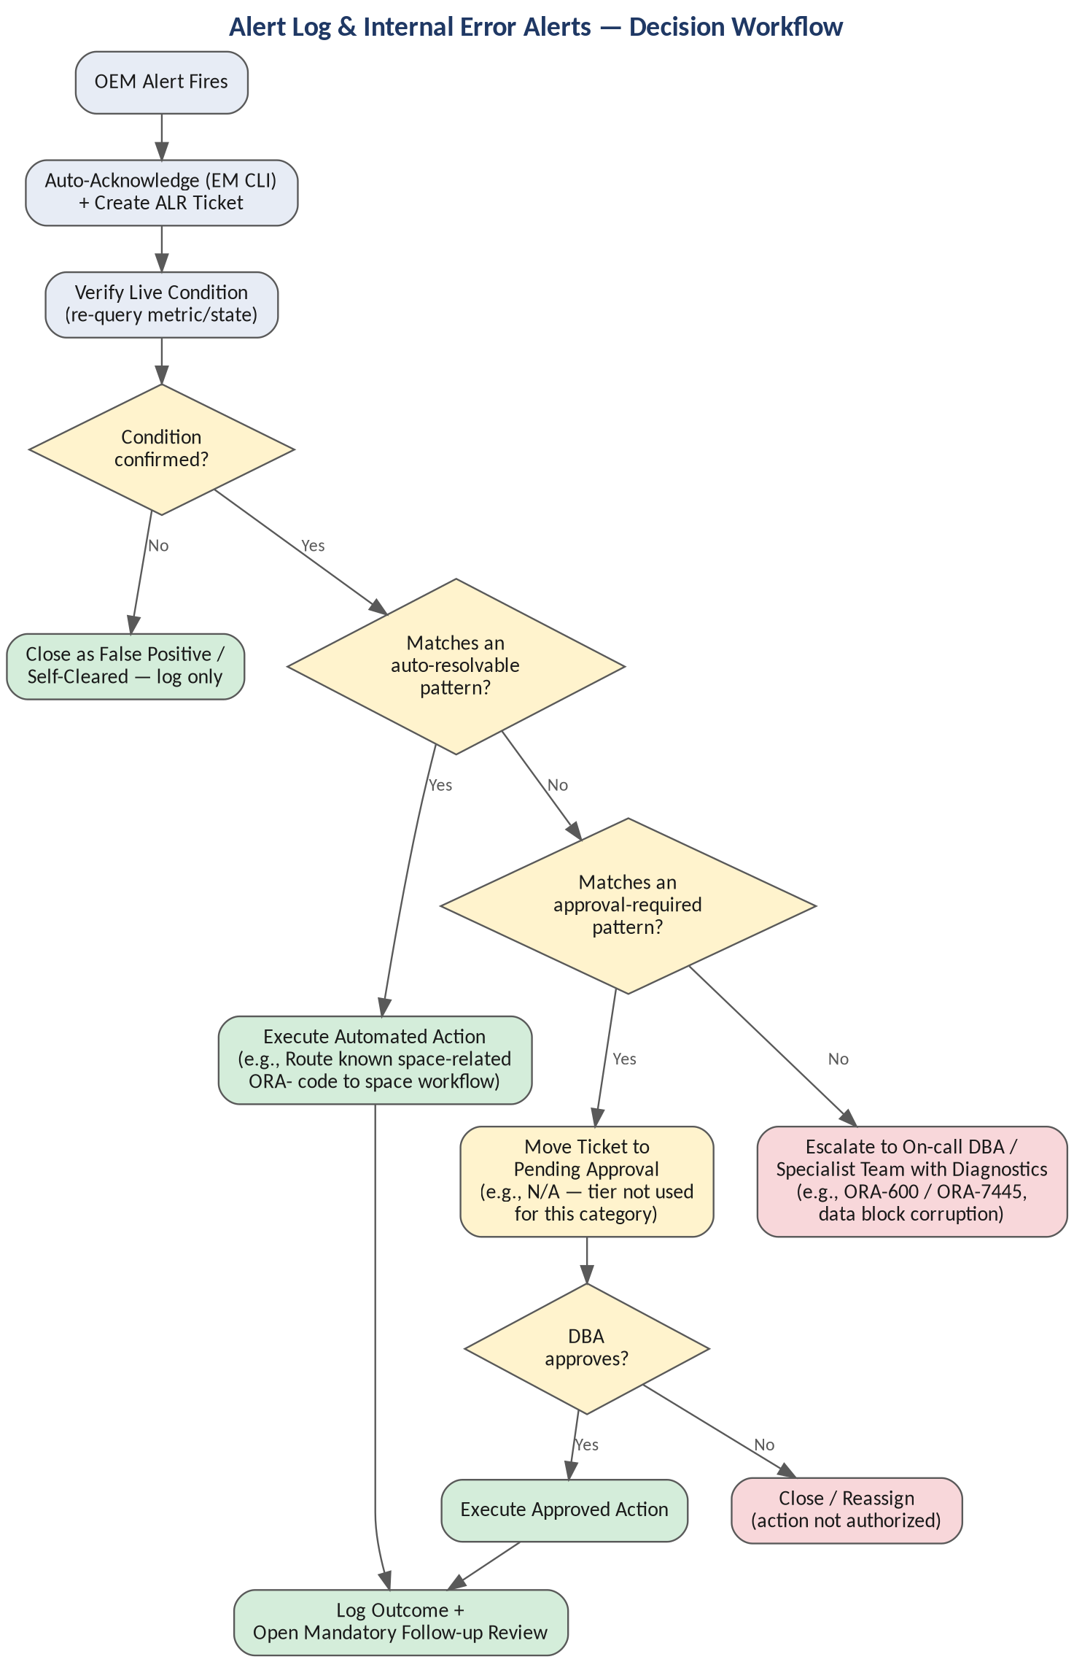

6.5 Backup & Recovery Alerts
Alert / Metric | Warning Threshold | Critical Threshold | Verification Step | Automated Resolution Action | Escalation / Corrective Action
RMAN Backup Failure | N/A | Any failed scheduled backup job | Pull the RMAN log for the failed job; identify failure point (space, connectivity, corruption, catalog) | Auto-retry once if failure was transient (e.g., timeout, temporary connectivity); if retry succeeds, close with note | If retry fails or failure is not transient, escalate to backup/DBA team with RMAN log attached — do not retry indefinitely
No Recent Successful Backup (Backup Age) | > 26 hours since last full/incremental | > 48 hours | Query RC_BACKUP_SET / V$BACKUP_SET or the backup catalog to confirm last successful backup timestamp | Trigger an out-of-cycle backup job if the miss was due to a scheduling conflict, not a failure | If underlying cause is unresolved failures, escalate — a database exceeding RPO must not remain in automated retry loops silently
Archive Log Backup Failure | N/A | Any failed archive log backup | Confirm archive log destination has not already filled (cross-reference the FRA/archive space alert) | Auto-retry once; if destination space was the cause, coordinate with the space-alert workflow before retrying | Escalate to backup team if retries fail — this alert is a leading indicator for an imminent archiver-stuck Sev-1

Decision Workflow
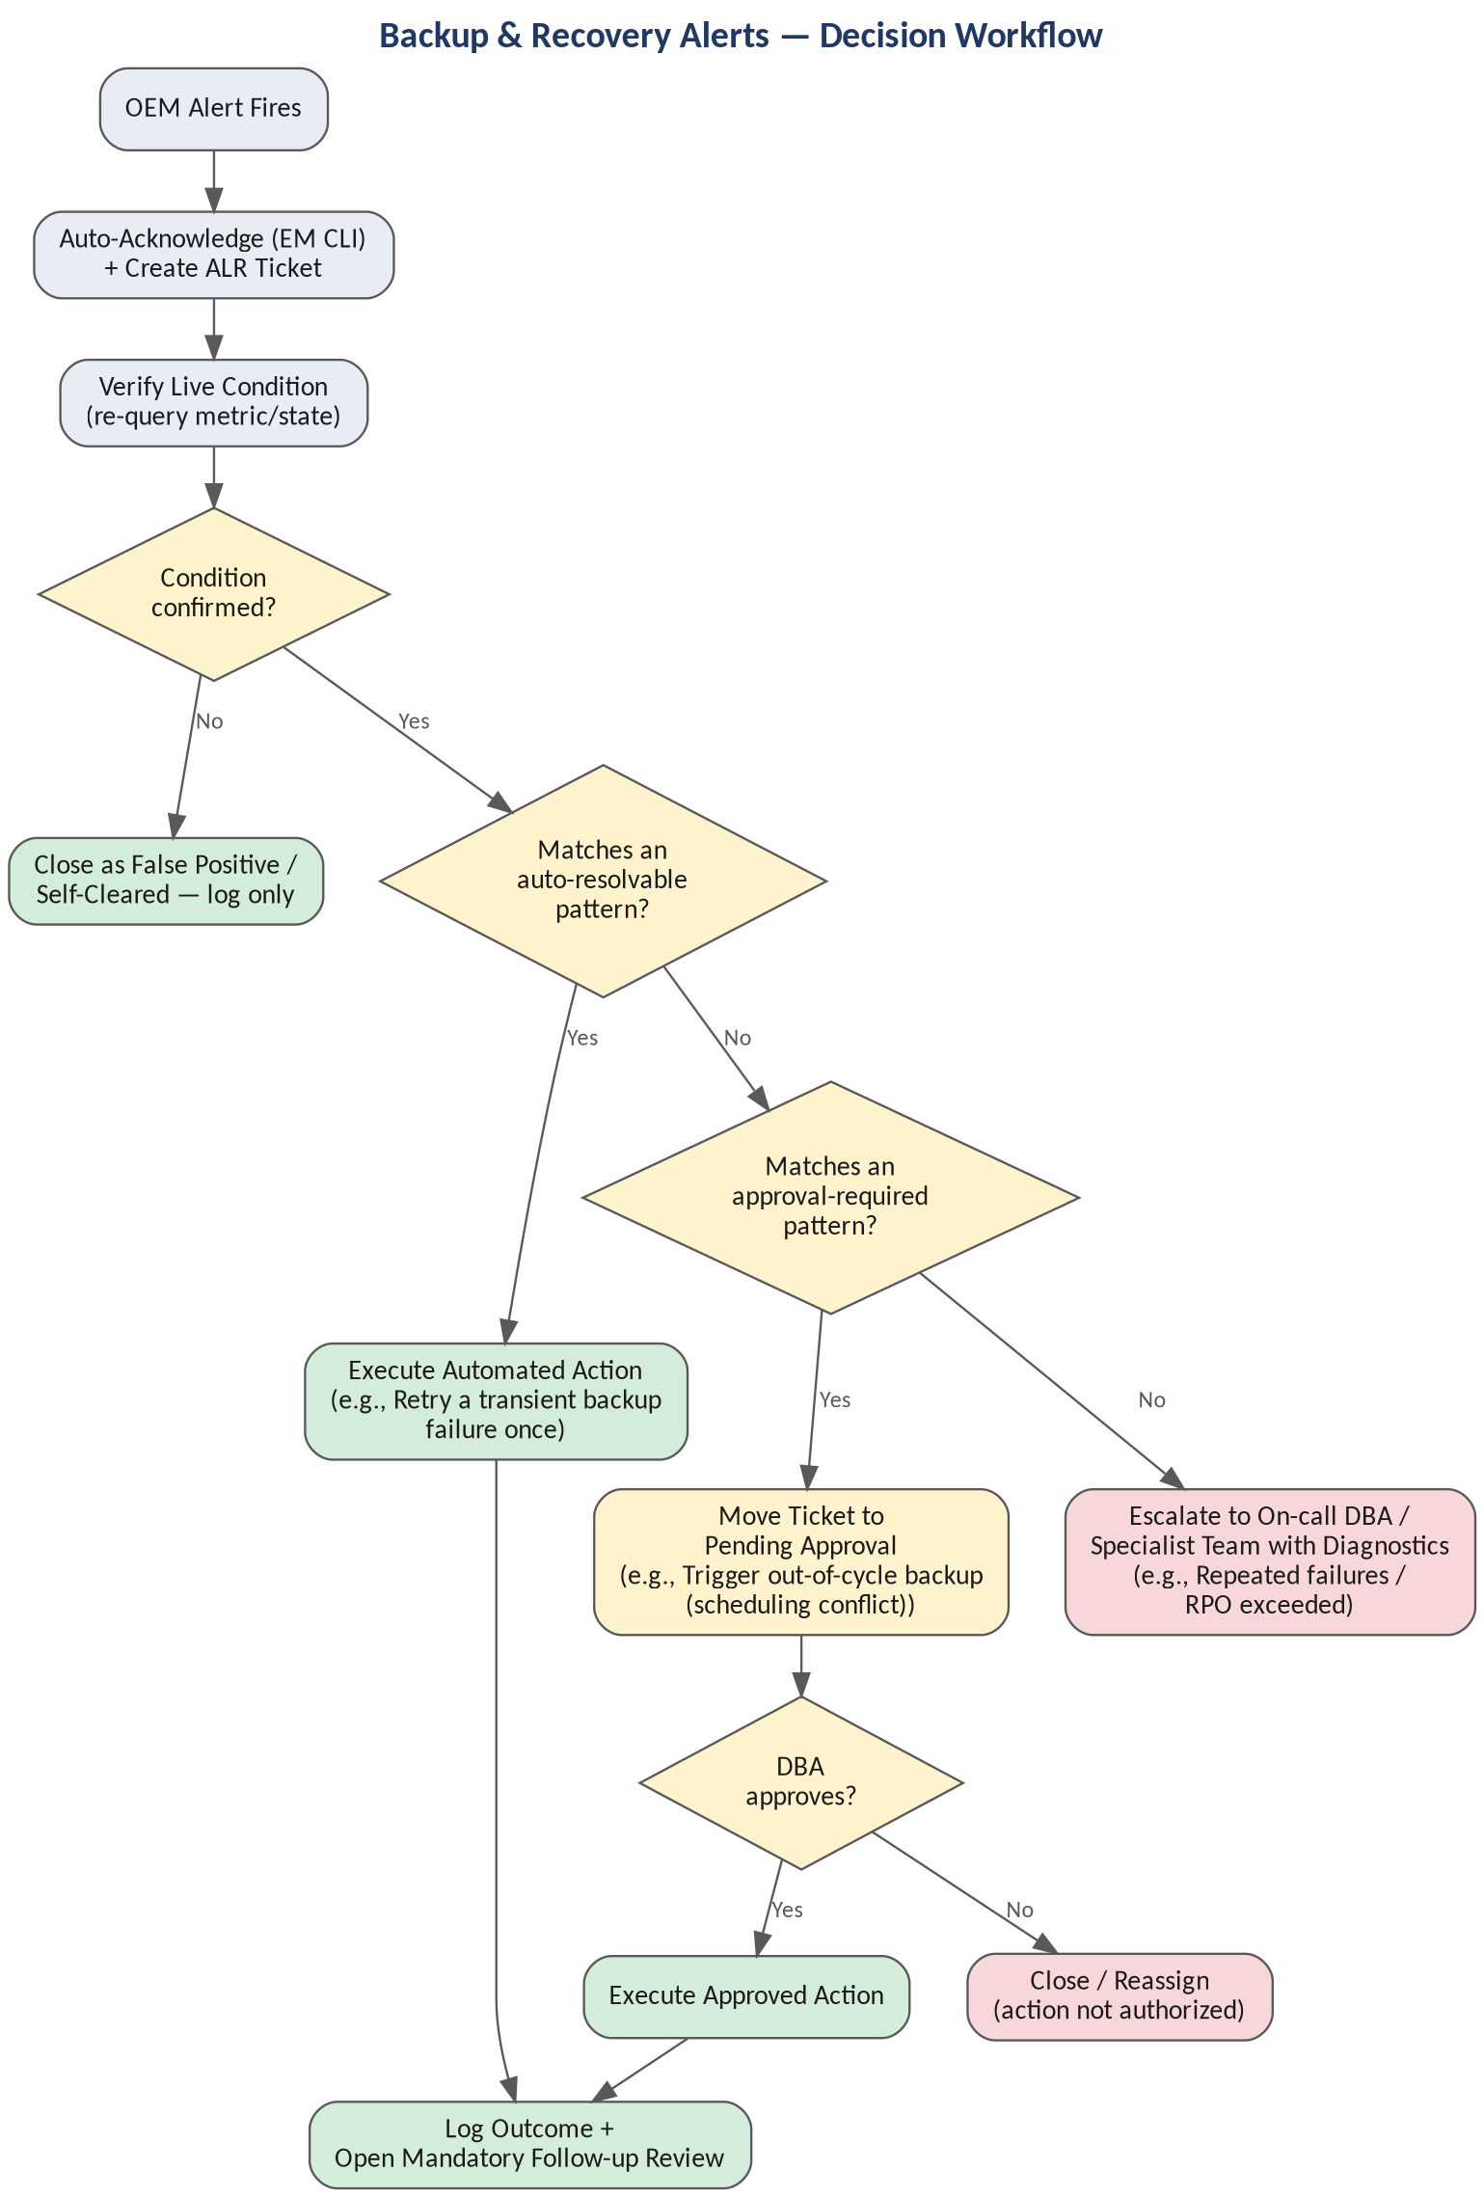

6.6 Data Guard Alerts
Alert / Metric | Warning Threshold | Critical Threshold | Verification Step | Automated Resolution Action | Escalation / Corrective Action
Apply Lag / Transport Lag | > 5 min | > 15 min or growing | Query V$DATAGUARD_STATS on standby for apply_lag/transport_lag; check standby MRP process status | If MRP is stopped unexpectedly and no gap exists: restart managed recovery; re-check lag trend | If lag continues to grow after restart, or a redo gap exists, escalate to on-call DBA — do not repeatedly restart MRP
Redo Gap | N/A | Any detected gap | Query V$ARCHIVE_GAP on the standby to identify the missing sequence range | Attempt automated gap resolution via RMAN incremental-from-SCN or manual log transfer only if pre-approved for that DG pair | Escalate immediately if automated gap resolution is not pre-approved or fails — extended gaps risk DR exposure
Standby Database Down | N/A | Always Critical | Confirm whether this is a planned switchover/failover maintenance window | If unplanned: attempt startup mount and re-enable managed recovery | If startup fails, escalate as Sev-1 — DR posture is compromised until standby is restored

Decision Workflow
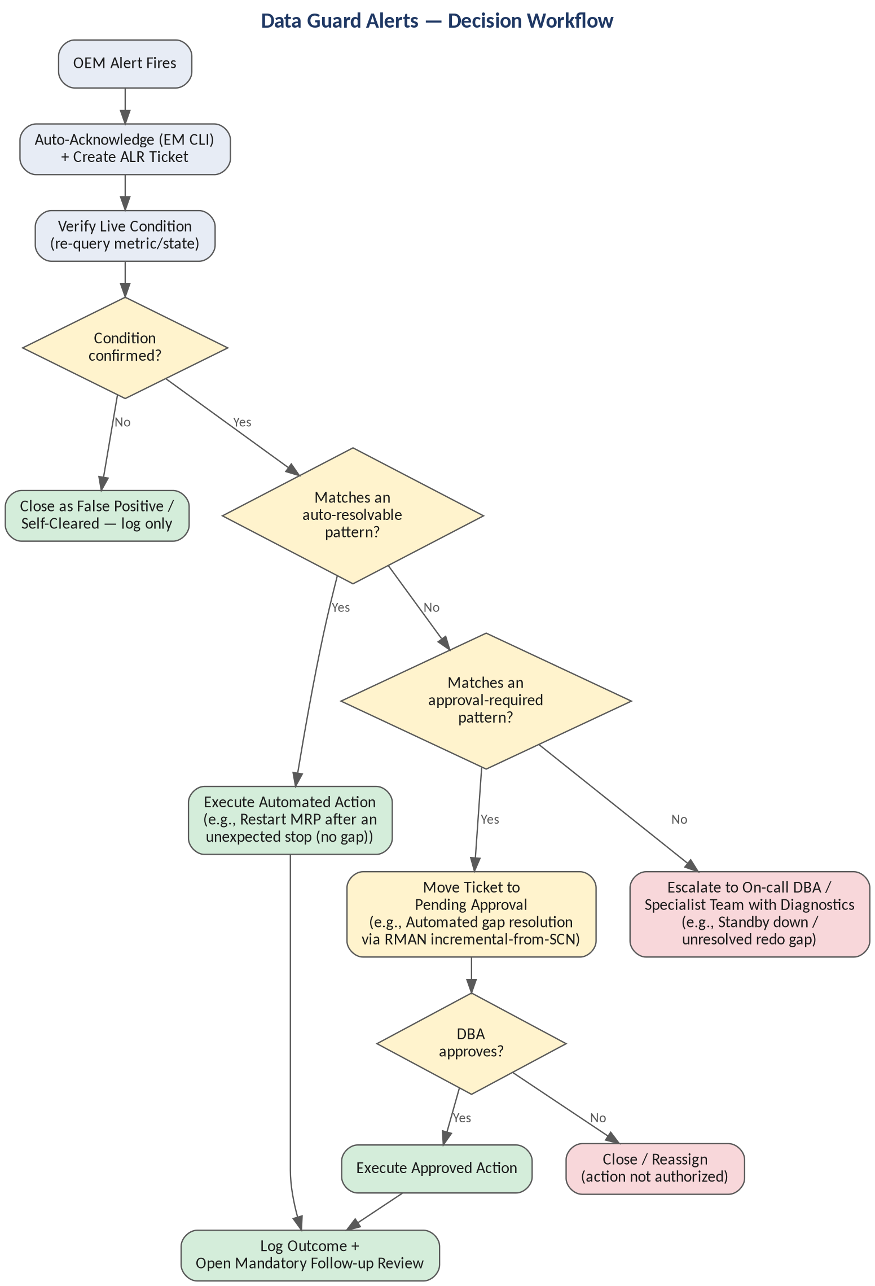

6.7 Job & Scheduler Alerts
Alert / Metric | Warning Threshold | Critical Threshold | Verification Step | Automated Resolution Action | Escalation / Corrective Action
Scheduler Job Failure (DBMS_SCHEDULER) | N/A | Any failed critical-tagged job | Query DBA_SCHEDULER_JOB_RUN_DETAILS for the failure error and additional_info | Auto-retry once for jobs tagged 'idempotent-safe'; log and skip retry for non-idempotent jobs | Escalate to the job owner (DBA or application team) if retry fails or job is not retry-safe
Job Chain Failure | N/A | Any failed chain step blocking downstream steps | Identify the failed step and whether downstream steps are dependent or independent | Resume independent downstream steps automatically; halt dependent steps | Escalate to job owner with the chain state — do not force downstream execution past a failed dependency

Decision Workflow
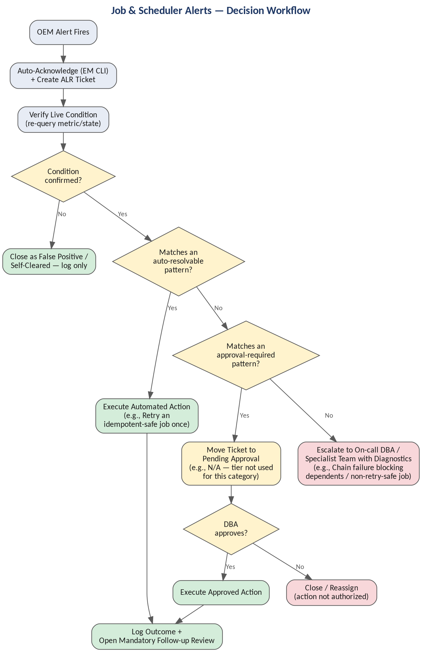

6.8 Security & Compliance Alerts
Alert / Metric | Warning Threshold | Critical Threshold | Verification Step | Automated Resolution Action | Escalation / Corrective Action
Failed Login Count | > 10 in 5 min for one account | > 25 in 5 min, or pattern across many accounts | Query the audit trail / unified audit for source IP, account, and pattern (single account vs. spray) | For a single-account lockout pattern, log and notify the account owner only | If pattern suggests credential spraying/brute force, escalate immediately to Security/InfoSec, not just DBA
Account Lock / Expired Password (Service Account) | Approaching expiry (7 days) | Locked or expired | Confirm whether the account is a monitored service account with a known password rotation schedule | For accounts on a managed rotation policy, auto-rotate per the CAU-style provisioning workflow already in use | For accounts outside managed rotation, escalate to the application owner — do not unlock without verifying cause
Audit Trail / Unified Audit Errors | N/A | Audit write failures detected | Check audit destination space and permissions | If space-related, route to the space-alert workflow; if permissions-related, log only | Escalate to Security/Compliance if audit capability itself is degraded — this is a compliance-impacting event

Decision Workflow
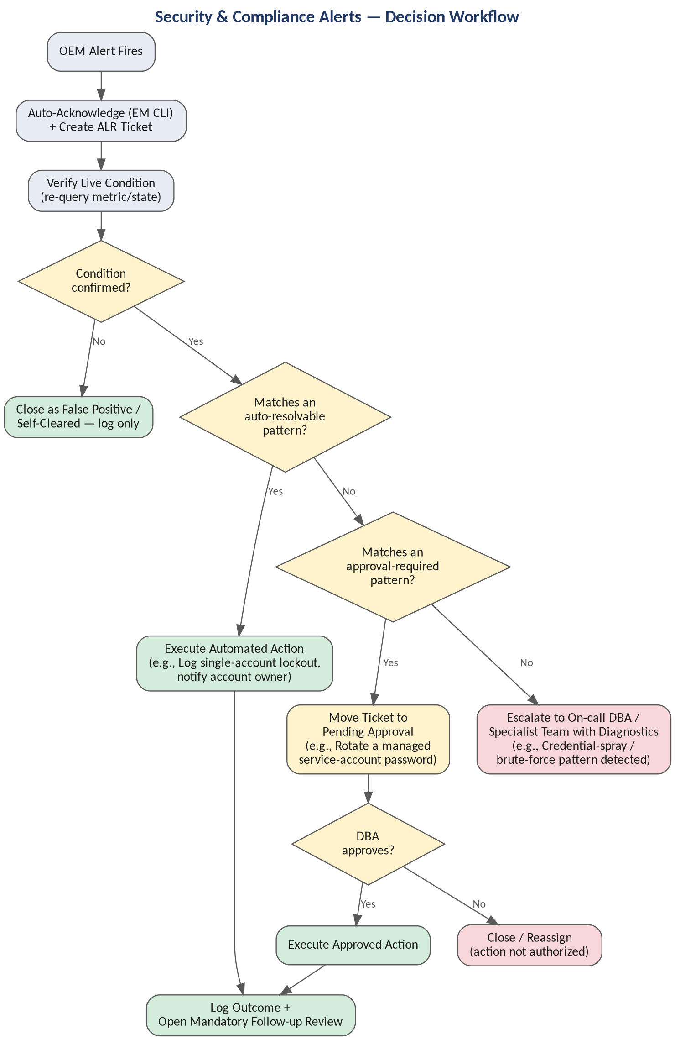

6.9 Host / Infrastructure Alerts
Alert / Metric | Warning Threshold | Critical Threshold | Verification Step | Automated Resolution Action | Escalation / Corrective Action
Host Memory Utilization | > 80% | > 90% or swapping detected | Check top memory consumers; confirm whether swap activity is occurring | If a known non-critical process is the cause, notify owning team; no automated kill of DB-related processes | Escalate to infrastructure team if swapping is active — this risks database performance collapse
Host Disk I/O Latency | > baseline x2 | > baseline x4 or service-impacting | Correlate with storage-side metrics/alerts if available; identify affected mount points | Log for trend and attach to ticket; no automated remediation at the host I/O layer | Escalate to storage/infrastructure team — this is typically outside DBA remediation scope
Network Latency / Packet Loss to DB Host | Elevated over baseline | Connectivity failures observed | Ping/traceroute from agent and from a known-good peer host to isolate DB-host vs. broader network issue | None — network-layer issues are not DBA-remediable | Escalate to network team immediately; note in ticket that DB-side metrics may be secondary symptoms

Decision Workflow
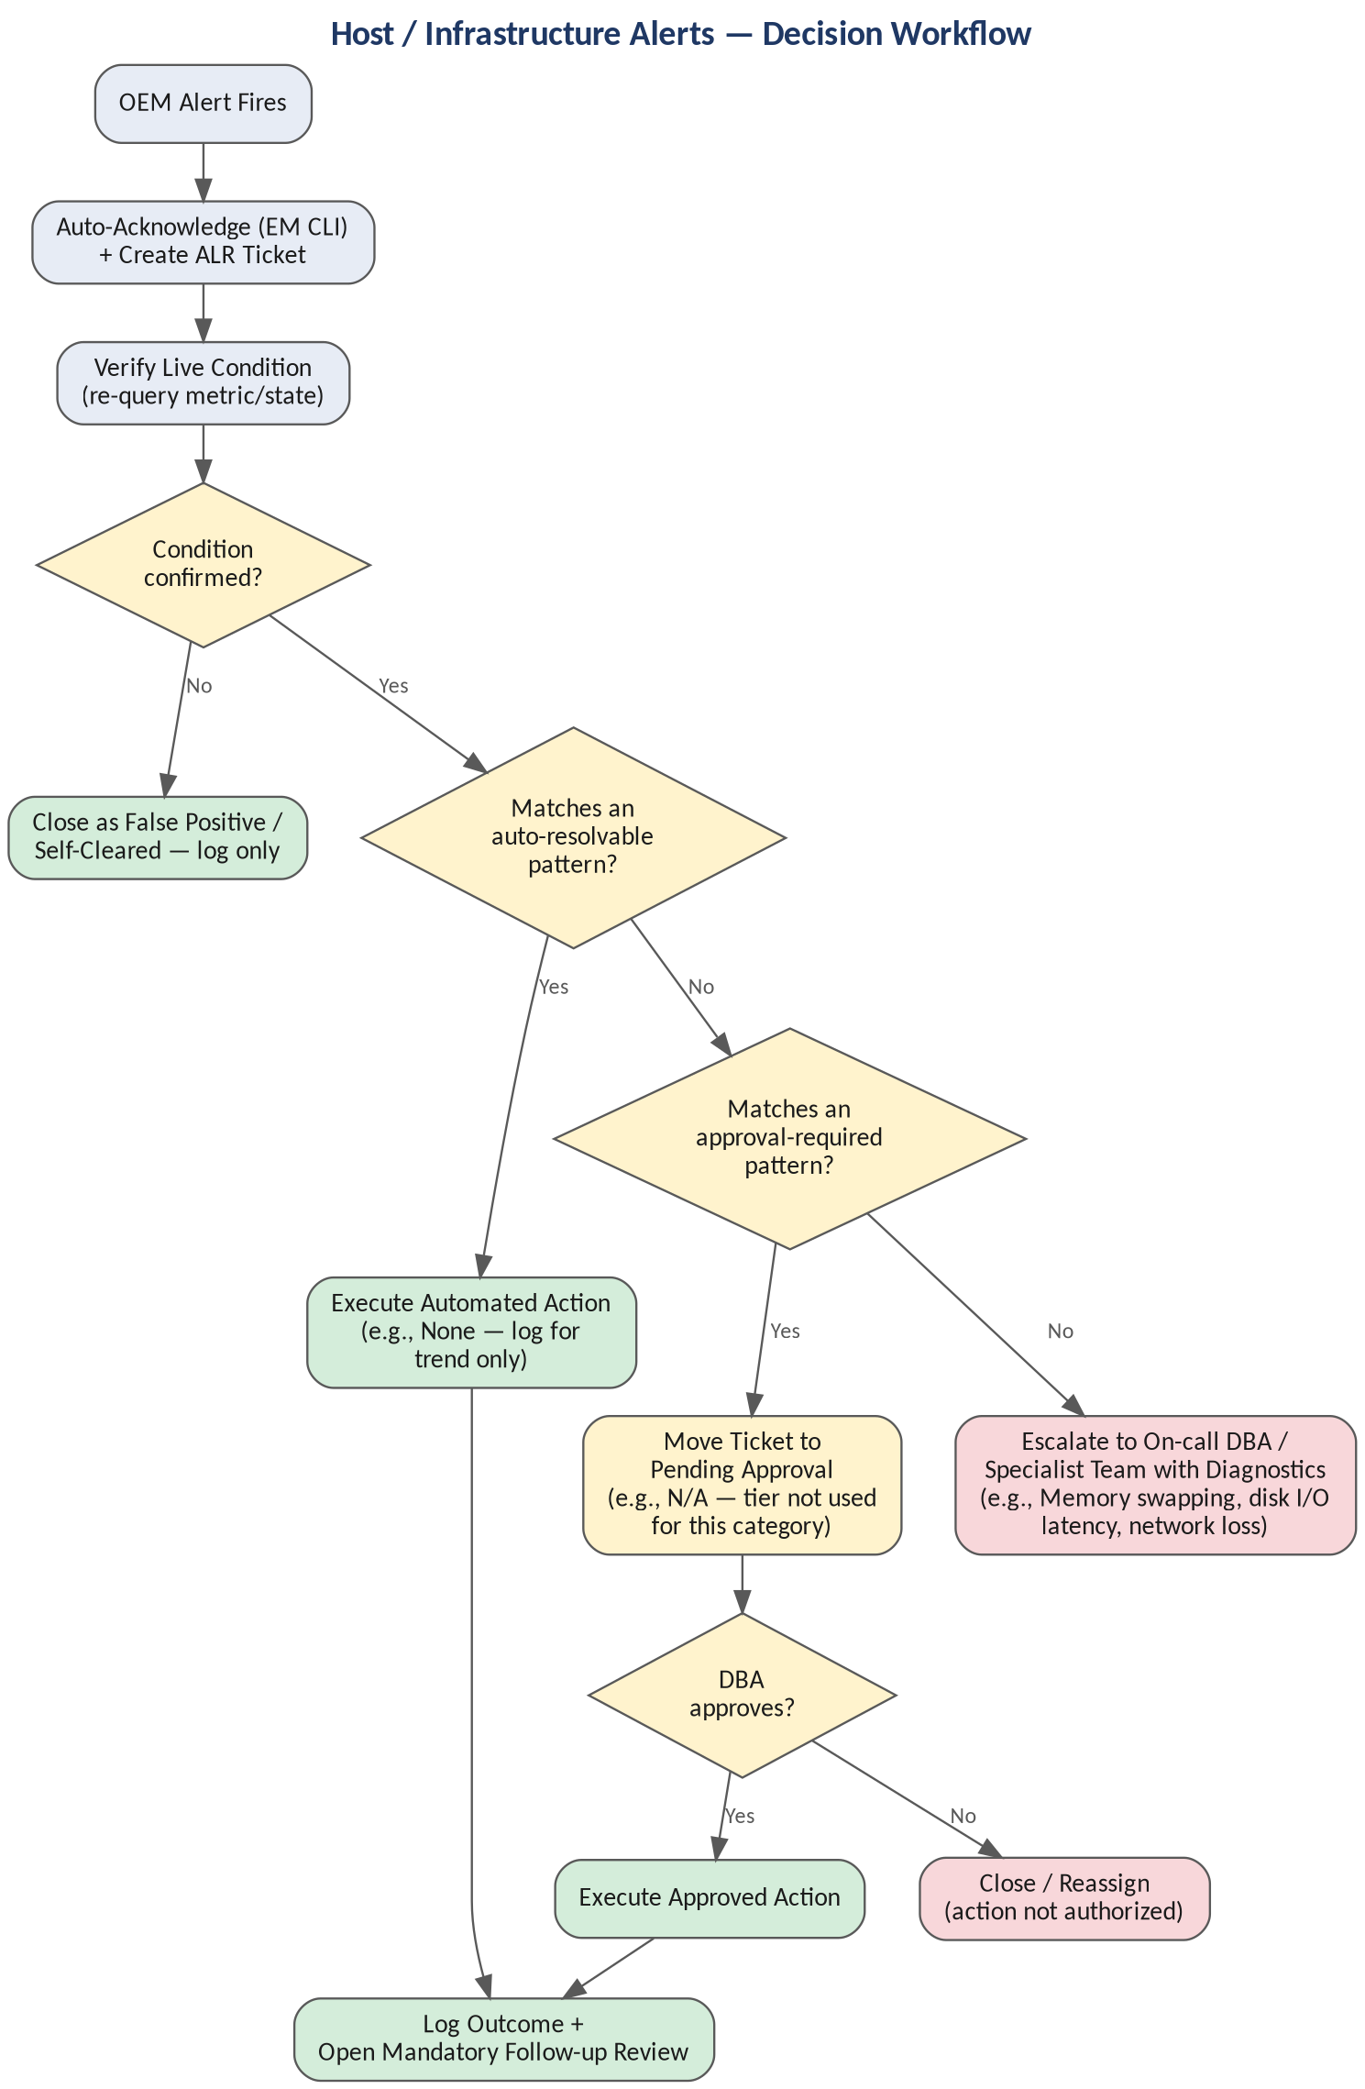

6.10 Exadata Alerts
Exadata introduces an additional hardware and fabric layer — storage cells, flash cache, InfiniBand — that sits below the database and ASM layers already covered above. These alerts are almost entirely escalate-only or log-only by design: hardware faults should never be auto-remediated, and the automation's role is to verify, classify, and package diagnostic detail for the vendor/infrastructure team as fast as possible, not to act on the hardware itself.
Alert / Metric | Warning Threshold | Critical Threshold | Verification Step | Automated Resolution Action | Escalation / Corrective Action
Cell Disk / Physical Disk Predictive Failure | Predictive failure flagged by ILOM | Disk offline / confirmed failure | CellCLI 'list physicaldisk' status; confirm ASM redundancy (NORMAL/HIGH) still covers the affected grid disks | None — log the fault and open a proactive hardware ticket automatically; do not attempt any disk operation | Escalate to Oracle ACS / hardware vendor for replacement dispatch; verify ASM redundancy before any cell maintenance is scheduled
Flash Cache / Flash Log Failure | Flash disk degraded | Flash cache unavailable on the cell | CellCLI 'list flashcache detail' and 'list griddisk' status across the cell | None — hardware-level fault; log and notify storage team automatically | Escalate to storage/vendor; confirm remaining flash cache redundancy across the other cells before any cell reboot or maintenance
InfiniBand Link / Switch Alert | Link errors increasing | IB port down or switch unreachable | ibstatus / ibdiagnet on affected compute and cell nodes; confirm the redundant fabric path is still healthy | None — network fabric fault; automatically attach diagnostic output to the ticket | Immediate escalation to network/Exadata infrastructure team — a single fabric failure risks cluster interconnect degradation fleet-wide
Cell Server (CELLSRV) Process Down | N/A | cellsrv process not running on a storage cell | 'cellcli -e list cell detail' / service celld status to confirm process state | Restart via 'service celld restart' only if pre-approved for that cell class, then re-verify cellsrv comes back online | If restart fails or recurs, escalate immediately — full cell loss reduces ASM redundancy across the whole rack, not just one database
Cell / Compute Node CPU or Memory Utilization | > 80% sustained 15 min | > 90% sustained 15 min | dcli across cells querying CPU_UT / memory metrics via CellCLI 'list metriccurrent' | Log for trend only — no automated remediation at the hardware layer | Escalate to DBA/infra if sustained; may indicate IORM misconfiguration or workload imbalance across databases sharing the rack
Exadata Capacity / Grid Disk Allocation (%) | > 80% allocated | > 90% allocated | CellCLI 'list griddisk attributes name, size, availableTo' aggregated across all cells | None automatic — capacity expansion is a hardware/licensing decision, not a scriptable fix | Escalate to capacity planning for grid disk expansion or an ASM rebalance scheduling window
ILOM Hardware Fault (power supply, fan, temperature) | Component degraded / pre-fail | Component failure or over-temperature | ipmitool sunoem cli 'show faulty', or the ILOM SNMP trap detail already captured by the Exadata plug-in | None — automatically package the fault class, message ID, and UUID into the ticket for the hardware vendor | Immediate escalation to Oracle ACS/hardware support for dispatch; treat as Sev-1 if a redundant component (e.g., one of dual PSUs) is impacted
IORM / Resource Plan Violation | Category exceeding its I/O allocation | Sustained starvation of a critical consumer group | CellCLI 'list metriccurrent where metricObjectName like N_IO%' to identify the starved category | None — log for DBA review; IORM plan changes are a deliberate tuning decision, not an automated action | Escalate to DBA for IORM plan tuning; not an emergency unless an SLA-critical workload is being starved

Decision Workflow
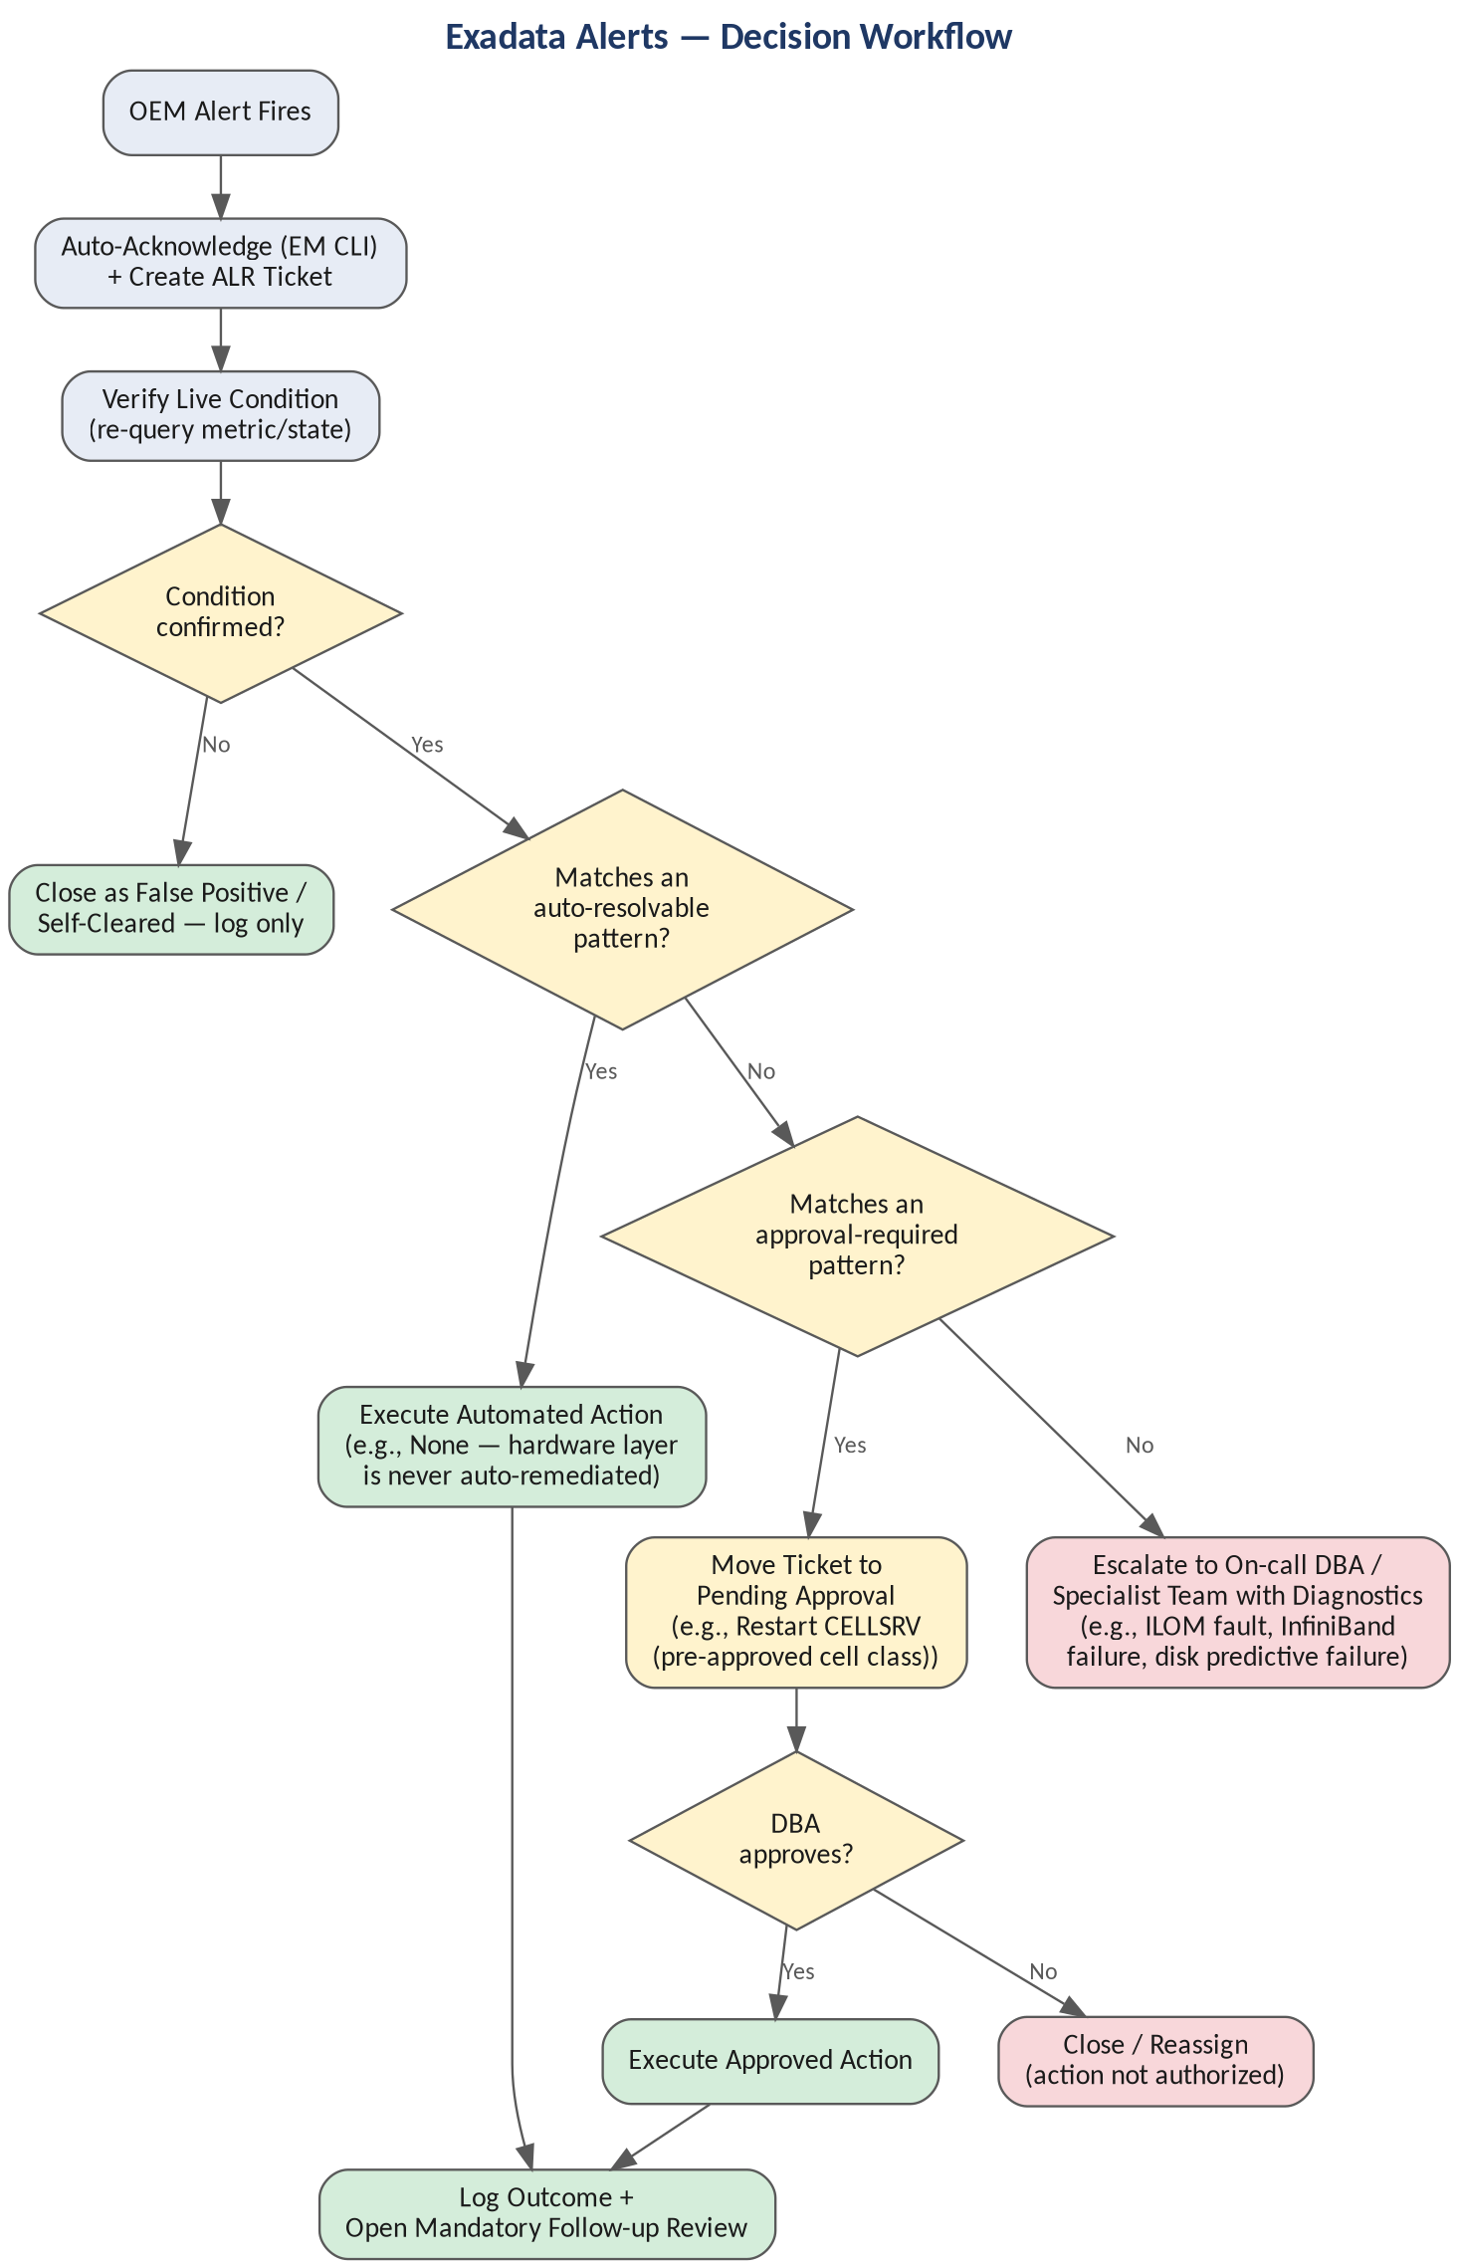

7. Oracle on AWS RDS Alert Management (via OEM)
Oracle databases running as Amazon RDS instances break the automation model used everywhere else in this proposal: there is no host access, no SSH, no OPatch, and no ASM. Alert acknowledgement, verification, and remediation for RDS must be rebuilt around AWS-native telemetry and the RDS API rather than the Ansible host-task pattern used on-prem and on Exadata — while still flowing through the same ServiceNow intake, approval, and follow-up structure.

7.1 Monitoring Model & Deployment-Type Differences
Which automation options are even available depends entirely on the RDS deployment type chosen:
Deployment Model | Host Access | OEM Agent Support | Automation Path
RDS for Oracle (standard) | None | Not supported — no agent can be installed | AWS API only: CloudWatch, Performance Insights, Enhanced Monitoring, and SQL*Net-level queries
RDS Custom for Oracle | Yes (EC2-based, limited) | Supported — EM Agent can be installed | Both the AWS API path below AND the standard on-prem catalog in Section 6, since host access is restored
Oracle on EC2 (self-managed) | Full | Fully supported | The existing on-prem Ansible/OEM playbook model in Section 6 applies unchanged
This proposal's RDS-specific catalog below applies to standard RDS for Oracle. RDS Custom deployments should also be enrolled in the Section 6 catalog wherever host-level monitoring is relevant, since they retain that capability.

7.2 Alert Sources for RDS
- Amazon CloudWatch — built-in RDS metrics: CPUUtilization, FreeStorageSpace, DatabaseConnections, ReadLatency/WriteLatency, ReplicaLag.
- RDS Performance Insights — database load (Average Active Sessions), top SQL, and top wait events, without requiring the Diagnostics Pack.
- Enhanced Monitoring — OS-level metrics (CPU, memory, swap, disk I/O, process list) at up to 1-second granularity, despite the lack of direct host access.
- CloudWatch Logs — RDS for Oracle can publish alert log, listener log, and audit log content to CloudWatch Logs, which restores alert-log-pattern monitoring that would otherwise be lost without host access.
- Direct SQL*Net queries — anything queryable over the database connection itself (tablespace usage, sessions, locks, long-running SQL) remains fully available and unaffected by the lack of host access.

7.3 RDS Alert Catalog & Resolution Routes
Alert / Metric | Warning Threshold | Critical Threshold | Verification Step | Automated Resolution Action | Escalation / Corrective Action
FreeStorageSpace (CloudWatch) | < 20% allocated free | < 10% free or trending to full | Query CloudWatch GetMetricData for FreeStorageSpace; cross-check growth trend against DBA_DATA_FILES over SQL*Net | If Storage Autoscaling is enabled, confirm it triggered as expected; if not enabled and within the approved growth ceiling, invoke modify-db-instance --allocated-storage via the AWS CLI/aws_rds Ansible module | If the required increase exceeds the approved ceiling or storage-type maximum, escalate for a sizing/cost approval — storage changes are billing-impacting
CPUUtilization (CloudWatch) | > 80% sustained 15 min | > 90% sustained 15 min | Cross-check Performance Insights DB Load (AAS) and top SQL to confirm the load is DB-driven | None for instance class changes (cost-impacting); automatically capture a Performance Insights top-SQL snapshot into the ticket | Escalate to DBA for tuning review; an instance class change requires approval since it carries a billing and availability impact
DatabaseConnections (CloudWatch) | > 80% of max_connections | > 95% of max_connections | Query V$SESSION / V$RESOURCE_LIMIT over SQL*Net — still fully available without host access | Kill sessions matching the same pre-approved 'safe to kill' idle-session whitelist used on-prem | Escalate if the connection storm persists after cleanup — may indicate an application connection-pool leak
Read / Write Latency (CloudWatch) | > baseline x2 | > baseline x4 | Cross-reference ReadLatency/WriteLatency with Enhanced Monitoring disk I/O and Performance Insights wait events | None — the AWS-managed storage layer is not directly remediable by the DBA team | Escalate to AWS infrastructure/DBA; consider a storage type (gp3/io1/io2) or provisioned-IOPS review
Swap Usage (Enhanced Monitoring) | > 20% of swap used | Sustained climb / memory pressure | Enhanced Monitoring OS process list to identify top memory consumers at the OS level | None — no host access is available to intervene at the OS level on standard RDS | Escalate for an instance class/memory sizing review
Multi-AZ Failover Event | N/A (informational) | Unplanned failover detected | Query the RDS event subscription / describe-events API for the failover cause | Verify application connectivity is restored post-failover; no remediation needed if failover completed cleanly | Escalate to DBA if the failover was triggered by a recurring underlying issue (e.g., repeated storage/instance health check failures) rather than routine AWS maintenance
Read Replica Lag | > 30 seconds | > 5 minutes or growing | Query the ReplicaLag CloudWatch metric and cross-check replica instance class and current load | Log and notify — replica lag typically reflects workload volume, not a fixable fault, so no automated action is taken | Escalate to DBA if lag is sustained and impacting read-offload SLAs; may require a larger replica instance class
Automated Backup Failure | N/A | Any failed automated backup window | describe-db-instance backup status; cross-check the configured backup window and storage headroom | Retry is not applicable (AWS-managed); confirm backup retention/window settings are still valid | Escalate to AWS Support if the failure is platform-side; escalate to DBA if caused by an in-flight maintenance conflict
Alert Log / Listener Log Errors (via CloudWatch Logs) | Isolated ORA- error in the published log group | Recurring error or matches the critical watchlist | CloudWatch Logs Insights query against the published alert log group for the specific error signature | Route known-safe patterns (e.g., space-related codes) to the matching RDS remediation workflow above | Escalate anything not on the known-safe watchlist — same default-to-escalate principle as the on-prem alert log workflow
Pending Maintenance / Patch Available | Patch available, not yet applied | Mandatory maintenance window approaching, unapplied | describe-db-instance pending maintenance actions via the AWS CLI | None — patching an RDS instance is a scheduled, approval-gated change, not an alert-driven automated action | Route to the existing PAT-style change workflow for scheduling rather than the alert pipeline

Decision Workflow
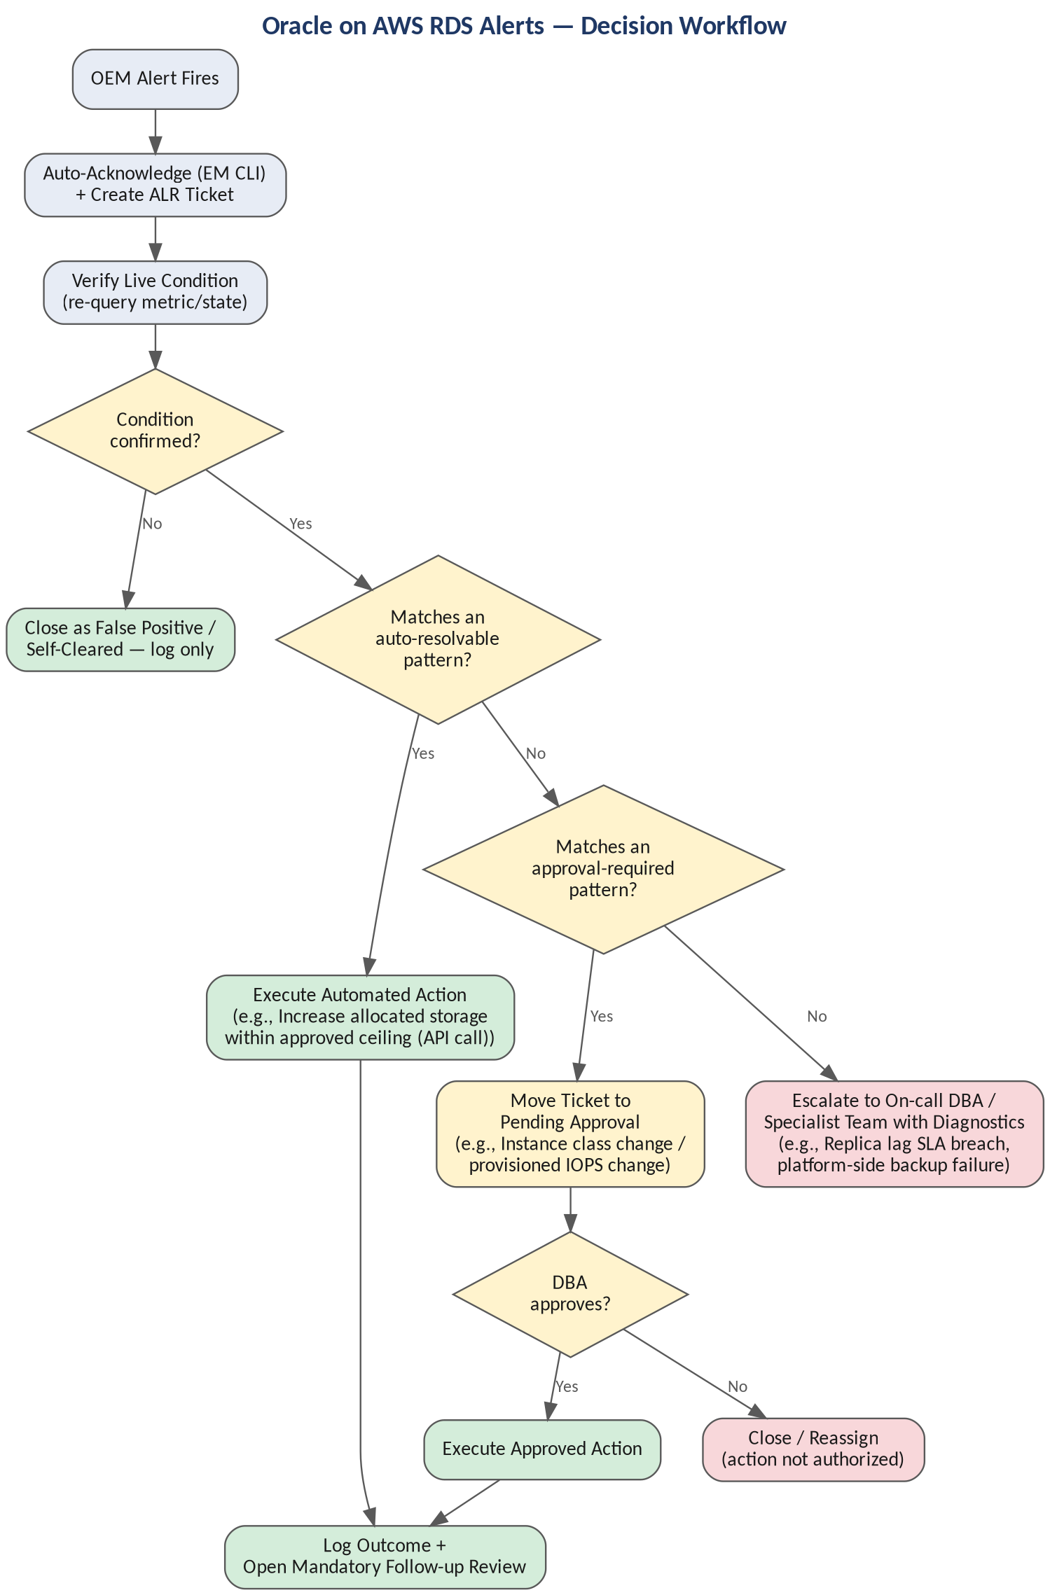

7.4 Automated Resolution Architecture for RDS
The RDS variant reuses the same Ansible ALR intake, approval-gate, and follow-up-task pattern already proposed for on-prem — only the execution layer changes. Verification and remediation tasks call the AWS CLI / boto3 (or the aws_rds Ansible collection) and CloudWatch APIs instead of SSH host modules. The shared ServiceNow automation intake/approval/follow-up structure ports cleanly to an AWS-API-driven engine even though the execution layer underneath is completely different.
- Any alert whose on-prem remediation depended on OS-level action — purging trace files, restarting a listener process, restarting an agent — has no automated resolution path on standard RDS. The catalog above reflects this with 'None' in the Automated Resolution Action column; these become escalate-only or are structurally not applicable rather than silently skipped.
- RDS Custom for Oracle restores host-level automation options since it grants EC2-level access — for that deployment model, apply the Section 6 catalog in addition to the CloudWatch-based catalog here.
- Recommend a dedicated RDS-ALR tag family (mirroring the CDPPG/CAUPG naming convention) kept fully isolated from the on-prem ALR project, the same way CDPPG was kept isolated from the production Oracle CDP project.

7.5 Governance Note for RDS
Several RDS remediation actions carry direct AWS billing impact — storage increases, instance class changes, provisioned IOPS changes. These must always route through the approval-gated tier regardless of confidence level, never the auto-resolvable tier, even where an equivalent on-prem action (like extending an autoextend-enabled tablespace) would be considered safe to automate outright.

8. Severity-Based Response & Escalation Matrix
Severity | Automated Response | Human Involvement | SLA Target | Escalation Path
Critical | Attempt only pre-approved, whitelisted auto-remediation immediately; page on-call DBA in parallel | Always — on-call notified at trigger time, not after automation fails | Acknowledge < 5 min; initial action < 15 min | On-call DBA -> DBA Team Lead -> Platform Engineering Manager (if unresolved in 30 min)
Warning | Auto-remediate if action is on the approved low-risk list; otherwise open ticket for next-business-day review | Reviewed within the business day by assigned DBA | Acknowledge < 30 min; action within 1 business day | Assigned DBA -> DBA Team Lead (if unresolved in 3 business days)
Clear | Log closure and outcome only | None required unless part of a recurring pattern | N/A | Weekly trend review only
Agent Unreachable / Metric Error | Auto-restart agent once; if unresolved, treat as an infrastructure alert, not a DB alert | Infrastructure/on-call as appropriate | Acknowledge < 15 min | Infrastructure team, cc DBA team lead for visibility

9. Proposed Automated Resolution Architecture
The architecture uses the certified ServiceNow ITSM automation collection running on a dedicated automation CTRL+ node:
- OEM alert fires → EM CLI polling job (or webhook) on the automation control node detects it and acknowledges it in OEM.
- A ticket is created in a new ALR Jira project, following shepherd-.
- The relevant Ansible playbook runs verification, then classifies the alert (auto-resolvable / approval-required / escalate-only).
- Auto-resolvable alerts execute immediately and transition the ticket to Done, with a worklog entry documenting the action taken — matching the existing worklog-per-issue pattern.
- Approval-required alerts move to Pending Approval and wait on the site-wide Approvals custom field.
- Any playbook failure automatically opens a DBA follow-up task via the existing COMMON_jira_create_followup_task.yml pattern, with logs attached.
- Status/transition handling uses the case-insensitive to.name.
Recommended new ALR project fields: alert_source_metric, target_database (multi-select), severity, remediation_tier (auto / approval / escalate), and verification_snapshot (text/attachment of the re-queried state at triage time).

10. Governance & Approval Workflow
Activity | Automation | Assigned DBA | DBA Team Lead | Other Stakeholders
Acknowledge alert | Automation (EM CLI) | — | — | —
Verify alert condition | Automation (Ansible playbook) | On-call DBA (Critical only) | — | —
Execute low-risk auto-remediation | Automation | On-call DBA (notified) | — | —
Approve medium/high-risk remediation | — | Assigned DBA | DBA Team Lead | Application Owner (if app-impacting)
Escalate Sev-1 incidents | Automation (pages on trigger) | On-call DBA | DBA Team Lead, Platform Eng. Manager | Security/Infra teams as applicable
Post-incident corrective action review | — | Assigned DBA | DBA Team Lead | —
Three remediation tiers govern what automation is allowed to do without waiting on a human:
- Auto-resolvable (high confidence, low risk): e.g., extending an autoextend-enabled tablespace within its approved ceiling, purging archive logs per retention policy, retrying a transient backup failure.
- Approval-required: e.g., adding a datafile beyond a threshold, killing a session, restarting a service.
- Escalate-only: e.g., ORA-600/ORA-7445 internal errors, data block corruption, ASM diskgroup exhaustion with no spare capacity, RAC node eviction.

11. Corrective Action & Continuous Improvement
- Every auto-resolved alert generates a mandatory review task so a DBA confirms the automated action was correct, even though it happened unattended.
- Alert signatures and their outcomes are logged to a shared knowledge base, so recurring patterns can be promoted from 'escalate-only' to 'approval-required' to 'auto-resolvable' as confidence is earned — never the reverse without cause.
- Thresholds and whitelists are reviewed quarterly against 90 days of outcome data, not left static from initial rollout.
- MTTA/MTTR/auto-resolution-rate metrics are tracked continuously and reviewed as part of the KPI framework in Section 12.

12. KPIs & Success Metrics
Metric | Current Baseline | Target
Mean Time to Acknowledge (MTTA) | Manual, variable (often 15–60 min) | < 5 min for Critical, < 30 min for Warning
Mean Time to Resolve (MTTR) — auto-resolvable alerts | 30–90 min manual | < 15 min end-to-end
% of alerts auto-resolved without human action | 0% (fully manual today) | 40–60% within 2 quarters of rollout
Alert noise reaching on-call (after-hours pages) | Baseline TBD from current OEM incident volume | Reduce by 50%+ via classification and auto-close of transient/self-clearing alerts
False positive / unnecessary escalation rate | Not currently tracked | < 5% of escalated tickets
Follow-up review completion rate for auto-resolved alerts | N/A (no auto-resolution today) | 100% reviewed within 5 business days

13. Implementation Roadmap
Phase | Scope | Key Deliverables
Phase 1 — Pilot (4–6 weeks) | Availability & Space alerts only, single environment (e.g., non-PROD PDBs) | New 'ALR' Jira project scaffolded with shepherd-status pattern; verification + auto-remediation playbooks for tablespace, archive log, listener down; approval gate wired for medium-risk actions
Phase 2 — Expand Scope (6–8 weeks) | Add Performance, Backup & Recovery alert categories; extend to all six environment PDBs | ASH/AWR auto-capture on performance alerts; RMAN retry/purge automation; follow-up review task automation extended from existing pattern
Phase 3 — Fleet Rollout (8–12 weeks) | Roll out to full production fleet; add Data Guard, Job/Scheduler, and Security alert categories | Fleet-wide deployment following the same phased-migration approach used for DCR/CAU/PAT; per-database opt-in list to control blast radius
Phase 4 — Continuous Improvement (ongoing) | Threshold tuning, expand auto-resolvable whitelist based on 90 days of outcome data, quarterly RCA review cadence | KPI dashboard tracking MTTA/MTTR/auto-resolution rate; feed outcomes back into playbook logic to progressively widen automation scope

14. Risks & Mitigations
Risk | Mitigation
Automated action taken on stale/incorrect alert data | Mandatory re-verification step against live metrics before any action is taken — never act on the original alert payload alone
Auto-remediation masks a recurring root cause | Every auto-resolved alert spawns a mandatory follow-up review task; recurring signatures are flagged for RCA, not indefinite auto-fix
Over-broad 'safe to kill' session matching harms a legitimate business process | Whitelist patterns are scoped narrowly and reviewed quarterly; default behavior for any non-matching pattern is escalate, not act
Automation credentials over-privileged | Reuse existing Ansible Vault encryption plan for stored credentials; scope automation accounts to least-privilege per action type
Alert fatigue during initial rollout (too many false triggers) | Phase rollout starting with highest-confidence alert types (space, availability); tune thresholds using historical OEM data before expanding scope
Single point of failure in the automation/control node | Apply the same HA/monitoring rigor to the automation control node itself as to production targets it manages

15. Recommendation
Approach: a Phase 1 pilot scoped to Availability and Space Management alerts on non-production environments. This scope was chosen because these alert categories are the highest-volume, best-understood, and lowest-risk to automate first, and because the underlying automation patterns — shepherd-status intake, approval gating, failure follow-up — are already proven in production. Success in Phase 1 provides the evidence base to expand into Performance, Backup, Data Guard, and Security alert categories across the full fleet in subsequent phases.

