Additional configurations when installing BWAnalysis on a system with multiple users

* Type ‘**regedit**’ in search field and press ‘**Enter**’.

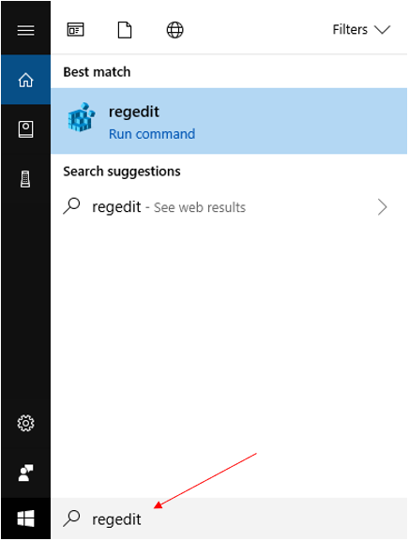

* Navigate to ‘**HKEY_CURRENT_USER**’.

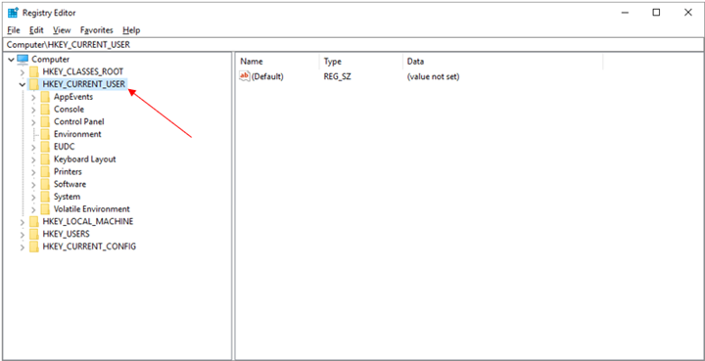

* Then navigate to ‘**Software**’.

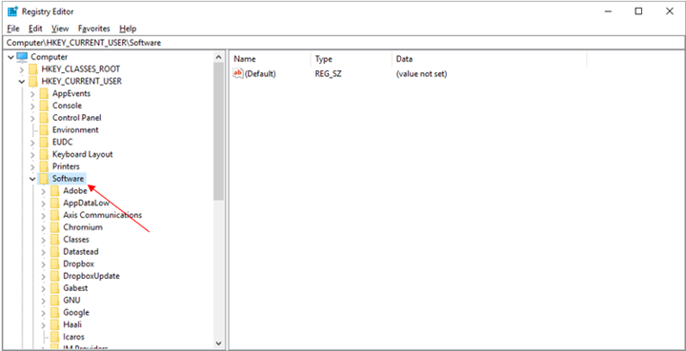

* Then right-click ‘**Neurovirtual**’.

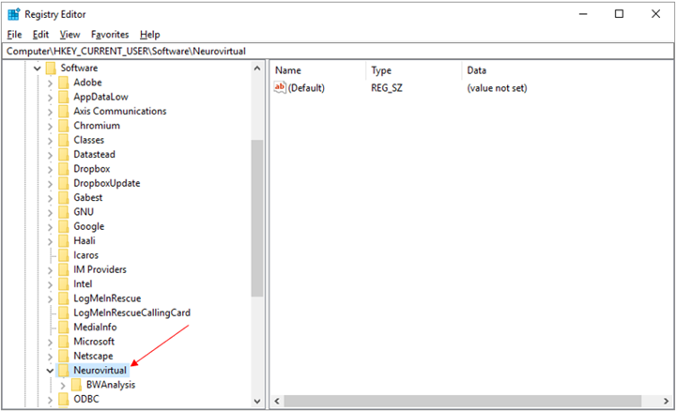

* Select ‘**Permissions**’.

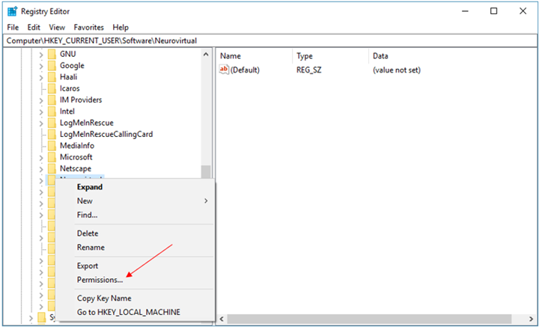

* Click ‘**Add**’.

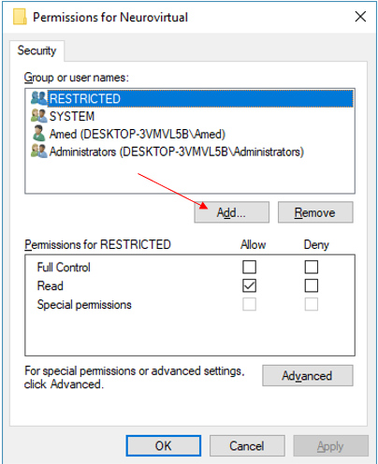

* Type ‘**Everyone**’ and click ‘**OK**’.

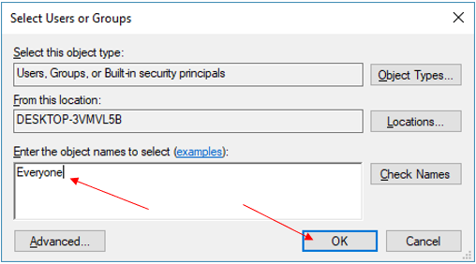

* Select ‘**Everyone**’, click ‘**Allow Full Control**’ and then click ‘**OK**’.

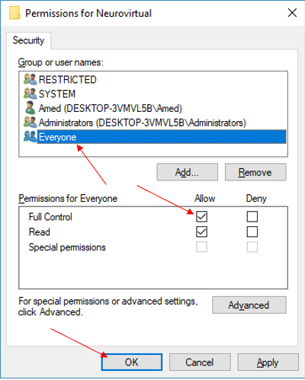

* Navigate to ‘**HKEY_LOCAL_MACHINE**’.

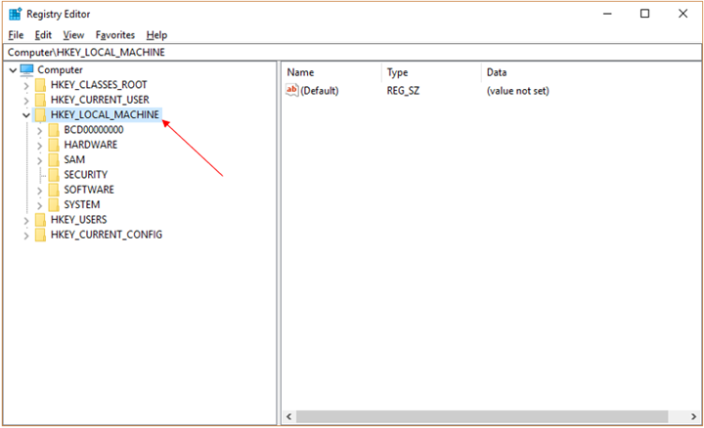

* Then navigate to ‘**Software**’.

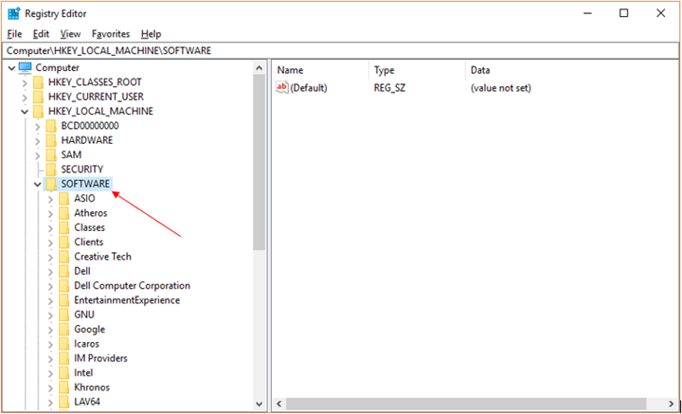

* Then right-click ‘**Neurovirtual**’.

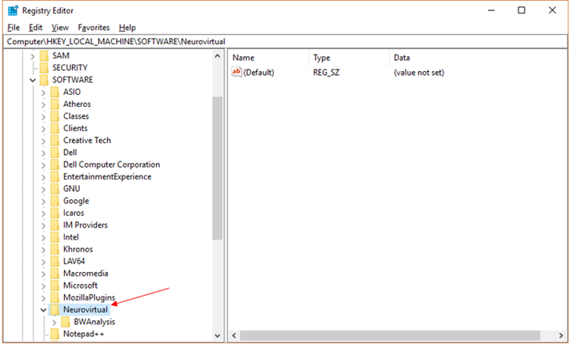

* Select ‘**Permissions**’.

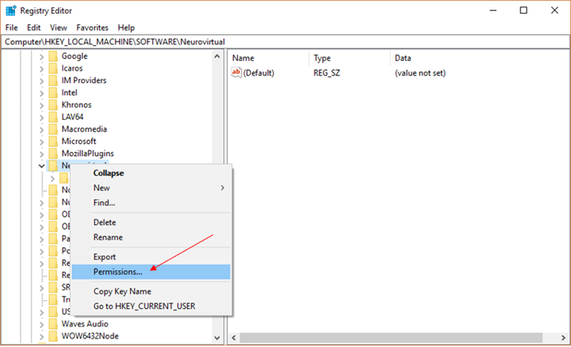

* Click ‘**Add**’.



* Type ‘**Everyone**’ and click ‘**OK**’.



* Select ‘**Everyone**’, click ‘**Allow Full Control**’ and then click ‘**OK**’.



* Open ‘**File Explorer**’.

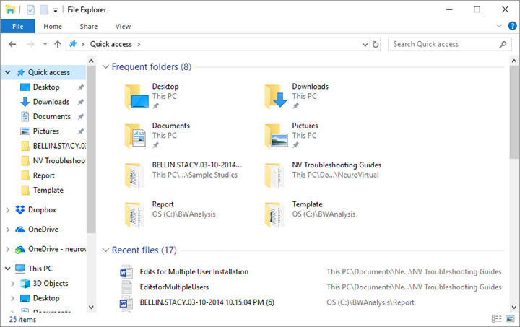

* Type ‘**C:\Windows\SysWOW64**’ as the path shown below.

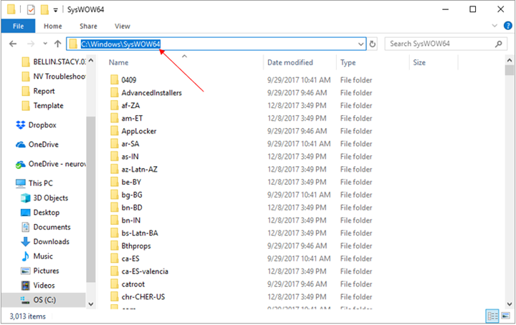

* Locate the file named ‘**systen3.sys**.

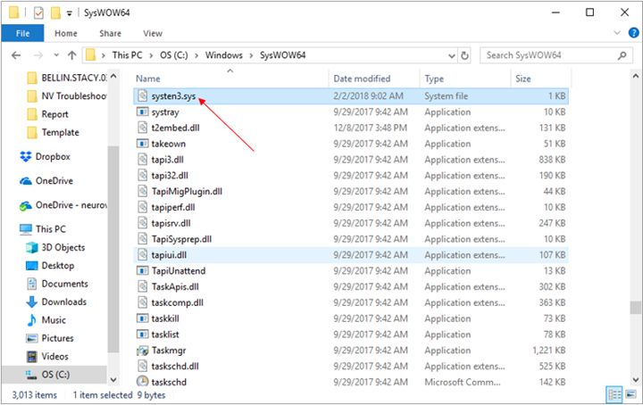

* Right-click and select ‘**Properties**’.

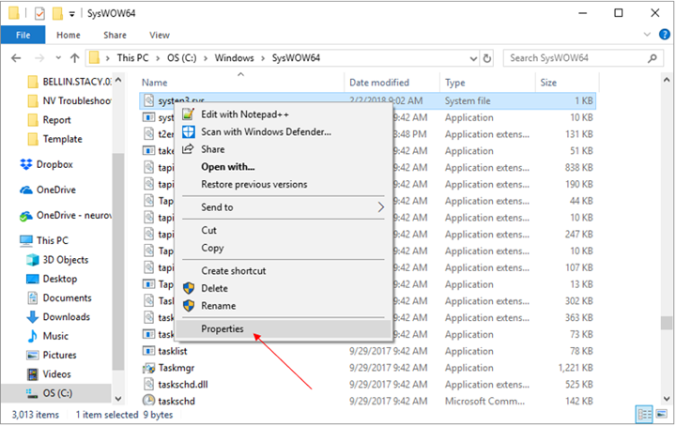

* Go to ‘**Security**’ tab and click ‘**Edit**’.

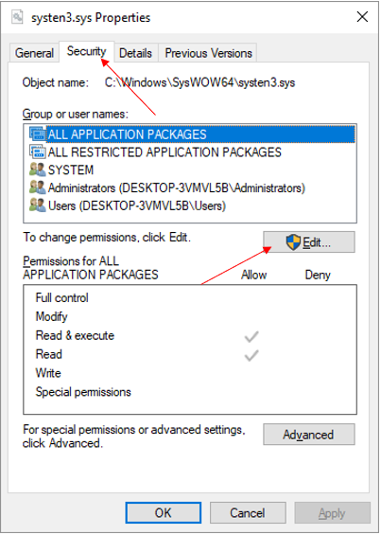

* Click ‘**Add**’.

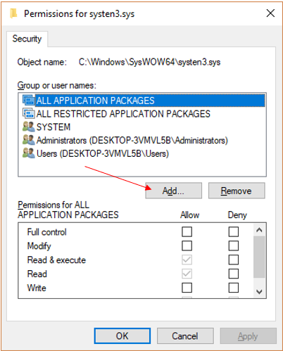

* Type ‘**Everyone**’ and click ‘**OK**’.



* Select ‘**Everyone**’, click ‘**Allow Full Control**’ and then click ‘**OK**’.

