Creating Photic Program

1. File> Configuration

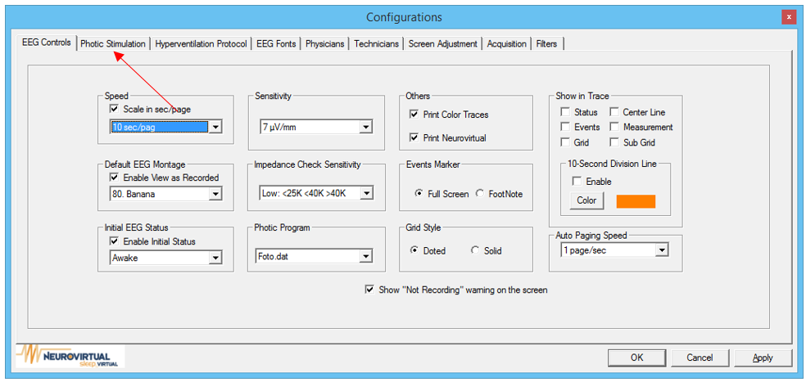2. Click on Photic Stimulation Tab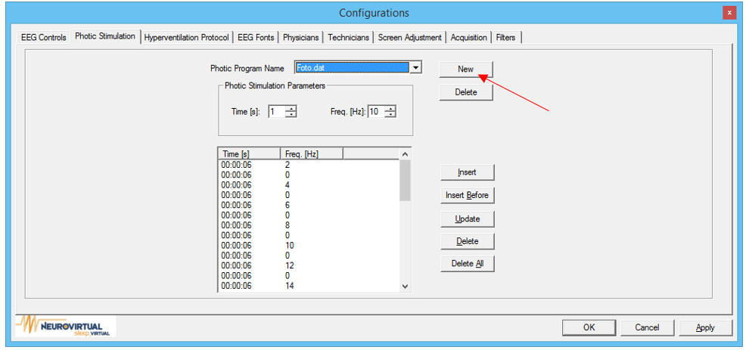3. Click New

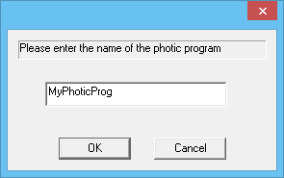4. Enter a name for your program

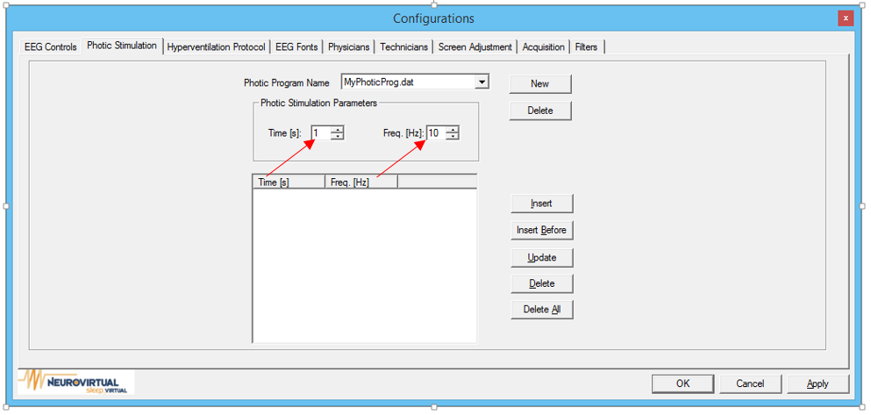

5. Select the parameters for your insertion. Time indicates the duration of the specified frequency in seconds. Freq indicates how fast the flash will be.

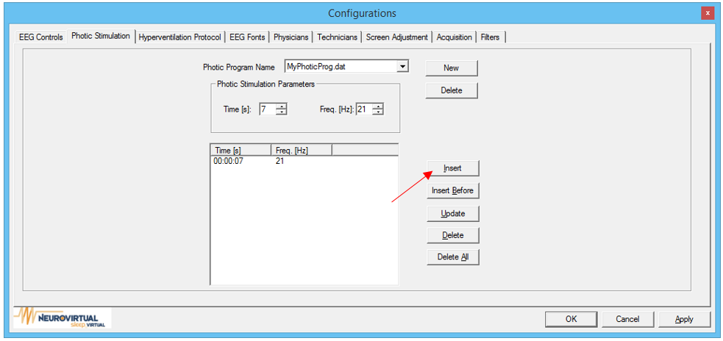6. Click Insert.

7. Repeat for the desired amount

8. Click Apply and Ok to finalize any changes.