EEG Controls

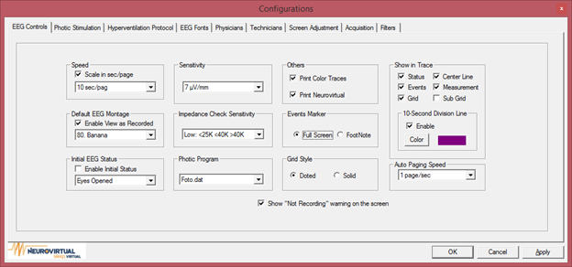

Speed

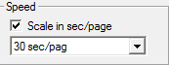

By enabling Scale in sec/page, paging will be in sec/page instead of mm/sec. The default sec/page or mm/sec can be select from the dropdown menu.

Sensitivity 

The default sensitivity for EEG studies can be select from the dropdown menu.

Default EEG Montage

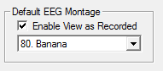

By enabling Enable View as Recorded, previously recorded study can viewed in the same montage it was recorded. The default montage can select from the dropdown menu.

Impedance Check Sensitivity

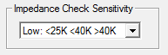

Allows the user to select the impedance sensitivity level.

Low: <25K=Green <40K=Yellow >40K=Red

Mid: <15K=Green <30K=Yellow >30K=Red

High: <5K=Green <20K=Yellow >20K=Red

Photic Program

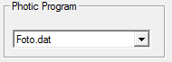

Allows the user to select the default starting Photic Program.

Show in Trace

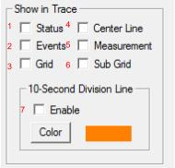

1. If enabled, statuses will be visible on the trace of EEGs. Statuses that include, montage changes and start/stop recording.
2. If enabled, events will be visible on the trace of PSGs. Events that include, lights on/off and start/stop recording.
3. If enable, the trace will be contained with a grid.

**Example**

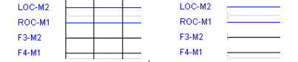

1. If enabled, a centerline will be placed in center of the trace.
2. If enabled, measurements placed on the trace will be displayed.
3. If enable, the grid will contain a subgrid

**Example**

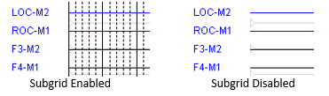

1. Allows the user to select a color for the 10-second line indicator.

Event Marker

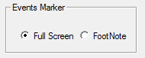

Full screen markers, will displayed a vertical line right after the event label. Footnote markers, will be displayed on the bottom of screen

**Example**

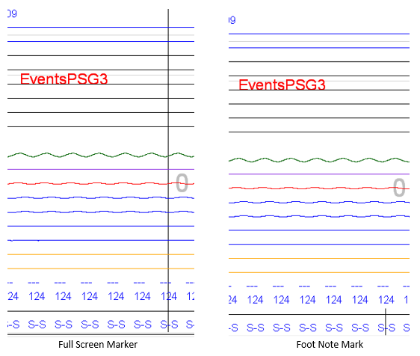

Grid Style

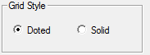

Grid Styles allows the user to select doted or solid a grid.

**Example**

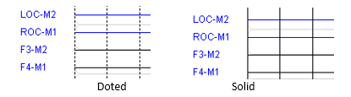

Auto Paging



Sets the initial speed for the auto-paging feature.

Other



If enabled, a not recording warning will be displayed at the start of a trace.