# Acquisition

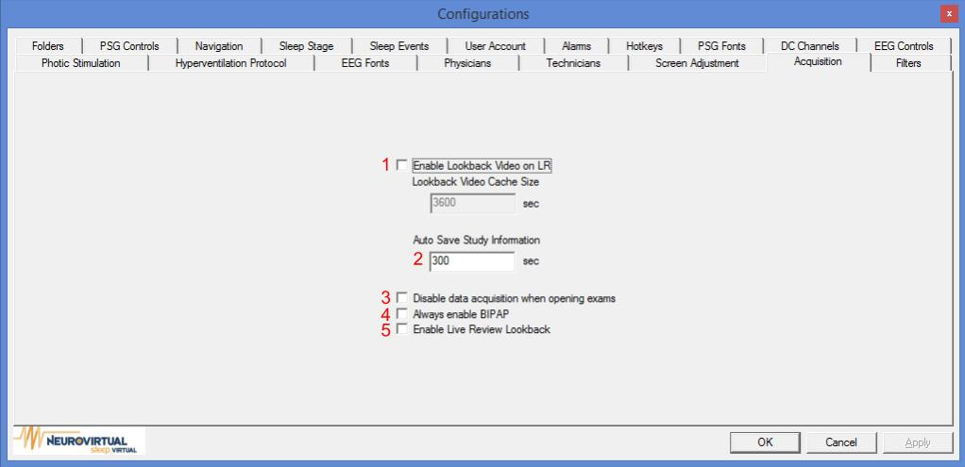

1. By enabling look back video during live review, the user will be able to see the recorded video during live review.

By adjusting the look back video cache size, recently recorded footage will be available in the seconds indicated.

1. The Auto Save feature controls how often BWAnalysis saves the study.
2. By enabling this option, previously recorded study will not be allowed to recording.
3. By enabling this option, study by default will have bi-level enable.
4. By enable Live Review Lookback, the live will now be display in a full screen format.