# Filters

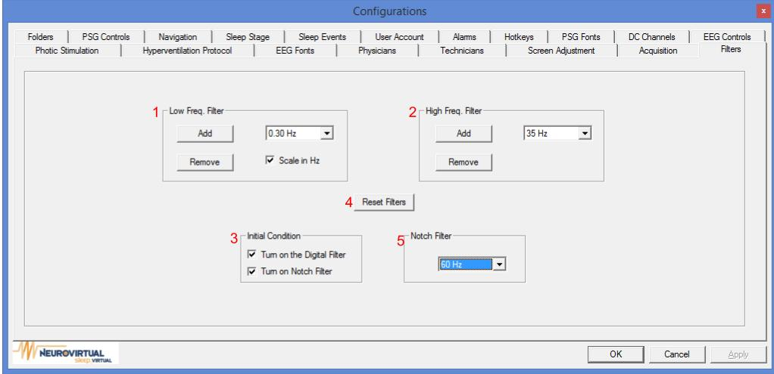

1. This setting allows the user select a default low frequency filter. It also allows the user to add and remove low frequency filters
2. This setting allows the user select a default high frequency filter. It also allows the user to add and remove high frequency filters
3. By clicking Reset Filters, all filter settings will be stored to factory settings.
4. If these options are enabled, Digital Filter and Notch Filter will be active the start of an exam by default.
5. Notch Filter can be set to 50Hz or 60H according to different countries specification.