# Fonts

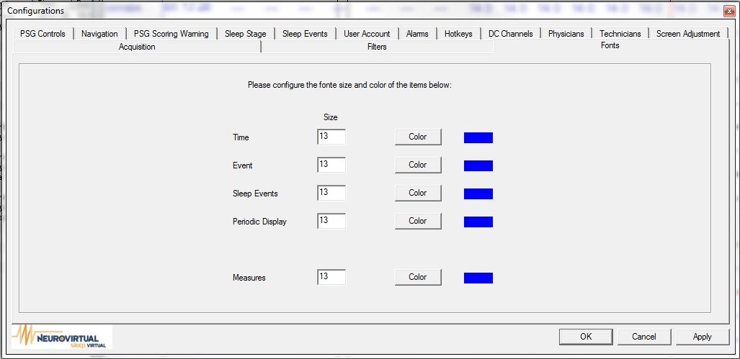

Can configure Size and Color for the following, Time, Event, Sleep Events, Periodic Display, and Measures

**Example**

**Time**

**Measurement**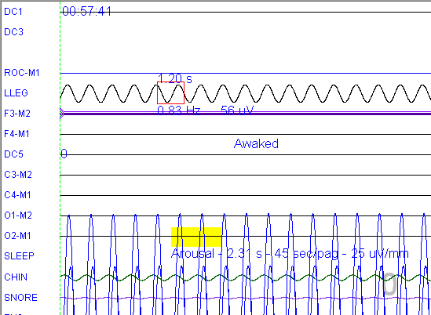

**Sleep Events**

**Event**