# Navigation

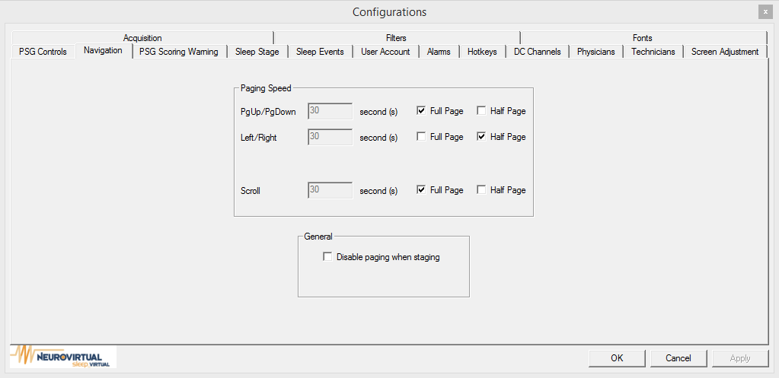

### Paging Speed

This option allows the change of the page speed of the Page Up / Page Down keys, Left and Right Arrow keys, or Scroll arrows. An exact number of seconds or Full and half pages can be set.

### General

By disabling paging when staging, the Page Up / Page Down keys, Left and Right Arrow keys, or Scroll arrows will become unable to the user during staging.