Patient Event Button (DC)

To enable your DC patient button please follow the steps outlined below:

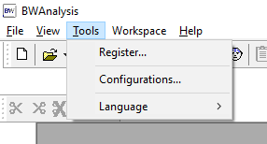

1. Go to Tools > Configuration

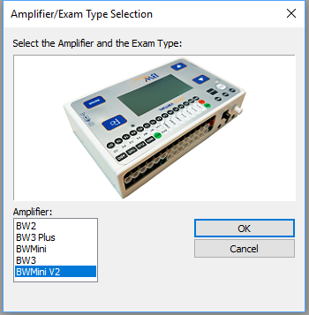

1. Select your amplifier

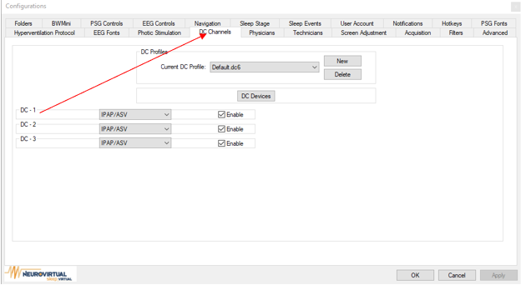

1. Click on DC Channels Tab

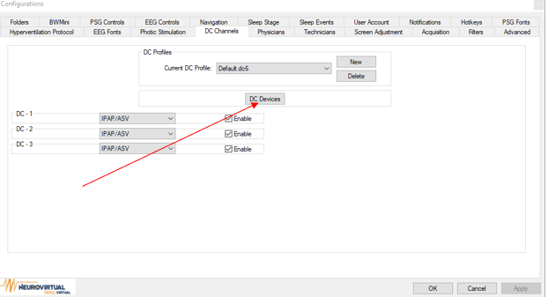

1. Click DC Devices

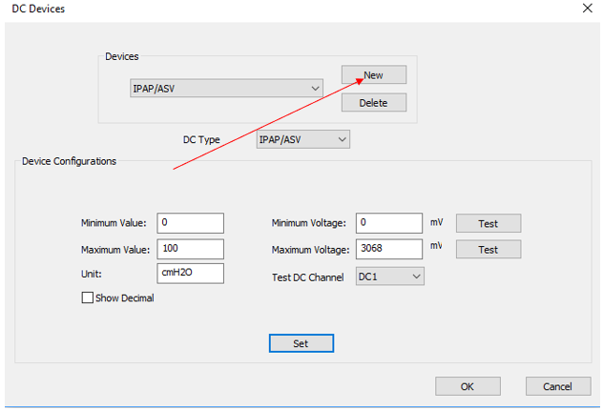

1. Click New

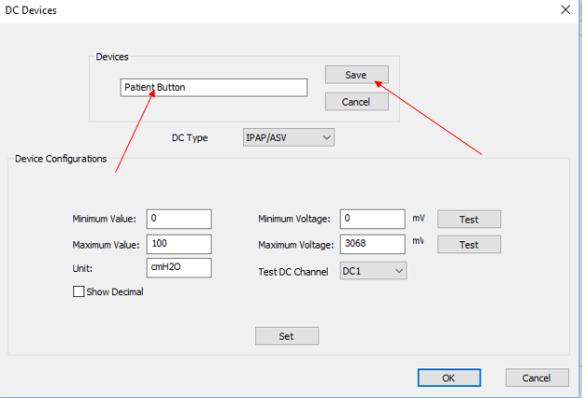

1. Enter “Patient Button” and click Save

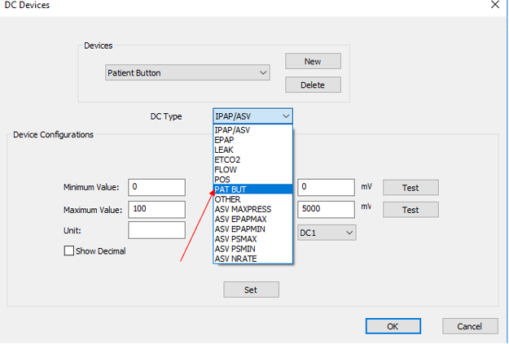

1. Change the DC Type to Pat But

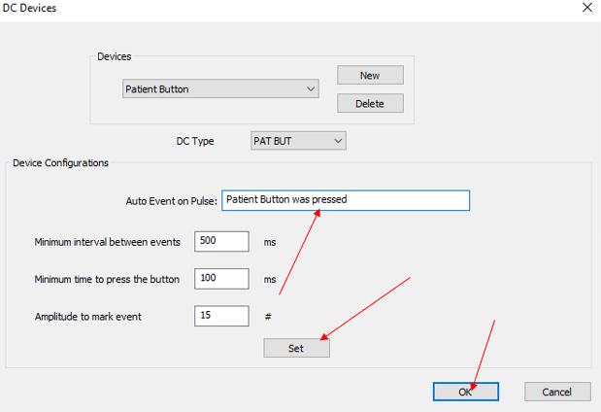

1. Enter the Event you want to insert every time the patient is pressed.
2. Click set and OK to save changes.
3. Click OK to exit configuration.