# Physicians

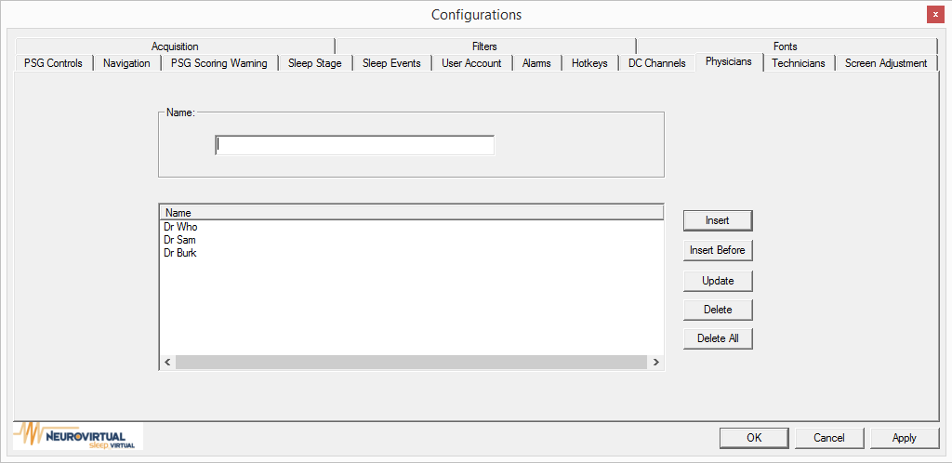

Allow you enter a list of physician that can used at the start of an exam. If a physician is selected at the start of an exam, the physician name will also be included on the generated reported.

**Example**

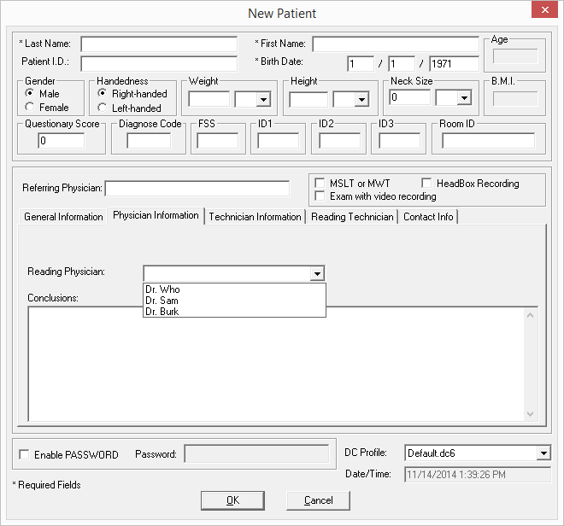

# Technicians

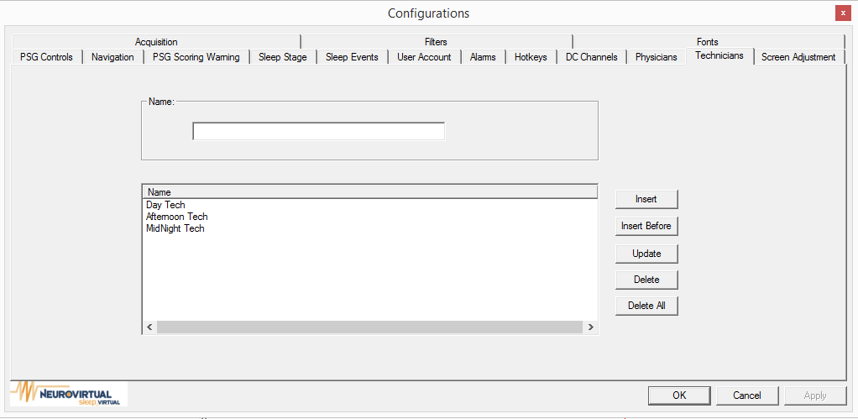

Allow you enter a list of techinicans that can used at the start of an exam. If a physician is selected at the start of an exam, the physician name will also be included on the generated reported.

**Example**

