# Screen Adjustment

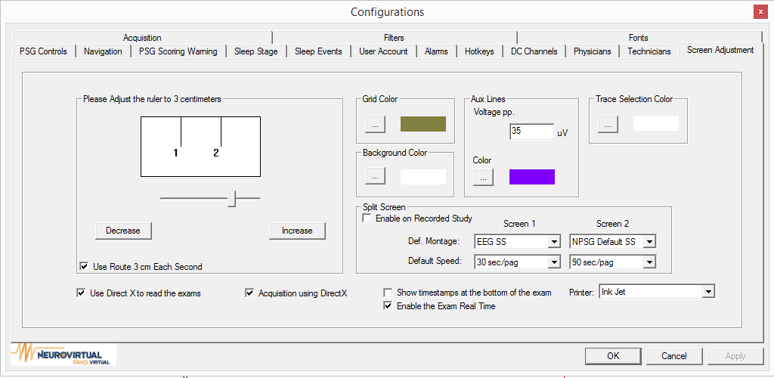

Please adjust the ruler to 3 centimeters: allow you to adjust the screen to match 3 centimeters, buy using the Decrease or Increase button.

Use Route 3 cm Each Second

Use Direct X to read the exams

Acquisition using DirectX

Show timestamps at the bottom of the exam

Enable the Exam Real Time

Grid Color, Trace Selection Color, Back Ground Color, Aux lines Color: The color can be changed by clicking on button and selecting color from palette.

Aux Lines Voltage pp. can be given a default uv value.

Split Screen: can be enable on recorded study, allowing you to set Screen1 and screen 2 Default Montage and Default Speed.

Printer type can be selected by electing one from drop down list.