# Creating A DC Device

* + - 1. Click DC Devices

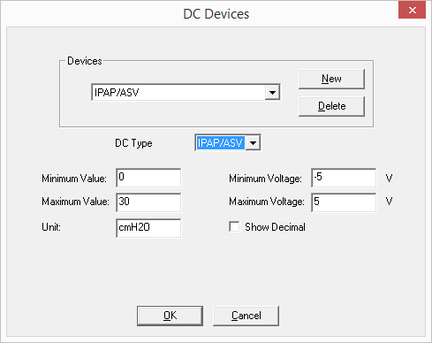

* + 1. Select a DC Type
    2. Enter the minimum value and the corresponding minimum voltage (Consult your DC device manual)
    3. Enter the maximum value and the corresponding maximum voltage (Consult your DC device manual)
    4. Enter the unit of measure
    5. Select Decimal if needed.
    6. Click Ok

You may assign a preconfigured DC Device by enabling the DC Channel and selecting the device for the drop down menu.