# Alarms

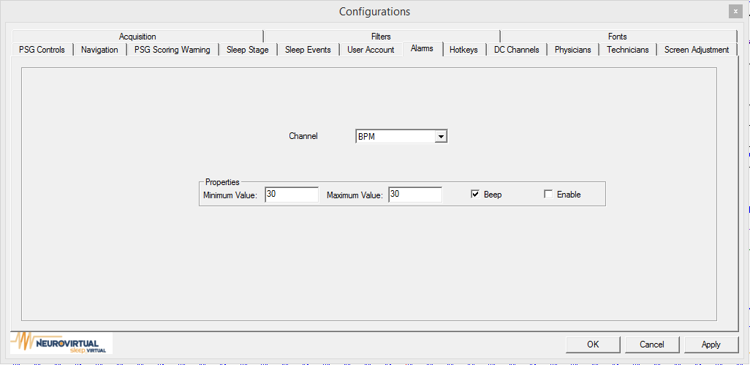

By select a channel, (BPM, SpO2, DC1, DC2, DC3, DC4, DC5, DC6, DC7, or DC8) users can set the minimum and maximum for an alarm trigger. If the value is smaller than the minimum or the value is greater than the maximum, the user will receive an alarm.