# Hot Keys

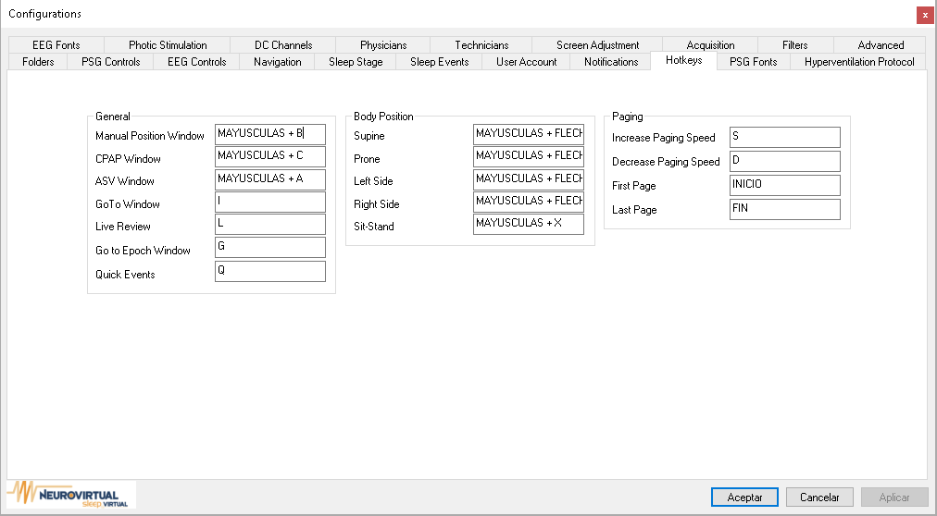

* 1. **General**

Opens the following windows:

1. Manual Position Window
2. CPAP Window
3. ASV Window
4. Go to Window
5. Live Review
6. **Body Position**

Inserts a manual body position:

* + 1. Supine
    2. Prone
    3. Left Side
    4. Right Side
    5. Sit-Stand

1. **Paging**

Increases or decreases the paging for auto paging.