# PSG Controls

### PSG Controls.jpgPeriodical Display

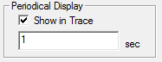

The periodical display option, allows you to adjust how often you want periodical data to be refreshed.

*For example, the periodical set to 5 sec on a 30 sec/page display*



### Speed

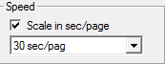

By enabling Scale in sec/page, paging will be in sec/page instead of mm/sec. The default sec/page or mm/sec can be select from the dropdown menu.

### Default PSG Montage

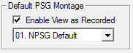

By enabling Enable View as Recorded, previously recorded study can viewed in the same montage it was recorded. The default montage can select from the dropdown menu.

### Sleep Begins with 3 Consecutive Sleep Epochs

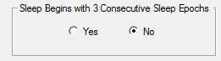.

### Sensitivity



The default sensitivity for PSG studies can be select from the dropdown menu.

### Auto Paging Speed



Auto Paging Speed, sets the default speed for auto paging for reviewing studies.

### Impedance Check Sensitivity

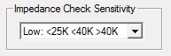

Allows the user to select the impedance sensitivity level.

Recommendation:

Low:<25K<40K >40K

Mid: <15K<30K >30K

High:<5K<20K>20K

### MSLT/MWT Graph Color

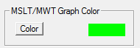

By clicking on Color button, you can change the color of the MSLT/MWT Graph generate on MSLT/MWT reports.

Example:

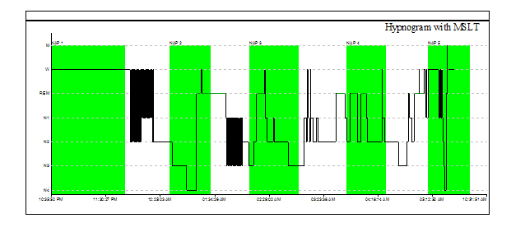

### Trace

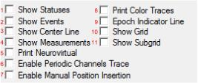

* 1. If enabled, statuses will be visible on the trace of EEGs. Statuses that include, montage changes and start/stop recording.
  2. If enabled, events will be visible on the trace of PSGs. Events that include, lights on/off and start/stop recording.
  3. If enabled, a centerline will be placed in center of the trace.
  4. .
  5. .
  6. If enabled, a trace will be added to the periods of periodic channels.

Example

 

With trace enabled Without trace enabled

* 1. If enabled, manuel position adjustment will on by default.
  2. If enabled, when traces are printed, the print will included color
  3. If enabled, each epoch will be divided by a Indicator Line
  4. If enable, the trace will be contained with a grid.

Example

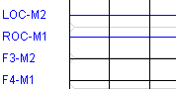 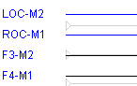

Grid Enabled Grid Disabled

* 1. If enable, the grid will contain a subgrid

Example

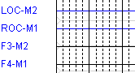 

Subgrid Enabled Subgrid Disabled

### Grid Style

Grid Style.png

Grid Styles allows the user to select dash or solid a grid.

**Example**

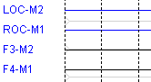 

Dash Solid

### Epoch Line Color

**Epoch.png**

Allows you select a color for epoch line indicator.

**Example:**

*Epoch Line indicator*

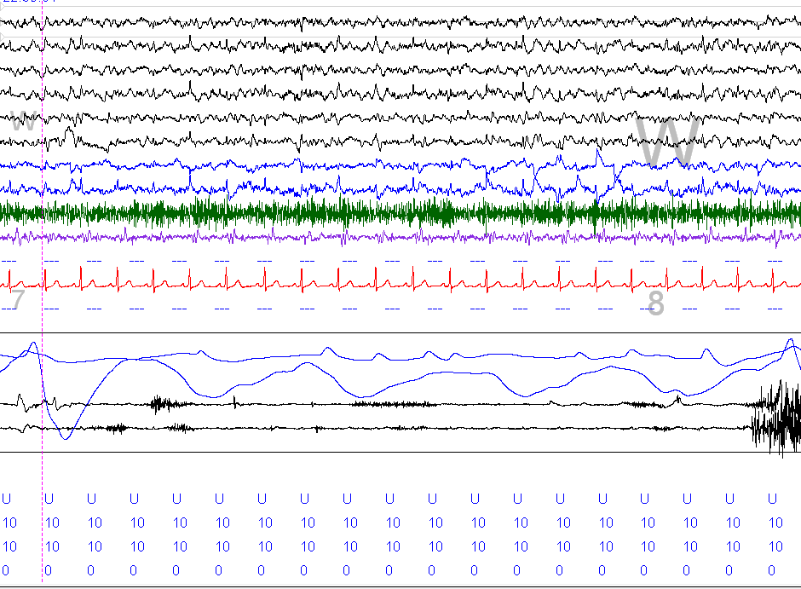

### Events

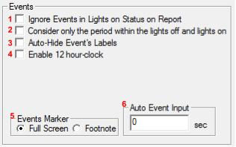

* 1. If enabled, events that occur during the lights on period will be excluded from reports
  2. If enabled, Periods that are contained with lights off and light will be used for evaluation
  3. If enabled, event labels will only be displayed if mouse is hovered over.
  4. If enabled, clock will be display in standard time (am/pm). If disabled, time will be a 24 hours format.
  5. Full screen markers, will displayed a vertical line right after the event label. Footnote markers, will be displayed on the bottom of screen

Example

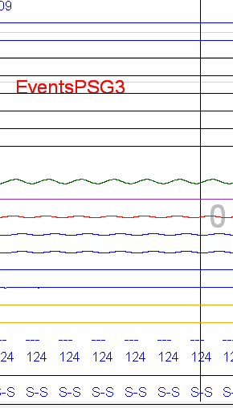 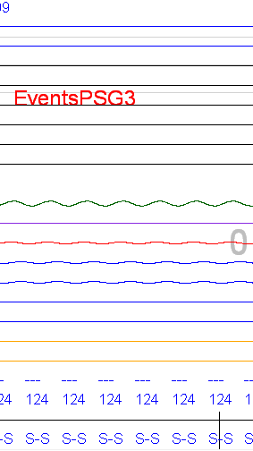

Full Screen Marker Foot Note Mark

* 1. At your desired amount of seconds, the user will receive an automatic request to enter an event.

### General

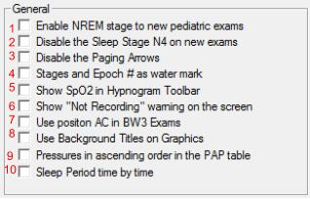

1. Enables NREM stage to new pediatric exams
2. If enabled, marking N4 sleep stage will not be allowed.
3. If enabled, paging using arrow keys will be disabled.
4. If enabled, the stage and epoch marked in the center of the trace.

Example

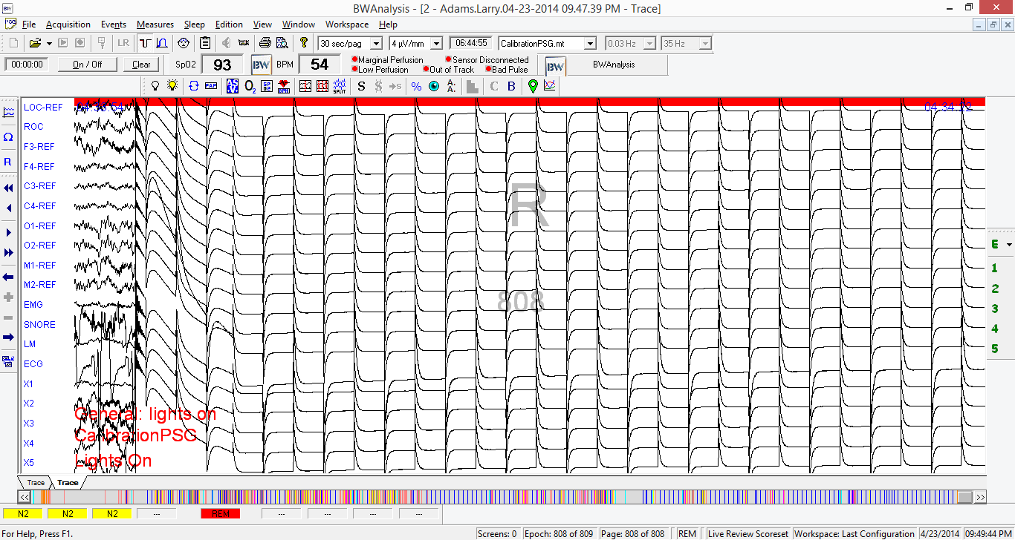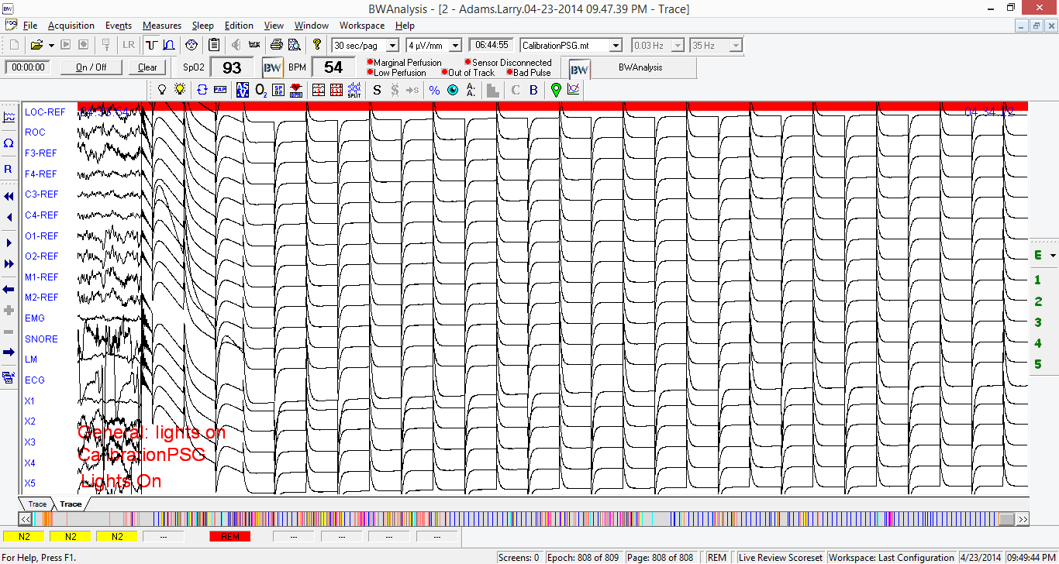

With epoch/stage watermark Without epoch/stage watermark

1. If enabled, the Sp02 will be displayed in the Hypnogram graphic.
2. If enabled, a not recording warning will be displayed at the start of a trace.
3. If enabled, the body position will be acquired from an AC Sensor. If disabled, the body position will be acquired from a DC Sensor.
4. If enabled, graphics that are generated on reports will have a title applied in the background.
5. If enabled, pressures, on a report generated pap table, will be display in ascending order.
6. Sleep Period time by time