# PSG Scoring Warning

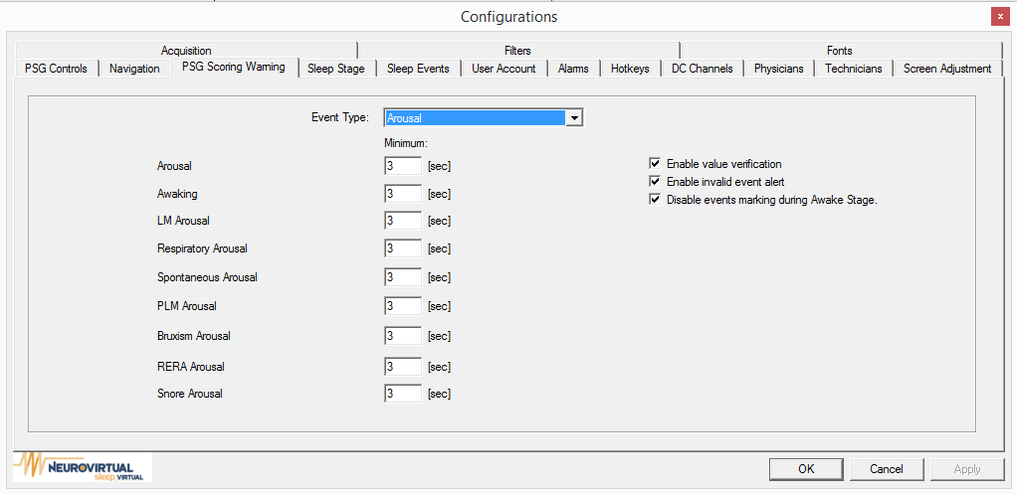

Event Type: Arousal, Movement, PLMS, Respiratory, Cardiac

1. Arousal: Arousal, Awaking, LM Arousal, Respiratory Arousal, Spontaneuos Arousal, PLM Arousal, Bruxism Arousal, RERA Arousal, Snore Arousal you can set a minimum by sec.
2. Movement: Bruxism you can set a minimum by sec.
3. PLMS: LM you can set a minimum or maximum by sec.
4. Respiratory: Apnea Central , Apnea Obstructive, Apnea Mixed, Hypopnea, Cheyne Stokes Breathing, RERA, Periodic Breathing you can set Minimum by sec.
5. Cardiac: you can set the following Bradycadia a maximum for BPM, Sinus Tachycardia a minimum for bpm, Asystole a minimum for sec, Wide Complex Tachycardia a minimum for bpm, Narrow Complex Tachycardia a minimum for bpm.

Enable value verification

Enable invalid event alert

“Disable events making during Awake Stage.” When checked you will not be able to mark events during wake stage.