# Sleep Events

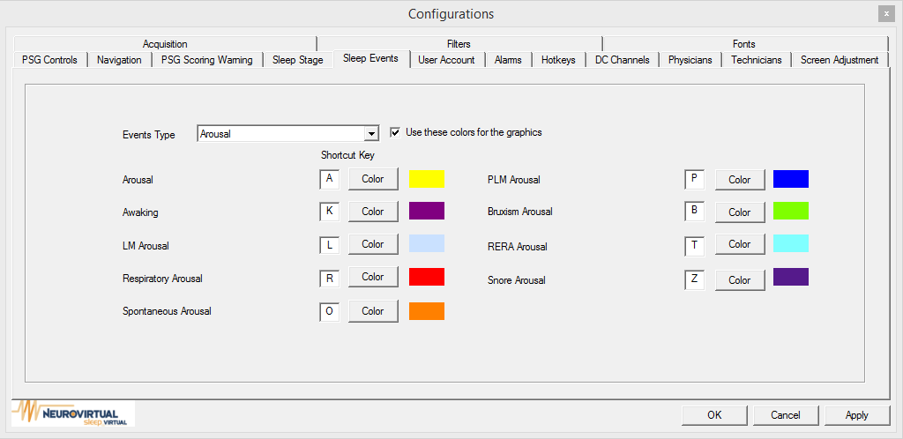

Event Type: Arousal, Cardiac, ETC02, LM, Movement, O2 Desaturation, Resperitory, Seizure, Snoring. You can select to use these colors for graphics by checking “Use these colors for the graphics” By selecting an event type from drop down it allows you to make changes to individual color event types by clicking on each individual Color.pngbutton and then selecting the color from color palette