# Sleep Stage

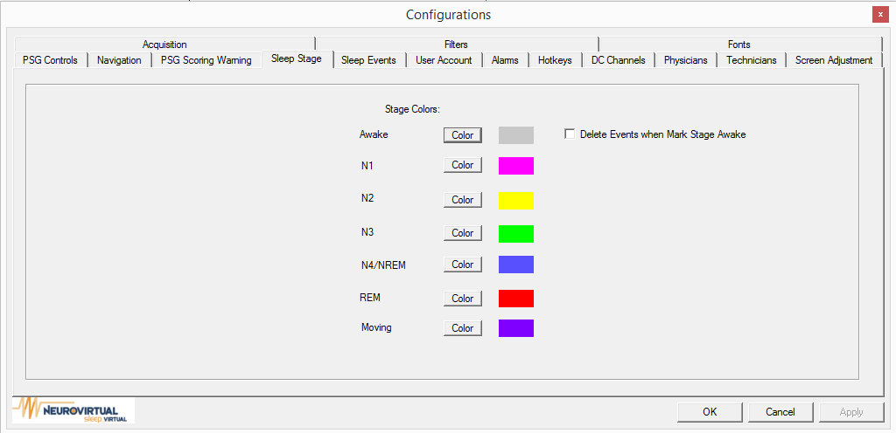

**Stage Colors:** This option allows the user to change the color indicators of each stage. The stage color indicators are displayed on the top of the trace or in the status tool bar.

**Example**

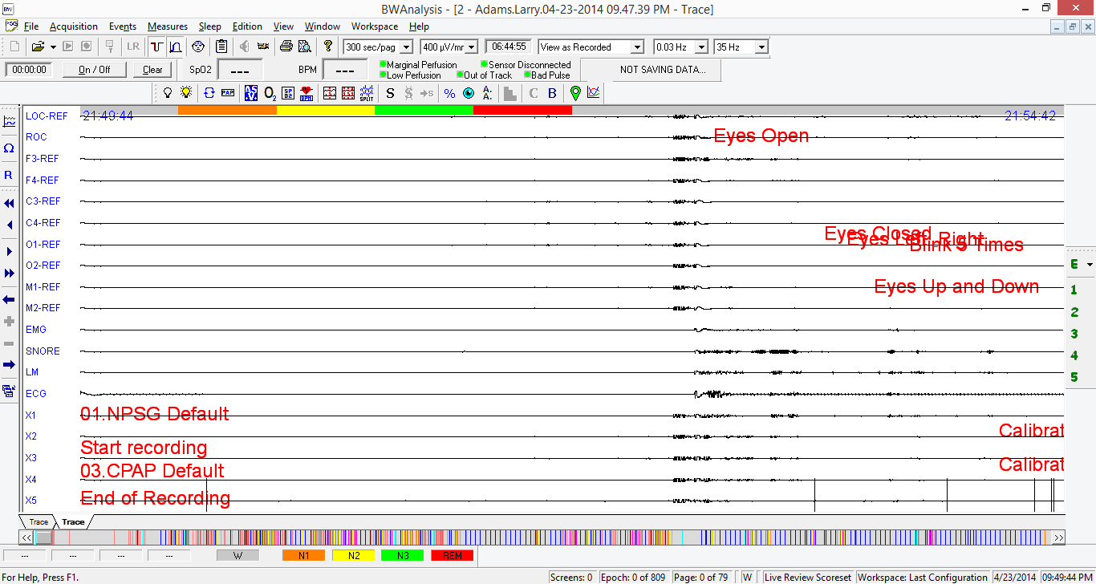

If “Delete Events when Mark Stage Awake” is enabled, events that are placed in a wake stage will be automatically removed.