## BWAnalysis Installation

1. Run BWAnalysis Setup

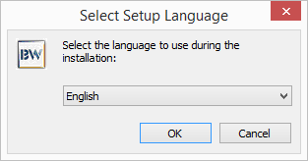

1. Select your preferred language and click ok.

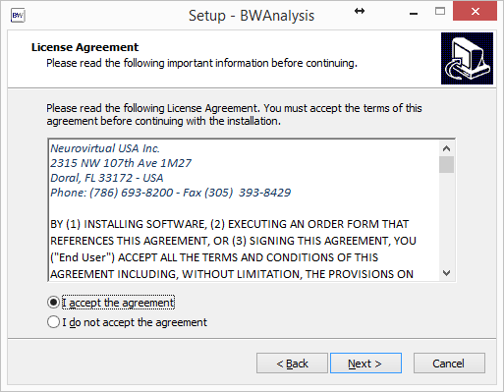

1. Accept the Agreement and click next.

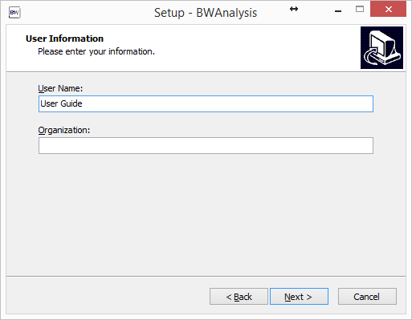

1. Click Next.

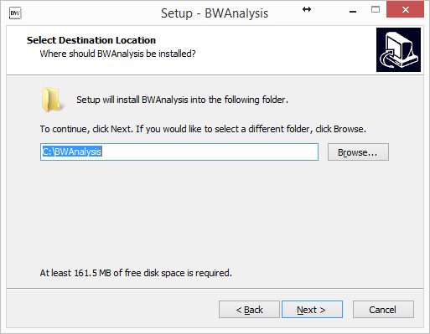

1. Accept the default configuration and Click Next

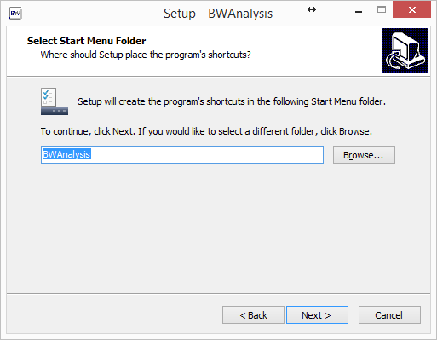

1. Accept the default configuration and click next

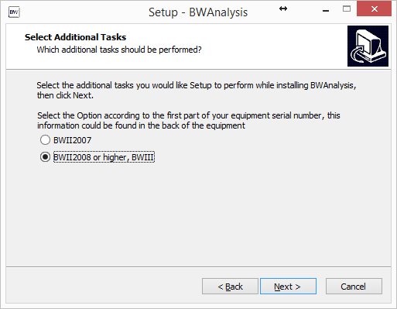

1. Accept the default configuration and click next

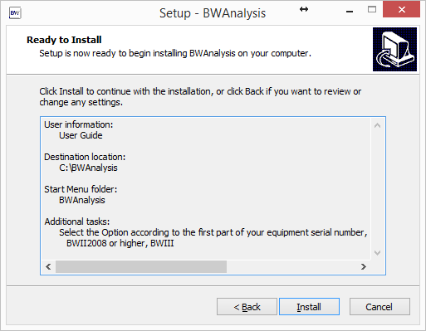

1. Click Install

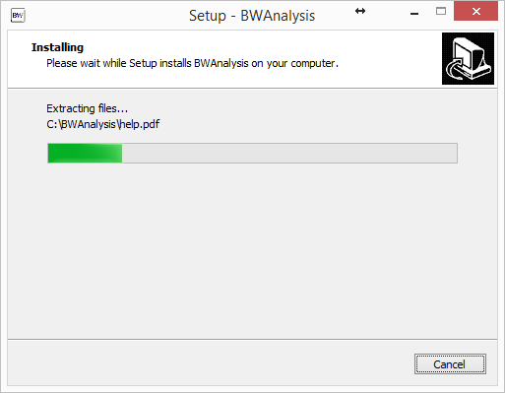

1. Allow a few minutes for the installation to complete.

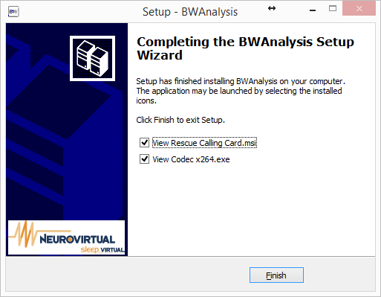

1. Click View Rescue Calling Card and View Codec x264 and click Finish.

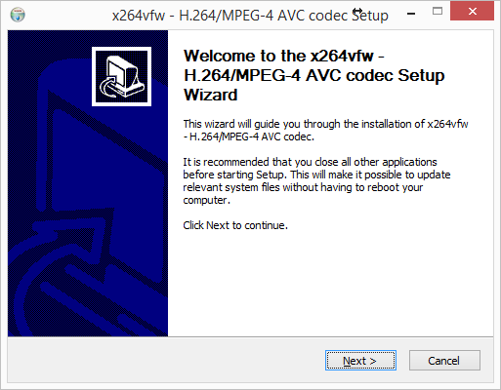

1. Click Next

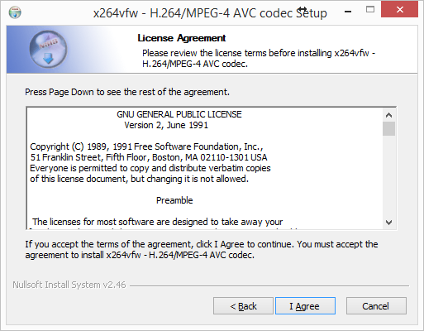

1. Click I agree

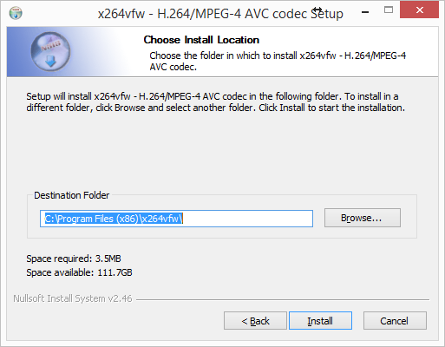

1. Accept the default configuration and click next

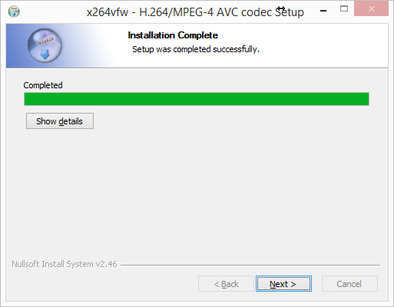

1. Allow a few minutes for the installation to complete.

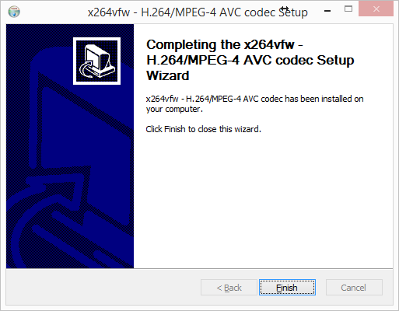

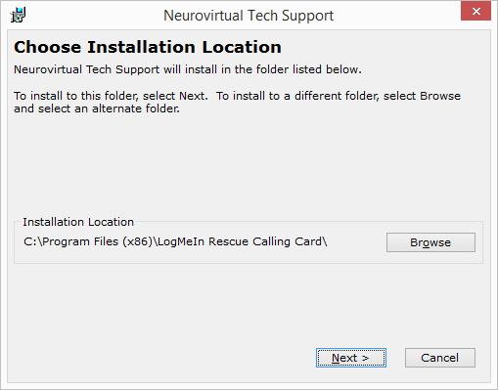

1. Accept the default configuration and click next

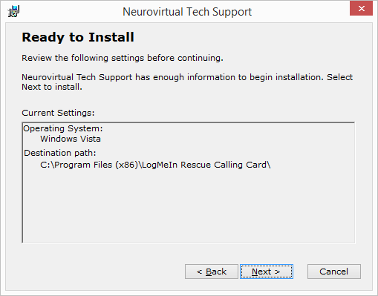

1. Click Next

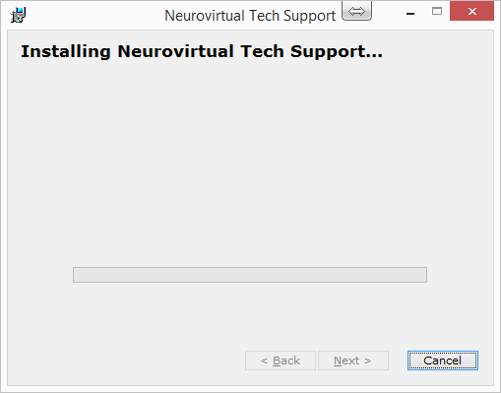

1. Allow a few minutes for the installation to complete.

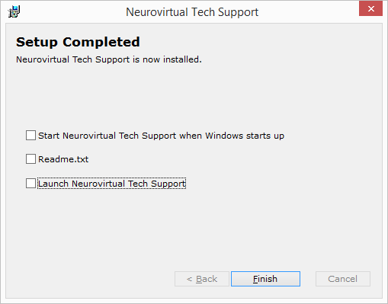

1. Unselect Start Neurovirtual Tech Support when Windows starts up, Readme.txt, and launch Neurovirtual Tech Support.
2. Click Finish

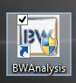

(Required only for acquisition computers)

1. Go to the desktop and start BWAnaylsis.

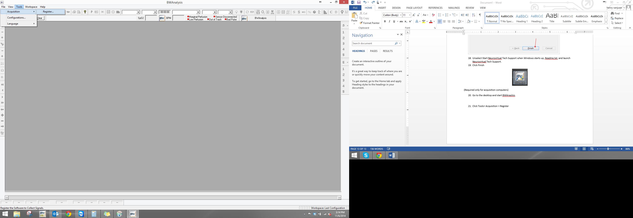

1. Click Tools> Acquisition > Register

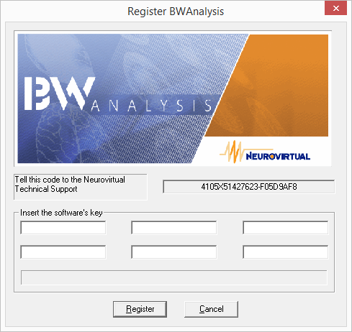

1. Enter the software key that was provide to you after your purchase and click register. If one wasn’t provided, please contact Neurovirtual’s Tech Support at 1-888-675-3378

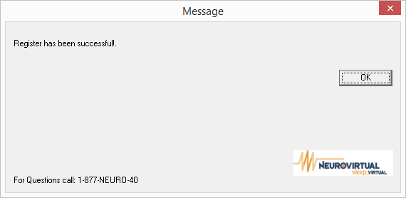

1. If the software key was enter successfully, you will be prompted by a confirmation. Click OK.

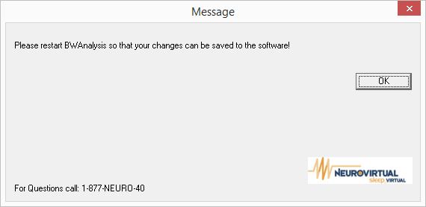

1. Click Ok and Close BWAnalysis