**Create a new user account.**

1. Log into BWCenter as an Administrator.

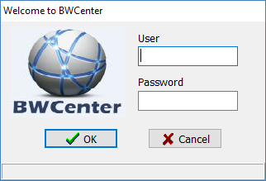

1. Select the Configurations Tab and click Login info

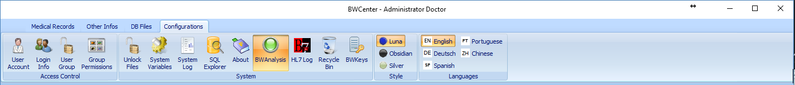

1. Click New

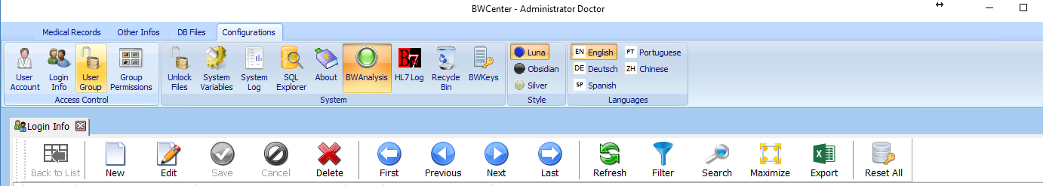

1. Enter the Username, Password (you will need to confirm the password), Select the user group for this User.

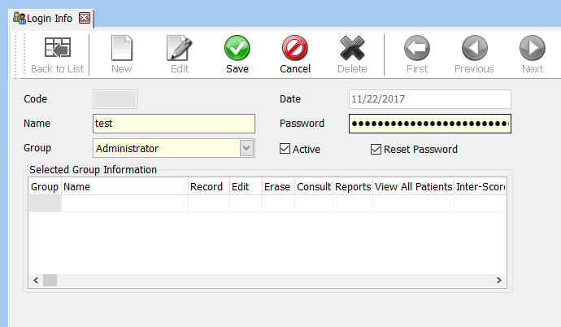

If you check reset password, the user will be prompted to reset password the next time they log in.

1. Click Save.